**Computer Organization 2016**

**HOMEWORK IV**

系級: 學號: 姓名:

**實驗結果圖(snapshot of result)**

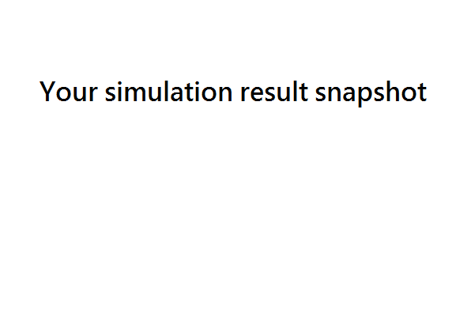

**The I-Cache hit rate of your simulation & your reason:**

**指令波型圖( Instruction waveform of some situations)**

(Please explain why your snapshot is correct, including the wires, signals.)

1. I-Cache Miss



Description:

1. I-Cache Hit:



Description:

1. Other situations you found (optional bonus)(可做可不做)



Description:

**心得(Report)**

(請寫下完成本次作業的心得、學到哪些東西、困難點的部分。大約   
 100~200字 )

(Please write your learned lesson and conclusion, and difficult point. About   
 100~200 words)