**Computer Organization 2016**

**HOMEWORK III**

系級: 學號: 姓名:

**實驗結果圖(snapshot of result)**

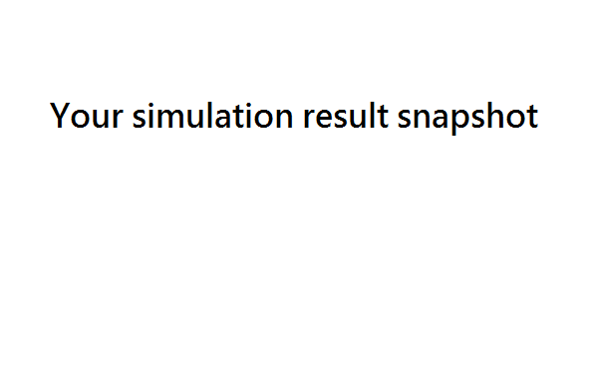

**指令波型圖( Instruction waveform of some situations)**

(Please explain why your snapshot is correct, including the wires, signals. The description should be as detailed as possible, e.g. why this situation occurs, and in waveform where does it occur?)

1. Instruction with Forwarding

R-type:



Description:

I-type:



Description:

1. Load Stall:



Description:

1. Branch Delay (& Flush):



Description:

1. Other snapshot (Optional for Bonus)



Description:

**心得(Report)**

(請寫下完成本次作業的心得、學到哪些東西、困難點的部分。大約   
 100~200字 )

(Please write your learned lesson and conclusion, and difficult point. About   
 100~200 words)