The Ideal Hash Function and Pseudorandom Number Generator

Yi Wang1,2, ??, Diego Barrios Romero3, Daniel Lemire4, Li Jin1,2*

1. Ministry of Education Key Laboratory of Contemporary Anthropology, Collaborative Innovation Center for Genetics and Development, School of Life Sciences, Shanghai, China.
2. Human Phenome Institute, Fudan University, Shanghai, China.
3. Fraunhofer Institute for Digital Medicine MEVIS, Bremen, Germany.
4. Université du Québec (TÉLUQ) Montreal, Canada

**Abstract**

Hash function and pseudorandom number generator (PRNG) are two fundamental functions in computer science. They have numerous applications and were estimated as important as algorithm and network. Even though hundreds of hash function and PRNG have been proposed in last decades, there are still rooms for improvement. We propose whish and wyrand as the ideal hash function and PRNG, which are high quality, fast, portable and elegant. They passed SMHasher, PractRand and BigCrush tests. Benchmark and practice usage show that replacing exist hash function and PRNG with wyhash lead to “incredible” speedup. wyhash and wyrand can be accessed at https://github.com/wangyi-fudan/wyhash

**Introduction**

A hash function is a function to convert arbitrary data to a fixed-length integer. The input data was called the “keys” and the output integer was called the “hashes”. (figure1) Hash is a cornerstone of computer science and has numerous applications: fast algorithms, hash table, file checksum, duplication/collision detection, password storage, unique ID generation, proof-of-work, etc.

***Figure 1: Hash function explained***

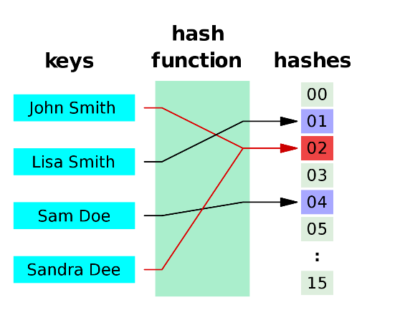

A pseudo-random number generator (PRNG) is an algorithm that can generate a stream of numbers which appears random. The PRNG-generated sequence is not truly random, because it is completely determined by an initial value, called the “seed”. PRNG brings “randomness” to a deterministic computer, thus has wide applications: randomized algorithm, statistical sampling, simulation, gaming, cryptography, lottery, music and art, etc.

To introduce the importance of hash and PRNG to the public, we show the number of GitHub files that contains the several keywords (figure 2). Hash and PRNG are roughly as important as network in the computer world. Due to their importance and openness, numerous hash functions (https://github.com/rurban/smhasher) and PRNGs (https://github.com/lemire/testingRNG) have been designed in last decades.

***Figure 2: Million of GitHub files that contain keywords***

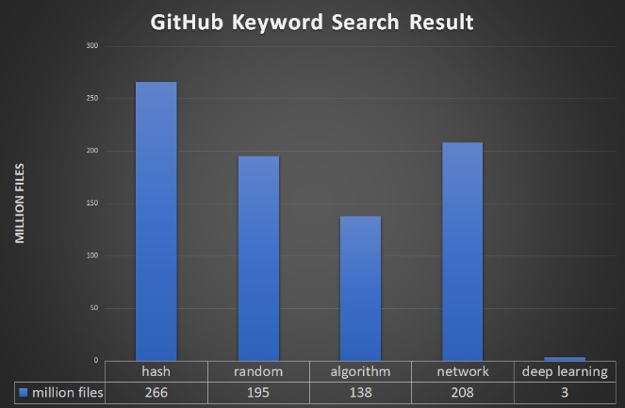

Despite the richness of hash functions and PRNGs, we still desire the ideal hash function (especially for short keys) and PRNG for non-cryptographic applications. According to practical demand, the ideal hash function and PRNG should be (1) uniformly distributed (2) very fast (3) portable (4) elegant. After one year of continual development, we are honored to announce wyhash (https://github.com/wangyi-fudan/wyhash), the ideal hash function and PRNG.

**Method**

***Mix Function:***

wyhash is based on a mix function call MUM that mix two 64-bit integer A and B to produce a 64-bit integer C: MUM(A,B) => C. @vnmakarov released the original version of MUM on Mother’s Day.

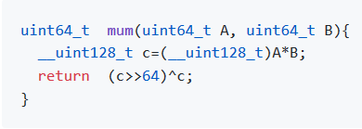

Despite the nominal 128-bit multiplication, the actual instructions on 64-bit machines are as simple as follow:

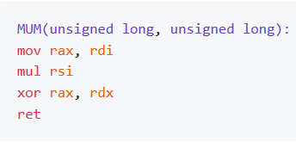

Our further improvements on MUM is the seed-masked-MUM: MUM(A^seed^p0, B^seed^p1), where p0 and p1 are random prime masks containing 32 1s. The seed-masked-MUM can protect the hasher, randomize biased real data and produce an avalanche effect. We observed experimentally that just two rounds of seed-masked-MUM suffice to pass all statistical tests.

***wyhash Hash Function***

wyhash hash function is based on seed-masked-MUM and contains two parts: A quick-return part and a batch part. The quick-return part processes the first K=(length mod 64) bytes while the batch part processes the rest of the data as 64-byte blocks. Then code is compact and elegant with only 21 lines of C code as follow.

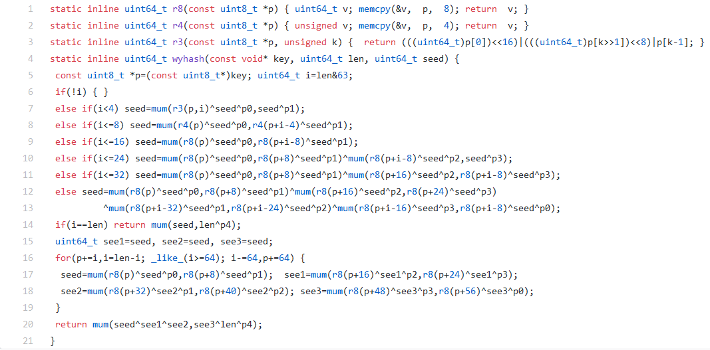

***wyrand PRNG***

Our PRNG is named wyrand is even simpler. It keeps a 64-bit internal status and updates it by adding a 64-bit prime. The internal status is mixed with masked itself by MUM function to produce a pseudorandom number. It is obvious that its cycle length is 2^64 as p0 is a large prime.

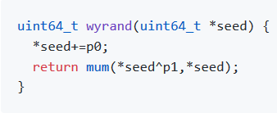

**Result**

We perform statistical quality test on wyhash by SMHasher. wyhash passed all quality tests. (supplemental material).

We performed statistical quality test of wyrand by PractRand and BigCrush via testingRNG suite. wyrand passed all tests despite of few suspicious false positives due to multiple testing (supplemental material).

We benchmark the speed of wyhash against the popular XXH64 hash function. Three benchmarks were carried: the plain short key hashing, the hashmap short key hashing and the 16MB bulk key hashing. We employ /usr/shared/dict/words as testing corpus and repeat 10000 times. We also list the compiled code size based on SMHasher. Relative speed is shown in figure 3. SMHasher also lists benchmark of 150 hash functions, in which wyhash is the fastest one without quality problem.

***Figure 3: Hash function benchmark***

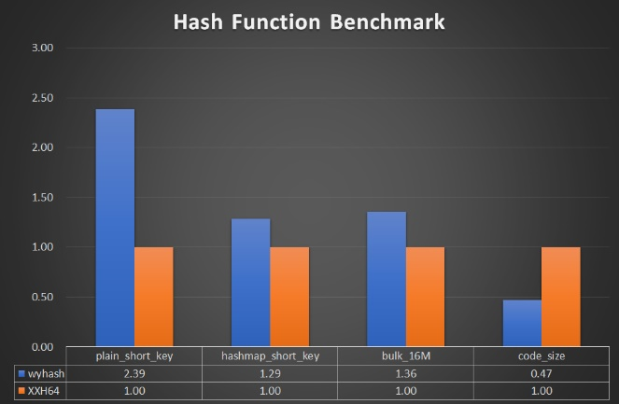

We benchmarked the speed of wyrand with other 16 PRNGs in testingRNG suite. We employed inlined benchmark code instead of testingRNG. Relative speed is shown in figure 4. Notably, wyrand is 8X faster than C library function rand() and 3.5X faster than popular Mersenne twist.

***Figure 4: PRNG Speed Benchmark***

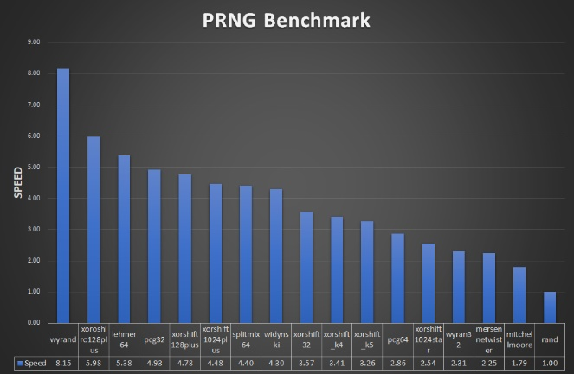

Portability Claim: wyhash and wyrand is portable on both 64-bit/32-bit/big endian/little endian machine. However, it is most efficient on 64-bit little endian machine which is most common today.

License Claim: wyhash and wyrand is an open source project and was distributed under UNLICENSE (<https://unlicense.org/>) which is completely free for the public.

**Discussion**

The MUM function is very fast on 64-bit machine but is slow on 32-bit machine. Yi Wang proposed an alternative MUM32 function to be efficient of 32-bit machine.

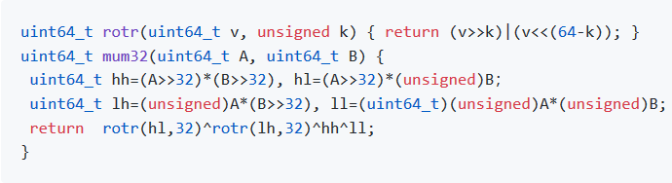

As @leo-yuriev pointed out, MUM function without xoring seed is vulnerable, as MUM(0, X)=0 for any X. As a solution to this problem, we evolved to the seed-masked-MUM. By keeping the seed as a secret or randomized value, MUM can not be cracked trivially in non-cryptographic applications.

wyhash use memcpy to access memory safely. It does not depend on the “read through” method that read across memory bound. It does not do unaligned memory access which is unsafe on some machines. One key technique that make wyhash fast is the fast reading of tail memory (<8 byte). It is credit to Yann Collet.

XXH3 is a recently developed hash function that is extremely fast by using AVX2 instruction. However, XXH3 fails two statistical tests according to SMHasher and relies on unaligned memory access. Thus, we choose XXH64 as the baseline rather than XXH3. On the other hand, XXH3’s scalar version (portable version) is slower than wyhash (supplement material).

The benchmark process, in fact, is complex. There are several benchmark suits available. There are common pitfalls in these suites. First, they employ function pointers, which disables powerful function inlining. Without function inlining, the speed is biased. Second, they use artificial data, which is either predictable or unrealistic. To avoid these pitfalls, we developed our own simple benchmark code (supplement material) and benchmark it using /user/shared/dict/word.

Currently, wyhash had make certain impacts during its one-year exposure on GitHub. There are 179 stars, 13 repository, 442 files associated with it. wyhash is adopted by Microsoft MixedReality-Sharing project which reported “much better” (https://github.com/microsoft/MixedReality-Sharing/issues/115). wyhash becomes the default hash function for V and Zig languages. The V language team reported “incredible” speed up (<https://github.com/vlang/v/pull/3591>).

**Acknowledgements**

We sincerely thank the following names due to their contributions to wyhash development: Reini Urban, Dietrich Epp, Joshua Haberman, Tommy Ettinger, Otmar Ertl, cocowalla, leo-yuriev, Diego Barrios Romero, paulie-g, dumblob, Yann Collet, ivte-ms.