Californian Surgeon General’s Playbook: Stress Relief during COVID-19

## IMPORTANCE OF STRESS MANAGEMENT DURING THIS TIME

The health and safety of our nearly 40 million Californians is the number-one priority for our state. This includes the physical and psychological well-being of all individuals. We are mindful that the public health policies and interventions necessary to slow the spread of COVID-19 are affecting all facets of society and our daily lives. These daily disruptions, coupled with the fear of not knowing what may come, are resulting in increased stress and anxiety for many.

Californians have come together to practice physical distancing to slow the spread of the novel coronavirus. While we take action to lessen the immediate impacts of COVID-19 on our communities and our health care systems, it is also important to minimize the secondary health effects of this pandemic. Widespread stress and anxiety regarding COVID-19, compounded by the economic distress due to lost wages, employment and financial assets; mass school closures; and necessary physical distancing measures can result in an increase of stress-related health conditions.

During this time, your body may be making more or less stress hormones than is healthy. This can lead to worsening of physical and/or mental health problems, such as diabetes, heart disease, anxiety, depression, smoking, or unhealthy use of alcohol or other drugs.

Stress can show up in our bodies, emotions and behavior in many different ways. For example in our bodies - changes to sleep patterns and appetite, headaches, stomach aches, or bowel changes, and spikes in blood pressure may all be signs of an overactive stress response. In our emotions and behavior – we may feel more irritable, experience mood changes, anxiety, depression, increased substance use, or anger. It’s important to know that these changes aren’t “just in your head”. They may be signs of a biological reaction occurring in our brains and bodies due to the collective stress we are all under. If you have experienced significant adversity in the past, especially during the critical years of childhood, you may be at higher risk of experiencing health and behavioral problems during times of stress.

The good news is there are simple things you can do every day, at home, to protect your health. The following guide can help you manage your stress response. They may seem simple at first, but they are evidence-based and demonstrated to be effective. Safe, stable, and nurturing relationships can protect our brains and bodies from the harmful effects of stress and adversity. Healthy nutrition, regular exercise, restful sleep, practicing mindfulness, staying connected to our social supports, and getting mental health care can help decrease stress hormones and improve health.

Take your time, build a program that works for you and be kind to yourself, as we all move through this challenge together.

## Stress Busting At Home

### STEP 1: AWARENESS – HOW IS STRESS SHOWING UP IN OUR OWN BODY

* First, we must all check-in with ourselves and recognize how stress shows up in our bodies. Changes to your sleep patterns or appetite, headaches or bowel changes, spikes in blood pressure or blood sugar are all signs of an overactive stress response.
* If you have a chronic illness or existing condition, you need to pay particular attention to your condition and ensure you are tracking any significant changes. Stress management is of utmost importance to help manage your condition.
* Stress can impact our health quite intensely. For example, if you have asthma you may find yourself reaching for the albuterol more often, if you’re diabetic you blood sugars may be running high, if you’re managing blood pressure fluctuations, they may be running high right now.

### STEP 2: MAKE A PLAN FOR YOU

* Making a plan that works for you that is realistic about what you can/will do is important.
* Think about what usually works for you when you’re feeling stressed and make a list.
* As you make your plan, make sure elements of the six categories of stress management to help regulate your stress response system are included. The six categories are:
  1. Supportive relationships – stay connected to our communities
  2. Exercise – 60 minutes a day (doesn’t have to be all at once)
  3. Healthy Sleep – practice good sleep hygiene including going to bed and waking up at the same time each day, and ensuring that your place of sleep is cool, quiet and free of distractions. Avoid caffeine in the afternoon or evening.
  4. Nutrition
  5. Mental and Behavioral Health Support
  6. Mindfulness — like meditation or prayer
* Included in this playbook are “Self-Care Templates” that can help you start building your program.

### STEP 3: WORK YOUR PROGRAM

* Make sure you’re practicing your program every day and twice a day if you need to.
* Check in with yourself regularly to see how you’re feeling – emotionally and physically. Ask yourself the questions – how does my chest feel, my stomach, my legs, my head, etc.
* Analyze your program. If you need to change things about it, go ahead and do so. Let your plan evolve to ensure it is working for you. If it’s not, change specifics up, but ensure elements from the six categories remain.

#### The Six Stress-Busting Strategies

Safe, stable, and nurturing relationships can protect our brains and bodies from the harmful effects of stress and adversity. Healthy nutrition, regular exercise, restful sleep, practicing mindfulness, staying connected to our social supports, and getting mental health care can help decrease stress hormones and improve health.

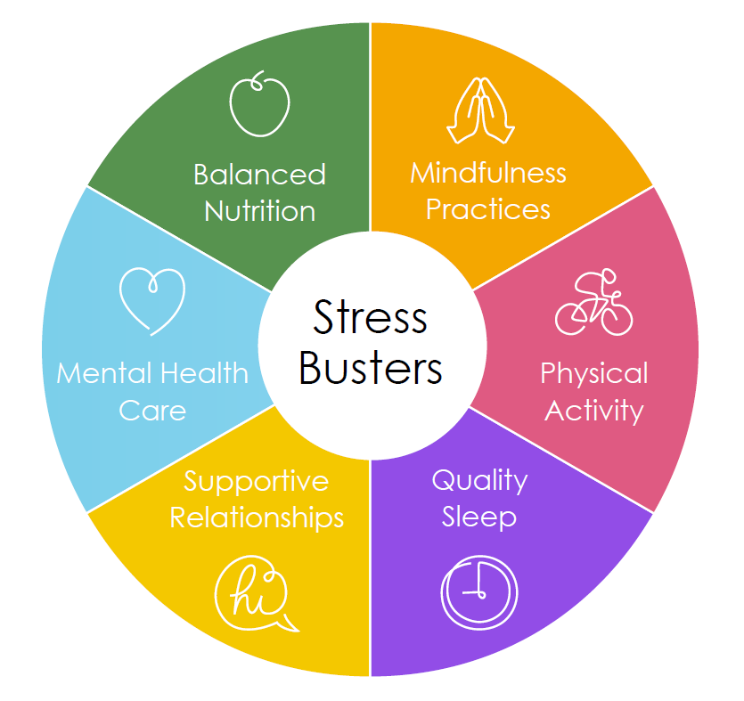

1. **SUPPORTIVE RELATIONSHIPS:** 
   1. Maintain your supportive relationships virtually or with those you are at home with. Turn off media and devices for high-quality time together making art, dancing, cooking or reading with loved ones. Remain in touch with mentors, friends, and family by phone or video chat, including schools and community- or faith-based organizations.

1. **EXERCISE DAILY:** 
   1. Engage in 60 minutes of physical activity every day. It doesn’t have to be all at one time. Dance party in your bedroom, 35 jumping jacks here and there, 20 minute hula hooping contest, film a TikTok and share it out, power walk around the block twice, running, bedtime yoga, 10 pushups, do some double dutch jump rope, the list can go on and on. Bottom line – get your body moving and your heart rate up to burn off stress.
   2. Ask friends what resources they have been using or get online and search for at home work-out routines and see what comes up and what can work for you.

1. **HEALTHY SLEEP:**
   1. Get sufficient, high-quality sleep. This may be particularly hard right now, but things that help are going to sleep and waking up at the same time each day. Turn off electronics at least a half hour before bed. Drink some warm water or hot tea and read a book after you climb into bed. Avoid caffeine in the afternoon and evening. Ensure your place of sleep is cool, quiet and free of distractions and devices.
2. **NUTRITION:** 
   1. This is not about losing weight. This is about ensuring you are getting proper nutrition to help combat stress. Keep regular mealtimes, so you aren’t just snacking all day. Minimize refined carbohydrates, high fat, high sugar foods and reduce your alcohol intake.
   2. General rule of thumb includes 5-9 servings of fruits and vegetables per day and foods rich in omega-3-fatty acids, including fish, nuts and fiber.
3. **MENTAL AND BEHAVIORAL HEALTH SUPPORT:**
   1. Engage in mental health care. Schedule video or phone sessions for psychotherapy, psychiatric care and substance use disorder treatment when possible.
   2. Minimize consumption of news or other media content that feels upsetting.
   3. If you do not have a regular appointment or have not been in contact with a mental health professional previously, [here are some resources](https://covid19.ca.gov/resources-for-emotional-support-and-well-being/) to help you get started.
4. **MINDFULNESS, MEDITATION, PRAYER:**
   1. Practice mindfulness, such as meditation, yoga, or prayer for 20 minutes, two times a day. Apps like Headspace and Calm are easy, accessible ways to get started. Meditations can be found online, as well.
   2. Mindfulness can help strengthen the brain pathways that actively buffer the stress response, helping you regulate your stress response more easily.

# THINGS TO LIMIT

* News – Make sure you give yourself a break from the 24 hour news cycle and news alerts. It really does make a difference for your physical and mental health.
* Substances – Because our bodies may be creating more stress hormones than usual, we are more susceptible to substance dependence. It’s important to keep this top of mind and make sure you’re actively regulating your substance intake.
* High-sugar/high-fat foods – An increase in the stress hormone cortisol triggers cravings for high-sugar and high-fat foods. Even if you’ve previously been a pretty healthy eater, you may find yourself reaching for potato chips, chocolate chip cookies, soda and other unhealthy snacks. Not only does stress increase our cravings for these types of foods, but stress hormones can also make our bodies more resistant to the hormone insulin, increasing our risk of type 2 diabetes, so try to keep the indulgence on these foods to a minimum.

# THINGS TO EMBRACE

* Each other – our supportive personal connections are scientifically demonstrated to help buffer the impacts of stress on our brains and bodies. Staying in touch with our loved ones and communities virtually, is truly healing. If you see your neighbors when you’re outside, remember to continue physical distancing, but say hello and ask how they are. When you’re at the grocery store – thank the people working there and engage in conversation. This isn’t just important for morale, but staying emotionally connected to one another is biologically crucial for our health.

* Deep breaths – you don’t have to be a yogi to know the power of a nice cleansing deep breath. Take them slowly, take them often. Deep breaths are also a great time to check in on our bodies and see where and how we are feeling.
* Stepping outside – while we have to practice physical distancing, being outside and finding green space — even if it’s in your back yard— is incredibly helpful for our well-being. Enjoy feeling the sun on our face, listen to the birds singing and see the flowers blooming.
* Hydration – stay hydrated. Drink those 8-10 glasses of water a day.
* Play – Finding ways to play and laugh is super important for our mental and physical health. Turn off the news and watch a silly movie, or better yet, get creative and make a silly movie with members of your household. Call a friend and talk about the times you laughed the hardest, figure out what impressions you can do, pretend the floor is hot lava. These are serious times, but you can still be silly.
* Asking for help or a moment – open up the communication in your house about times when we need help. Whether you have a special code word or just the reminder to yourself. If you need a moment, communicate it and take the moment. If you are having a really hard time, feeling unsafe at home or thinking of harming yourself or someone else, that’s, unfortunately, increasingly common right now. [Services and numbers you can call for support are here.](https://covid19.ca.gov/resources-for-emotional-support-and-well-being/)

# SELF-CARE TEMPLATE FOR ADULTS

During this time your body may be making more or less stress hormones than is healthy. This can lead to physical and/or mental health problems, such as diabetes, heart disease, anxiety, smoking, or unhealthy use of alcohol or other drugs. Safe, stable, and nurturing relationships can protect our brains and bodies from the harmful effects of stress and adversity. The following tips can help you manage your stress response. Healthy nutrition, regular exercise, restful sleep, practicing mindfulness, building social supports, and getting mental health care can help decrease stress hormones and improve health.

Here are some goals you can set to support your health. [*Check the goals that you are choosing for yourself or write in others that will work for you in each category!*]

* **Self-Care Planning.** I’ve set a goal of...
  + Building my stress busting routine
  + Limiting screen/news time to less than __ hours per day
  + Making a plan for what to do when I’m feeling stressed out, angry, or overwhelmed
  + Planning with my partner, friends, or family to get support when I need it
  + Identifying my strengths and learning more about building resilience
  + Calling **211** if I need help meeting basic needs such as food and shelter
  + Create your own goal: ______________________________________
* **Supportive relationships.** I’ve set a goal of...
  + Spending more high-quality time together with loved ones, such as:
    - Having regular meals together with my household or virtually with those outside my household.
    - Having regular “no electronics” time for us to talk and connect with each other
  + Making time to call or video chat with friends and family to maintain a healthy support system for myself
  + Connecting regularly with members of my community to build social connections
  + Asking for help if I feel physically or emotionally unsafe in my relationships
    - The National Domestic Violence hotline is **800-799-SAFE (7233)**
    - The National Sexual Assault hotline is **800-656-HOPE (4673)**
    - To reach a crisis text line, **text HOME** to **741-741**
  + Create your own goal: ______________________________________
* **Exercise.** I’ve set a goal of...
  + Limiting screen time to less than ____ hours per day
  + Walking at least 30 minutes every day
  + Finding a type of exercise that I enjoy and doing it regularly
  + Create your own goal: ______________________________________
* **Nutrition.** I’ve set a goal of...
  + Eating a healthy breakfast daily (with protein, whole gains, and/or fruit)
  + Drinking water instead of juice or soda
  + Limiting my alcohol consumption
  + Limiting high sugar and/or high fat foods
  + Eating at least 5 vegetables and/or fruits every day
  + Choosing whole wheat bread and brown rice instead of white bread or rice
  + Create your own goal: ______________________________________
* **Sleep.** I’ve set a goal of...
  + Being consistent about going to bed at the same time every night
  + Creating a cool, calm, and quiet place for sleep, and a relaxing bedtime routine
  + Using mindfulness or other stress reduction tools if worry is keeping me up at night
  + Turning off electronic devices at least 30 minutes before bed
  + Create your own goal: ______________________________________
* **Mindfulness.** I’ve set a goal of...
  + Taking moments throughout the day to notice how I’m feeling, both physically and emotionally
  + Practicing mindful breathing or other calming technique(s) during stressful situations
  + Writing a list of five or more things I am grateful for each day
  + Creating a regular routine of prayer, meditation, and/or yoga
  + Downloading a mindfulness app and doing a mindfulness practice 20 minutes per day
  + Create your own goal: ______________________________________
* **Mental health.** I’ve set a goal of...
  + Learning more about mental health and/or substance use services (e.g., counseling, groups, medications,)
  + Identifying a local mental health professional or support group.
  + Scheduling an appointment with a mental health professional
  + If I am feeling like I am in crisis, I will get help
    - The National Suicide Prevention Lifeline is **800-273-TALK (8255)**
    - To reach a crisis text line, **text HOME** to **741-741**
    - SAMHSA Disaster Distress Line **800-985-5990**
  + Create your own goal: ______________________________________

For more information on resources related to COVID-19, please visit [**COVID19.CA.GOV**](https://covid19.ca.gov/)**.**