(3 Point) You have main function which is saved on folder named Q3 already. Use these classes and functions to test all your operations in this question, DO NOT EDIT ANY CODE in main function. You can add more operations/classes/interfaces to be able to answer the below question.

A password is valid if it has at least a digit character.
Design and code a class named Password that holds information of a Password for an user, including:
- A string describes value of an user’s role.
- A string describes value of a password for an user.
Include the following member functions in your design:
- Constructors to set values for instance variables.
- Add needed operations to the class and complete below method which is declared in Password class, the function will be used in the second test case.
- String getCode() – assuming that length of password is greater than 4 (four); this function return code of password as the rule:
  - Code of password = first 4 characters of original password if given password is valid.
  - Otherwise code of password = last 4 characters of original password.
The program output might look something like:

No of test case | Correct output
2 | 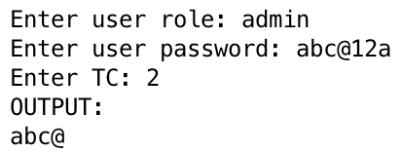
2 | 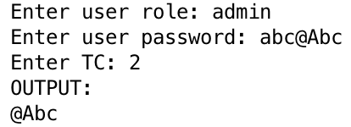
1 | 