**考前大冲刺——2016~2012年各地高考真题短文改错汇总**

短文改错对考生的要求较高，是对语言知识综合运用能力的考查，检测考生发现、判断、纠正文章错误的能力，进而考查学生的词法、句法及行文逻辑等方面的水平。考生在该项上往往失分较多，对该题感到束手无策。这里小编把2016~2012年间各地高考真题中短文改错题总结出来给到大家，希望在高考前的最后一周能帮助各位学生做好考前冲刺准备。

1. 2016 全国I卷

My uncle is the owner of a restaurant close to that I live. Though not very big, but the restaurant is popular in our area. It is always crowded with customers at meal times. Some people even had to wait outside. My uncle tells me that the key to his success is honest. Every day he makes sure that fresh vegetables or high quality oil are using for cooking. My uncle says that he never dreams becoming rich in the short period of time. Instead, he hopes that our business will grow steady.

答案：

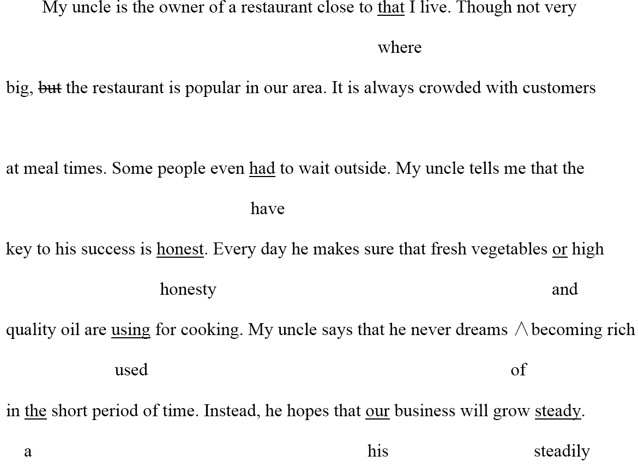

2. 2016年全国II卷

The summer holiday is coming. My Classmates and I are talking about how to do during the holiday. We can chose between staying at home and take a trip. If we stay at home, it is comfortable but there is no need to spend money. But in that case, we will learn little about world. If we go on a trip abroad, we can broaden your view and gain knowledges we cannot get from books. Some classmates suggest we can go to places of interest nearby. I thought that it is a good idea. It does not cost many, yet we can still learn a lot.

答案：

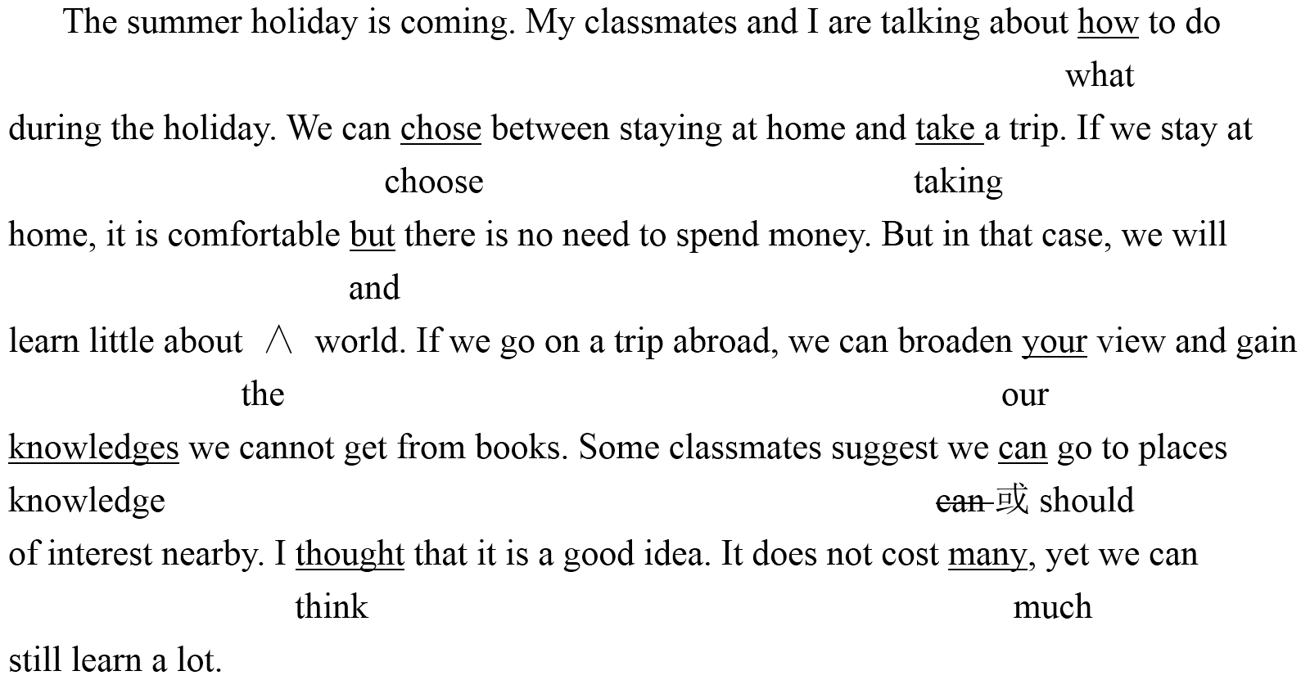

3. 2016年全国III卷

The teenage year from 13 to 19 were the most difficult time for me. They were also the best and worse years in my life. At the first, I thought I knew everything and could make decisions by yourself. However, my parents didn’t seem to think such. They always tell me what to do and how to do it. At one time, I even felt my parents couldn’t understand me so I hoped I could be freely from them. I showed them I was independent by wear strange clothes. Now I am leaving home to college. At last, I will be on my own, but I still want to have my parents to turn to whenever need help.

答案：

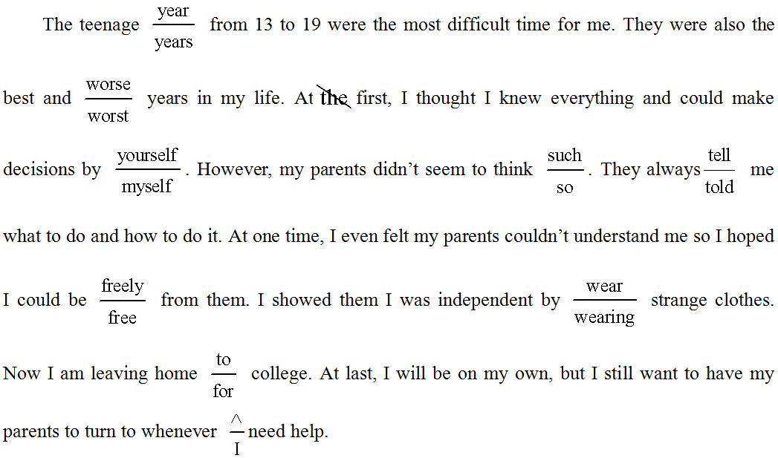

4. 2016年浙江卷

When I was a very young children, my father created a regular practice I remember well years

late. Every time he arrived home at end of the day, we’d greet her at the door. He would ask who

we was and pretend not to knowing us. Then he and my mother would have had a drink while she

prepared dinner and they would talk about his day and hers. While they chat, my father would lift

my sister and me up to sit in the top of the fridge. It was both excited and frightening to be up there!

My sister and I thought he was so cool for putting us there.

答案：

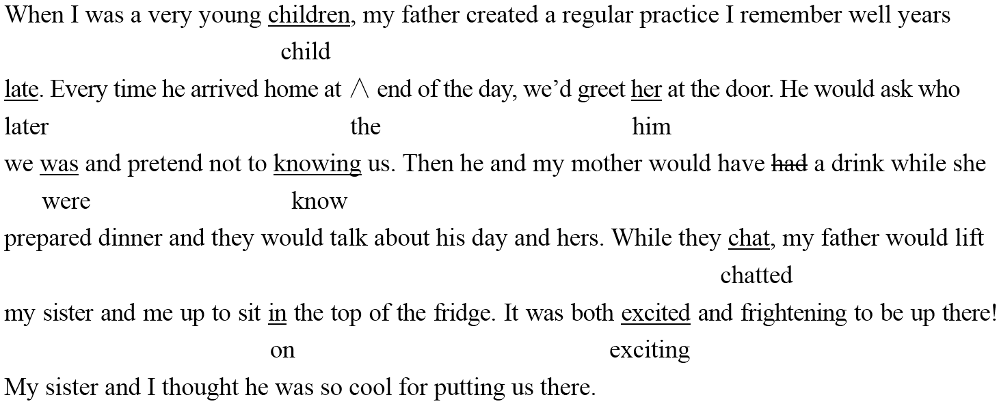

5. 2015年全国I卷

When I was a child, I hoped to live in the city. I think I would be happy there. Now I am living in a city, but I miss my home in countryside. There the air is clean or the mountains are green. Unfortunately, on the development of industrialization, the environment has been polluted. Lots of studies have been shown that global warming has already become a very seriously problem. The airs we breathe in is getting dirtier and dirtier. Much rare animals are dying out. We must found ways to protect your environment. If we fail to do so, we’ll live to regret it.

答案：

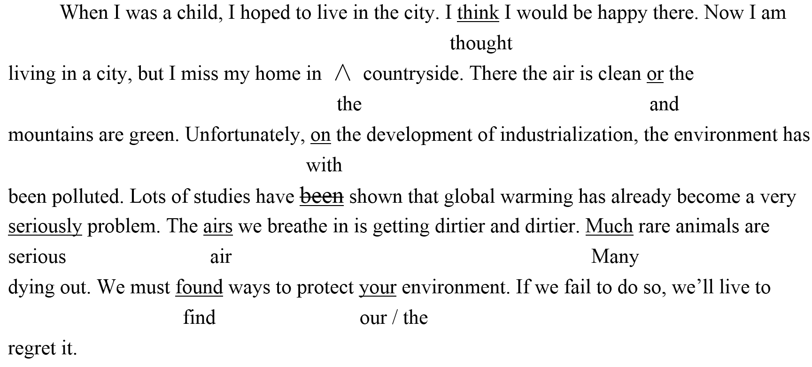

6. 2015年全国II卷

One day, little Tony went to a shopping center with his parent. It was very crowded. Tony saw a toy on a shop window. He liked it so very much that he quickly walked into the shop. After looks at the toy for some time, he turned around and found where his parents were missing. Tony was scared and begun to cry. A woman saw him crying and telling him to wait outside a shop. Five minutes later, Tony saw parents. Mom said,“ How nice to see you again! Dad and I were terrible worried.” Tony promised her that this would never happen again.

答案：

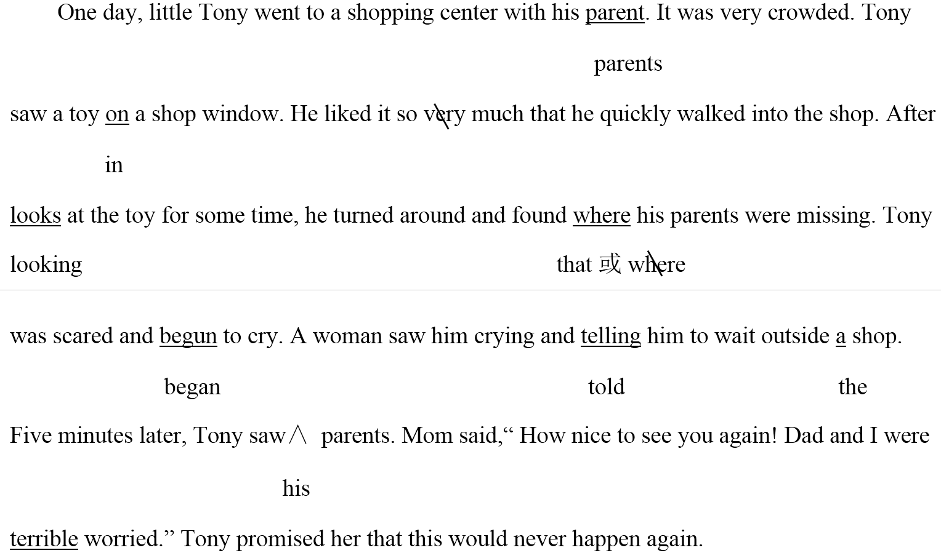

7. 2015年陕西卷

My soccer coach retired in last week. I wanted to do anything special for him at his retirement party. My mum makes the better biscuits in the world, so I decide to ask her for help. Mum taught me some basic step of baking. I insisted on doing most of the baking myself. I thought the biscuits were really well. My only mistake was that I dropped some on the floor after I was packing them up.

At a party, my coach, with a biscuit in his mouth, asked surprisingly who made them and joked, “I might have to retire again next year just get some more of these biscuits.”

My favorite picture at the party is of my coach and me enjoy the biscuits with happy laughter!

答案：

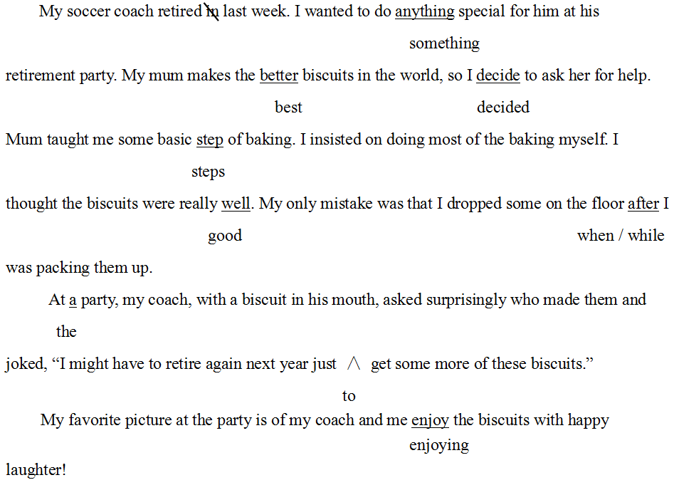

8. 2015年四川卷

Hi, Janice,

It’s been a month since I came to this new school and I really want share with you some of the problems I have been experiencing.

As I tell you last time, I made three new friend here. We hang out together during lunch and after school. We’ve been spending a lot of time sing in karaoke bars. It’s been three Saturdays now and it really costs me many. And I started to see this as a time-wasting activity! In fact, I don’t like to go anymore, so I’m afraid I’ll lose their friendship. How do you think I should do? If you are me, would you talk to him?

Please help with me and give me some advice.

答案：

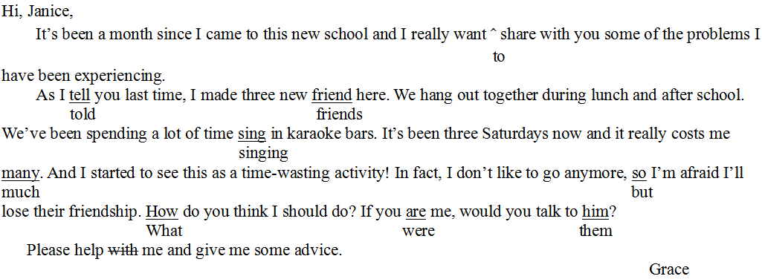

9. 2015年浙江卷

My old classroom was interesting because three side of the classroom were made from glass. I enjoyed sit close to the windows and looking at the view. On the left-hand side of the class, I could easy see the football field. In the mornings, it was full of students exercising. The view from the back of the classroom is also splendid. Close to the school there was a beautiful park with many trees around them. Farther in the distance, I could not enjoy the view of snowy mountains. On the right side of the class was the road. I was always interested to see the drivers in hurry in the morning. The position of the classroom with its view made me felt like I was dreaming. If I was only a child when I studied in that classroom, I will never forget it.

答案：

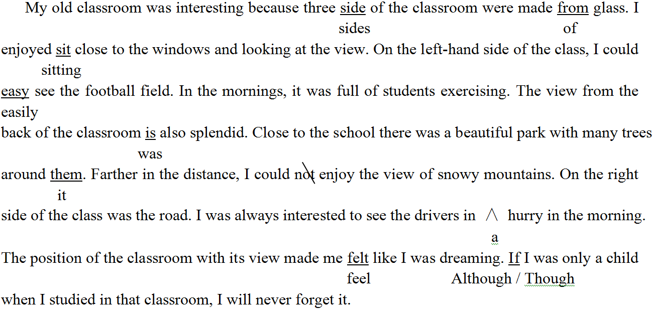

10. 2014年全国I卷

Nearly five years before, and with the help by our father, my sister and I planted some cherry tomatoes (圣女果) in our back garden. Since then — for all these year — we had been allowing tomatoes to self-seed where they please. As result, the plants are growing somewhere. The fruits are small in size, but juicy and taste. There are so much that we often share them with our neighbors. Although we allow tomato plants to grow in the same place year after year, but we have never had any disease or insect attack problems. We are growing wonderfully tomatoes at no cost!

答案：



11. 2014年陕西卷

My father took me out camping for the first time when I was seven. He wanted teach me about animals, insects and trees. My uncles all come along with bows and arrows for hunting.

One evening at sunset, we sat by the fire, have our barbecue. Just then a bird was flying over us. My uncles immediate jumped up and shot their arrows on the bird. Neither of the arrows hit the target. Suddenly the arrows was flying down at us from the sky — they were looked like rain! We ran to escape but fortunately no one was injured.

That day I didn’t learn much about animals, insects or trees, but I learnt a impressive lesson about gravity!

答案：

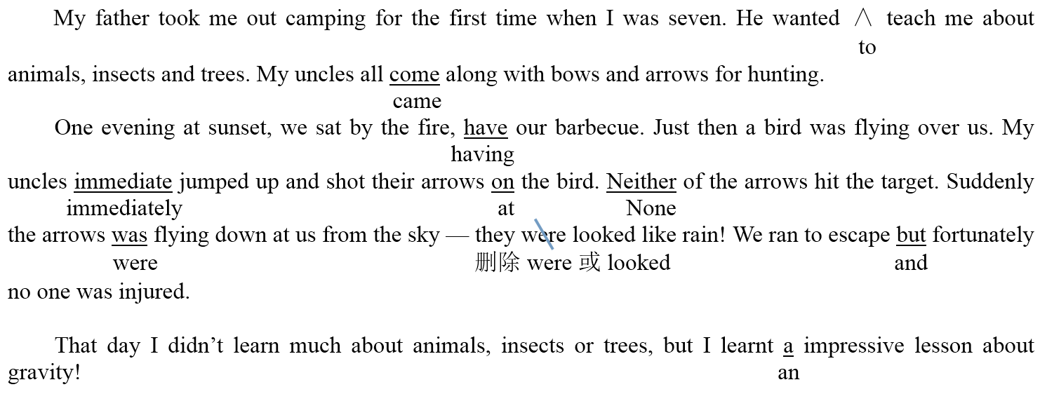

12. 2014年新课标II卷

My dream school starts at 8:30 a.m. and ends at 3:30 p.m. They are three lessons in the morning and two in the afternoon. We didn’t need to do so many homework. Therefore, we have more time with after-school activities. For example, we can do reading for one and a half hour and play sports for one hour every day.

My dream school look like a big garden. There are all kinds of the flowers and trees around the classroom buildings. We can lie on the grass for a rest, or sat by the lake listening music. The teachers here are kind and helpfully. They are not only our teachers but also our friends.

答案：

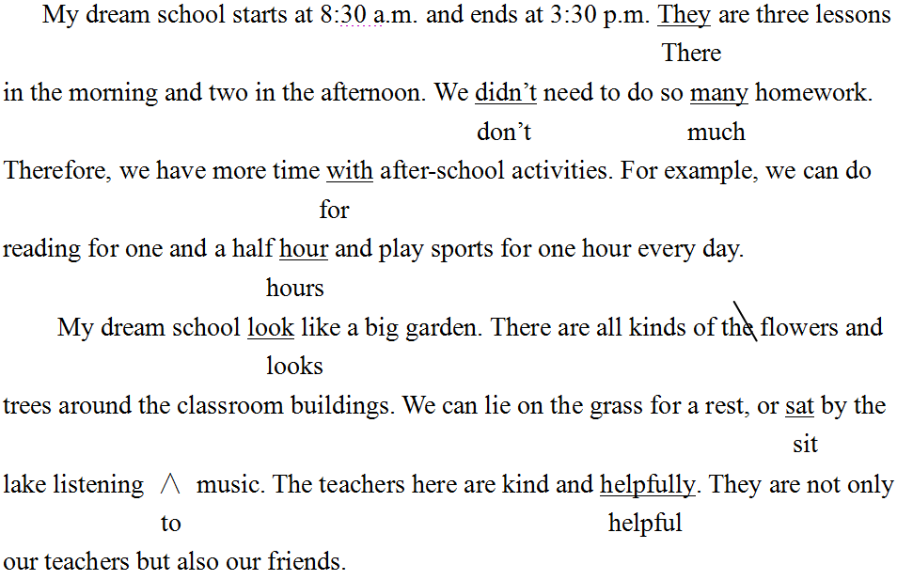

13. 2014年四川卷

Hello, boys and girls! Today, I am going to talk with what you should do when a fire alarm go off. If you hear the alarm, stand in line at the door and wait your teacher to lead you outside. Stay close to your teacher and classmate. Don’t panic or get out of line, and trying to remain quiet and calmly. Soon the firefighters will come and put out a fire. If it’s a false alarm and there is no fire, your teacher will lead us back to the classroom. If you notice that when someone is missing and hurt, tell your teacher immediately.

答案：

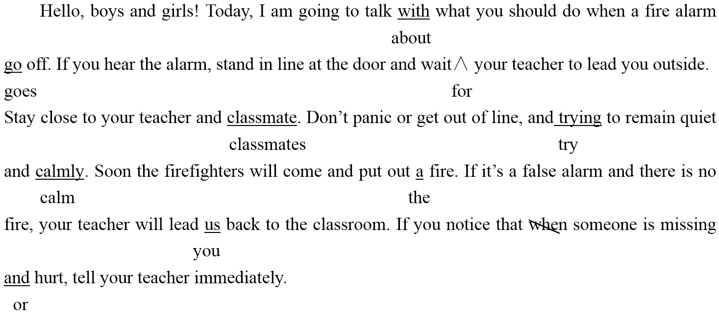

14. 2014年浙江卷

I was taking a train to London’s Victoria Station. I had noticed that the carriage was noise and filled with people.

     Before long, a train inspector comes to check our tickets. A passenger realized he couldn’t find his ticket but became quite upset. Then everyone in the carriage began searching the ticket, which was eventually found under a seat several rows from his owner. The person who found a ticket smiled with pleasure at his success.

     No one in the carriage had previous spoken to or even noticed the ticket-owner before. Yet they had so quickly offered the strangers their help. If we could show concern to others on need, the world would be a better place to live in.

答案：

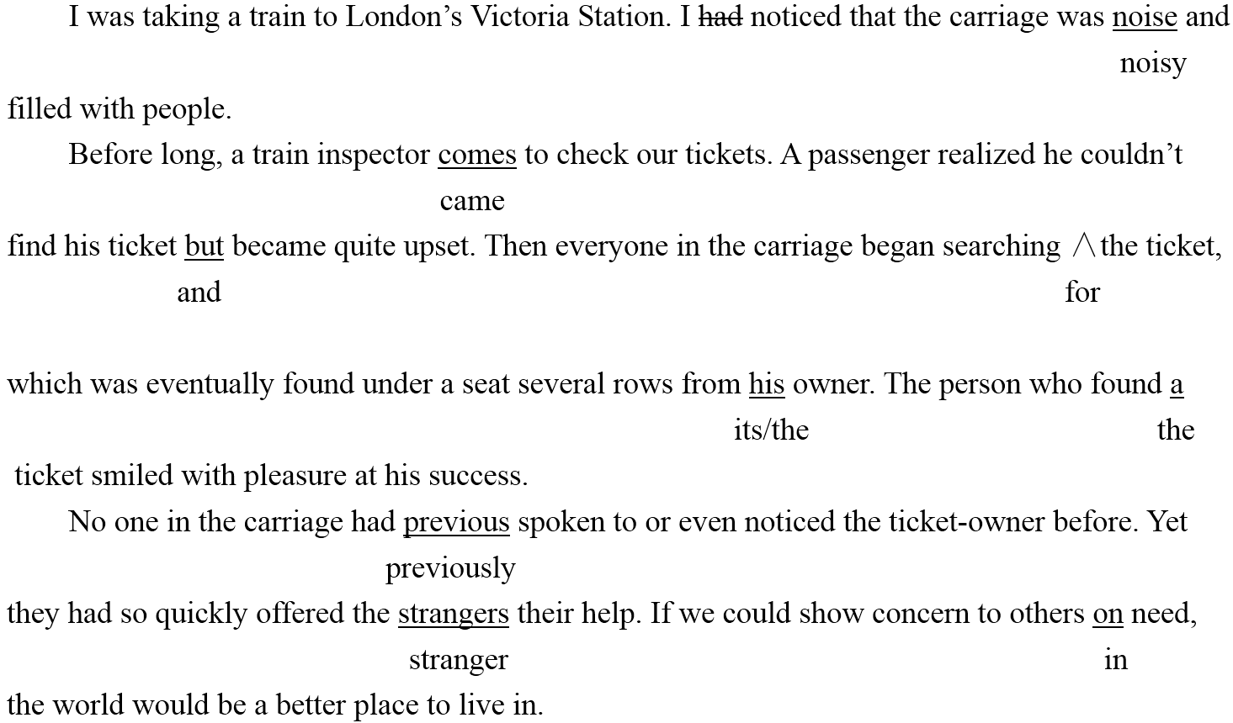

15. 2013年全国新课标I卷

I hardly remember my grandmother. She used to holding me ono her knees and sing old songs. I was only four when she passes away. She is just a distant memory for me now. I remember my grandfather very much. He was tall, with broad shoulder and a beard that turned from black toward gray over the years. He had a deep voice, which set himself apart from others in our small town, he was strong and powerful. In a fact, he even scared my classmates away during they came over to play or do homework with me. However, he was the gentlest man I have never known.

答案：

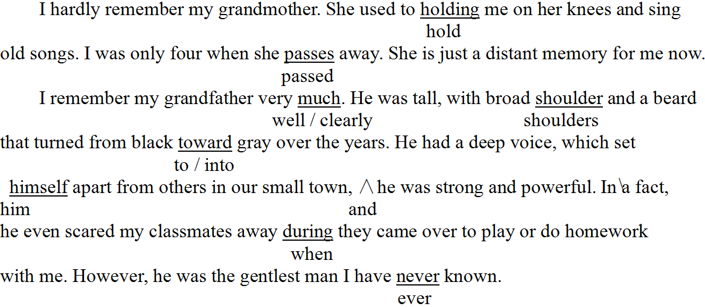

16. 2013年全国新课标Ⅱ卷

The book I’m reading of talks about afternoon tea in Britain. It is said to have started in the early 1800’s. Have tea in the late afternoon provides a bridge between lunch and dinner, that might not be served until 8 o’clock at night. This custom soon becomes another meal of day. Interesting, it had a connection by the British porcelain (瓷器) industry. Tea in China was traditionally drank from cups without handles. When tea got popular in Britain, there was a crying need for good cup with handles to suit British habits. This made for the grow in the porcelain industry.

答案：

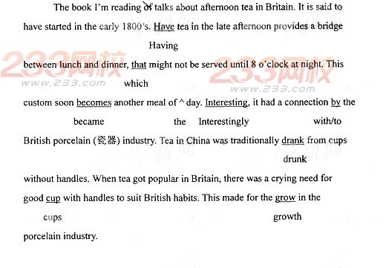

17. 2013年全国大纲卷

In my family, there are three people. My father is

hardworking but goes to work in the field every day. 76. _______

He isn’t good at talk but he gets on well with other 77. _______

people. My mother is very much kind and is 78. _______

friendly to everybody. So when I have the problem 79. _______

I will turn to her for help. My friends say I am clever. 80. _______

When the teacher asks us very difficulty questions, 81. _______

I’ll think quickly and stand to answer. At home my 82. _______

father often thinks I’m silly. He said if I decide 83. _______

to do something, it takes him much times to stop me. 84. _______

This is how I need to improve in the future. 85. _______

答案：

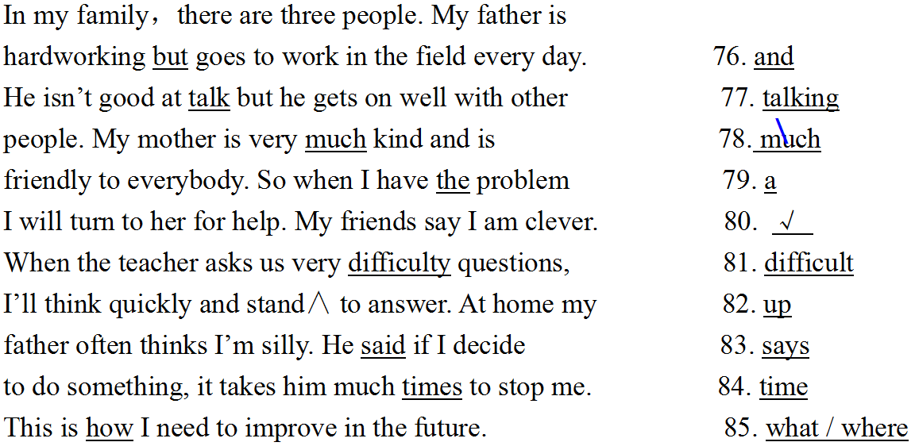

18. 2013年辽宁卷

Mr. Johnson is a hardworking teacher. Every day, he spends too much time with his work. With little sleep and hardly any break, so he works from morning till night. Hard work have made him very ill. “He has ruined his healthy. We are worried about him.” That is which other teachers say. Yesterday afternoon, I paid visit to Mr. Johnson. I was eager to see him, but outside her room I stopped. I had to calm myself down. Quietly I step into the room. I saw him lying in bed, looking at some of the picture we had taken together. I understood that he missed us just as many as we missed him.

答案：

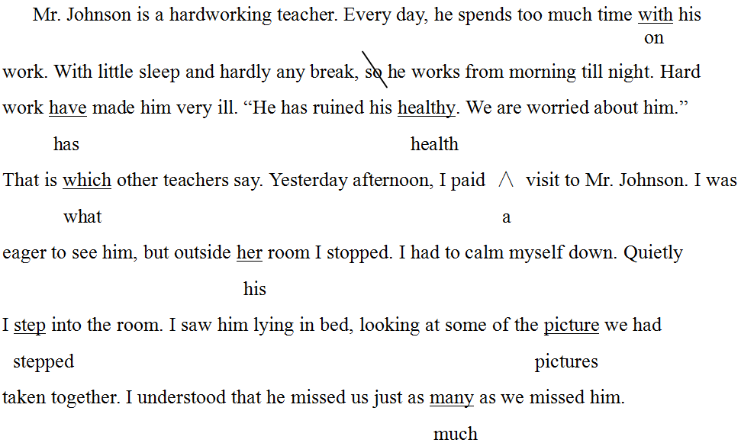

19. 2013年陕西卷

My grandfather and I enjoy fishing.

One Sunday morning we go fishing at a lake. We took ours fishing poles and headed for the lake. As soon as we arrived, so we dropped the lines into the water. Before waiting for about half an hour, I was beginning to get impatiently. I wanted to give up, and my grandfather told me to wait a little longer. Finally, there was a sudden pull at the pole and fish was caught. Within the next few minute, my grandfather also caught a fish.

Felt hungry, we built a fire by the lake and barbecued the fish. It was delicious.

答案：

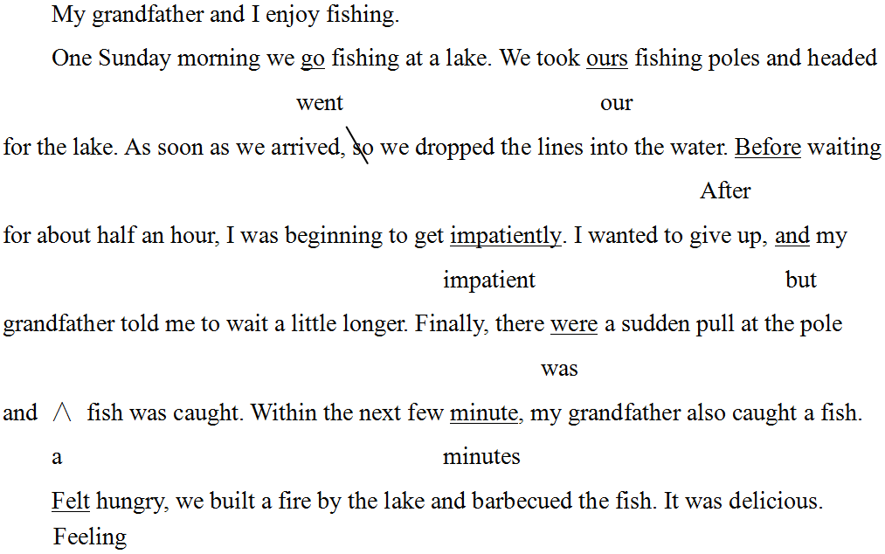

20. 2013年四川卷

Today we had a chemistry test. I found the test difficulty, but I tried hardly to do it. Suddenly Mary, my best friend, asking me to let her to copy my answers. After think for some time, I let her copy my answers. But after the test, all of us were called to the teacher’s office. The teacher was angry because we had same answers in the tests. We were warned not to cheat again so she would need to see our parents. I was very upset. I didn’t cheat. I was just helping a friend. Why does she punish me?

答案：

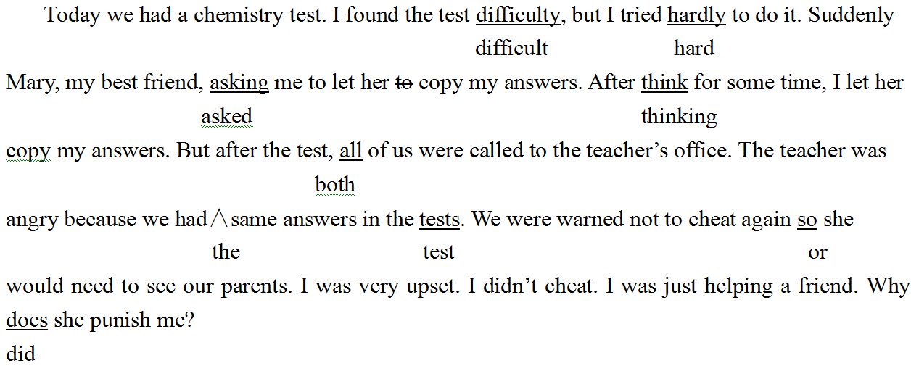

21. 2013年浙江卷

Dear Diary,

Here I am in the middle of a city, 350 miles far away from our farmhouse. Do you want to know why we move last week? Dad lost his job, and as Mom explained, “He was lucky to find other one.” His new job meant I had to say goodbye to my classmate, my school or just everything else I love in the world. To make matters bad, now I have to share a room with my younger sister, Maggie. Tomorrow is first day of school. I am awfully tiring, but I know I’ll never fall sleep.

Good night and remember, you, dear diary, is my only souvenir from my past life and my only friend.

Yours,

Rosemary

答案：

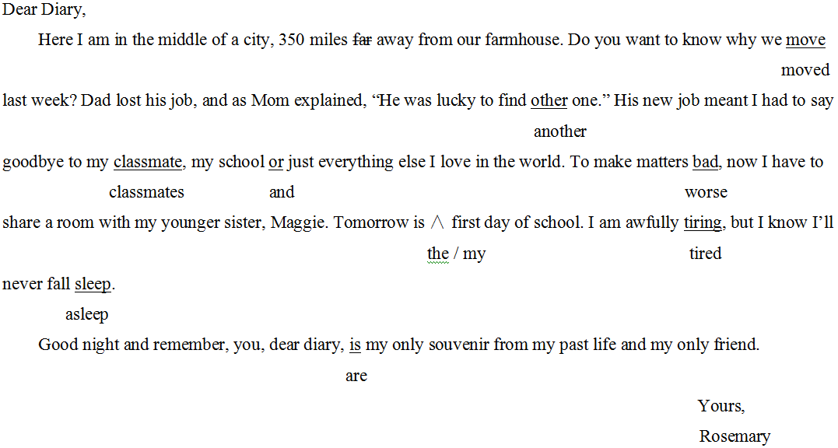

22. 2012年全国I卷

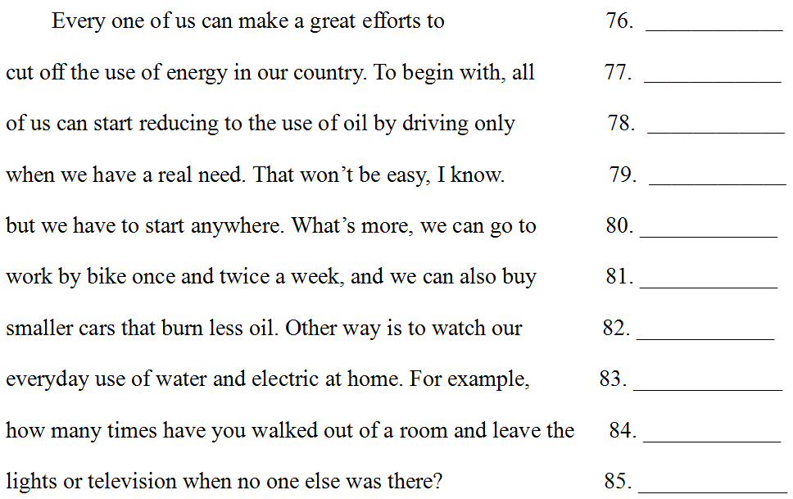

答案：

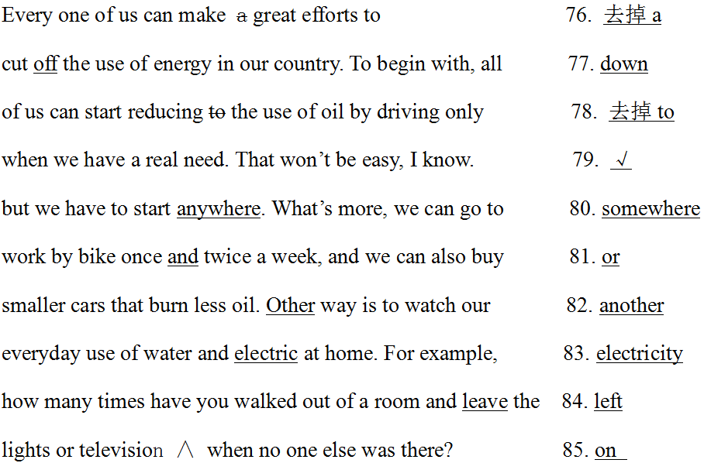

23. 2012年全国II卷

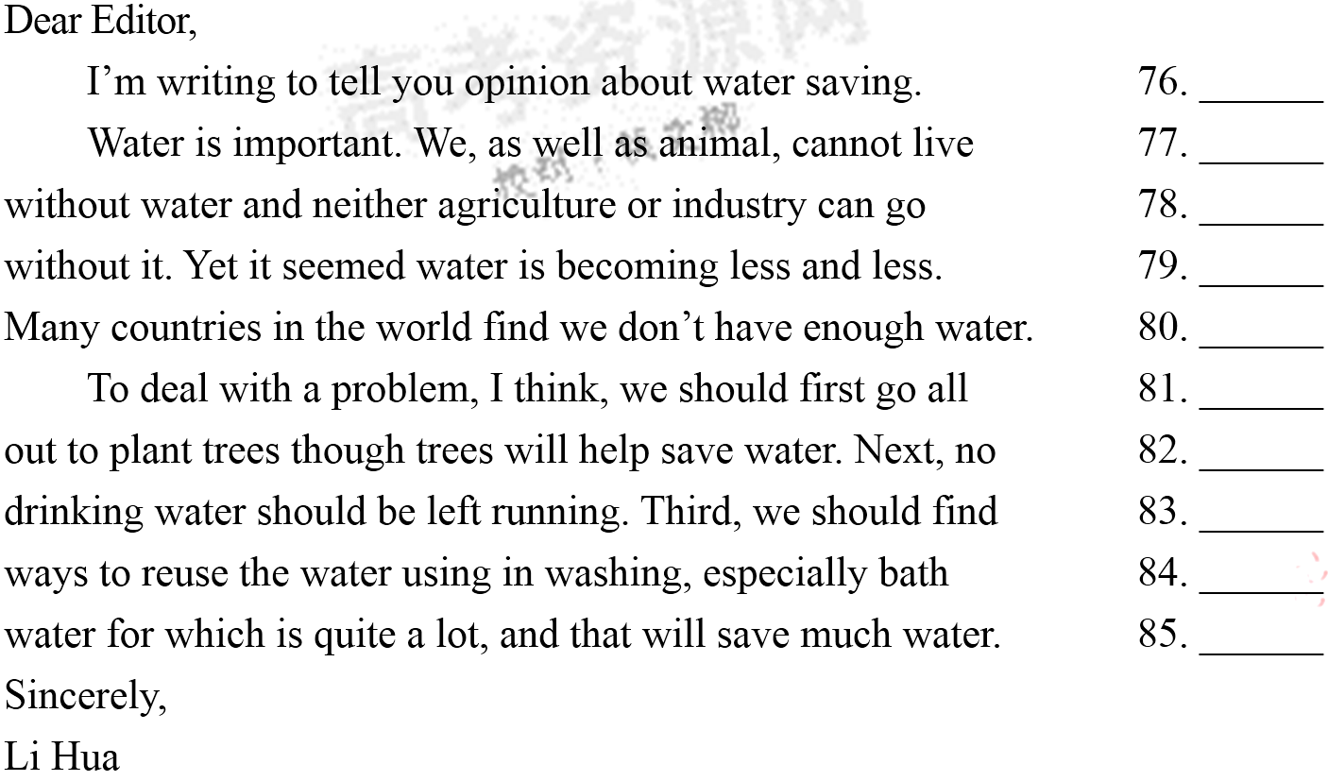

答案：

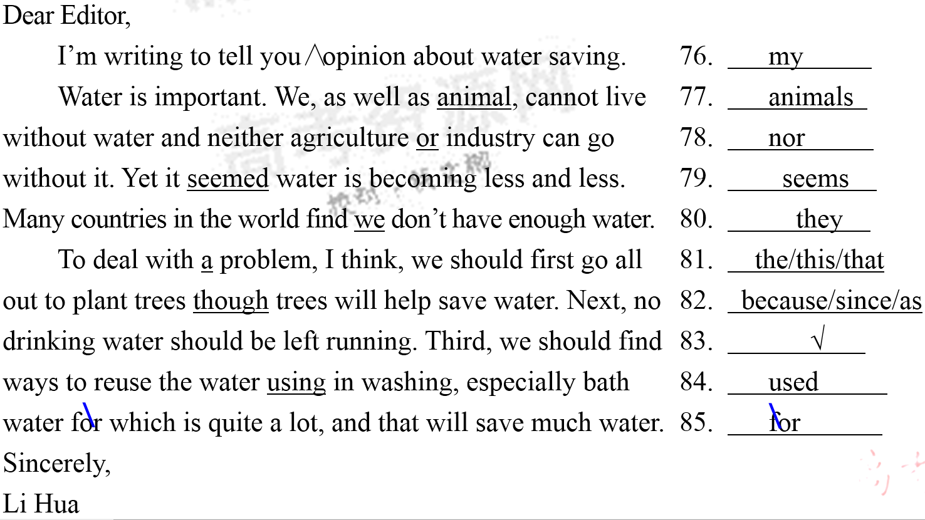

24. 2012年新课标卷

I learned early in life that I had to be more patient and little aggressive. From  
the time I was about four until I was about six, I destroyed each of my toy. I  
was happy when the toys worked, but when things did wrong, I got angry and  
broke it. For a while parents bought me new toys. But before long they began  
to see which was happening. When I tear apart my fifth birthday toy train, my  
father said, “That’s it. No more toys to you.” My punishment lasted a year.  
Meanwhile, I found out that with more patience I must make my toys to last.  
My attitude changed from then on.

答案：

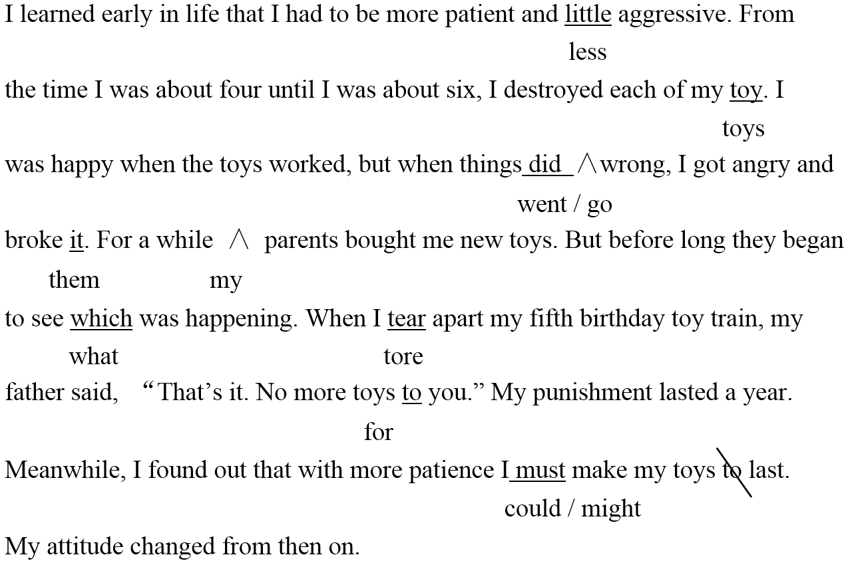

25. 2012年辽宁卷

Dear Diana,

Thank you for the lovely day we have with you. It was so kind for you to let us bring Anne’s friend, Gina. Unfortunate, the only problem was the journey home. There had been a terrible accident on the highway and, for a result, there was a long line of traffic for at least six mile. In the end, we drove to a service station and waited there unless the road was clear. In the car park here Gina nearly got knocked over as car drove out far too quickly from behind a lorry. They finally dropped Gina off at her parents and made our own way to home.

Much love,

Fiona

答案：

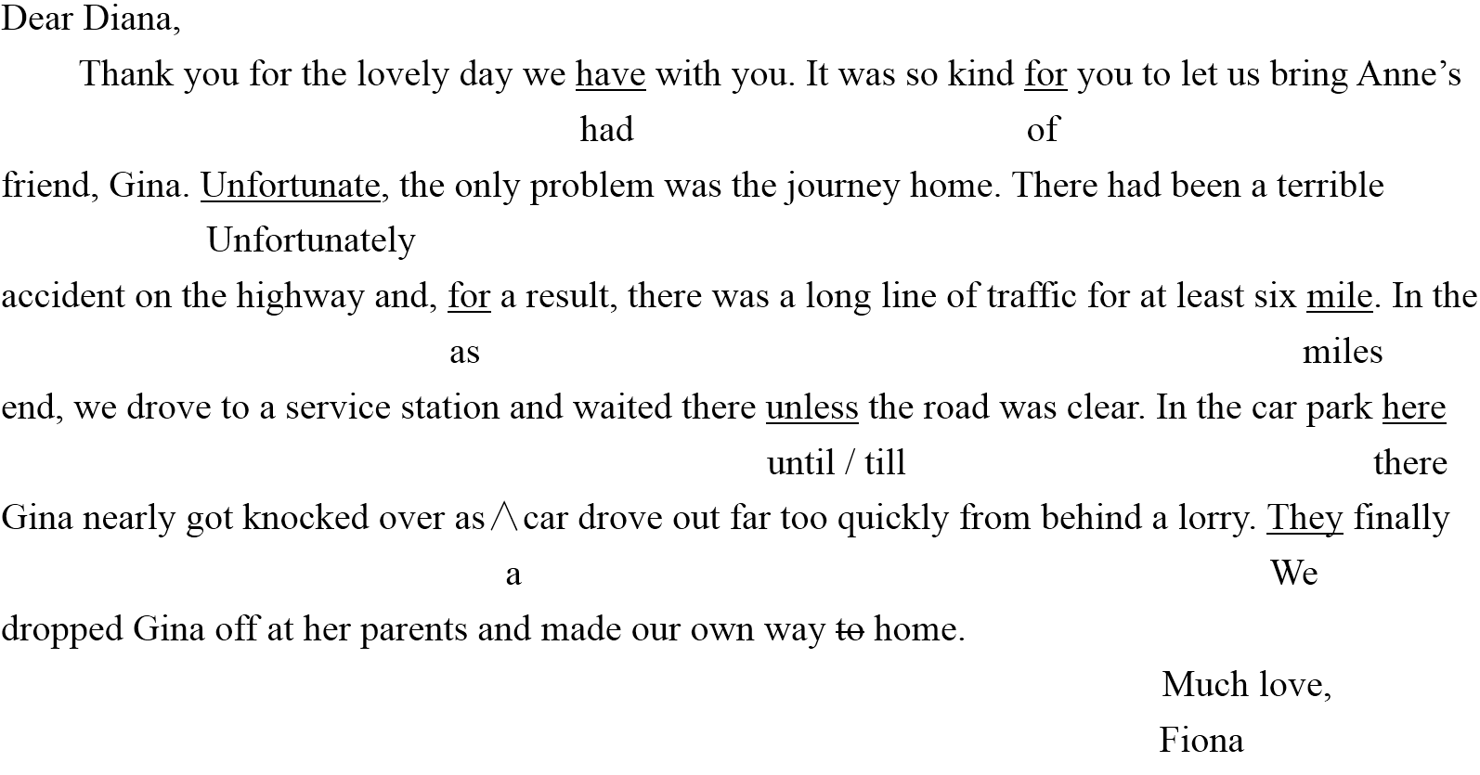

26. 2012年陕西卷

My father and I stayed at the South Lake Hotel for a week when we visit Beijing last month. It is in the downtown area, but it is easy to go to anywhere from the hotel by public transport.

We lived in a comfortably double-room with a big bath. What I liked best were the free high-speed Internet connection in the room. I checked my email messages every day. I also shared for my friends many photos taking in Beijing. The food was wonderful with reasonable prices, and we enjoyed several local dish.

It is such great hotel that I would recommend it to any friend of me who is going to Beijing.

答案：

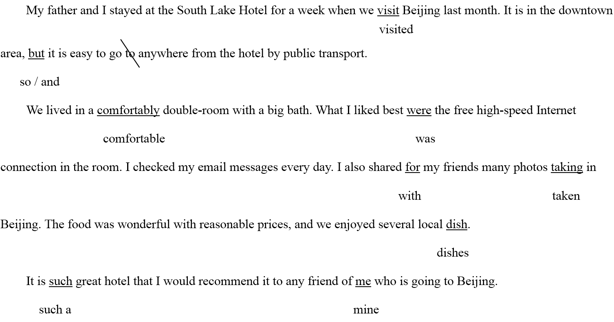

27. 2012年四川卷

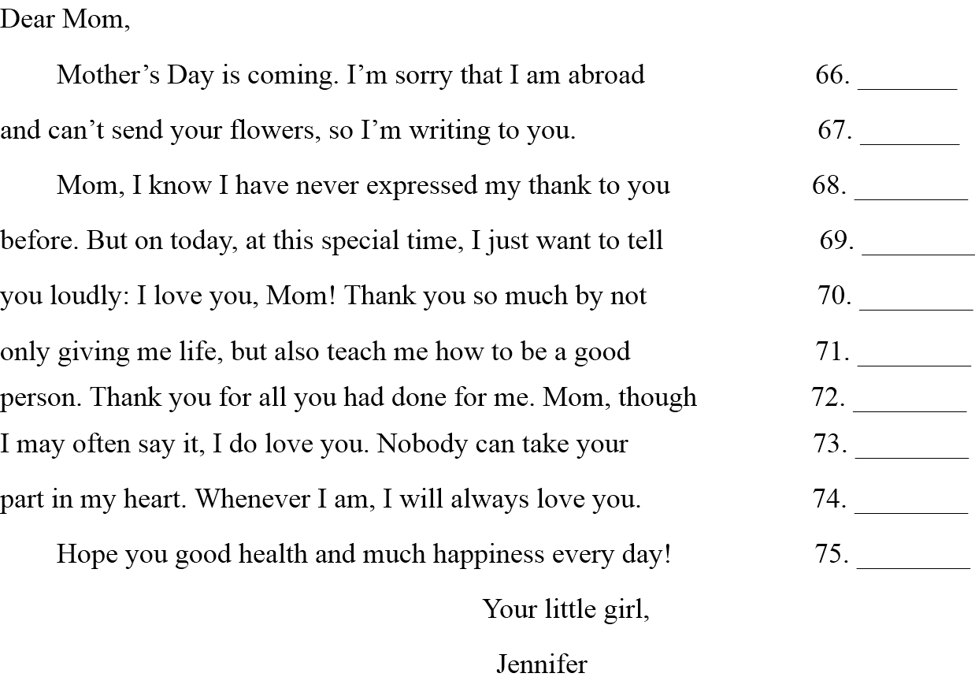

答案：

66. 正确 67. your改为you 68. thank改为thanks 69. 去掉on 70. by改为for

71. teach改为teaching 72. had改为have 73. may后加not 74. Whenever改为Wherever 75. Hope改为Wish

28. 2012年浙江卷

Two years before, I traveled to Brazil and I rented for a car. Unfortunate, I had an accident and hit another car, and I needed to stay in a hospital for at least two week. 1 called my parents, so I did not tell them what had happened. I knew that they will be worried about myself because I was so farther away, and that my mother would not sleep if she knew. Therefore, I told them interested stories and how I was enjoying Brazil. As a result, nobody knew truth. I still think that it was the right thing to do.

答案：

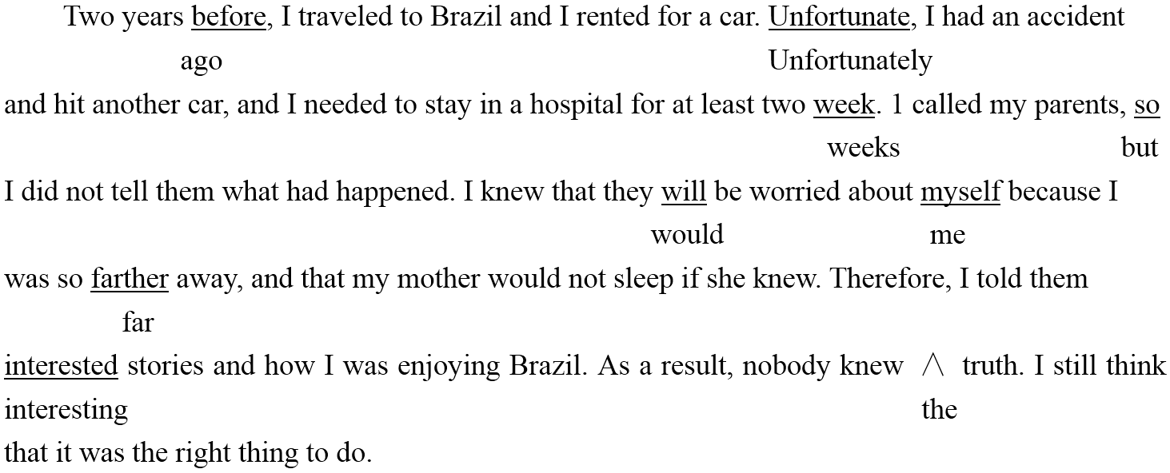

Two years before, I traveled to Brazil and I rented for a car. Unfortunate, I had an accident

ago Unfortunately

and hit another car, and I needed to stay in a hospital for at least two week. 1 called my parents, so

weeks but

I did not tell them what had happened. I knew that they will be worried about myself because I

would me

was so farther away, and that my mother would not sleep if she knew. Therefore, I told them

far

interested stories and how I was enjoying Brazil. As a result, nobody knew ∧ truth. I still think interesting the

that it was the right thing to do.

29. 2012年重庆卷

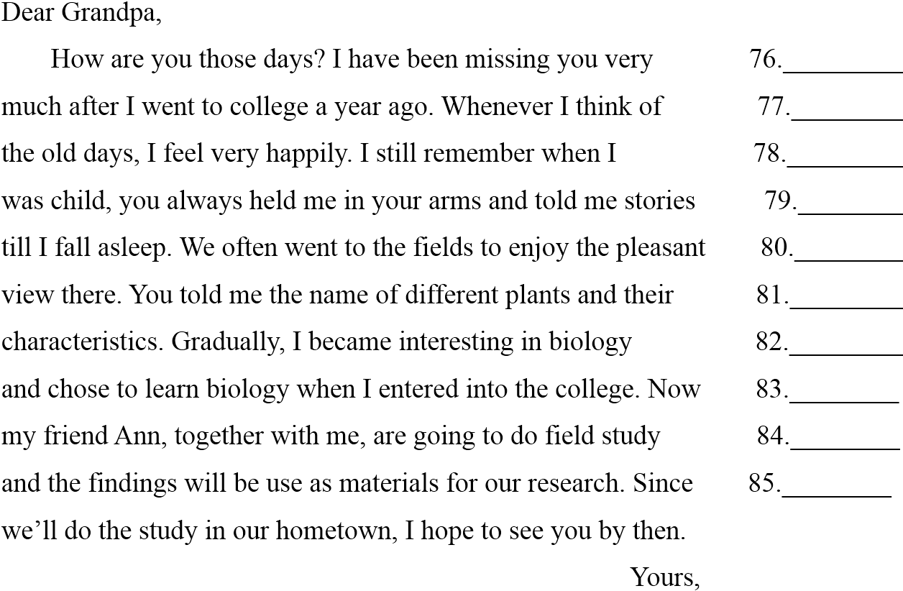

答案：

