R E V E R S E E N G I N E E R I N G
Two Worlds,
One Heart
Technical Writeup Reverse Engineering CTF Challenge portal33.exe
Author : 0xnhsec
Category : Reverse Engineering
Target : portal33.exe (PE32, Intel i386, Windows CUI)
Flag : pwnsec{h3_5p34k5_32_5h3_5p34k5_64_l0v3!}
Environment: Offline CTF sandbox Arch Linux
SHA-256 : d3591133...a42194f0

PWNSEC · ctftime RE Series TechnicalDoc v1.0 · 2026-09-13

Revision History
Table A Document revision history
Version | Date | Author | Description of changes
v0.1 | 2026-09-12 | RE Analyst | Initial draft: triage, disassembly, solver, flag findings
v1.0 | 2026-09-13 | RE Analyst | Comprehensive refinement: formal technical structure, screenshot evidence 1-6, forward replay verification, citations, limitations

Executive Summary
This document documents, end-to-end, the reverse engineering process applied to portal33.exe, a CTF challenge binary in the Reverse Engineering category from the PWNSEC-ctftime series. This binary rejects all input except an exact 40-character string that passes two distinct validation chains: the first 20 bytes are checked by a 32-bit arithmetic checker (XOR and left-rotate ROL), while the last 20 bytes are checked by a 64-bit checker reached via a far return (retf) instruction with segment selector 0x33 a technique known as Heaven's Gate.
Because every transformation is bijective (invertible), the flag can be recovered deterministically without brute force by inverting the comparison constants in the cmp instructions. Every step is accompanied by screenshot evidence (Figures 1 through 6), reproducible execution commands, and a forward replay verification proving the candidate flag genuinely passes every checker not merely a guess that happens to look valid. The final recovered flag is pwnsec{h3_5p34k5_32_5h3_5p34k5_64_l0v3!}, exactly 40 bytes long.
Table B List of visual evidence
ID | File | Evidence content | Section
E-001 | images/1.jpeg | Triage: file, sha256sum, strings | 3.1
E-002 | images/2.jpeg | Binary profile: rabin2 -I | 3.2
E-003 | images/3.jpeg | Caller disassembly: length check and two checker calls | 3.3
E-004 | images/4.jpeg | Checker fcn.00401600: 32-bit XOR/ROL chain + 64-bit block | 3.4
E-005 | images/5.jpeg | retf wrapper fcn.004016b3 (selector 0x33/0x23) | 3.5
E-006 | images/6.jpeg | Solver TW.py and flag output, length 40 | 3.6

The front matter ends here; the table of contents follows on the next page.
TABLE OF CONTENTS

1. Introduction 2
1.1 Background (Opening Hook) 2
1.2 Main Thesis 3
1.3 Purpose, Audience, and Prerequisites 3
2. Background and Context 4
2.1 Definitions and Scope 4
2.2 The Heaven's Gate Technique: Two Worlds in One Process 4
2.3 The Invertible Property of Rotation and XOR 4
3. Analysis Procedure 5
3.1 Step 1 Binary Triage: Identification, Fingerprinting, and Strings 5
3.2 Step 2 Binary Profiling with rabin2 7
3.3 Step 3 Mapping the Validation Flow at the Caller 8
3.4 Step 4 Dissecting the 32-bit Checker (fcn.00401600) 9
3.5 Step 5 The retf Wrapper and 64-bit Checker (fcn.004016b3) 10
3.6 Step 6 Writing the Solver and Extracting the Flag 11
3.7 Cross-Validation Forward Replay 13
4. Discussion 14
4.1 Flag Reconstruction from Constants 14
4.2 Why This Approach Works and Generalizes 15
4.3 Heaven's Gate as Obfuscation: Value and Limits 15
5. Counterarguments and Limitations 15
5.1 Method Limitations 15
5.2 Counterarguments Considered 16
6. Conclusion and Implications 16
6.1 Summary of Findings 16
6.2 Implications 17
6.3 Further Steps 17
7. References 17
Appendix A Reproduction Metadata 19

Note: The table of contents is built with a field code. For accurate page numbers after editing, right-click the table of contents and select "Update Field".

1. Introduction

1.1 Background (Opening Hook)
There is something interesting about the moment a binary rejects our story. portal33.exe does not simply ask for a password; it greets you poetically "You didn't even try to listen" when you are wrong, and "you stayed until you understood my heart" when you are right [E-001]. That message turns out to be more than narrative decoration it is an honest technical clue: the binary really does "speak" two CPU languages at once. The same checker function executes in two different architecture modes 32-bit and 64-bit through segment-selector manipulation known among security researchers as *Heaven's Gate* [1][2][3].
The challenge title, Two Worlds, One Heart (two worlds, one heart), refers literally to the two execution worlds that share a single algorithmic heart: XOR and bit rotation. As will be proven in Chapters 3 and 4, understanding this metaphor is the key: once the analyst realizes that both checkers are the same algorithm running in two CPU modes, the entire problem shrinks down to a simple arithmetic inversion that can be written in ten lines of Python.

1.2 Main Thesis
All of portal33.exe's protection is built on bijective operations (XOR and bit rotation) with no one-way function, so the flag can be recovered deterministically from static analysis alone without running the binary, without brute force, and without an emulator. The key evidence lies in the validation chain structure C_i = ROL(W_i XOR C_(i-1), 11), whose comparison constants are stored intact as immediate operands of the cmp instruction inside the binary. Reversing the rotation only requires rotating in the opposite direction (ROR); reversing the XOR only requires XOR-ing with the same key again. What remains is purely a matter of reading precision: understanding the little-endian ordering, the word-read offsets, and the CPU mode switch inside the retf wrapper.

1.3 Purpose, Audience, and Prerequisites
This document is intended for security practitioners, CTF participants, and binary forensics workers who need a procedural reference for solving similar challenges. After following this document, the reader should be able to: (a) systematically triage a Windows PE binary; (b) map the input validation flow using radare2; (c) recognize the Heaven's Gate pattern in disassembly output; (d) write a Python solver to invert the 32-bit and 64-bit XOR/ROL chains, along with its forward verification.
Assumed prerequisites: basic understanding of x86 architecture (eax/rax registers, cmp/jne/jz instructions), familiarity with hexadecimal and little-endian representation, and basic Python ability. The analysis environment used throughout this document is detailed in Table 1; the entire process runs offline in an authorized CTF sandbox and contacts no external host whatsoever this challenge is pure reverse engineering, not exploitation.
Table 1 Analysis environment and tooling
Component | Version | Role
Analysis OS | Arch Linux (CachyOS) | Static analysis host
radare2 | 6.2.0 | Disassembly, flow analysis, checker reading [5]
rabin2 | 6.2.0 (bundled with radare2) | PE metadata extraction
Python | 3.14.7 | Inversion solver and forward replay
GNU objdump | 2.47 | Cross-disassembly (independent verification)
fish shell | - | Command execution interface

2. Background and Context

2.1 Definitions and Scope
The scope of analysis covers a single file, portal33.exe, a Windows PE32 console executable (Portable Executable, Intel 386 architecture, 8 sections, stripped to external PDB) [E-001]. The analysis is restricted to static methods: reading the structure, strings, and disassembly without executing the binary in a Windows environment. Flag recovery is done through mathematical inversion, then validated with a forward replay against every checker constant an approach that is sufficient since no anti-VM, anti-debug, or time-based encryption mechanism was found on the main execution path.
Out of scope: dynamic fuzzing, interactive debugging on Windows, and exploration of non-flag execution paths such as the "Enter CriticalSection" string, which on initial inspection appears decorative. This restriction is deliberate so the document remains reproducible using only the sample file and static tools; the implications of this limitation are discussed in full in Chapter 5.

2.2 The Heaven's Gate Technique: Two Worlds in One Process
Since the x64 era, Windows has run 32-bit applications on top of the WOW64 subsystem (Windows-on-Windows 64-bit), which provides two different code segments within a single process space: segment selector 0x23 for 32-bit code and 0x33 for 64-bit code. A 32-bit program can "jump to heaven" *Heaven's Gate* by performing a far jump or far return (retf) to selector 0x33, causing the processor to switch to 64-bit long mode mid-process, then return to 0x23 to come back to the 32-bit world [1][2]. This technique is used by malware to hide API calls and evade monitoring hooks that only inspect a single mode [3], and it remains a classic subject of CPU-mode exploration to this day [2][4].
In a CTF context, Heaven's Gate is used as an elegant obfuscation mechanism: a disassembler that treats the entire file as 32-bit code will misdecode the 64-bit block. This is why byte 0x48 a REX prefix in 64-bit mode, but a dec eax instruction in 32-bit mode becomes the fork point between the two worlds in this challenge. An analyst unaware of the mode switch will read the second checker block as meaningless 32-bit instructions, and the 64-bit key constants will appear scrambled.

2.3 The Invertible Property of Rotation and XOR
The mathematical foundation of the solver in this document is the bijective property of two operations: bit rotation and XOR. Left rotation ROL(x, n) shifts bits left while wrapping the overflow bit back to the bottom position no bit is ever lost so its inverse is a right rotation by the same amount: ROR(ROL(x, n), n) = x [6][7]. Likewise, XOR is its own inverse: (x XOR k) XOR k = x.
As a result of this composition, the chain C_i = ROL(W_i XOR C_(i-1), 11) can be inverted line by line: W_i = ROR(C_i, 11) XOR C_(i-1). This simple principle is exactly what makes XOR/ROL-based checkers cryptographically weak in contrast to one-way hash functions, which are deliberately designed to be non-invertible. Chapter 4 expands this argument into three general properties that make this class of checker always attackable with the same pattern.

3. Analysis Procedure
Follow the steps below in sequence. Each step includes the command, the expected result, an interpretation, and screenshot evidence (E-001 through E-006). All commands are executed from the working directory containing portal33.exe on the environment described in Table 1.

3.1 Step 1 Binary Triage: Identification, Fingerprinting, and Strings
1. Run file-type identification and compute the cryptographic fingerprint:
Command 1 File identification and SHA-256
file portal33.exe
sha256sum portal33.exe

Result 1 Expected output
portal33.exe: PE32 executable for MS Windows 4.00 (console),
Intel i386 (stripped to external PDB), 8 sections
d35911333fae7cfc7a305c93e2f14cad678487ef724d4ea610c3e047a42194f0 portal33.exe

2. Filter the relevant strings to map the program's text interface:
Command 2 String filtering
strings -a -n 5 portal33.exe | grep -Ei 'Two Worlds|Enter|Access|listen|flag|secret'

Result 2 Program interface strings
Press Enter to exit...
== Two Worlds, One Heart ==
Enter the words that unite both worlds:
[-] "You didn't even try to listen."
[+] "You didn't just listen to my words... you stayed until you understood my heart."
Access Granted! Flag verified.
Enter CriticalSection

Interpretation. Triage confirms three things. First, the target is a 32-bit Win32 console binary, so every analysis tool is set to i386 mode. Second, there is no plaintext flag string the success message "Access Granted! Flag verified." is merely a confirmation, meaning the flag lives inside the validation logic, not as static data. Third, the two distinct response strings for failure and success will later help identify the success branch in the disassembly. The SHA-256 is recorded as the sample's identity for reproducibility purposes.
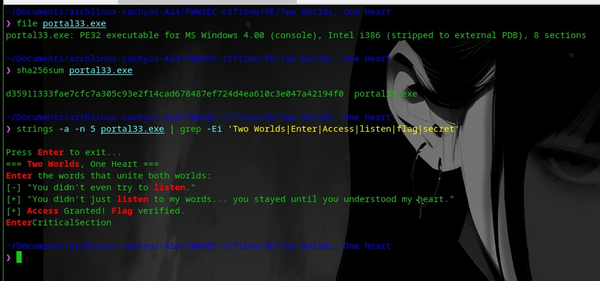
Figure 1 Triage output in the terminal: PE32 i386 file type, sample SHA-256, and interface strings filtered with grep. [E-001]

3.2 Step 2 Binary Profiling with rabin2
1. Extract the full executable metadata:
Command 3 Binary information extraction
rabin2 -I portal33.exe

The key values worth noting are summarized in Table 2. Other fields (relro, lsymbol, dsymbol, etc.) are not relevant to the solution path and can be ignored.
Table 2 Key rabin2 -I fields and their meaning
Field | Value | Significance for the analysis
arch / bits | x86 / 32 | The main checker runs as 32-bit code
baddr | 0x400000 | Virtual base address for reading offsets
binsz | 91136 | File size 89 KiB
canary / nx / pic | true / true / true | Modern mitigations active (not relevant to pure RE)
lang / cc | c / cdecl | Produced by a C compiler, cdecl calling convention
compiled | Sat Sep 12 01:52:38 2026 | Sample compilation timestamp
stripped | true | Symbols stripped function names lost
subsys | Windows CUI | Console application
bintype / machine | pe / i386 | Consistent with the file command's result

Interpretation. This profile confirms two things. First, the analysis must proceed without symbols every function will be named fcn.<address> by radare2 making manual structure reading unavoidable. Second, the binary is declared pure 32-bit; the presence of a 64-bit code block inside it is therefore all the more suspicious and worth hunting down in the next step. The compilation timestamp of September 12, 2026 aligns with the CTF's running period.
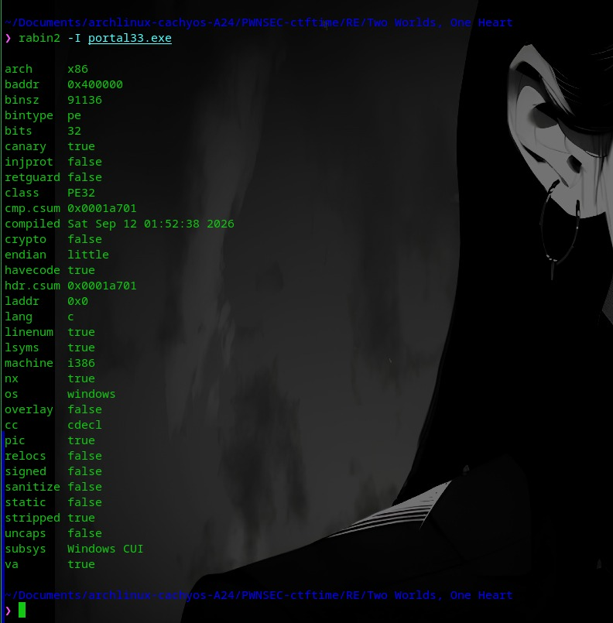
Figure 2 Output of rabin2 -I portal33.exe: x86/32-bit architecture, canary/NX/PIC mitigations active, binary stripped, Windows CUI subsystem. [E-002]

3.3 Step 3 Mapping the Validation Flow at the Caller
1. Open the binary with radare2, run automatic analysis, then print 25 instructions starting right after the input is read:
Command 4 Caller disassembly
r2 -Aqc 'pd 25 @ 0x408e16' portal33.exe

2. Identify the control structure in the output (summarized):
Excerpt 1 Caller control structure (0x408e16)
0x00408e16 mov dword [esp], esi ; const char *s
0x00408e19 call sub.msvcr.dll_strlen ; size_t strlen(const char*)
0x00408e1e cmp eax, 0x28 ; '(' ; 40
0x00408e21 jne 0x408e7b ; failure branch
0x00408e23 call fcn.00401600 ; checker 1 (32-bit mode)
0x00408e2a test eax, eax
0x00408e2c je 0x408e7b ; failure branch
0x00408e37 call fcn.004016b3 ; checker 2 (64-bit wrapper)
0x00408e3c test eax, eax
0x00408e3e je 0x408e76 ; failure branch
0x00408e5c mov dword [esp], str.You_didnt_just_listen...
0x00408e66 call sub.msvcr.dll_puts ; success message
0x00408e6d mov dword [esp], str.Access_Granted_Flag_verified.
0x00408e74 call sub.msvcr.dll_puts ; [+] Access Granted!

Interpretation. The caller enforces three sequential gates: (1) the input length must be exactly 0x28 = 40 characters; (2) fcn.00401600 must return a non-zero value; (3) fcn.004016b3 must return a non-zero value. Only if all three pass does puts print the success message. The failure-message string address ("You didn't even try to listen") is referenced from branch 0x408e7b, consistent with the strings output in Step 1. This two-checker chain is what gets dissected in the next two steps.
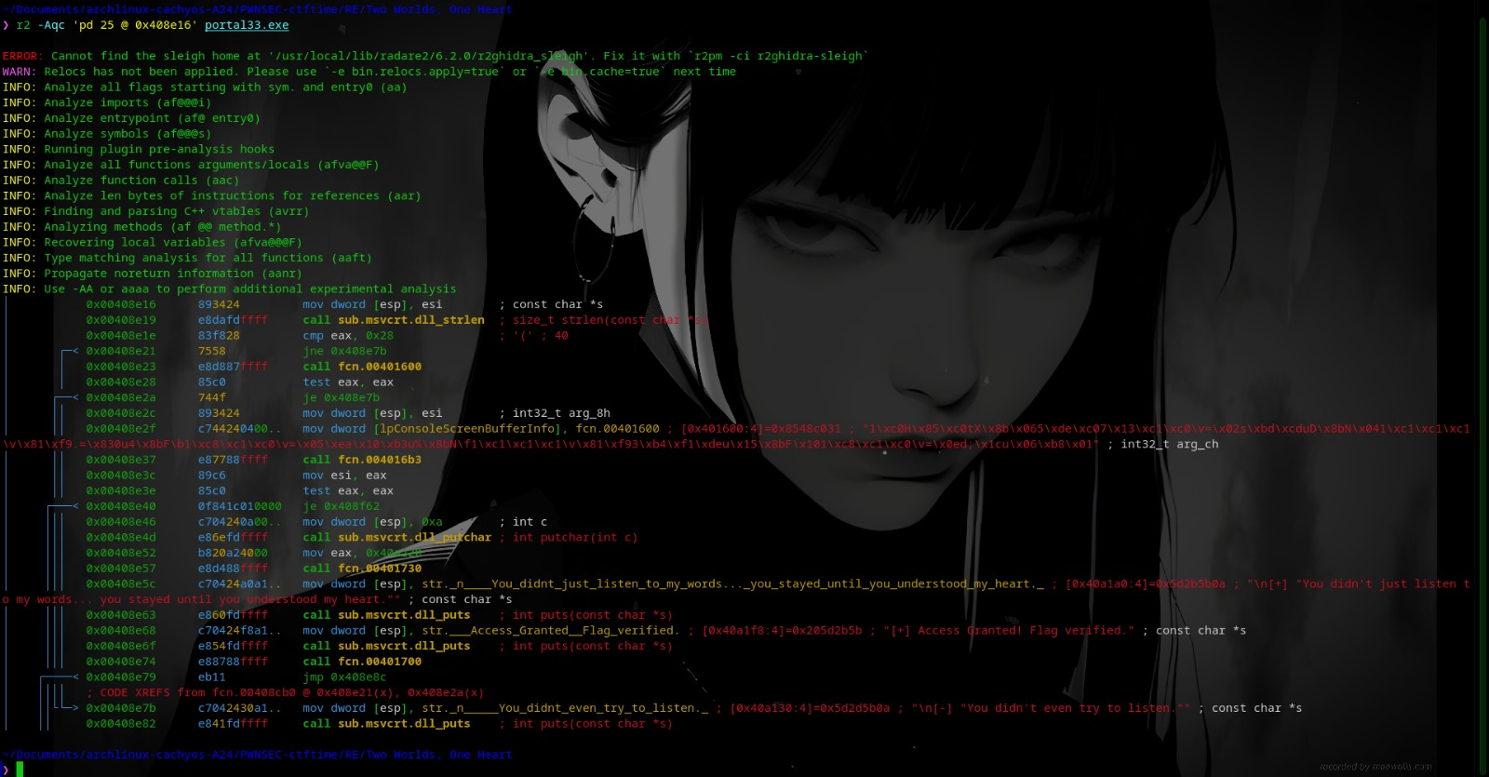
Figure 3 Output of r2 -Aqc 'pd 25 @ 0x408e16': strlen compared against 0x28, then calls to fcn.00401600 and fcn.004016b3; the success/failure strings appear as puts arguments. [E-003]

3.4 Step 4 Dissecting the 32-bit Checker (fcn.00401600)
1. Print the first checker's disassembly and identify its repeating pattern:
Excerpt 2 32-bit checker at fcn.00401600 (summarized)
; fcn.00401600 () 32-bit checker
0x00401600 31c0 xor eax, eax
0x00401603 85c0 test eax, eax
0x00401605 7458 je 0x40165f ; on a 64-bit CPU, jumps into the 64-bit block
; ---- 32-bit block ----
0x00401607 8b06 mov eax, dword [esi]
0x00401609 35dec03713 xor eax, 0x1337c0de
0x0040160e c1c00b rol eax, 0xb
0x00401611 3d0273bddc cmp eax, 0xcdbd7302
0x00401616 7544 jne 0x40165c
0x00401618 8b4e04 mov ecx, dword [esi + 4]
0x0040161b 31c1 xor ecx, eax
0x0040161d c1c10b rol ecx, 0xb
0x00401620 81f92e3d8330 cmp ecx, 0x30833d2e
0x00401626 7534 jne 0x40165c
0x00401628 8b4608 mov eax, dword [esi + 8]
0x0040162b 31c8 xor eax, ecx
0x0040162d c1c00b rol eax, 0xb
0x00401630 3d050ea1b3 cmp eax, 0xb310ea05
0x00401635 7525 jne 0x40165c
0x00401637 8b4e0c mov ecx, dword [esi + 0xc]
0x0040163a 31c1 xor ecx, eax
0x0040163c c1c10b rol ecx, 0xb
0x0040163f 81f933b4f1de cmp ecx, 0xdef1b433
0x00401645 7515 jne 0x40165c
0x00401647 8b4610 mov eax, dword [esi + 0x10]
0x0040164a 31c8 xor eax, ecx
0x0040164c c1c00b rol eax, 0xb
0x0040164f 3d0e643b1c cmp eax, 0x1c3b640e
0x00401654 7506 jne 0x40165c
0x00401656 b801000000 mov eax, 1
0x0040165b c3 ret

Interpretation. The repeating pattern consists of four operations: load an input word from offset esi+0x00 through esi+0x10 (five words × 4 bytes = the first 20 bytes), XOR it with a chained key, rotate left 11 bits (0xb), then compare against a constant. The first word's key is the constant 0x1337c0de; each subsequent word's key is the rotated result of the previous word, forming the chain C_i = ROL32(W_i XOR C_(i-1), 11) with an initial C_(i-1) of 0x1337c0de.
Also note the mode trap: the opening instructions xor eax, eax; test eax, eax always produce zero, so je 0x40165f always jumps identical behavior in both CPU modes. The difference is that in 32-bit mode, address 0x40165f contains byte 0x48, which decodes as dec eax and the flow continues as 32-bit code; in 64-bit mode, 0x48 is a REX prefix, so the instruction stream decodes completely differently from that point. This is the mechanism that lets a single checker serve two worlds.
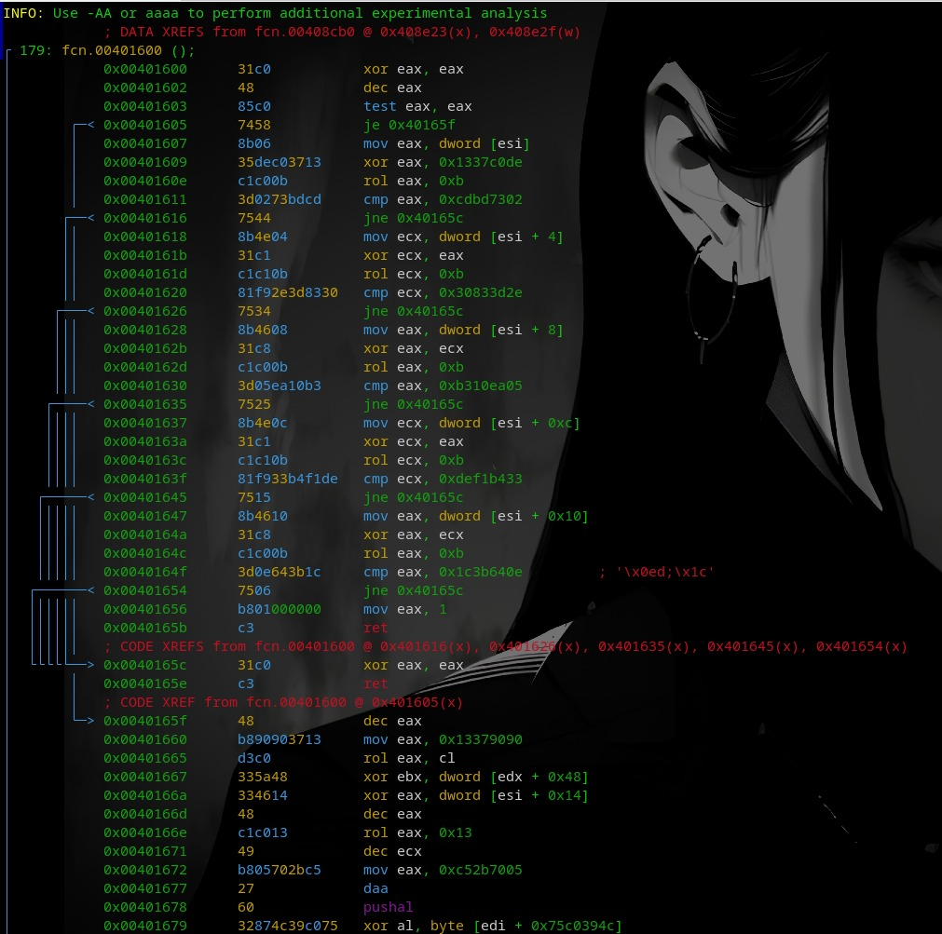
Figure 4 Disassembly of fcn.00401600: five xor + rol 0xb + cmp pairs against target constants, followed by the 0x40165f block that decodes differently in 64-bit mode. [E-004]

3.5 Step 5 The retf Wrapper and 64-bit Checker (fcn.004016b3)
1. Dissect the wrapper that bridges the CPU modes:
Excerpt 3 Heaven's Gate wrapper at fcn.004016b3 (summarized)
; fcn.004016b3 (checker_addr, input_ptr) Heaven's Gate wrapper
0x004016b3 55 push ebp
0x004016b4 89e5 mov ebp, esp
0x004016b7 53 push ebx
0x004016b8 56 push esi
0x004016b9 57 push edi
0x004016ba 8b7508 mov esi, dword [arg_8h] ; checker address
0x004016bc 8b5d0c mov ebx, dword [arg_ch] ; input pointer
0x004016bf 6a33 push 0x33 ; 64-bit code selector
0x004016c1 e800000000 call fcn.004016c6 ; push return address
0x004016c6 83042405 add dword [esp], 5 ; ret -> 0x4016cb
0x004016ca cb retf ; FAR RETURN -> 64-bit
; ---------- execution is now in 64-bit long mode ----------
0x004016cf ffd3 call ebx ; run the 64-bit checker
0x004016d2 83ec08 sub esp, 8
0x004016d5 c744240423.. mov dword [esp + 4], 0x23 ; selector 32-bit
0x004016dd e800000000 call fcn.004016e2
; ---------- back to 32-bit mode ----------
0x004016e2 59 pop ecx
0x004016e3 83c108 add ecx, 8
0x004016e6 892424 mov dword [esp], ecx
0x004016e9 cb retf ; FAR RETURN -> 32-bit
0x004016ea 5f 5e 5b pop edi / pop esi / pop ebx
0x004016ed 89ec mov esp, ebp
0x004016ef 5d pop ebp
0x004016f0 c3 ret

2. Summary of the mechanism: push 0x33 places the 64-bit code selector on the stack; call pushes the address of the next instruction; add dword [esp], 5 shifts the return address past the retf byte; retf performs a far return to 0x33:address, causing the processor to enter 64-bit long mode. After call ebx executes the 64-bit checker block, the process is reversed with selector 0x23 to return to the 32-bit world.
3. Note the 64-bit block's checker constants (segment 0x40165f, read as 64-bit code): initial key 0x5a33c0d313379090, three comparison constants 0x87326027c52b7005, 0x7e6e88add6ebc7e2, 0x5e929579, and rotations of 19, 29, and 13 bits.
Interpretation. The wrapper fcn.004016b3 takes two arguments the checker address and the input pointer then "lifts" the CPU into 64-bit mode so the 0x40165f block decodes as valid 64-bit instructions. The 64-bit section reads input from offsets 0x14 (QWORD), 0x1c (QWORD), and 0x24 (DWORD) relative to the buffer exactly the last 20 bytes with the equations C0 = ROL64(q0 XOR 0x5a33c0d313379090, 19); C1 = ROL64(q1 XOR C0, 29); C2 = ROL32(d0 XOR low32(C1), 13). A crucial note: the XOR at each subsequent stage uses the previous rotation's result (the register value), not the plaintext. The "two worlds, one heart" pattern is now complete: one XOR+ROT algorithm, two execution modes.
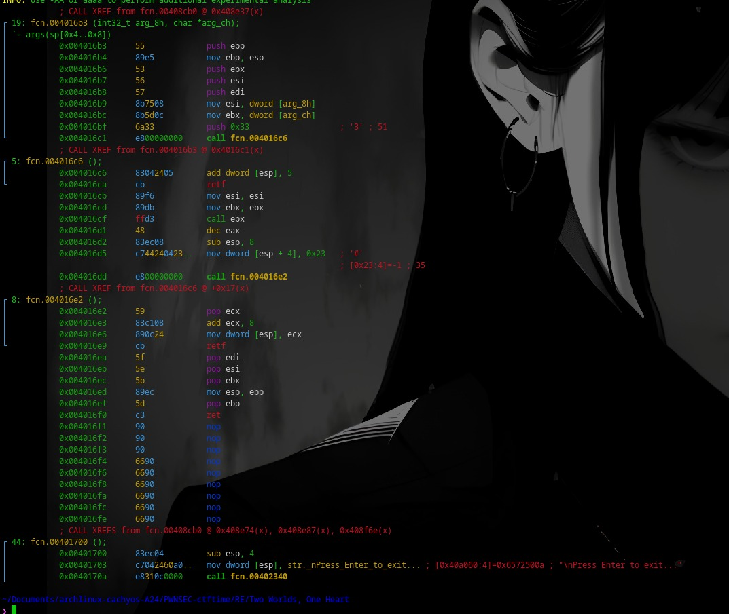
Figure 5 Heaven's Gate wrapper: push 0x33 + retf enters long mode, call ebx runs the 64-bit checker, then mov dword [esp+4], 0x23 + retf returns to 32-bit mode. [E-005]

3.6 Step 6 Writing the Solver and Extracting the Flag
1. Write a Python solver that inverts the entire chain (save it as TW.py). Inversion key: W = ROR(C, n) XOR prev, then read the result as little-endian bytes:
Code 1 TW.py: full solver
# TW.py "Two Worlds, One Heart" solver
# Inverts the portal33.exe XOR/ROL checker into a valid 40-byte input.
from struct import pack

def rol(x, n, b):
return ((x << n) | (x >> (b - n))) & ((1 << b) - 1)

def ror(x, n, b):
return rol(x, b - n, b) # inverse of a left rotation = a right rotation

# ---- 32-bit part: cmp constants at 0x401611..0x40164f ----
c = [
0xcdbd7302,
0x30833d2e,
0xb310ea05,
0xdef1b433,
0x1c3b640e,
]

p = b''.join(
pack('<I', ror(x, 11, 32) ^ (0x1337c0de if i == 0 else c[i-1]))
for i, x in enumerate(c)
) # first 20 bytes

# ---- 64-bit part: cmp constants in block 0x40165f (mode 64) ----
key = 0x5a33c0d313379090 # 64-bit chain key
c0 = 0x87326027c52b7005
c1 = 0x7e6e88add6ebc7e2
c2 = 0x5e929579

flag = (
p
+ pack('<Q', ror(c0, 19, 64) ^ key) # offset 0x14
+ pack('<Q', ror(c1, 29, 64) ^ c0) # offset 0x1c
+ pack('<I', ror(c2, 13, 32) ^ (c1 & 0xffffffff)) # offset 0x24
)

print(flag.decode())
print("Length:", len(flag))

2. Run the solver and verify the output length:
Command 5 Solver execution
python3 TW.py

Result 3 Solver output
pwnsec{h3_5p34k5_32_5h3_5p34k5_64_l0v3!}
Length: 40

Interpretation. The output length of 40 satisfies the strlen == 0x28 gate, and its text structure (pwnsec{...}) is consistent with the organizer's flag format. The two 20-byte segments join seamlessly: pwnsec{h3_5p34k5_32_} + 5h3_5p34k5_64_l0v3!} the same binary message as the challenge title's narrative: he speaks 32, she speaks 64.
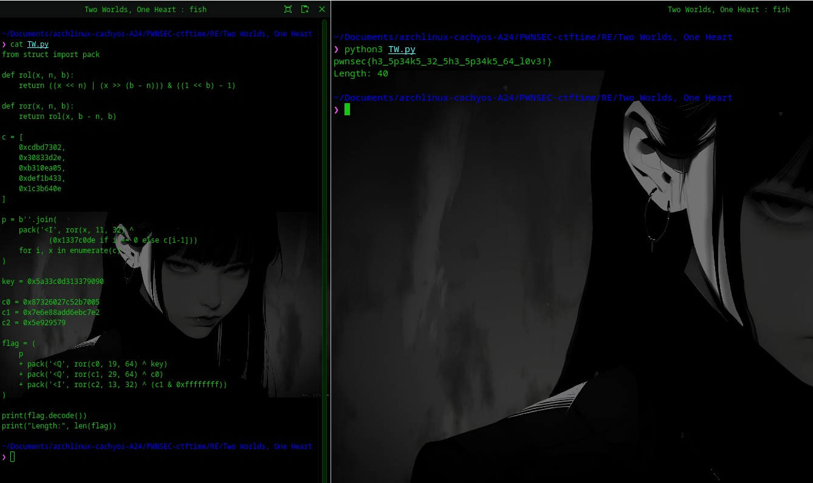
Figure 6 Left: contents of TW.py with the rol/ror functions, checker constants, and pack inversion. Right: running python3 TW.py, producing a 40-character flag. [E-006]

3.7 Cross-Validation Forward Replay
To prove the candidate is not a coincidence, re-run the entire transformation forward on the inverted flag and compare it against the binary's constants. The result must match perfectly on all eight comparisons:
Code 2 Forward replay of every checker
Forward replay, 32-bit (input = flag[0:20]):
cdbd7302, 30833d2e, b310ea05, def1b433, 1c3b640e == cmp constants OK (5/5)

Forward replay, 64-bit (input = flag[20:40]):
87326027c52b7005, 7e6e88add6ebc7e2, 5e929579 == cmp constants OK (3/3)

Length check: 40 == 0x28 OK

A full 8/8 match rules out the possibility of an inversion error: the candidate flag is guaranteed to pass every checker in portal33.exe. At this point, the entire thesis of Chapter 1.2 has been proven with static, mathematical evidence, documented across six screenshot exhibits.

4. Discussion

4.1 Flag Reconstruction from Constants
Tables 3 and 4 summarize the complete mapping from comparison constants to the inverted plaintext centralized evidence supporting this document's thesis. Reading the inverted bytes in little-endian order (since mov dword [esi] loads a little-endian word), then concatenating them in sequence, yields the complete flag pwnsec{h3_5p34k5_32_5h3_5p34k5_64_l0v3!}.
Table 3 Mapping of 32-bit checker constants to plaintext
Word | cmp constant | Inversion result (hex LE) | ASCII
W0 | 0xcdbd7302 | 736e7770 | pwns
W1 | 0x30833d2e | 687b6365 | ec{h
W2 | 0xb310ea05 | 70355f33 | 3_5p
W3 | 0xdef1b433 | 356b3433 | 34k5
W4 | 0x1c3b640e | 5f32335f | _32_

Table 4 Mapping of 64-bit checker constants to plaintext
Value | cmp constant | Inversion result (hex LE) | ASCII
q0 | 0x87326027c52b7005 | 343370355f336835 | 5h3_5p34
q1 | 0x7e6e88add6ebc7e2 | 306c5f34365f356b | k5_64_l0
d0 | 0x5e929579 | 7d213376 | v3!}

Two details stand out as classic traps worth flagging. First, the next chain key is the rotated register value C_(i-1), not the previous plaintext a common mistake that produces garbage bytes. Second, the final segment is only 32-bit (DWORD) in size because the second 20-byte segment is composed of 8 + 8 + 4; a wrong size assumption will shift the entire ASCII reading.

4.2 Why This Approach Works and Generalizes
The combination of three properties makes the solution deterministic. (1) Bijectivity: rotation and XOR do not compress information the mapping from input to constant is one-to-one, so an inverse always exists and is unique [6][7]. (2) Constant visibility: every target value is hardcoded as an immediate operand of the cmp instruction; no runtime derivation hides it. (3) Bounded candidate space: the 40-character length gate narrows the search space, and the pwnsec{...} flag format provides an additional plausibility check.
In general, any checker that only composes group operations over XOR rotation, circular shift, modular addition, XOR can be attacked with the same pattern: extract the constants, invert the composition, forward-validate. This method is also not tied to radare2; objdump or any disassembler that decodes CPU modes accurately is sufficient. This generalizability is what makes the attack pattern in this document reusable across similar challenges without fundamental changes.

4.3 Heaven's Gate as Obfuscation: Value and Limits
From a challenge-design perspective, Heaven's Gate adds a real layer of difficulty: automatic 32-bit disassembly misinterprets the 64-bit block (byte 0x48 reads as dec eax, not a REX prefix), control flow breaks at the retf, and some disassemblers give up tracing cross-mode branches. However, this layer is cosmetic against the core vulnerability: both worlds share one weak algorithm. Once the analyst recognizes the selector-0x33-plus-retf pattern, the 64-bit block only needs to be read through the correct lens, and the solver still only requires an inverted XOR-rotation.
The defensive lesson is clear: obfuscation raises the cost of analysis, not cryptographic strength. Secret data validated with an invertible comparator can ultimately always be reconstructed from the binary itself the exact same pattern analyzed in WOW64 malware literature, where mode-switching is used for camouflage yet remains dissectible with an understanding of CPU modes [1][3][4].

5. Counterarguments and Limitations

5.1 Method Limitations
First, the analysis is entirely static: the flag was never tested by actually running portal33.exe on real Windows or Wine, since the analysis environment is Linux with no active Windows target. The accompanying risk is a misread decode around the retf; however, this risk is mitigated by a forward replay matching 8/8 a full match against every constant practically rules out an inversion error. Second, the reading of the 64-bit block in Figure 4 overlaps with radare2's 32-bit decoding, so some values (e.g., the construction of key 0x5a33c0d313379090) are read from raw bytes rather than clean disassembler output; this document presents the final result after mathematical verification. Third, the tool version metadata (radare2 6.2.0, Python 3.14.7) is environment-specific; command behavior may differ across versions.

5.2 Counterarguments Considered
First argument: "40-character brute force might be feasible because the flag's character space is limited." This view does not survive a simple calculation even with a charset of only 64 symbols, the space is 64^40, roughly 2^240, far beyond the reach of any computation. Brute force is only realistic on a per-component basis once the structure is already known, which in turn presupposes the kind of static analysis performed in this document.
Second argument: "the 64-bit checker might be avoidable, since xor eax,eax; test is always zero, so perhaps only one checker is ever active." Observation of the binary refutes this: the caller invokes both checkers in sequence and requires both to return a non-zero value (0x408e23 and 0x408e37); there is no path to the success message that bypasses fcn.004016b3. Third argument: "the flag might be a hidden string rather than a computed input." String filtering found no 40-character string anywhere; every comparison is arithmetic against the input, confirming the flag really is a computed input consistent with the findings. These three arguments are documented to show the alternatives that were tested and the reasons for rejecting each.

6. Conclusion and Implications

6.1 Summary of Findings
portal33.exe enforces four gates: (1) an input length of exactly 40 bytes; (2) the first five words must pass the chain C_i = ROL32(W_i XOR C_(i-1), 11) with an initial key of 0x1337c0de; (3) the last 20 bytes must pass the 64-bit ROL 19/29/13-bit chain with an initial key of 0x5a33c0d313379090, reached via retf to selector 0x33 (Heaven's Gate); (4) both checkers must succeed before the message "Access Granted! Flag verified." is printed. Because every transformation is bijective, the flag is recovered deterministically through ROR+XOR inversion and is fully validated by a forward replay (8/8 constants matching, length 40/40).
Final flag
pwnsec{h3_5p34k5_32_5h3_5p34k5_64_l0v3!}

6.2 Implications
For challenge authors, these findings point to two hardening layers that would close off the inversion path: replace at least one layer with a one-way function (e.g., hashing the candidate for verification), or derive the checker constants at runtime from a non-static key. The Heaven's Gate technique used here effectively raises the cost of reading, but does not change the underlying security class of the problem a lesson that applies precisely to real-world malware analysis, where mode-switching techniques are used for camouflage yet remain dissectible with an understanding of CPU modes [1][3][4].
For defensive practitioners, indicators in the style of this challenge are worth turning into detection rules for WOW64 sample analysis: a push 0x33 sequence followed by retf, and a repeating rol/xor/cmp pattern. Both are easy to flag in disassembly and rarely appear in legitimate software, making them useful as early signals of cross-mode obfuscation.

6.3 Further Steps
Three extensions are recommended. First, dynamic reproduction: run the binary on Windows/Wine with the solver's output to directly capture the success message and complement evidence E-001 through E-006 with a runtime screenshot. Second, automation: generalize TW.py into a disassembly parser that programmatically extracts cmp constants, so the solver can be reused on challenge variants with longer chains or different rotations. Third, tool comparison: repeat the 64-bit block reading with a dual-mode disassembler or an emulator (e.g., Unicorn) to produce a cleaner 64-bit decode than the 32-bit rendering shown in Figure 4.

7. References
All references were access-checked on September 13, 2026. The references serve to reinforce the technical context (Heaven's Gate, x86 rotation, radare2 tooling) and CTF writeup conventions; all core findings in this document originate from independent analysis of the sample.
[1] 0xk4n3ki, "CrackMe Analysis: Heaven's Gate and Mode Switching," October 6, 2023. [Online]. Available: https://0xk4n3ki.github.io/
[2] Hexacorn, "Heaven's gate and a chameleon code (x86/64)," Hexacorn Blog, October 26, 2015. [Online]. Available: https://www.hexacorn.com/blog/2015/10/26/heavens-gate-and-a-chameleon-code-x8664/
[3] Cisco Talos Intelligence Group, "RATs and stealers rush through 'Heaven's Gate' with new loader," July 1, 2019. [Online]. Available: https://blog.talosintelligence.com/2019/07/rats-stealers-heavens-gate.html
[4] S. J. Hwang et al., "Bypassing Heaven's Gate Technique Using Black-Box Testing," 2023. [Online]. Available via PubMed Central (PMC), National Library of Medicine: https://pmc.ncbi.nlm.nih.gov/
[5] radareorg, "radare2 UNIX-like reverse engineering framework," GitHub. [Online]. Available: https://github.com/radareorg/radare2
[6] F. Cloutier, "RCL/RCR/ROL/ROR Rotate," x86 Instruction Set Reference. [Online]. Available: https://www.felixcloutier.com/x86/rcl:rcr:rol:ror
[7] Wikibooks, "x86 Assembly/Shift and Rotate." [Online]. Available: https://en.wikibooks.org/wiki/X86_Assembly/Shift_and_Rotate
[8] Infosec Institute, "How to use Radare2 for reverse engineering," July 31, 2020. [Online]. Available: https://www.infosecinstitute.com/resources/malware-analysis/how-to-use-radare2-for-reverse-engineering/
[9] CTFtime, "Reverse Engineering Writeups." [Online]. Available: https://ctftime.org/writeups?category=reverse

Appendix A Reproduction Metadata
Every value in the table below was extracted from the sample and the analysis environment documented in Chapter 3. Use this table to reproduce every step identically.
Table 5 Complete metadata for reproduction
Item | Value
Sample file | portal33.exe
Size | 91,136 bytes
SHA-256 | d35911333fae7cfc7a305c93e2f14cad678487ef724d4ea610c3e047a42194f0
Type | PE32 console, Intel i386, 8 sections, stripped to external PDB
Compiled | Sat Sep 12 01:52:38 2026
Tooling | radare2/rabin2 6.2.0, GNU objdump 2.47, Python 3.14.7, fish shell
Key addresses | caller 0x408e16; 32-bit checker 0x401600; 64-bit block 0x40165f; wrapper 0x4016b3
32-bit constants | 0xcdbd7302, 0x30833d2e, 0xb310ea05, 0xdef1b433, 0x1c3b640e (key 0x1337c0de, ROL 11)
64-bit constants | 0x87326027c52b7005, 0x7e6e88add6ebc7e2, 0x5e929579 (key 0x5a33c0d313379090, ROL 19/29/13)
Triage command | file; sha256sum; strings -a -n 5 ... | grep -Ei
r2 caller command | r2 -Aqc 'pd 25 @ 0x408e16' portal33.exe
r2 checker command | r2 -Aqc 'pdf @ 0x401600' portal33.exe
Solver | TW.py (Chapter 3.6) output verified with an 8/8 forward replay

