## Q1(a)

touch 22241157_1.txt 22241157_2.txt 22241157_3.txt 22241157_4.txt

mkdir Riyadh1 Riyadh2

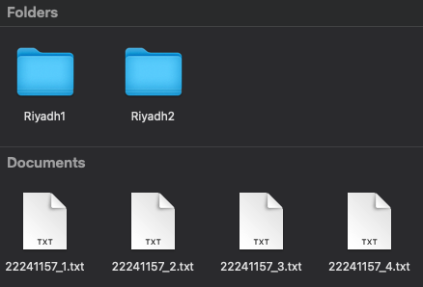

mv 22241157_1.txt 22241157_2.txt 22241157_3.txt Riyadh1

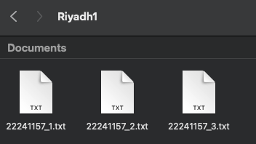

cp ./Riyadh1/22241157_1.txt ./Riyadh1/22241157_2.txt Riyadh2

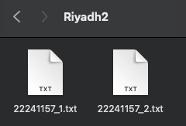

mkdir Riyadh3

cp -r Riyadh1 Riyadh3

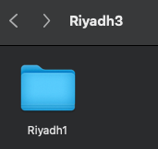

cd Riyadh3

chmod go=rx Riyadh1

chmod go=rx ./Riyadh1/22241157_1.txt ./Riyadh1/22241157_2.txt ./Riyadh1/22241157_3.txt

ls -l

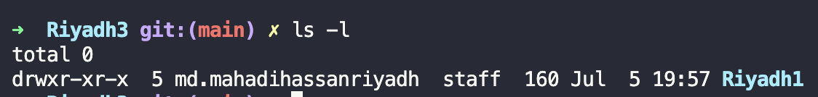

ls -l ./Riyadh1

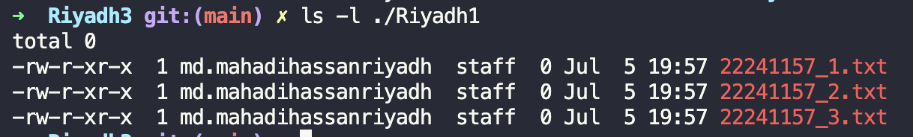

cd ..

ls -a



mv Riyadh3 ~ or mv Riyadh3 ..  
rm 22241157_4.txt

rm -r Riyadh1 Riyadh2

## Q1(b)

cat > course.txt

CSE321 - Operating Systems - 05(NTR)

CSE340 - Computer Architecture - 01(ACH)

CSE423 - Computer Graphics - 01(MZU)

PSY101 - Introduction to Psychology - 02(SNN)

grep -c "CSE" course.txt



## Q1(c)

ls -a ~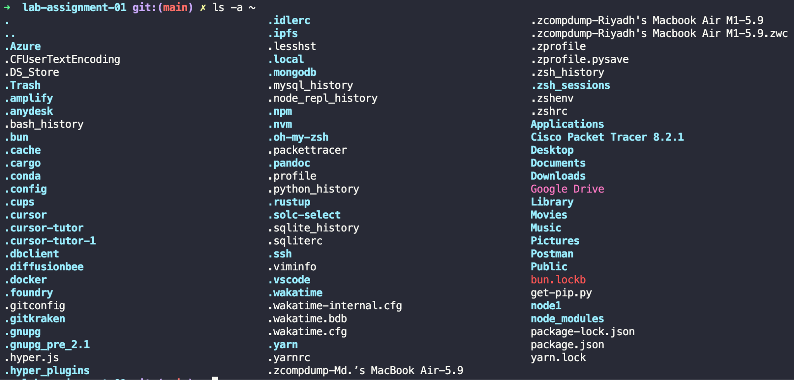

## Q1(d)

cat > lines.txt

line 1

line 2

line 3

line 4

line 5

line 6

line 7

line 8

line 9

line 10

line 11

line 12

line 13

line 14

line 15

line 16

line 17

line 18

line 19

line 20

line 21

head -n 17 lines.txt | tail -n 13

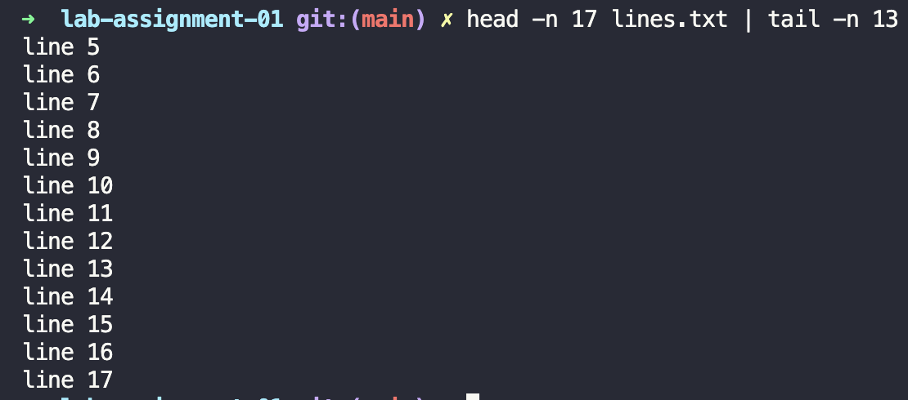

## Q2(a)

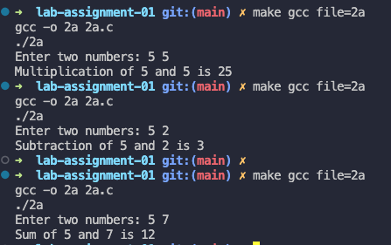

## Q2(b)

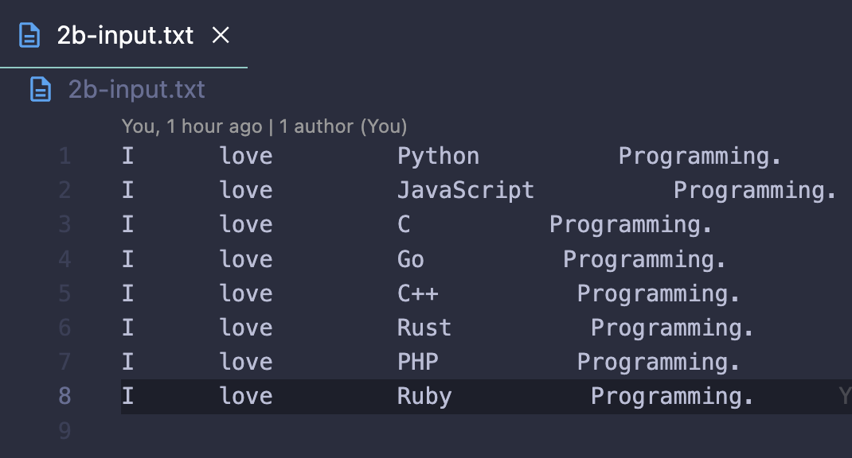

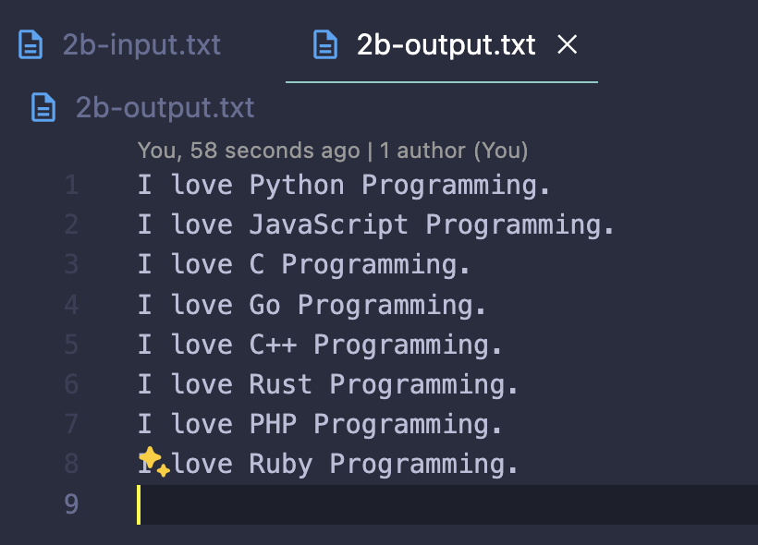

## Q2(c)

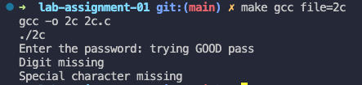

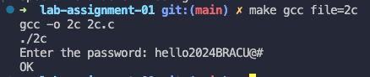

## Q2(d)

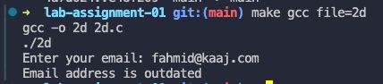

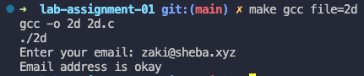

## Q2(e)

