# Struct & Function

## Task 01

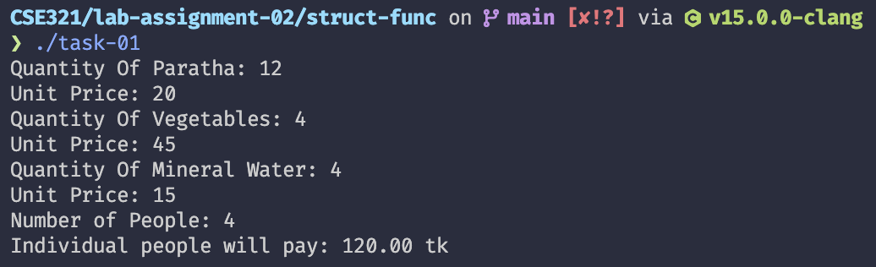

## Task 02

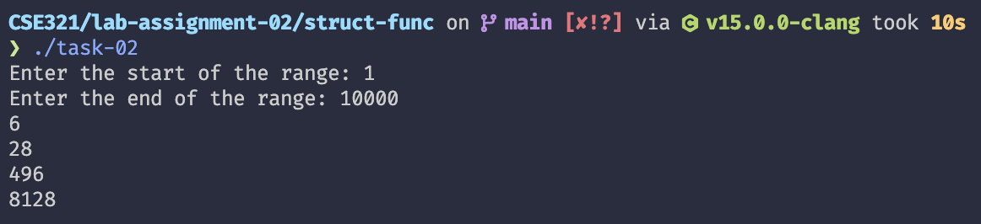

# 

# System Call

## Task 01

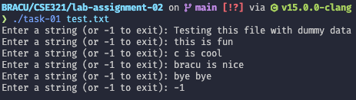

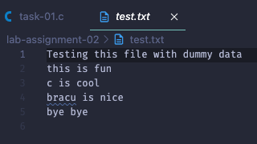

## Task 02

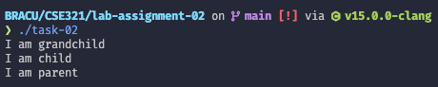

## Task 03

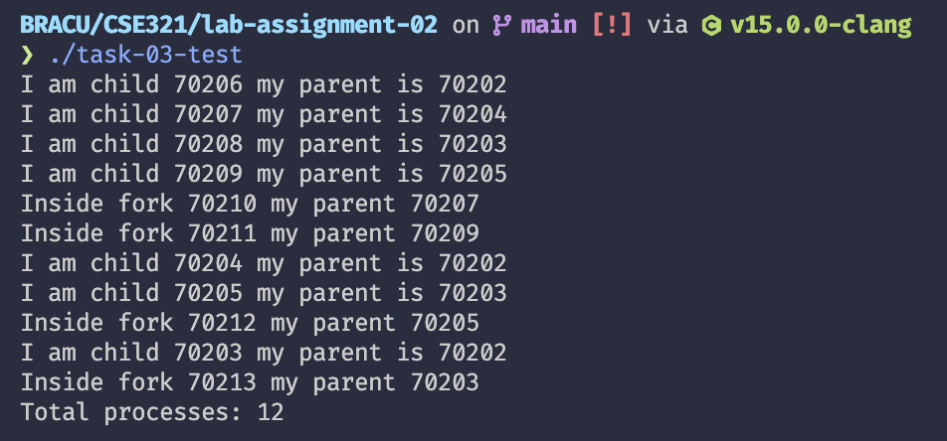

## Task 04

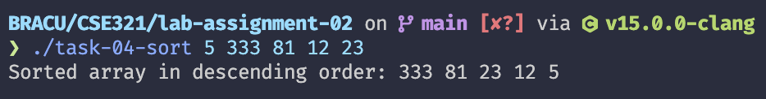

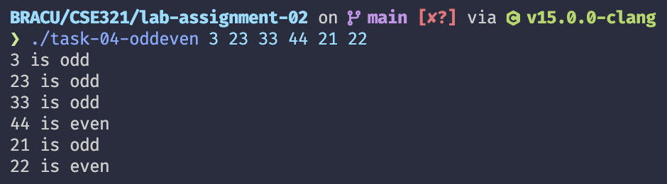

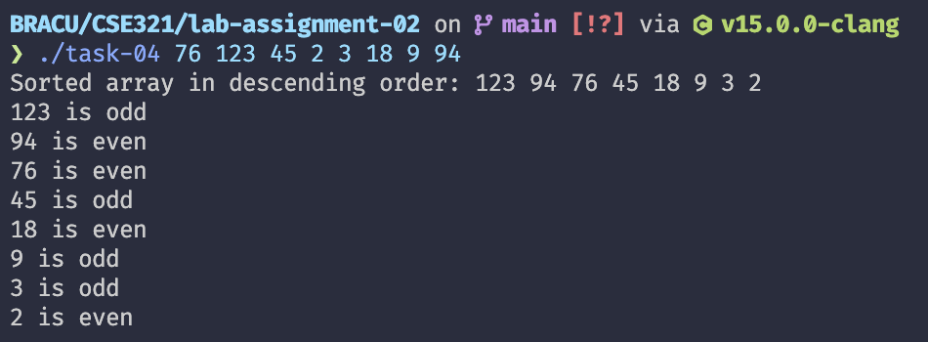

## Task 05

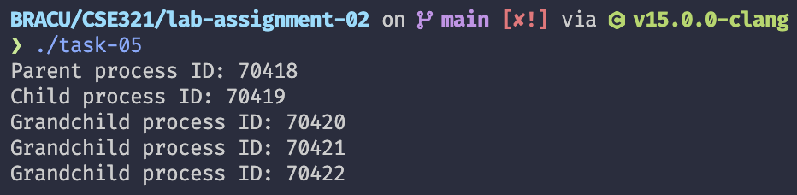

# Threads

## Task 01

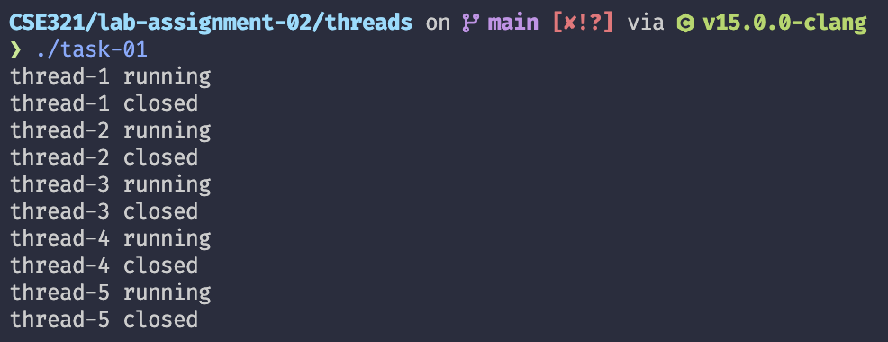

## Task 02

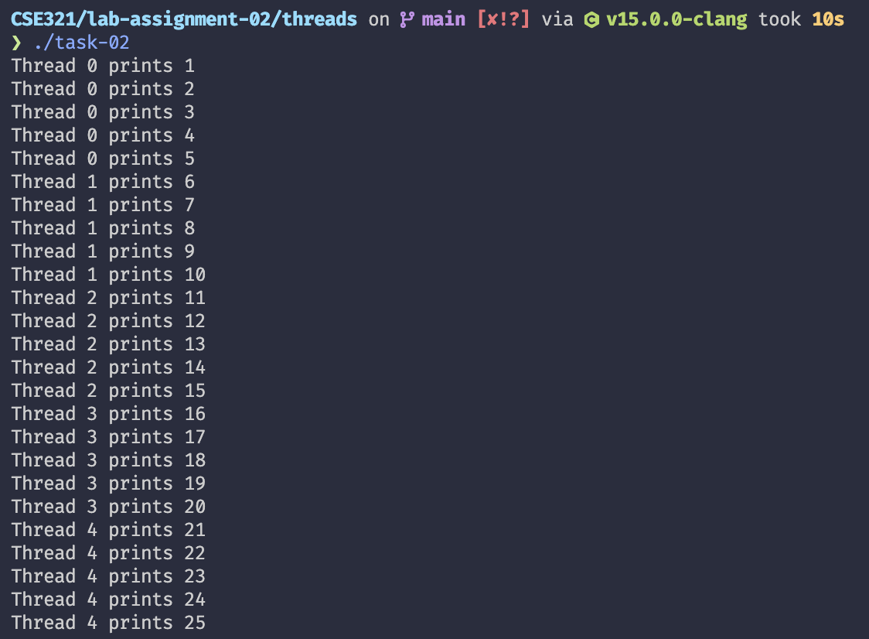

## Task 03

