**通过frp反向代理实现内网穿透**

frp server(vps):

https://github.com/fatedier/frp/releases/download/v0.31.1/frp_0.31.1_linux_amd64.tar.gz

frps.ini:

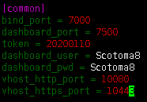

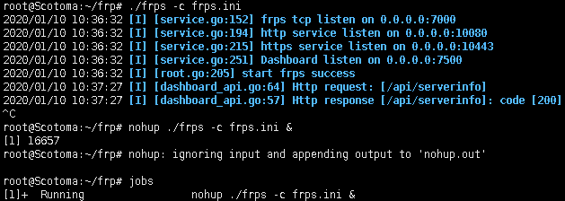

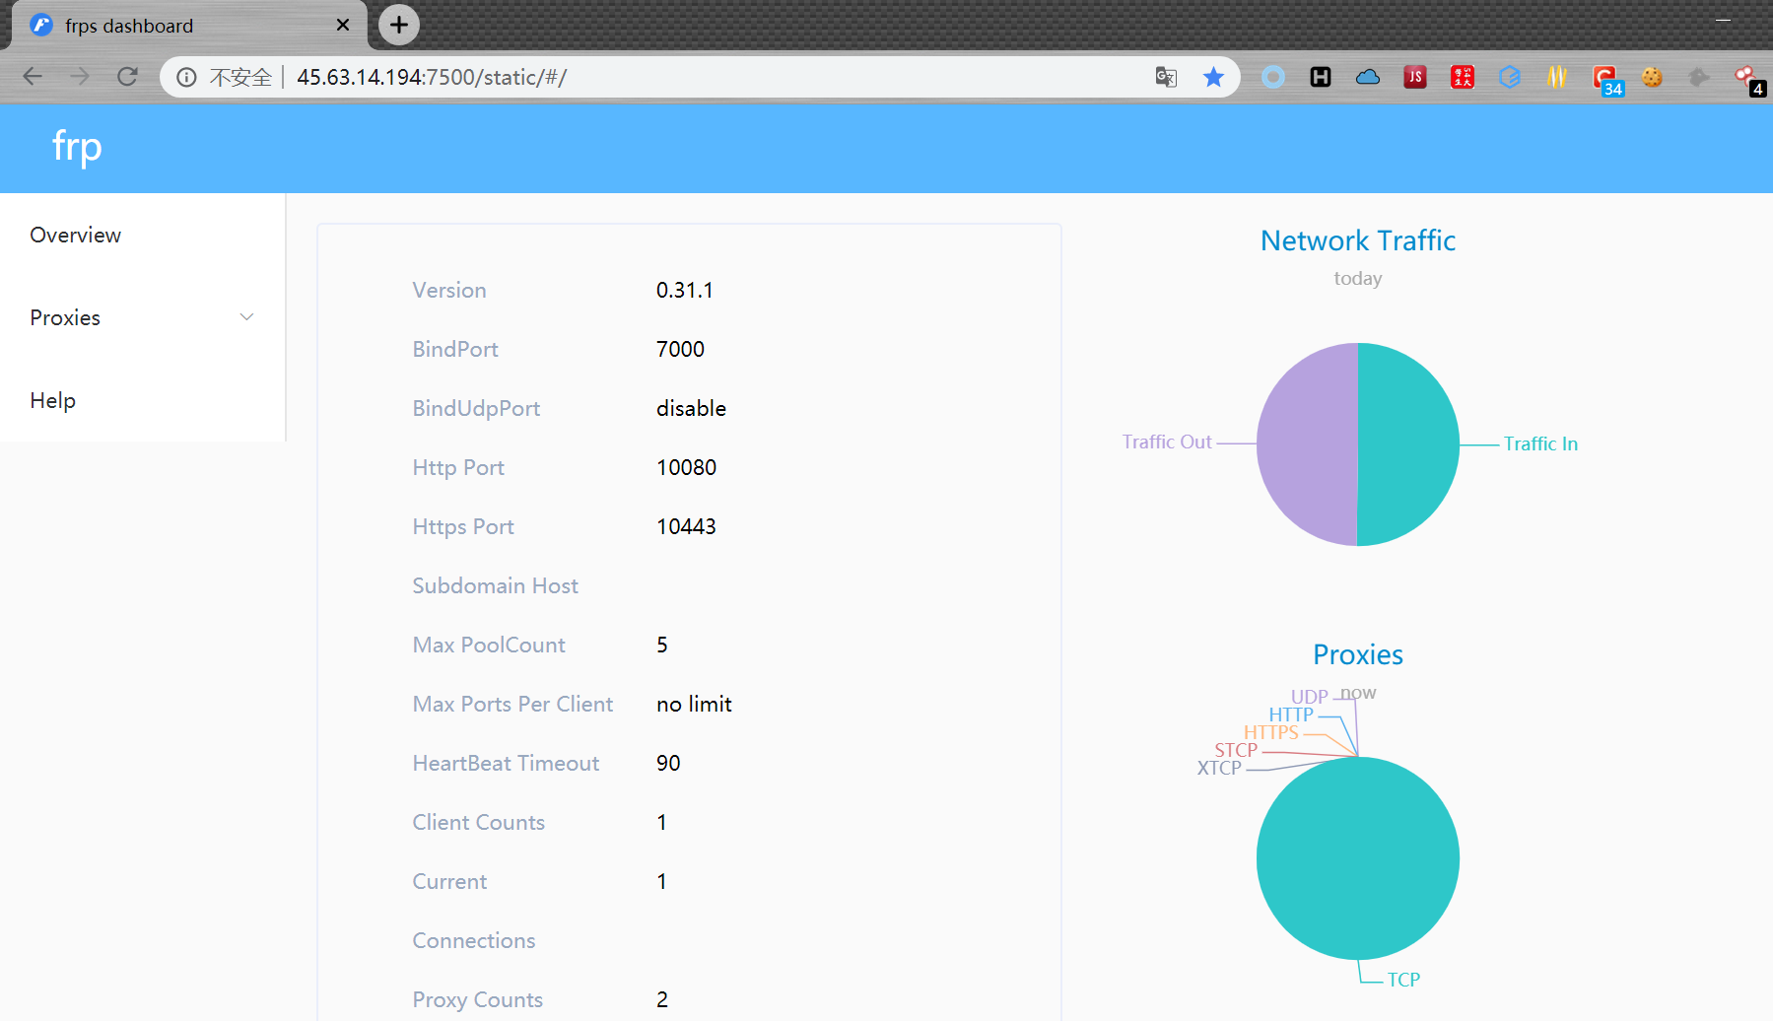

frp client(内网主机):

https://github.com/fatedier/frp/releases/download/v0.31.1/frp_0.31.1_windows_amd64.zip

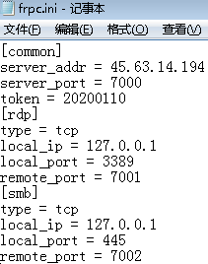

普通用户权限执行:

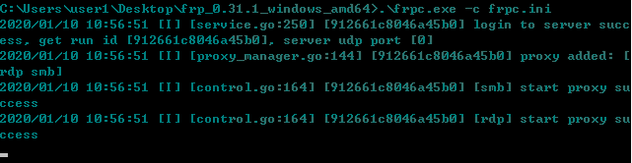

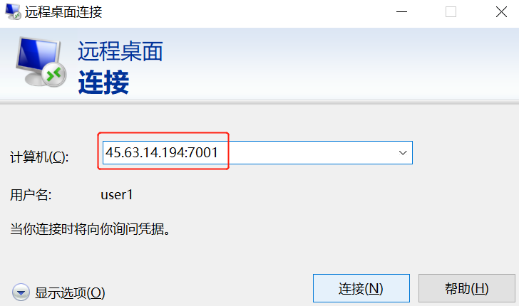

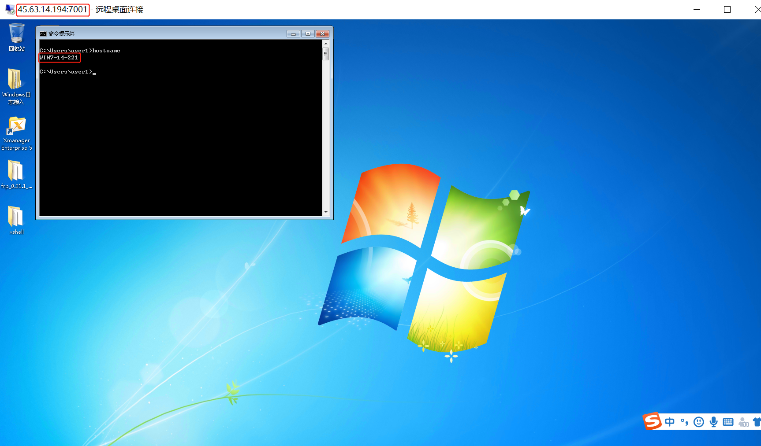

内网主机开机自启:

