Step1: Starting Consul

$ consul agent -dev

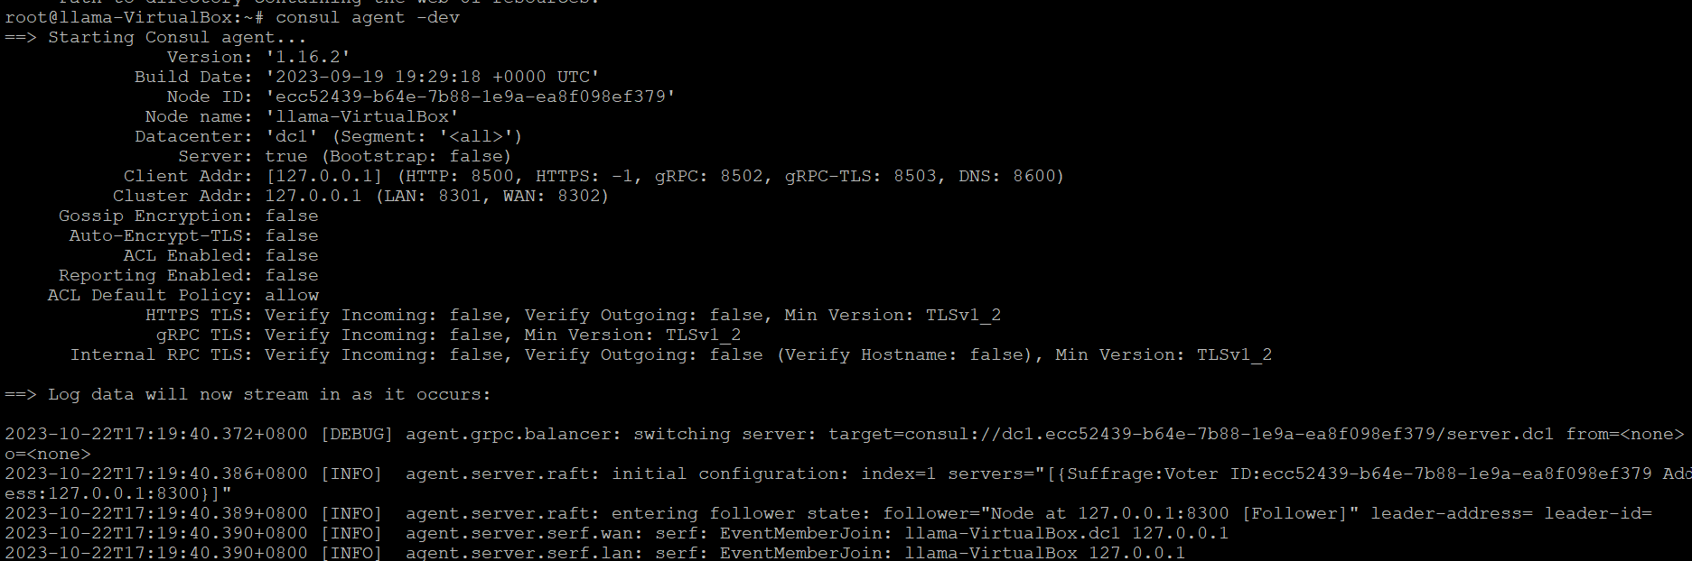

Step2: Check Consul Member  
  
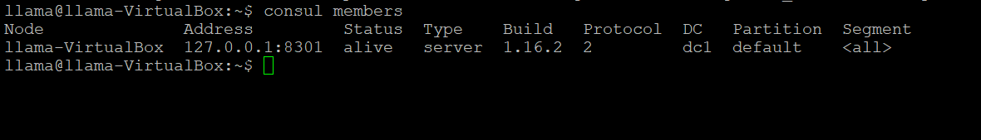

Step3: Checking numbers of nodes through API  
  
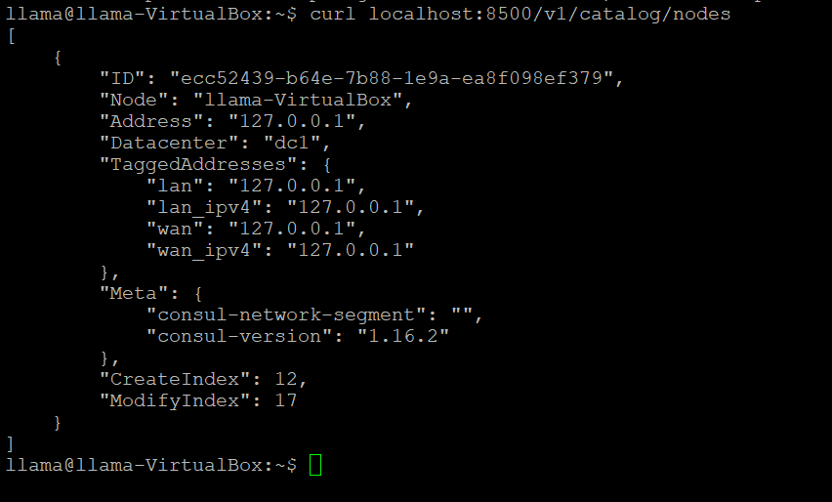

Step4: Started node-exporter on 9100 port  
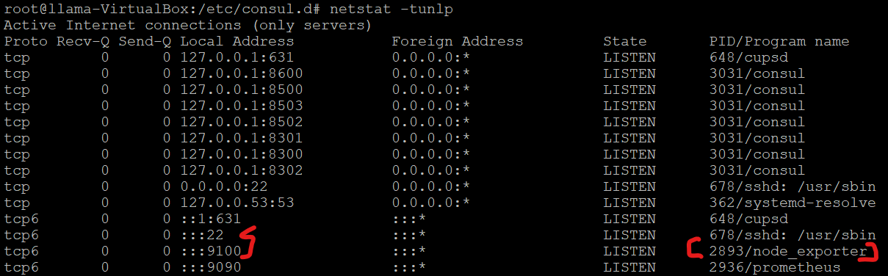

Step5: Register node-exporter as a service in consul

Made a file called node.json under /etc/consul.d

  
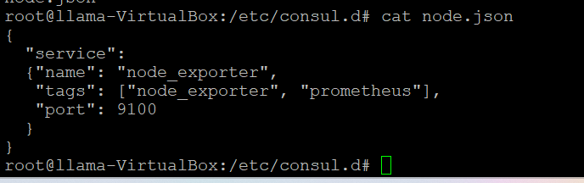  
  
Step6: Restarted consul server  


Step7: API call  
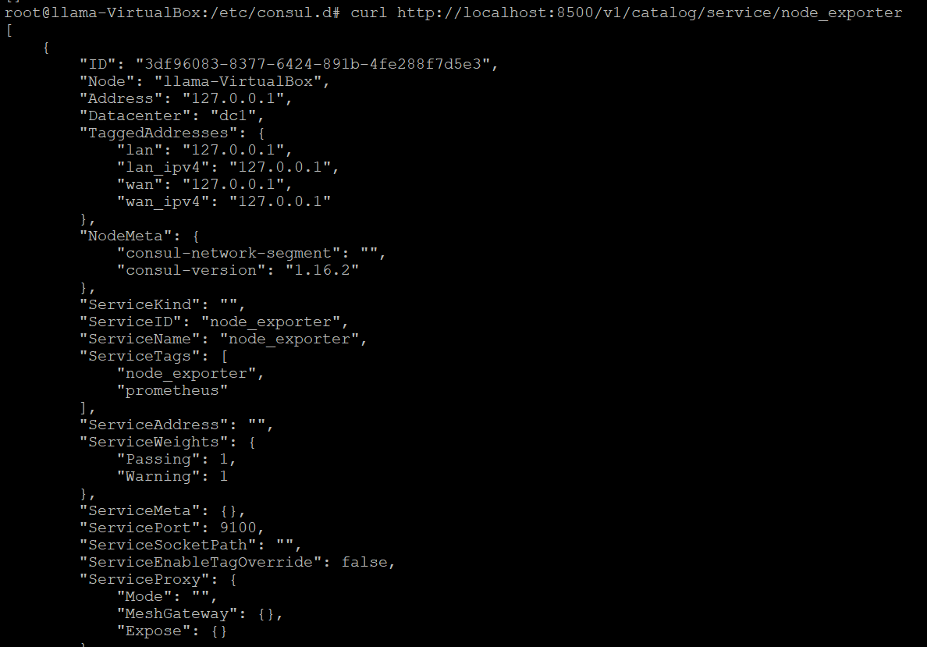

List all running services  
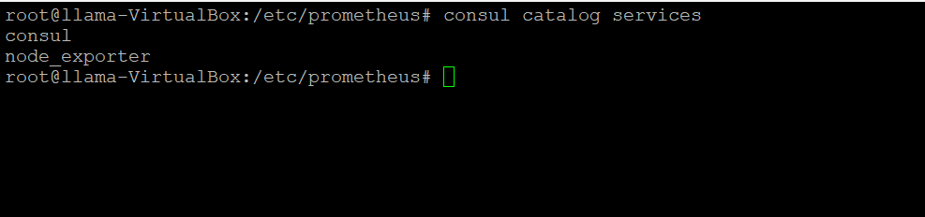

Step8: Run the below shell script to update firewall rules based on consul catalog data.  
  
