**Upload your project report and related documents in BlackBoard by 11:59PM, 03/31/2019**

**This project is not a teamwork project. You accomplish this project by yourself. You can use any programming language and make reference to any existing open source code or library to accomplish this project.**

**Project 1. Traveling Salesman Problem**

The traveling salesman problem (TSP) is a popular AI problem that asks for the most efficient trajectory possible given a set of points and distances that must all be visited. In computer science, the problem can be applied to the most efficient calculation.

**Task 1:** Study the paper attached in the project 2. The paper is “Traveling Salesman Problem: An Overview of Applications, Formulations, and Solution Approaches”.

Read this paper and understand some questions like what the traveling salesman problem is and its applications.

After you read the paper in the task 1, you would provide the answers to the following questions. These answers are required to be written into the project report.

1. What is the traveling salesman problem?
2. What are applications of the traveling salesman problem?
3. According to solution approaches in the paper, which technique you will use to solve the traveling salesmen problem in the task 2?

**Task 2:** Give 10 cities located within 1,000 miles (left to right) by 1,000 miles (bottom to top) region, calculate the shortest traveling path from the traveling salesman problem. The 10 cities are A, B, C, D, E, F, G, H, I, and J. Locations of 10 cities are

A (X: 100, Y: 300)

B (X: 200, Y: 130)

C (X: 300, Y: 500)

D (X: 500, Y: 390)

E (X: 700, Y: 300)

F (X: 900, Y: 600)

G (X: 800, Y: 950)

H (X: 600, Y: 560)

I (X: 350, Y: 550)

J (X: 270, Y: 350)

Note: X is the horizontal coordinate (from left to right) and Y is the vertical coordinate (from bottom to top).

The starting city and the ending city is the city A. The traveling salesman should leave the city A and travel all other cities only one time and then come back to the city A. **The traveling path between any two cities is considered as a straight line**. Note: according to the traveling salesman problem, any city (except the city A, because it is the starting and ending points) can be visited only one time. That means each city (except the city A) must be visited exactly once.

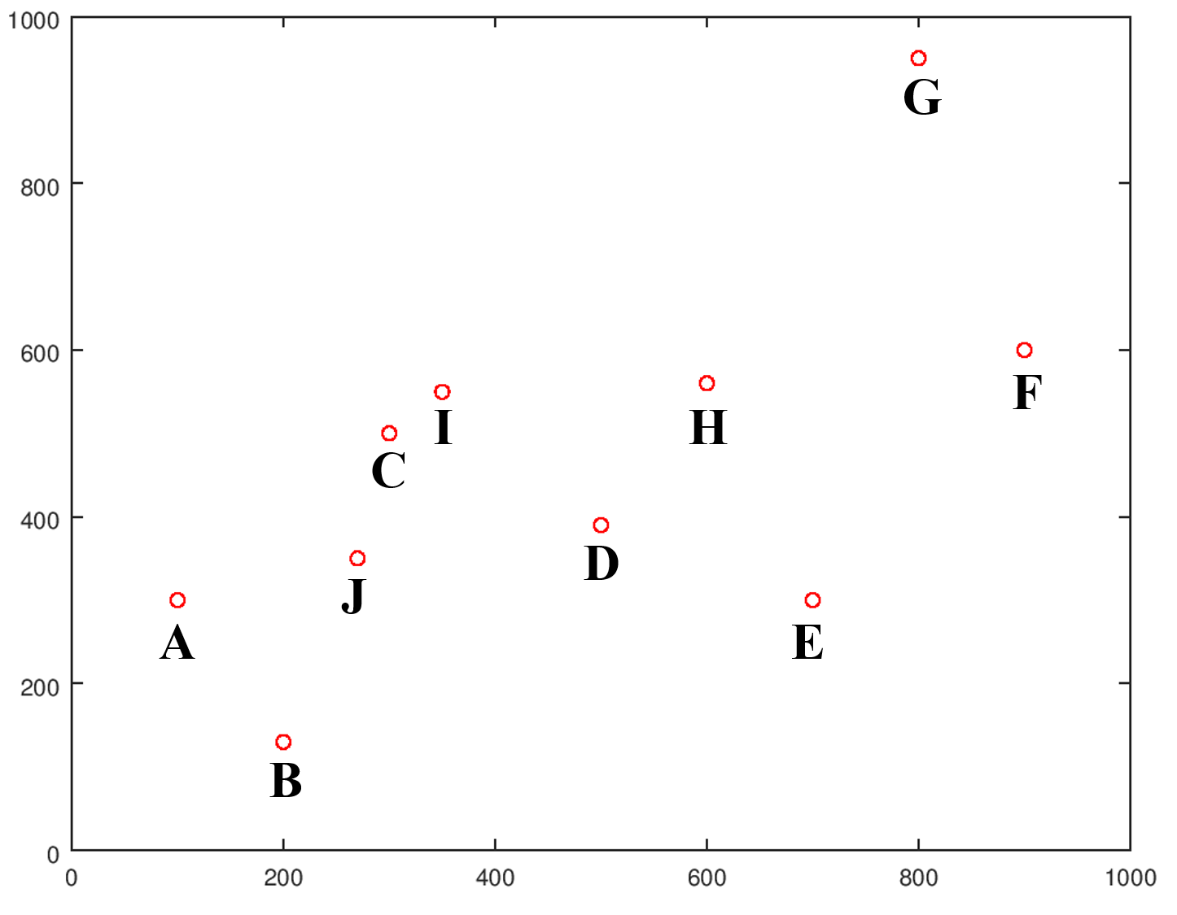

You can use any programming language and make reference to any existing open source code or library to accomplish the Task 2. For example, if you use C++ programming language, you can make reference to the following code.

<https://github.com/samlbest/traveling-salesman>

If you use Java programming language, you can make reference to the following code.

<https://github.com/ReadyPlayer2/TSP>

If you use Python programming language, you can make reference to the following code.

<https://github.com/jaunerc/TravelingSalesmanPy>

The above resources are just examples. You can also use any other programming languages and make reference any other open source code or library.

**Upload the following documents (compressed in a zip file) on BlackBoard by 11:59PM, 03/31/2019 for grading evaluation.**

1. **Project report containing answers of 3 questions in the Task 1.**
2. **All source code for solving the Task 2.**
3. **The text file contains the shortest path value and the sequence order of 10 cities visited. This value and order should be calculated from your solution on the traveling salesman problem in the Task 2 above. The content of this text file may like follows.**

Shortest distance value: 3961.67 miles

Sequence order of 10 cities: A -> B -> J -> C -> I -> D -> H -> G -> F -> E -> A

Note: the above content is just an example. The value and sequence order are not necessary the correct answer.