**Module Name:**sales_bom_check

**Architecture:**Odoo 10

**Project Name:**Admiral

**Objective:**For the system to have a check on the Product’s Bill of Material (BOM) when confirming the Quotation. System to be able to check on existing Raw Materials quantity and whether the quantity is enough to produce the Product. Auto generate PO when not available

**Requirement:**

1. When confirming the Quotation to become a Sales Order, a pop up will show
   1. Black – information required to show on the pop up
   2. Red – explanation

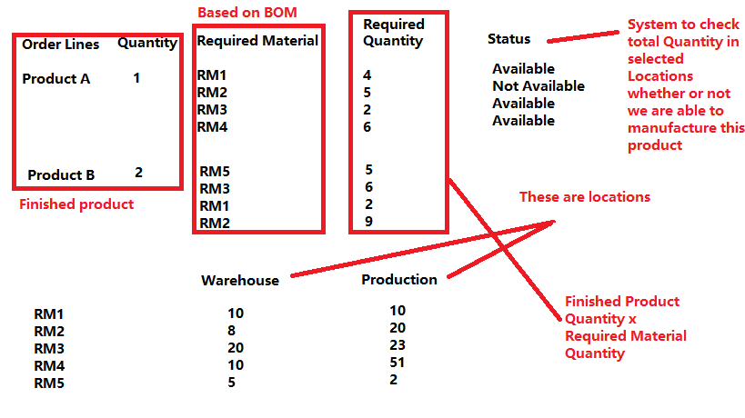

1. System to check on the Bill of Materials of the Product and list down in the Required Materials
2. Required Quantity to be the Quantity needed to produce the Product
   1. Product Quantity x Required Materials Quantity
3. Status will check the total Quantity of selected Locations and match against Required Quantity
   1. Total Quantity > Required Quantity = Available
   2. Total Quantity < Required Quantity = Not Available
4. If all Available, click on confirm and proceed with Sales Order
5. If some are Not Available, click on confirm:
   1. Automatically create PO for the Raw Materials
   2. Supplier to be set in Products
   3. Quotation will confirm to be a Sales Order