**MINI PROJET WEB**

**"PROJECT AND TASK MANAGMENT"**

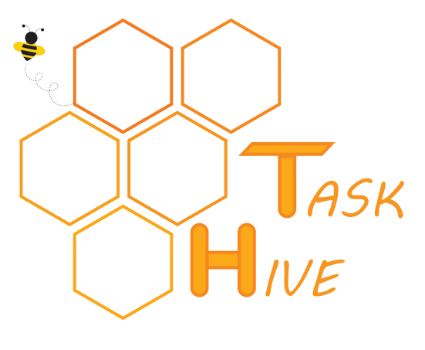



Année Universitaire : 2022-2023

## Introduction:

Effective project and task management is essential for the success of any organization. With the increasing complexity of modern projects, it is becoming increasingly important to have a robust system in place for managing tasks and projects. In this final report, we present a project that focuses on developing a comprehensive task and project management system that allows users to easily add, delete and modify tasks and projects.

The project management system is designed to be user-friendly and flexible, allowing users to customize their tasks and projects according to their specific needs. The system provides a range of features including task assignment, progress tracking and deadline management that help users collaborate effectively.

Throughout the project, we have utilized modern software development methodologies and technologies to ensure that the system is scalable, reliable, and secure. We have also implemented various testing techniques to ensure that the system meets the desired level of quality.

This report provides a comprehensive overview of the project, including the methodology used, the system architecture, the features implemented, and the testing performed. We also discuss the challenges faced during the project and the solutions implemented to overcome them. Finally, we provide recommendations for future improvements to the system.

Overall, this project demonstrates the importance of effective project and task management, and the benefits of using a comprehensive system for managing tasks and projects.

## Functional needs:

Ability to create, modify, and delete tasks and projects.

Task assignment to team members.

Progress tracking and monitoring of tasks and projects.

Ability to set deadlines for tasks and projects.

User authentication and authorization for secure access to the system.

## Non-functional needs:

Performance: the system should respond quickly and efficiently to user requests.

Reliability: the system should be stable and free from errors or downtime.

Security: the system should have measures in place to protect user data and prevent unauthorized access.

Scalability: the system should be able to handle increasing volumes of data and users as the organization grows.

Usability: the system should be intuitive and easy to use, with clear and concise instructions.

Accessibility: the system should be accessible to users with disabilities.

Compatibility: the system should be compatible with a range of devices and browsers.

## Actors:

The actors for this project are individuals or groups of people who interact with the system or have an interest in the outcome of the project. They can be categorized as follows:

Users: These are individuals who use the system to manage their tasks and projects. They interact with the system to create, modify, and delete tasks, track progress, assign tasks to team members, and communicate with other users.

Team members: These are individuals who are assigned tasks by other users and collaborate with other team members to complete tasks and achieve project objectives. They use the system to access task details, update progress, and communicate with other team members.

Administrators: These are individuals responsible for managing the system, configuring user access permissions, and ensuring that the system is secure and functional. They use the system to manage user accounts, configure system settings, and generate reports.

## Diagram of use case:

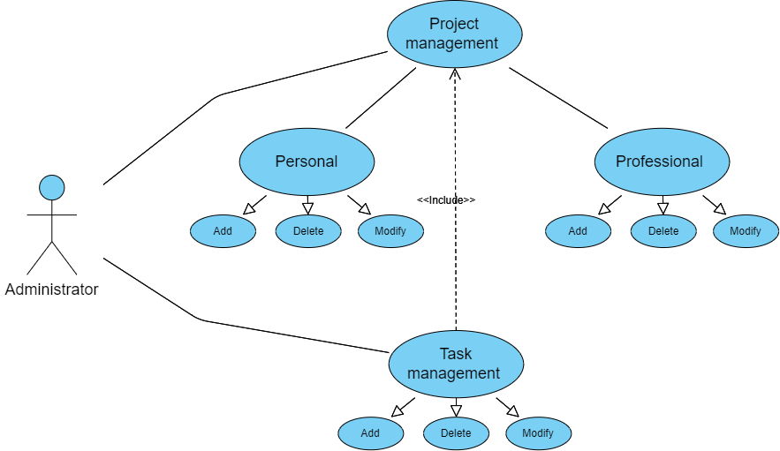

Figure n1: use case diagram

## Sequence diagrams:

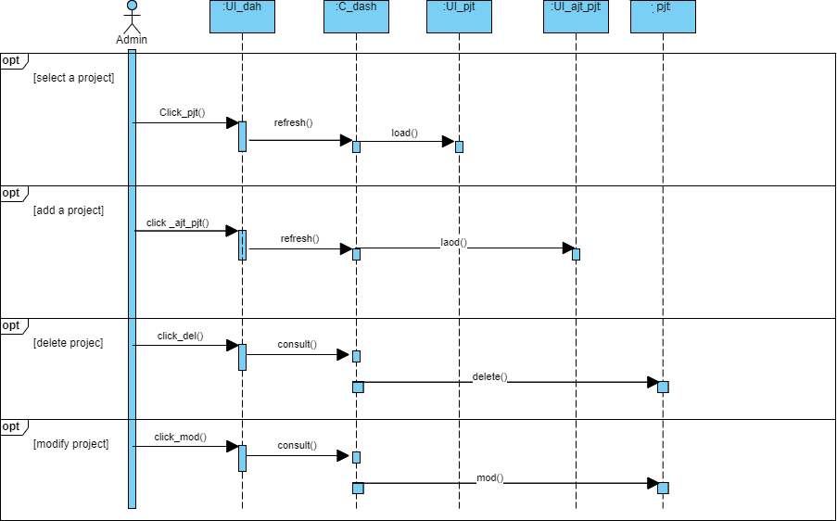

Figure n2: sequence diagram of project management

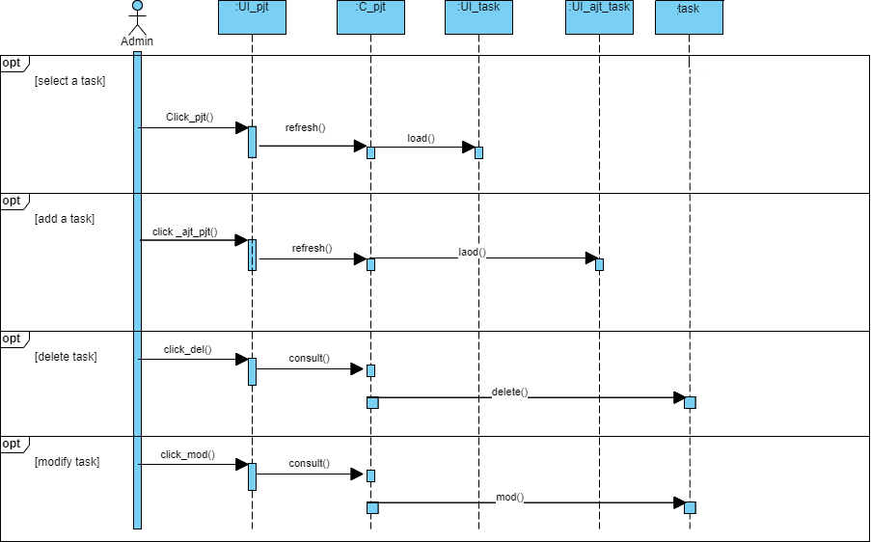

Figure n2: sequence diagram of task management

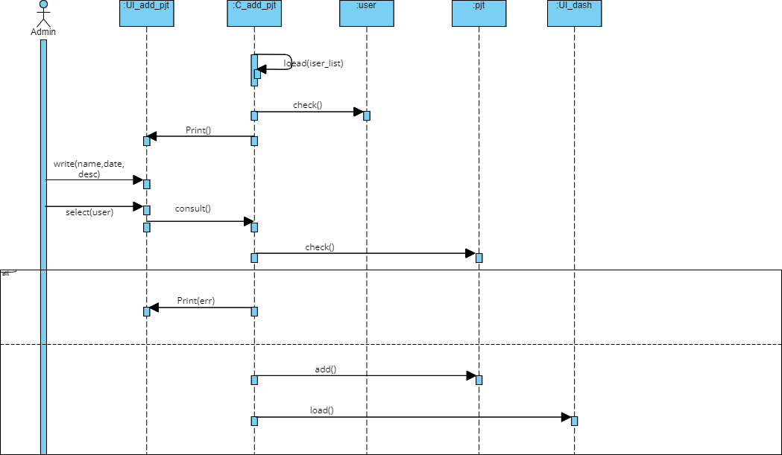

Figure n3: sequence diagram of adding a project

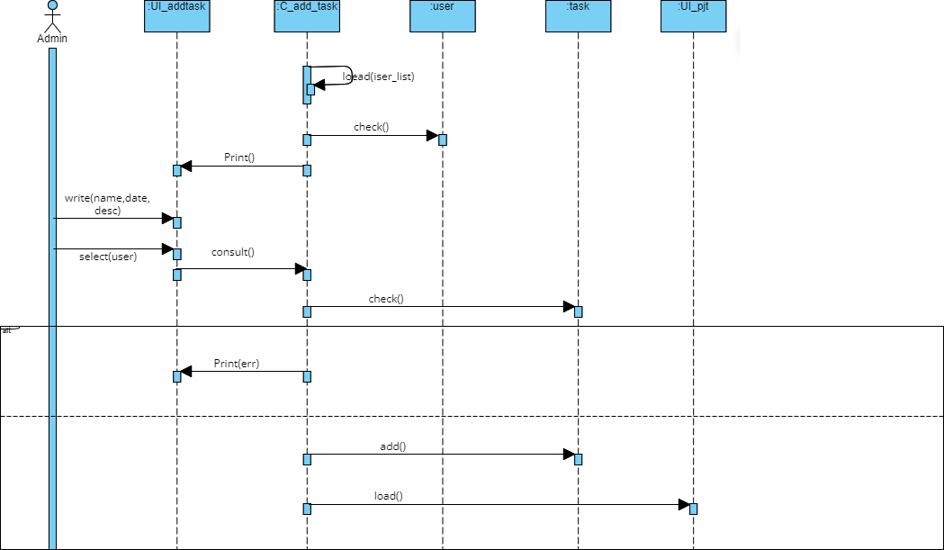

Figure n4: sequence diagram of adding a task

***By***

*Ahmed Hajjem*

*Mohamed Aziz bel haj Yahya*

*Mohamed Amine Jemmali*