<http://www.sac.gov.cn/>

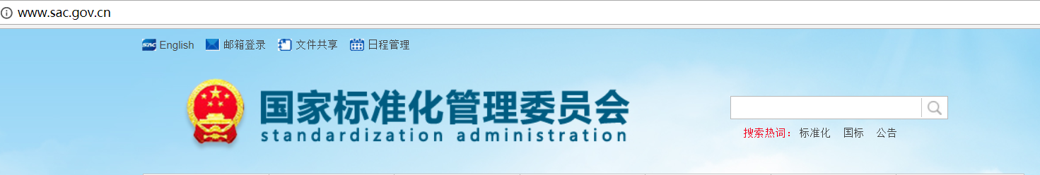

<http://www.gb688.cn/bzgk/gb/newGbInfo?hcno=2790825C43AD0B69E3C38C140BFFCFE6>

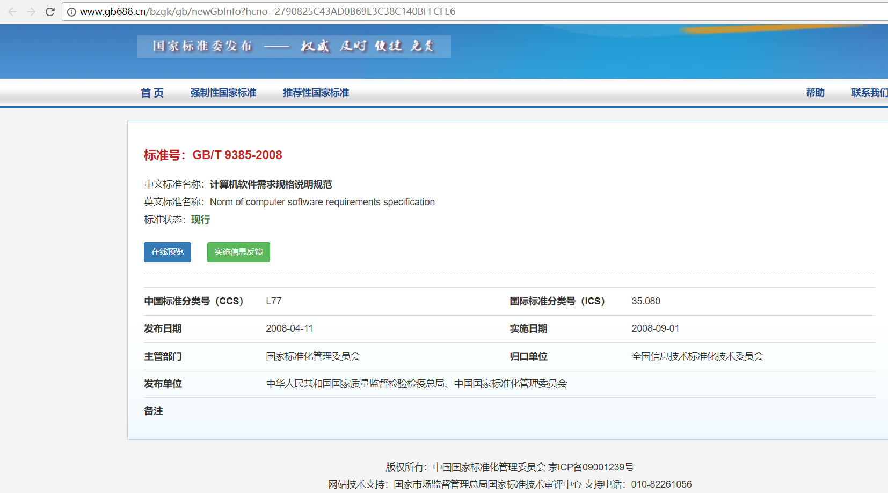

<http://c.gb688.cn/bzgk/gb/showGb?type=online&hcno=2790825C43AD0B69E3C38C140BFFCFE6>

