# Working paper – model-based estimates of COVID-19 burden in King and Snohomish counties through April 7, 2020

Dan Klein1, Brittany Hagedorn1, Cliff Kerr1, Hao Hu2, Trevor Bedford3, Mike Famulare1*

1Institute for Disease Modeling; 2Bill & Melinda Gates Foundation; 3Fred Hutchinson Cancer Research Institute; [*mfamulare@idmod.org](mailto:*mfamulare@idmod.org)

***Results as of March 10, 2020 at 4:00 pm****.*

**Summary**

We describe projections for the burden of infections and deaths in King and Snohomish Counties through April 7, as projections further out are strongly sensitive to assumptions about the scale of the local outbreak and importation dynamics from other regions that are not yet known. For the projections, we considered four scenarios for the increasingly effective impact of social distancing on COVID-19 incidence:

* A baseline scenario assuming no change since January 15.
* Scenarios with 25, 50, and 75 percent reductions in the rate of transmission assumed to take place starting March 10.

The scenarios describe the generalized impacts of social distancing policies but do not currently speak to specific policy recommendations on issues like school closures, event cancellation, and work policies.

We estimate that in the baseline scenario, on average across multiple simulations, there will have been roughly 25,000 people infected by April 7. Assuming mortality statistics will be like those seen in China, we expect that roughly 80 deaths will have occurred by April 7 and that roughly 400 total deaths will have been destined but not yet occurred. Effective social distancing slows the growth rate of the epidemic, and very effective interventions may stop the continued exponential growth. The table below illustrates the reductions in infections and deaths we expect with social distancing interventions.

|  |  |  |
| --- | --- | --- |
| **Social distancing intervention** | **Estimated infections** | **Destined deaths** |
| Business as usual | 25,000 | 400 |
| 25% reduction | 9,700 | 160 |
| 50% reduction | 4,800 | 100 |
| 75% reduction | 1,700 | 30 |

We do not yet know which scenario best represents current conditions in King and Snohomish counties, but previous experience in the region with weather-related social distancing and in other countries suggests to us that current efforts will likely land between baseline and 25% reduction scenarios. While we are not yet confident in our ability to estimate when the volume of new infections will overwhelm the health system, we discuss the issue below and believe it will be a critically important issue to address in the weeks to come. Thus, we believe more comprehensive non-pharmaceutical intervention policies in the region as soon as possible will be necessary to slow the onslaught of the disease, and we hope these are accompanied by policies to mitigate the broader societal impacts on the healthcare workforce and vulnerable populations.

**Introduction**

The novel coronavirus SARS-CoV-2 virus emerged in Wuhan, China, in [late Nov or early Dec 2019](http://virological.org/t/phylodynamic-analysis-of-ncov-2019-genomes-29-jan-2020/353/9). As of 9 March 2020, it is responsible for 109,577 confirmed cases and 3,809 deaths of the disease COVID-19 ([WHO](https://www.who.int/emergencies/diseases/novel-coronavirus-2019/situation-reports)). After initial emergence in China, travel associated cases started to appear in other parts of the world with strong travel connections to Wuhan (<http://rocs.hu-berlin.de/corona/>). The first confirmed case in the US was a travel-associated case in Snohomish County, WA, screened on 19 January 2020. In the 6 weeks following to late February, a [second presumptive case](http://snohd.org/Blog.aspx?IID=13) was identified roughly 10 miles away from where the first case was treated.  As of the afternoon of March 10, [Washington State reports 267 confirmed cases and 24 confirmed deaths associated with COVID-19](https://www.doh.wa.gov/emergencies/coronavirus) with the majority from King and Snohomish counties.

In this working paper, we describe projections for the burden of infections and deaths through April 7 based on modeling results informed by early incidence data and genomic epidemiology as described [publicly by Trevor Bedford](https://twitter.com/trvrb).

**Key inputs and assumptions**

Additional details about the model itself are provided at the end of this document. Here, we describe the key inputs and assumptions that affect our results. *This is science in rapid development and represents our best current understanding which may change within days.*

* Data
  + The estimated doubling time of the local epidemic for the epidemic is 6.2 days. This is based on evidence from multiple countries around the world and is consistent so far with research data from the [Seattle Flu Study](https://twitter.com/trvrb/status/1237395936193605633).
  + All genetic sequences of the SARS-CoV-2 virus from western Washington [belong to one transmission cluster.](https://twitter.com/trvrb/status/1237394739143438338)
* Baseline assumptions
  + There is only one large transmission cluster in the region as of March 10. This ignores the possibility that there are other clusters not yet discovered.
    - The total population assumed in the model is 3 million people—representative of King and Snohomish counties only.
  + For projecting deaths, we assume numbers from other countries that are most informed by data from China. We are working on numbers tailored to the region but they are not available yet.
    - We assume that 1.6% of all infected people will die from the disease ([Ref](https://www.medrxiv.org/content/10.1101/2020.03.04.20031104v1.full.pdf)).
      * This averages over differences in age and comorbidities that may make outcomes in the US different than elsewhere, but evidence to date is consistent with this number being reasonable across multiple countries.
      * This does not account for clustering of deaths within small communities such as in Kirkland Life Care.
    - We also assume the delay from initial infection to death is 3 weeks on average (central estimate among many [referenced here](https://github.com/midas-network/COVID-19/tree/master/parameter_estimates/2019_novel_coronavirus)).
* Projection assumptions
  + We only model the impact of generalized social distancing on total-population transmission. This work does not currently speak directly to specific policies such as school, workplace, or event closures. We are rapidly improving our models to provide useful input on specific policy measures, but those are not available at the time of writing.
  + We ignore the impact of continued importation from other regions and only focus on King and Snohomish counties. State-wide burden may be larger if interventions to reduce transmission are not sufficiently effective.
  + Our health system estimates are based on public data under normal circumstances.
* Alternative evidence
  + As an alternative to the results presented here, you may explore assumptions more thoroughly with [this interactive tool](http://scratch.neherlab.org/) developed by [Richard Neher and collaborators](https://www.biozentrum.unibas.ch/research/researchgroups/overview/unit/neher/).

**Transmission modeling**

The figures below show the results of our model, run forward from the putative initial importation event into Snohomish County on January 15, through May 5. The baseline scenario assumes no change in social distancing behavior for the entire time period, and thus is a worst-case scenario that will likely over-estimate the severity of the epidemic. The 25%, 50%, 75% reduction in transmission scenarios show possible impacts on disease burden of sustained social distancing, where the distancing in the simulation starts on March 10 (a few days after the King County recommendations began). The model shows that any social distancing that results in reduced transmission rates will slow the rate of growth of the epidemic, but only large changes in contact rate can interrupt ongoing transmission. We estimate that in the baseline scenario, on average across multiple simulations, there will have been roughly 25,000 people infected by April 7, but that this declines to roughly 9,700 total infections for a 25% reduction in contact, to 4,800 for a 50% reduction, and only 1,700 for a 75% reduction. Furthermore, by looking at the estimated active infections, only the 75% scenario shows the number of infections getting smaller over time.

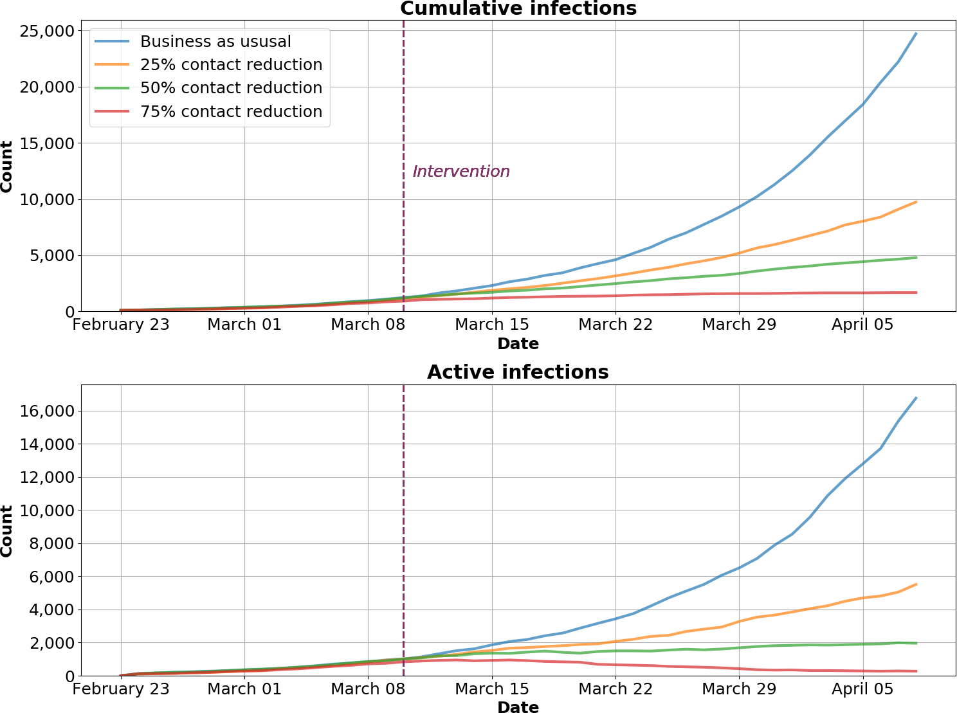

**Figure 1.** Scenarios for the possible cumulative burden of COVID-19 infection in King and Snohomish counties. Based on data from China and other countries, deaths occur in approximately 1 percent of the infected population (averaged across all ages) with an average three week delay relative to infection.

Assuming mortality statistics will be like those seen in China, we expect that roughly 80 deaths will have occurred by April 7 and that roughly 400 additional deaths will occur among people infected at that time. Effective interventions will also reduce mortality, with the 25% reduction scenario showing roughly 160 expected deaths, 50% showing 100 expected deaths, and 75% showing roughly 30* expected deaths. (*Note that the model represents averages and does not account for clustering as seen in Kirkland Life Care that may be important with small numbers of infections.)

*We do not yet know which scenario best represents the current conditions in King and Snohomish counties.* We expect to start seeing evidence in data of the impacts of current social distancing efforts by March 20, but until then, we can make some general comments based on previous experience. In the Seattle metro area in early 2019, the “Snowpocalypse” event caused impromptu school closures and generalized social distancing during the 2018-2019 flu season. The [Seattle Flu Study team analyzed the impacts of this on transmission](https://www.medrxiv.org/content/10.1101/2020.03.02.20027599v1.full.pdf). For diseases with a broad age distribution (not specifically concentrated in kids, with more than 40% of regional hospital cases in adults), the largest impact we saw of combined school closures and snow-related adult social distancing was 52%, and the smallest was only 16% for typical human coronavirus. With information from [Facebook Data for Good](https://dataforgood.fb.com/) on regional mobility showing a stable 50% reduction in weekday incoming traffic from other regions to Seattle and Eastside since March 5th, we think the mixing among workforces has been similarly disrupted, but without school closures that likely have an additional effect on reducing transmission. Thus, we think realistic impacts of recent policy changes will likely be between baseline and the 25% scenario, and we will be working with incoming data to measure this as soon as possible.

**Healthcare system**

The healthcare system must be able to respond rapidly and have adequate capacity to diagnose, treat, and care for patients – both those with COVID-19 and those without. *We are not yet able to provide precise estimates for how soon the Seattle Metro area health system will reach a tipping point*, and how delaying the outbreak would affect hospital operations. Under the baseline scenario, the number of active infections will exceed the number of beds by a large margin in the next two weeks. Assessments of how infections map onto bed demand are still in progress, and we hesitate today to provide specifics until a more complete analysis has finished. The discussion below lays out the most relevant factors we currently understand that affect the ability of the health system to remain effective.

Total staffed hospital bed capacity in Seattle and Snohomish counties is approximately 4,900, of which 940 are critical care beds (ICU). Depending on the rate at which the outbreak progresses, this capacity may quickly be filled (some hospitals normally operate near 100% occupancy and thus would not have much space for additional volumes), leaving patients without access to prompt, high-quality care.

Overcrowding has been well studied and it is known to delay care and increase patient mortality. ([Reference](https://link.springer.com/article/10.1007/s11606-016-3936-3)) This is cause for concern, both for COVID-19 and non-COVID patients. In ICU patients (which severely ill COVID-19 cases are likely to be), a delay of just six hours has been shown to increase mortality rates by 27% ([Reference](https://www.ncbi.nlm.nih.gov/pubmed/17440421)). For stroke and heart attack patients admitted to overwhelmed hospitals during a previous flu outbreak, their mortality rates were 15% and 20% higher than normal, respectively ([Reference](https://www.ncbi.nlm.nih.gov/pubmed/23295577)).

The benefits to the health system from a delayed and flattened outbreak are to reduce overcrowding and delayed care. More importantly, keeping the health system operating below maximum capacity has direct mortality benefits for both acutely ill COVID-19 patients and for others who will continue to need healthcare available to provide non-COVID care.

But, the availability of the healthcare workforce is an important concern, in addition to physical bed capacity, care-related equipment such as ventilators, diagnostics, personal protective equipment, and treatment supplies. There are three categories of reasons that healthcare workers do not show up for work during an emergency situation: they are unable because they are themselves ill, they are unable because of other responsibilities or logistical reasons, or they are unwilling due to perceived risk to themselves and their families. Interventions to address each of these are needed in order to mitigate the likelihood of staff absenteeism during the outbreak.

The need to provide both childcare and elder care at home is a key driver of healthcare worker ability and willingness to attend work in a catastrophic pandemic situation. Being a caregiver has been reported as a barrier for 21-53% of workers ([Reference](https://www.ncbi.nlm.nih.gov/pubmed/19952885), [Reference](https://www.ncbi.nlm.nih.gov/pubmed/19877816), [Reference](https://www.researchgate.net/publication/23233311_Likely_impact_of_school_and_childcare_closures_on_public_health_workforce_during_an_influenza_pandemic_A_survey), [Reference](https://www.ncbi.nlm.nih.gov/pmc/articles/PMC3456052/)). In some studies, cancellation of school and closure of childcare was a contributing factor. In Seattle, a 30% absenteeism rate of likely caregivers would translate to approximately 3,500 nurses.

As far as actual illness in healthcare workers, studies from the US, Canada, and Japan during previous flu epidemics have reported absenteeism due to respiratory illness in up to 8.5% of workers, resulting in more than two weeks of absence from work ([Reference](https://www.ncbi.nlm.nih.gov/pmc/articles/PMC6427598/)). Considering the need for self-quarantine for COVID-19, we would expect the impact here to be much higher. In the longer term, several studies indicated that if treatments are prioritized for healthcare workers, they may be more able and willing to return to work ([Reference](https://www.ncbi.nlm.nih.gov/pubmed/19952885)).

Thus, while we think that more comprehensive social distancing policies are needed as soon as possible to reduce the escalation of the outbreak, there also need to be strategies to mitigate the risks to the healthcare system caused by issues that affect the hospital workforce.

**Conclusions to date**

Social distancing measures are critical to slowing the progression of the COVID-19 epidemic ([Reference](https://www.pnas.org/content/104/18/7582)). There remains a great deal of uncertainty about the scale of the epidemic and the effect of current social distancing policies. But, given past experience with weather-related social distancing in the Seattle metro region, we do not expect current policies will be sufficient to prevent severe overburden on the health care system. For COVID around the world, societies that have reduced established community transmission to what appear to be manageable levels, like South Korea, Hong Kong, Singapore, and now China, have implemented more restrictive social distancing policies and extensive testing for case confirmation, isolation, and containment than have occurred anywhere in the US. Health system impacts come from both the demands of the sick and the needs of the caregivers, and so we appreciate the need to mitigate the societal impacts of widespread social distancing. But we think the most acute need is to prevent the overwhelming accumulation of disease, and so we hope to see more comprehensive non-pharmaceutical intervention policies implemented as soon as possible.

**Detailed transmission model methods**

To model plausible ranges for the cumulative incidence and current prevalence following the introduction of SARS-CoV-2 into Snohomish County, WA, from the presumptive index case described in the New England Journal of Medicine ([Reference](http://dx.doi.org/10.1056/NEJMoa2001191)), we used a stochastic susceptible-exposed-infectious-recovered (SEIR) model with the following assumptions. The exposed (latent) period prior to the onset of viral shedding is normally distributed with a mean of 4 days and standard deviation of 1 day; this is one day shorter than the 5-day consensus estimate of the incubation period prior to symptom onset ([MIDAS-network](https://github.com/midas-network/COVID-19/tree/master/parameter_estimates/2019_novel_coronavirus)) to acknowledge reports of pre-symptomatic shedding. The infectious period is normally distributed with mean 8 days and standard deviation 3 days, based on measured upper-respiratory viral shedding after symptom onset ([Reference](https://www.nejm.org/doi/full/10.1056/NEJMc2001737)). We drew transmission events from a truncated normal distribution to approximately reproduce the negative binomial transmission dynamics with transmission heterogeneity parameter *k*=0.54 from ref. ([Reference](https://www.biorxiv.org/content/10.1101/2020.01.23.917351v1)).  We chose a truncated normal to reproduce the general overdispersion associated with SARS-CoV-2 transmission but with reduced probability of very large events involving more than twenty transmissions from a single person.  For the initial conditions, we assumed that the introduction into Snohomish County began on 15 January 2020, coincident with the return of the presumptive index case to western Washington from Wuhan, China and with his symptom onset ([Reference](http://dx.doi.org/10.1056/NEJMoa2001191)). To model the expected number of deaths associated with this transmission cluster to date, we assume that death occurs on average [21 days after infection](https://github.com/midas-network/COVID-19/tree/master/parameter_estimates/2019_novel_coronavirus) and that [roughly 1.6% of all infections will die](https://www.medrxiv.org/content/10.1101/2020.03.04.20031104v1.full.pdf) with only current treatment options available.