MODULE-1
- Explain the characteristics and applications of loT.
Internet of Things (IoT) is a system in which physical and virtual “things” have unique identities and are connected to the Internet. These things can collect, communicate, process, and exchange data.

Characteristics of IoT
- Dynamic and Self-Adapting
  - IoT devices can adapt to changing conditions.
  - They can take actions according to their operating environment.
  - Example: A surveillance camera changes its mode between day and night.
- Self-Configuring
  - IoT devices can configure themselves automatically.
  - A large number of devices can work together to provide a function.
- Interoperable Communication
  - IoT devices can support different communication protocols.
  - They can communicate with other devices and systems.
- Unique Identity
  - Every IoT device has a unique identity or identifier.
  - Examples include an IP address and URI.
- Integrated into an Information Network
  - IoT devices are connected to an information network.
  - They can communicate and exchange data with other devices and systems.

Applications of IoT
- Weather Monitoring
  - Sensors collect temperature, humidity and other environmental data.
  - The collected data is analyzed to understand weather conditions.
- Indoor Air Quality Monitoring
  - IoT sensors monitor indoor air quality and the concentration of different gases.
- Smart Irrigation
  - Sensors monitor soil moisture.
  - When the moisture level falls below a threshold, the irrigation system can be switched on automatically.
- Surveillance Systems
  - IoT devices and sensors can collect surveillance data such as motion detection data.
- Smart Grid
  - IoT-based wireless sensors can monitor different points in an electrical grid.
- Structural Health Monitoring
  - Sensors monitor structures by collecting vibration data from different points.
- Home Automation
  - IoT can be used to remotely control lights and home appliances.
- Package Tracking
  - IoT sensors can monitor vibration levels of packages during transportation.
  - An alert can be generated when vibration exceeds a specified limit.
- Noise Monitoring
  - Multiple IoT nodes can be placed in different locations to monitor noise levels in an area.
- Forest Fire Detection
  - Multiple sensors can monitor temperature, humidity and carbon dioxide levels in a forest.
  - The collected data is analyzed in the cloud to make predictions.
D-S-I-U-I → Dynamic, Self-configuring, Interoperable, Unique identity

2. List and Explain the Various IoT Enabling Technologies

1. Wireless Sensor Networks (WSN)
- These sensors are used to monitor physical and environmental conditions.
- The collected data is sent to a coordinator, which can act as a gateway to the Internet.
- Examples: Weather monitoring, soil moisture monitoring, surveillance and smart grid.

2. Cloud Computing
- Cloud computing provides computing, storage and networking resources through the Internet.
- Resources can be obtained when needed using a pay-as-you-go model.
- It helps IoT systems store and process large amounts of data.
- Cloud services include IaaS, PaaS and SaaS.

3. Big Data Analytics
- IoT devices generate a large amount of data.
- Big Data Analytics is used to clean, process, analyze and visualize this data.
- It helps extract useful information from IoT data.
- Examples include sensor data, machine data, health data, vehicle location data and retail inventory data.

4. Communication Protocols
- Communication protocols form the backbone of IoT systems.
- They allow IoT devices to exchange data over a network.
- They define data formats, encoding, packet routing, flow control and transmission of lost packets.

5. Embedded Systems
- An embedded system is a computer system designed to perform a specific task.
- It contains components such as a microprocessor or microcontroller, memory, networking units and input/output devices.
- Embedded systems are commonly used inside IoT devices.
IoT Enabling Technologies = W C B C E
3. What is IoT? Explain the generic block diagram of an loT device.

Generic Block Diagram of an IoT Device
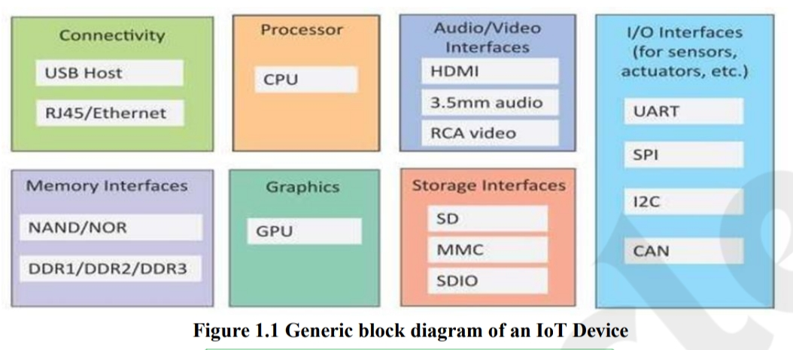
1. Processor (CPU) : It is the main processing unit of the IoT device.
- It processes the data received from sensors and controls other components.
2. Connectivity : It provides network connectivity to the IoT device.
- Examples given in the diagram include USB Host and RJ45/Ethernet.
3. I/O Interfaces : These interfaces connect sensors and actuators to the device.
- Examples include UART, SPI, I2C and CAN.
4. Memory Interfaces : They provide access to memory used for storing data and programs.
- Examples include NAND/NOR, DDR1/DDR2/DDR3.
5. Storage Interfaces: hey provide additional storage for the IoT device.
- Examples include SD, MMC and SDIO.
6. Audio/Video Interfaces : These interfaces allow the device to handle audio and video data.
- Examples include HDMI, 3.5 mm audio and RCA video.
- Graphics (GPU) : It handles graphics-related processing and display operations.

4. Describe the components of an loT system and explain the loT level-1 system with a diagram.
Components of an IoT System :

1. Device
- An IoT device provides identification, remote sensing, actuation, and monitoring capabilities.
- It collects data using sensors and can perform actions using actuators.

2. Resources
- Resources are software components present on the device.
- They are used for accessing and storing information and controlling actuators.
- They also help the device access the network.

3. Controller Service
- It is a service that runs on the IoT device.
- It interacts with web services.
- It sends data from the device to the web service and receives commands from the application to control the device.

4. Database
- The database stores the data generated by the IoT device.
- It can be located locally or in the cloud.

5. Web Service
- It acts as a link between the device, application, database, and analysis components.
- It can be implemented using HTTP and REST principles or WebSocket protocols.

6. Analysis Component
- It analyzes IoT data and produces results that are easy for users to understand.
- Analysis can be performed locally or in the cloud.
- The results are stored in a local or cloud database.

7. Application
- It provides an interface for users to control and monitor the IoT system.
- Users can view the system status and processed data.

Diag

Example: Home Automation
- A single IoT node is used to control lights and home appliances remotely.
- The device is connected to lights and appliances using electronic relay switches.
- The status of each light or appliance is stored in a local database.
- The REST service retrieves and updates the status.
- The controller service continuously monitors the status and controls the relay switches.
- A local application provides a user interface to control the lights and appliances.
- Since the device is connected to the Internet, the application can also be accessed remotely.

5. Summarize the IoT Protocols.
IoT protocols are communication rules that allow IoT devices to exchange data over a network. They are divided into four main layers.

1. Link Layer Protocols
Link layer protocols define how data is transmitted over a physical medium, such as a cable or radio waves.
Protocol | Explanation
IEEE 802.3 (Ethernet) | Provides wired network communication using cables.
IEEE 802.11 (Wi-Fi) | Provides wireless local area network communication.
IEEE 802.16 (WiMAX) | Provides wireless broadband communication.
IEEE 802.15.4 (LR-WPAN) | Provides low-cost, low-power communication for devices with limited power.
2G/3G/4G | Provides mobile communication and Internet connectivity.
Example: A smart device uses Wi-Fi to connect to the Internet.

2. Network / Internet Layer Protocols
These protocols are responsible for addressing and routing data packets from the source device to the destination device.
Protocol | Explanation
IPv4 | Uses 32-bit addresses to identify devices on a network.
IPv6 | Uses 128-bit addresses and provides a much larger address space.
6LoWPAN | Enables IPv6 communication on low-power wireless personal area networks.
Example: IPv6 helps identify and communicate with IoT devices on the Internet.

3. Transport Layer Protocols
Transport layer protocols provide end-to-end communication between devices. They support functions such as error control, flow control and congestion control.
Protocol | Explanation
TCP | Connection-oriented protocol that provides reliable and ordered data delivery.
UDP | Connectionless protocol suitable for time-sensitive applications where low communication overhead is important. It does not guarantee delivery.
Example: TCP is used when reliable data delivery is required, while UDP can be used for time-sensitive data transmission.

4. Application Layer Protocols
Application layer protocols define how applications exchange data over a network.
Protocol | Explanation
HTTP | Uses a request-response model for communication between clients and servers.
CoAP | A lightweight protocol designed for machine-to-machine communication in constrained environments.
WebSocket | Supports full-duplex communication between a client and a server over a persistent connection.
MQTT | Uses a lightweight publish-subscribe model and is suitable for constrained IoT environments.
XMPP | Supports real-time communication and the exchange of XML data.
DDS | Uses a data-centric publish-subscribe model and supports quality-of-service controls.
AMQP | Supports business messaging, queuing, routing and publish-subscribe communication.
Example: MQTT allows IoT sensors to publish data to a topic, and subscribed devices can receive that data.

Application Layer : HTTP, CoAP, MQTT, WebSocket, XMPP, DDS, AMQP

Transport Layer : TCP, UDP

Network / Internet Layer : IPv4, IPv6, 6LoWPAN

Link Layer : Ethernet, Wi-Fi, WiMAX, LR-WPAN, 2G/3G/4G

6. Describe the functional blocks of an IoT system and communication model

Functional Blocks of an IoT System
The following are the main functional blocks of an IoT system.

1. Devices
- Devices perform sensing, actuation, monitoring, and control functions.
- Sensors collect data from the environment.
- Actuators perform actions based on commands.
Example: A temperature sensor measures room temperature.

2. Communication
- The communication block handles communication between IoT devices and other systems.
- It enables the exchange of data over a network.
Example: A smart sensor sends data to a server through Wi-Fi.

3. Services
- IoT systems provide different services to users and devices.
- These include:
  - Device monitoring services.
  - Device control services.
  - Data publishing services.
  - Device discovery services.

4. Management
- The management block provides functions to manage and govern the IoT system.

5. Security
- The security block protects the IoT system and its data.
- It provides functions such as:
  - Application authorization.
  - Message and content integrity.
  - Data security.

6. Application
- The application provides an interface for users to control and monitor the IoT system.
- Users can view the system status and analyze processed data.
Example: A mobile application used to control smart home lights.

IoT Communication Models

1. Request-Response Model
- In this model, the client sends a request to the server.
- The server processes the request and sends a response.
- Each request-response pair is independent of the others.
- It is a stateless communication model.
Example: A mobile application requests the current temperature from an IoT server.

Request-Response
Client(Mobile app or IoT device) > Request > Server(Processes the request ) > Response > Client receives data

2. Publish-Subscribe Model
- This model consists of publishers, brokers, and consumers.
- Publishers send data to a topic managed by a broker.
- Consumers subscribe to topics of interest.
- The broker forwards the published data to all subscribed consumers.
- Publishers do not need to know who the consumers are.
Example: A temperature sensor publishes temperature data, and several applications receive it by subscribing to the topic.

Publish-Subscribe
Publisher (Temperature sensor ) > Publishes data > Broker(Manages topics) > Forwards messages > Subscribers(Mobile app • Dashboard • Other devices)

3. Push-Pull Model
- In this model, data producers push data into queues.
- Consumers pull data from the queues.
- Producers do not need to know the consumers.
- Queues act as buffers when the producer and consumer work at different speeds.
- This model separates the producer from the consumer.
Example: Sensors push data into a queue, and a data analysis service pulls the data when it is ready.

Push-Pull
Producer(IoT sensor) > Pushes data > Queue(Stores data temporarily) > Pulls data >
Consumer(Analysis service)

4. Exclusive Pair Model
- This is a bidirectional, full-duplex communication model.
- It uses a persistent connection between the client and the server.
- The connection remains open until one side closes it.
- Both the client and server can send messages to each other.
- It is a stateful communication model because the server maintains information about open connections.
Example: A WebSocket connection allows a live IoT dashboard and a server to exchange updates continuously.

7. Discuss a Level - 6 IoT systems for weather monitoring with diagram.

IoT Level 6 System for Weather Monitoring

Definition
An IoT Level 6 system consists of multiple independent nodes that perform sensing and/or actuation and send data to the cloud.
- Data is stored in a cloud database.
- Data analysis is performed in the cloud.
- The application is cloud-based.
- A centralized controller can monitor the status of all nodes and send control commands to them.

Weather Monitoring Example
In a Level 6 weather monitoring system:
- Multiple sensor nodes are placed in different locations.
- Each node measures:
  - Temperature
  - Humidity
  - Atmospheric pressure
- The sensor nodes send data to the cloud in real time using a WebSocket service.
- The data is stored in a cloud database.
- The cloud analyzes the collected data to:
  - Combine data from different locations.
  - Identify weather patterns.
  - Make weather predictions.
- A cloud-based application displays the collected and analyzed data to users.

Diagram of IoT Level 6 Weather Monitoring System

Main Components
Component | Function
Independent sensor nodes | Collect temperature, humidity, and pressure data
WebSocket service | Sends sensor data to the cloud in real time
Cloud database | Stores the collected weather data
Cloud analytics | Aggregates data and makes weather predictions
Centralized controller | Monitors the status of all nodes and sends control commands
Cloud-based application | Displays weather data, graphs, and predictions

MODULE-2
1. Describe the M2M system architecture and M2M gateway with block diagrams.
Or
1. Outline the End-to-End Architecture for M2M systems with diagram.

M2M System Architecture
M2M (Machine-to-Machine) means connecting machines or devices so that they can exchange data and control each other without human involvement.
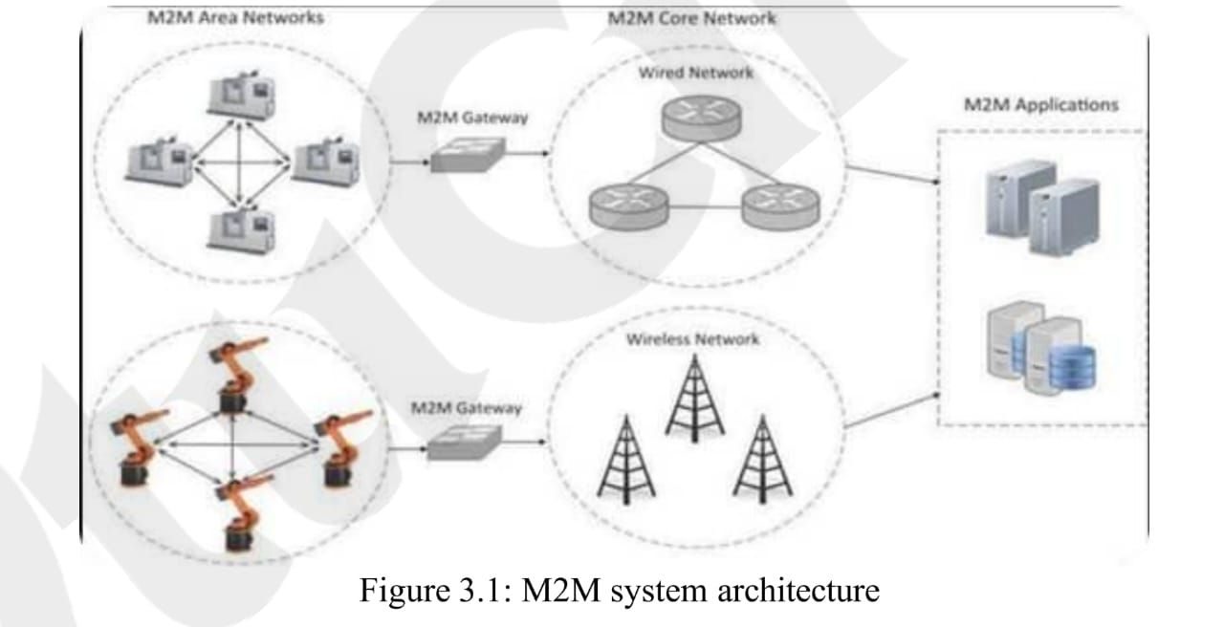

Main parts
1. M2M Area Network
- It contains local machines or M2M nodes.
- The nodes contain sensors, actuators and communication modules.
- They communicate using short-range protocols.
- Examples are ZigBee, Bluetooth and Modbus.
2. M2M Gateway
- It connects the local M2M area network to the external network.
- It acts as a bridge or translator between non-IP devices and IP networks.
3. M2M Core/Communication Network
- It connects different M2M area networks.
- It uses IP-based communication, such as the Internet.
4. M2M Application
- It receives and uses the M2M data.
- It supports applications such as remote monitoring, service management and business tools.

M2M Gateway
An M2M gateway is a device that connects M2M nodes using local/non-IP protocols to an IP-based external network.
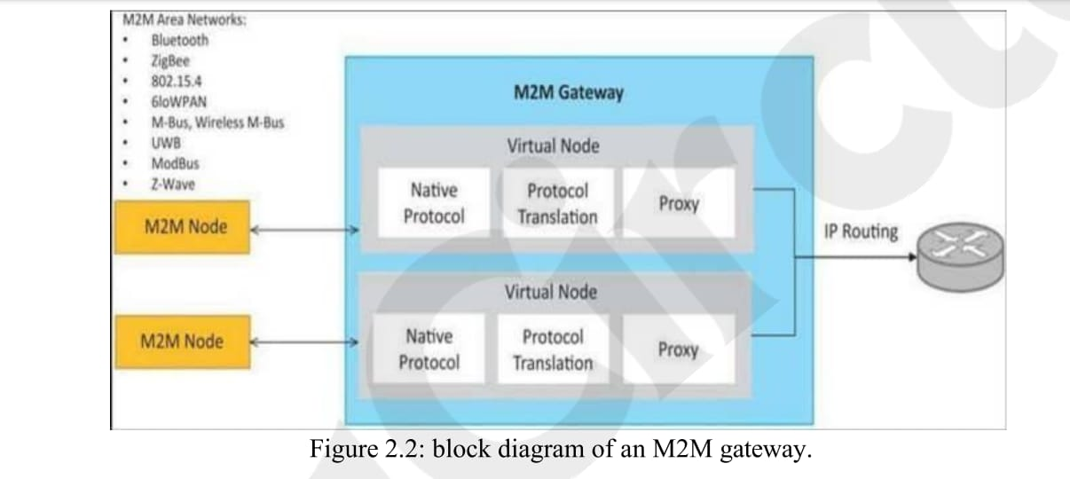

Functions of M2M Gateway
- Connects M2M nodes to the external communication network.
- Receives data from local M2M devices.
- Uses the native protocol used by the local device.
- Performs protocol translation.
- Converts local/non-IP communication into IP-based communication.
- Uses a proxy to represent local devices to the external network.
- Provides IP routing to send data to other networks.
- Allows devices in different locations to communicate with each other.
- Makes local devices appear as if they are directly connected to the external network.

Easy way to remember
M2M Architecture: M2M Nodes → Gateway → Core Network → Application
M2M Gateway: Local/Non-IP Protocol → Protocol Translation → IP Network

2. Explain the need for loT system management.
Or
2. What is the need for IoT System Management?

Need for IoT System Management
IoT systems contain many devices and nodes, so they need proper management for efficient and reliable operation. The main needs are:

1. Automating Configuration
- It automatically sets up and configures IoT devices.
- It reduces manual work and errors.
- It is useful when a large number of devices are involved.

2. Monitoring Operational and Statistical Data
- It collects device information such as CPU usage and memory usage.
- It helps to monitor the health and performance of the system.
- It helps in finding faults.

3. Improving Reliability
- It checks configurations before applying them.
- It prevents problems caused by incorrect or untested settings.
- This improves system stability.

4. System-Wide Configuration
- It allows configuration changes to be applied to all devices at once.
- It prevents differences or mismatches between devices.
- It can use an “all or nothing” approach for reliable operation.

5. Multiple System Configurations
- Different configurations may be required at different times or under different conditions.
- IoT management provides flexibility to use these different configurations.

6. Retrieving and Reusing Configurations
- Existing configurations can be retrieved and reused.
- This provides a consistent setup for similar devices.
- It is especially useful when adding new devices.

Easy to remember
Configure → Monitor → Reliable → System-wide → Multiple configurations → Reuse

3. Discuss the differences between M2M and IoT systems.
M2M | IoT
1. M2M mainly uses proprietary or non-IP protocols within local networks. | IoT mainly uses IP-based protocols.
2. Common protocols include ZigBee, Bluetooth, Modbus, M-Bus, PLC, 6LoWPAN, IEEE 802.15.4 and Z-Wave. | Common protocols include HTTP, CoAP, WebSockets, MQTT, XMPP, DDS and AMQP.
3. M2M focuses mainly on protocols below the network layer. | IoT focuses mainly on protocols above the network layer.
4. M2M generally has homogeneous devices (similar types of devices) in one network. | IoT contains heterogeneous devices (different types of devices).
5. M2M focuses more on hardware and embedded modules. | IoT focuses more on software, data collection, analysis and cloud communication.
6. M2M data is generally stored locally/on-premises. | IoT data is generally stored in the cloud.
7. M2M supports applications such as diagnosis, service management and enterprise solutions. | IoT supports analytics, enterprise applications, remote monitoring and management.
8. M2M is mainly concerned with communication between machines. | IoT connects different kinds of physical things/devices with unique identifiers.
9. M2M applications are commonly on-premises. | IoT applications are commonly cloud-based.
10. M2M generally has a more hardware-oriented approach. | IoT has a more software, cloud and data-oriented approach.

Easy way to remember
M2M → Hardware + Local + Non-IP + Machines
IoT → Software + Cloud + IP + Things

4. Describe the loT system management with NETCONF-YANG with a diagram.

IoT System Management with NETCONF-YANG
NETCONF-YANG is used to manage IoT devices by configuring devices, retrieving state information, and performing management operations. In this approach, YANG defines the data model, while NETCONF is used to exchange and manage the data.
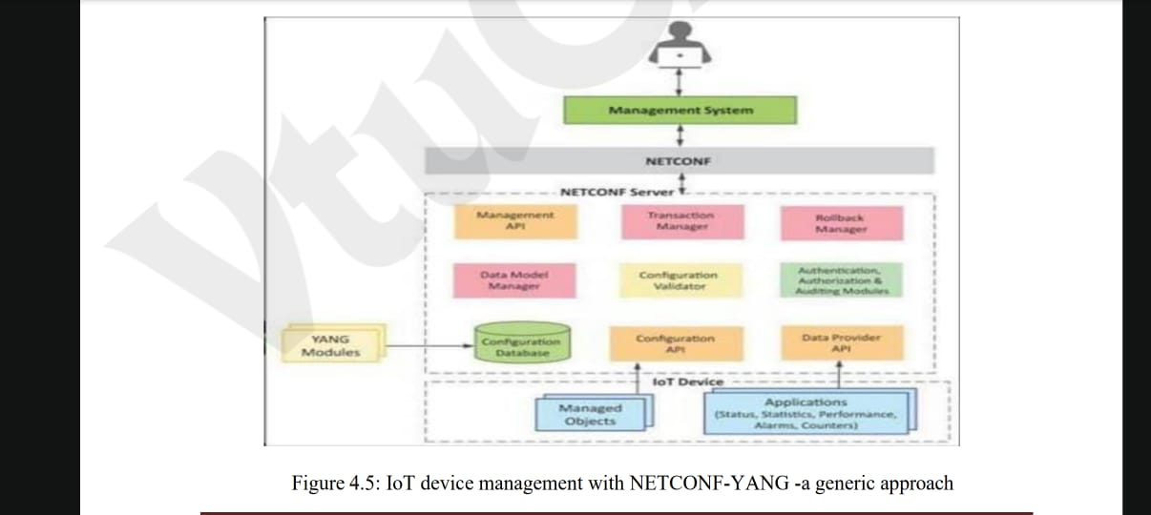

Components and Their Functions

1. Management System
- It is used by the operator to manage IoT devices.
- It sends NETCONF messages to configure devices.
- It receives notifications and current state information from devices.

2. Management API
- It allows applications to perform NETCONF operations.
- It can start NETCONF sessions.
- It can read/write configuration data and read state data.
- It can also invoke RPCs.

3. Transaction Manager
- It executes NETCONF transactions.
- It follows ACID properties:
  - Atomicity – transaction is completed fully or not at all.
  - Consistency – device moves between valid configurations.
  - Isolation – simultaneous transactions do not cause conflicts.
  - Durability – committed changes remain after failures.

4. Rollback Manager
- It returns the device to its previous configuration.
- It is used when a configuration error occurs.

5. Data Model Manager
- It maintains the YANG data models used for device configuration.
- It keeps track of which applications provide data for each YANG model.

6. Configuration Validator
- It checks whether a new configuration is valid.
- It prevents incorrect configurations from being applied or saved.

7. Configuration Database
- It stores configuration data and operational/state data.
- It acts as the central storage for device-related data.

8. Configuration API
- It allows IoT applications to read configuration data.
- It also allows applications to write operational data.

9. Data Provider API
- IoT applications can register callbacks for different events.
- It allows applications to report statistics and operational data.

5. What is NFV (Network Function Virtualization)? How NFV can be used to Virtualized the Home Gateway

1. What is NFV?
Network Function Virtualization (NFV) is a technology that converts traditional hardware-based network functions into software-based functions.
Instead of using separate hardware devices for each network function, NFV runs these functions on general-purpose servers using virtualization.

Examples of network functions
- Router
- Firewall
- Network Address Translation (NAT)
- Intrusion Detection System (IDS)
- Load balancer

2. How NFV Virtualizes the Home Gateway
A home gateway connects home devices to the Internet. Traditionally, it performs many functions using dedicated hardware.
Using NFV, these functions can be converted into software and run on a single virtualized platform.

3. Working of NFV in a Home Gateway
- Identify functions: Functions such as routing, firewall, NAT, and DHCP are identified.
- Convert into software: These functions are implemented as software called Virtual Network Functions (VNFs).
- Run on virtual machines: VNFs run on a common physical server using virtualization technology.
- Process network traffic: Home devices send data through the virtual functions.
- Manage centrally: The service provider can update, configure, start, or stop these functions remotely.

4. Advantages
- Reduced hardware cost: One device can perform many network functions.
- Easy management: Functions can be controlled remotely.
- Flexible configuration: New functions can be added through software.
- Easy upgrades: Software can be updated without replacing hardware.
- Better resource utilization: Several functions share the same physical resources.

MODULE-3
1. Explain the steps involved in IoT system design methodology with a diagram

IoT System Design Methodology

According to the given PDF, IoT system design methodology consists of 10 steps. It provides a general method for designing an IoT system without depending on a particular product, service, or programming language.
IoT System Design Methodology
1. Purpose & Requirements Specification
2. Process Specification
3. Domain Model Specification
4. Information Model Specification
5. Service Specifications
6. IoT Level Specification
7. Functional View Specification
8. Operational View Specification
9. Device & Component Integration
10. Application Development

1. Purpose & Requirements Specification
- Define the purpose and requirements of the IoT system.
- Identify system behavior and requirements.
- Requirements may include:
  - Data collection
  - Data analysis
  - System management
  - Security and privacy
  - User interface
- Example: A smart home system should remotely control lights.

2. Process Specification
- Define the processes and use cases of the IoT system.
- It describes how the system should work under different conditions.
- Example: In a smart home, the light can work in auto mode or manual mode.

3. Domain Model Specification
- Identify the main entities, objects, and concepts in the IoT system.
- Define their attributes and relationships.
- The main elements include:
  - Physical Entity
  - Virtual Entity
  - Device
  - Resource
  - Service

4. Information Model Specification
- Define the structure of information used in the IoT system.
- Identify the attributes and relationships of virtual entities.
- Example:
  - Room → Light level
  - Light appliance → Light state

5. Service Specifications
- Define the services provided by the IoT system.
- Specify service inputs, outputs, endpoints, schedules, and effects.
- Example services are:
  - Mode service
  - State service
  - Controller service

6. IoT Level Specification
- Select the appropriate IoT deployment level for the system.
- The PDF mentions five IoT deployment levels.
- The smart home automation example is designed as Level 1.

7. Functional View Specification
- Define the functions of the IoT system and group them into Functional Groups (FGs).
- Main functional groups are:
  - Device
  - Communication
  - Services
  - Management
  - Security
  - Application

8. Operational View Specification
- Define how the IoT system will be deployed and operated.
- Decide:
  - Devices
  - Communication protocols
  - Services
  - Application hosting
  - Storage
  - Security
  - Management
- Example devices include Raspberry Pi, LDR sensor, and relay switch.

9. Device & Component Integration
- Integrate all the devices and components of the IoT system.
- Example:
  - Raspberry Pi
  - LDR sensor
  - Relay switch actuator

10. Application Development
- Develop the final IoT application.
- The application allows users to monitor and control the IoT system.
- In the smart home example, the web application allows users to control the mode and light.

Easy way to remember
Purpose → Process → Domain → Information → Service → Level → Functional → Operational → Integration → Application

2. With a neat diagram Explain process specification, information model, controller service & deployment design for home automation IoT

Home Automation IoT System
The home automation example in the PDF is used to explain the IoT design methodology. It allows the user to control a light remotely using a web application. The system works in automatic and manual modes.

3. Explain the following python data types with examples:
i) Numbers, ii) Strings, iii) Lists, iv) Tuples, v) Dictionaries

Python Data Types with Examples
Python has different data types to store different kinds of values. The five important data types are Numbers, Strings, Lists, Tuples, and Dictionaries.

i) Numbers
- Numbers are used to store numeric values.
- Python supports three main numeric types:
  - int – stores whole numbers.
  - float – stores decimal numbers.
  - complex – stores complex numbers.
Example:
a = 10 # Integerb = 10.5 # Floatc = 2 + 3j # Complexprint(a)print(b)print(c)

ii) Strings
- A string is a sequence of characters.
- Strings are enclosed in single quotes (' ') or double quotes (" ").
- Strings are immutable, which means their characters cannot be changed directly.
Example:
name = "Python"print(name)print(name[0])print(name[1:4])

iii) Lists
- A list is used to store multiple items in a single variable.
- Lists are written using square brackets [ ].
- Lists are ordered and mutable, which means their elements can be changed.
- Lists allow duplicate values.
Example:
fruits = ["apple", "banana", "mango"]print(fruits)fruits.append("orange")fruits[0] = "grapes"print(fruits)

iv) Tuples
- A tuple is used to store multiple items in a single variable.
- Tuples are written using parentheses ( ).
- Tuples are ordered and immutable, which means their elements cannot be changed after creation.
- Tuples allow duplicate values.
Example:
numbers = (10, 20, 30, 20)print(numbers)print(numbers[0])

v) Dictionaries
- A dictionary stores data in key-value pairs.
- Dictionaries are written using curly braces { }.
- Each key is unique, and values can be accessed using their keys.
- Dictionaries are mutable, so their contents can be added or modified.
Example:
student = { "name": "Ravi", "age": 21, "branch": "CSE"}print(student["name"])print(student["age"])student["age"] = 22print(student)

vi) Sets in Python
- A set is a collection of unique elements.
- Sets are written using curly braces { }.
- Sets do not allow duplicate values.
- Sets are unordered, so their elements do not have a fixed position.
- Sets are mutable, which means elements can be added or removed.
- Sets are useful for removing duplicate values and performing mathematical set operations.
Example :
# Creating a set
numbers = {10, 20, 30, 20, 40}
print(numbers)
# Adding an element
numbers.add(50)
print(numbers)
# Removing an element
numbers.remove(10)
print(numbers)

Also write output for all

4. Explain the IoT system for weather monitoring

An IoT-based weather monitoring system collects environmental data such as temperature, pressure, humidity, and light using multiple end nodes. These nodes send the collected data to the cloud, where it is stored, combined, and analysed.

Working of the system
- Data collection: Sensors measure temperature, pressure, humidity, and light in the environment.
- Data processing: The Raspberry Pi or other single-board computer reads the sensor values.
- Data transmission: The controller sends the collected measurements to the cloud using a REST service.
- Data storage: The measurements are stored in a cloud database.
- Data analysis: The cloud analyses and combines the data from multiple locations to make predictions.
- Data visualization: A cloud-based application displays the weather information to users.
- Remote control: A centralized controller can send commands to the end nodes, such as changing the monitoring interval.

3. Main components
- Sensors: Measure environmental conditions.
- End nodes: Collect sensor readings using a computing device.
- Controller service: Reads the sensors every 15 seconds and sends the measurements to the cloud.
- Cloud database: Stores the collected data.
- REST service: Transfers measurements to the cloud.

- Web application: Displays the collected and analysed data.

4. Explain the Information model for the weather monitoring IoT system

Information Model for Weather Monitoring IoT System
The Information Model defines the structure of information in an IoT system. It specifies the attributes and relationships of virtual entities.
Dig

Explanation
- Virtual Entity: The environment being monitored is represented as a virtual entity in the IoT system.
- Temperature: Stores the temperature value of the environment.
- Pressure: Stores the atmospheric pressure value.
- Humidity: Stores the humidity level of the environment.
- Light: Stores the light level of the environment.
- Purpose: The information model defines these attributes to represent the environmental conditions being monitored.
Conclusion: The weather monitoring IoT system has one virtual entity representing the environment, with four main attributes: temperature, pressure, humidity, and light.

- Dig(4M) pdf, if they don’t ask also write

5. With a program, describe the File Handling functionality of python to read and write using file object.

File Handling in Python
File handling is used to store data permanently in a file and to read the stored data when required. Python uses the open() function to open a file and return a file object.

Program to write and read a file
# Write data into a file
f = open("sample.txt", "w")
f.write("Welcome to Python")
f.close()

# Read data from the file
f = open("sample.txt", "r")
data = f.read()
print(data)
f.close()

Output: Welcome to Python

Explanation
- open("student.txt", "w") opens the file in write mode. If the file does not exist, Python creates it.
- f.write() writes data into the file.
- f.close() closes the file and saves pending changes.
- open("student.txt", "r") opens the file in read mode.
- f.read() reads the complete contents of the file.
- print(data) displays the contents on the screen.
- f.close() closes the file after reading.

File Opening Modes
Mode | Description
r | Opens a file for reading.
w | Opens a file for writing and replaces existing content.
a | Opens a file for appending data at the end.
x | Creates a new file and gives an error if it already exists.
r+ | Opens a file for both reading and writing.

Important File Object Methods
Method | Function
read() | Reads the entire file.
readline() | Reads one line from the file.
readlines() | Reads all lines into a list.
write() | Writes a string to the file.
writelines() | Writes multiple strings to the file.
close() | Closes the file.

6. Differentiate between Operator overloading and Function overriding with examples.

Difference Between Operator Overloading and Function Overriding
1. Operator Overloading
Operator overloading means giving a special meaning to an existing operator so that it can work with user-defined objects.
Example :
class Number:
def __init__(self, value):
self.value = value
def __add__(self, other):
return self.value + other.value
a = Number(10)
b = Number(20)
print(a + b)
Output: 30
Explanation: The __add__() method overloads the + operator to add the values of two Number objects.

2. Function Overriding
Function overriding occurs when a child class provides its own implementation of a method already defined in its parent class.
Example :
class Parent:
def display(self):
print("This is the parent class")
class Child(Parent):
def display(self):
print("This is the child class")
obj = Child()
obj.display()

Output: This is the child class
Explanation: The Child class overrides the display() method of the Parent class.

Differences

Operator Overloading | Function Overriding
It gives a special meaning to an operator. | It provides a new implementation of an inherited method.
It uses special methods such as __add__() and __sub__(). | It uses a method with the same name in the parent and child classes.
It allows operators to work with user-defined objects. | It allows a child class to change inherited behaviour.
It is commonly used with operators such as +, -, and *. | It is used in inheritance and runtime polymorphism.
Example: Overloading the + operator. | Example: Redefining the display() method.

Module-4
1. Explain the various components and peripherals of the Rasberry Pi board.

Introduction
The Raspberry Pi is a small, low-cost, single-board computer (SBC) used for general-purpose computing, programming, and Internet of Things (IoT) applications. It can connect to sensors, actuators, displays, and network devices.

Components and peripherals

1. Processor and RAM : The board uses an ARM-based processor to execute instructions and perform calculations. RAM (Random Access Memory) temporarily stores the data and programs currently in use.
PDF specification: 700 MHz ARM1176JZF-S processor and 512 MB SDRAM.
2. USB Ports : The board has two USB 2.0 ports for connecting peripherals such as a keyboard, mouse, USB storage device, and other accessories. A powered USB hub can be used for devices requiring more power.
3. Ethernet Port : Provides wired network connectivity through an Ethernet cable. The PDF specifies a 10/100 Ethernet port. A USB Wi-Fi adapter can be used for wireless connectivity.
4. HDMI Output : Connects the Raspberry Pi to a monitor or television. It provides digital video and audio output, allowing users to view the operating system's desktop and applications.
5. Composite Video Output : Provides video output through an RCA connector for older televisions and monitors that do not support HDMI.
6. GPIO Pins (General Purpose Input/Output) : These programmable pins connect the Raspberry Pi to external electronic components.
- Input: Reads data from switches and sensors.
- Output: Controls LEDs, relays, and other devices.
They are particularly important in IoT applications.
7. DSI (Display Serial Interface) : Connects a compatible Raspberry Pi display or LCD touchscreen to the board.
8. CSI (Camera Serial Interface) : Connects a compatible Raspberry Pi camera module for capturing images and video. It can be used in surveillance and computer-vision applications.
9. Audio Output : The 3.5 mm audio jack provides analog audio output for compatible headphones and speakers.
10. LED Indicators : These LEDs indicate the board's operating status.
Indicator | Function
ACT | SD card access
PWR | 3.3 V power present
FDX | Full-duplex LAN connected
LNK | Network link/activity
100 | 100 Mbit LAN connected
11. SD Card Slot : Holds the SD card used to store the operating system, programs, and user data. The PDF explains that the board does not have onboard storage and requires an SD card to boot.
12. Power Input : Supplies electrical power to the board through a micro-USB connector, typically using a 5 V power adapter in the model described by the PDF.

2. Write a python program for switching LED based on reading LDR (Light Sensor) reading.

import RPi.GPIO as GPIO
import time
GPIO.setmode(GPIO.BCM)
LDR_PIN = 4
LED_PIN = 18
def readLDR(pin):
count = 0
GPIO.setup(pin, GPIO.OUT)
GPIO.output(pin, False)
time.sleep(0.1)
GPIO.setup(pin, GPIO.IN)
while GPIO.input(pin) == GPIO.LOW:
count += 1
return count
GPIO.setup(LED_PIN, GPIO.OUT)
while True:
ldr_value = readLDR(LDR_PIN)
print("LDR Value:", ldr_value)
if ldr_value < 1000:
GPIO.output(LED_PIN, GPIO.HIGH)
else:
GPIO.output(LED_PIN, GPIO.LOW)
time.sleep(1)

Explanation
- Import libraries: RPi.GPIO controls GPIO pins, and time provides delays.
- Set GPIO mode: GPIO.setmode(GPIO.BCM) uses Broadcom GPIO numbering.
- Define pins: LDR uses GPIO 4 and LED uses GPIO 18.
- Read LDR: The readLDR() function counts while the input pin remains LOW and returns the count.
- Check condition: If ldr_value < 1000, the LED turns ON; otherwise, it turns OFF.
- Repeat: The loop checks the sensor continuously, with a one-second delay after each reading.

Working principle
- When the measured LDR count is below 1000, the LED turns ON.
- When the measured LDR count is 1000 or above, the LED turns OFF.

3. Describe the Home Intrusion Detection system using IoT.

Home Intrusion Detection System Using IoT
Definition: A Home Intrusion Detection System is an IoT-based security system that detects unauthorized entry into a house using sensors and sends alerts when an intrusion is detected.

Components used
- Raspberry Pi: Acts as the controller and processes sensor readings.
- PIR motion sensor: Detects movement in each room.
- Door sensor: Detects whether a door is opened or closed.
- Database: Stores sensor events and the current status of rooms and doors.
- RESTful web services: Retrieve and update the motion status of rooms and the state of doors.
- Alert service: Sends alerts when necessary.

Dig

Working of the system
The system operates as follows:
- Sensors detect vehicles entering or occupying parking slots.
- The controller processes the sensor data and determines which slots are vacant.
- The availability information is transmitted through the network.
- The server updates the parking database.
- Drivers view available spaces through a mobile application or display board.
- When a vehicle parks or leaves, the system updates the slot status.

4. Advantages
- Reduces the time required to find parking.
- Reduces traffic congestion around parking areas.
- Saves fuel and reduces unnecessary vehicle movement.
- Provides real-time parking availability.
- Improves the utilization of available parking spaces.

5. Example
Suppose a parking area has 100 slots, of which 25 are occupied. The IoT system identifies 75 vacant slots and displays the availability to drivers. When another vehicle parks, the system updates the count to 74 vacant slots.

4. Explain the smart parking IoT system.
A Smart Parking IoT System uses Internet of Things (IoT) technology to monitor parking spaces and help drivers find available parking slots easily.
It uses sensors, a controller, network connectivity, and software to collect parking information and provide it to users.
The main objective is to reduce the time spent searching for parking spaces, traffic congestion, and fuel consumption.

Components of a Smart Parking System
- Parking sensors: Detect whether a parking slot is occupied or vacant.
- IoT controller: A microcontroller or Raspberry Pi collects sensor readings.
- Communication network: Sends parking data to a server using Wi-Fi or another network.
- Database or cloud server: Stores parking-slot availability information.
- Mobile application or web dashboard: Displays available parking spaces to drivers.
- Display board: Shows the number or location of available slots at the parking entrance.

Working of the system

4. Explain the basic building blocks of an IoT device.
An IoT device consists of modules based on functional attributes. The three basic building blocks are Sensing, Communication, and Data Processing.

1. Sensing
Sensing is the process of collecting information from the surrounding environment using sensors. Sensors may be built into the IoT device or attached externally.
- Collects environmental data such as temperature, humidity, light, and motion.
- Sensors detect changes in the surroundings.
- The collected data is sent for processing.
Example: A temperature sensor measures the temperature of a room.

2. Communication
Communication modules are responsible for sending and receiving data between IoT devices and other devices or cloud-based servers.
- Transfers the collected sensor data.
- Receives control commands from other devices or servers.
- Enables devices to exchange information over a network.
Example: A Wi-Fi-enabled temperature-monitoring device sends temperature readings to a cloud server.

3. Data Processing
Data processing modules analyze the collected data and make it useful for decision-making.
- Processes the data received from sensors.
- Analyzes the data to determine what action is required.
- Helps the IoT device respond to changes in the environment.
Example: A system processes temperature readings and determines whether a room is too hot.

Example: Smart temperature monitoring
- Sensing: A sensor measures the room temperature.
- Communication: The device sends the reading to a server.
- Data processing: The system analyzes the reading and determines whether cooling is required.

5. List and explain the Rasberry Pi frequently used commands.
These commands help users manage files and directories, monitor the system, configure networking, and download files.

Frequently used commands and their functions
Command | Function | Example
cd | Changes the current directory. | cd /home/pi
cat | Displays the contents of a file. | cat file.txt
ls | Lists files and directories. | ls /home/pi
locate | Searches for a file by name. | locate file.txt
lsusb | Lists connected USB devices. | lsusb
pwd | Displays the current working directory. | pwd
mkdir | Creates a new directory. | mkdir project
mv | Moves or renames a file. | mv old.txt new.txt
rm | Removes a file. | rm file.txt
reboot | Restarts the Raspberry Pi. | sudo reboot
shutdown | Shuts down the Raspberry Pi. | sudo shutdown -h now
grep | Searches for lines matching a pattern. | grep "error" file.txt
df | Displays filesystem disk-space usage. | df -h
ifconfig | Displays or configures network interfaces. | ifconfig
netstat | Displays network connections, routing tables, and interface statistics. | netstat -tuln
tar | Creates or extracts archive files. | tar -czf files.tar.gz folder/
wget | Downloads files from the network. | wget https://example.com/file.tar.gz

6. Discuss the benefits of using cloud based system for Data collection and Analysis in a smart irrigation setup.

Benefits of Cloud-Based Data Collection and Analysis in Smart Irrigation

Benefits
1. Remote monitoring: Farmers can monitor soil moisture and other environmental conditions from anywhere using a cloud-connected device.
2. Real-time data collection: Sensors continuously collect information about soil moisture, temperature, and humidity and send it to the cloud for monitoring.
3. Data analysis: Cloud platforms analyse collected data to help determine when irrigation is required.
4. Water conservation: Irrigation can be scheduled according to soil moisture levels, reducing unnecessary water usage.
5. Automated irrigation: Based on sensor readings and predefined rules, the system can control water pumps and valves automatically.
6. Mobile alerts: Farmers can receive notifications about soil conditions or irrigation-system status, helping them respond quickly.
7. Better crop management: Analysing environmental data helps farmers make informed decisions about watering their crops.
8. Reduced labour and cost: Remote monitoring and automated irrigation reduce the need for frequent manual inspection and operation.

8. Describe the deployment design of the Home Automation IoT system.
The home automation system is implemented using the Django framework and provides remote control of household lights through a web application.
Web Application
User selects Auto or Manual mode
Django REST Services
Mode service and State service
Database
Stores current mode and light state
Raspberry Pi Controller
Reads LDR and controls relay switch
LDR Sensor and Relay Switch
Measures light level and switches the light

Main components
- Web application: Allows users to remotely switch lights ON or OFF and select the operating mode.
- Mode REST service: Uses HTTP GET to retrieve the current mode and HTTP PUT to change it to Auto or Manual.
- State REST service: Uses HTTP GET to retrieve the current light state and HTTP PUT to change it to ON or OFF.
- Database: Stores the operating mode and the current state of the light.
- Raspberry Pi controller service: Runs on the Raspberry Pi and controls the light based on the selected mode.
- LDR sensor: Measures the light level in the room.
- Relay switch actuator: Switches the connected light ON or OFF.

Operating modes
Auto mode: The Raspberry Pi reads the LDR sensor. When the room becomes dark, the controller switches the light ON; when sufficient light is available, it switches the light OFF. The light status is updated in the database.
Manual mode: The user remotely selects ON or OFF through the web application. The controller retrieves the current state from the database and switches the light accordingly.

Module-5
1. Explain the components of Hadoop cluster and Hadoop MapReduce Job Execution.

1. Components of a Hadoop Cluster
Apache Hadoop is an open-source framework used for distributed batch processing of big data. It distributes data storage and processing across multiple computers in a cluster.
A Hadoop cluster consists of a Master Node, Backup Node, and multiple Slave Nodes.

Dig

The main components of the Hadoop cluster are explained below.

1. NameNode
- The NameNode manages the directory tree of files in the Hadoop Distributed File System (HDFS).
- It tracks where file data is stored across the cluster.
- It stores metadata about files, not the actual file contents.
- Client applications contact the NameNode to locate files.

2. Secondary NameNode
- The Secondary NameNode periodically creates checkpoints of the HDFS namespace.
- It helps maintain checkpoint information for the NameNode.
- It runs on a separate machine in the architecture described in the PDF.
- It is not a direct backup that automatically replaces the NameNode if it fails.

3. JobTracker
- The JobTracker manages and schedules MapReduce jobs.
- It distributes Map and Reduce tasks to suitable nodes in the cluster.
- It tries to schedule tasks on nodes that contain the required data or on nodes in the same rack.
- It monitors task execution and handles task failures.

4. TaskTracker
- The TaskTracker runs on slave nodes and accepts Map, Reduce, and Shuffle tasks from the JobTracker.
- It has a fixed number of task slots that determine how many tasks it can accept.
- It sends heartbeat messages to the JobTracker to report its status and available slots.
- It monitors task processes and reports their completion or failure.

5. DataNode
- The DataNode stores the actual data blocks in HDFS.
- Multiple DataNodes store data across the cluster, with replication for fault tolerance.
- It communicates with the NameNode regarding file-system operations.
- It provides data directly to clients and processing tasks when the data location is known.

Types of nodes
Node | Components | Main function
Master Node | NameNode, JobTracker | Manages storage metadata and MapReduce jobs
Backup Node | Secondary NameNode | Creates HDFS namespace checkpoints
Slave Nodes | DataNode, TaskTracker | Store data and execute processing tasks

2. Hadoop MapReduce Job Execution
Hadoop MapReduce is a parallel programming model used to process and analyze massive datasets. It divides a large job into smaller tasks that can run across multiple nodes.
The main stages include job submission, initialization, task selection, execution, monitoring, and completion.

Steps involved in MapReduce job execution
Dig

Explanation of each step
1. Job submission: The client submits the job to the JobTracker, which returns a unique JobID.
2. Job initialization: The JobTracker contacts the NameNode to find the locations of the input data.
3. Task selection: The JobTracker identifies TaskTrackers with available slots. It prefers nodes containing the input data or nodes in the same rack to reduce network communication.
4. Map phase: The input data is divided into splits. Mapper tasks process records independently and produce intermediate key-value pairs. These intermediate results are stored on local disks.
5. Shuffle and sort: Intermediate data is transferred to the appropriate reducers and grouped by key. An optional Combiner can perform local aggregation before the data is transferred.
6. Reduce phase: Each reducer processes the values associated with a key and produces the final aggregated output.
7. Monitoring and completion: TaskTrackers send heartbeat messages to the JobTracker. If a task fails, the JobTracker may reschedule it on another TaskTracker. After successful completion, the job status is updated and made available to the client.

2. Write a short note on Apache Storm Framework

Apache Storm is an open-source, distributed framework used for real-time processing and analysis of streaming data. It processes data continuously as it arrives, making it suitable for applications that require immediate results.

Components of Apache Storm
- Spout: Collects data from sources such as sensors or cloud services and emits streams of data.
- Bolt: Processes the data emitted by a Spout. It performs operations such as filtering, aggregation, and machine learning predictions.
- Topology: Represents the processing workflow formed by connecting Spouts and Bolts.
- Storm Cluster: Executes the topology across multiple machines to support distributed processing.

Working of Apache Storm
- The Spout collects real-time data from a source.
- It emits the data as a stream of tuples.
- Bolts receive and process the data.
- The processed results are used to generate alerts, predictions, or other outputs.

Applications
- Forest fire detection using temperature, humidity, and smoke sensors.
- Real-time fraud detection.
- Network monitoring and analysis.
- Real-time IoT data analytics.
Example: In a forest fire detection system, the Spout retrieves sensor readings from the cloud, and the Bolt uses a Decision Tree classifier to predict the possibility of a forest fire.

3. Describe how Hadoop MapReduce for Batch Data Analysis with a diagram.

Hadoop MapReduce for Batch Data Analysis
Hadoop MapReduce is used for batch analysis of IoT data to calculate aggregate values such as mean, maximum, minimum, and counts over different time periods.

Dig

Working of Hadoop MapReduce
1. Data collection: The data collector retrieves IoT sensor readings from the cloud database and creates a raw data file suitable for Hadoop.
2. Input: The prepared data file is supplied as input to the Hadoop MapReduce workflow.
3. Map phase: Map tasks load and process the input records, generate key-value pairs, perform local sorting, and optionally combine intermediate values.
4. Reduce phase: Reduce tasks merge and combine values belonging to the same key and write the final results.
5. Output: The system produces aggregated sensor information for analysis over minute, hourly, daily, or monthly periods.

Application
For example, in a forest fire detection system, Hadoop MapReduce can analyze temperature, humidity, light, and CO₂ readings collected from multiple sensors to calculate average and maximum values over a given time period.

4. Explain the key components of Hadoop YARN and its job execution framework.
Hadoop YARN (Yet Another Resource Negotiator) is the next-generation architecture introduced in Hadoop 2.x. It separates resource management from the MapReduce processing engine, allowing multiple processing frameworks to run on a Hadoop cluster.

1. Key Components of Hadoop YARN

1. ResourceManager (RM)
- Manages the allocation of computing resources to applications across the cluster.
- It consists of two main services:
- Scheduler: Allocates resources according to the cluster's scheduling policy.
- Application Manager: Manages Application Masters, including starting and restarting them when necessary.

2. ApplicationMaster (AM)
- Each application has its own ApplicationMaster.
- Manages the application's life cycle.
- Negotiates resources from the ResourceManager.
- Works with NodeManagers to execute and monitor tasks.

3. NodeManager (NM)
- Runs on each machine in the cluster.
- Manages application processes running on that machine.
- Launches and monitors containers allocated to applications.

4. Containers
- A container is a bundle of resources allocated by the ResourceManager.
- It provides resources such as CPU and memory to run an application component or task.
- Each NodeManager can manage multiple containers.
- Containers can execute both Map and Reduce tasks.

2. Hadoop YARN Job Execution Framework
Dig

Steps in YARN Job Execution
1. Application submission: The client submits a new application request to the ResourceManager.
2. Application ID allocation: The ResourceManager returns a unique Application ID and information about the cluster's available resources.
3. ApplicationMaster launch: The ResourceManager identifies a suitable container and asks the corresponding NodeManager to launch the ApplicationMaster.
4. Resource negotiation: The ApplicationMaster registers with the ResourceManager and requests resources required to execute the application's tasks.
5. Task execution: NodeManagers launch containers to run Map and Reduce tasks. The ApplicationMaster coordinates and monitors their execution.
6. Monitoring and completion: The ApplicationMaster tracks task progress and handles failures. Once the application finishes, its status is made available to the client.

Advantages of YARN
- Flexible resource allocation: Resources are allocated according to application requirements.
- Better cluster utilization: Containers can be used for both Map and Reduce tasks.
- Multiple frameworks: Supports processing engines such as MapReduce and Apache Tez.
- Fault handling: Application Masters can be restarted on other nodes when failures occur.
- Scalability: Supports distributed processing across multiple machines.

5. Explain the MapReduce job execution workflow for Hadoop MapReduce frame work with diagram
The Hadoop MapReduce job execution workflow describes how a job is submitted, scheduled, executed, monitored, and completed across a Hadoop cluster.
Dig

Steps involved in MapReduce Job Execution
1. Job submission
The client application submits a MapReduce job to the JobTracker. The JobTracker returns a unique JobID to the client.
2. Input data location
The JobTracker communicates with the NameNode to determine where the input data is stored in the Hadoop Distributed File System (HDFS).
3. Task selection and scheduling
The JobTracker selects TaskTrackers with available task slots, preferably on the same node as the input data or within the same rack. The default scheduling algorithm described in the PDF is FIFO (First In, First Out).
4. Map task execution
The TaskTracker launches the Map tasks. Each mapper processes its input records independently and generates intermediate key-value pairs.
5. Shuffle and Reduce execution
Intermediate data is transferred and grouped by key. Reduce tasks process the grouped values and generate the final output.
6. Monitoring and failure handling
TaskTrackers send heartbeat messages to the JobTracker to report their status and available slots. If a task fails, the JobTracker may resubmit it to another TaskTracker. Repeated failures may cause a TaskTracker to be blacklisted.
7. Job completion
When the tasks finish, the JobTracker updates the job status. The client application can query the JobTracker to check the progress and completion status.

6. Explain a Hadoop MapReduce workflow for batch analysis of IoT data with diagram.
Hadoop MapReduce is used for batch analysis of IoT sensor data to calculate aggregate values such as mean, maximum, minimum, and counts over different time periods.
Dig

Explanation of the workflow
1. Data collection: IoT sensor nodes collect temperature, humidity, light and CO₂ readings and send them to the cloud.
2. Data preparation: The data collector retrieves sensor data from the cloud database and creates a raw data file suitable for Hadoop processing.
3. Map phase: The mapper reads the input records and generates key-value pairs. In the PDF example, the timestamp is used as a key to group readings by minute, while the sensor values form the associated values.
4. Reduce phase: The reducer processes readings belonging to the same key and calculates aggregate statistics, such as the average temperature, humidity, light and CO₂ values.
5. Output: Hadoop produces the aggregated results, which can be analyzed over minute, hourly, daily or monthly periods.

Example :
Suppose the temperature readings collected during one minute are 30°C, 32°C and 34°C.
Phase | Result
Map | (10:00, 30), (10:00, 32), (10:00, 34)
Grouping | (10:00, [30, 32, 34])
Reduce | (10:00, 32°C)
The average temperature is:
{30+32+34}/{3}=32 C

7. Explain Hadoop YARN job execution with a diagram.

Hadoop YARN (Yet Another Resource Negotiator) is the architecture introduced in Hadoop 2.x that separates resource management from the MapReduce processing engine. It allows different processing frameworks to run on a Hadoop cluster.

Dig

Steps involved in YARN job execution
1. Application submission: The client submits a new application request to the ResourceManager.
2. Application ID allocation: The ResourceManager returns a unique Application ID and information about the cluster's resource capabilities.
3. ApplicationMaster launch: The ResourceManager identifies a suitable container and asks the corresponding NodeManager to launch the ApplicationMaster.
4. ApplicationMaster registration: After starting, the ApplicationMaster registers with the ResourceManager and provides information for tracking the application's status.
5. Resource negotiation: The ApplicationMaster requests the resources required to execute the application tasks from the ResourceManager.
6. Task execution: The NodeManagers launch containers to run Map and Reduce tasks. The ApplicationMaster coordinates and monitors their execution.
7. Monitoring and completion: The ApplicationMaster monitors task progress and handles failures. After the tasks finish, the application status is updated and made available to the client.

8. Write a short note on Apache Oozie, Apache Spark and and Apache Storm.

1. Apache Oozie
Apache Oozie is a workflow scheduler system used to manage and coordinate Hadoop jobs. It allows multiple jobs to be connected and executed in a specific sequence.
Features:
- Creates workflows consisting of multiple actions.
- Represents workflows as Directed Acyclic Graphs (DAGs).
- Executes an action only after its required preceding actions are completed.
- Uses an XML-based Process Definition Language called hPDL.
- Supports actions such as MapReduce, Hadoop file system operations, Java, Pig, Hive, Shell and SSH.
Example: Oozie can schedule one MapReduce job to clean IoT sensor data and another job to calculate average temperature after cleaning is complete.
Conclusion: Apache Oozie simplifies the scheduling and coordination of multiple Hadoop jobs.

2. Apache Spark
Apache Spark is an open-source cluster computing framework used for large-scale data processing and analytics. It supports in-memory computing, which can make processing faster than traditional disk-based approaches for suitable workloads.
Main components:
- Spark Core: Handles task scheduling, memory management, fault recovery and storage interaction.
- Spark Streaming: Processes incoming data streams in small batches.
- Spark SQL: Processes structured data using SQL-like queries.
- MLlib: Provides machine learning algorithms for classification, regression and clustering.
- GraphX: Supports graph processing and graph algorithms.
- Bagel: Implements Google's Pregel-style graph processing model on Spark.
Applications:
- Large-scale data analytics.
- Real-time data processing.
- Machine learning.
- Graph computation.
Conclusion: Apache Spark provides a flexible framework for fast, large-scale data processing and analytics.

3. Apache Storm
Apache Storm is an open-source distributed framework used for real-time processing and analysis of streaming data. It continuously processes data as it arrives.
Main components:
- Spout: Retrieves data from sources and emits data streams.
- Bolt: Processes incoming streams and performs operations such as filtering, aggregation and prediction.
- Topology: Represents the processing workflow created by connecting Spouts and Bolts.
- Storm Cluster: Executes the topology across multiple machines.
Working: The Spout collects sensor data and emits streams of readings. The Bolt processes the readings and generates results, alerts or predictions.
Applications:
- Forest fire detection using IoT sensors.
- Real-time monitoring.
- Fraud detection.
- Streaming data analytics.
Example: In a forest fire detection system, a Spout retrieves sensor readings from the cloud, while a Bolt uses a Decision Tree classifier to predict possible forest fires.

