# Fixations and saccades calculation Procedure

Objective- to find the saccade and fixations duration and count for each AOI by running each every cell in Kaggle notebook.

Procedure-

1. Note the time stamps for the required video (trip – 1,2,3,4a,4b,5)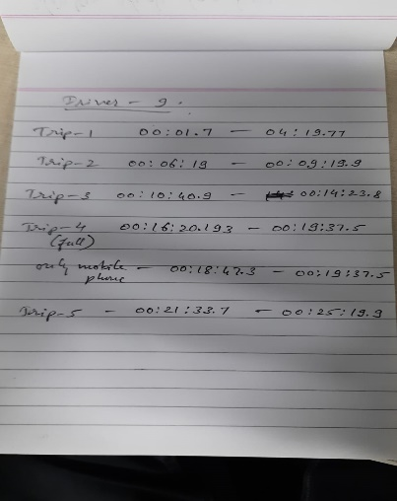
2. Login/Signup into Kaggle.
3. Open the following Kaggle notebook - <https://www.kaggle.com/code/abhinavpaidisetti/fork-of-iith-proj-final/edit>
4. Kaggle notebook will be opened. You will see an option of copy and edit, click on it. Your own copy of notebook will be created.
5. Now on the right side of the notebook you can see two options: add input and upload. Click on upload and upload the video and name it as chosen driver no. (for ex- driver3).



1. Change the address in the below cell according to the chosen driver for the csv from

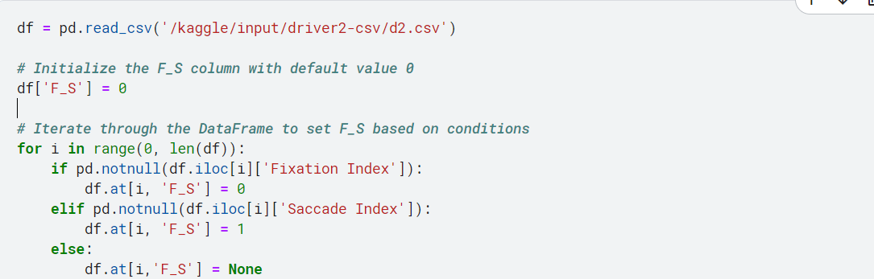



1. Give the starting time of the video in seconds. For ex- let starting time of a video be 20 mins 3 seconds give 1203 as value



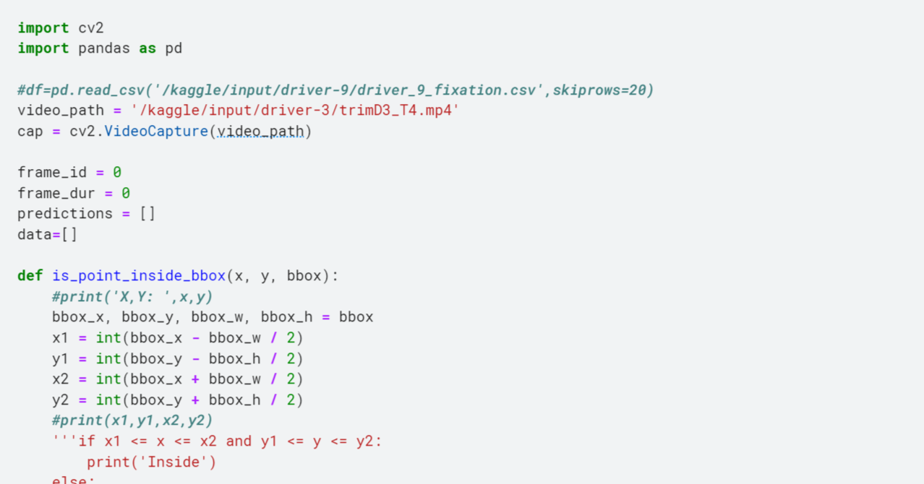



1. Start running all the cells After changing the video path one after another.
2. Finally, note this values for in excel sheet provided.

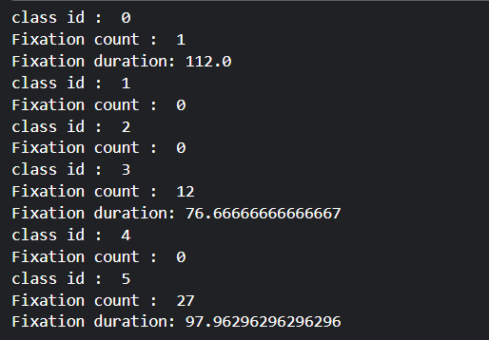

{0: 'ADAS', 1: 'Pedestrian', 2: 'Phone', 3: 'Road', 4: 'Traffic light',5: ‘Empty’}

1. Note the values for both ‘fixations’ and ‘saccades’, as mentioned in 9th step.