ANSHKA GUPTA
11500219038
LAB-EXAM

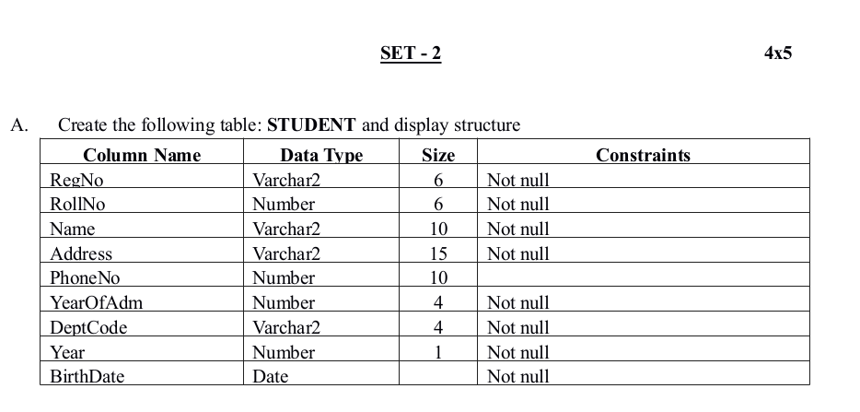

create table student(REGNO VARCHAR2(6) NOT NULL,ROLLNO NUMBER(6) NOT NULL,NAME VARCHAR2(10) NOT NULL,ADDRESS VARCHAR2(15) NOT NULL,PHONENO NUMBER(10),YEAROFADM NUMBER(4) NOT NULL,DEPTCODE VARCHAR2(4) NOT NULL,YEAR NUMBER(1) NOT NULL,BIRTHDATE DATE NOT NULL);

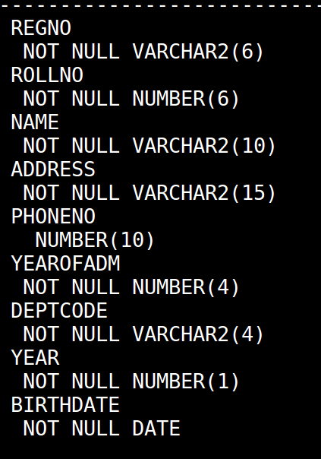

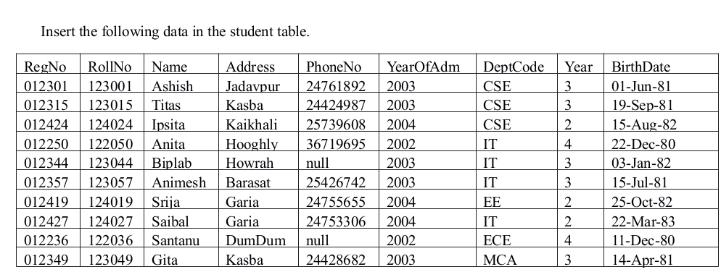
INSERTINTOstudentvalues('&Regno',&Rollno,'&Name','&Address',&Phoneno,&YEAROFADM,'&Deptcode',&Year,'&Birthdate');

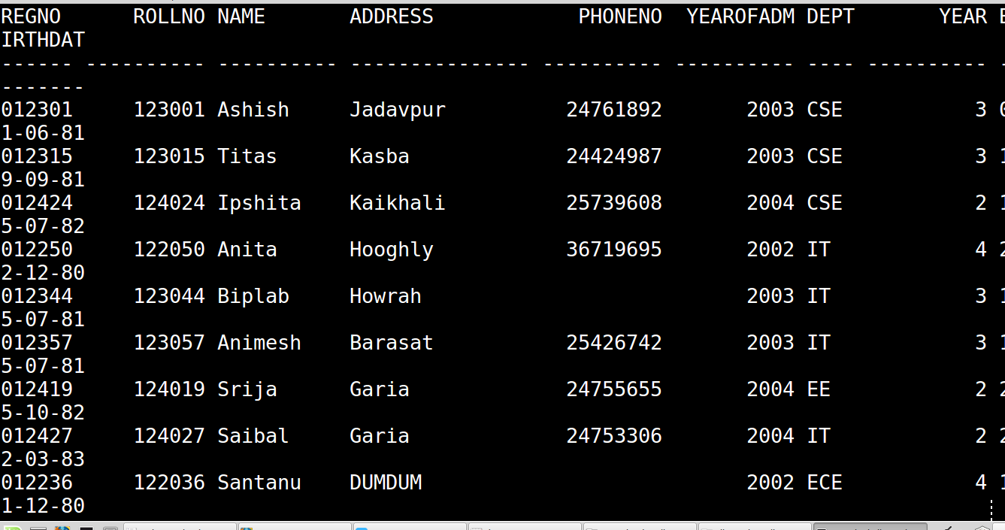

B.Display names of students with ‘a’ as the second letter in their names.

QUERY SELECT NAME FROM STUDENT WHERE NAME LIKE '_a%';

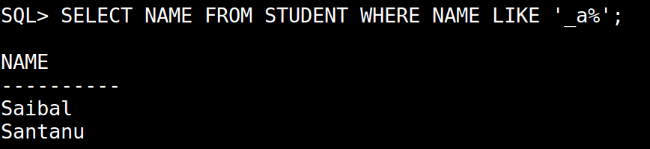

Display names of students in descending alphabetical order.

QUERY SELECT NAME FROM STUDENT ORDER BY NAME DESC;

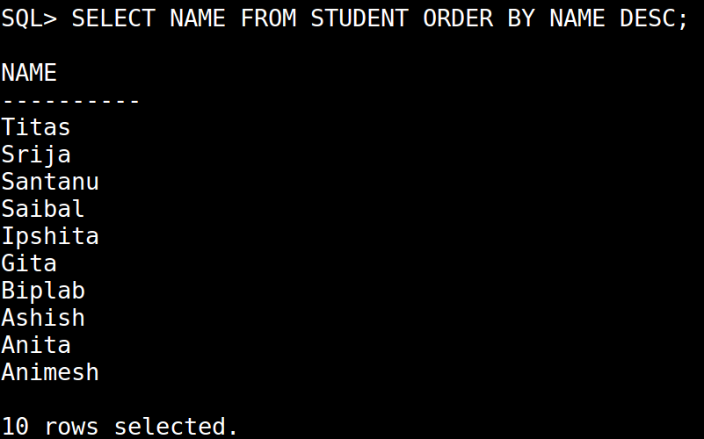

List the names of students who do not have a phone number.

QUERY SELECT NAME FROM STUDENT WHERE PHONENO IS NULL;

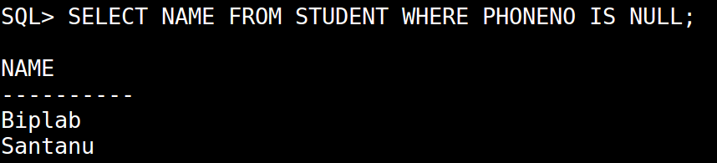

List names of student and their departments whose date of birth is after 1st June 1981.

QUERY SELECT NAME,DEPTCODE FROM STUDENT WHERE BIRTHDATE>'01/06/1981';

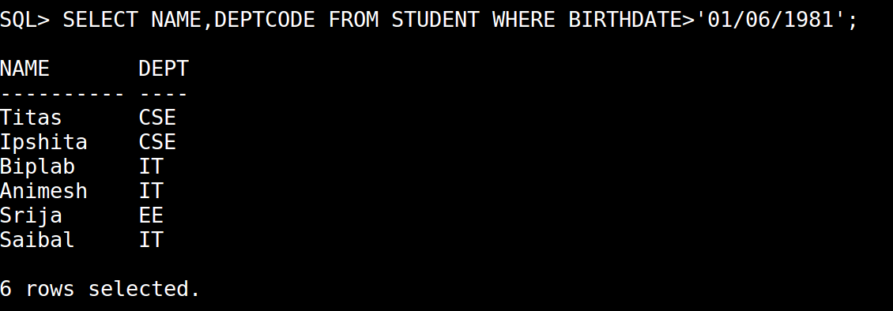

Create a CHECK constraint on this table for the field Year such that Year should be between 1&4.

QUERY ALTER TABLE STUDENT ADD CHECK(YEAR BETWEEN 1 AND 4);

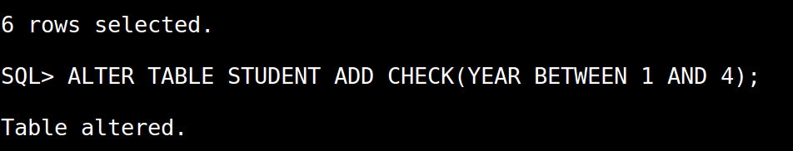

D. Write PL/SQL code segments:

DECLARE

n NUMBER(10);
temp_sum NUMBER(10);
r NUMBER(10);
BEGIN
n := &n;
temp_sum := 0;

WHILE n <> 0 LOOP
r := MOD(n, 10);
temp_sum := temp_sum + r;
n := Trunc(n / 10);
END LOOP;
dbms_output.Put_line('sum of digits = ' || temp_sum);
END;
/

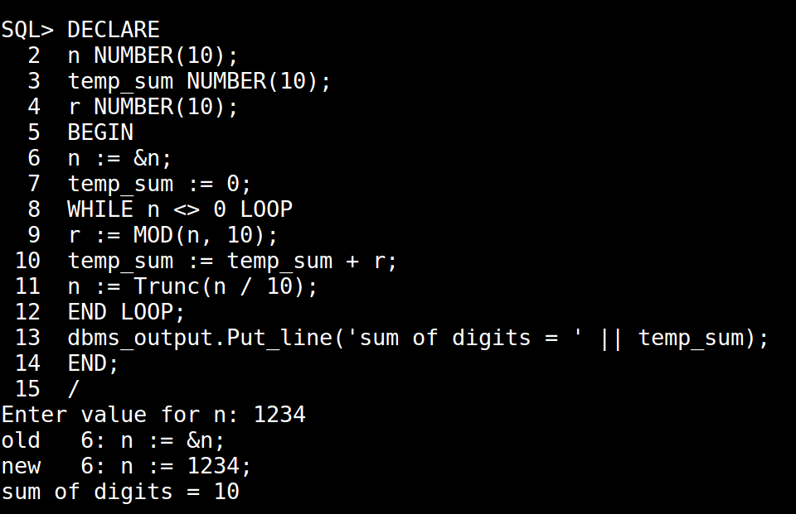

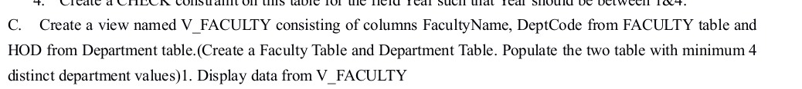

QUERY create table faculty(Facultycode varchar2(4) PRIMARY KEY,FacultyName varchar2(15) not null,DateOfJoin date not null,Deptcode varchar2(4) not null);

QUERY INSERT INTO faculty values('&Facultycode','&FacultyName','&DateOfjoin','&Deptcode');

QUERY create table DEPARTMENT1(Deptcode varchar2(4) NOT NULL PRIMARY KEY,DeptName varchar2(50) not null,HOD varchar(4));
INSERT INTO department1 values('&Deptcode','&DeptName','&HOD');

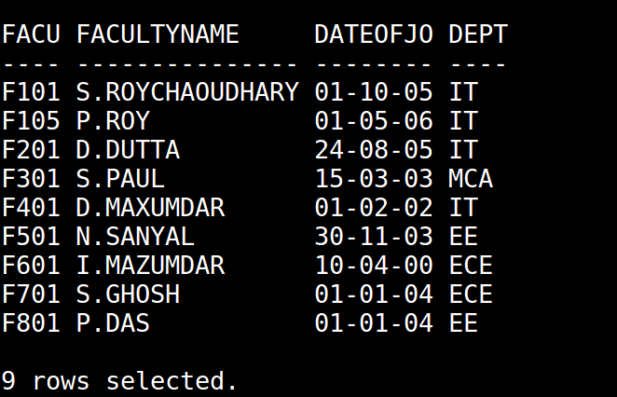

CREATE VIEW v_FACULTY AS SELECT facultyname,deptcode from faculty;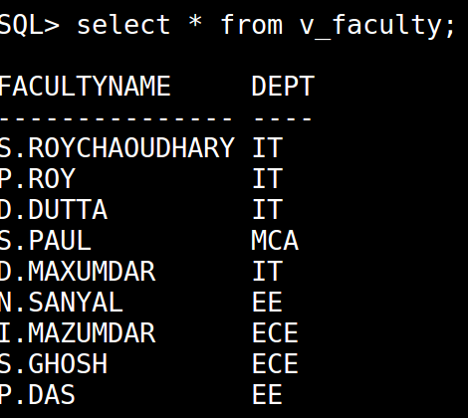

- Try to update the DeptCode of a CSE faculty to IT.
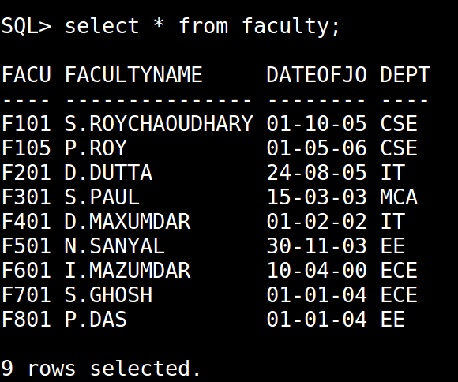

SQL> update faculty set deptcode = 'IT' where deptcode = 'CSE';

