Economy of Kazakhstan: Income, Inflation, Unemployment and Human Development
SIS 1 – Data Collection & Preparation | Ospanov Daniyar | KBTU

1. Goal
The project compares the economy of Kazakhstan with Central Asian and neighbouring countries (GDP per capita, inflation, unemployment) and checks how these indicators are related to the Human Development Index (HDI). 16 countries were selected.

2. Data sources
- API: World Bank Indicators API – GDP per capita (current US$), inflation (consumer prices, % per year) and unemployment (% of labour force) for 2010–2023, one request per indicator for all countries.
- Web scraping: Wikipedia pages “List of countries by Human Development Index” and “List of countries in Asia and Oceania by Human Development Index” (the second page fills countries missing in the HTML of the first, e.g. Kazakhstan), scraped with requests and BeautifulSoup. robots.txt was checked first. From the HTML tables the country name, HDI value and world rank were extracted.

3. Methods
- Cleaning: data types were fixed, duplicates removed, impossible values (non-positive GDP, unemployment outside 0–100 %) set to missing; footnote marks like [a] were removed from the scraped names; short gaps (up to 2 years) were interpolated. Country names were unified (e.g. Kyrgyz Republic / Kyrgyzstan, Türkiye / Turkey, Russian Federation / Russia). Turkmenistan has no inflation data in the World Bank dataset, so it was left out of the correlations (15 of 16 countries used).
- Merging: yearly data were averaged for 2015–2023 (at least 5 years required) to get one row per country, then joined with the HDI table by the normalised country name (one-to-one inner join). Final dataset: 16 countries.
- Analysis: descriptive statistics by group and Pearson / Spearman correlations between each indicator and HDI (GDP per capita on a log scale).

4. Results
Kazakhstan: GDP per capita 9,827 US$ (7th of 16 countries in our table), inflation 9.4 %, unemployment 5.0 %, HDI 0.837 (6th of 16). Compared with other Central Asian countries, Kazakhstan has higher income per person (9,827 vs. 2,393 US$ on average) and higher HDI (0.84 vs. 0.73). Its GDP per capita was the highest in Central Asia in every year; it fell from about 13,500 US$ in 2013 to about 7,500 US$ in 2016 and recovered to about 12,900 US$ in 2023. Average inflation (9.4 %) is the third highest in the sample after Turkiye and Uzbekistan, while unemployment (5.0 %) is slightly lower than the Central Asian average (5.3 %).
Correlation with HDI (15 countries): log GDP per capita has Spearman rho = 0.87 (p < 0.001; Pearson r = 0.95), inflation rho = -0.25 (p = 0.36) and unemployment rho = -0.40 (p = 0.14). The strongest relationship is GDP per capita: it is positive, strong and statistically significant. The relations of inflation and unemployment with HDI are negative but weak or moderate and not significant.
Figures (see notebook): GDP per capita in Central Asia over time, GDP vs. HDI, correlation heatmap, average inflation by country.
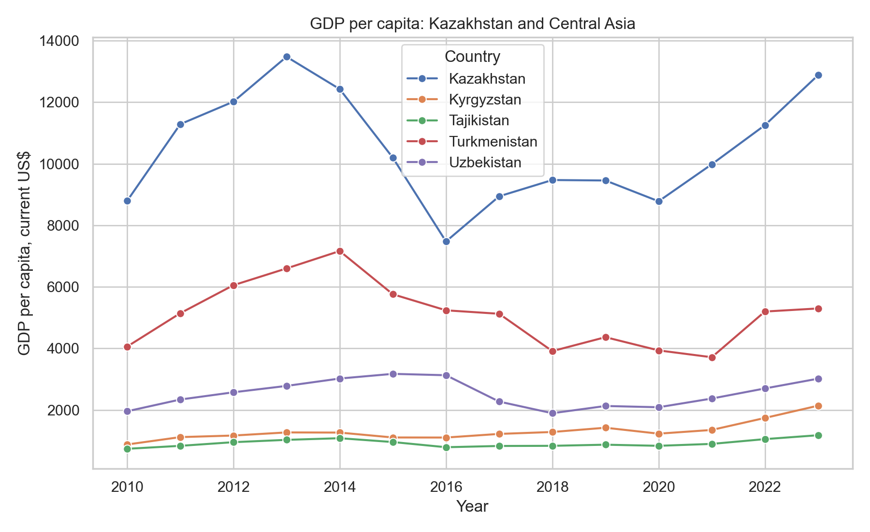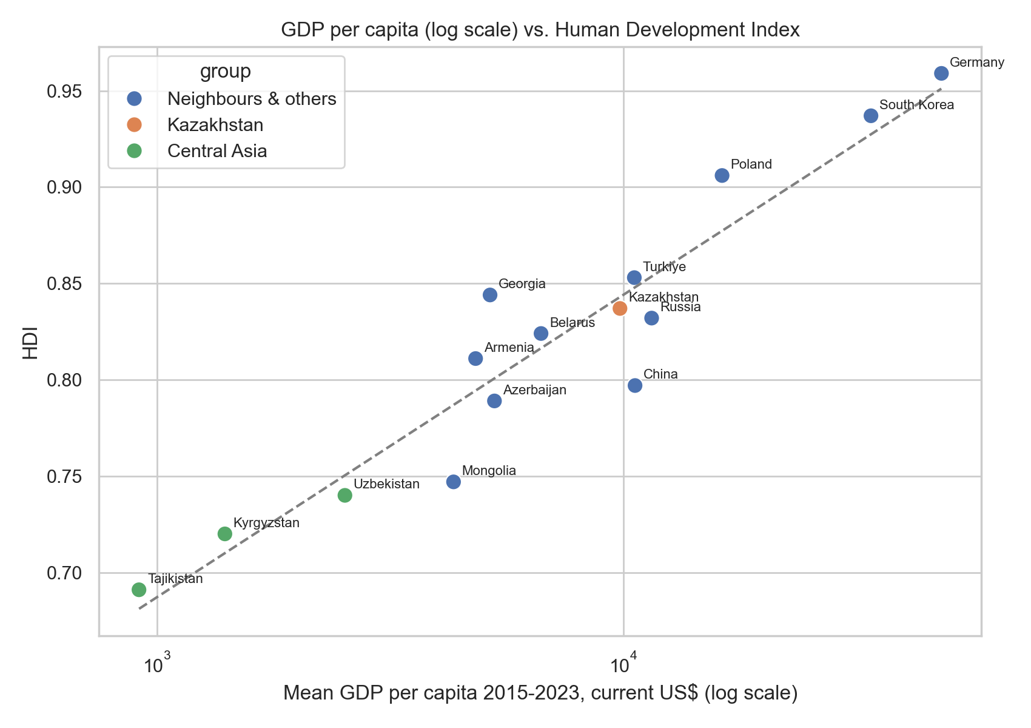

5. Conclusions and limitations
Kazakhstan has the highest income per person and HDI in Central Asia and is in the upper middle of our 16-country sample (7th by GDP per capita, 6th by HDI). Of the three economic indicators only GDP per capita is strongly and significantly related to HDI: richer countries are more developed. Inflation and unemployment do not explain HDI differences in this sample.
- About 15 countries only, so correlations are indicative, not proof.
- Averages for 2015–2023 hide changes over time (e.g. the inflation jump of 2022).
- GDP per capita in current US$ is affected by exchange rate changes; HDI on Wikipedia is copied from the UNDP report.
- Some countries have missing indicators, so they were excluded. Future work: more countries and indicators, panel analysis over time.

