2026-2027学年第一学期
《高级语言程序设计(C++语言)》
实验报告
实验名称：实验二 C++简单程序设计
实验日期：2026年10月23日 | 实验地点：A237
学 号：2025302013135 | 姓 名：汪熙博
学 院：人工智能 | 专 业：人工智能
指导老师：丁建利

一、实验目的
编写并运行简单C++程序，练习基本数据类型、运算符和顺序、选择、循环结构。
二、实验环境
Windows，VS Code，TDM-GCC 10.3.0，C++17。各题分别编译运行。
三、实验过程及结果
练习1 基本数据类型
补充2-1 读入并显示整数
#include <iostream>
using namespace std;
int main() {
int radius = 0;
cout << "Please enter the radius!\n";
if (!(cin >> radius)) return 1;
cout << "The radius is:" << radius << '\n';
cout << "PI is:" << 3.14 << '\n';
cout << "Please enter a different radius!\n";
if (!(cin >> radius)) return 1;
cout << "Now the radius is changed to:" << radius << '\n';
}
依次输入5和8，radius先输出5，再输出8。
补充2-2 为常量命名
#include <iostream>
using namespace std;
int main() {
const double pi(3.14159);
int radius = 0;
cout << "Please enter the radius!\n";
if (!(cin >> radius)) return 1;
cout << "The radius is:" << radius << '\n';
cout << "PI is:" << pi << '\n';
cout << "Please enter a different radius!\n";
if (!(cin >> radius)) return 1;
cout << "Now the radius is changed to:" << radius << '\n';
cout << "PI is still:" << pi << '\n';
}
radius由5变为8，常量pi的两次输出均为3.14159。
补充2-3 变量初始化
#include <iostream>
using namespace std;
int main() {
const double pi(3.14159);
int radius(0);
cout << "The initial radius is:" << radius << '\n';
cout << "PI is:" << pi << '\n';
cout << "Please enter a different radius!\n";
if (!(cin >> radius)) return 1;
cout << "Now the radius is changed to:" << radius << '\n';
cout << "PI is still:" << pi << '\n';
}
radius初始化为0，输入12后变为12。
补充2-4 有符号与无符号整数
#include <iostream>
using namespace std;
int main() {
unsigned short j = 50000;
short i = static_cast<short>(j);
cout << "Short int is:" << i << '\n';
cout << "Short unsigned int is:" << j << '\n';
cout << "sizeof(short)=" << sizeof(short) << '\n';
}
本机short占2字节。j为50000，转换为short后i为−15536。
补充2-5 整数类型最值
#include <iostream>
#include <climits>
using namespace std;
int main() {
cout << "Min of short is: " << SHRT_MIN << '\n';
cout << "Max of short is: " << SHRT_MAX << '\n';
cout << "Min of int is: " << INT_MIN << '\n';
cout << "Max of int is: " << INT_MAX << '\n';
cout << "Min of long is: " << LONG_MIN << '\n';
cout << "Max of long is: " << LONG_MAX << '\n';
cout << "Max of unsigned short is: " << USHRT_MAX << '\n';
cout << "Max of unsigned int is: " << UINT_MAX << '\n';
cout << "Max of unsigned long is: " << ULONG_MAX << '\n';
}
short范围为−32768～32767；int和long范围均为−2147483648～2147483647。unsigned short最大值为65535，unsigned int和unsigned long最大值均为4294967295。
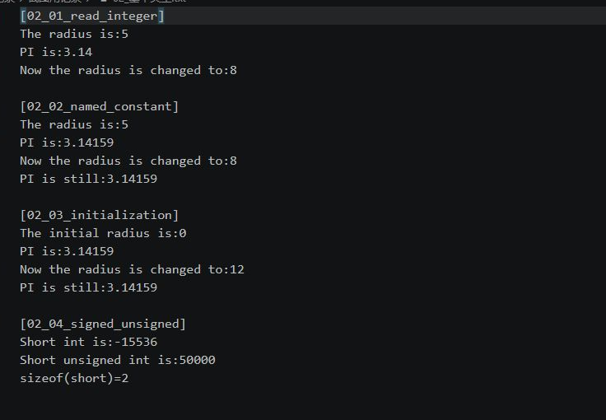
图1 整数与常量运行结果
补充2-6 整数字面量与进制
#include <iostream>
using namespace std;
int main() {
int isample = 0, osample = 0, hsample = 0;
if (!(cin >> isample >> oct >> osample >> hex >> hsample)) return 1;
cout << isample << ';' << oct << osample << ';' << hex << hsample << '\n';
isample = 123; osample = 0173; hsample = 0x7B;
unsigned long ulsample = 4294967295UL;
for (int value : {isample, osample, hsample})
cout << dec << value << ';' << oct << value << ';' << hex << value << '\n';
cout << dec << ulsample << ';' << oct << ulsample << ';' << hex << ulsample << '\n';
}
按十进制、八进制和十六进制分别输入123、173和7B，输出为123;173;7b。
补充2-7 浮点类型与圆面积
#include <iostream>
#include <iomanip>
using namespace std;
int main() {
const float piF = 3.1415926f;
const double piD = 3.1415926;
const long double piL = 3.1415926L;
float rF = 5.5f, areaF = piF * rF * rF;
double rD = 5.5, areaD = piD * rD * rD;
long double rL = 5.5L, areaL = piL * rL * rL;
cout << "default: " << areaF << ' ' << areaD << ' ' << areaL << '\n';
cout << setprecision(18);
cout << "float: " << areaF << ", bytes=" << sizeof(areaF) << '\n';
cout << "double: " << areaD << ", bytes=" << sizeof(areaD) << '\n';
cout << "long double: " << areaL << ", bytes=" << sizeof(areaL) << '\n';
}
半径为5.5时，默认精度下三种类型均输出95.0332。设置18位有效数字后，float为95.033172607421875，double为95.0331761500000027，long double为95.03317615。
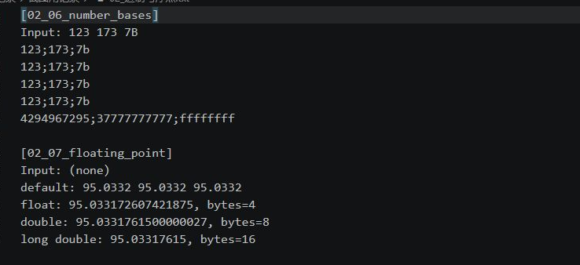
图2 进制与浮点运算结果
补充2-8 字符与转义序列
#include <iostream>
using namespace std;
int main() {
cout << 'A' << ' ' << 'a' << '\n';
cout << "one\ttwo\tthree\n";
cout << "123\b\b45\n";
cout << "Alert\a\n";
}
输出字符A、a，并运行制表、退格和响铃转义序列。
补充2-9 bool转换
#include <iostream>
using namespace std;
int main() {
bool bV1 = true, bV2 = false;
cout << "bool value bV1 = " << bV1 << '\n';
cout << "bool value bV2 = " << bV2 << '\n';
int nV1 = bV1, nV2 = 0;
bV1 = nV2;
cout << "int value nV1 = " << nV1 << '\n';
cout << "bool value bV1 = " << bV1 << '\n';
cout << "bool(-7) = " << static_cast<bool>(-7) << '\n';
}
true输出1，false输出0；整数0转换为false，非零整数−7转换为true。
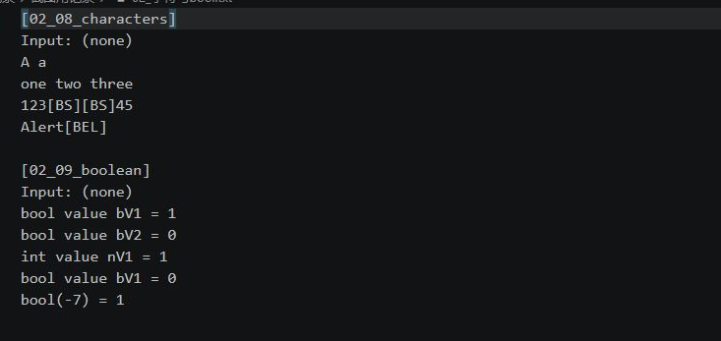
图3 字符与bool运行结果
练习2 算术运算符与赋值运算符
补充2-10 算术运算与自增自减
#include <iostream>
using namespace std;
int main() {
int val1 = 24, val2 = 5;
double val3 = 24, val4 = 5;
cout << "24/5 = " << val1 / val2 << '\n';
cout << "24%5 = " << val1 % val2 << '\n';
val2 = -5;
cout << "24%(-5) = " << val1 % val2 << '\n';
cout << "24.0/5.0 = " << val3 / val4 << '\n';
cout << "24.0/(-5) = " << val3 / val2 << '\n';
cout << "24/5.0 = " << val1 / val4 << '\n';
val1 = 5;
cout << val1++ << ", "; cout << ++val1 << ", ";
cout << val1-- << ", "; cout << --val1 << '\n';
val1 = 5;
int a = val1++, b = ++val1, c = val1--, d = --val1;
cout << "stored sequence: " << a << ", " << b << ", " << c << ", " << d << '\n';
}
24/5为4，24%5和24%(−5)均为4；24.0/5.0为4.8，24.0/(−5)为−4.8。自增自减依次输出5、7、7、5。
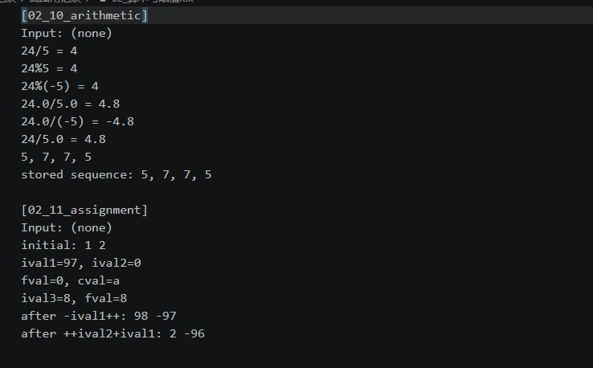
图4 算术与赋值运行结果
补充2-11 赋值运算
#include <iostream>
using namespace std;
int main() {
int ival1 = 1, ival2 = 2;
double fval = 0;
char cval = '\0';
cout << "initial: " << ival1 << ' ' << ival2 << '\n';
ival1 = ival2 = 0;
ival1 = fval = 0;
ival1 = cval = 'a';
cout << "ival1=" << ival1 << ", ival2=" << ival2 << '\n';
cout << "fval=" << fval << ", cval=" << cval << '\n';
int ival3 = fval = 8;
cout << "ival3=" << ival3 << ", fval=" << fval << '\n';
ival2 = -ival1++;
cout << "after -ival1++: " << ival1 << ' ' << ival2 << '\n';
ival1 = ++ival2 + ival1;
cout << "after ++ival2+ival1: " << ival1 << ' ' << ival2 << '\n';
}
字符a赋给ival1后得到97。执行ival2=−ival1++后，两者为98和−97；再执行ival1=++ival2+ival1后，两者为2和−96。
练习3 关系逻辑 sizeof与位运算
补充2-12 关系与逻辑运算
#include <iostream>
using namespace std;
int main() {
int a = 1, b = 2, c = 3, d = 4;
cout << "1 == 2: " << (a == b) << '\n';
cout << "1 < 2: " << (a < b) << '\n';
cout << "1 < 2 && 3 < 4: " << (a < b && c < d) << '\n';
int x = 0;
bool flag = false && (++x > 0);
cout << "false && (++x>0): " << flag << ", x=" << x << '\n';
flag = true || (++x > 0);
cout << "true || (++x>0): " << flag << ", x=" << x << '\n';
}
三个比较表达式依次输出0、1、1。两次短路运算后，x仍为0。
补充2-13 sizeof运算
#include <iostream>
using namespace std;
int main() {
cout << "sizeof(short)=" << sizeof(short) << '\n';
cout << "sizeof(unsigned short)=" << sizeof(unsigned short) << '\n';
cout << "sizeof(int)=" << sizeof(int) << '\n';
cout << "sizeof(unsigned int)=" << sizeof(unsigned int) << '\n';
cout << "sizeof(long)=" << sizeof(long) << '\n';
cout << "sizeof(unsigned long)=" << sizeof(unsigned long) << '\n';
cout << "sizeof(float)=" << sizeof(float) << '\n';
cout << "sizeof(double)=" << sizeof(double) << '\n';
cout << "sizeof(long double)=" << sizeof(long double) << '\n';
cout << "sizeof(char)=" << sizeof(char) << '\n';
}
sizeof测得的字节数：short为2，int、long、float为4，double为8，long double为16，char为1。
补充2-14 位运算与位修改
#include <iostream>
#include <bitset>
using namespace std;
int main() {
cout << "~15 = " << ~15 << '\n';
cout << "15 & 21 = " << (15 & 21) << '\n';
cout << "15 ^ 21 = " << (15 ^ 21) << '\n';
cout << "15 | 21 = " << (15 | 21) << '\n';
unsigned int nTest = 9;
cout << "start: " << nTest << ' ' << bitset<16>(nTest) << '\n';
nTest |= 1u << 4;
cout << "set bit 4: " << nTest << ' ' << bitset<16>(nTest) << '\n';
nTest &= ~(1u << 4);
cout << "clear bit 4: " << nTest << ' ' << bitset<16>(nTest) << '\n';
for (int i = 0; i < 16; ++i) {
if (nTest & (1u << i)) nTest &= ~(1u << i);
else nTest |= 1u << i;
}
cout << "flip low 16 bits: " << nTest << ' ' << bitset<16>(nTest) << '\n';
}
~15=−16，15&21=5，15^21=26，15|21=31。将9的第4位置1得到25，清零后恢复9，翻转低16位后得到65526。
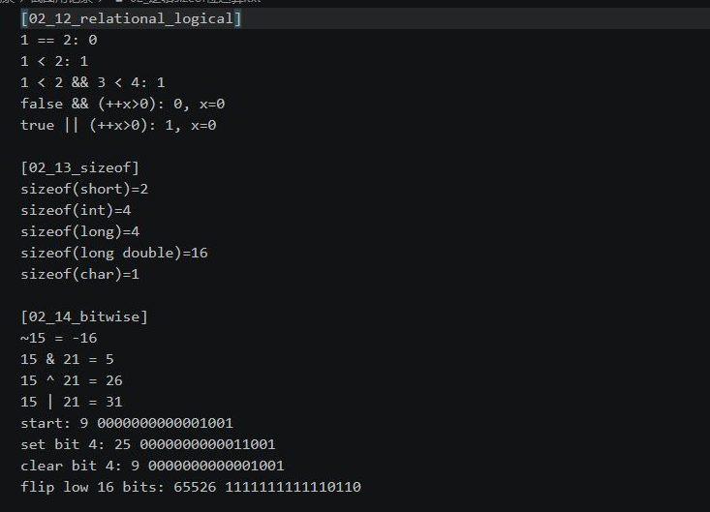
图5 逻辑运算、sizeof与位运算结果
练习4 结构化程序设计
题目1 利润分段奖金
输入利润，按各档比例分段累加奖金，结果保留两位小数。
#include <iostream>
#include <iomanip>
#include <cmath>
using namespace std;
int main() {
long double profit = 0;
if (!(cin >> profit) || !isfinite(profit) || profit < 0 || profit > 9e12L) {
cout << "Invalid profit\n"; return 1;
}
const long long width[] = {10000000, 10000000, 20000000, 20000000, 40000000};
const long long rate[] = {1000, 750, 500, 300, 150};
long long remaining = llround(profit * 100), scaled = 0;
for (int i = 0; i < 5 && remaining > 0; ++i) {
long long part = remaining < width[i] ? remaining : width[i];
scaled += part * rate[i];
remaining -= part;
}
scaled += remaining * 100;
long long cents = (scaled + 5000) / 10000;
cout << "Bonus = " << cents / 100 << '.'
<< setfill('0') << setw(2) << cents % 100 << '\n';
}
利润为10万、20万、40万、60万、100万和120万元时，奖金分别为10000、17500、27500、33500、39500和41500元。
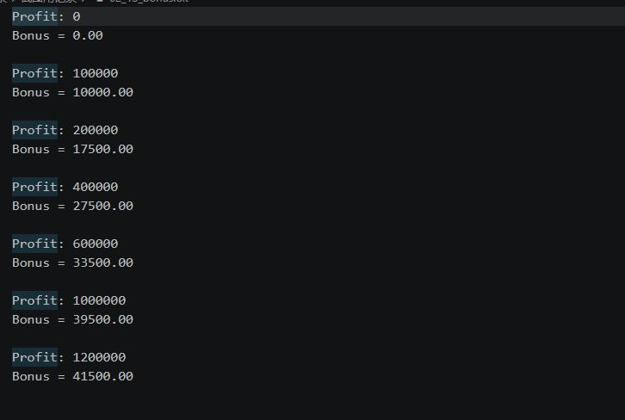
图6 利润分段奖金运行结果
题目2 电影评分分级
输入0～10的整数评分，用if语句判断评分等级。
#include <iostream>
using namespace std;
int main() {
int score = 0;
if (!(cin >> score) || score < 0 || score > 10) {
cout << "Invalid score\n"; return 1;
}
if (score >= 9) cout << "你认为电影经典\n";
else if (score >= 7) cout << "你认为电影非常好\n";
else if (score >= 5) cout << "你认为电影一般\n";
else cout << "你认为电影烂片\n";
}
输入7，输出“你认为电影非常好”。测试9～10、7～8、5～6、0～4，分别输出经典、非常好、一般、烂片。
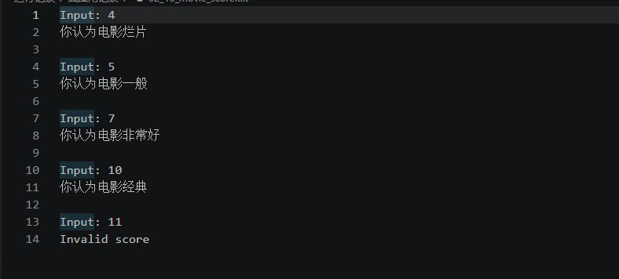
图7 电影评分运行结果
题目3 回文整数判断
将整数转为字符串，逐个比较首尾对应字符。
#include <iostream>
#include <string>
using namespace std;
int main() {
long long number = 0;
if (!(cin >> number)) return 1;
string s = to_string(number);
bool palindrome = number >= 0;
for (size_t i = 0; i < s.size() / 2; ++i)
if (s[i] != s[s.size() - 1 - i]) palindrome = false;
cout << number << (palindrome ? " is palindrome\n" : " is not palindrome\n");
}
121为回文数，123和−121不是回文数。
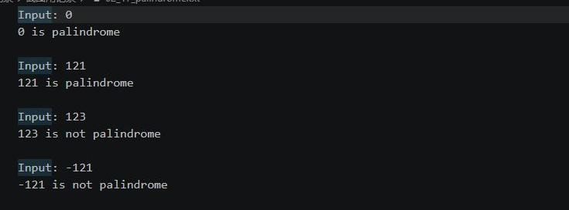
图8 回文数判断运行结果
题目4 三位水仙花数
分离百、十、个位，判断各位数字的立方和是否等于原数，再遍历100～999。
#include <iostream>
using namespace std;
bool isNarcissistic(int n) {
if (n < 100 || n > 999) return false;
int a = n / 100, b = n / 10 % 10, c = n % 10;
return a * a * a + b * b * b + c * c * c == n;
}
int main() {
int n = 0;
if (!(cin >> n)) return 1;
if (n < 100 || n > 999) cout << "Input must be three digits\n";
else cout << n << (isNarcissistic(n) ? " is narcissistic\n" : " is not narcissistic\n");
cout << "All three-digit narcissistic numbers:";
for (int i = 100; i <= 999; ++i)
if (isNarcissistic(i)) cout << ' ' << i;
cout << '\n';
}
输出的三位水仙花数为153、370、371和407。
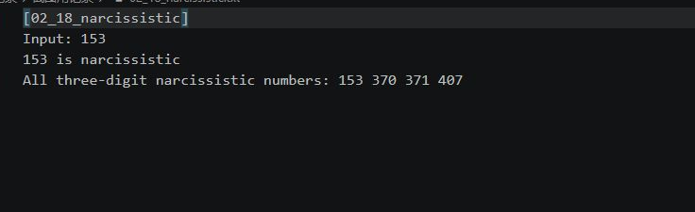
图9 水仙花数运行结果
题目5 重复数字数列求和
输入n和a，每轮生成term=term*10+a，并累加到sum。
#include <iostream>
#include <limits>
using namespace std;
int main() {
int n = 0, a = 0;
if (!(cin >> n >> a) || n <= 0 || a < 1 || a > 9) {
cout << "Require n>0 and 1<=a<=9\n"; return 1;
}
unsigned long long term = 0, sum = 0;
const auto limit = numeric_limits<unsigned long long>::max();
for (int i = 0; i < n; ++i) {
if (term > (limit - a) / 10) {
cout << "Overflow\n"; return 1;
}
term = term * 10 + a;
if (sum > limit - term) {
cout << "Overflow\n"; return 1;
}
sum += term;
}
cout << "Sum = " << sum << '\n';
}
输入n=3、a=2，得到2+22+222=246；输入n=5、a=3，得到37035。
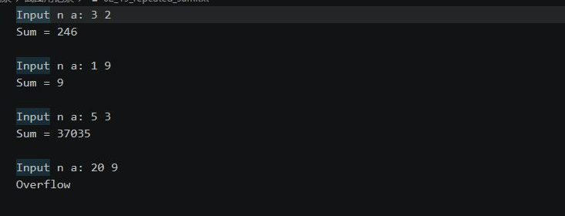
图10 数列求和运行结果
题目6 九九乘法口诀表
使用两层循环，外层控制1～9行，内层输出本行的乘法式。
#include <iostream>
using namespace std;
int main() {
for (int i = 1; i <= 9; ++i) {
for (int j = 1; j <= i; ++j)
cout << j << '*' << i << '=' << j * i << (j == i ? '\n' : '\t');
}
}
输出9行、45个乘法式，第一项为1*1=1，最后一项为9*9=81。
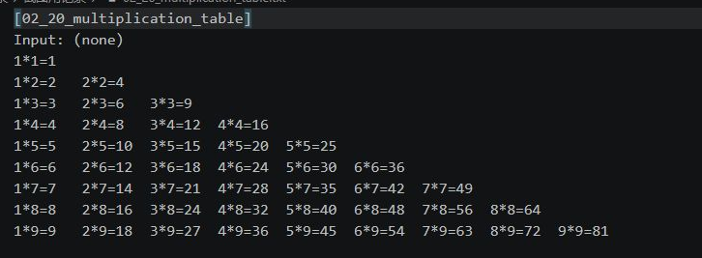
图11 九九乘法表运行结果
拓展题1 二十个月兔子数量
前两个月各有1对兔子，从第3个月起，每月对数为前两个月之和。
#include <iostream>
using namespace std;
int main() {
int previous = 1, current = 1;
for (int month = 1; month <= 20; ++month) {
int pairs = 1;
if (month >= 3) {
pairs = previous + current;
previous = current;
current = pairs;
}
cout << "Month " << month << ": pairs=" << pairs
<< ", rabbits=" << 2 * pairs << '\n';
}
}
前6个月为1、1、2、3、5、8对，第20个月为6765对，共13530只。
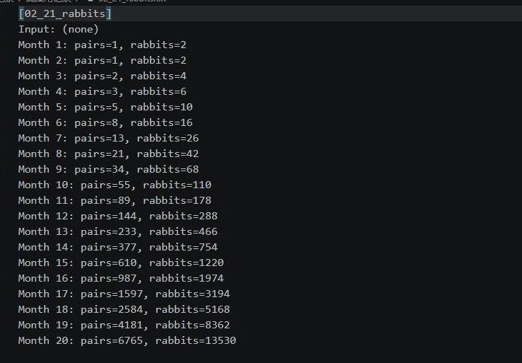
图12 兔子数量运行结果
拓展题2 猴子吃桃
由第10天剩1个桃子开始，按“前一天=(后一天+1)*2”反推9次。
#include <iostream>
using namespace std;
int main() {
int peaches = 1;
cout << "Day 10: " << peaches << '\n';
for (int day = 9; day >= 1; --day) {
peaches = (peaches + 1) * 2;
cout << "Day " << day << ": " << peaches << '\n';
}
cout << "Initial peaches = " << peaches << '\n';
}
第10天到第1天依次为1、4、10、22、46、94、190、382、766、1534个。第一天共有1534个桃子。
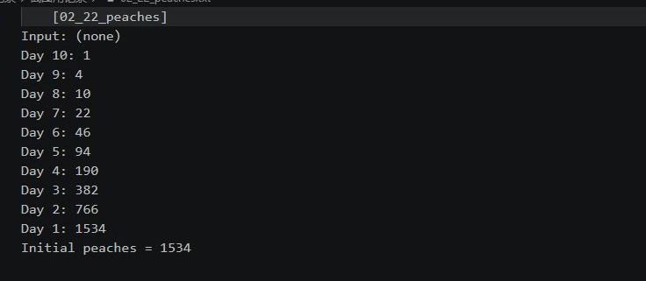
图13 猴子吃桃运行结果
四、实验总结
完成了14个基础练习和8道编程题，记录了各题的运行结果。通过这些程序练习了类型转换、运算符、分支判断和循环计算。

