

1. username, passwordACTUAL    -login successful , STATUS-pass

2) wrongusername,wrongpassword

 EXPECTED- couldn't find an  account associated with user

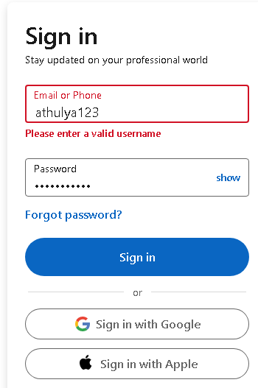

 ACTUAL    -couldn't find an  account associated with user , STATUS-pass

3) wrongusername,password

  EXPECTED- couldn't find an  account associated with user



1. username,wrongpassword

