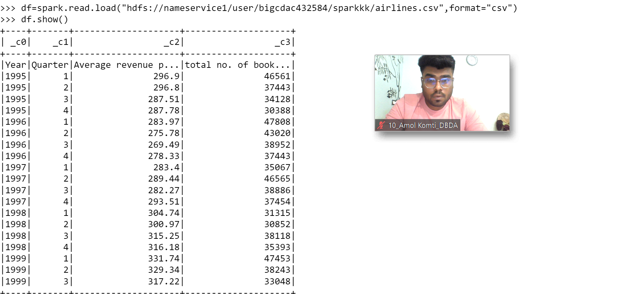

**df.registerTempTable("airlines")**

1. What was the highest number of people travelled in which year?

**select year,sum(Total number of booked seats) as totalSeats from airlines group by year having totalSeats in**

**(select max(totalSeats) from ((select year,sum(Total number of booked seats) as totalSeats from airlines group by year)abctable));**

1. Identifying the highest revenue generation for which year

**select year,sum(Average revenue per seat * Total number of booked seats) as avgRev from airlines group by year order by avgRev desc limit 1;**

1. Identifying the highest revenue generation for which year and quarter (Common group)

**select year,quarter,sum(Average revenue per seat * Total number of booked seats) as Rev from airlines group by year,quarter order by Rev desc limit 1;**