Leetcode Question(Excel Sheet column Title):

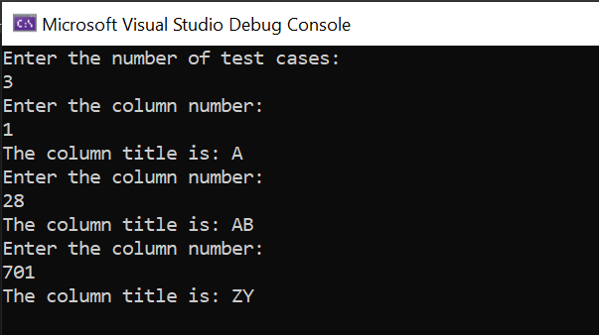

Leetcode Question(Linked List Cycle Detection)



Leetcode Question(Minimum depth of binary tree)

