<https://app.codility.com/demo/results/trainingT326QG-2MF/>

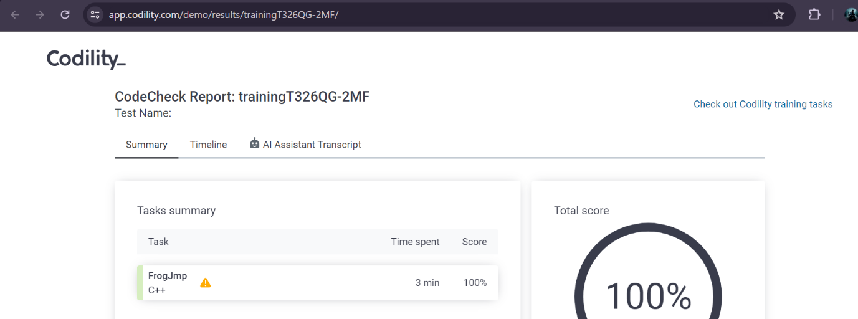



<https://app.codility.com/demo/results/training2A8S24-NJU/>

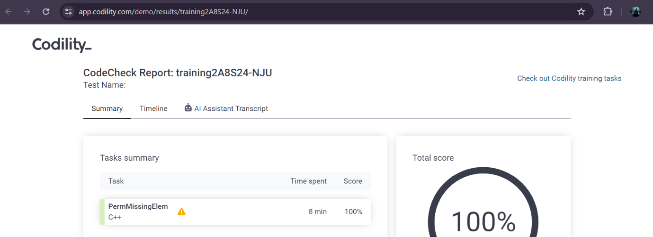



<https://app.codility.com/demo/results/trainingTD8EME-6MJ/>

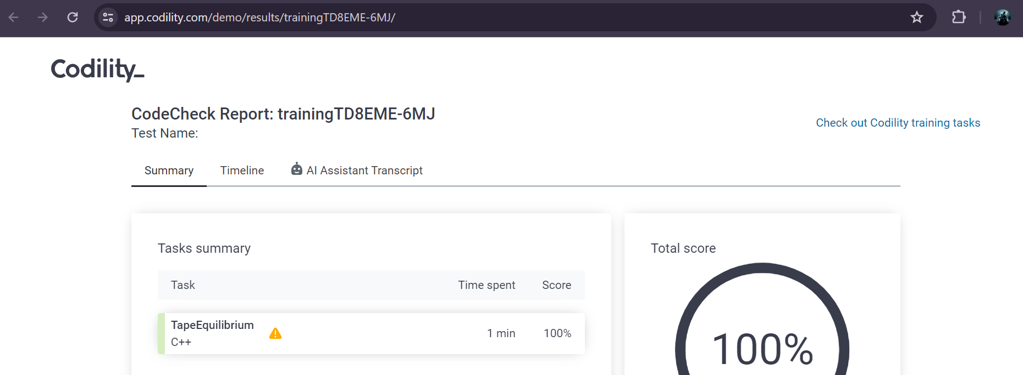



<https://app.codility.com/demo/results/trainingTT7QDK-S7F/>

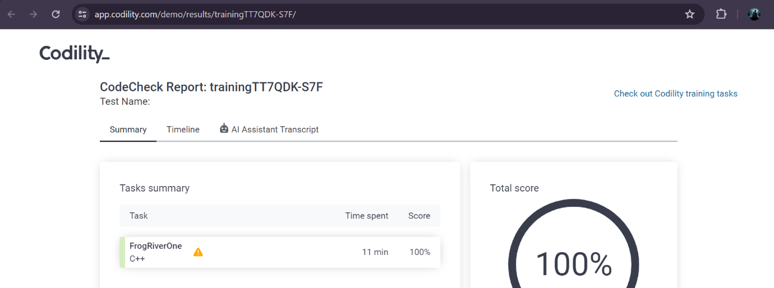



<https://app.codility.com/demo/results/trainingUAT7UA-9KX/>

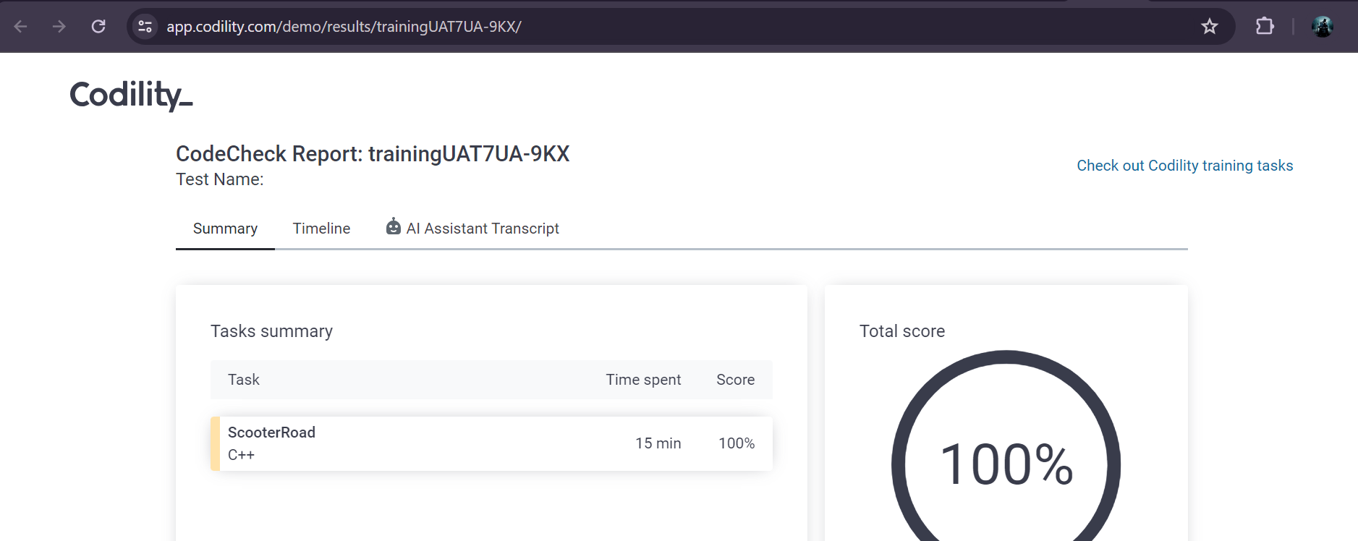

1. <https://app.codility.com/cert/view/certDQTW2Y-7G2VG3WWSY2UPX4B/details/>

