QuestLabs Requirements Document
A personal development companion app helping college students build reflection habits, track long-term goals, and grow together in supportive cohorts

Team Members:
Zhi Kang (Student ID: 300416721)
Dong Zhang (Student ID: 300403848)

Course: CSIS 3375 - Section 1
Douglas College

Team Lead: Zhi Kang
Instructor: Padmapriya Arasanipalai Kandhadai
November 2 2025

Contents
QuestLabs Requirements Document 1
Team Lead: Zhi Kang 1
1. Requirements Gathering 3
1.1 Purpose and Objectives 3
1.2 User Study Choice and Sample 3
1.3 Survey Questions 3
1.4 Data Analysis 6
1.5 Key Insights 6
2. Requirements Generation 7
2.1 Personas and Scenarios 7
2.2 Requirements from Personas 11
3. Synthesis of Requirements 12
3.1 Final Prioritized Requirements 12
2. Three-Layer Goal Framework 12
3. Progress Dashboard with Visual Graphs 12
4. Cohort Space (Aggregated) 12
5. Push Notifications/Reminders 12
6. Quest Board (BINGO Grid) 12
7. Encouragement Reactions 12
8. Structured Reflection Prompts 12
P2 - Medium Priority 12
3.2 Conclusions 14
4. AI Use Section 15
4.1 AI Tools Used 15
4.2 Value Addition 15
4.3 Prompt History 15
5. Work Date/Hours Logs 16
Work Log - Zhi Kang 16
6. References and Acknowledgments 17
Acknowledgments 17
References 17

1. Requirements Gathering

1.1 Purpose and Objectives
We conducted this user study to understand the needs and challenges of college or university students interested in personal development. Our main objectives were:
- To identify current reflection habits and frequency among college students
- To discover barriers preventing consistent personal development practices
- To validate our assumption about quick daily check-ins (under 2 minutes)
- To determine preferences for visual vs. text-based progress tracking
- To assess the importance of peer accountability features
- To identify most desired app features
- To understand users' willingness for long-term goal planning
- To discover privacy concerns in cohort settings

1.2 User Study Choice and Sample
Method: We used an online survey because it efficiently reaches many students and provides data for statistical analysis. The survey included both closed-ended (multiple choice) and open-ended questions to capture measurable preferences and detailed insights.
Target Users: College students (undergraduate and graduate) aged 18-31+ interested in personal development, who balance academics with other responsibilities and struggle with consistent reflection.
Sample: 14 valid responses collected over 7 days (October 16-23, 2025). 50% graduate students, 43% undergraduates, 65% aged 27+.

1.3 Survey Questions
Below is the complete survey we used for our requirements gathering. The survey was distributed through Google Forms and included 17 questions organized into five main sections.
Link:https://docs.google.com/forms/d/e/1FAIpQLSecelozNUqU-wZzHfmVYWwrKLkcN-iYRBxQTutOt5N7o5qchw/viewform
Target Time: 4-5 minutes per response
Purpose: Explore college students' current habits, preferences, and pain points related to personal reflection, goal tracking, and peer accountability.

Section 1: Screening and Demographics
Q1. [Required] Are you currently a college/university student?
- Yes, full-time undergraduate
- Yes, part-time undergraduate
- Yes, graduate student
- No, but I graduated within the last 2 years
- No → [Survey ends]
Q2. [Required] Age range:
- 18-20
- 21-23
- 24-26
- 27-30
- 31+
Q3. Have you ever participated in a personal development program, workshop, or cohort?
- Yes, in a structured program (like Quest Labs, coaching cohort, etc.)
- Yes, informally (online community, study group, etc.)
- No, but I'm interested
- No, and I'm not interested

Section 2: Current Habits and Pain Points
Q4. How often do you intentionally reflect on your emotions, relationships, or goals?
- Daily
- 2-3 times per week
- Weekly
- Monthly or less
- Rarely or never
Q5. What's the BIGGEST challenge that prevents you from maintaining regular reflection habits? [Select up to 2]
- I don't have time
- I don't know what to reflect on
- It feels overwhelming or boring
- I forget to do it
- I don't see the value/results
- I prefer talking to someone instead of writing
- Other: [text field]
Q6. Do you currently use any apps or tools to track your mood, goals, or habits?
- Yes, regularly [If yes → "Which ones?" (optional text field)]
- Yes, but I stopped using them
- No, I use pen and paper
- No, I don't track anything
Q7. [Conditional - only shown if Q6 = "stopped"] If you stopped using a tracking app, what was the main reason?
- Too time-consuming
- Too complicated
- Felt like a chore, not helpful
- Didn't integrate different life areas
- Privacy concerns
- Other: [text field]

Section 3: Preferences and Design Insights
Q8. How much time would you realistically spend on a daily check-in app?
- Under 1 minute (just a few taps)
- 1-2 minutes (quick ratings + optional note)
- 3-5 minutes (some writing/reflection)
- 5-10 minutes (detailed journaling)
- 10+ minutes
Q9. Which format do you prefer for tracking progress over time?
- Visual graphs and charts
- Written journal entries
- Calendar/streak view
- A mix of visuals and text
- I don't care about tracking history
Q10. Rate your interest in these features: [Scale: 1 = Not interested at all → 5 = Very interested]
- Quick daily mood check-in (1-2 min)
- Long-term goal tracking (3 months+)
- Structured reflection prompts (fill-in-the-blank)
- Progress dashboard with trend graphs
- See your peer group's aggregated progress (anonymous)
- Give/receive encouragement reactions from peers
Q11. Which statement best describes your ideal reflection tool?
- "Give me complete freedom to write whatever I want" (blank canvas)
- "Give me some structure but also flexibility" (prompts + open space)
- "Give me clear structure and guidance" (templates, fill-in-blanks)
- "Just let me rate things quickly and see patterns" (minimal writing)

Section 4: Social and Privacy
Q12. In a small growth group (5-10 people), what would make you comfortable sharing progress? [Select all that apply]
- Knowing members personally
- Only seeing group summaries (no individual details)
- Controlling what I share
- No public profiles or rankings
- Anonymous usernames
- I wouldn't share at all
Q13. How important is peer accountability to your personal growth?
- Very important - I need others to stay motivated
- Somewhat important - it helps but isn't essential
- Not very important - I prefer working independently
- Not important at all - accountability feels like pressure
Q14. If you were in a personal growth cohort, what support from the group would be most helpful? [Select up to 3]
- Weekly check-ins or standups
- Celebrating milestones together
- Accountability reminders from peers
- Sharing struggles/challenges openly
- Giving/receiving encouragement reactions
- Collaborative goal-setting sessions
- Seeing others' progress for motivation
- Anonymous peer feedback
- One-on-one buddy system
- I prefer not to engage with the group
- Other: [text field]
Q15. What would motivate you to keep using a personal development app? [Rank top 3 or select top 3]
- Seeing my own progress over time
- Encouragement from peers
- Achieving my long-term goals
- Understanding patterns in my emotions/behavior
- Feeling part of a supportive community
- Quick and easy to use
- Beautiful, enjoyable interface
- Reminders and notifications

Section 5: Open Feedback
Q16. If you could wave a magic wand and create the perfect personal development companion app, what ONE feature would it MUST have? [Optional]
Q17. Any other thoughts, concerns, or ideas about tracking emotional wellness, relationships, and goals in a cohort setting? [Optional]

1.4 Data Analysis
Sample Size: 14 valid responses (50% graduate, 43% undergraduate, 65% aged 27+)
The following are some charts of the analysis results:
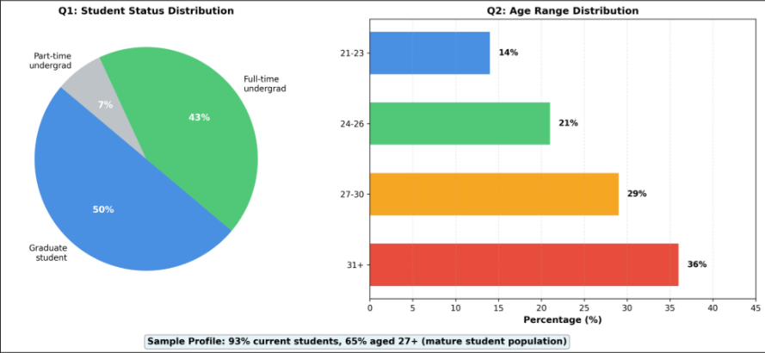
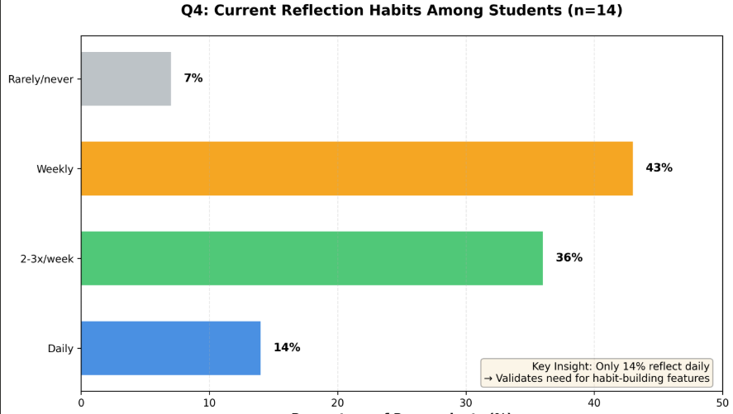
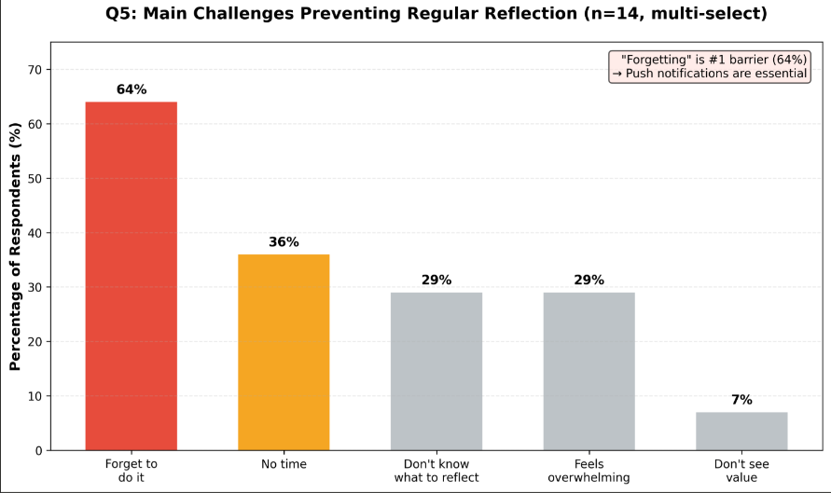
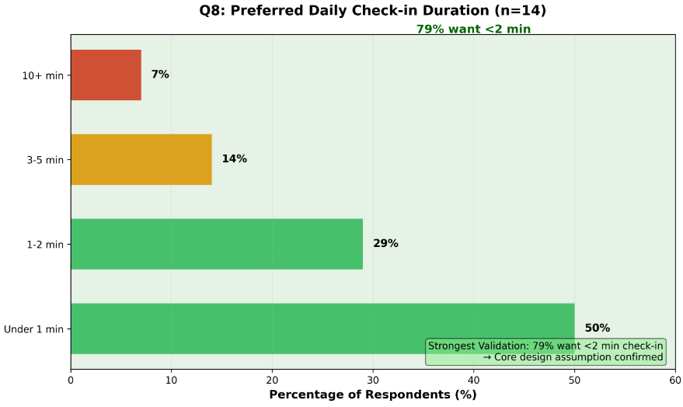
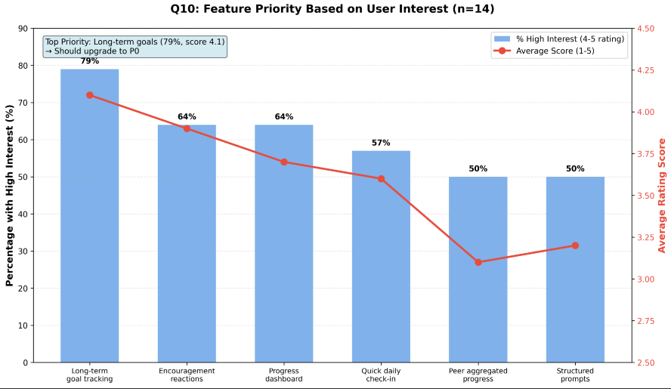
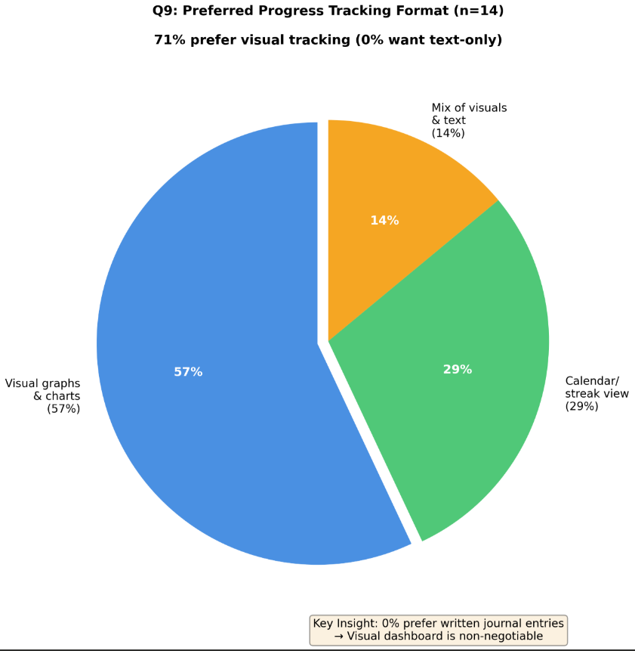

Key Findings:
- Reflection Frequency: Only 14% reflect daily; 43% weekly, 36% 2-3x/week → habit gap exists
- Top Barriers: 64% forget, 36% lack time, 29% don't know what to reflect on
- Time Preference: 79% want <2min check-ins (50% want <1min) → strongest validation
- Format Preference: 71% prefer visual tracking; 0% want text-only
- Top Features (4-5 rating): Long-term goals 79%, Dashboard 64%, Reactions 64%
- Privacy: 71% need sharing control, 43% reject public rankings
- Top Motivator: 79% motivated by seeing own progress

1.5 Key Insights
- "Forgetting" is the #1 barrier (64%) → reminders are essential
- 79% want <2min check-ins → speed is non-negotiable
- 71% prefer visual formats → dashboard is must-have
- 79% high interest in long-term goals → should be P0 priority
- 64% value peer support BUT 71% need privacy → aggregated cohort design validated
- 36% prefer independence → solo mode must work fully
- Function > form: Only 21% motivated by beautiful interface

2. Requirements Generation

2.1 Personas and Scenarios
https://www.figma.com/design/7yernNajsd3bIY94FhmVon/Personas-and-Scenarios?node-id=0-1&t=8Ubo8iYRTC65XMh5-1
We created 4 diverse personas representing our target users:
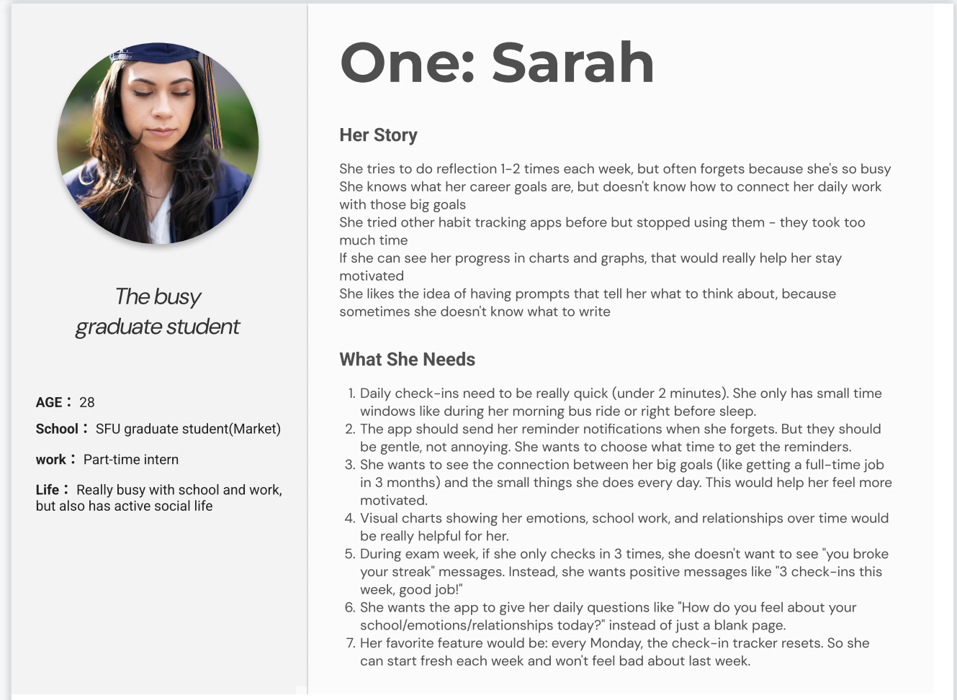
Persona 1: Sarah - The Busy Graduate Student
Age: 28 | Role: Part-time intern, SFU Marketing graduate student
Life: Very busy with school and work, active social life
Her Story:
Sarah tries to reflect 1-2 times weekly but often forgets because she's busy. She knows her career goals but doesn't know how to connect daily work with those goals. She tried habit apps before but stopped - they took too much time. Visual progress charts would help her stay motivated.
What She Needs:
- Check-ins under 2 minutes (during bus ride or before sleep)
- Gentle reminder notifications at chosen times
- See connection between daily actions and 3-month goals
- Visual charts showing emotions, school, relationships over time
- Positive messaging (not "you broke your streak")
- Daily prompts instead of blank pages
- Weekly reset - fresh start every Monday
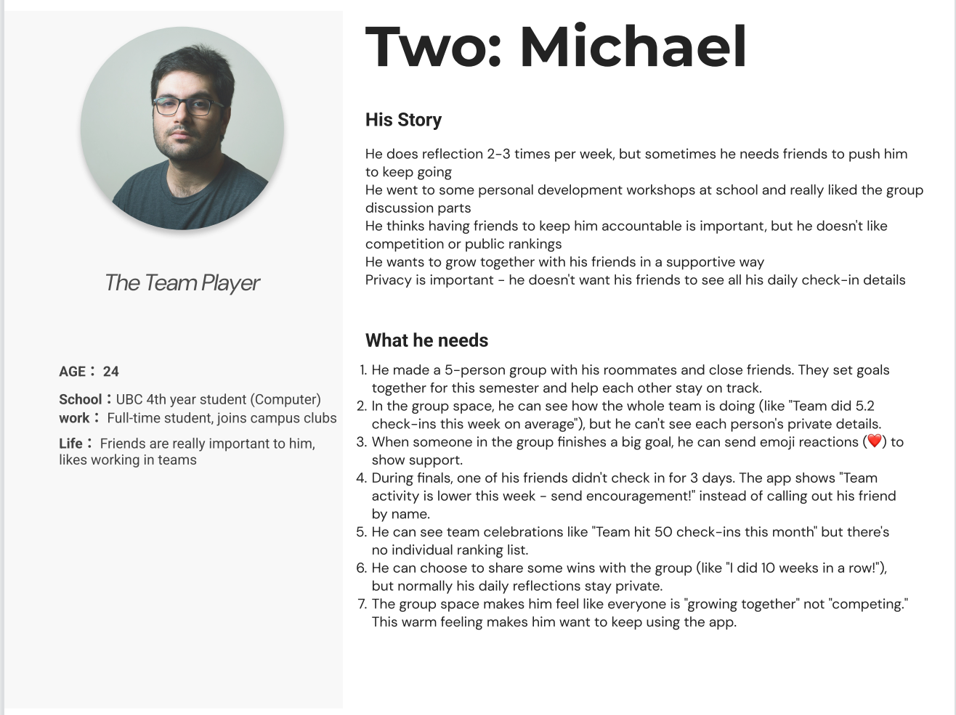
Persona 2: Michael - The Team Player
Age: 24 | Role: UBC 4th year Computer Science, joins campus clubs
Life: Friends important, likes working in teams
His Story:
Michael reflects 2-3x/week but needs friends to stay accountable. He likes group discussions but doesn't want competition or public rankings. He values growing together with friends in supportive ways. Privacy is important - doesn't want friends seeing all details.
What He Needs:
- Small cohorts (5-10 people) with close friends
- See aggregated team progress, not individual scores
- Send emoji reactions to celebrate wins
- Protected privacy - teammates can't see personal details
- Team celebrations without individual rankings
- Optional sharing - daily reflections stay private
- "Growing together" feeling, not competing
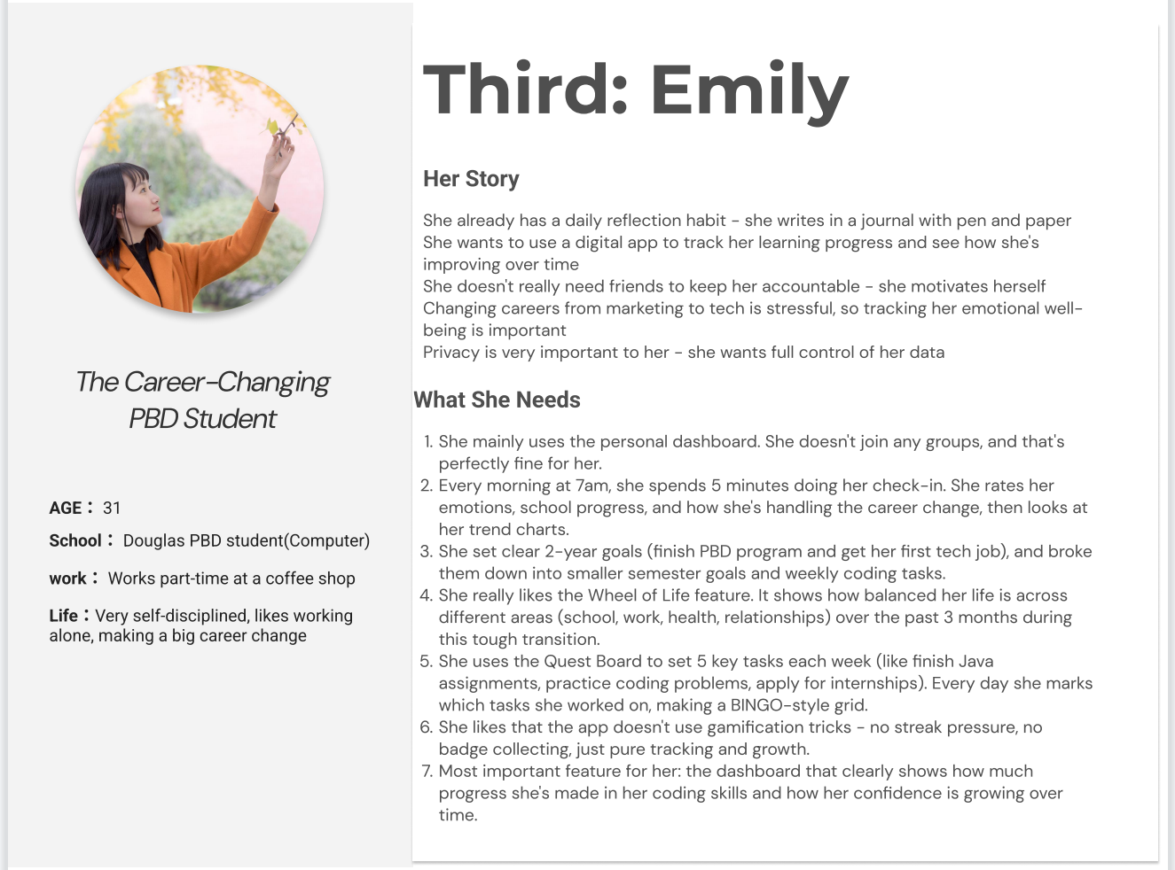
Persona 3: Emily - The Career-Changing PBD Student
Age: 31 | Role: Part-time barista, Douglas PBD Computer Science
Life: Very self-disciplined, making big career change
Her Story:
Emily has daily reflection habit with pen and paper. She wants digital tracking to see improvement over time. Doesn't need friends for accountability - self-motivated. Career change is stressful, so tracking emotional wellbeing matters. Privacy is very important.
What She Needs:
- Personal dashboard - no group requirement
- Morning routine at 7am with 5-minute check-in
- 2-year goals broken into semester goals and weekly tasks
- Wheel of Life showing balance across life areas
- Quest Board for 5 weekly tasks (BINGO style)
- No gamification pressure - just tracking and growth
- Dashboard showing skill improvement over time
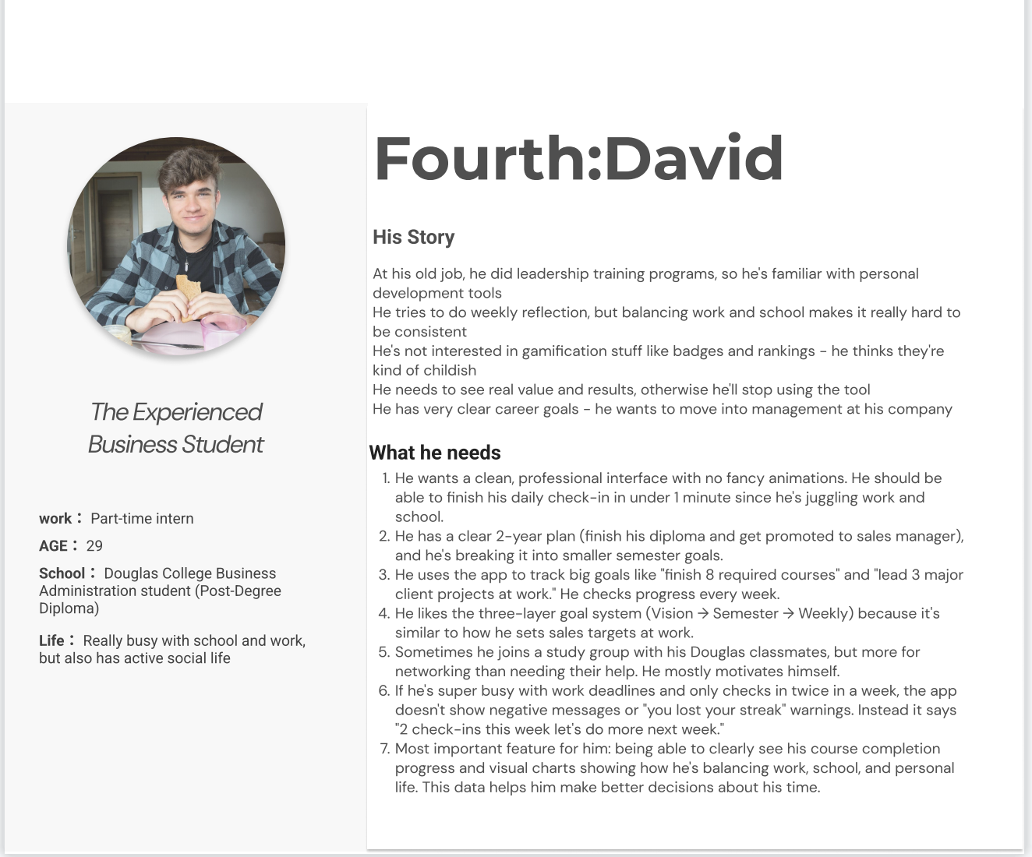
Persona 4: David - The Experienced Business Student
Age: 29 | Role: Part-time intern, Douglas Business PDD
Life: Busy with work and school, active social life
His Story:
David did leadership training at his old job, so he's familiar with personal development. Weekly reflection is hard while balancing work and school. Not interested in childish gamification - needs real value and results. Has clear career goals for management.
What He Needs:
- Clean professional interface, <1 minute check-in
- Clear 2-year plan with semester goals
- Three-layer goals: Vision → Semester → Weekly
- Track concrete goals like courses and projects
- Optional groups for networking, not required
- No negative streak messages during busy periods
- Visual charts for work/school/life balance

2.2 Requirements from Personas
Based on analyzing these personas, we generated the following requirements:
From Sarah (Busy Graduate):
- Check-in must complete in <2 minutes
- Gentle, customizable reminder notifications
- Visual connection between daily work and long-term goals
- Charts showing emotions/school/relationships over time
- Positive, supportive messaging (never guilt-inducing)
- Daily reflection prompts, not blank pages
- Weekly reset feature (fresh start every Monday)
From Michael (Team Player):
- Create small cohorts (5-10 people)
- Show aggregated team progress only
- Emoji reactions for encouragement
- Protected individual privacy
- Team milestones without individual rankings
- Optional win sharing, private by default
From Emily (Career-Changer):
- Full functionality in solo mode
- Support for daily morning routines
- 2-year vision with semester and weekly breakdown
- Wheel of Life showing life balance
- Quest Board (BINGO grid) for weekly tasks
- No gamification pressure
- Dashboard showing skill/confidence growth
From David (Experienced):
- Clean, professional interface
- Three-layer goal hierarchy
- Track concrete milestones
- Weekly progress checks
- Optional, not mandatory groups
- Supportive messaging during busy periods
- Work/school/life balance charts

3. Synthesis of Requirements

3.1 Final Prioritized Requirements
Combining insights from user research (14 survey responses) and persona analysis, we created this prioritized feature list using P0-P4 tiers based on user value, strategic fit, and technical feasibility.
P0 - Must Have (MVP Core)
1. Daily Check-In System (<2 minutes)
- 3 rating sliders: Emotional, Relational, Academic
- Quest selection checkboxes
- Optional quick note (<100 chars)
- Validation: 79% want <2min (strongest finding)

2. Three-Layer Goal Framework
- Vision (2-3 years) → Quarterly → Weekly
- Shows how daily work connects to long-term goals
- Validation: 79% high interest (highest score 4.1)

3. Progress Dashboard with Visual Graphs
- Emotion/academic/relationship trends
- Goal completion rates
- Wheel of Life visualization
- Validation: 71% prefer visual, 64% high interest

4. Cohort Space (Aggregated)
- Small cohorts (5-10 members)
- Shows team averages, not individual data
- Team milestone celebrations
- Validation: 64% value peers, 71% need privacy control
P1 - High Priority

5. Push Notifications/Reminders
- Customizable times, gentle tone
- Validation: 64% forget to reflect (top barrier)

6. Quest Board (BINGO Grid)
- 5 weekly tasks linked to quarterly goals
- Visual progress without gamification

7. Encouragement Reactions
- Emoji support system (💪❤️🔥👏)
- Validation: 64% high interest

8. Structured Reflection Prompts
- Daily questions guide reflection
- Validation: 79% want structure, 29% don't know what to reflect on

P2 - Medium Priority
- 9. Milestone Celebrations: Recognize achievements (validation: 50% want)
- 10. Weekly Planning: 5-10min weekly intention setting
- 11. Wheel of Life: Life balance across domains
P3 - Nice to Have
- 12. Extended Journal: Longer reflection option (validation: 50% interested)
- 13. Affect-Agency Grid: Emotion vs. control mapping
P4 - Future Phase
- 14. SEL Timeline: Social-emotional learning analytics
Cross-Functional Requirements:
- Privacy: Granular sharing controls, no public rankings
- Tone: Always supportive, never guilt-inducing
- Design: Function > form, clean professional interface
- Independence: Solo mode fully functional

3.2 Conclusions
- Speed is Essential: 79% want <2min → any longer design will fail
- Visual Feedback Required: 71% prefer visual, 0% text-only → dashboard is critical
- Long-Term Goals Matter Most: 79% interest → differentiates us from simple trackers
- Reminders Not Optional: 64% forget → must add notifications to P1
- Privacy Enables Social: 64% want peers BUT 71% need control → aggregated design correct
- Anti-Gamification Confirmed: Mature users (65% age 27+) want meaningful progress, not badges
Surprise Findings:
- Long-term goals scored higher than daily check-in (79% vs 57%)
- Encouragement reactions (64%) more desired than expected
- Zero users want blank-page journaling

4. AI Use Section

4.1 AI Tools Used
AI Tool Name | Version, Account | Specific Use
Claude | 4.5 Sonnet | “Based on our survey finding that 79% of users want check-ins under 2 minutes, what are the best UX patterns for ultra-fast daily interactions? Show examples from successful apps.”
Claude | 4.5 Sonnet | “We have 14 features prioritized as P0-P4. Given that we're a 2-person team with 8 weeks, which P0 and P1 features should we prototype first for maximum user validation?”
Claude | 4.5 Sonnet | “Compare the following apps: Fabulous, Strava, Way of Life, and Reflectly. What  features led to high abandonment rates? What keeps users engaged long-term?”

4.2 Value Addition
While AI tools provided initial drafts and analysis, our team added critical value through research validation, competitive analysis, and data-driven refinement. We systematically verified AI suggestions against academic research and grounded all design decisions in our survey findings.
For example, when AI suggested gamified quest systems, we recognized this contradicted our data showing 65% of users aged 27+ prefer professional, meaningful tools. We researched alternatives like Todoist and designed a minimal BINGO-style Quest Board aligned with the 57% who want "quick ratings and patterns" (Q11).
Similarly, AI recommended 5-10 person cohorts based on general practices. We validated this through Dunbar's number research on "sympathy groups" (5-9 people) and analyzed Strava's most active clubs (7-12 members), concluding that 6-8 is optimal for balancing connection with sustainability.
Most importantly, when AI suggested prioritizing goal completion in the dashboard, our Q15 data revealed users care more about "Own progress" (79%) than "Achieving goals" (64%). This insight led us to redesign the dashboard to emphasize trend lines over completion percentages—a decision that differentiates our app from competitors who prioritize goals first.

4.3 Prompt History
(Sample prompts - full history in appendix)
https://claude.ai/share/4ace28bf-6d6b-4870-b56f-a8b2e00182b3
https://claude.ai/share/5b9f63e3-d857-4639-8980-ce0bae6983b7
https://claude.ai/share/74ae75d1-32c0-4dd3-8146-59e570dd8037

5. Work Date/Hours Logs

Work Log - Zhi Kang
Represented finished tasks
Represented planning tasks
Date | Number of Hours | Description of work done
Sep 28, 2025 | 1.0 | Chosen our program topic, and met with professor for the first meeting
Oct 1, 2025 | 3.5 | Project kickoff meeting with team Makēda; Started researching futures literacy concepts and key program step
Oct 4, 2025 | 3 | Met with team to align on research direction; Reviewed 2020 wireframe example and wrote the program proposal
Oct 8, 2025 | 3 | Conducted 3 student interviews about reflection habits and support needs; Shared preliminary findings in team check-in
Oct 11, 2025 | 3.5 | Analyzed interview data and created affinity diagram showing key themes; Started researching engagement patterns in micro-journaling apps
Oct 15, 2025 | 4 | Completed competitive analysis research examining 5 apps (Forest, Strava, Habitica, Fabulous, Discord); Compiled best practices for collaborative mechanisms and privacy-preserving design
Oct 18, 2025 | 4.5 | Presented research synthesis to team; Created user journey map identifying 6 touchpoints and key pain points based on interview and competitive findings
Oct 22, 2025 | 4.0 | Started learning Figma basics including frames and mobile layouts; Practiced Auto Layout with responsive card components
Oct 25, 2025 | 4.5 | Explored advanced Figma prototyping features; Drew paper sketches for Section 1 daily prompt system (8 screens)
Oct 29, 2025 | 4.5 | Created digital wireframes for Section 1 with 6 core screens; Planned Section 3 cohort features with team
Oct 30, 2025 | 0.5 | Discussion with teacher about repo naming, worklog practices, and making content readable for others
Oct 31, 2025 | 1 | Meeting with Makēda to share survey results and user personas, with feedback on privacy levels, scaffolding, habit tracking formats, BJ Fogg's behavior model, and success progression
Nov 1, 2025 | 3 | Organize the requirement document for our project

Work Log - Dong Zhang
Date | Number of Hours | Description of work done
Sep 28, 2025 | 1.0 | Chosen our program topic, and met with professor for the first meeting
Oct 1, 2025 | 3.5 | Project kickoff meeting with team Makēda; Started researching futures literacy concepts and some key steps for the program
Oct 4, 2025 | 3 | Met with team to align on research direction; Reviewed 2020 wireframe example to understand design evolution, and wrote the program proposal
Oct 8, 2025 | 3.5 | Designed comprehensive Google Forms survey with 15 questions covering reflection habits, collaboration preferences, mental health needs, and technology usage patterns; Distributed survey to target student groups
Oct 11, 2025 | 3.5 | Followed up on survey distribution and monitored response rate; Divided Figma learning modules with team; Started preliminary review of incoming responses
Oct 15, 2025 | 3.5 | Continued survey data collection (currently 12+ responses); Studied collaborative game mechanics (Battleship, BINGO) and their psychological effects; Researched Self-Determination Theory applications
Oct 18, 2025 | 3.5 | Completed survey data collection with 20+ student responses; Analyzed results showing 70% prefer visual tracking and 65% want low-pressure collaboration; Built feature prioritization matrix ranking 12 potential features; Presented key research findings
Oct 22, 2025 | 3 | Established design standards with team; Learned Figma interface basics; Set up color styles (8 colors) and typography scales
Oct 24, 2025 | 1.5 | Prepare for the meeting outline for the Friday meeting about the options for the weekly restart design mechanics.
Oct 25, 2025 | 2.5 | Explored advanced Figma prototyping features; Drew paper sketches for Section 1 daily prompt system (8 screens)
Oct 30, 2025 | 0.5 | Discussion with teacher about repo naming, worklog practices, and making content readable for others
Oct 31, 2025 | 1 | Meeting with Makēda to share survey results and user personas, with feedback on privacy levels, scaffolding, habit tracking formats, BJ Fogg's behavior model, and success progression
Nov 1, 2025 | 1.5 | Review the requirement document for the project

6. References and Acknowledgments

Acknowledgments
We would like to thank all 14 survey respondents for their time and thoughtful feedback. Special thanks to our course instructor for guidance on requirements gathering methodology, and to the Douglas College community for supporting our user research.

References
- Nielsen, J. (2012). Usability 101: Introduction to Usability. Nielsen Norman Group. https://www.nngroup.com/articles/usability-101-introduction-to-usability/
- Fogg, B. J. (2009). A Behavior Model for Persuasive Design. Proceedings of the 4th International Conference on Persuasive Technology.
- Google Forms Survey Platform. https://www.google.com/forms/about/
- QuestLabs Companion Project Proposal. October 2025.
- Feature Prioritization Matrix. October 2025.
- Survey Data Analysis Report. October 23, 2025.

