[Document title]

[Company name] | [Company address]

[Document subtitle]

Johan Vermaak

[Year]

Contents

Task A: 2

A1: 2

A2: 2

A3: 2

References 7

# Task A:

## A1:

ZAPTEST is a New Generation software test automation solution for testing applications Cross-Platform. ZAPTEST allows testing of any GUI based software on any modern OS, mobile or conventional including iOS; Android; WinMo; Blackberry; Windows; Mac; and Linux and supports testing of Agile and CI (DevOps) development. ZAP’s main technologies are ZAPTEST and ZAPFARM. (ZapTest, 2018)  
Zaptest was made with the purpose of automating testing processes, they try and automate any manual testing for Graphic User Interface (GUI). This software can be used cross platform meaning any device, and any operating system can use this software to test their GUI’s.

## A2:

The only requirement I was able to find for installing ZapTest was “for windows 7 or later”.

My Computer specs:  
Operating System: Windows 10 home version 1803  
System type: 64-bit  
Ram: 16gb  
Processor: Quad-core processor 3.80 GHz

## A3:

Step 1:

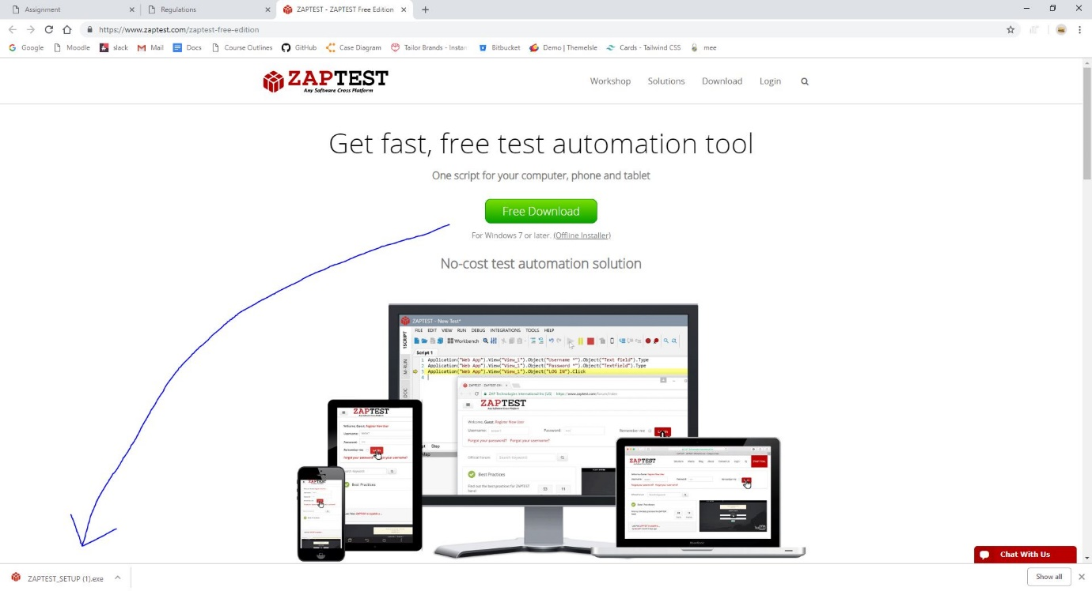  
Step 2: Once you open the downloaded application your computer will ask if this application can make changes to your computer, Select “Yes”.

Step 3: Click download and install.

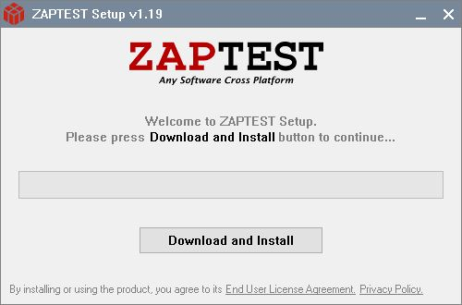

Step 4: Wait for the download to finish.  
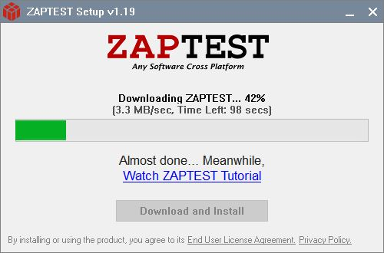

Step 5: Once it finishes installing it will ask if your using the free edition or the enterprise edition. I selected the free edition.  
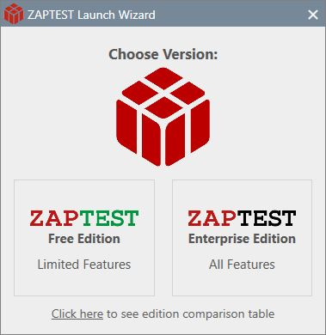

Step 6: After selecting the free version it asks for you to sign up or login if you already have an account. As I did not have an account I had to sign up.  
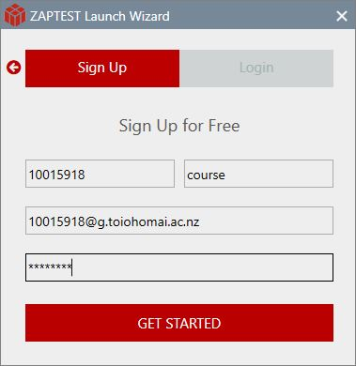

Step 7: After clicking “Get Started” you will need to go to your email and activate your new account.  
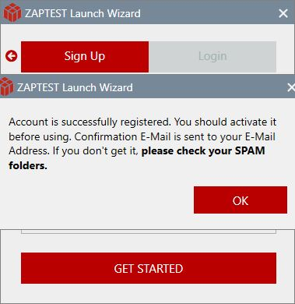

Step 8: Activating your account from your sent email.

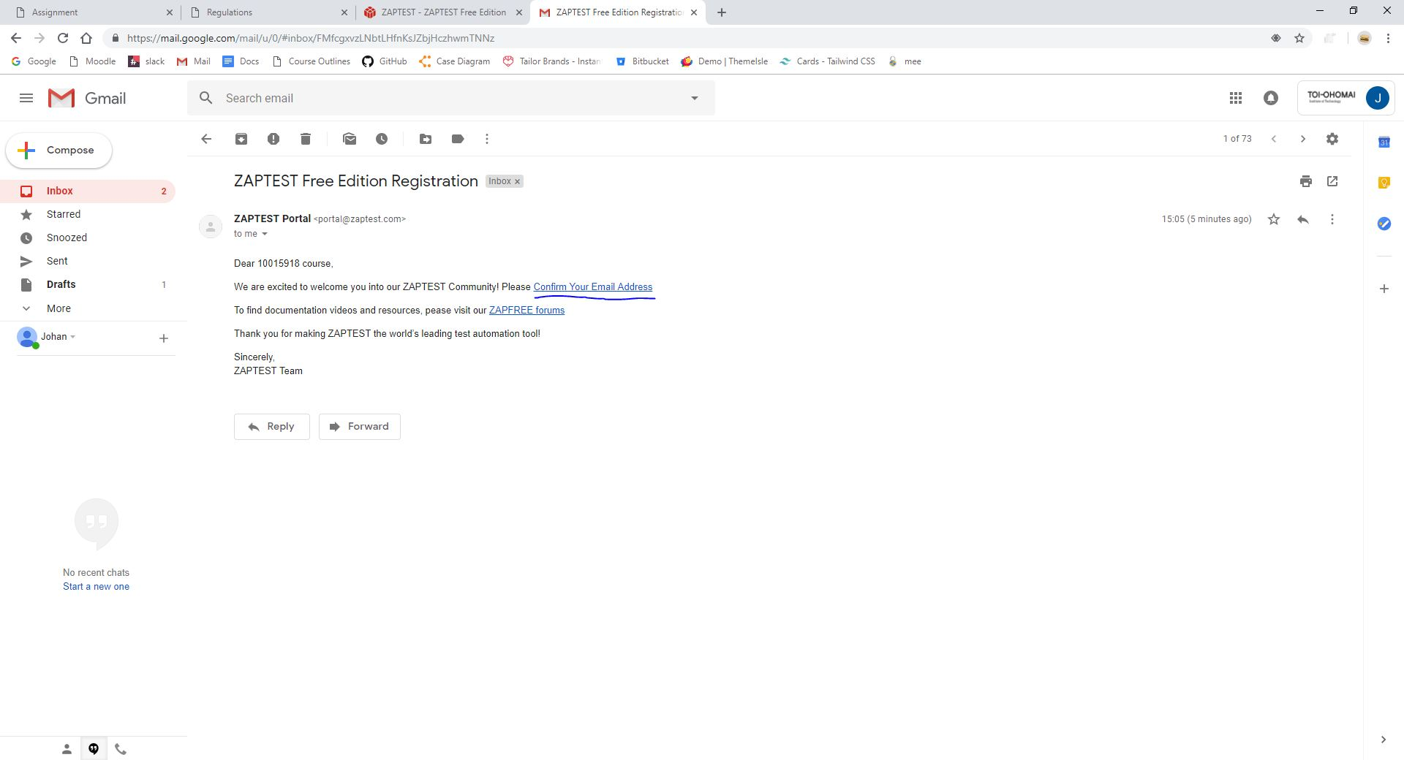

Step 9: Follow the “confirm your email address” link to activate your account.  
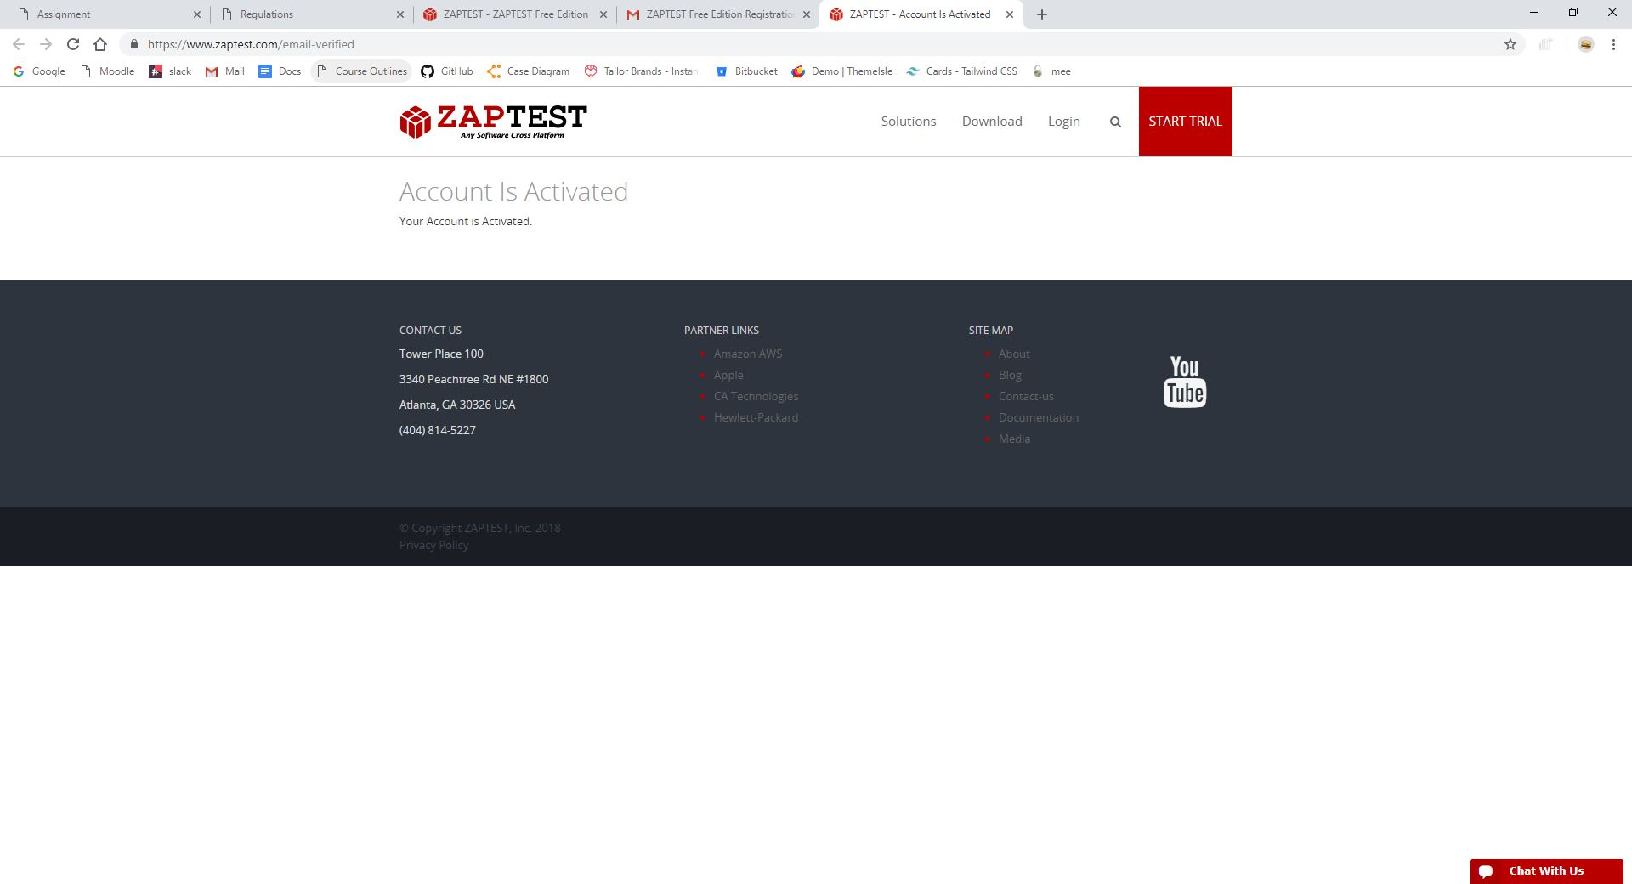

Step 10: Login using your activated account.  
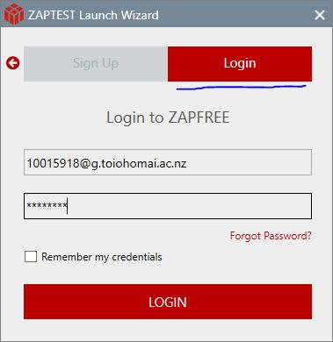

# Task B

## B1:

Zaptest provides testing cross platform which includes; Windows, Mobile Platforms, MacOS and Linux

# References

ZapTest. (2018). *About Us*. Retrieved from Zaptest any software cross platform: https://www.zaptest.com/about