**PHARMACY MANAGEMENT SYSTEM**

**FOR**

**BAJRA PHARMACY**

**BY**

**Nicky Maharjan**

**T.U. Registration No**. **7-2-551-210-2020**

National College of Computer Studies (NCCS)

*A Summer Project Report Submitted to*

**Faculty of Management, Tribhuvan University**

in partial fulfillment of the requirements for the degree of

**Bachelor of Information Management**

Paknajol, Kathmandu

June/2024

# **STUDENT DECLARATION**

This is to certify that I have completed the Summer Project entitled “Pharmacy Management System” under the guidance of “Teksan Gharti Magar” in partial fulfillment of the requirements for the degree of **Bachelor of Information Management** at Faculty of Management, Tribhuvan University. This is my original work and I have not submitted it earlier elsewhere.

Date: June/2024 Signature:

Name:

# **CERTIFICATE FROM THE SUPERVISOR**

This is to certify that the summer project entitled “Pharmacy Management System” is an academic work done by “Nicky Maharjan” submitted in the partial fulfillment of the requirements for the degree of **Bachelor of Information Management** at Faculty of Management, Tribhuvan University under my guidance and supervision. To the best of my knowledge, the information presented by her in the summer project report has not been submitted earlier.

_____________________

Signature of the Supervisor

Name: Teksan Gharti Magar

Designation: Supervisor

Date: June/2024

# **ACKNOWLEDGEMENT**

I would like to express my sincere appreciation to **Tribhuvan University(TU)** for providing me with the opportunity to undertake this project. Their dedicated approach to encouraging innovation and academic excellence has enlighten my path, leading me to endless opportunities and incredible accomplishment.

I am really grateful to **National College of Computer Studies (NCCS)** for their constant dedication to encouraging learning and personal growth. It has helped me shape my academic path. I am extremely grateful for the college’s great guidance and encouragement, which has enabled me to approach this project with confidence and determination.

I would like to express my heartfelt gratitude and indebtedness to my mentor, **Mr. Teksan Gharti Magar** for his unwavering support, kindness, and understanding spirit. Without his encouragement and guidance, this project would not have been possible.

I would like to express my sincere appreciation to **Bajra Pharmacy** for their incredible support and participation during the project’s implementation. Their commitment to encouraging innovation and building connections has been essential in ensuring the success of the project. I am grateful to **Mr. Suresh Bajracharya** for his support and kindness, which helped to meet the opportunities of the project and make an impact in my field.

This project would not have been completed without the participation and assistance of so many people, some of whom may not be named. Their contributions are deeply appreciated and humbly acknowledged. All of the members who contributed to this project provided invaluable guidance and support, which was critical to its success. I am grateful for their ongoing support and assistance with this project.

Sincerely,

Nicky Maharjan

# **EXECUTIVE SUMMARY**

A summer project report is a requirement for completing the Bachelor of Information Management (BIM) degree. This summer project is designed to manage a pharmacy using a "Pharmacy Management System" for an organization called "Bajra Pharmacy" located at Tahachal, Kathmandu. The "Pharmacy Management System" focuses on the simple management of pharmacy-related activities. This project aims to learn about how the pharmacy currently operates its various activities and how the same activity can be performed more efficiently using software. This system will assist pharmacists in keeping track of their medicine inventory, as well as users’ and suppliers’ information. It also includes features for managing and printing bills.

Chapter one provides an overview of the Pharmacy Management System (PMS). This project aimed at solving the issues that Bajra Pharmacy has been facing. The pharmacy relies on manual processes for inventory management, sales monitoring, and supplier data maintenance, which leads to difficulties including unreliable management of medicine stock, mismanaged suppliers’ data and inaccurate sales tracking. The project aims include automating inventory management, tracking sales, and effectively managing supplier data. The project's methodology is incremental development, including phases for initiation, planning, execution, and review, with the owner's feedback being included throughout the process. Information is gathered using a variety of data gathering methods, including interviews, observations, and secondary research. Tools like Java Swing, Java, MySQL, and NetBeans IDE are used for system development.

Chapter two takes into the task and activity analysis that was performed as part of the implementation of the Pharmacy Management System (PMS) for Bajra Pharmacy. It starts with an Entity Relationship Diagram (ERD) that demonstrates the links between entities in the system. The chapter also performs an issue analysis to identify operational problems that the pharmacy has as a result of manual record-keeping system. Potential solutions are considered, including functional needs like user authentication and role-based access control, as well as non-functional requirements like usability and dependability. To determine the project's feasibility, feasibility studies are undertaken in the areas of economic, technical, operational, and schedule. System architecture, class diagram, activity diagrams, and sequence diagrams are used to describe process modeling and provide explanations for the system's design and operation. System preparation and evaluation is discussed, including test cases for capabilities such as user authentication and medicine data management, with findings pointing out progress toward addressing the pharmacy's difficulties.

The Pharmacy Management System (PMS) is designed to automate medical store processes and increase efficiency by organizing and securing pharmaceutical data. It deals with manual management difficulties, while increasing accuracy, safety, and efficiency in pharmaceutical operations. The PMS handles essential data that enables effective pharmaceutical store operations, and offers choices for data entry, sales transactions, and user and supplier information management. To improve the system even further, recommendations include automatic data entry and notifications for low stock levels and expired drugs.

# **TABLE OF CONTENTS**

*TITLE PAGE.........................................................................................................................................i*

*STUDENT DECLARATION ii*

*CERTIFICATE FROM THE SUPERVISOR iii*

*ACKNOWLEDGEMENT iv*

*EXECUTIVE SUMMARY v*

*TABLE OF CONTENTS vi*

*LIST OF TABLES viii*

*LIST OF FIGURES ix*

*ABBREVIATIONS x*

**CHAPTER I: INTRODUCTION**

1.1 Background 1

1.2 Introduction of the organization 1

1.3 Current situation of the organization 1

1.4 Issues/Problems of the report 1

1.5 Objectives 2

1.6 Methodology 2

1.6.1 Project Framework 2

1.6.2 Data and Information 2

1.6.3 Tools Used 3

1.6.4 Technique of Project Report Analysis 3

**CHAPTER II: TASK AND ACTIVITY PERFORMED**

2.1 Analysis of tasks, activities, problem and issues 4

2.1.1 Entity Relationship Diagram 4

2.2 Problem Analysis 4

2.3 Analysis of Possible Solutions 5

2.3.1 Requirement Analysis 5

2.3.2 Functional Requirement 5

2.3.2.1 Use Case Diagram 6

2.3.3 Non-Functional Requirement 7

2.4 Feasibility Study 7

2.4.1 Economic Feasibility 7

2.4.2 Technical Feasibility 8

2.4.3 Operational Feasibility 8

2.4.4 Schedule Feasibility 8

2.5 Process Modeling 8

2.5.1 System Architecture 9

2.5.2 Class Diagram 10

2.5.3 Activity Diagram 11

2.5.4 Sequence Diagram 13

2.6 System Implementation 15

2.6.1 Development Methodology 15

2.6.2 Module Description 16

2.7 System Testing 16

2.8 Findings 20

**CHAPTER III: DISCUSSION AND CONCLUSION**

3.1 Discussion 21

3.2 Conclusion 21

3.3 Recommendation 21

**REFERENCES 22**

**APPENDICES 1: QUESTIONNAIRE a**

**APPENDICES 2: SCREENSHOTS b**

# **LIST OF TABLES**

Table 2. 1: Use Case Diagram Description 6

Table 2. 2: Gantt Chart 8

Table 2. 3: Class Diagram of Pharmacy Management System 10

Table 2. 4: Description of Test Case for Login Module 16

Table 2. 5: Test Case for Login Module 17

Table 2. 6: Description of Test Case for Manage Medicine Module 18

Table 2. 7: Test Case for Manage Medicine Module 18

# **LIST OF FIGURES**

Figure 2. 1: ER Diagram of Pharmacy Management System 4

Figure 2. 2: Use Case Diagram of Pharmacy Management System 6

Figure 2. 3: Architecture Design 9

Figure 2. 4: Activity Diagram of Pharmacy Management System for Admin 11

Figure 2. 5: Activity Diagram of Pharmacy Management System for Pharmacist 12

Figure 2. 6: Sequence Diagram of Pharmacy Management System for Admin 13

Figure 2. 7: Sequence Diagram of Pharmacy Management System for Pharmacist 14

Figure 2. 8: Incremental Methodology Design 15

# **ABBREVIATIONS**

BIM Bachelor of Information Management

ERD Entity Relationship Diagram

FR Functional Requirements

GPP Good Pharmacy Practice

MySQL My Structured Query Language

NCCS National College of Computer Studies

NFR Non-Functional Requirements

OTC Over-the-counter

PMS Pharmacy Management System

TC Test Case

TU Tribhuvan University

UI User Interface

**UML Unified Modeling Language**

**UNIX** UNiplexed Information Computing System

XAMPP C**ross-Platform Apache MySQL PHP Perl**

# **CHAPTER I: INTRODUCTION**

## **Background**

A pharmacy is a facility that dispenses, sells, and manages medications, drugs, and other healthcare products. Pharmacists, as trained professionals, play an important role in ensuring the safe and effective use of medicines. Pharmacies offer a variety of services, including prescription filling, over-the-counter (OTC) medication sales, health consultations, and public health education (Collins, 2007).

A pharmacy management system (PMS) is a software application that simplifies and automates a variety of pharmacy tasks (SlideShare, 2006). It enables pharmacists and pharmacy staff to efficiently manage inventory, process prescriptions, handle billing. And these are just the traditional functions that can be automated. The system is intended to improve accuracy, reduce errors, and increase overall operational efficiency in a pharmacy setting. The use of technology in PMS improves inventory control, and overall business operations.

## **Introduction of the organization**

Bajra Pharmacy was established in the year 2013 by Suresh Bajracharya. It is located in the center of Tahachal area and is a sole owned organization with no collaborating partners. This pharmacy has provided services like dispensing over-the-counter and prescribed medications, prescription for medications and advising patients about medications, including how to take, what reactions may occur and answering patient’s questions for almost 10 years. Since the beginning, this organization has successfully adopted Good Pharmacy Practice (GPP). The supply of medications and other health care products is always assured quality with appropriate information and advice for the patients. All of them are purchased legally. This organization does not have any medications on the online platform.

## **Current situation of the organization**

Currently, the organization has two working staff along with Suresh Bajracharya and Maya Bajracharya. They manage all the records of sales, suppliers and stocks. As now there is no computerized record-keeping system used in this organization. All the records are manually handled and stored in written form. The pharmacist records all the daily transactions at the end of day and examines the stock every two or three months to filter out the expired medicines. The suppliers’ information is kept in the journal or phone and contacted through provided telephone number or email address.

## **Issues/Problems of the report**

Even though adopting Good Pharmacy Practice (GPP), the organization has encountered several issues. Some of the pharmacy's major issues include unmanaged medicine stock, difficulty separating expired medicine, and misplacement of supplier data, among many others. The main cause of these problems is a lack of a digitalized system. However, we will only be identifying a few problems and possibly finding solutions to them.

* **Lack of Digital Record Keeping of**
* **Inventory Management:**

Bajra Pharmacy stores all stock documents manually. So, consistent stock tracking has been a problem for this pharmacy. Using manual inventory tracking procedures is time-consuming, redundant and vulnerable to errors. The pharmacy has been struggling to keep track of its medicine stocks.

* **Sales report:**

The difficulty faced by Bajra Pharmacy is tracking the sales of medicines. The pharmacy currently records medicine sales in a journal at the end of each day. The issue with pharmacy sales tracking is ensuring that everything sold is accurately recorded.

* **Supplier’s data:**

At present, Bajra Pharmacy has a dozen of suppliers. As per the collected data, there used to be more than 25 different suppliers. One of the major problems faced by the pharmacy is the lack of suppliers’ data maintenance. This pharmacy stores data in written format with a high chance of misplacement or data loss.

## **Objectives**

A major objective is to build a system that can solve most of the above-mentioned problems and create value for this pharmacy. Some of the core objectives are:

* To automate inventory management.
* To track sales report.
* To maintain supplier’s data.

## **Methodology**

The methodology used to prepare this report was quantitative and qualitative research methods. The process was greatly enhanced by the coordination of the owner himself.

### **Project Framework**

The overall project is divided into four segments. They are:

1. **Initiation**

In this stage of the project, all the activities related to brainstorming, research, feasibility analysis, and owner’s interviews are carried out. The key focus of this stage is to identify which key components are required to put the project into action.

1. **Planning**

In the planning stage, all the plans for the project are determined including a number of individuals to be interacted with, planning of progress and proper management is addressed.

1. **Execution**

This stage focuses on the actual production of a system and all the action required for the development of the system. This stage helps to make progress in this project.

1. **Management and Review**

This stage focuses on documentation and monitoring of the project. Progress is identified and necessary steps are further implemented. In this review stage, the overall project is analyzed and discussed with relevant individuals involved in the development if the project.

### **Data and Information**

The data and information for this report were collected using two methods. They are:

1. Primary data collection method

Primary data were collected by gathering data through surveys, interviews and observation. For the data collection, different sets of questionnaires were prepared and provided to the owner and working staff. Some of the questions that were asked to owner of the organization were:

* How frequently is the medicine stock checked?
* How do you record the sales report?
* How many suppliers are you associated with?

1. Secondary data collection method

The secondary data were collected using internet that helped to know which type of software will be suitable for the organization.

### **Tools Used**

For the development of the Pharmacy Management System (PMS), different tools were used. They are mentioned below:

* **Front end:**

Java Swing: This API helped to create a suitable user interface for this PMS project. Different swing events were used to create an interactive interface.

* **Backend:**

Java: Java helped to create an independent platform for the PMS project along with database connectivity. In this project, Java is used to perform all the backend programs.

* **Database:**

MySQL: MySQL is used for the database management for the PMS system.

* **Editor:** NetBeans IDE

### **1.6.4 Technique of Project Report Analysis**

As for the data collection, the following techniques were used:

* Interview:

Direct personal interview method was used to collect the information from the owner of the pharmacy organization and working staffs by personally visiting and meeting from where the necessary data were collected.

* Questionnaire:

Many questions were prepared to ask the owner, working staff as well as some of the customers. The questionnaire included both subjective and objective questions and all the answer were filled by the participator themselves.

* Observation:

The activities on the organizations’ premises were observed and analyzed accordingly to study the working mechanism and to study the problem of the organization.

* Internet:

Internet was used to further gain information about the problems most of the other pharmacies as well are facing. Internet helped to fill out all the answers that were ambiguous.

# **CHAPTER II: TASK AND ACTIVITY PERFORMED**

## **2.1 Analysis of tasks, activities, problem and issues**

To achieve the intended goals, task analysis is performed, which assists in determining how a system should be designed for the user, what design should be adopted, and what measures should be taken to complete tasks.

### **2.1.1 Entity Relationship Diagram**

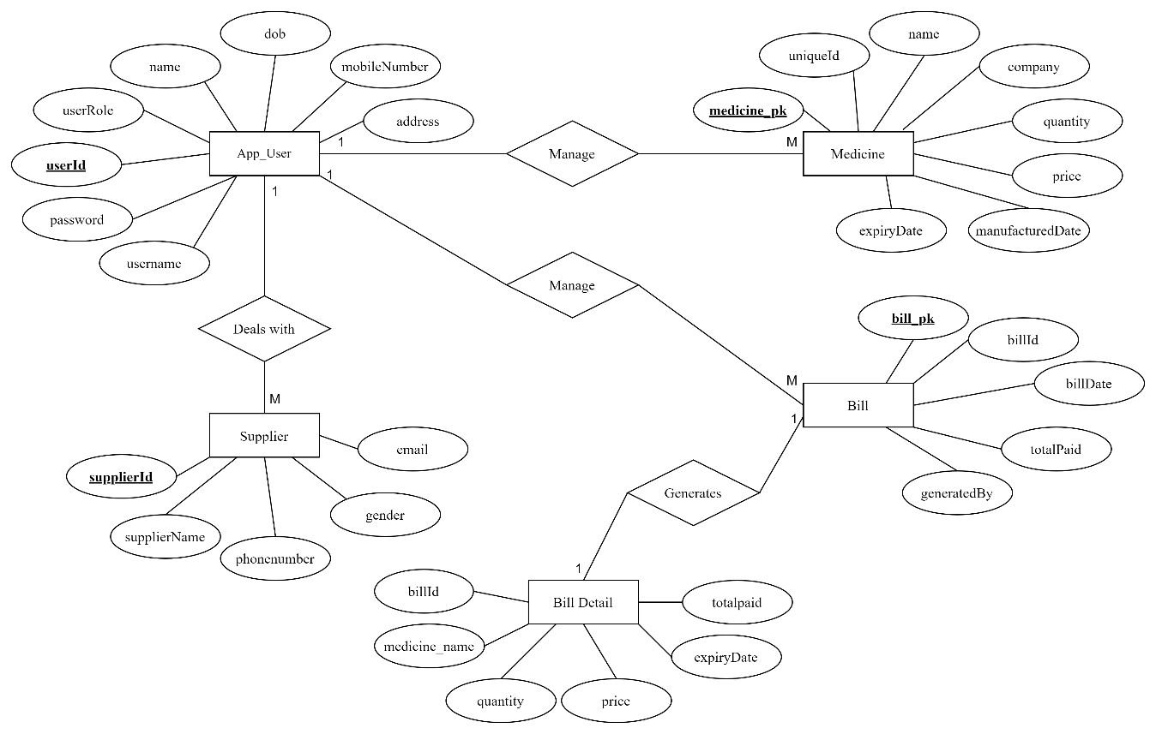

Figure 2. 1: ER Diagram of Pharmacy Management System

In the given Entity Relation diagram (ERD), the relationship between entities such as app_user, medicine, supplier and bills are illustrated. Every entity consists of different attributes. Here, the app_user entity has userId, username, password, userRole, name, dob, mobileNumber and address as its attributes. Similarly, medicine with medicine_pk, uniqueId, name, company, quantity, price, manufacturedDate and expiryDate. Supplier have attributes like supplierId, supplierName, phoneNumber, gender and email. Bills have bill_pk, billId, billDate, totalPaid and generatedBy attributes. Bill Detail have billId, medicine_name, quantity, price, expiryDate, totalpaid attributes. There are different relations between these entities such as: “App_user manage Medicine”, “App_user manage Bill”, “App_user deals with Supplier” and “Bill generates Bill Detail”. These are the relations used in the Pharmacy Management System (PMS).

### **2.2 Problem Analysis**

Bajra Pharmacy faces major operational issues as it operates using manual record-keeping techniques rather than computerization. The absence of digitization has resulted in problems such as mismanaged medicine stock, difficulties separating outdated medicine, and misplacement of supplier data, among others. Root cause analysis helps to identify the root cause behind the problem by asking the people involved directly which in this case is the owner of the Pharmacy (altexsoft, 2007).

According to root cause analysis, the limitation of manual tracking and recording of information is the cause behind the pharmacy struggling with inventory management, tracking sales, and keeping suppliers’ information. These concerns cause errors, inefficiencies, and possible losses for pharmacies. Implementing digital solutions could solve these difficulties and simplify processes, assuring more accurate record-keeping, efficient stock management, and better supplier data management.

## **2.3 Analysis of Possible Solutions**

### **2.3.1 Requirement Analysis**

The Pharmacy Management System provides functions to store data of application users and suppliers, facilitate the accessibility of medicines information in pharmacies, and provide sales data. This system will solve the problems that the pharmacy is currently facing and reduce inconsistent and inflexible data storage system.

### **2.3.2 Functional Requirement**

There are functions that are done by the system such as: storing the information of the medicines, preparing bill for the medicine, easy retrieval of medicine information along with updating and deleting features. The following are the functional requirements of the PMS system:

* **Login:** Application user can login to access the system and its functionalities.
* **User Role:** The user is granted access to the system based on the role assigned to the user, which can be either administrator or pharmacist.
* **Manage Medicine:** Application user can manage the information of medicine by adding, updating or deleting as per requirement and handle returned medicine.
* **Manage Supplier:** Administrator of the application user can manage the information of all the linked supplier by storing their name, phone number and email.
* **Manage Bills:** Pharmacists can generate bills for the purchase made by the customer.
* **Retrieve Sales Report:** Sales report based on either date or bill id can be retrieved.
* **Logout:** Logout will send the user back to the login page.

### **2.3.2.1 Use Case Diagram**

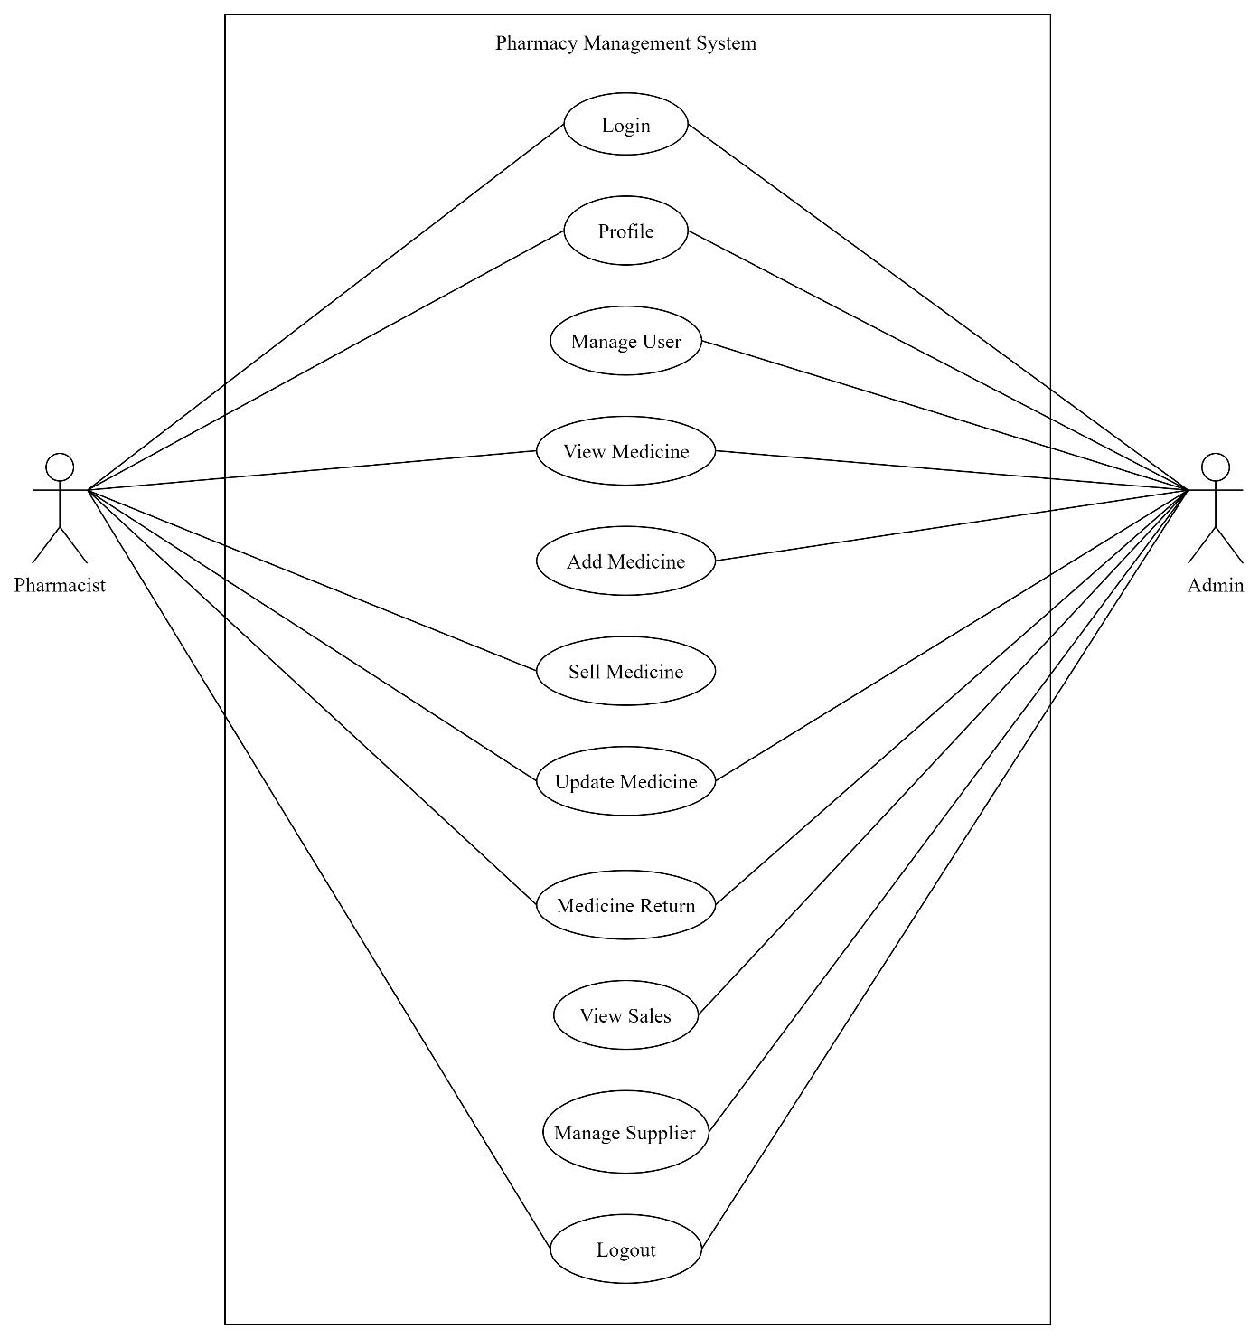

Figure 2. 2: Use Case Diagram of Pharmacy Management System

Table 2. 1: Use Case Diagram Description

|  |  |
| --- | --- |
| Actors | Administrator, Pharmacist |
| Description | Application User can easily login to the system with the help of username and password. The access is granted after verification. Access is granted based on the user role, whether the user is an administrator or a pharmacist. An administrator manages all  the users, medicine, supplier, returned medicine and sales. A pharmacist manages medicine and billing. Administrator can view sales report based on bill date or id. Application user can logout from the system easily. |
| Data | User information, medicine information with manufactured date and expiry date, suppliers’ information, sales data and bills. |
| Stimulus | The command is issued by an application user. |
| Response | Confirmation of user, medicine, supplier updates and deletion along with bill records update. |
| Comment | An administrator can have access to information related to user, medicine, supplier and bill. A pharmacist can have access to information related to medicine and billing. All the information is entered by an application user. |

### 

### **2.3.3 Non-Functional Requirement**

This Pharmacy Management System is able to operate in the following non-functional characteristics:

* **Usability:** Any person who is familiar with the windows operation can operate the system since it has user friendly user interface.
* **Reliability:** The pharmacy system is available based on the user needs and can work properly. The information can only be stored if it is verified by the system. Any attempt to store improper data will not be allowed.
* **Performance:** The pharmacy management system operates its functions in small amount of time.
* **Security:** The pharmacy management system can only be accessed by the authorized person of safe work. Without login details no individual can access the system. Administrator and pharmacists have different access rights.

## **2.4 Feasibility Study**

The pharmacy provides a wide variety of medications such as cough medicines, pain relievers and personal hygiene products/ supplies. This project aims to provide the efficient management of all the medicines information along with its amount of stock. It can provide services to the pharmacist with the help of easy data storage and retrieve functionality. This project aims to contribute to the daily management of pharmacy activities.

### **2.4.1 Economic Feasibility**

All of the tools used to build this system are open source, making it cost-effective. The initial development costs are significantly reduced, as there are no licensing fees associated with the language. This system was built without using any external hardware, which saved money. Additionally, Java’s platform independence allows the PMS to run seamlessly across different operating systems and hardware configurations, eliminating the need for costly infrastructure upgrades and ensuring compatibility with existing systems.

### **2.4.2 Technical Feasibility**

The PMS software is created using the Java programming language, which is platform independent. As a result, this software is compatible with all operating systems, including Linux, Windows, UNIX, and Mac. As a result, there will be no problems during the installation process on any computer, ensuring that it is technically feasible.

### **2.4.3 Operational Feasibility**

Operational feasibility of the PMS system is:

* The proposed system offers more user-friendly lines.
* The proposed system achieves the best results and provides high performance.
* It can be easily implemented. So, the project is operationally feasible.

### **2.4.4 Schedule Feasibility**

The Pharmacy Management system was developed within a considerable amount of time. This system can be updated or maintained from time to time without any nuisance.

Table 2. 2: Gantt Chart

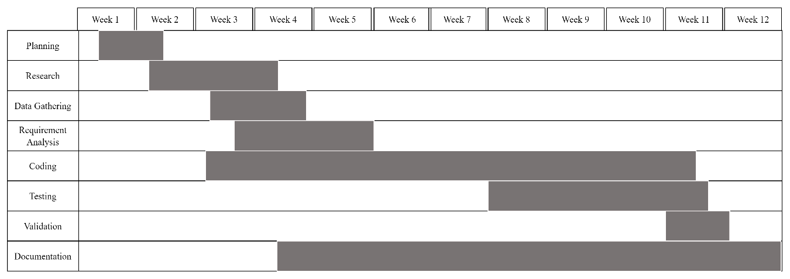

As per above table 2.2, the Pharmacy Management System’s development began with planning, research and data gathering. After gathering enough resources, the system’s requirements were analyzed. Coding and documentation took up the majority of the time while development of this system. Testing and validation were performed both during and after the completion of the code.

## **2.5 Process Modeling**

Software process is a partially ordered set of activities undertaken to manage, develop and maintain software systems, that is, the software process centers on the construction process rather than on the product output. The definition of a software process usually specifies the actors executing the activities, their roles and the artefacts produced (ResearchGate, ResearchGate, 2008).

As the suitable solutions presented in previous section, the details of the design models can be provided. Typically, the proposed models represent the description of solution through various attributes. With the help of activity diagram, use case diagram, class diagram and ER diagram, the process model of Pharmacy Management System is presented.

### **2.5.1 System Architecture**

The design of a pharmacy management system is essential in ensuring efficient and secure operations within the pharmacy. This architecture is intended to address the various needs of administrator and pharmacists by providing an organized system for handling essential elements such as medicine inventories, user accounts, supplier information, and sales data. The design provides easy access and operation by combining user-friendly interfaces with backend components.

The architecture of PMS is as follows:

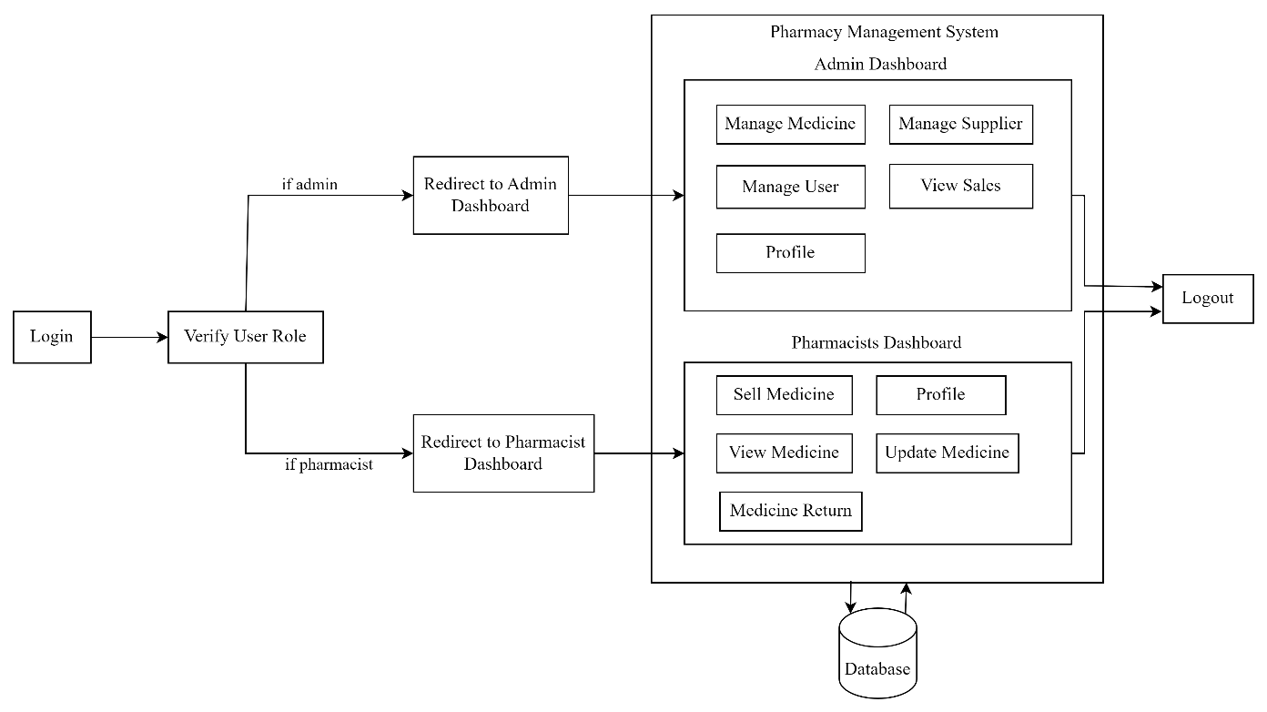

Figure 2. 3: Architecture Design

As shown in the above figure 2.3, the pharmacy management system functions as a central point. As user login through the main entrance, their credentials determine where they are directed inside the system or not. The access is granted in accordance with the user role. Administrators can access, add, update, and remove medicine, user, supplier information and medicine return functionality. Pharmacists can view, update, sell medicine and handle returned medicine. Both users are able to examine their individual profiles. The system interacts with the database during the execution of the user's request. The user can then log out of the system.

### **2.5.2 Class Diagram**

Table 2. 3: Class Diagram of Pharmacy Management System

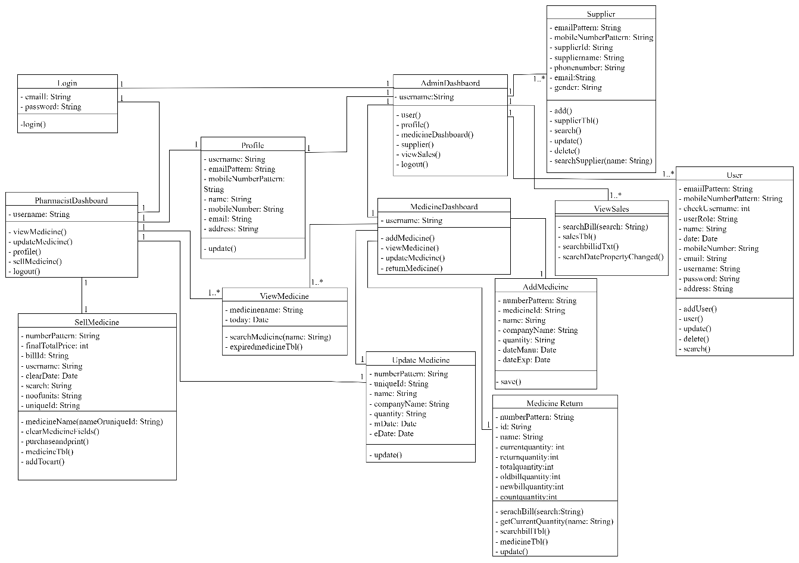

In table 2.3, it is shown that Login class has one to one relations with AdminDashboard and PharmacistsDashboard. After authentication, application user will be redirected to either AdminDashboard or PharmacistDashboard, depending on the user’s role. AdminDashboard stores username and offers functionalities like user(), profile(), medicinedashboard(), supplier(). viewSales() and logout(). The User class handles user related information. It stores information like emailPattern, mobileNumberPattern, checkUsername, userRole, name, date, mobileNumber, email, username, password and address. This class includes methods like addUser(), user(), update(), delete() and search(). The Supplier class handles supplier related information. It stores information such as emailPattern, mobileNumberPattern, supplierId, suppliername, phonenumber, email and gender. This class includes methods like add(), supplierTbl(), search(), update(), delete() and searchSupplier(name: String). The MedicineDashboard class stores user name and consists of addMedicine(), viewMedidicne(), updateMedicine() and return Medicicne(). The AddMedicine class stores numberPattern, medicineId, name, companyName, quantity, dateManu and dateExp information and offers save() function. The ViewMedicine class stores medicinename and todayinformation and offers searchMedicne(name: String) and expiredmedicineTbl() function. The UpdateMedicine class stores numberPattern, uniqueId, name, companyName, quantity, mDate and eDate information and consists of update() function. Similarly, MedicineReturn class stored numberPattern, id, name, currentquantity, returnquantity, totalquantity, oldbillquantity, newbillquantity and countquantity and offers functionalities like searchBill( searchBill: String), getCurrentQuantity(name: String), searchBillTbl(), medicineTbl() and upadte(). The ViewSales class

offers searchBill(search: String), salesTbl(), searchBillTbl() and searcgDatePropertyChanged() functionalities. The Profile class stores username, emailPattern, mobileNumberPattern, name, mobileNumber, email and address and offers update() function. The PharmacistDashboard class stores username and consists of viewMedicine(), updateMedicine(), profile(), sellMedicine() and logout() functions. The SellMedicine class consists of numberPattern, finalTotalPrice, billId, username, clearDate, search, noofunits and uniqueId information and offers medicineName(nameOruniqueId: String). clearMedicineFields(), purchaseandprint(), medicineTbl() and addTocart() functions. The above class diagram represents different classes that are fundamental to the system's functionality.

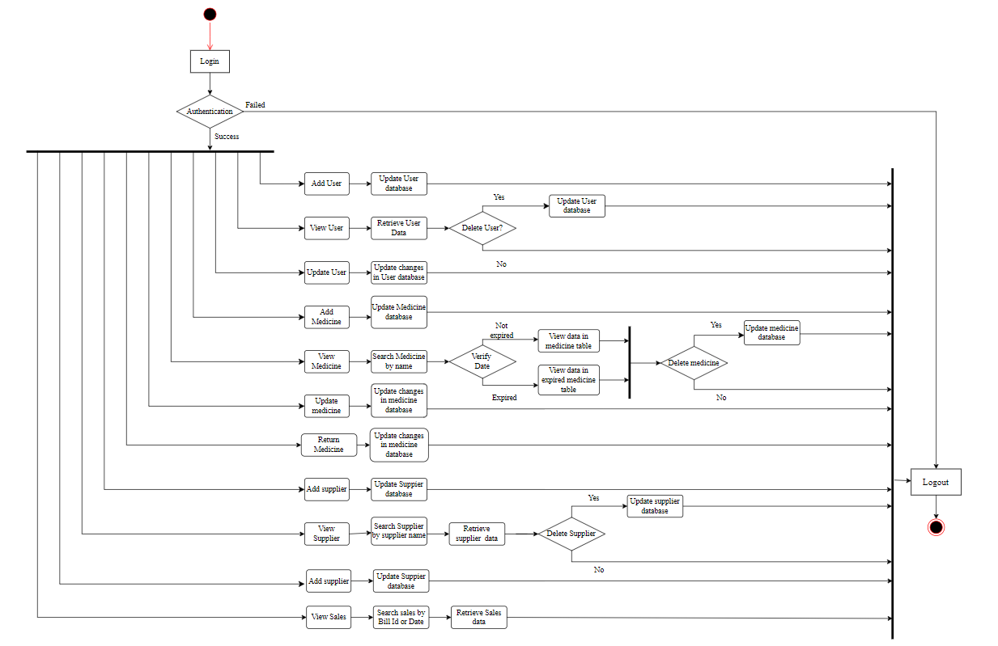**2.5.3 Activity Diagram**

Figure 2. 4: Activity Diagram of Pharmacy Management System for Admin

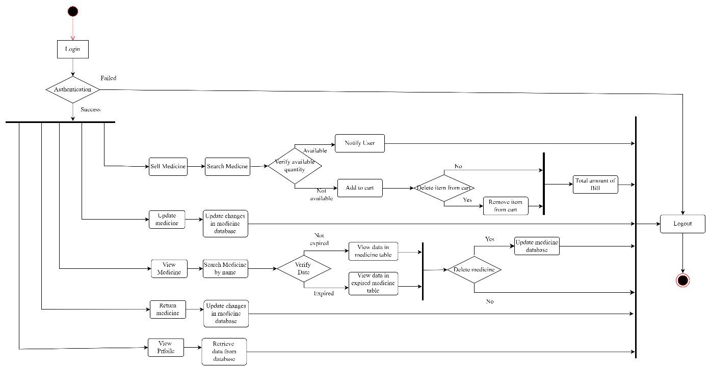

Figure 2. 5: Activity Diagram of Pharmacy Management System for Pharmacist

From Figure 2.4 and 2.5, the activity of PMS starts from the Login for both users, admin and pharmacists. After checking its authentication, if the login fails it displays the message to user and move user to logout page else, it enters into the system. If the user's role is administrator, they are moved to the admin dashboard, otherwise to the pharmacist’s dashboard. As an administrator, the user can add medicine, users, and suppliers, update medicine and users. An administrator can view user, medicine, supplier, and sales data as well as handle returned medicine. As a pharmacist, the user will be able to view, update, sell medicines and handle returned medicine. Different records of medicine are displayed which can be updated or deleted. However, if the given data of medicine is expired then it will display medicine in expired table. The changes are then saved. The supplier data can be retrieved or deleted based on requirement. Similarly, sales report can be retrieved by bill id or date. The medicine stock record is shown and based on those records the medicines can be sold. The medicine name and quantity are required to make any kind of sales. It also prints bill to provide to the customer. The user can easily log out the system.

### **2.5.4 Sequence Diagram**

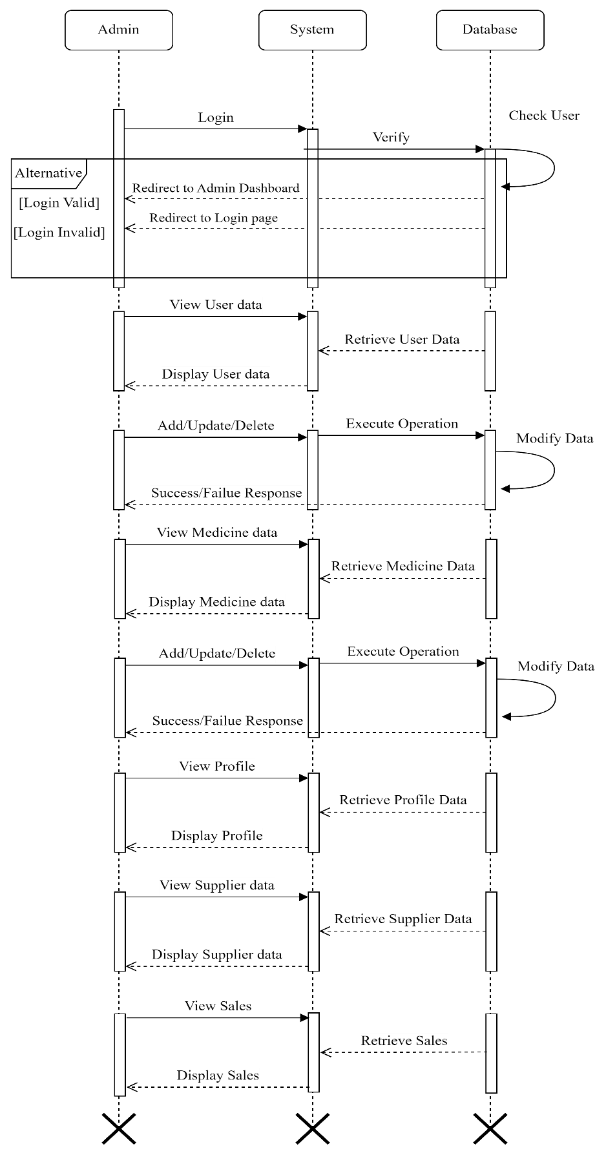

Figure 2. 6: Sequence Diagram of Pharmacy Management System for Admin

In figure 2.6, the diagram shows the admin’s interaction with the system, which begins with login authentication using database checks. Once authenticated, admin can view, add, update, and delete medicine, user, and supplier data. They can also check their profile and view sales data. Each action initiates database interactions, with the system returning results indicating success or failure.

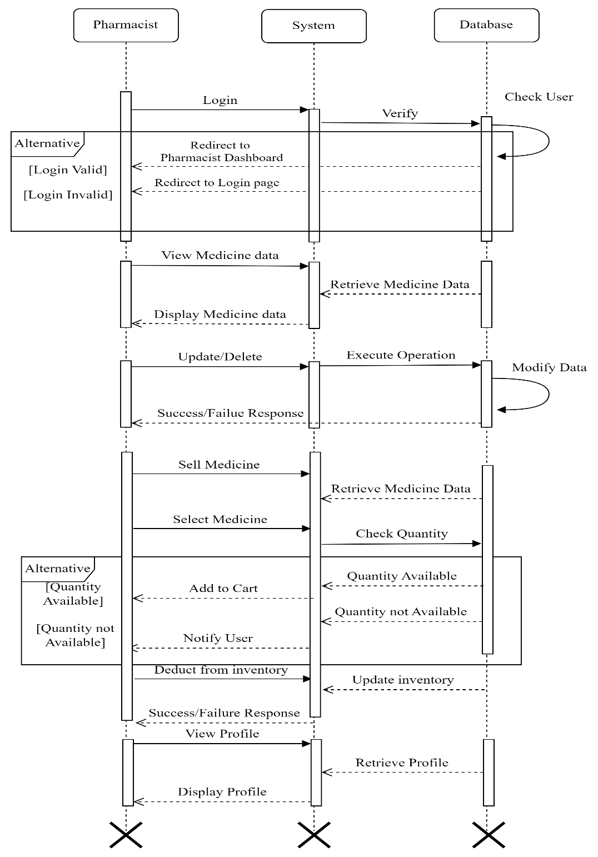

Figure 2. 7: Sequence Diagram of Pharmacy Management System for Pharmacist

In figure 2.7, the diagram shows the interaction between pharmacists, the system, and the database. Initially, the pharmacist makes a login request, which the system checks from the database. After successfully authenticating, the pharmacist can view their profile, access medicine data, and take actions such as updating or deleting medicine data. When selling medicine, the system obtains relevant data from the database, deducts sold amounts from inventory, and adjusts inventory levels accordingly. Throughout these exchanges, the system returns success or failure results to the pharmacist.

## **2.6 System Implementation**

The Pharmacy Management System was easily implemented. It enables administrators and pharmacists to effectively manage users, medicines, suppliers, and sales. The system seeks to improve pharmacy management efficiency and accuracy by including secure access control and user-friendly interfaces.

### **2.6.1 Development Methodology**

The Pharmacy Management System was created using an incremental methodology. Instead of taking on everything at once, the project was divided into smaller phases. Each phase focuses on gradually adding more features. Staying in touch with the pharmacy owner ensured their feedback was considered, enabling for future modifications and improvements. This gradually implemented approach, made the development process easier to manage and flexible, resulting in successful system evolution. The process was greatly enhanced by the coordination of the owner himself.

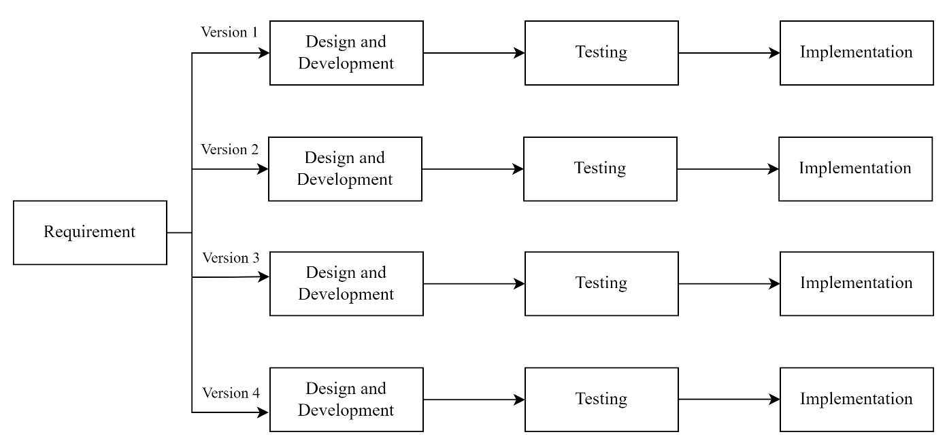

Figure 2. 8: Incremental Methodology Design

From Version 1 to Version 4, great progress was made in the system by addressing feedback from the pharmacy owner and making incremental changes. Initially, version 1 enabled pharmacists to do basic tasks such as adding, updating, deleting, and selling medicines, while administrators managed application users. However, in version 2, the system was significantly extended and improved. Following pharmacy owners' ideas, administrators were given more authority to control users, drugs, and suppliers, with the addition of supplier management functionality. Pharmacists' capabilities were also improved with the ability to view, update, and sell medicines, as well as the addition of low stock medicine table and a search option for easier browsing. Version 3 included more refinements based on feedback from the owner. Additionally, the view medicine function has been significantly improved, displaying medical facts in a more clear and logical manner. Improved access features, such as filters and search options, were also added, which created a more user-friendly experience. Version 4 covered two key features: an alert table for medicines about to expire and a medicine return module. The alert table helped inventory management by alerting pharmacists to medicines that were about to expire. Meanwhile, the medicine return module reduced the process of handling returns for both bills and medicines, resulting in more efficient transactions when customers returned product. The modifications improved the system's functioning  resulting in better productivity.

### **2.6.2 Module Description**

A module description of a pharmacy management system typically outlines the functionality and features of the system related to managing various aspects of a pharmacy's operations. The system utilizes role-based access control to cater to the specific needs of administrators and pharmacists, granting them functionalities tailored to their responsibilities. The pharmacy management system consists of the following modules:

1. **Authentication Module:**

This module is responsible for the login functionality of the system. It verifies the credentials provided by the user during login. Upon successful verification, it determines the role of the user (admin or pharmacist).

1. **Admin Dashboard Module:**

This module provides access to the functionalities specific to administrators.

* Manage Medicine: Allows admins to add, update, and delete medicine information and manage returned medicine in the system. Also handle medicine that any customer returns.
* Manage Users: Enables admins to add, update, and delete user accounts, particularly pharmacists.
* Manage Supplier: Provides functionality for admins to manage supplier information, such as adding and deleting supplier details.
* Profile: Allows admins to view and potentially update their own profile information.
* Logout: Enables admins to securely log out of the system.

1. **Pharmacists Dashboard Module:**

This module is designed for pharmacists, providing access to functionalities relevant to their role.

* View Medicine: Allows pharmacists to view details of medicines available in the system.
* Update Medicine: Enables pharmacists to update medicine information, such as stock levels.
* Medicine Return: Enables pharmacists to handle returned medicine.
* Sell Medicine: Provides functionality for pharmacists to process sales transactions for medicines.
* View Profile: Allows pharmacists to view their own profile information.
* Logout: Enables pharmacists to securely log out of the system.

Each module serves a specific purpose within the pharmacy management system, catering to the needs and responsibilities of different user roles (admin and pharmacist) while ensuring secure access and efficient operation of the system.

## **2.7 System Testing**

Table 2. 4: Description of Test Case for Login Module

|  |  |
| --- | --- |
| Project Name: Pharmacy Management System (PMS) | |
| Test Case | |
| Test Case ID: TC_login | Test Designed Date: February, 2024 |
| Test Case Type: Functional Test Case | Test Executed By: Nicky Maharjan |
| Module Name: Login Module | Test Execution Date: February, 2024 |
| Test Title: Login | |
| Severity: Critical | |
| Summary: To check the functionality of login module | |
| Pre-condition: Need a valid username and password login | |

Table 2. 5: Test Case for Login Module

|  |  |  |  |
| --- | --- | --- | --- |
| **Testcase Id** | **Test Scenario** | **Test Case** | **Test Steps** |
| TC_login_1 | To test if an appropriate message is displayed when the user login without appropriate username and password | Enter valid username and invalid password OR Enter invalid username and valid password OR Enter invalid username and password | 1. Enter username  2. Enter password  3. Click Login Button |
| **Test Data** | **Expected Result** | **Actual Result** | **Status** |
| <invalid username>  <invalid password> | A message “Incorrect username or password” is displayed | Message shown | Pass |

|  |  |  |  |
| --- | --- | --- | --- |
| **Testcase Id** | **Test Scenario** | **Test Case** | **Test Steps** |
| TC_login_2 | To test if the user is redirected to the admin dashboard if they are an administrator | Enter valid administrator username and password | 1. Enter username  2. Enter password  3. Click Login Button |
| **Test Data** | **Expected Result** | **Actual Result** | **Status** |
| <valid username>  <valid password> | Successful Login. Redirected to Admin Dashboard | User redirected to admin dashboard | Pass |

|  |  |  |  |
| --- | --- | --- | --- |
| **Testcase Id** | **Test Scenario** | **Test Case** | **Test Steps** |
| TC_login_3 | To test if the user is redirected to the pharmacist dashboard if they are a valid user | Enter valid username and password | 1. Enter username  2. Enter password  3. Click Login Button |
| **Test Data** | **Expected Result** | **Actual Result** | **Status** |
| <valid username>  <valid password> | Successful Login. Redirected to Pharmacist Dashboard | User redirected to pharmacist dashboard | Pass |

Table 2. 6: Description of Test Case for Manage Medicine Module

|  |  |
| --- | --- |
| Project Name: Pharmacy Management System (PMS) | |
| Test Case | |
| Test Case ID: TC_manageMedicine | Test Designed Date: February, 2024 |
| Test Case Type: Functional Test Case | Test Executed By: Nicky Maharjan |
| Module Name: Manage Medicine Module | Test Execution Date: February, 2024 |
| Test Title: Manage Medicine | |
| Severity: Critical | |
| Summary: To check the functionality of login module | |
| Pre-condition: Need Successful database connectivity and accurate input. | |

Table 2. 7: Test Case for Manage Medicine Module

|  |  |  |  |
| --- | --- | --- | --- |
| **Testcase Id** | **Test Scenario** | **Test Case** | **Test Steps** |
| TC_manageMedicine_1 | To test if an appropriate message is displayed if invalid input is provided while adding and updating medicine | Enter invalid price or Enter invalid quantity | 1. Enter given fields with invalid price and quantity field  2. Click add / update button |
| **Test Data** | **Expected Result** | **Actual Result** | **Status** |
| <invalid price>  <invalid quantity> | “Price per unit filed invalid” and “Quantity field invalid” messages shown | Messages shown | Pass |

|  |  |  |  |
| --- | --- | --- | --- |
| **Testcase Id** | **Test Scenario** | **Test Case** | **Test Steps** |
| TC_manageMedicine_2 | To test if an appropriate message is displayed if any filed is left empty while adding or updating medicine | Leave manufactured date field empty | 1. Enter given fields except for manufactured date field  2. Click add / update button |
| **Test Data** | **Expected Result** | **Actual Result** | **Status** |
| <empty manufactured date field> | “Manufactured date field is required” message shown | Message shown | Pass |

|  |  |  |  |
| --- | --- | --- | --- |
| **Testcase Id** | **Test Scenario** | **Test Case** | **Test Steps** |
| TC_manageMedicine_3 | To test if the data is added or updated successfully | Enter all fields with valid inputs | 1. Enter data in all fields  2. Click add / update button |
| **Test Data** | **Expected Result** | **Actual Result** | **Status** |
| <valid inputs> | “Medicine added/updates successfully” message shown | Message shown | Pass |

|  |  |  |  |
| --- | --- | --- | --- |
| **Testcase Id** | **Test Scenario** | **Test Case** | **Test Steps** |
| TC_manageMedicine_4 | To test if accurate medicine information is displayed according to the sought medicine name | Enter medicine name that exists in medicine database | 1. Enter medicine name |
| **Test Data** | **Expected Result** | **Actual Result** | **Status** |
| <medicine name> | Information about the stated medicine name is displayed. | Information displayed | Pass |

|  |  |  |  |
| --- | --- | --- | --- |
| **Testcase Id** | **Test Scenario** | **Test Case** | **Test Steps** |
| TC_manageMedicine_5 | To test if medicine information is deleted successfully | Select a row from medicine table and confirm delete | 1. Select a row from medicine table  2. Confirm delete |
| **Test Data** | **Expected Result** | **Actual Result** | **Status** |
| <medicine id> | “Medicine deleted successfully” message shown | Message shown | Pass |

## **2.8 Findings**

In this project, the organization's problems were analyzed, and a few potential solutions were implemented to eliminate those problems. The Pharmacy Management System (PMS) has greatly improved inventory management by automating stock tracking, allowing pharmacists to easily monitor the amount of stock and ensuring timely reordering, lowering the risk of stockouts. Furthermore, the system improved the accuracy of sales tracking. The PMS has also improved supplier management by storing detailed supplier information. The use of user authentication and role-based access control has improved security. These enhancements have led to a more efficient and secure pharmaceutical operation at Bajra Pharmacy.

# **CHAPTER III: DISCUSSION AND CONCLUSION**

## **3.1 Discussion**

The Pharmacy Management System is a project developed to automate various activities within medical stores, thereby significantly increasing productivity and operational efficiency. This system offers the capability to organize, manage, and secure extensive information regarding medicines effectively. By integrating such a system, Bajra Pharmacy can overcome numerous challenges associated with traditional manual pharmacy management. These challenges include unreliable handling of medical inventory, inaccurate tracking of sales, and frequent misplacement of crucial supplier data. The system's features are particularly beneficial for maintaining a comprehensive and accurate record of medicine supplies. It ensures that sales reports are generated accurately and that supplier information is meticulously maintained. This functionality not only helps in monitoring the availability of medicines but also in preventing the wastage of medicines by identifying those that are close to expiring. Detailed notifications and reports on low-stock medicines, medicines nearing their expiration date, and expired medicines make medical inventory management far more efficient and reliable. Furthermore, the Pharmacy Management System securely records and stores data related to suppliers and sales, ensuring that this vital information is always accessible and protected. This secure data management enhances the overall safety and accuracy of pharmacy operations. By storing information digitally and streamlining medical store processes, the Pharmacy Management System supports the pharmacy in providing better service to their customers and maintaining regulatory compliance. Overall, this computer-based system represents a significant step forward in the modernization and optimization of pharmacy operations, ensuring that pharmacy can operate more efficiently and effectively in an increasingly complex healthcare environment.

## **3.2 Conclusion**

In conclusion, the Pharmacy Management System (PMS) software project was successfully developed and completed within the specified timeframe, meeting predefined objectives effectively. The system allows for the efficient operation of pharmaceutical stores by managing and preserving critical data. It provides comprehensive information on medicines in stock, with options to update or delete data as needed, addressing user requirements effectively. Users can easily input manufacturing and expiry dates for medicines, track sales transactions, and print sales receipts. The software also supports the maintenance of application user and supplier information, ensuring secure and efficient data management. Designed to optimize pharmacy operations, the system's user-friendly interface and robust functionality contribute to enhanced efficiency and accuracy in managing pharmacy data.

## **3.3 Recommendation**

Designing this system (Pharmacy Management System) was a challenging work. The process began with the collecting of requirements and went through several stages before conclusion. To further improve the quality of the system, it is recommended that the pharmacy management system be enhanced by incorporating features such as automated data input instead of human data entry. Additionally, the inclusion of automatic alerts and notifications for various scenarios, such as low stock levels or outstanding invoices, is suggested as a means to improve the quality of the system. Enhancing the system with a mobile application interface could provide users with greater flexibility and access to real-time information, improving overall efficiency. Lastly, incorporating secure cloud storage for data backup and disaster recovery would ensure the safety and integrity of critical data, further strengthening the system's reliability and security.

# **REFERENCES**

altexsoft. (2007). *altexssoft software r&d engineering*. Retrieved from altexsoft: https://www.altexsoft.com/blog/pharmacy-management-system

Collins. (2007). *Collins*. Retrieved from collinsdictionary: https://www.collinsdictionary.com/us/dictionary/english/pharmacy

ResearchGate. (2008). *ResearchGate*. Retrieved from ReseacrhGate: https://www.researchgate.net/publication/221595006_Software_Process_Modelling

SlideShare. (2006). *SlideShare*. Retrieved from SlideShare: https://www.slideshare.net/sudiahmad1/pharmacy-management-system-112602894

# **APPENDICES 1: QUESTIONNAIRE**

* What is the name of your organization?
* When was it established?
* How many employees are currently working in the organization?
* Please list a few services you provide.
* Are there any work along partners?
* Have you used any computerized system in your organization before?
* How do you record your inventory?
* How do you record your sales report?
* How frequently is the medicine stock checked?
* How many suppliers are you associated with?
* How do you record suppliers’ data?
* How often do you prepare bill?
* How does the business flow in recent times?
* Do you have any specific preference for the application?

# **APPENDICES 2: SCREENSHOTS**

**Login Page**

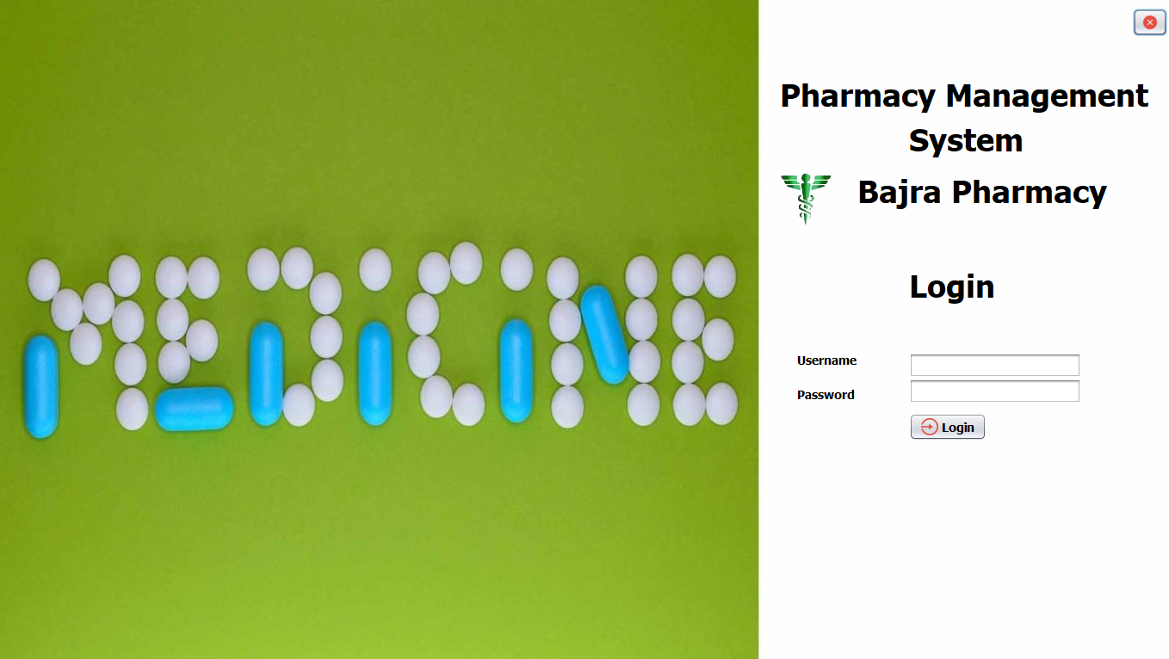

**Admin Dashboard**

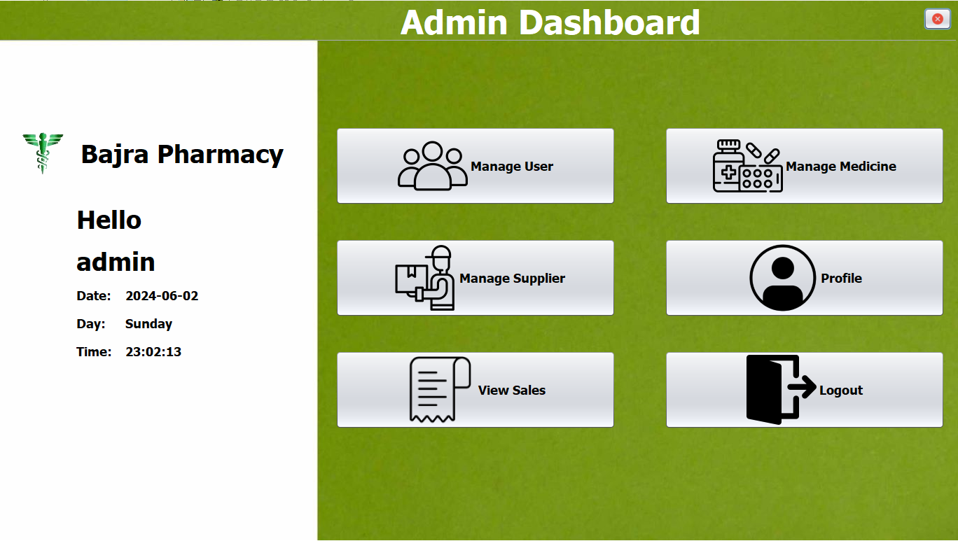

**Pharmacists Dashboard**

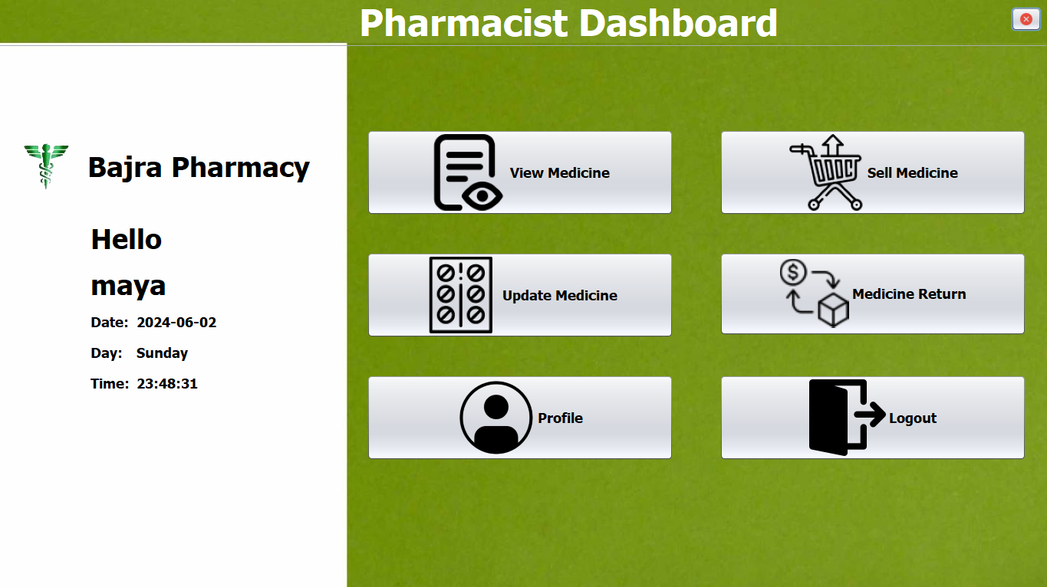

**Manage User Page**

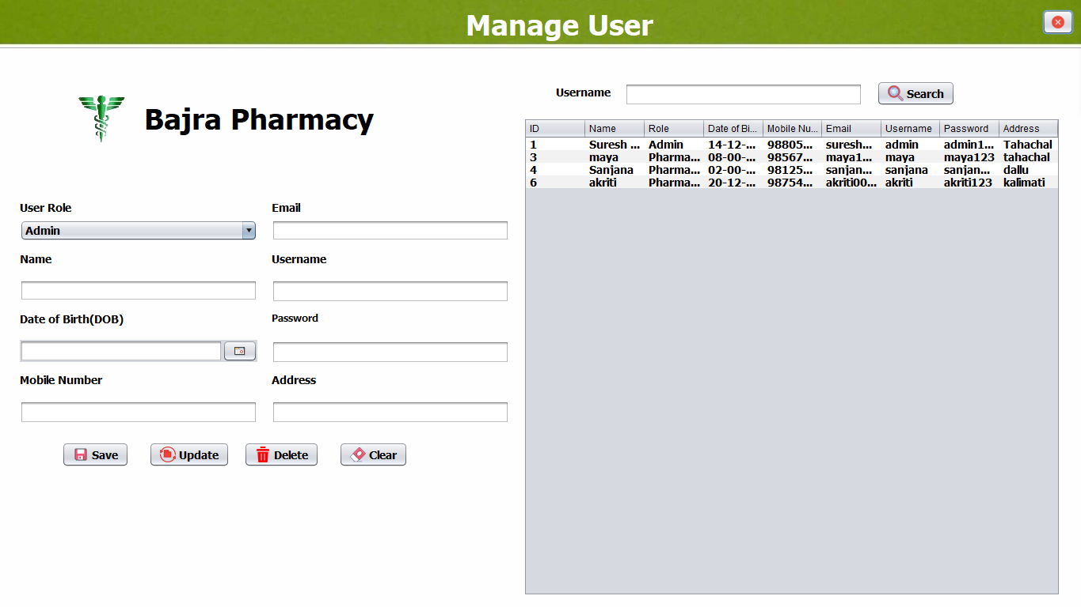

**Medicine Page**

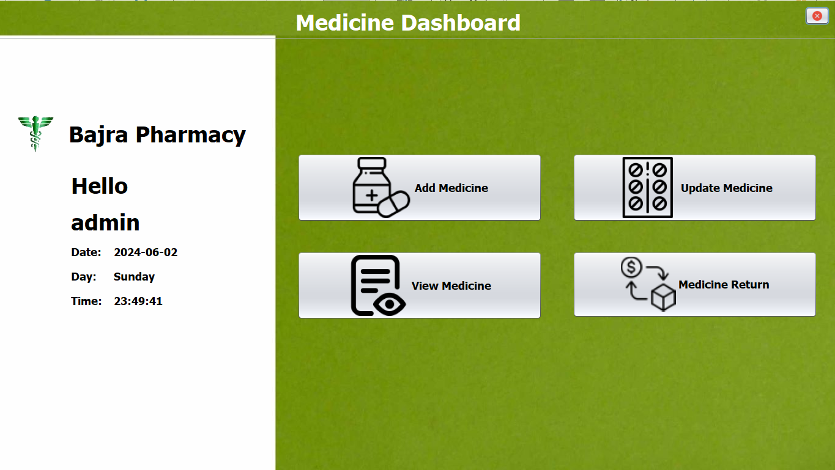

**Add Medicine Page**

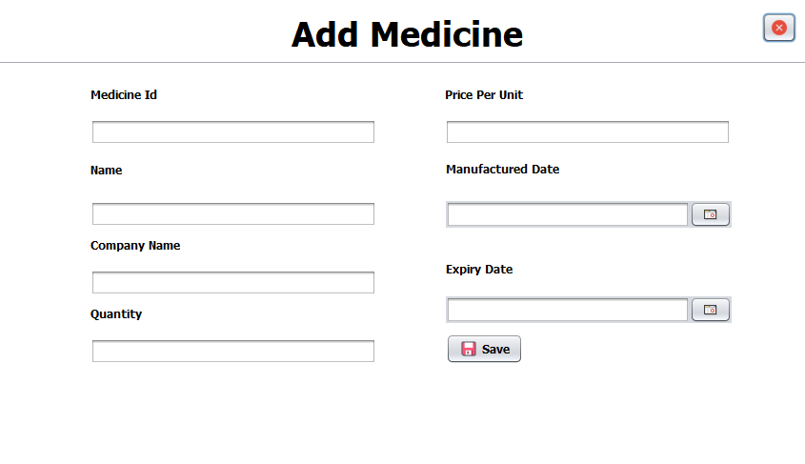

**View Medicine Page**

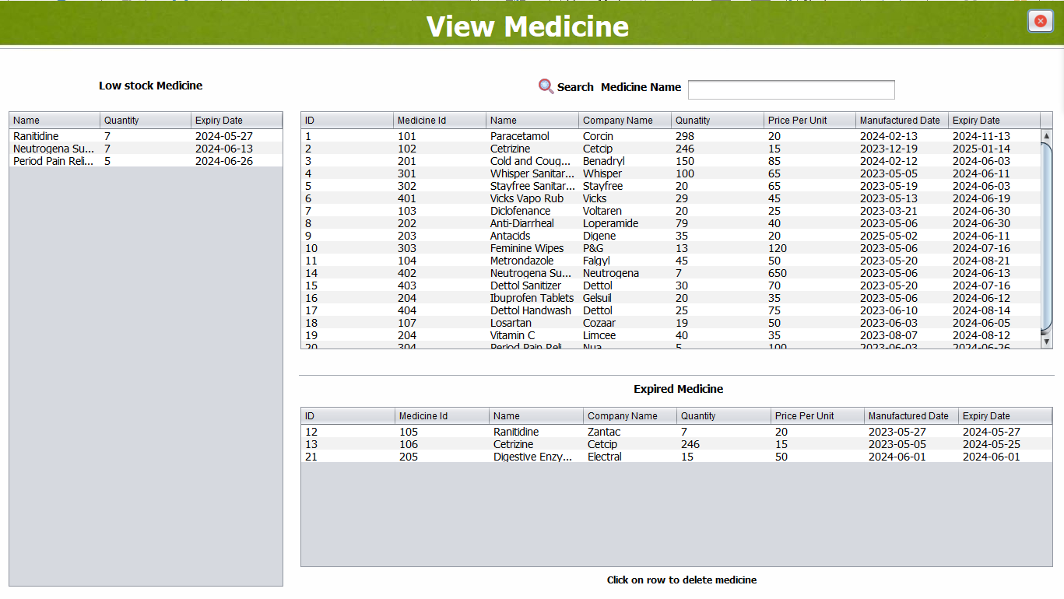

**About to Expire Medicine Table**

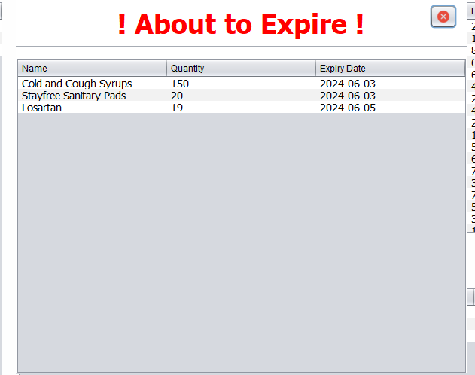

**Update Medicine Page**

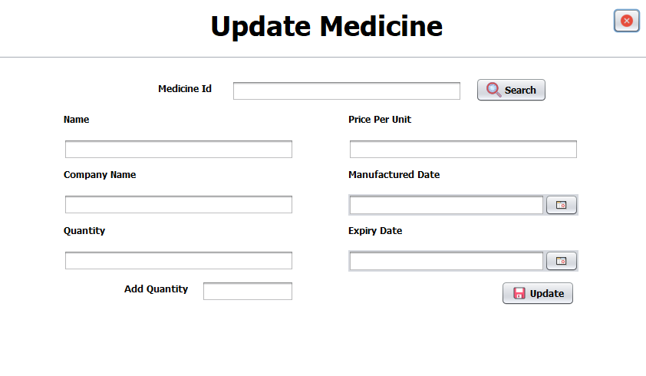

**Medicine Return Page**

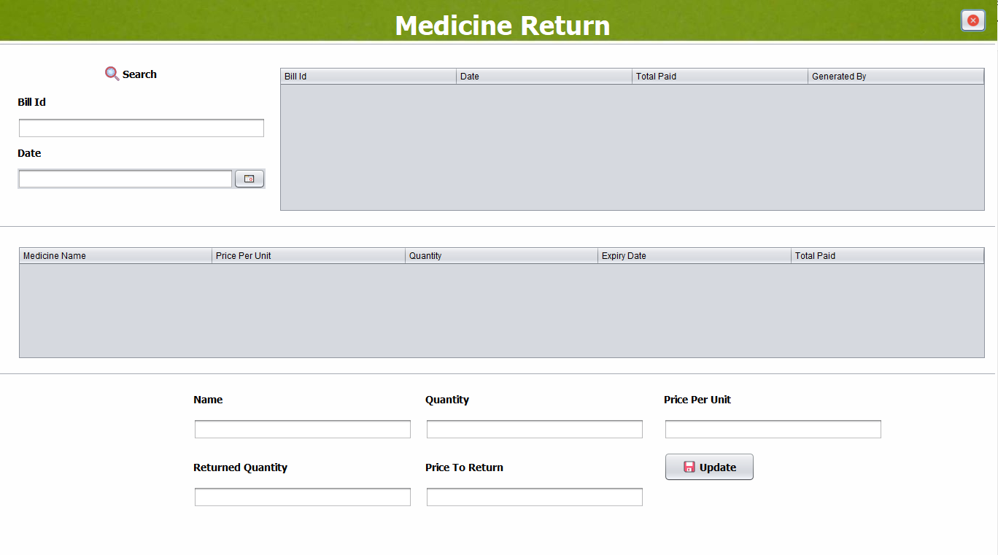

**Supplier Page**

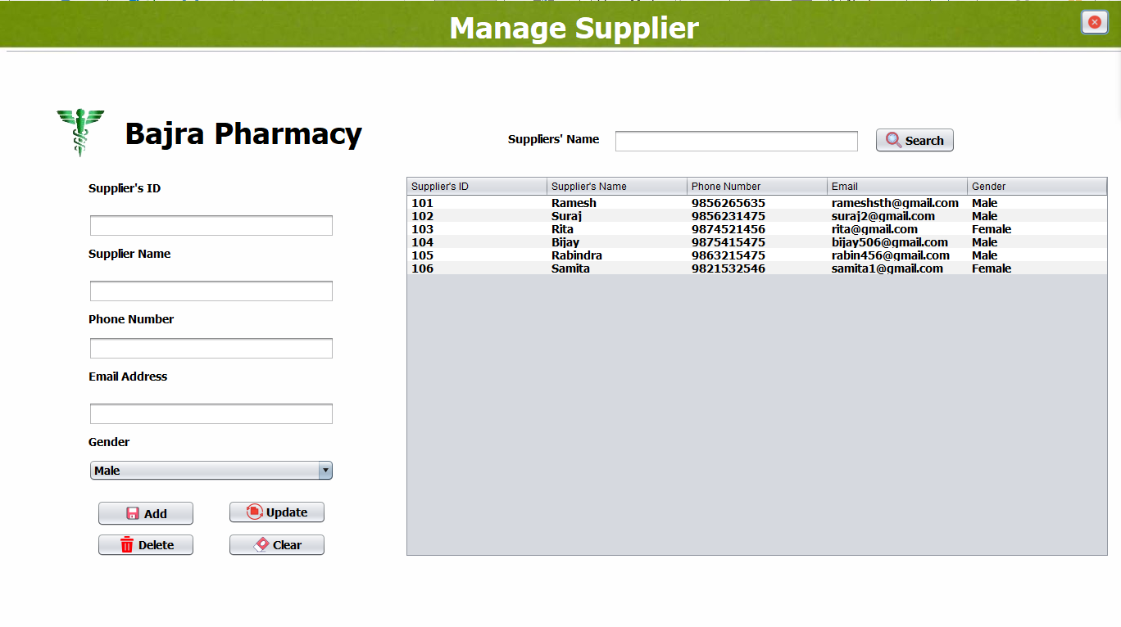

**View Sales Page**

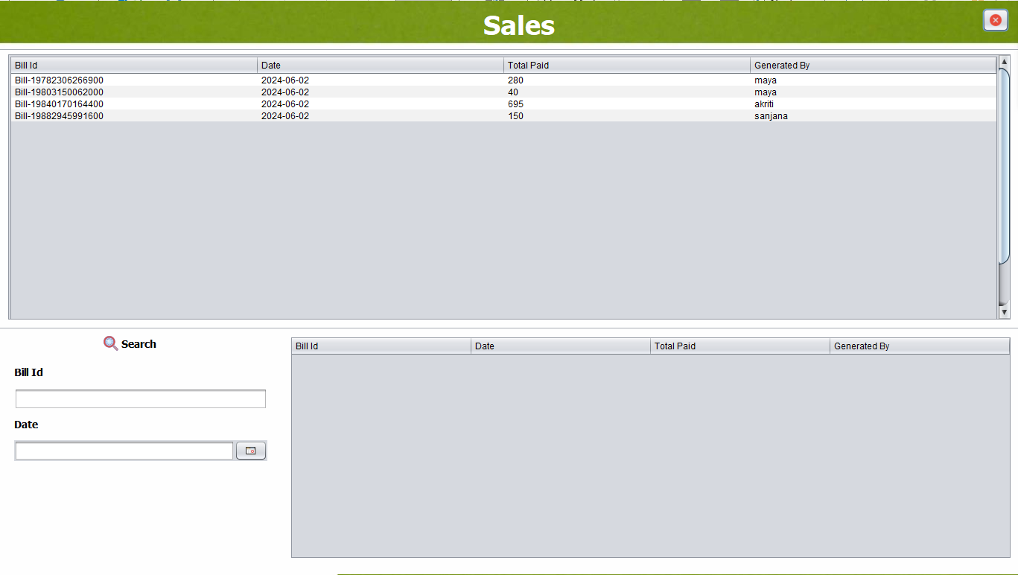

**Profile Page**

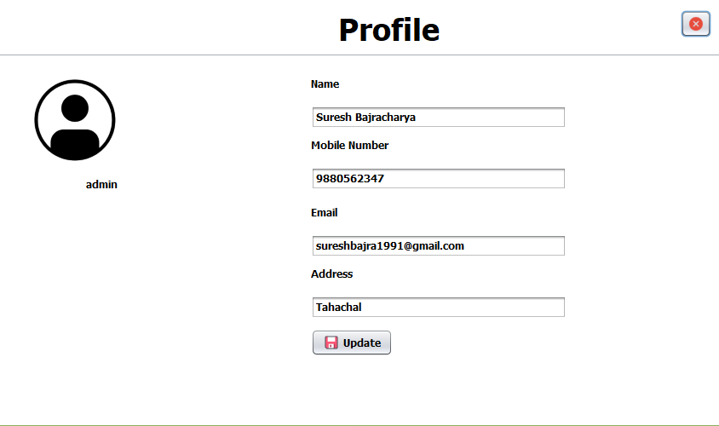

**Sell Medicine Page**

