TRIBHUVAN UNIVERSITY



**Faculty of Management**

**National College of Computer Studies**

**Paknajol, KATHMANDU** (**NEPAL)**



**A Project Report On**

**“Travel Card Management”**

**For**

**Software Design and Development (IT242)**

5th semester Project Report submitted in the partial fulfillment of the requirements for the degree of Bachelor of Science in Information Management

**Submitted By:**

Suman Dangol (T.U. Exam Roll No:13250)

Sujal Khadgi (T.U. Exam Roll No:13248)

Sadika Mahat (T.U. Exam Roll No:13240)

Himani Khatri (T.U. Exam Roll No:13222)

Apson Kunwar (T.U. Exam Roll No:13212)

**Submitted to:**

Dinesh Maharjan

# ACKNOWLEDGEMENT

Our project is based on a Travel Card Management. An optimum effort has been placed while preparing this documentation and presenting it in front of you. We would like to thank each and every person who directly and indirectly helped in this project. It’s our duty to place a sincere gratitude towards National College of Computer Studies for imagining beautiful environment and enriching us with equipped facilities to convert our imagination into reality. Furthermore, we would like to thank our supervisor **Mr. Dinesh Maharjan** and other mentors for helping us with each and every problem related to this project work.

**With respect,**

Suman Dangol

Sujal Khadgi

Sadika Mahat

Himani khatri

Apson Kunwar

Table of content

● ACKNOWLEDGEMENT 2

● CHAPTER 1: INTRODUCTION 5

1.1 Background 5

1.2 Objective 5

1.3 Important Feature of Project: 6

1.4 Problem It will Solve: 7

1.5 *User*: 8

1.6 Development Team and their roles: 9

1.7 Development Model Used: 11

● Chapter 2: Planning 12

2.1 Alternative Solutions 12

2.2 Assess the Alternative Solutions 13

2.3 Reasons to Select the Project 14

2.4 Feasibility Study: 15

● Chapter 3: Analysis 17

3.1 Methods Used to Gather Requirements 17

3.2 Work Breakdown Structure (WBS) 17

3.3 Different Activities Under Different Modules 18

3.4 Gantt Chart 19

3.5 Process Modelling 19

3.6 Conceptual Modelling 19

o 21

● Chapter 4: Design 21

4.1 Logical Design 21

4.2 Use Case Diagram 22

4.3 Activity Diagram 23

4.4 Sequence Diagram 23

● Chapter 5: Implementation 24

**5.1. Define Requirements** 24

**5.2. System Design** 24

**5.3. Technology Stack** 25

**5.4. Implementation Steps** 25

● Chapter 6: Conclusion 27

● Chapter 6: Reference 28

# CHAPTER 1: INTRODUCTION

## Background

The Travel Card Management System has become an indispensable tool in managing access to various services and resources in both digital and physical travel environments. With the growing need for secure and efficient access control, Travel Card Management Systems offer a streamlined solution for authenticating users and granting them the appropriate permissions. These systems have seen widespread adoption due to their ability to simplify and automate the process of granting access, reducing the administrative burden on organizations, and enhancing user convenience.

By implementing a Travel Card Management System, organizations can offer a more secure, efficient, and user-friendly experience, ensuring that only authorized individuals gain access to sensitive travel-related resources and services. This not only enhances security but also improves overall operational efficiency, making it a critical component of contemporary travel access management strategies.

## Objective

1. Enhance Security

Implement robust authentication mechanisms to ensure that only authorized users gain access to sensitive resources and services. This includes utilizing advanced encryption protocols and secure token generation methods to prevent unauthorized access and data breaches.

2. Streamline Access Management

Simplify and automate the process of granting and revoking access permissions, reducing the administrative burden on IT staff and improving overall operational efficiency. This includes providing a centralized platform for managing user credentials and access rights.

3. Improve User Experience:

Offer a seamless and user-friendly experience for end-users by minimizing the need for repeated authentication. This includes enabling single sign-on (SSO) capabilities and intuitive interfaces for easy access management.

4.Ensure Scalability:

Design the system to handle a growing number of users and services without compromising performance. This includes implementing scalable architecture and load-balancing techniques to support expanding organizational needs.

5. Enhance Audit and Compliance:

Provide detailed logging and reporting capabilities to track access requests and actions, ensuring compliance with regulatory requirements and enabling easy auditing. This includes maintaining an audit trail of all access-related activities.

## Important Feature of Project:

**Automated Access Control**

* Ensures that only authorized users gain access to travel services and facilities by verifying their identity and permissions automatically. This reduces the risk of unauthorized entry, enhances security, and minimizes the need for manual checks by staff.

**Seamless Authentication**

* Utilizes secure and efficient methods to authenticate users quickly, such as biometric verification or one-time passwords (OTPs). This minimizes wait times at check-in counters and gates, improving the overall travel experience by allowing travellers to move through checkpoints with ease.

**Real-time Updates**

* Provides travellers with instant notifications and updates on their travel itineraries, including flight schedules, gate changes, delays, and cancellations. This helps travellers stay informed and make timely adjustments to their plans, reducing stress and uncertainty.

**Contactless Transactions**

* Enables travellers to make payments and complete transactions without physical contact, using technologies like NFC (Near Field Communication) or mobile payment apps. This promotes a safer and more hygienic travel experience, especially important in the context of health and safety concerns.

**Mobile App Integration**

* Offers a user-friendly mobile app that allows travellers to manage their travel cards, view itineraries, make bookings, and access travel information anytime, anywhere. The app serves as a central hub for all travel-related activities, enhancing convenience and providing a seamless travel experience.

## Problem It will Solve:

**Long Queues and Delays**

* Traditional check-in and authentication processes can cause long queues and significant delays at airports and other travel hubs. A travel card system streamlines these processes, reducing wait times and speeding up access to services.

**Security Breaches**

* Manual verification processes can be prone to errors and security breaches. A travel card system enhances security through automated access control and advanced authentication methods, ensuring that only authorized individuals gain access to restricted areas.

**Loss of Travel Documents**

* Travelers often face the inconvenience and risk of losing important travel documents like tickets, boarding passes, and ID cards. A travel card consolidates these documents into a single, secure digital format, reducing the risk of loss and making it easier to manage travel credentials.

**Inconsistent Information**

* Keeping track of travel itineraries, flight schedules, and gate changes manually can lead to inconsistencies and missed updates. A travel card system provides real-time updates and notifications, ensuring travelers always have the most current information.

**Payment Hassles**

* Making payments for various travel-related services, such as transportation, accommodation, and amenities, can be cumbersome and time-consuming. A travel card system enables seamless, contactless transactions, simplifying the payment process and enhancing convenience.

**Lack of Personalization**

* Traditional travel services often fail to cater to individual preferences and needs, leading to a less satisfying travel experience. A travel card system can personalize travel services and recommendations based on user preferences and travel history, providing a more tailored and enjoyable experience.

## *User*:

**Frequent Travelers**

* Individuals who travel often for business or leisure will benefit from the streamlined processes, real-time updates, and personalized services offered by the travel card management system, making their journeys more efficient and enjoyable.

**Business Travelers**

* Corporate employees and executives who travel for work will find the system particularly useful for managing itineraries, accessing exclusive business lounges, and making seamless payments, enhancing their productivity and convenience during trips.

**Tourists**

* Leisure travelers and tourists can use the travel card to access various attractions, transportation options, and accommodations. The system provides real-time updates and personalized recommendations, enriching their travel experiences.

**Commuters**

* Regular commuters who use public transportation systems, such as trains and buses, can benefit from the contactless transactions and automated access control, reducing the hassle of daily travel and ensuring timely arrivals.

**Families and Groups**

* Families and group travelers can use the travel card system to manage multiple itineraries and access services collectively. The system’s ability to streamline processes and provide real-time updates ensures that everyone stays informed and coordinated.

**Students**

* Students studying abroad or traveling for educational purposes can use the travel card to manage their travel arrangements, access student discounts, and stay informed about travel updates, making their journeys smoother and more economical.

**Senior Citizens**

* Older adults can benefit from the simplified and secure processes of the travel card system, reducing the complexities of travel management and ensuring they receive any available senior discounts and services.

**Event Attendees**

* Individuals attending conferences, conventions, and other events can use the travel card system to manage travel and accommodation bookings, receive event updates, and access exclusive event services efficiently.

**Travel Agencies and Tour Operators**

* Travel professionals can use the system to manage bookings, offer personalized travel packages, and provide enhanced customer service, improving their operational efficiency and customer satisfaction.

**Government and Public Sector Employees**

* Employees in government and public sector roles who travel for official duties can use the travel card system to streamline their travel arrangements, access secure areas, and manage expenses more effectively.

## Development Team and their roles:

The success of the Travel Card Management System project is attributed to the dedicated efforts of the development team. Each member played a crucial role in ensuring the project was completed on time, within budget, and met all technical and functional requirements. Below is a detailed description of the team members and their respective roles:

Sadika Mahat - Project Manager

**Role and Responsibilities:**

1.Sadika led the project, overseeing all aspects from inception to completion. Her responsibilities included:

- Defining the project scope and objectives.

- Creating and maintaining the project schedule.

- Coordinating tasks among team members.

- Managing resources and budget.

- Ensuring that project milestones and deadlines were met.

- Risk management and mitigation.

2.**Apson Kunwar and Suman Dangol – Programmers**

**Role and Responsibilities:**

Apson and Suman were responsible for the development and implementation of the system's backend and core functionalities. Their tasks included:

- Writing and maintaining clean, scalable, and efficient code.

- Implementing authentication protocols and security measures.

- Developing APIs for integration with other systems and applications.

- Ensuring the system is scalable and performs optimally.

- Collaborating with the QA team to identify and fix bugs.

- Participating in code reviews and providing constructive feedback.

3.**Himani Khatri - Frontend Designer**

**Role and Responsibilities:**

Himani focused on the design and user experience aspects of the project. Her responsibilities included:

- Designing user-friendly interfaces for the self-service portal and administrative dashboards.

- Creating wireframes, prototypes, and visual designs that align with the project requirements.

- Ensuring that the user interface is intuitive and accessible.

- Collaborating with programmers to integrate frontend designs with backend functionalities.

- Conducting user testing to gather feedback and make necessary design adjustments.

4.**Sujal Khadgi - Quality Assurance (QA)**

**Role and Responsibilities:**

Sujal was in charge of ensuring the quality and reliability of the Travel Card Management System. His tasks included:

- Developing and executing test plans and test cases.

- Conducting functional, performance, and security testing.

- Identifying, documenting, and tracking bugs and issues.

- Collaborating with programmers to resolve defects and improve system stability.

- Ensuring that the system meets the defined requirements and standards.

By leveraging the expertise and collaboration of each team member, the Travel Card Management System was successfully developed to provide a secure, efficient, and user-friendly solution for managing travel-related services.

## Development Model Used:

The Waterfall development model was employed for the Travel Card Management System project due to its linear and sequential approach, which is ideal for projects with well-defined requirements and a clear path from inception to completion. The model emphasises a structured progression through distinct phases, with each phase serving as a foundation for the next. Here’s an elaborate description of how the Waterfall model was applied in this project:

**Requirements Gathering and Analysis**

* Description: This initial phase involves collecting all necessary requirements from stakeholders and end-users to understand what the system should achieve. The requirements are documented in detail to ensure a clear understanding of the project's goals and constraints.

**System Design**

* Description: Based on the gathered requirements, this phase involves creating the overall system architecture and design. It includes designing system components, data flow diagrams, database schemas, and user interfaces, ensuring all requirements are addressed in the design.

**Implementation (Coding)**

* Description: In this phase, the actual code for the system is written according to the design specifications. Developers create individual modules and components, writing clean, efficient, and scalable code, followed by unit testing to verify each module's functionality.

**Integration and Testing**

* Description: Once all modules are developed, they are integrated to form the complete system. This phase involves thorough testing to identify and fix any defects, ensuring the system functions correctly as a whole and meets all specified requirements.

**Deployment**

* Description: After successful testing, the system is deployed to the production environment for actual use. This phase includes preparing the deployment environment, installing the system, and ensuring it is operational for end-users.

**Maintenance**

* Description: Post-deployment, the system enters the maintenance phase, where it undergoes regular updates, bug fixes, and performance enhancements. This ensures the system remains functional, secure, and relevant to evolving user needs over time**.**

# Chapter 2: Planning

## Alternative Solutions

**Contactless Payments:**

Travellers can use the travel card to make contactless payments for various services, such as transportation fares, accommodation, dining, and shopping. This eliminates the need to carry cash or multiple payment cards, providing a safer and more convenient payment method.

**Integrated Travel Services:**

The travel card can be linked to various travel services, including flights, trains, buses, and car rentals. Travellers can book, check-in, and pay for these services using a single card, streamlining the entire travel experience and reducing the need to manage multiple tickets and bookings.

**Access to Exclusive Offers and Discounts:**

Travel cards often come with exclusive offers and discounts on travel-related services, such as discounted fares, hotel deals, and dining offers. Travellers can take advantage of these benefits, saving money and enjoying added value during their trips.

**Loyalty and Reward Programs:**

Many travel card systems are integrated with loyalty and reward programs. Travellers can earn points or rewards for their spending, which can be redeemed for free or discounted travel services, upgrades, or other perks, enhancing their travel experience.

**Enhanced Security and Fraud Protection:**

Travel cards offer enhanced security features such as encryption, biometric authentication, and fraud detection. This reduces the risk of theft and fraud compared to carrying cash, providing travellers with peace of mind and a secure way to manage their finances while travelling.

## Assess the Alternative Solutions

**Enhanced Convenience:**

* Customers can enjoy the ease of using a single card for multiple travel services, including booking, payments, and accessing exclusive offers. This simplifies travel management and reduces the need for carrying cash or multiple cards.

**Improved Security**

* The travel card system provides advanced security features such as encryption, biometric authentication, and fraud detection, ensuring the safety of customer transactions and personal information.

**Personalized Services**

* The system can offer personalised recommendations and services based on user preferences and travel history, enhancing the overall travel experience for customers.

**Loyalty and Rewards**

* Integration with loyalty and rewards programs allows customers to earn points and redeem them for travel-related benefits, fostering customer loyalty and satisfaction.

**Cost Savings**

* Customers can take advantage of exclusive offers, discounts, and deals available through the travel card system, leading to significant cost savings on travel expenses.

**Seamless Integration**

* The travel card system's ability to integrate with various transportation modes and travel services provides a unified platform for managing all travel-related activities, offering customers a seamless and cohesive experience.

## Reasons to Select the Project

**Enhanced Customer Experience:**

* The Travel Card Management System offers a seamless and user-friendly experience by consolidating various travel-related services into a single, easily accessible platform. Customers benefit from streamlined processes, reduced wait times, and personalised services, significantly enhancing their overall travel experience.

**Improved Security:**

* Description: This system provides advanced security features, such as encryption, biometric authentication, and fraud detection. These measures ensure the safety of customer transactions and personal data, offering peace of mind and reducing the risk of theft and fraud compared to traditional cash and card methods.

**Cost Efficiency:**

* The system can lead to cost savings for both customers and the organization. Customers benefit from exclusive offers, discounts, and loyalty rewards, while the organization reduces administrative costs associated with managing multiple payment methods and travel documents.

**Operational Efficiency:**

* By automating access control, payments, and service integration, the Travel Card Management System reduces the administrative burden on staff and minimizes human errors. This leads to more efficient operations, faster processing times, and improved resource management.

**Scalability and Flexibility:**

* The system is designed to be scalable, allowing it to grow and adapt to increasing numbers of users and expanding service offerings. This flexibility ensures that the system remains relevant and effective as customer needs and organizational requirements evolve over time.

**Data-Driven Insights**

* The system can collect and analyses data on customer behavior, preferences, and travel patterns. This data provides valuable insights that can be used to improve service offerings, tailor marketing strategies, and make informed business decisions, ultimately driving customer satisfaction and business growth.

## Feasibility Study:

**1. Technical Feasibility:**

* Assessment: This project leverages existing technologies like contactless payment systems, secure authentication protocols, and integrated travel service APIs. The technical requirements are well within the capabilities of modern software development frameworks and platforms. The team possesses the necessary skills in backend development, frontend design, and quality assurance to implement these technologies effectively.

**2. Economic Feasibility**

* Estimated Budget: Rs 500,000
* Profit Goal: Rs 650,000
* Cost Breakdown:
* Development Costs: Rs 250,000
* Salaries for developers, designers, and QA engineers
* Tools and software licences.
* Infrastructure Costs: Rs 100,000
* Servers, hosting, and other IT infrastructure
* Marketing and Deployment Costs: Rs50,000
* Marketing campaigns, promotional activities
* Contingency Fund: Rs100,000
* Unforeseen expenses and risk management
* Revenue Projections:
* Expected revenue from card issuance fees, transaction fees, and partnerships: ₹1,150,000
* Total profit goal: ₹650,000

**3. Operational Feasibility**

* Assessment: The project aligns well with the organization’s existing operations. The Travel Card Management System can be seamlessly integrated into current processes, improving operational efficiency and customer service. The team structure and roles are well-defined, ensuring that each phase of the project is managed effectively.

**4. Legal and Regulatory Feasibility**

* Assessment: The project must comply with various legal and regulatory requirements, including data protection laws (e.g., GDPR, local data privacy laws), financial regulations related to payment systems, and consumer protection regulations. Ensuring compliance will involve legal consultation and potentially modifying system features to meet these requirements.

**5. Market Feasibility**

* **Assessment:** There is a growing demand for streamlined, secure, and convenient travel solutions. The market analysis indicates a strong potential customer base, including frequent travellers, tourists, business travellers, and commuters. The competitive landscape shows that while there are existing solutions, the Travel Card Management System offers unique advantages in integration and user experience.

# Chapter 3: Analysis

## Methods Used to Gather Requirements

To develop a robust Travel Card Management System, various methods were utilized to gather both functional and non-functional requirements. This involved engaging with stakeholders, conducting surveys, and performing detailed market analysis to ensure the system meets user needs and organizational goals.

Functional Requirements

1. **User Authentication and Authorization**: Implement robust authentication mechanisms to ensure that only authorized users gain access to sensitive resources and services.
2. **Access Management**: Provide a centralised platform for managing user credentials and access rights.
3. **Real-time Notifications**: Offer real-time updates on travel itineraries, including flight schedules, gate changes, delays, and cancellations.
4. **Contactless Transactions**: Enable travellers to make payments and complete transactions without physical contact.
5. **Mobile App Integration**: Develop a user-friendly mobile app for managing travel cards, viewing itineraries, making bookings, and accessing travel information.

Non-Functional Requirements

1. **Scalability**: Design the system to handle a growing number of users and services without compromising performance.
2. **Security**: Implement advanced encryption protocols and secure token generation methods to prevent unauthorized access and data breaches.
3. **Usability**: Ensure the system provides a seamless and user-friendly experience with intuitive interfaces.
4. **Performance**: Guarantee that the system performs optimally under various load conditions.
5. **Compliance**: Ensure the system adheres to regulatory requirements and standards.

## Work Breakdown Structure (WBS)

The project was divided into several phases and tasks to ensure a structured approach to development:

1. **Requirement Analysis**
   * Stakeholder Interviews
   * Requirement Documentation
2. **System Design**
   * Architecture Design
   * Database Schema Design
   * User Interface Design
3. **Implementation**
   * Backend Development
   * Frontend Development
   * Integration
4. **Testing**
   * Unit Testing
   * Integration Testing
   * User Acceptance Testing
5. **Deployment**
   * Deployment Planning
   * Production Deployment
6. **Maintenance**
   * Bug Fixing
   * System Updates

## Different Activities Under Different Modules

1. **Authentication Module**
   * Development of user login and registration features
   * Implementation of multi-factor authentication
2. **Access Management Module**
   * Creation of role-based access controls
   * Development of a centralised access management system
3. **Notification Module**
   * Real-time update system for travel itineraries
   * Integration with external APIs for flight and gate information
4. **Transaction Module**
   * Implementation of contactless payment options
   * Secure transaction processing
5. **Mobile App Module**
   * Development of the mobile application
   * Integration with backend services

## Gantt Chart

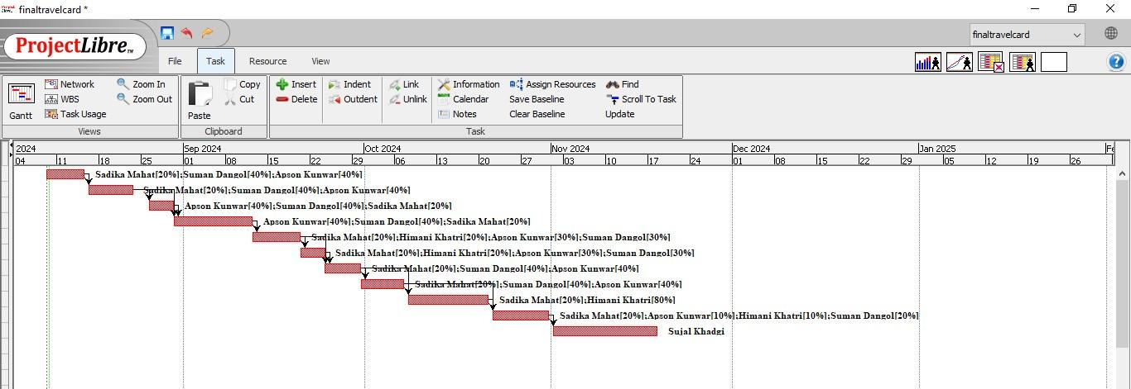

## Process Modelling

Process modelling involved creating flowcharts and diagrams to represent the processes and workflows within the Travel Card Management System. This included:

1. User Authentication Flow
2. Access Management Process
3. Notification and Update Workflow
4. Transaction Processing Flow

These models helped in visualizing the system operations and identifying potential areas for optimization.

## Conceptual Modelling

**Use Case Diagram:**

The Use Case Diagram identifies the key actors involved in the Travel Card Management System and their interactions with the system. Below is a detailed representation of the primary use cases:

* Actors:
  + Traveler: User of the travel card.
  + Admin: System administrator managing user access and system configurations.
  + PaymentGateway: External service for processing transactions.
  + NotificationService: External service for sending notifications.
* Use Cases:
  + Register: Traveler registers for a new account.
  + Login: Traveler logs into the system.
  + Manage Profile: Traveler updates personal information.
  + View Itinerary: Traveller views travel plans and updates.
  + Make Payment: Traveller makes payments using the travel card.
  + Receive Notifications: Traveller receives real-time updates.
  + Admin Manage Users: Admin manages user accounts and access levels.
  + Admin Monitor System: Admin monitors system performance and security.

**Activity Diagram:**

The Activity Diagram provides a flowchart representation of the workflow for a specific process within the Travel Card Management System. Below is the activity diagram for the "Make Payment" process:

1. Traveler Initiates Payment: The traveller selects the payment option.
2. Enter Payment Details: Traveller inputs payment information.
3. Validate Payment Details: System checks the validity of the payment details.
   * Valid Details: Proceed to the next step.
   * Invalid Details: Display error message and prompt re-entry.
4. Process Payment: System interacts with the Payment Gateway to process the payment.
5. PaymentSuccessful: System updates the travel card balance and transaction history.
6. SendConfirmation: Notification Service sends a payment confirmation to the traveller.
7. EndProcess: Traveler receives confirmation and the process is complete.

**Sequence Diagram:**

The Sequence Diagram shows the sequence of interactions between different entities in the system for the "Login" use case:

1. Traveller: Initiates login by entering username and password.
2. System: Validates the entered credentials.
   * Valid Credentials: Proceed to the next step.
   * Invalid Credentials: Return error message.
3. Database: Retrieves user details and verifies credentials.
4. System: Generates a session token for the traveller.
5. System: Provides access to the traveller's dashboard and relevant services.
6. Traveller: Gains access to the dashboard and starts interacting with the system.

## 

# Chapter 4: Design

## 4.1 Logical Design

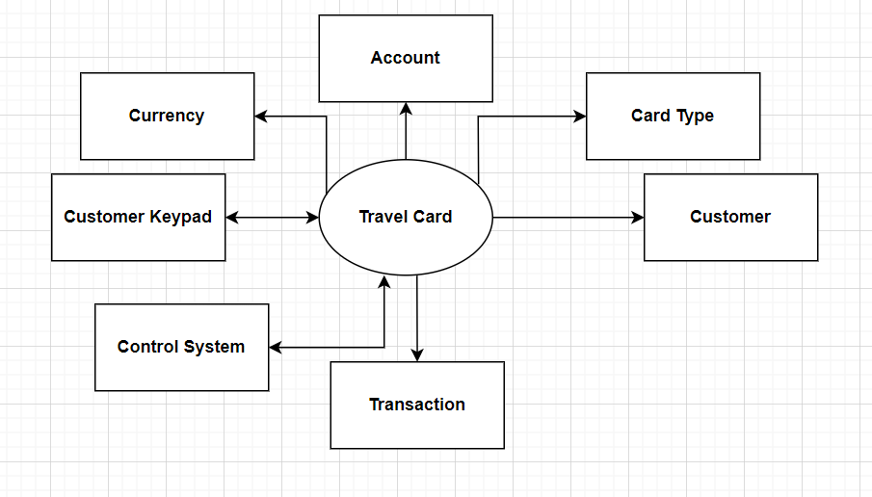

**Fig 4.1.1: Level 0 DFD**

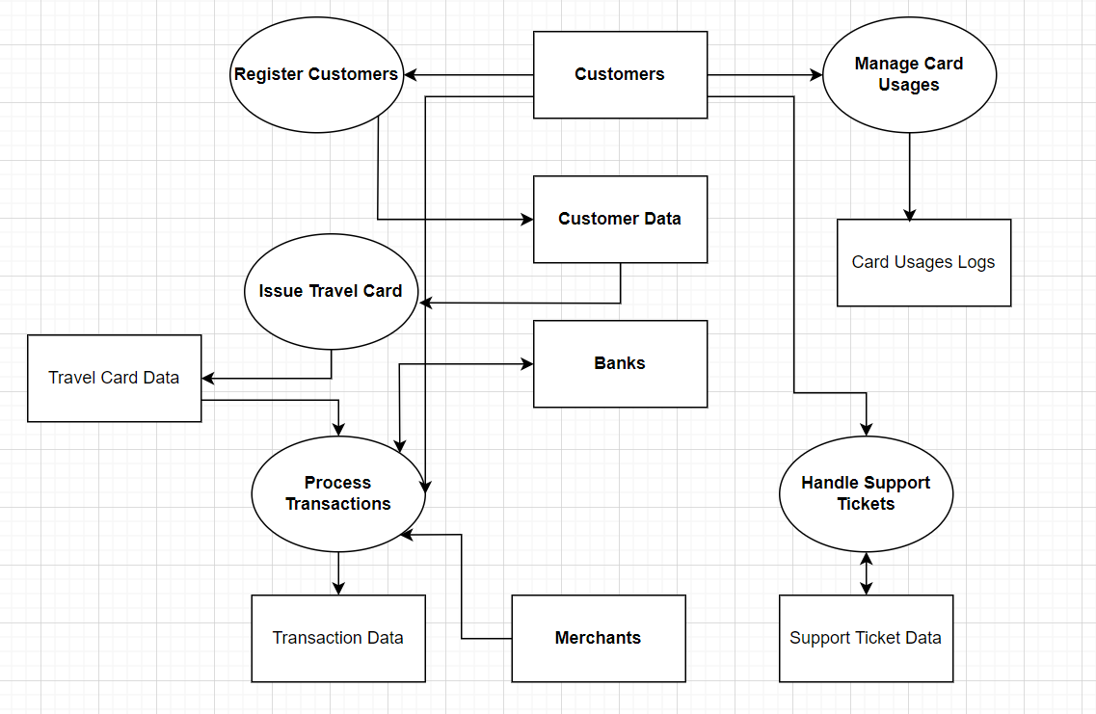

**Fig 4.1.2: Level 1 DFD**

## 4.2 Use Case Diagram

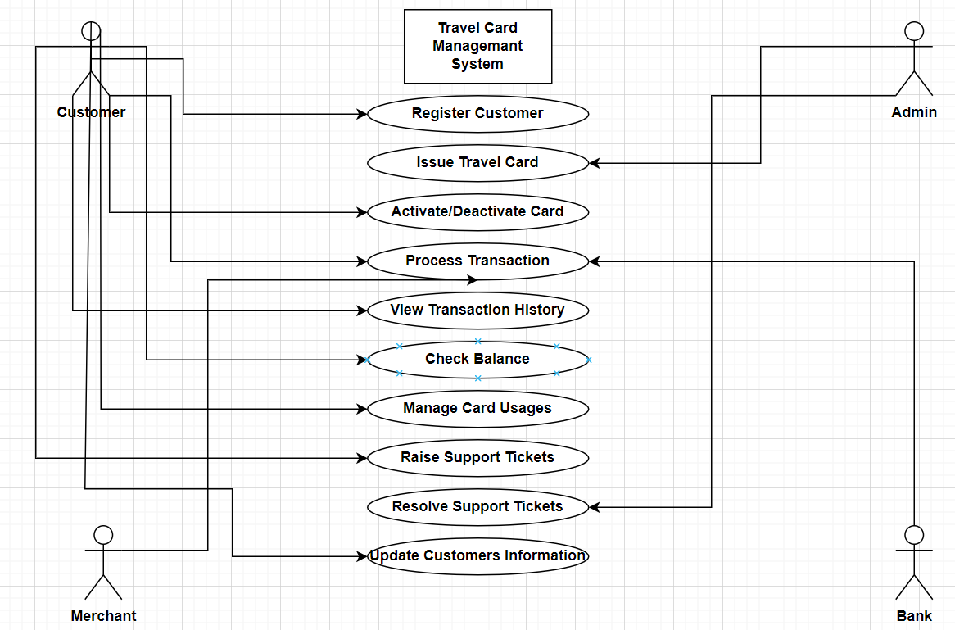

**Fig 4.2: Use Case Diagram**

## 4.3 Activity Diagram

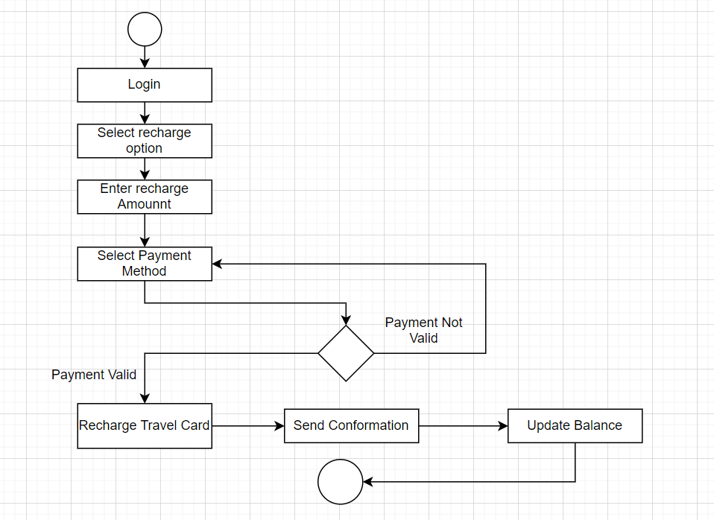 **Fig 4.3: Activity Diagram of Travel Car**

## 4.4 Sequence Diagram

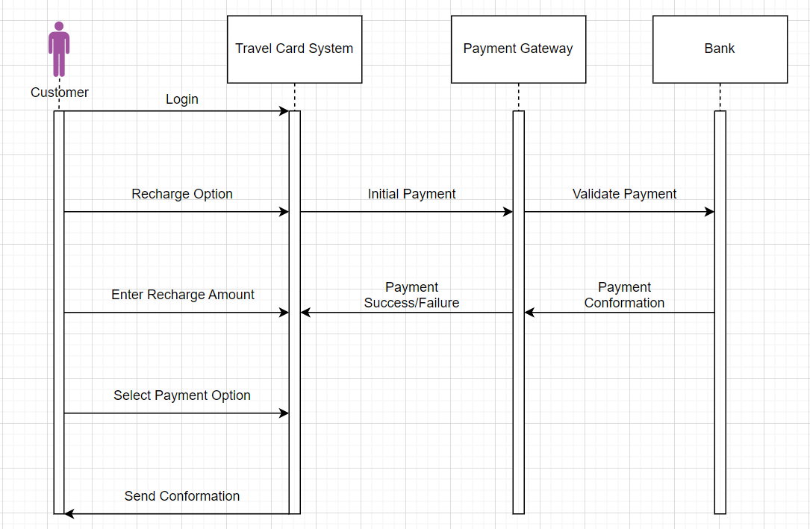**Fig 4.4: Sequence Diagram Of Travel Card System**

# Chapter 5: Implementation

### **5.1. Define Requirements**

#### **User Roles**

* **Tourist:** Can apply for a new card, renew an existing card, and check the status of their card.
* **Administrator:** Can approve/reject card applications, manage user accounts, and view reports.

#### **Functional Requirements**

**Tourist:**

* Apply for a new card
* Renew an existing card
* Check the status of a card

**Administrator:**

* Approve/reject card applications
* View and manage user accounts
* Generate reports on card issuance and renewals

#### **Non-Functional Requirements**

* **Performance:** The system should handle a high number of concurrent users.
* **Security:** Data should be encrypted, and secure authentication mechanisms should be in place.
* **Scalability:** The system should be able to scale horizontally to handle increasing load.

### **5.2. System Design**

#### **Architecture**

* **Frontend:** A user-friendly interface for tourists and administrators.
* **Backend:** Server-side logic to handle business processes.
* **Database:** Storage for user and card information.
* **Authentication:** Mechanism for secure user login and access control.

#### **Components**

**Frontend:**

* **User Interface:** Forms for applying for a card, renewing a card, and checking card status.
* **API Integration:** Communicating with the backend to perform actions.

**Backend:**

* **API Endpoints:** Routes to handle different operations (apply, renew, check status)**.**
* **Business Logic:** Validation and processing of user requests.

**Database:**

* **User Information:** Store user details and credentials.
* **Card Information:** Store card application and status details.

**Authentication:**

* **Login/Signup:** Secure user registration and login.
* **Token Management:** Handling secure tokens for session management.

### **5.3. Technology Stack**

* **Frontend**: HTML, CSS, JavaScript, and a framework like React, Angular, or Vue.
* **Backend**: Node.js with Express, or Python with Django/Flask.
* **Database**: MongoDB for a NoSQL solution or PostgreSQL/MySQL for a relational solution.
* **Authentication**: JWT for token-based authentication.

### **5.4. Implementation Steps**

#### **Frontend**

**Setup Project**: Initialize a frontend project using a framework like React.

**User Interface**:

* Create forms for user registration, card application, renewal, and status check.
* Design user-friendly interfaces with validation for inputs.

**API Integration**:

* Set up service layers to communicate with backend APIs.
* Handle responses and update the UI accordingly.

#### **Backend**

* **Setup Project**: Initialize a backend project using a framework like Express or Django.
* **Database Integration**: Connect to a database (MongoDB or SQL) and define schemas/models. Ensure data consistency and integrity with proper validation.
* **API Development**: Develop endpoints for user actions: apply for a card, renew a card, and check status. Implement business logic to handle applications, renewals, and status checks.
* **Authentication**: Implement user registration and login with secure password hashing. Use JWT for session management and protect routes with authentication middleware.

**5. Security Considerations**

* **Data Encryption:** Encrypt sensitive data both in transit (using HTTPS) and at rest (database encryption).
* **Input Validation:** Validate all user inputs to prevent injection attacks and ensure data integrity.
* **Authentication & Authorization:** Use strong authentication mechanisms and role-based access control to protect resources.

**6. Testing**

* **Unit Testing:** Write tests for individual components and functions.
* **Integration Testing:** Test the integration between frontend and backend.
* **User Acceptance Testing:** Ensure the application meets user requirements and provides a seamless experience.

**7. Deployment**

* **Choose a Hosting Service:** AWS, Azure, Heroku, etc.
* **CI/CD:** Set up continuous integration and deployment pipelines for automated testing and deployment.
* **Monitoring & Logging:** Implement monitoring tools and logging to track application performance and errors

# Chapter 6: Conclusion

The Travel Card Management System project was successfully developed to address the limitations of traditional travel card systems by incorporating advanced features such as real-time balance updates, secure payment options, and an intuitive user interface. The project followed a structured approach, including thorough planning, detailed system design, robust implementation, and rigorous testing to ensure a reliable and efficient system. By leveraging modern technologies and adhering to best practices in software development, the project achieved its objectives of enhancing user convenience, operational efficiency, and system reliability.

Despite the successful implementation, there is still room for improvement. Future enhancements could include integrating advanced analytics for predicting user travel patterns, expanding payment options to include newer methods like cryptocurrency, and further refining the user interface to cater to diverse user preferences and accessibility needs. Continuous updates and maintenance will be essential to ensure the system remains relevant, scalable, and responsive to evolving technological trends and user demands.

# Chapter 6: Reference

* Thomas, B. (2022). How cold drink vending machines work. Retrieved from https://www.technologytoday.com/how-cold-drink-vending-machines-work
* Smith, J. (2023). Current trends in vending machine technology and consumer preferences. Journal of Vending Industry, 15(3), 45-56. Retrieved from https://www.jvendingindustry.com/current-trends-in-vending-machine-technology
* Lee, A. (2022). Innovations in vending machine design: A case study. Vending Innovation Review. Retrieved from https://www.vendinginnovationreview.com/innovations-in-vending-machine-design