

PROJECT

DESKTOP PUBLISHING

Submitted by - Submitted to –

Name – Harshita Name – Jasleen Kaur

UID – 23BCA10038 Designation – Assistant Prof.

Section – 23BCA 2 – A

**Process**

**Step 1: Setting Up the Workspace**

1. Open Adobe Photoshop and create a new document with the desired dimensions (e.g., 1920x1080 pixels for HD resolution).
2. Import or paste the background image (a school hallway) into the document.

**Step 2: Adding the Character**

1. Find or create an illustration of a character with headphones, resembling the one in the uploaded image.
2. Import the character illustration into your Photoshop project as a new layer.
3. Position the character in the bottom-left corner.

**Step 3: Adding the Text Elements**

1. Use the **Text Tool (T)** to create text boxes.
2. In the first text box, write the narrative text about Sophia:
   * "There was a girl named Sophia who didn’t want to socialize much. In a room full of people, she'd be in the corner with her headphones on, completely lost in her music…."
3. In the second text box, add the inner thought:
   * "World is too noisy and chaotic… I only find peace, calm, and clarity in music."
   * Emphasize "I just love music" in red or another standout color.

**Step 4: Designing the Heartbeat and Headphones Graphic**

1. Use the **Pen Tool (P)** to draw the heartbeat line.
2. Create or import a headphone graphic and position it around a heart symbol.
3. Use **Layer Styles** (such as Stroke, Glow) to make the graphic pop.

**Step 5: Styling and Composition**

1. Adjust the opacity of background layers to focus attention on the character and text.
2. Add a subtle vignette or gradient to enhance the mood.
3. Use **Blending Modes** to integrate all elements cohesively.
4. Ensure the text is legible by tweaking font size, color, and contrast against the background.

**Step 6: Final Touches**

1. Add any additional effects or filters as needed to achieve the desired artistic feel.
2. Save the project in both PSD format (for future edits) and export as a high-quality JPEG or PNG.

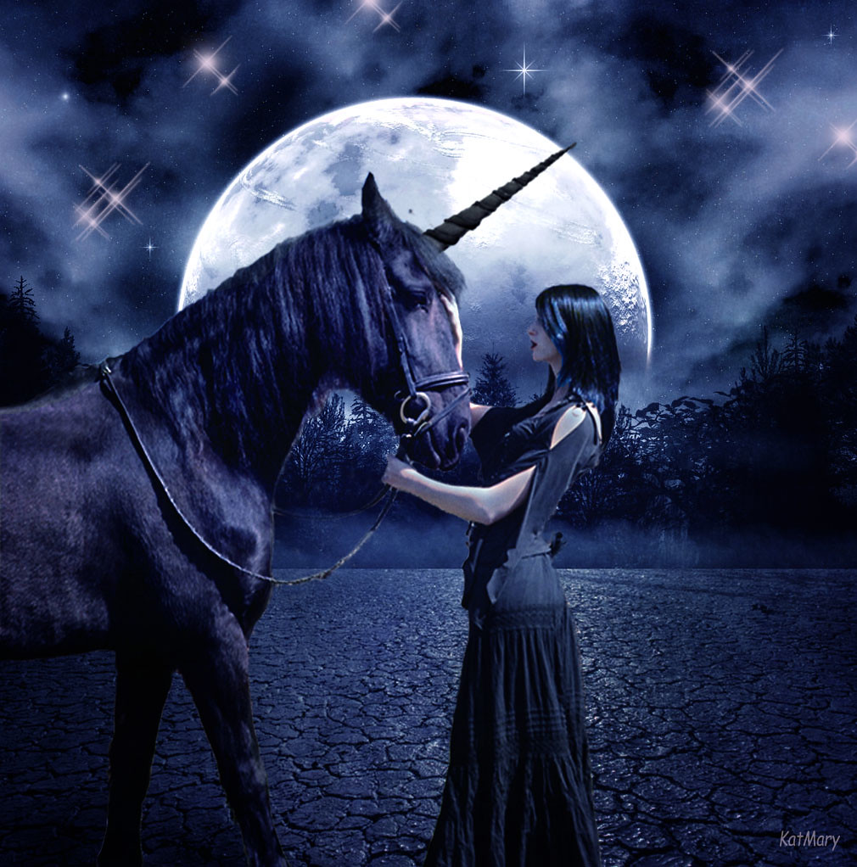

**Story:-**

***"The Midnight Blessing"***

**Under a vast, moonlit sky, where stars glittered like scattered shards of diamonds, a young woman named Lira stood face-to-face with an elusive creature thought only to exist in myths. The air was cool, the ground dry and cracked beneath her feet—a barren, forgotten land untouched by time.**

**Lira had spent years searching for this creature, a rare midnight unicorn said to possess the power to heal even the deepest wounds, be they of the flesh or soul. Legends told of its jet-black coat and an ebony horn that shimmered with otherworldly energy. Some said only those pure of heart could even see it, let alone approach it. For Lira, this encounter was the culmination of her life’s journey. She had ventured through enchanted forests, crossed treacherous rivers, and faced her own fears to reach this place on the night of the full moon, the only time the unicorn would reveal itself.**

**As she looked into the creature’s wise, ancient eyes, she felt as if it could see right into her soul. The unicorn exuded both strength and tranquility, a quiet reassurance that comforted Lira, even in this desolate landscape. She reached out, hesitantly, her hand trembling slightly as she touched its soft, velvety nose. The connection sparked a deep, inexplicable bond between them. In that moment, Lira felt a surge of energy, as though the unicorn was imparting to her some of its ancient wisdom and magic.**

**The unicorn lowered its head, pressing its horn gently against her forehead. A vision unfolded before her eyes—a vision of her village, ravaged by illness and sorrow, now flourishing with life, laughter, and light. She understood then that the unicorn was gifting her with a piece of its magic, a power to carry back with her to heal her people.**

**As the first light of dawn approached, the unicorn let out a soft, melodic sound, like a final farewell. Lira knew she would never see it again, but she would carry its spirit within her, forever changed. She watched as the unicorn turned and faded into the mist, leaving her standing under the waning glow of the moon, her heart brimming with hope and newfound purpose.**