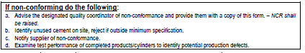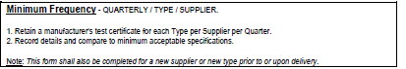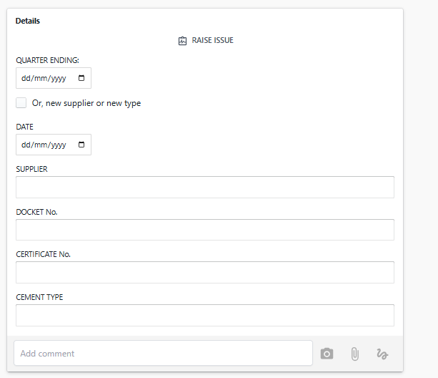

QA – 001 – Cement Records

Can you please add this text if you can add a separate section and call it “Procedure” or if you have a better suggestion?

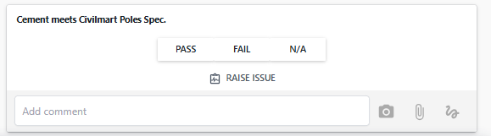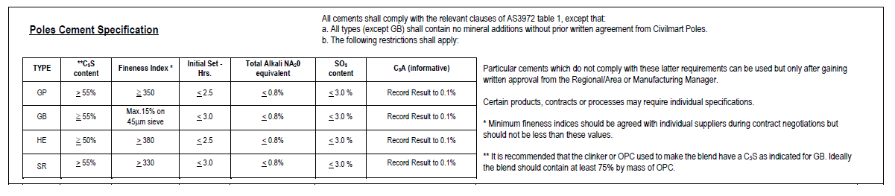

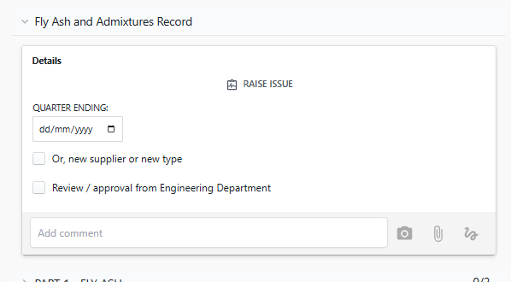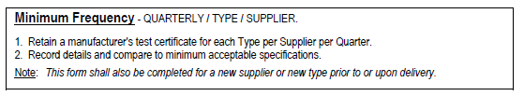

Can you please add this text if you can add a separate section and call it “Procedure” or if you have a better suggestion?

QA – 002 – Flyash

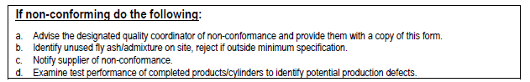

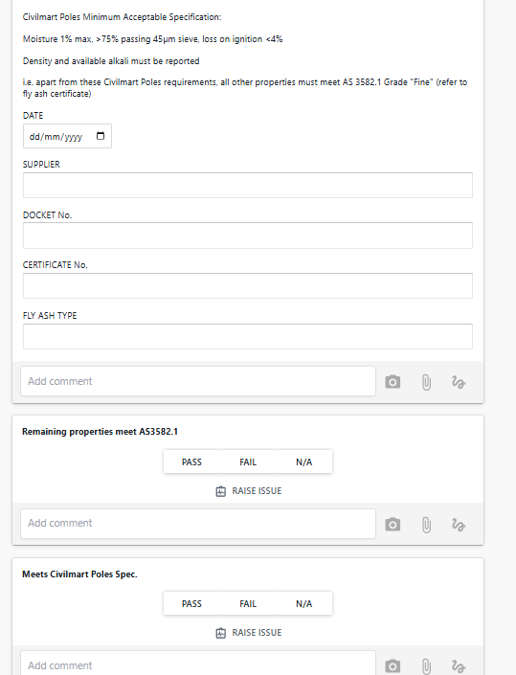

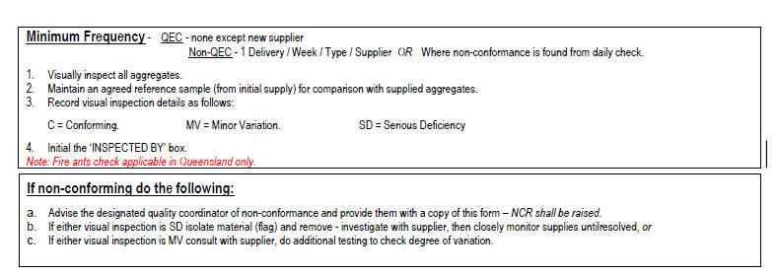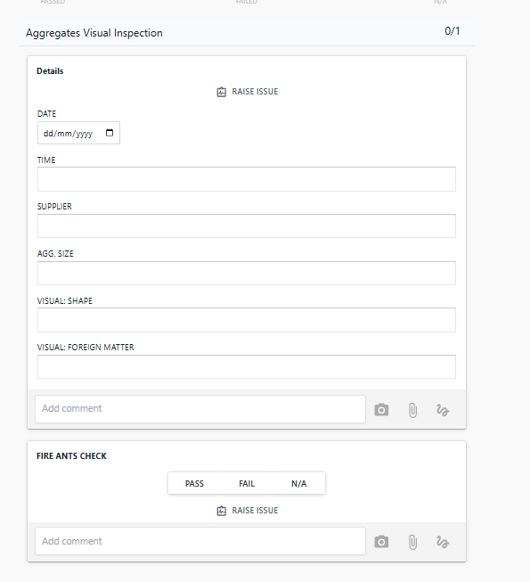

Can you please add this text if you can add a separate section and call it “Procedure” or if you have a better suggestion?

Can you make these three button options to selected it would be C / MV / SD

QA – 003 – Agg

QA – 007 – Reinforcement

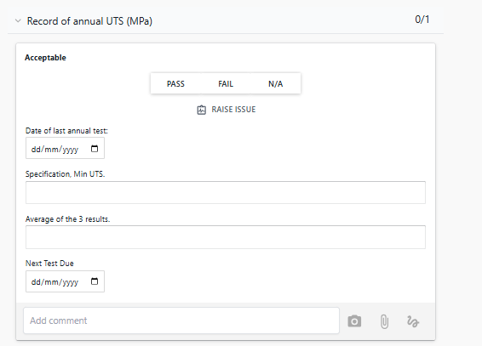

Remove this section

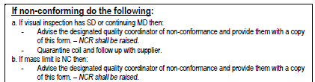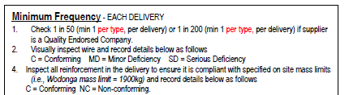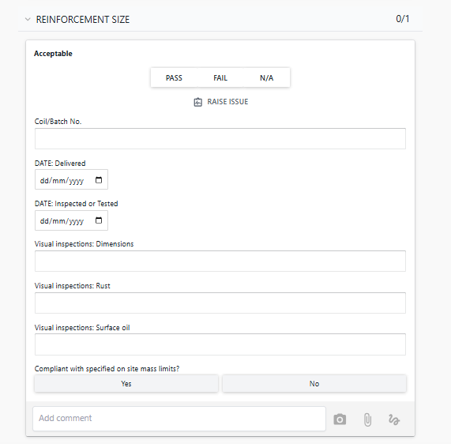

Can you please add this text if you can add a separate section and call it “Procedure” or if you have a better suggestion?

Before coil/batch no.  
Can you add (Reinforcement Size) – have a DDBOX with (5.55, 7.02, 9.88, 12.33, 15FWB, 20FWB, N20, N24, 12.7 STRAND, 9.5 STRAND)

Can you add (Delivery Docket No.) field where we can record for traceability.

Can you make these three button options to selected it would be C / MD / SD

CONFORMING / NON-CONFORMING

REINFORCEMENT “INSPECTION”

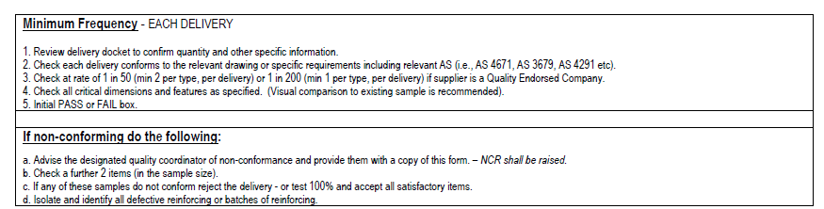

Can you please add this text if you can add a separate section and call it “Procedure” or if you have a better suggestion?

QA – 008 – Fabricated Reinforcement

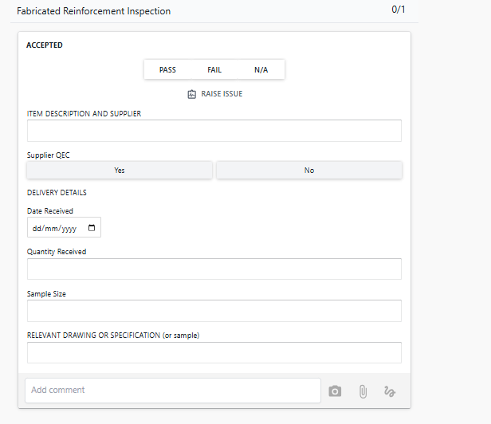

Can you add (Delivery Docket No.) field above the date where we can record for traceability.

Can we split these two fields?

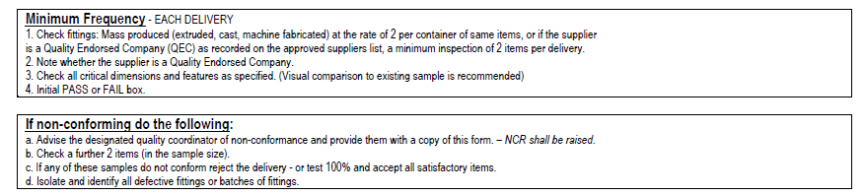

Can you please add this text if you can add a separate section and call it “Procedure” or if you have a better suggestion?

QA – 008 – Fittings Inspection

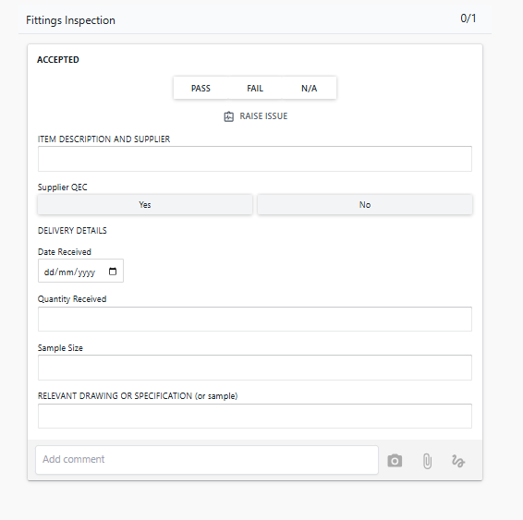

Can you add (Delivery Docket No.) field above the date where we can record for traceability.

Can we split these two fields?

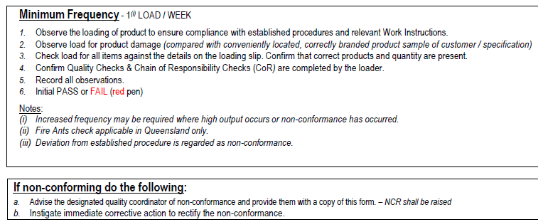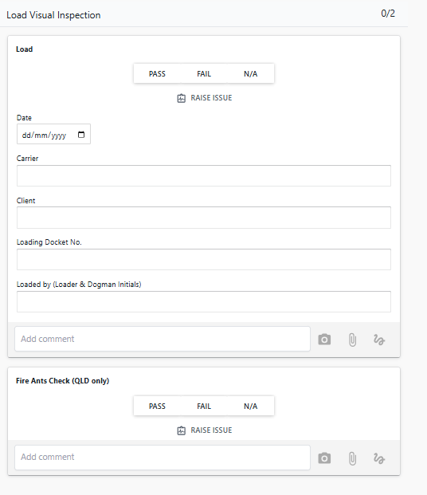

Can you please add this text if you can add a separate section and call it “Procedure” or if you have a better suggestion?

Can you please add an additional checkpoint:  
**Observation:**Exclusion zone established? (YES / NO)  
Platform ladders in place and used? (YES / NO)  
Work crew wearing all required PPE? (YES / NO)  
Lifting equipment positively attached? (YES / NO)  
Tagline used at all times? (YES / NO)  
Lifting and shifting completed as per SOP? (YES / NO)  
Any unsafe practices or deviations observed? (YES / NO)  
Quality Checks completed by the loader? (YES / NO)  
Chain of Responsibility Checks (CoR) completed? (YES / NO)  
Any product damage identified? (YES / NO)  
Products, items, and quantity, correct? (YES / NO)

QA – 028 – Load Visual Inspection