# Overview

## What is an ITP?

**I**nspection **T**est **P**lan. Or in plain terms, essentially a larger and more verbose checklist.

## Who uses ITPs?

ITPs are primarily used by AU/NZ infrastructure clients, but it is not exclusive to them. Electricians, HVAC and a couple other trade types also utilise and call their checklists “*ITP*” to some extent -- even though they may not necessarily be as verbose as their infrastructure counterparts.

## What’s CX’s role in this?

Digitising ITPs is the bread and butter of working with infrastructure clients. The process of making an ITP isn’t too different from building checklists for regular non-infrastructure clients; it just involves a little more nuance when it comes to ***formatting*** the ITP.

### Formatting? What for?

Unlike regular checklists, ITPs need to be structured in a certain way when digitising them for use in CONQA. For starters, you can expect checkpoint items to have multiple *notes* (aka *labels*) appended to them. In addition to notes, you may need to include textboxes, *dropdown lists*, *buttons*, *radios*, *tickboxes* (aka *bools*), and most importantly, *signoffs* (aka *holdpoints*).

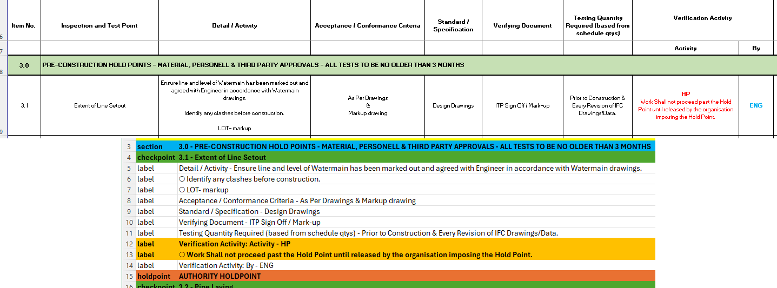

*Example of an ITP in its raw format (top) converted into a CONQA ready format*

It should be noted that whilst ITPs across clients may share a similar layout, formatting requirements *will* vary depending on the client’s requirements and the Quality Engineer in charge of the project(s). You can expect to revise the structure of an ITP more than once over the lifetime of a project as the client’s team(s) work through the ITP.

# Digitisation Process – The Tools Part 1

Digitising an ITP isn’t too different from building a regular checklist. You’ll need a spreadsheet editor to start digitising – ideally, **Microsoft Excel**, either for Windows or Mac. **OpenOffice Calc** is an alternative to Excel and shares most of its functionality (barring a few limitations). **Google Sheets** is also an option, though its capabilities are far more limited compared to Excel and OpenOffice Calc.

ITPs will almost always arrive in .xls/.xlsx format but this isn’t always the case. You can expect to receive raw ITPs in .pdf (*Portable Document Format*), .doc (*Microsoft Word document*), .txt (*Text document*), and even screenshots in .jpg/.png format.

Converting these into .xls/.xlsx is another facet of the ITP digitisation process. The tools you’ll need are separate from those that you’ll be using to build the ITP:

* For .pdf, you’ll need a PDF viewer to be able to open them. **Adobe Acrobat** is the obvious option, but you can also open a .pdf using **Microsoft Word**.
  + Offline options for converting a .pdf into .xls/xlsx can be done by Adobe Acrobat’s **Convert** tool, though this comes with the caveat of the module being a premium feature.
  + Online (free) options range from Adobe’s online converter (<https://www.adobe.com/au/acrobat/online/pdf-to-excel.html>) which can near-perfectly replicate the offline tool’s functionality. **PDF24** is another great free alternative (<https://github.com/PDF24/PDF24-Online-PDF-Tools>, click on the website link on the repository’s description) that has decent accuracy and has the added benefit of splitting up pages into individual sheets.
* For .doc, **Microsoft Word** and **OpenOffice Writer** can both open the file(s).
  + You may want to further convert the .doc file into .xls/.xlsx. Both Microsoft Word and OpenOffice Writer have the ability to export the .doc into a .pdf. Once you’ve exported the file, it’s just a case of converting from .pdf to .xls/.xlsx.
* For .txt, any simple text editor will suffice. **Sublime Text**, **Notepad** (and **Notepad++**), or **TextEdit** (for Mac) will be capable of opening the file.
* For images (.jpg/.png), the process is a little trickier as there are few options for converting them into a usable format that you can copy text from.
  + **Optical Character Recognition** (OCR) tools can do the bulk of work for you, but they aren’t perfect, and the error ratio can be rather high. Examples include Adobe Acrobat’s reader and Google Docs.
  + LLM AIs like OpenAI’s **ocr.chat** and DeepSeek’s **VL-2** have the ability to process images. However, they also have the tendency to hallucinate results. For some ITPs, they have error ratios arguably worse than OCR tools, so it’s best to avoid LLMs as much as possible.

# Digitisation Process – The Tools Part 2

So now that you’ve got all the programs you need, what next?

One final tool that you’ll find very useful is a concatenation spreadsheet that was built specifically to be used with ITPs. It utilises Excel’s **FILTERXML** (<https://support.microsoft.com/en-au/office/filterxml-function-4df72efc-11ec-4951-86f5-c1374812f5b7>) to quickly batch convert text from the raw ITP into a CONQA-ready layout.

Thanks to FILTERXML, you only need to plug in values into the concat spreadsheet and copy the text that the function generates for you.

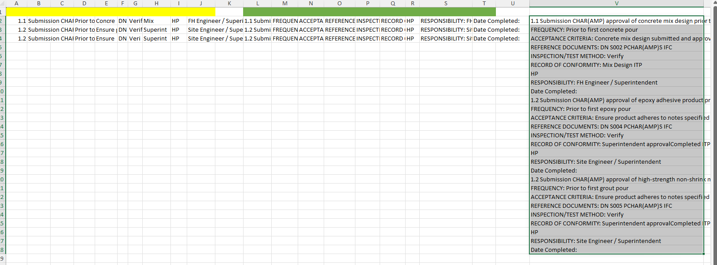

*Using the concat spreadsheet to batch convert an ITP’s items*

This tool is invaluable for speeding up the digitisation process since you’ll only need to focus on formatting the items instead of building everything. It can handle ITPs of any size; you need only ensure that the raw ITP’s contents are copied over properly.

## Do I need anything specific to use this concat spreadsheet?

Just Microsoft Excel or OpenOffice Calc. As of writing (February 2025), Google Sheets doesn’t support nor possess an equivalent to FILTERXML, so those two editors are your best options.

## The supplied ITP doesn’t match the concat spreadsheet’s columns and I’m getting a lot of #VALUE! errors!

The concat spreadsheet is easily customisable. You can add as many columns as you need to expand the yellow columns (depending on how spread out the raw ITP is).

This applies to the actual concatenation section of the spreadsheet (but just before the cell that has the FILTERXML function defined). If you need more rows, just include more columns under the green columns of the spreadsheet.

# Digitisation Process – Initial procedures

Before you even begin digitisation, the first thing you’ll need to do is determine if this is a *new* ITP, is a *revision* to an ITP that requires updates to all existing instances, or is a *revised* ITP that does not replace any existing instances of the ITP.

***Do not confuse the three tasks!*** A ***revision*** to an existing ITP is not the same as creating a ***revised*** ITP that will be used for new instances going forward.

## “Revision” versus “Revised”

* A **revision** to an ITP *does not* need the previous version of the ITP template to be maintained. It *replaces* the ITP for all instances within the project completely.
* A **revised** ITP requires the previous version of the ITP template to be kept. It *does not* need to replace any existing ITP instances within the project. However, you *do* need to make sure that the revision number is clearly identifiable so that it can be distinguished against the older versions of the ITP.

Remember to always check what the Quality Engineer specifies when they send through an ITP to you. ***This is especially important if you are making revisions to an ITP.***

## Terms to remember

### “Lot”

Across the board (but especially with AU infrastructure clients), Quality Engineers will often refer to existing instances of ITPs within a project as a “**lot**”.

### “Hold Point”

As the term’s name suggests, holdpoints are stopping points where QA/QC cannot proceed until the item is signed off by the project supervisor and/or main contractor. For these items on the ITP, you *must* include a signoff option.

### “Approval Point”/”Inspection Point”/”Test Point”/”Survey Conformance Point”

For all intents and purposes, these terms are mostly irrelevant to the digitisation process. The only thing that you need to know is that these items on the ITP do not require anything special (no signoff option is required).

On some occasions, you may get a request from a Quality Engineer to append a signoff option onto items with APs/IPs/TPs/SCPs. However, these kinds of requests are relatively rare and are only requested on a case-by-case basis. In every other situation, you *do not* need to append a signoff onto these items.

# Digitisation Process – Sanitisation Part 1

With the initial checks done, it is time to see if you need to sanitise the ITP.

When ITPs are supplied in their raw format, they may not always be “clean” and ready for processing. Examples of this include ITPs that have in-line pictures inserted into cells, empty columns, empty rows, and cells with blank values. In other cases, the rows/columns may not align consistently or there may be sections of the ITP that have differently named columns.

Skim through the raw ITP briefly and try to identify these issues (if any). Excel/OpenOffice Calc have a few options to speed up the process:

* For identifying blank cells, you can drag-click and select all cells with data in them (avoid the temptation to highlight entire columns and rows).
  + Once you’ve selected these cells, select **HOME** -> **Find & Select** -> **Go To** (Hotkeys: *LEFT CONTROL* + *G*). Then, click on **Special…** and finally select the **Blanks** radio.
  + Consider using the **Fill Color** tool to change the cell colours as well.
  + You can enter an identifiable placeholder character (e.g. an em dash “—“) so that these cells won’t be affected if you shift the data left or right.

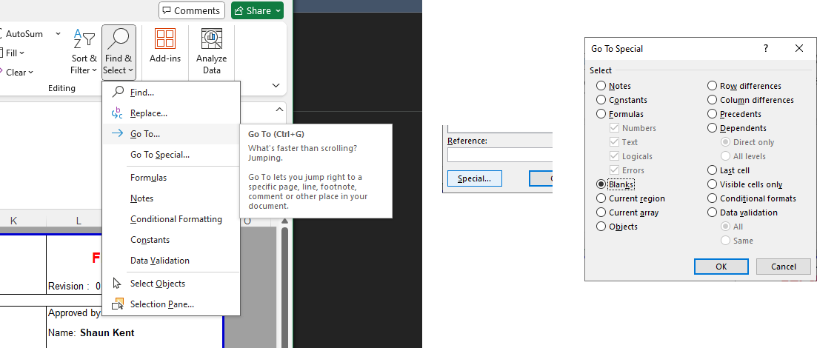

* Bulk replacing bad text such as non-UTF-8 symbols or words that have gaps (e.g. “**Conforman ce**” instead of “*Conformance*”) can be done by selecting **HOME** -> **Find & Select** -> **Replace…** (Hotkeys: *LEFT CONTROL* + *H*).
* For deleting blank rows or unnecessary columns, simply hold *LEFT CONTROL* as you click on each row/column. Then select **HOME** -> **Delete** -> **Delete cells…**.

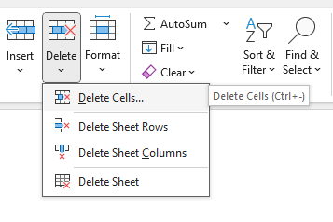

# Digitisation Process – Sanitisation Part 2

You’ll need to ensure the column headers on the raw ITP match up with those on the concat spreadsheet.

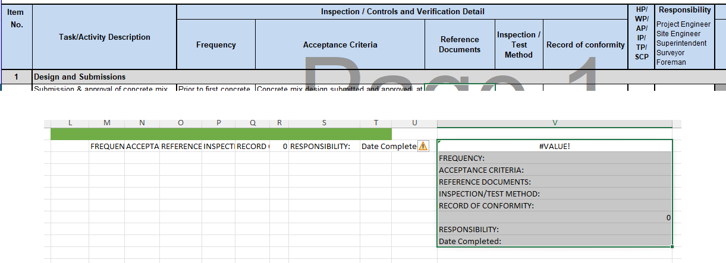

This part of the process shouldn’t take too long. Just copy the text from the raw ITP columns onto the concat spreadsheet. You can then add as many columns as needed under the green section of the concat spreadsheet.

* To do this, click on the empty cell to the right of the green section. Then, hold the *LEFT SHIFT* key and then press the *RIGHT ARROW* key as many times as needed until you have the necessary number of columns. Finally, select **HOME** -> **Insert** -> **Insert cells…**. Repeat this process for as many times as needed.

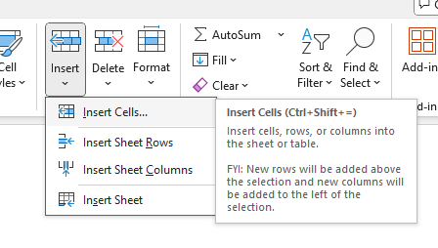

Keep in mind that it’s worthwhile to keep separate spreadsheets for each customer account/project with these column headers already saved.

In the majority of cases, you won’t need to adjust the column headers since any ITPs that get sent through from the same customer will utilise the exact same layouts. Which means that digitising the ITP will be even simpler since you can just copy the text and drop the text straight into the concat spreadsheet without too much trouble.

## The green cells don’t pull text correctly from the yellow section!

To fix this, you just need to change the green cell formulae. Simply change the cell numbers so that they pull from the right columns under the yellow section.

For example, in the following ITP, the green column for “**FREQUENCY:**” is obviously missing its value. The issue here is caused by **="FREQUENCY: "&C2** pulling from cell **C2** instead of **D2** (which *has* the text that you need):

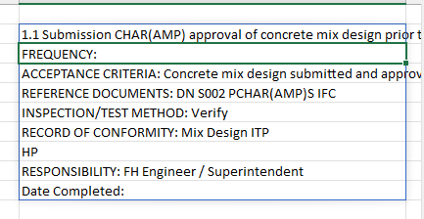

All you have to do is change the formula to point towards cell **D2** instead. If you’ve done this correctly, FILTERXML will automatically update itself to reflect this change:

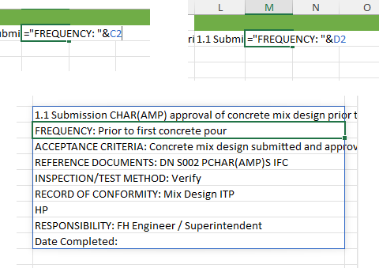

***Remember to always check this by testing out a few items from the ITP before you start digitising the rest of it.*** You don’t want to end up in a situation where you accidentally miss out on large chunks of the ITP just because of one or two wrongly configured formulae.

# Digitisation Process – Sanitisation Part 3

With the raw ITP mostly cleaned up, the only thing that needs to be done is to ensure that the text you copy over to the concat spreadsheet is in:

* Plain text
* Does not have special characters for **ampersand** (&) and **less-than** (<)

Copying over in plain text is simple:

* Click on **HOME** -> **Paste** -> **Paste Special…** (Hotkeys: *LEFT CONTROL* + *LEFT ALT* + *V*). When the *Paste Special* window opens, select the **Values** radio then click on **OK**.

In order to strip out the two special characters from the text (**&** and **<**), you have two options:

* Do a mass find and replace to swap out both characters with a temporary placeholder string within the ITP.
* Copy the ITP’s items and paste them into a text editor (Notepad, Sublime Text, etc.), then do a find and replace operation to swap out the characters there.

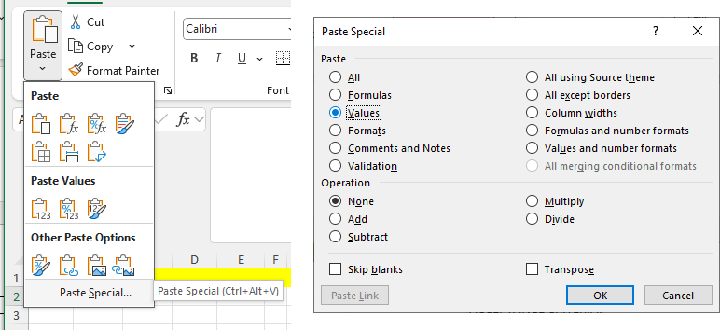

Regardless of method, it is recommended that you use something that is easily distinguishable and cannot be confused with anything else when the time comes to restore these special characters i.e. **CHAR(AMP)** for ampersands and **CHAR(LESS)** for less-than.

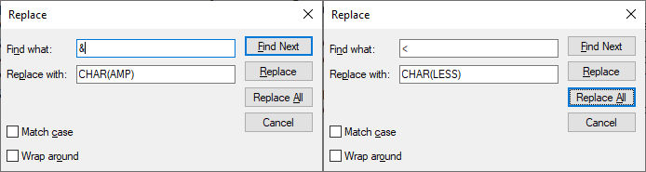

Your copied text will appear to have all these CHAR(AMP)s and CHAR(LESS)s but don’t worry about it. This is temporary and will only be used for the concat spreadsheet.

## Why do these characters need to be replaced?

Long story short, the FILTERXML function follows basic XML syntax rules. Both characters on their own are illegal to use and will throw an error if you attempt to straight up paste text that has either character in it.

<https://www.w3schools.com/xml/xml_syntax.asp>

It requires both characters to be “escaped” in order to be able to use them (‘**&**’ is reserved for entity references whereas ‘**<**’ opens a new element). As shown in the example below, the concat spreadsheet’s FILTERXML will warn you about this:

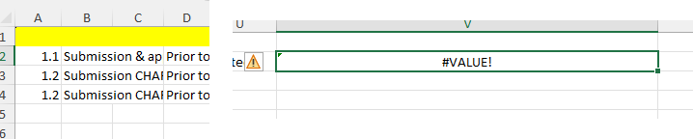

*Cell B2 has an ampersand which causes FILTERXML to fail and report an error*

Therefore, replacing both characters with a placeholder string will allow you to bypass the restriction without affecting the contents of the ITP once it gets processed by the concat spreadsheet.

## Why does it matter for the copied text to be in plain text?

Copying over text directly from the raw ITP will not just copy its contents, but it also moves over the cell references from the ITP onto the concat spreadsheet.

Copying in plain text removes this risk and ensures that you won’t get any errors when FILTERXML attempts to combine all the text from the green section of the concat spreadsheet.

# Digitisation Process – Conversion

Now that the raw ITP has been sanitised, you can begin the actual conversion process into a CONQA-ready format.

For starters, copy and paste the ITP’s content into the yellow section of the concat spreadsheet. If done correctly, the green section of the spreadsheet will concatenate the contents of the yellow section, which in turn will be combined by FILTERXML.

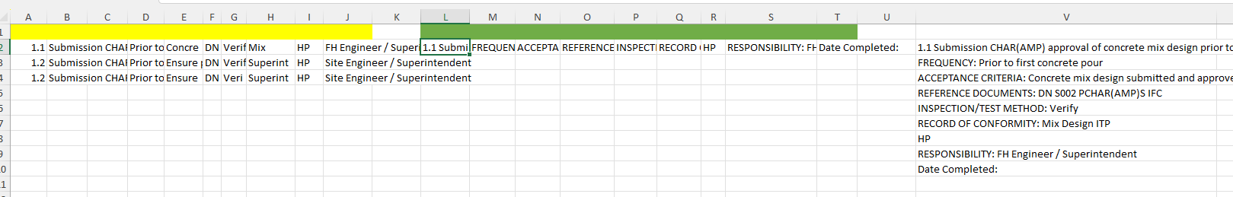

However, only one row of the ITP has been converted. You’ll need to expand the green section rows so that they match up with the rows under the yellow section. To do this, drag-select the highlighted cell until the whole first row under the green section is highlighted.

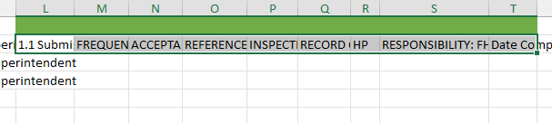

Now hover your mouse cursor over the bottom-right hand corner of the selection; your cursor should change to a black/white cross. Click and hold this selection, dragging it down several rows until it matches the number of rows on the yellow section.

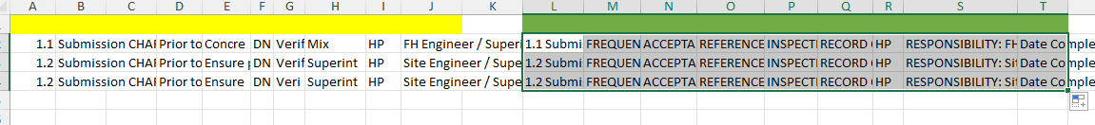

Release the cursor once everything matches up accordingly. FILTERXML should automatically update to take this change into account and generate the necessary number of rows.

Lastly, copy the generated text from FILTERXML, making sure that you copy everything that it generates (Excel/OpenOffice Calc will only copy what you highlight).

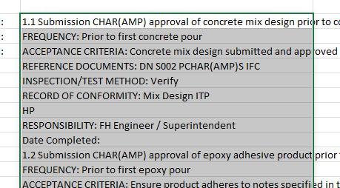

## I’m getting an error about #CALC!

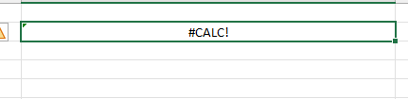

FILTERXML has a maximum character limit of **32,767**. It will automatically throw the *#CALC!* error once you hit this limit. You can work around this cap by limiting the number of rows that FILTERXML draws its data by editing the FILTERXML function.

Click on the cell with the FILTERXML function and press F2 (or double-click on the cell to edit its formula). You should see a pale blue box appear over the green section columns.

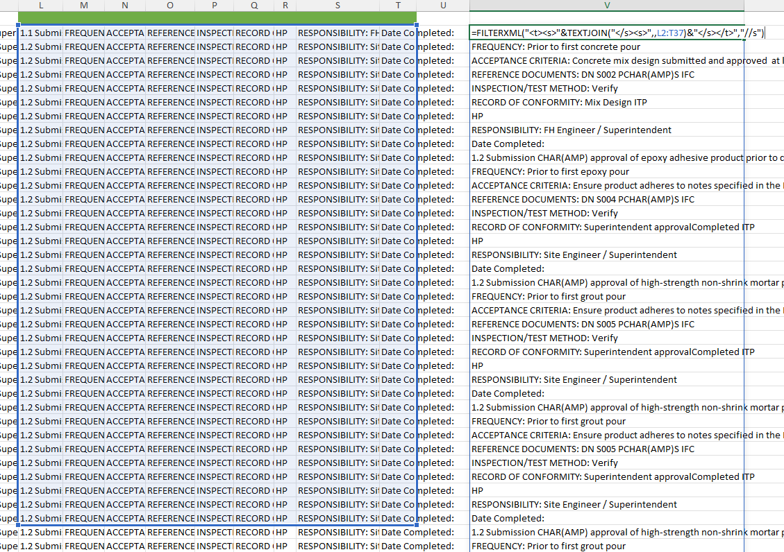

Hover your cursor to the bottom-right hand corner of the box and drag it up or down as many rows as needed until the #CALC! error is no longer thrown.

## I’ve swapped out &s and <s but I’m still getting the #NAME? error

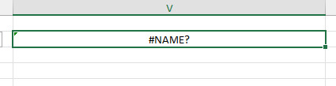

*#NAME?* errors are usually caused by text within the ITP having ‘**-**‘ (minus) symbols. Excel/OpenOffice Calc interprets the symbol as the start of a formula, causing FILTERXML to fail since it cannot concatenate an incomplete formula.

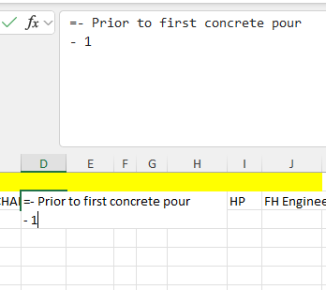

Like &s and <s, you can fix this simply by replacing minus symbols with em dashes (‘—‘) or hollow bullet points (‘○’).

# Digitisation Process – Formatting overview

With the ITP converted successfully, you can now paste the contents of FILTERXML’s output onto your spreadsheet.

## Digitisation Process – Formatting - Establishing the ITP’s layout

However, even though you can *technically* convert the spreadsheet into a .csv file and upload it onto CONQA straight away, you still have to format the spreadsheet to ensure that line items with paragraphs are delineated properly, Hold Points have signoffs appended to them, textboxes and other data input items are available, etc.

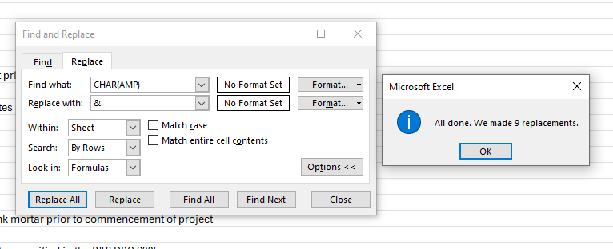

You also need to revert changes to special characters. **CHAR(AMP)** needs to become ‘**&**’ and **CHAR(LESS)** must be reverted to a ‘**<**’ symbol again. As before, you can either do this within your own spreadsheet or paste the contents onto a text editor first and do the replacements there.

Furthermore, the checklist types have not been fully entered for every row yet. Even if you attempted to upload this checklist, you’d be warned about the checklist being incomplete.

Thankfully, this process can be sped up easily; you only need to fill out the data for one item on the ITP. Once you’ve filled it out, highlight those specific cells (under the **Type** column only) and drag-select the box all the way to the final row on the checklist.

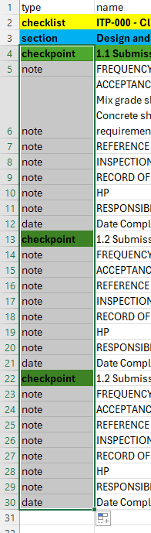

If done properly, all items should now have their data types filled out correctly.

## Digitisation Process – Formatting - Hold points

You now need to identify if there are any hold points within the ITP.

The quickest way is to simply apply a filter (Hotkeys: *LEFT CONTROL* + *LEFT SHIFT* + *L*) to the checklist and search for “**HP**”, “**Hold Point**”, or “**Holdpoint**” (varies depending on what the ITP is using).

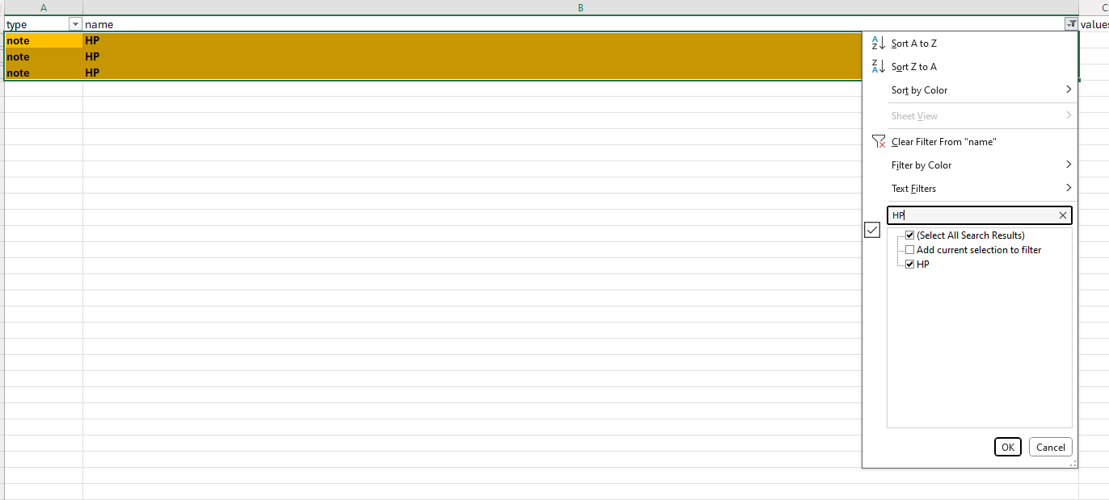

Highlight any holdpoints with the **Fill Color** tool and pick an easily identifiable colour of your choice. Clear your filter and start adding a signoff option to each item where a holdpoint has been identified.

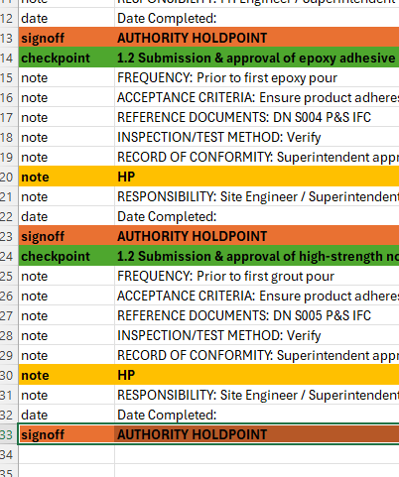

As a safety precaution, before you proceed any further with the ITP, do one final sweep by filtering out the rows with a HP note versus the number of signoff options that you’ve added. You should have the exact same number of signoffs as HPs. If you have either more or less signoffs, then you’ve either missed a HP, or you added far too many than what was required.

## Digitisation Process – Formatting – Data inputs

In addition to date type fields, you may commonly be asked to add an extra textbox or tickbox field for the Quality Engineers to use on the item. Simply add the requisite data type under the **Type** column wherever these are needed.

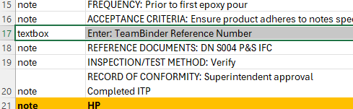

## Digitisation Process – Formatting – Line items/paragraphs

On many ITPs, you will often see cells where the text is written over multiple lines and has delineated paragraphs. You must preserve the original text’s paragraph structure and individual line items if needed.

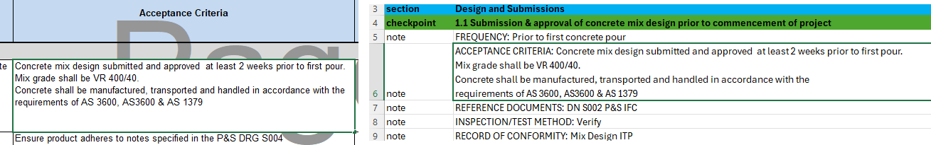

*Left: Raw ITP, Right: Checklist template*

Fortunately, FILTERXML automatically preserves line breaks from the raw ITP (so long as it was copied over properly). As a result, you can easily spot items that need multiple notes for each sentence and/or paragraph by simply clicking on the **HOME** -> **Wrap Text** tool. If Excel identifies any rows that have overlapping text, you’ll need to fix those by separating them onto individual notes.

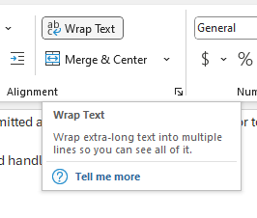

This is as simple as inserting a new row above the specified note in the checkpoint. Select the cell immediately below the note that needs to be separated, then click on **HOME** -> **Insert** -> **Insert Sheet Rows** (Hotkeys: *LEFT ALT* + *I* + *R*).

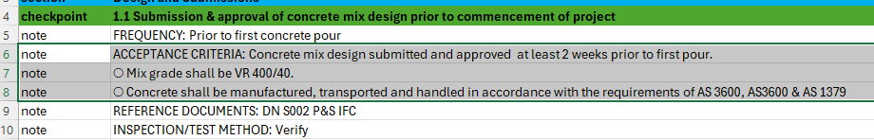

For each line item, use a mix of hollow bullet points (‘○’: hotkeys are *LEFT ALT* + *Numpad 9*) and em dashes (‘—‘: hotkeys are *LEFT ALT* + *0* + *1* + *5* + *1*) wherever necessary to distinguish line items. Don’t overdo it though; only insert new line items when they’re actually required to match the layout on the raw ITP.

Lastly, **readability matters**! Use your own judgement to determine whether or not notes need to be separated. The best metric is this: if ***you*** are struggling to read the ITP’s contents, imagine how much more difficult it is for the Quality Engineer.

# Digitisation Process – Section names

Just like on regular checklists, section names should correspond to those used on the ITP.

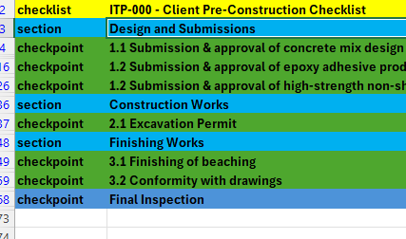

Add as many sections as needed to match the raw ITP’s layout. Don’t forget to do a final sweep by filtering out the checkpoints *and* sections. Each section should have the right number of checkpoints to match those on the raw ITP. If there’s too many checkpoints under one section, then it means you added the section in the wrong location.

# Digitisation Process – Final Inspection/Signoff checkpoint

Not all ITPs require a final inspection/final signoff checkpoint. Whether or not these are needed depends on the client and the Quality Engineer in charge of the project.

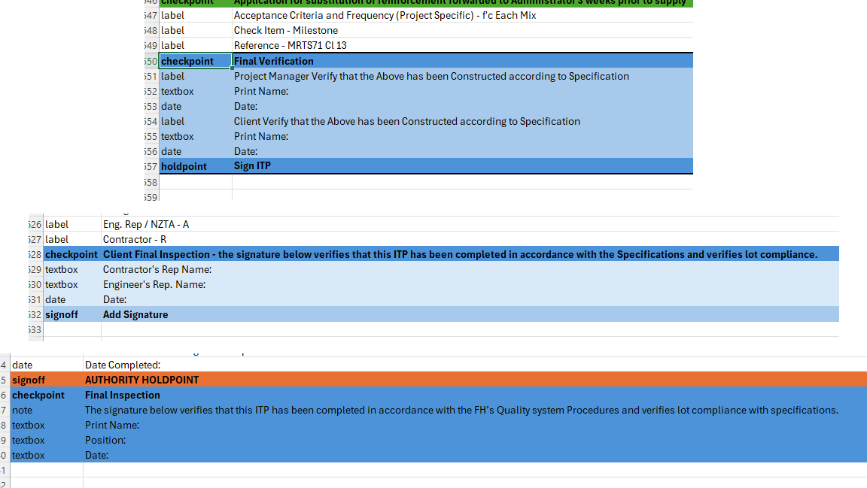

*Top: Fulton Hogan Civil Department, Centre: Downer, Bottom: Doval Constructions*

In the majority of cases, this checkpoint is quite literally that: the last checkpoint on the template, perhaps a signoff, and maybe a few inputs for text and/or dates.

***Remember that this is not universally required across every infrastructure account/project.*** If you need to check whether or not an ITP requires a final inspection/final signoff checkpoint, be sure to download the project’s library and compare this with other existing ITPs first.