**Project:** Downer – WestLink 22/23 Rehabs

<https://dashboard.con.qa/#/account/818c42c4-cf06-42cc-b787-49cee7fcda1e/project/1cc1af0c-4af7-4eed-afb5-096621cec1d4>

<https://account.con.qa/matrix/818c42c4-cf06-42cc-b787-49cee7fcda1e/1cc1af0c-4af7-4eed-afb5-096621cec1d4>

# **Example 3 – Excessive rows**

## **CONTEXT:**

Overall progress for all ITPs in the project needs to be displayed (*Figure 1*), displaying only the sections rather than individual checkpoints:

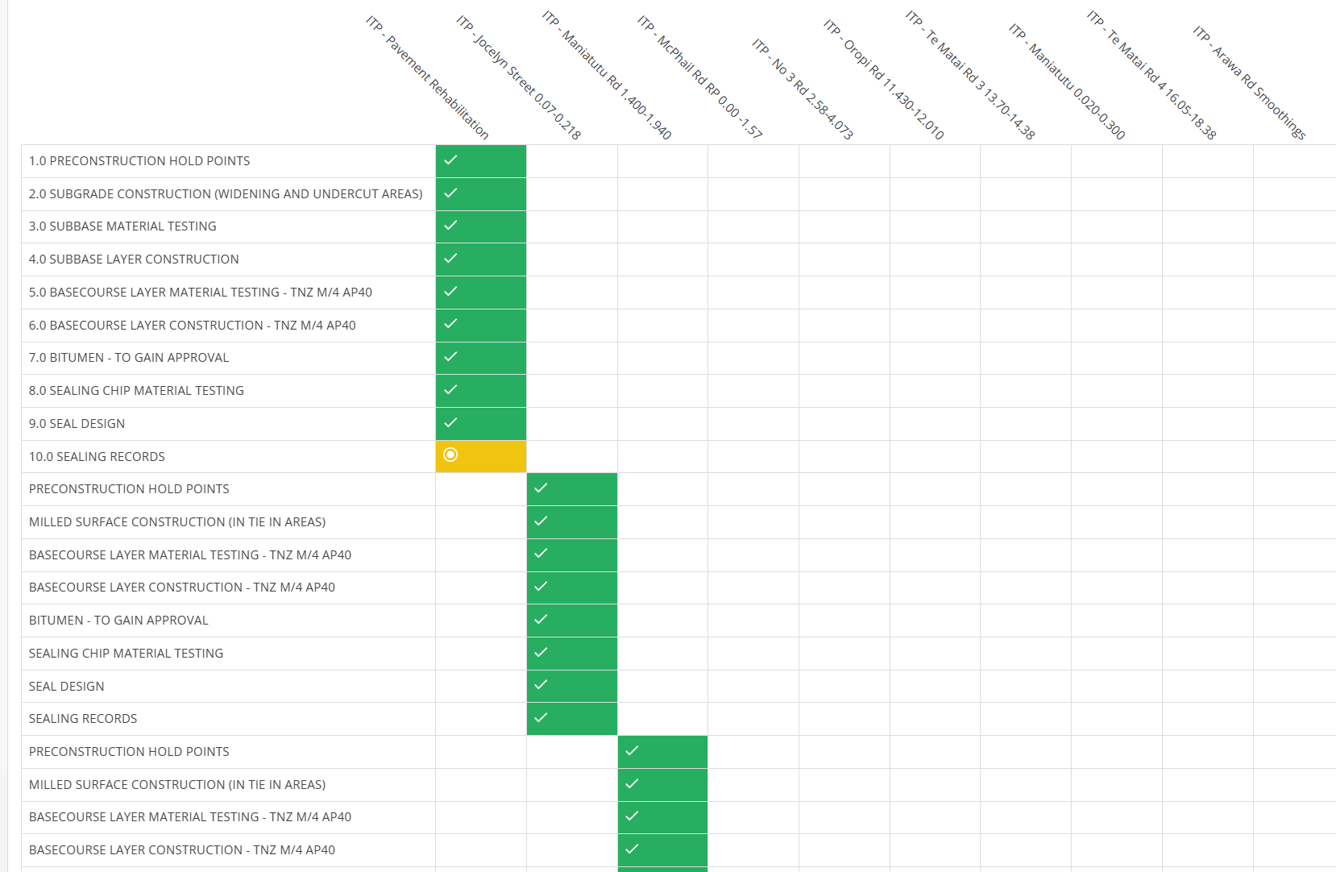

*Figure 1*

## **ISSUE:**

To build this matrix, rows need to be added for every single unique section per ITP. However, there are actually several sections that share almost identical names barring their number prefixes (i.e. **SEAL DESIGN** and **9.0 SEAL DESIGN**).

The usual workaround is to rename the sections so that they all share the same name. However, this ***is not possible*** as the tags needed for the section in one ITP would not be the same as those in another ITP.

Case in point, **ITP - No 3 Rd 2.58-4.073’s** SEAL DESIGN is named as “*12.0 - SEAL DESIGN*” whilst **ITP - Te Matai Rd 3 13.70-14.38’s** SEAL DESIGN is named as “*11.0 SEAL DESIGN*” instead.

Therefore, unique rows need to be added for every single SEAL DESIGN section since the tags for one section would not be compatible with another. This results in bloat to the matrix and requires excessive scrolling to view everything else.

## **SOLUTION:**

Through the usage of matrix keys, a key could be defined for each section that is also shared by other ITPs (*Figure 2*):

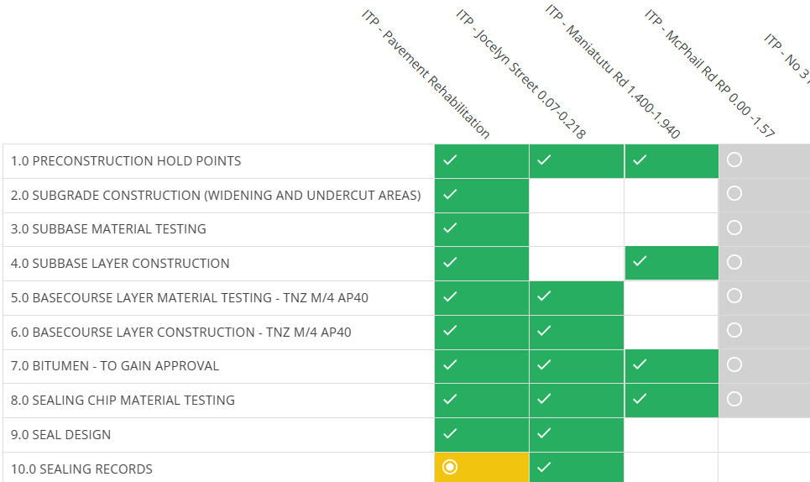

*Figure 2 (Example)*

Although there would still be empty cells on each row as every single ITP does not contain the same number of sections, the matrix would be less bloated overall and not require as much vertical scrolling.