**Project:** Fulton Hogan – Craigieburn Road Upgrade

<https://dashboard.con.qa/#/account/92386481-abfa-4672-b1b6-33f5bc00033d/project/22b6e739-211b-4ae4-a9ea-3ccc4bcfe0da>

<https://account.con.qa/matrix/92386481-abfa-4672-b1b6-33f5bc00033d/22b6e739-211b-4ae4-a9ea-3ccc4bcfe0da>

# **Example 1 – Duplicate columns**

## **CONTEXT:**

All three matrices require two columns just for the ‘*Work Completed On*’ textbox (*Figure 1*):

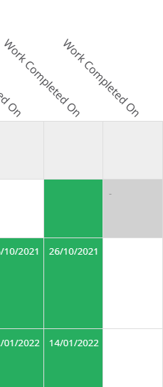

*Figure 1*

In *Figure 2*, the rows are pulling from the same type of checklist (*ITP-006 - Excavation, Fill with Type B and Subgrade Prep*), but one is more recent and has had changes made to its **Final Inspection** checkpoint.

Specifically, this relates to the location of the ‘*Work Completed On*’ textbox. The more recent checklist (*Figure 3*) has it nested within the **Final Inspection** checkpoint as a child, whilst the older version (*Figure 4*) has it as a standalone *checkpoint-no-status,* and is named accordingly as **Final Inspection - Work Completed On**:

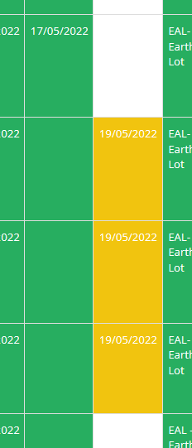

*Figure 2*

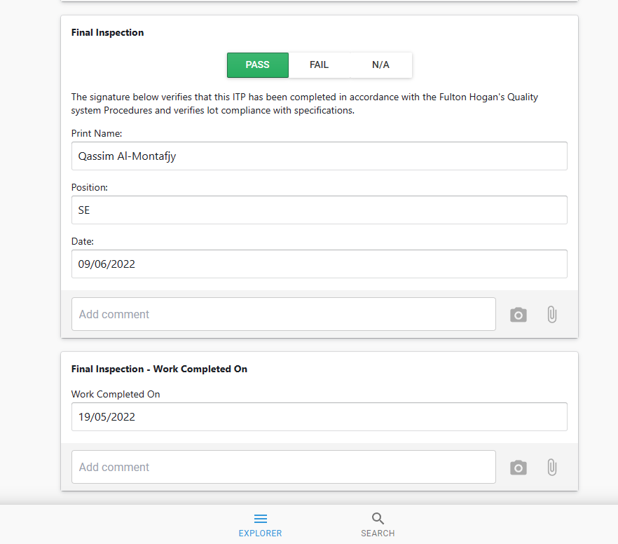

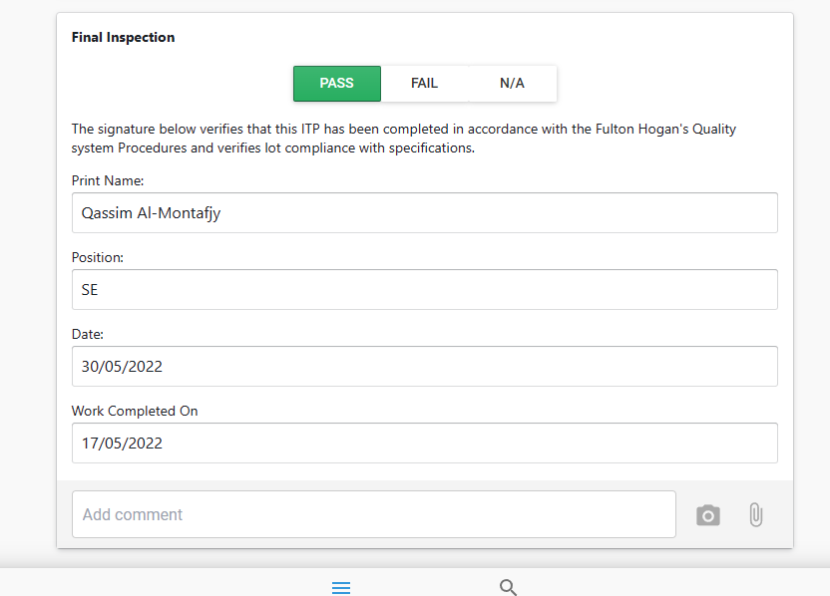

*Figure 3*

*Figure 4*

## **ISSUE:**

Due to the limitations of tags, we need to include an extra column specifically to pull data from the standalone checkpoint, resulting in a duplication of columns to accommodate the older checklist (*Figure 5*):

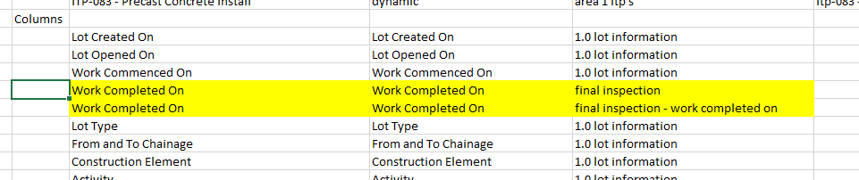

*Figure 5*

## **SOLUTION:**

However, with the (hypothetical) introduction of matrix keys, we could instead define a common key for both checkpoints and reference it directly when building the matrix:

*Figure 6 (example only)*

In *Figure 6*, “**fiwco_itp006**” is a reference to the key shared by both checkpoints, which we would have defined via bulk edit to the **Final Inspection** and **Final Inspection - Work Completed On** checkpoints on all ITP-006 checklists throughout the project.

The end result is the matrix no longer requiring a duplicate column:

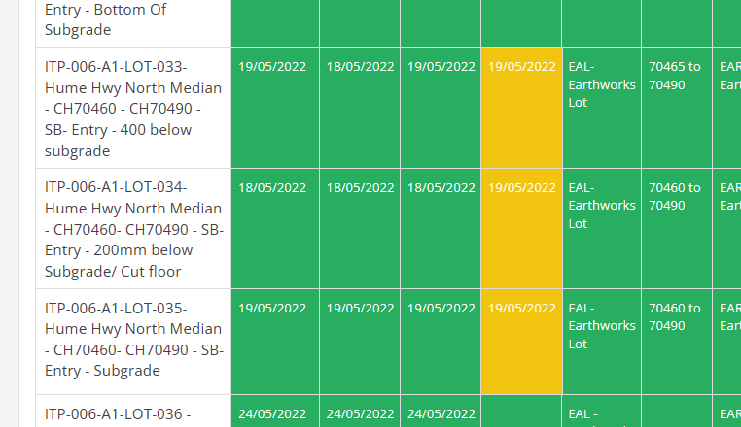

*Figure 7 (example only)*