**Project:** Fulton Hogan – Craigieburn Road Upgrade

<https://dashboard.con.qa/#/account/92386481-abfa-4672-b1b6-33f5bc00033d/project/22b6e739-211b-4ae4-a9ea-3ccc4bcfe0da>

<https://account.con.qa/matrix/92386481-abfa-4672-b1b6-33f5bc00033d/22b6e739-211b-4ae4-a9ea-3ccc4bcfe0da>

# **Example 2 – Cannot disambiguate section and checkpoint**

## **CONTEXT:**

**NOTE:** The issue in this example has already been addressed in a prior ticket by adopting one of the workarounds (*2. Rename the item(s) so that they don't share the same name.*). For the sake of demonstration, this example assumes that the change has not been implemented yet.

ITP-017 has a section titled as **Lot Verification** (*Figure 1*) Within this section is a standalone checkpoint also titled as **Lot Verification** (*Figure 2*):

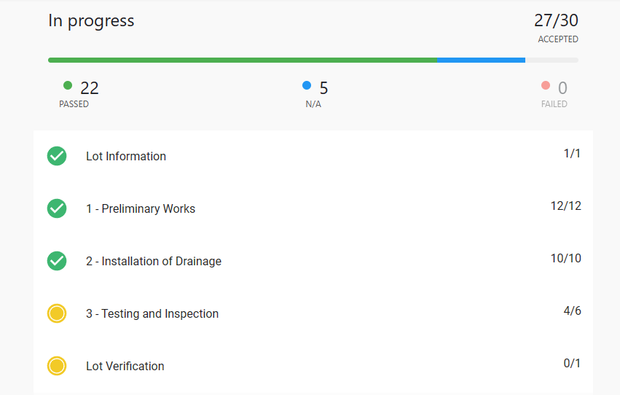

*Figure 1*

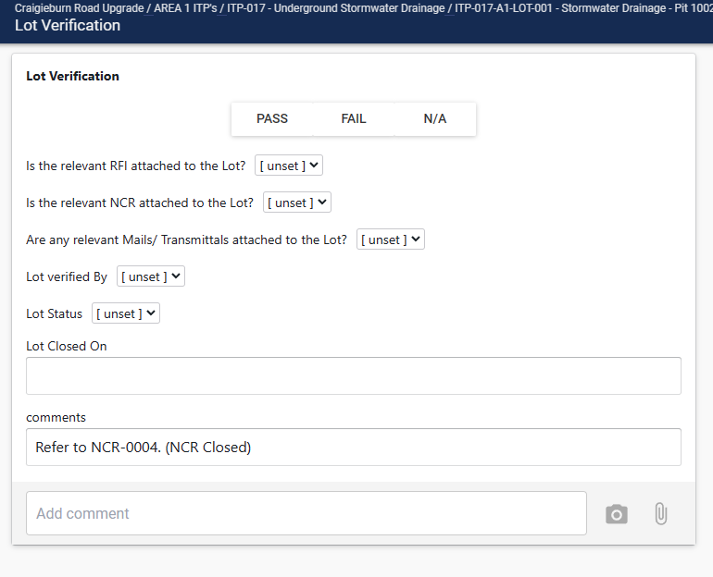

*Figure 2 (image contents have been edited for demo purposes)*

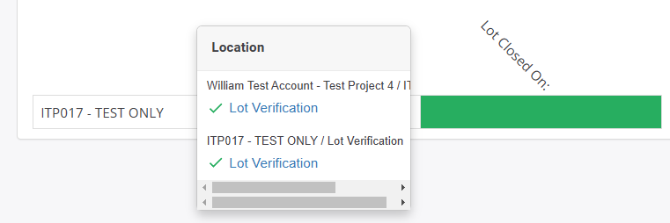Due to both sharing the same name, the matrix attempts to pulls data from both but only the section’s progress is displayed instead of the **Lot Verification** checkpoint (*Figure 3*):

*Figure 3*

## **ISSUE:**

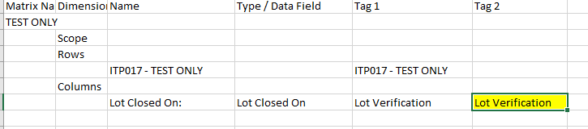Adding an extra tag after **Lot Verification** would normally be the solution to narrow down the column (*Figure 4*). However, this does not actually affect the outcome as the matrix will still pull from the section rather than the checkpoint (as per *Figure 3*):

*Figure 4*

Renaming the section to something else is not possible as ITP-017 follows a strict layout which mandates that the section and checkpoint be named as-is. The only remedy to this is to add a period to the **Lot Verification**(+ “.”) checkpoint, keeping its name mostly intact (*Figure 5*) whilst ensuring that the matrix pulls the contents of **Lot Closed On:** correctly (*Figure 6*):

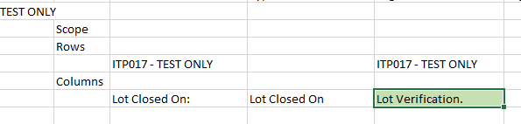

*Figure 5*

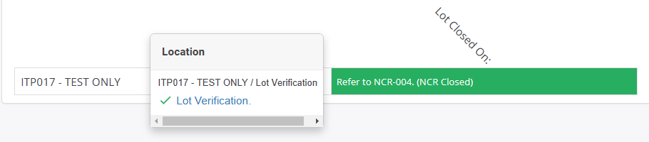

*Figure 6*

## **SOLUTION:**

By using matrix keys, we would no longer need to bulk edit and replace the checklist as a resource by simply defining a key called **lv_itp017** (*Figure 7*), *specifically* to be used for the checkpoint:

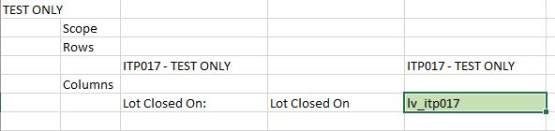

*Figure 7 (example only)*

The matrix would then pull the same data properly as per *Figure 6*.

## **ADDENDUM:**

QA reports are also affected by this inability to disambiguate as they will only output a PASS, FAIL or N/A rather than the desired textbox value.