# CS 255 System Design Document Template

This template lays out all the different sections that you need to complete for Project Two. Each section has guidance to prompt your thinking. You will need to continually reference the interview transcript as you work to make sure that you are addressing your client’s needs. There is no required length for the final document. Instead the goal is to complete each section based on what your client’s needs are. Remove this note when you are finished, and replace all bracketed text with the relevant information.

## UML Diagrams

### UML Use Case Diagram

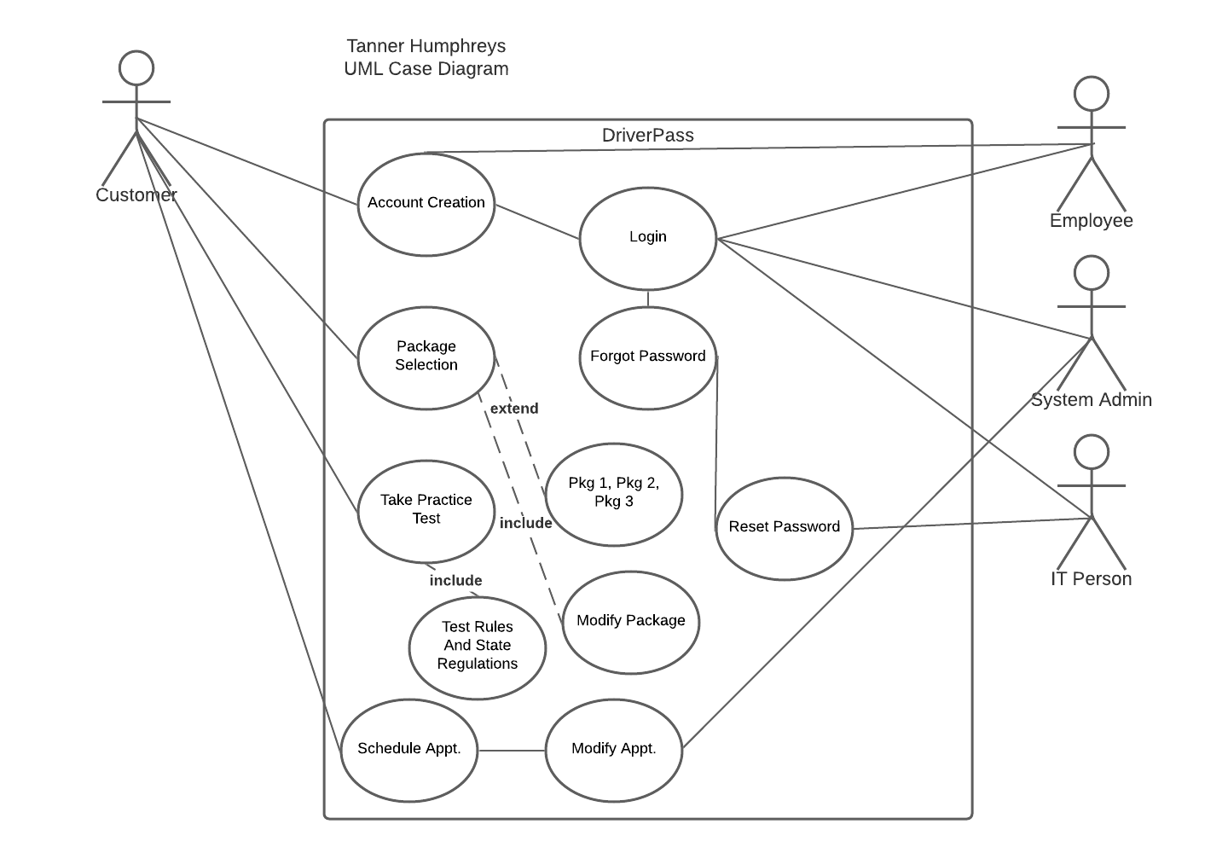

### UML Activity Diagrams

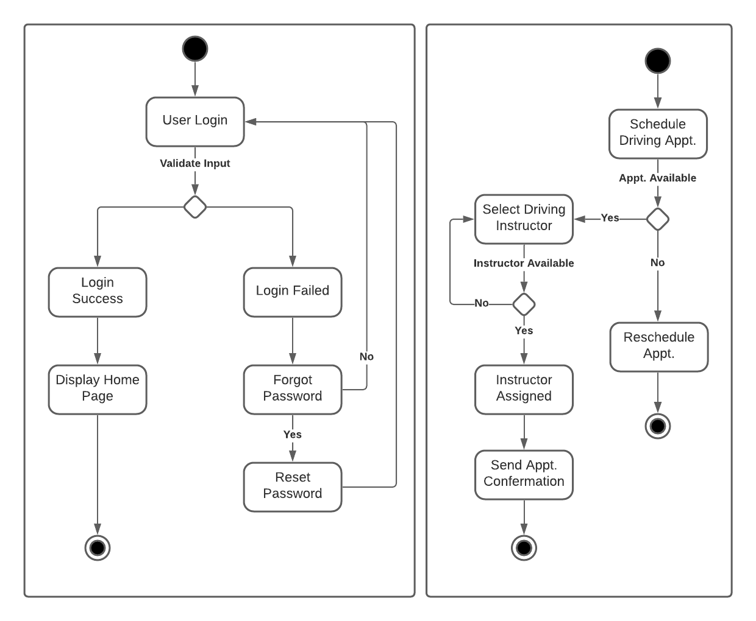

### UML Sequence Diagram

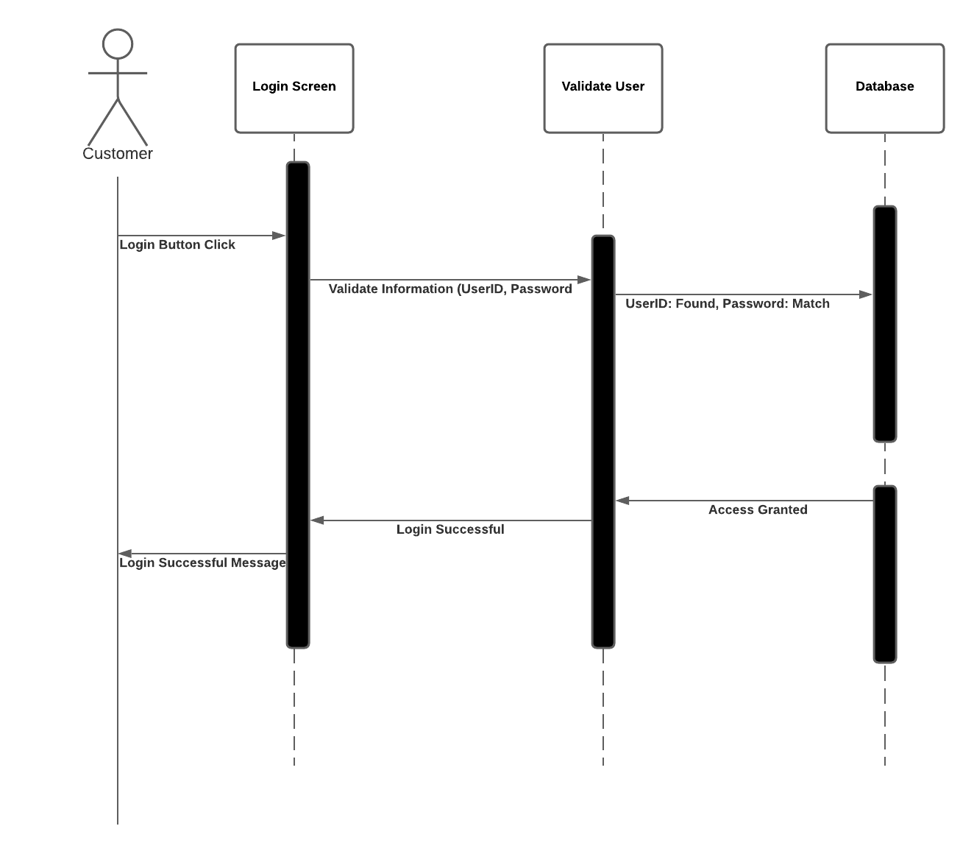

### UML Class Diagram

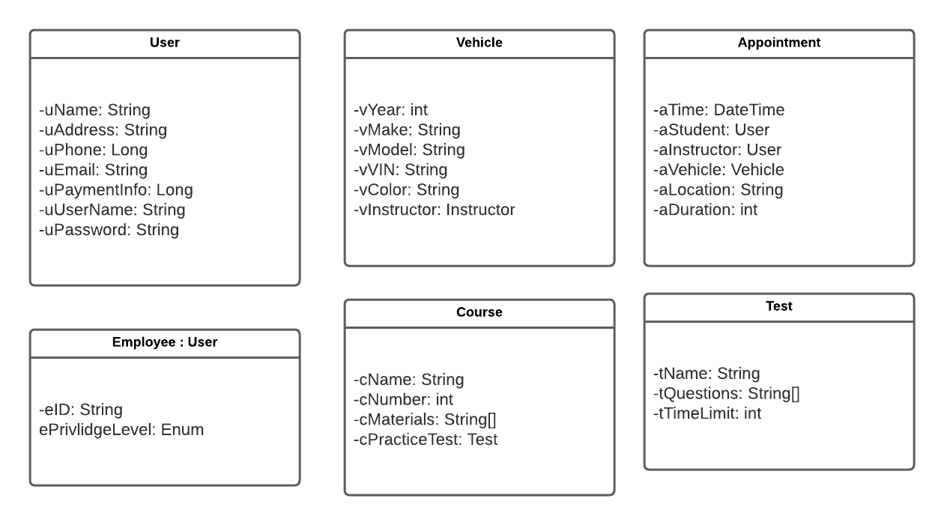

## Technical Requirements

* System will be web based and take the form of a website.
* System will need to need to process requests from users.
* System will need to be able to scale up for a growing user base.
* Cross platform availability is wanted for the system.
* Because the system will be running in a cloud environment, no additional tools are required.
* The system shall validate user credentials when logging in.
* The system shall provide access to content based on user privilege.
* The system shall allow users to subscribe to different driving packages.
* The system shall schedule hands on training reservations made by users.
* The system shall allow access to practice tests and courses.
* The system shall give detailed information about driving reservations.
* The system shall track user progress through courses.
* The system shall show progress made on tests and courses for each user.