Python语言程序设计基础实验报告12-218
学号:117060400218 姓名:孙文华 班级:应用统计学2班 指导老师:林卫中
实验名称:爬虫实验指导
实验要求:熟练运用requests和beautifulsoup4函数库爬取数据，利用百度搜索提供的这个链接接口，可以通过requests的get（）函数提交查询，响应结果为百度搜索结果。
实验题目:
第一次实验任务：
任务一：按照省份输出中国大学排名。大学排名网址：
http://www.zuihaodaxue.cn/zuihaodaxuepaiming2018.html
请分别输出江西省和山东省的高校排名；
任务二： USNEWS美国大学排名爬虫。美国大学排名网址如下：
https://www.usnews.com/best-colleges/rankings/national-universities
注意：由于该网站有反爬虫机制，需要模拟浏览器行为进行爬虫，参考代码如下：
def getHTMLText(url):
send_headers = {
"User-Agent": "Mozilla/5.0 (Windows NT 10.0; Win64; x64) AppleWebKit/537.36 (KHTML, like Gecko) Chrome/61.0.3163.100 Safari/537.36",
"Connection": "keep-alive",
"Accept": "text/html,application/xhtml+xml,application/xml;q=0.9,image/webp,image/apng,*/*;q=0.8",
"Accept-Language": "zh-CN,zh;q=0.8"}
try:
r = requests.get(url, headers=send_headers)
r.raise_for_status()
print(r.status_code)
r.encoding = 'utf-8'
return r.text
except:
return ""
任务三： 爬取并分析robots.txt文件
一般网站的robots.txt文件存放在网站的根目录下，如上题的USNEWS网站的robotx.txt文件URL是：https://www.usnews.com/robots.txt

任务四：
分析百度图片搜索返回结果的HTML代码，编写爬虫抓取图片并下载形成专题图片库。
参考代码如下：

#下载图片
#imgUrl: 图片的URL
#destUrl: 图片保存的本地文件夹名字
#fname: 图片保存到本地时的另存名，如果为空，则默认用原来的文件名
def downloadImageFile(imgUrl, destUrl, fname=''):
local_filename = imgUrl.split('/')[-1]
print('Download Image File={}'.format(local_filename))
try:
r = requests.get(imgUrl, stream=True)
r.raise_for_status()

if len(fname) == 0:
fname = local_filename

with open(destUrl + "/" + fname, 'wb') as f:
for chunk in r.iter_content(chunk_size=1024):
if chunk:
f.write(chunk)
f.flush()
f.close()
return r.status_code
except:
return r.status_code
第二次实验任务：
任务一：爬取美国大学排名前30名的学校名称、学费、培养规模。
（提示： https://www.usnews.com/best-colleges/rankings/national-universities 网页源代码3259行）
扩展练习：列出前100名高校中学费低于$50,000的所有学校
任务二：从百度图片上爬取90张范冰冰（或其他明星）的照片 http://image.baidu.com/
任务三：爬取网易云音乐上所有播放次数超过500万次的歌曲信息，包括：歌曲名，播放次数，歌曲链接地址等信息
1．准备工作
1）. selenium支持以下浏览器：chrome，Edge，Firefox，Safari。本指南以Firefox浏览器为例
2）. 安装selenium
见：https://pypi.org/project/selenium/
3）. 安装驱动
对于chrome浏览器，由于谷歌在国内不能访问，可通过某宝的镜像下载chrome的驱动
https://npm.taobao.org/mirrors/chromedriver/
对于其它浏览器，在上一节给出的网站中能找到下载链接
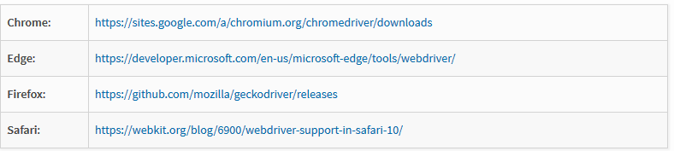
2．爬取信息。网易云音乐地址：
http://music.163.com/#/discover/playlist/

算法实现:
①#e23.1CrawUnivRanking.py
import requests
from bs4 import BeautifulSoup
allUniv = []
def getHTMLText(url):
try:
r = requests.get(url, timeout=30)
r.raise_for_status()
r.encoding = 'utf-8'
return r.text
except:
return ""
def fillUnivList(soup):
data = soup.find_all('tr')
for tr in data:
ltd = tr.find_all('td')
if len(ltd)==0:
continue
singleUniv = []
for td in ltd:
singleUniv.append(td.string)
allUniv.append(singleUniv)
def printUnivList(province):
print("{:^4}{:^10}{:^5}{:^8}{:^10}".format("排名","学校名称","省份","总分","培养规模"))
for u in allUniv:
if province in u[2]:
print("{:^4}{:^10}{:^5}{:^8}{:^10}".format(u[0],u[1],u[2],u[3],u[4]))
def main(p):
url = 'http://www.zuihaodaxue.cn/zuihaodaxuepaiming2018.html'
html = getHTMLText(url)
soup = BeautifulSoup(html, "html.parser")
fillUnivList(soup)
printUnivList(p)
main('江西')
②#e23.1CrawUnivRanking.py
import requests
from bs4 import BeautifulSoup
allUniv = []
def getHTMLText(url):
try:
r = requests.get(url, timeout=30)
r.raise_for_status()
r.encoding = 'utf-8'
return r.text
except:
return ""
def fillUnivList(soup):
data = soup.find_all('tr')
for tr in data:
ltd = tr.find_all('td')
if len(ltd)==0:
continue
singleUniv = []
for td in ltd:
singleUniv.append(td.string)
allUniv.append(singleUniv)
def printUnivList(province):
print("{:^4}{:^10}{:^5}{:^8}{:^10}".format("排名","学校名称","省份","总分","培养规模"))
for u in allUniv:
if province in u[2]:
print("{:^4}{:^10}{:^5}{:^8}{:^10}".format(u[0],u[1],u[2],u[3],u[4]))
def main(p):
url = 'http://www.zuihaodaxue.cn/zuihaodaxuepaiming2018.html'
html = getHTMLText(url)
soup = BeautifulSoup(html, "html.parser")
fillUnivList(soup)
printUnivList(p)
main('山东')
③
import requests
import re
from bs4 import BeautifulSoup
allUniv=[]
def getHTMLText(url):
send_headers = {
"User-Agent": "Mozilla/5.0 (Windows NT 10.0; Win64; x64) AppleWebKit/537.36 (KHTML, like Gecko) Chrome/61.0.3163.100 Safari/537.36",
"Connection": "keep-alive",
"Accept": "text/html,application/xhtml+xml,application/xml;q=0.9,image/webp,image/apng,*/*;q=0.8",
"Accept-Language": "zh-CN,zh;q=0.8"}
try:
r = requests.get(url, headers=send_headers)
r.raise_for_status()
print(r.status_code)
r.encoding = 'utf-8'
return r.text
except:
return ""
def fillUnivList(soup):
data = soup.find_all('div',{'class':re.compile('shadow-dark')})
for div in data:
singleUniv = []
div1 = div.find('div',{'style':'margin-left: 2.5rem;'})
rank = div1.get_text().strip()
singleUniv.append(rank.split(' ')[0])
div2 =div.find('h3')
singleUniv.append(div2.get_text().strip())
ldiv = div.find_all('div',{'style':'padding-right: 0.5rem;'})
singleUniv.append(ldiv[0].strong.string)
singleUniv.append(ldiv[1].strong.string)
allUniv.append(singleUniv)
def printUnivList():
print("{:<6}{:<20}{:<6}{:<10}".format("排名","学校名称","经费","培养规模"))
for u in allUniv:
print("{:<6}{:<20}{:<10}{:<10}".format(u[0],u[1],u[2],u[3]))
def main():
url = 'https://www.usnews.com/best-colleges/rankings/national-universities'
html = getHTMLText(url)
soup = BeautifulSoup(html,'html.parser')
fillUnivList(soup)
printUnivList()
main()
④
from NetSpider import *
from bs4 import BeautifulSoup
import re
def getHTMLText(url,coding='gbk'):
try:
r = requests.get(url,timeout=30)
print(r)
r.raise_for_status()
r.encoding = coding
return r.text
except:
return ""
def downloadImageFile(imgUrl, destUrl, fname=''):
local_filename = imgUrl.split('/')[-1]
print('Download Image File={}'.format(local_filename))
try:
r = requests.get(imgUrl, stream=True)
r.raise_for_status()
if len(fname) == 0:
fname = local_filename
print('fname={}'.format(fname))
with open(destUrl + "/" + fname, 'wb') as f:
for chunk in r.iter_content(chunk_size=1024):
if chunk:
f.write(chunk)
f.flush()
f.close()
return r.status_code
except:
return r.status_code
def getImg(html):
imgre = re.compile('"objURL":"(.*?)"')
imglist = re.findall(imgre,html)
return imglist
def download(urls,path):
index = 1
for url in urls:
print("Download Image from page:{}".format(url))
status = downloadImageFile(url,path,str(index)+".jpg")
try:
if str(status)[0] == '4':
print("未下载成功{}".format(url))
continue
except Exception as e:
print("未下载成功{}".format(url))
index += 1
page = ''
html= getHTMLText(page,'utf-8')
download(getImg(html),'FileURL')
⑤
import requests
import re
from bs4 import BeautifulSoup
allUniv=[]
def getHTMLText(url):
send_headers = {
"User-Agent": "Mozilla/5.0 (Windows NT 10.0; Win64; x64) AppleWebKit/537.36 (KHTML, like Gecko) Chrome/61.0.3163.100 Safari/537.36",
"Connection": "keep-alive",
"Accept": "text/html,application/xhtml+xml,application/xml;q=0.9,image/webp,image/apng,*/*;q=0.8",
"Accept-Language": "zh-CN,zh;q=0.8"}
try:
r = requests.get(url, headers=send_headers)
r.raise_for_status()
print(r.status_code)
r.encoding = 'utf-8'
return r.text
except:
return ""
def fillUnivList(soup):
data = soup.find_all('div',{'class':re.compile('shadow-dark')})
for div in data:
singleUniv = []
div1 = div.find('div',{'style':'margin-left: 2.5rem;'})
rank = div1.get_text().strip()
singleUniv.append(rank.split(' ')[0])
univName = div.find('h3')
singleUniv.append(univName.get_text().strip())
ldiv = div.find_all('div',{'style':'padding-right: 0.5rem;'})
singleUniv.append(ldiv[0].strong.string)
singleUniv.append(ldiv[1].strong.string)
allUniv.append(singleUniv)
def printUnivList():
print("{:<6}{:<20}{:<6}{:<10}".format("排名","学校名称","学费","培养规模"))
for u in allUniv:
print("{:<6}{:<20}{:<10}{:<10}".format(u[0],u[1],u[2],u[3]))
def main(n):
url = 'https://www.usnews.com/best-colleges/rankings/national-universities?_page='
for i in range(1,n):
ri = url + str(i)
html = getHTMLText(ri)
soup = BeautifulSoup(html,'html.parser')
fillUnivList(soup)
printUnivList()
main(3)
⑥
import requests
import re
from bs4 import BeautifulSoup
allUniv=[]
def getHTMLText(url):
send_headers = {
"User-Agent": "Mozilla/5.0 (Windows NT 10.0; Win64; x64) AppleWebKit/537.36 (KHTML, like Gecko) Chrome/61.0.3163.100 Safari/537.36",
"Connection": "keep-alive",
"Accept": "text/html,application/xhtml+xml,application/xml;q=0.9,image/webp,image/apng,*/*;q=0.8",
"Accept-Language": "zh-CN,zh;q=0.8"}
try:
r = requests.get(url, headers=send_headers)
r.raise_for_status()
print(r.status_code)
r.encoding = 'utf-8'
return r.text
except:
return ""
def fillUnivList(soup):
data = soup.find_all('div',{'class':re.compile('shadow-dark')})
for div in data:
singleUniv = []
div1 = div.find('div',{'style':'margin-left: 2.5rem;'})
rank = div1.get_text().strip()
singleUniv.append(rank.split(' ')[0])
univName = div.find('h3')
singleUniv.append(univName.get_text().strip())
ldiv = div.find_all('div',{'style':'padding-right: 0.5rem;'})
singleUniv.append(ldiv[0].strong.string)
singleUniv.append(ldiv[1].strong.string)
allUniv.append(singleUniv)
def printUnivList():
print("{:<6}{:<20}{:<6}{:<10}".format("排名","学校名称","学费","培养规模"))
for u in allUniv:
ls = u[2].split(" ")
s = ls[0].replace(',','')
f = s[1:]
if int(f) < 50000:
print("{:<6}{:<20}{:<10}{:<10}".format(u[0],u[1],u[2],u[3]))
def main(n):
url = 'https://www.usnews.com/best-colleges/rankings/national-universities?_page='
for i in range(1,n):
ri = url + str(i)
html = getHTMLText(ri)
soup = BeautifulSoup(html,'html.parser')
fillUnivList(soup)
printUnivList()
main(11)
⑦
from bs4 import BeautifulSoup
import re
import requests
def downloadImageFile(imgUrl, destUrl, fname=''):
local_filename = imgUrl.split('/')[-1]
print('Download Image File={}'.format(local_filename))
try:
r = requests.get(imgUrl, stream=True)
r.raise_for_status()
if len(fname) == 0:
fname = local_filename
print('fname={}'.format(fname))
with open(destUrl + "/" + fname, 'wb') as f:
for chunk in r.iter_content(chunk_size=1024):
if chunk:
f.write(chunk)
f.flush()
f.close()
return r.status_code
except:
return r.status_code
def getMorePages(kw, pages):
params = []
for i in range(30, 30*pages+30, 30):
params.append({
'ipn': 'rj',
'ct': 201326592,
'is': '',
'fp': 'result',
'queryWord': kw,
'cl': 2,
'lm': -1,
'ie': 'utf-8',
'oe': 'utf-8',
'adpicid': '',
'st': -1,
'z': '',
'ic': 0,
'word': kw,
's': '',
'se': '',
'tab': '',
'width': '',
'height': '',
'face': 0,
'istype': 2,
'qc': '',
'nc': 1,
'fr': '',
'pn': i,
'rn': 30,
'gsm': '1e',
'1528253616462': ''
})
url = 'https://image.baidu.com/search/acjson?tn=resultjson_com'
datalist = []
for param in params:
dj = requests.get(url, params=param).json()
data = dj['data']
if data is not None and len(data) > 0:
datalist.append(data)
return datalist
def main(kw, pages, desurl):
datalist = getMorePages(kw, pages)
index = 1
for data in datalist:
for i in data:
if i.get('thumbURL') is not None:
ir = i.get('thumbURL')
downloadImageFile(ir, desurl, str(index)+'.jpg')
index = index + 1
main('范冰冰',3, 'e:/baidupic')

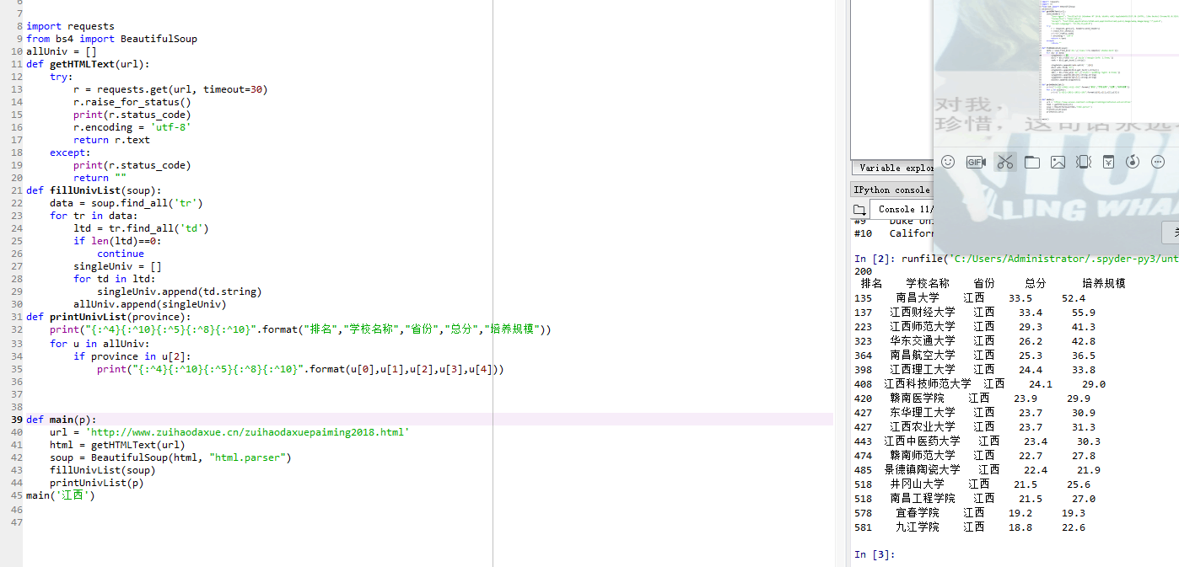
实验结果:

