­Name: ______________________________________________________



Bootstrap:2



­

Class: ______________________________________________________

# Lesson 1

|  |  |  |
| --- | --- | --- |
|  | **Racket Code** | **Pyret Code** |
| ***Numbers*** | (define AGE 14)  (define A-NUMBER 0.6)  (define SPEED -90) | AGE = 14  A-NUMBER = 0.6  SPEED = -90  Two of your own:  **MY-NUMBER = 75.9**  **THREE = 3** |
| ***Strings*** | (define CLASS “Bootstrap”)  (define PHRASE "Coding is fun!")  (define A-STRING "2500") | CLASS = “Bootstrap”  PHRASE = “Coding is fun!”  A-STRING = “2500”  Two of your own:  **MY-NAME = “Elizabeth”**  **MY-NUMBER = 75.9** |
|  | (define SHAPE  (triangle 40 "outline" "red"))  (define OUTLINE  (star 80 "solid" "green"))  (define SQUARE   (rectangle 50 50 "solid" "blue")) | SHAPE =  triangle(40, "outline", "red")  OUTLINE =  star(80, “solid”, “green”)  SQUARE =  rectangle(50, 50, “solid”, “blue”)  One of your own:  **MY-SHAPE = rhombus(90, 60, “solid”, “red”)** |
| ***Booleans*** | (define BOOL true)  (define BOOL2 false) | BOOL = true  One of your own:  **BOOL2 = false** |
| ***Functions*** | ; double : Number -> Number  ; Given a number, multiply by  ; 2 to double it  (EXAMPLE (double 5) (* 2 5)  (EXAMPLE (double 7) (* 2 7))  (define (double n) (* 2 n)) | # double : Number -> Number  # Given a number, multiply by  # 2 to double it  examples:  double(5) is 2 * 5  double(7) is 2 * 7  end  fun double(n):  2 * n  end |

## Fast Functions!

Fill out the contract for each function, then try to write two examples and the definition by yourself.

n

n

3 * n

3 * 8

3 * 16

n

8

16

triple

triple

triple

triple

Number

Number

|  |
| --- |
| # _________________:_________________ -> ________________  double  Number  Number  name domain range |
| examples:  ___________(________) is ______________________________  2 * 5  5 |
| ___________(________) is _______________________________  2 * 7  7  double  double  end  n  fun ____________(_________________): |
| 2 * n  n  double  ______________________________________________________  end |
| # _________________:_________________ -> ________________  name domain range |
| examples:  n  ___________(________) is ______________________________ |
| ___________(________) is _______________________________  end  fun ____________(_________________): |
| _______________________________________________________  end |

## Fast Functions!

Fill out the contract for each function, then try to write two examples and the definition by yourself.

n

n

n

55

6

plus1

n + 1

55 + 1

6 + 1

Number

Number

plus1

plus1

plus1

n

n

n

75 - 4

30

75

mystery

Number

Number

mystery

mystery

30 - 4

mystery

n - 4

|  |  |
| --- | --- |
| # _________________:_________________ -> ________________  name domain range | |
| examples:  ___________(________) is ______________________________ |
| ___________(________) is _______________________________  end  fun ____________(_________________): |
| ______________________________________________________  end |
| # _________________:_________________ -> ________________  name domain range | |
| examples:  ___________(________) is ______________________________ |
| ___________(________) is _______________________________  end  fun ____________(_________________): |
| _______________________________________________________  end |

## Fast Functions!

Fill out the contract for each function, then try to write two examples and the definition by yourself.

radius

radius

circle(radius, “solid”, “red”)

circle(99, “solid”, “red”)

circle(20, “solid”, “red”)

20

99

Number

Image

red-spot

red-spot

red-spot

radius

red-spot

|  |  |
| --- | --- |
| # _________________:_________________ -> ________________  name domain range | |
| examples:  ___________(________) is ______________________________ |
| ___________(________) is _______________________________  end  fun ____________(_________________): |
| ______________________________________________________  end |
| # _________________:_________________ -> ________________  name domain range | |
| examples:  ___________(________) is ______________________________ |
| ___________(________) is _______________________________  end  fun ____________(_________________): |
| _______________________________________________________  end |

# Bug Hunting: Pyret Edition

|  |  |  |
| --- | --- | --- |
| ***#1*** | SECONDS = (7)  STRING = my string | **SECONDS = 7**  **STRING = “my string”** |
| ***#2*** | SHAPE1 = circle(50 “solid” “blue”)  SHAPE2 = triangle(75, outline, yellow) | **SHAPE1 = circle(50, “solid”, “blue”)**  **SHAPE2 = triangle(75, “outline”, “yellow”)** |
| ***#3*** | # triple : Number -> Number  # Multiply a given number by  # 3 to triple it  examples:  triple(5) = 3 * 5  triple(7) = 3 * 7  end | **# triple : Number -> Number**  **# Multiply a given number by 3 to triple it**  **examples:**  **triple(5) is 3 * 5**  **triple(7) is 3 * 7**  **end** |
| ***#4*** | fun triple(n):  3 * n | **fun triple(n) :**  **3 * n**  **end** |
| ***#5*** | # ys : Number -> Number  # Given a number, create a solid  # yellow star of the given size  examples:  ys(99) is star(99, “solid”, “yellow”)  ys(33) is star(99, “solid”, “yellow”)  ys(size):  star(size “solid” “yellow”)  end | **# ys : Number -> Number**  **# Given a number, create a solid yellow star of the given size**  **examples:**  **ys(99) is star(99, “solid”, “yellow”)**  **ys(99) is star(99, “solid”, “yellow”)**  **end**  **ys(size) :**  **star(size, “solid”, “yellow”)**  **end** |

# Lesson 2

# Word Problem: double-radius

Write a function *double-radius*, which takes in a radius and a color. It produces an outlined circle of whatever color was passed in, whose radius is twice as big as the input.

## Contract+Purpose Statement

Every contract has three parts:

Image

Number, String

double-radius

# _______________ : ____________________________________ -> ____________

name Domain Range

Consumes a number and a string, produces an outlined circle of the given color, whose radius is twice the given number

# ________________________________________________________________________

What does the function do?

# Give Examples

Write examples of your function in action

radius

examples:

50, “pink”

double-radius

_____________(___________________) is

the user types…

color

circle(50 * 2, “outline”, “pink”)

________________________________________________________________

...which should become

double-radius

918, “orange”

_____________(___________________) is

color

the user types…

circle(918 * 2, “outline”, “orange”)

________________________________________________________________

...which should become

end

radius

# Function

Circle the changes in the examples, and name the variables.

Write the code, copying everything that isn't circled, and using names where you find variables!

double-radius

radius, color

fun ___________________(__________________) :

circle(radius * 2, “outline”, color)

______________________________________________________________

end

# Word Problem: double-width

Write a function *double-width*, which takes in a number (the length of a rectangle) and produces a solid green rectangle whose width is twice the given length.

## Contract+Purpose Statement

Every contract has three parts:

Image

Number

double-width

# _______________ : ____________________________________ -> ____________

name Domain Range

Consumes a length and produces a solid green rectangle whose width is twice the given length

# ________________________________________________________________________

What does the function do?

# Give Examples

Write examples of your function in action

length

examples:

45

double-width

_____________(___________________) is

the user types…

rectangle(45, 45 * 2, “solid”, “green”)

________________________________________________________________

...which should become

length

8

double-width

_____________(___________________) is

the user types…

rectangle(8, 8 * 2, “solid”, “green”)

________________________________________________________________

...which should become

end

# Function

Circle the changes in the examples, and name the variables.

Write the code, copying everything that isn't circled, and using names where you find variables!

length

double-width

fun ___________________(__________________) :

rectangle(length, length * 2, “solid”, “green”)

______________________________________________________________

end

# Word Problem: next-position

Write a function *next-position*, which takes in two numbers (an x and y-coordinate) and returns a Coord, increasing the x-coordinate by 5 and decreasing the y-coordinate by 5.

## Contract+Purpose Statement

Every contract has three parts:

Coord

Number, Number

next-position

# _______________ : ____________________________________ -> ____________

name Domain Range

Given 2 numbers, make a Coord by adding 5 to x and subtracting 5 from y

# ________________________________________________________________________

What does the function do?

# Give Examples

x

Write examples of your function in action

y

examples:

30, 250

next-position

_____________(___________________) is

the user types…

coord(30 + 5, 250 – 5)

________________________________________________________________

...which should become

y

65, 800

next-position

_____________(___________________) is

the user types…

coord(65 + 5, 800 – 5)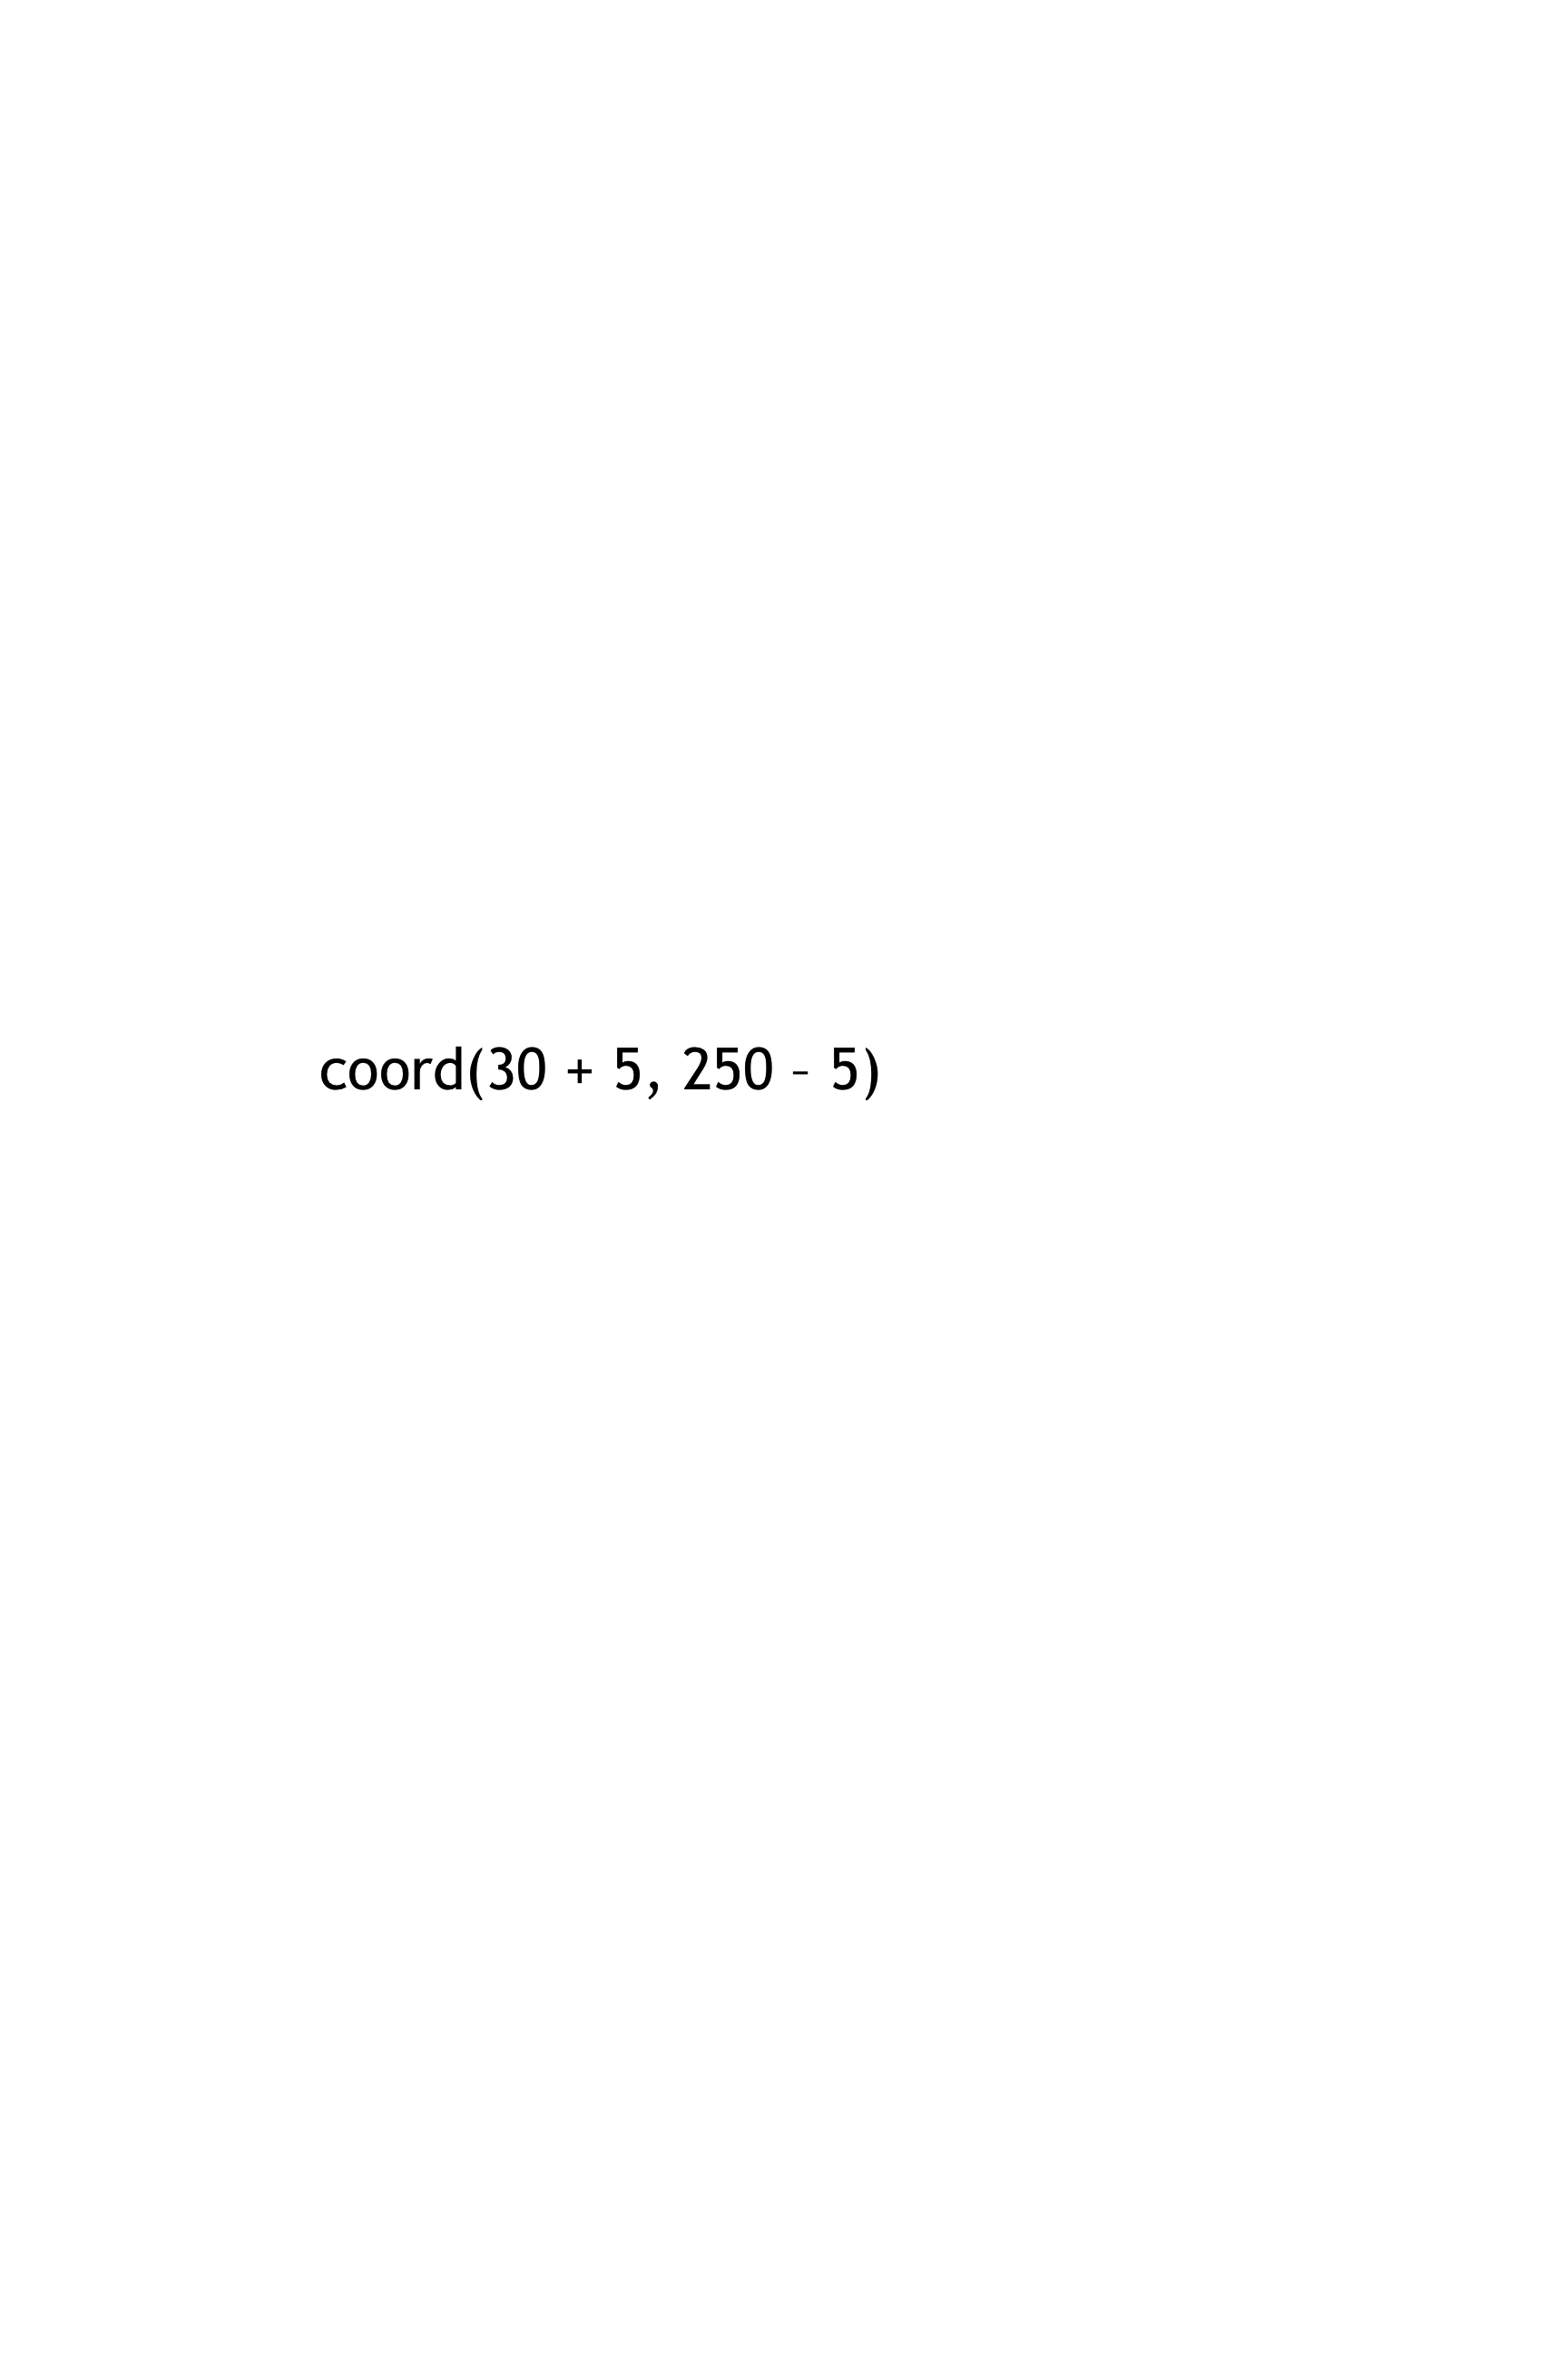 – 5)

________________________________________________________________

x

...which should become

end

# Function

Circle the changes in the examples, and name the variables.

Write the code, copying everything that isn't circled, and using names where you find variables!

x , y

next-position

fun ___________________(__________________) :

coord(x + 5, y – 5) – 5)

______________________________________________________________

end

# Data Structure

# a Cake is a **flavor, color, message, layers, & is-iceCream**

data **Cake**:

flavor :: String,

| **cake**(______________________________________________

color :: String,

______________________________________________

message :: String,

______________________________________________

layers :: Number,

______________________________________________

is-iceCream :: Boolean

______________________________________________)

end

To make examples of this structure, I would write:

cake(“Vanilla”, “white”, “Happy wedding!”, 4, false)

**cake1** = ____________________________________________

cake(“Red Velvet”, “darkred”, “I love cakes!”, 2, true)

**cake2** = ____________________________________________

To access the fields of **cake2**, I would write:

cake2.flavor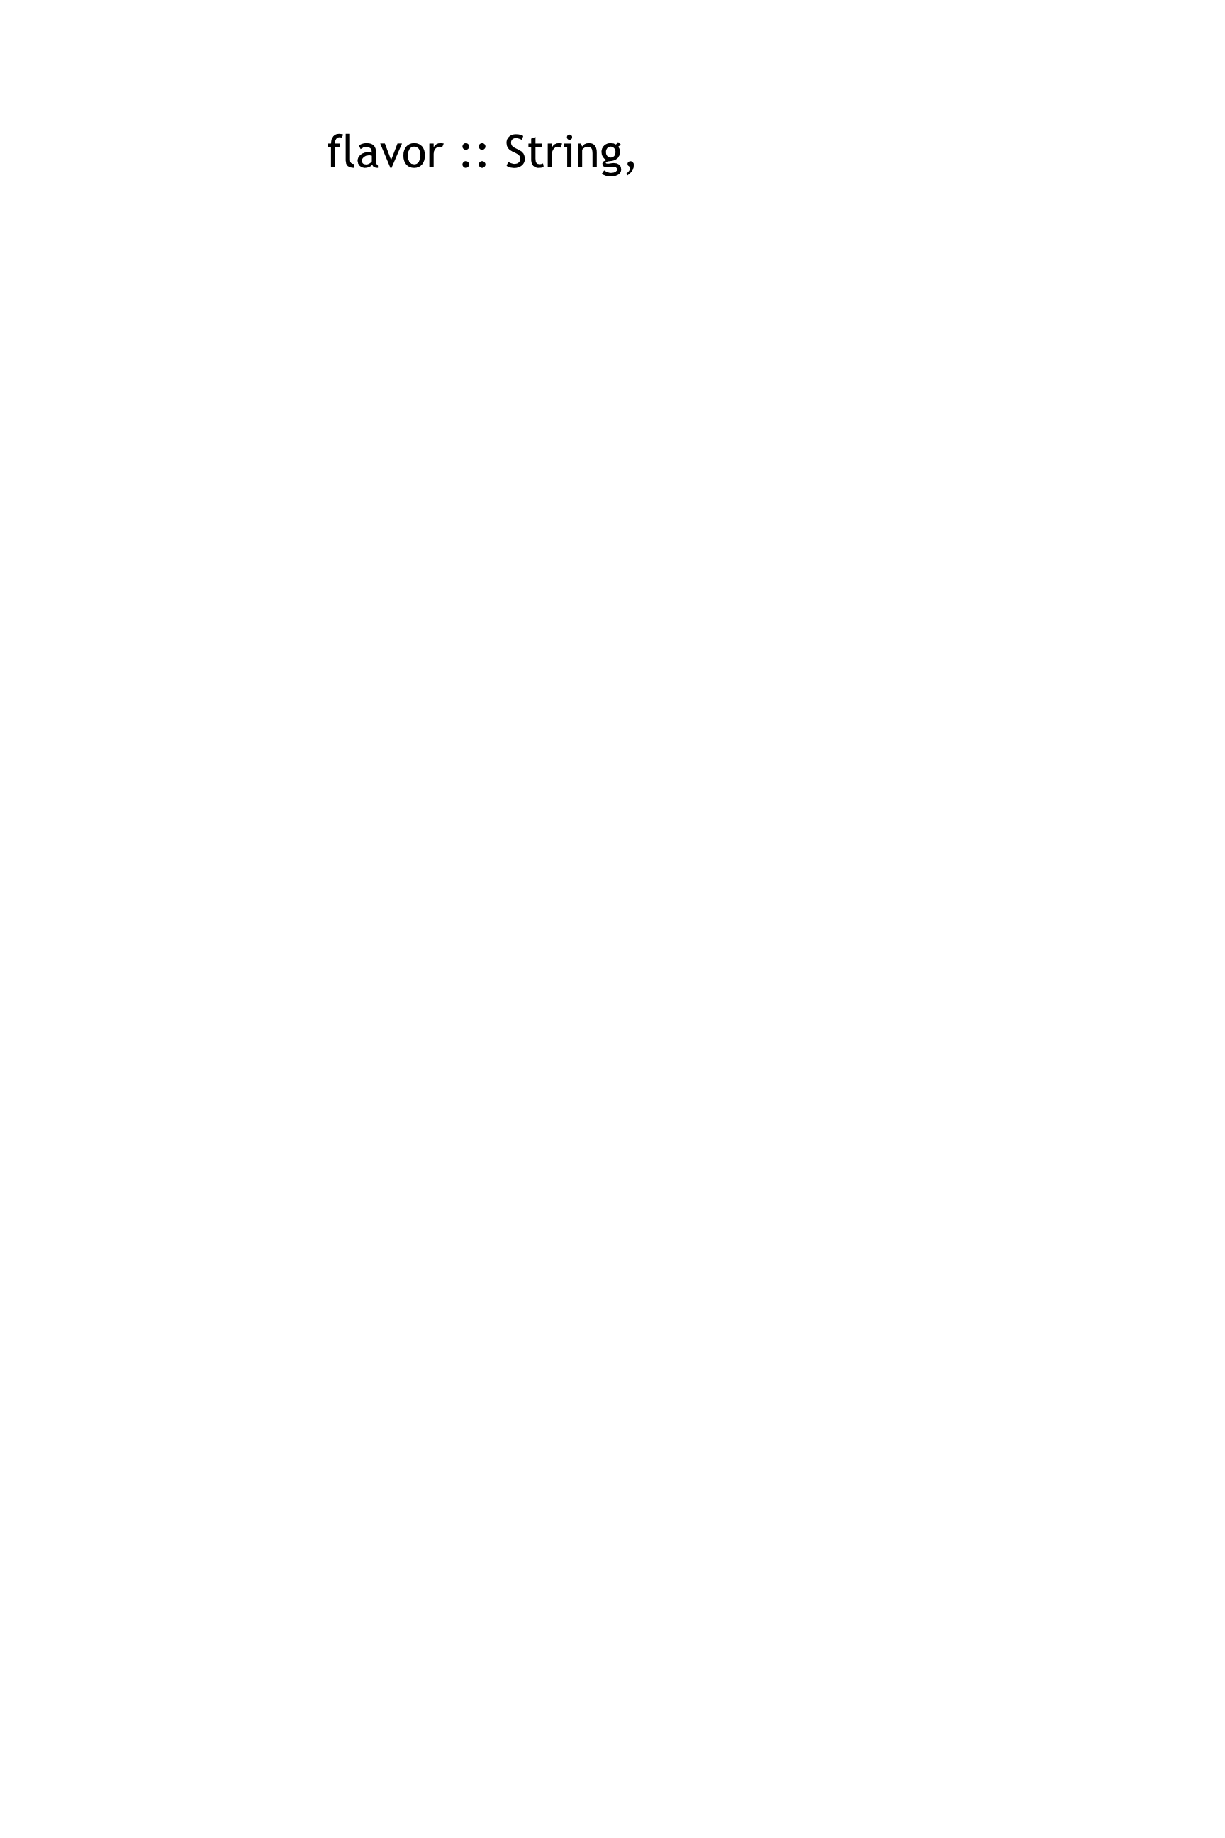r

_______________________________________

cake2.colorr

_______________________________________

cake2.messager

_______________________________________

cake2.layersr

_______________________________________

cake2.is-iceCreamr

_______________________________________

# Lesson 3

# Data Structure

# a Party is a **location, theme, and number of guests**

data **Party**:

location :: String,

| **party**(___________________________________________

theme :: String,

___________________________________________

guests :: Number

___________________________________________)

end

To make examples of this structure, I would write:

party(“Downtown”, “80s”, 34)

**party1** = ____________________________________________

party(“bowling ally”, “bowling”, 20)

**party2** = ____________________________________________

To access the fields of **party2**, I would write:

party2.location

_______________________________________

party2.theme

_______________________________________

party2.guests

_______________________________________

# Word Problem: change-flavor

Write a function called *change-flavor,* which takes in a Cake and a flavor, and returns a new Cake that is almost the same as the original, but is now the given flavor.

# Contract+Purpose Statement

Cake, String

Cake

change-flavor

# __________________ : _________________________________ -> ____________

Given a Cake and a flavor, return a new Cake that is the same as the original, but with the given flavor

# ________________________________________________________________________

# Give Examples

examples:

a-cake

change-flavor

cake1, “strawberry”

_____________(___________________) is

cake(“strawberry”,

cake1.color,

cake1.message,

cake1.layers,

cake1.is-iceCream)

___________________________________________

___________________________________________

a-cake

___________________________________________

___________________________________________

___________________________________________

cake2, “vanilla”

change-flavor

_____________(___________________) is

a-cake

cake(“vanilla”,

cake2.color,

cake2.message,

cake2.layers,

cake2.is-iceCream)

___________________________________________

___________________________________________

a-cake

___________________________________________

___________________________________________

___________________________________________

end

# Function

a-cake, new-flavor

change-flavor

fun ___________________(__________________) :

cake(new-flavor,

a-cake.color,

a-cake.message,

a-cake.layers,

a-cake.is-iceCream)

___________________________________________

___________________________________________

___________________________________________

___________________________________________

___________________________________________

end

# Word Problem: will-melt

Write a function called *will-melt,* which takes in a Cake and a temperature, and returns true if the temperature is greater than 32 degrees, AND the Cake is an ice cream cake.

# Contract+Purpose Statement

Cake, Number

Boolean

will-melt

# __________________ : _________________________________ -> ____________

Given a Cake and a temperature, return true if the temp is greater than 32 degrees, AND the Cake is an ice cream cake

# ________________________________________________________________________

# Give Examples

examples:

will-melt

cake3, 75

_____________(___________________) is

______________________________________________________________

temp

a-cake

(75 < 32) and cake3.is-iceCream

cake4, 10

will-melt

_____________(___________________) is

a-cake

______________________________________________________________

temp

(10 < 32) and cake4.is-iceCream

end

# Function

a-cake, temp

will-melt

fun ___________________(__________________) :

______________________________________________________________

(temp < 32) and a-cake.is-iceCream

end

# Lesson 4

# Lesson 5

# Word Problem: keypress (Ninja World)

# State the Problem

For each keypress in Ninja World, show how (keypress <world > <key>) should change the world.

# Contract+Purpose Statement

# keypress : World, String -> World

# Given a world and a key, produce a new world with NinjaCat’s position

# moved by 10 pixels, depending on which arrow key was pressed

# Give Examples

examples:

key

keypress(worldA, “up”) is

world(worldA.dogX, worldA.coinX, worldA.catX, worldA.catY + 10)

current-world

keypress(worldB, “down”) is

world(worldB.dogX, worldB.coinX, worldB.catX, worldB.catY - 10)

direction

keypress(worldA, “left”) is

world(worldA.dogX, worldA.coinX, worldA.catX - 10, worldA.catY)

current-world

keypress(worldB, “right”) is

world(worldB.dogX, worldB.coinX, worldB.catX + 10, worldB.catY)

end

# Function

fun keypress(current-world, key) :

ask:

| string-equal(key, “up”) then:

world(current-world.dogX, current-world.coinX,

current-world.catX, current-world.catY + 10)

| string-equal(key, “down”) then:

world(current-world.dogX, current-world.coinX,

current-world.catX, current-world.catY + 10)

| string-equal(key, “left”) then:

world(current-world.dogX, current-world.coinX,

current-world.catX - 10, current-world.catY)

| string-equal(key, “right”) then:

world(current-world.dogX, current-world.coinX,

current-world.catX + 10, current-world.catY)

| otherwise: current-world

end

end

# Word Problem: next-world (Ninja World)

Given a world, return the next world by adding 10 to dogX, subtracting 5 from coinX, and subtracting 5 from catY *only* when the cat’s y-coordinate is greater than 75.

# Contract+Purpose Statement

World

next-world

# __________________ : _________________________________ -> ____________

Given a World, check whether CatY is greater than 75. If so, create a world by adding 10 to dogX and subtracting 5 from coinX and catY. Otherwise, create a world whose catY is the same as the current world, with dogX and coinX changing as above

World

# ________________________________________________________________________

# Give Examples

examples:

falling-speed

current-world

worldA

next-world

_____________(___________________) is

world(worldA.dogX + 10, worldA.coinX – 5, worldA.catX, worldA.catY – 5)

_______________________________________________________________________________

next-world

worldB

_____________(___________________) is

_______________________________________________________________________________

world(worldB.dogX + 10, worldB.coinX – 5, worldB.catX, worldB.catY)

end

# Function

current-world

next-world

fun ___________________(__________________) :

ask:

current-world.catY > 75

| ___________________________________________ then:

world(current-world.dogX + 10, current-world.coinX – 5, current-world.catX, current-world.catY - 5)

___________________________________________________________________

| otherwise:

world(current-world.dogX + 10, current-world.coinX – 5, current-world.catX, current-world.catY)

__________________________________________________________________

end

­end

# Lesson 6

# Word Problem: red-shape

Write a function *red-shape*, which takes in the name of a shape (such as “circle”, “triangle”, “star”, or “rectangle”), and draws that solid, red shape. Use 50 as the radius of the circle and star, and side-length of the triangle. Make the rectangle 99 pixels long by 9 wide.

String

Image

# : ->

Consumes the name of a shape, and produces a solid, red image of that shape. Use 50 for size of the circle, star, and triangle, and make the rectangle 99 x 9

red-shape

#

# Give Examples

examples:

circle( 50, “solid”, “red”)

“circle”

red-shape

_____________(_______________) is _________________________________

triangle( 50, “solid”, “red”)

“triangle”

red-shape

_____________(_______________) is _________________________________

star( 50, “solid”, “red”)

“star”

red-shape

_____________(_______________) is _________________________________

rectangle( 99, 9, “solid”, “red”)

“rectangle”

red-shape

_____________(_______________) is _________________________________

end

shape-name

shape

size

# Function

shape

red-shape

fun _______________(_____________________) :

ask:

string-equal(shape, “circle”)

| ________________________________________ then:

circle( 50, “solid”, “red”)

_______________________________________________________

string-equal(shape, “triangle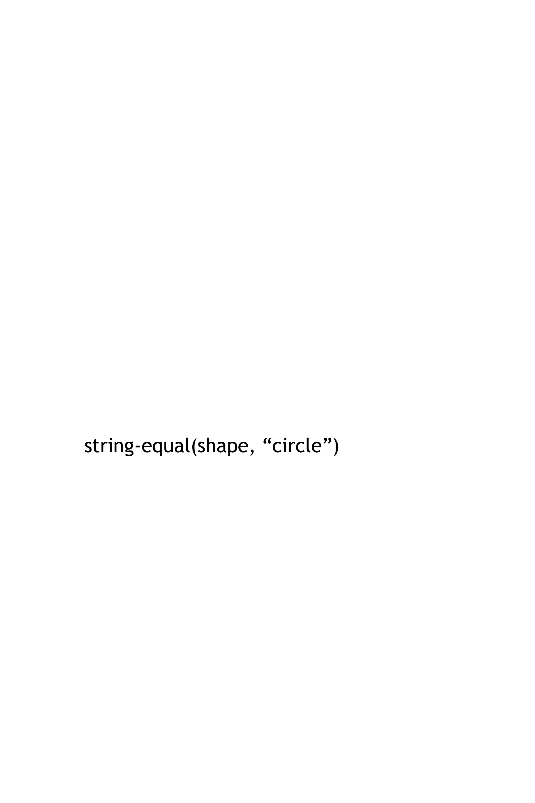”)

| ________________________________________ then:

triangle( 50, “solid”, “red”)

_______________________________________________________

string-equal(shape, “star”)

| ________________________________________ then:

star( 50, “solid”, “red”)

_______________________________________________________

string-equal(shape, “rectangle”)

| ________________________________________ then:

rectangle( 99, 9, “solid”, “red”)

_______________________________________________________

end

end

# Word Problem: strong-password

Websites have strict password requirements. Write a function *strong-password*, which takes in a username and password, and checks to make sure they aren’t the same, and then checks the string-length of the password to make sure it is greater than 8 characters. The function should return a message to the user letting them know if their password is strong enough.

strong-password

# : ->

Given a username and password, check whether they are the same, then check whether the string-length of the password is greater than 8

String, String

String

#

# Give Examples

examples:

username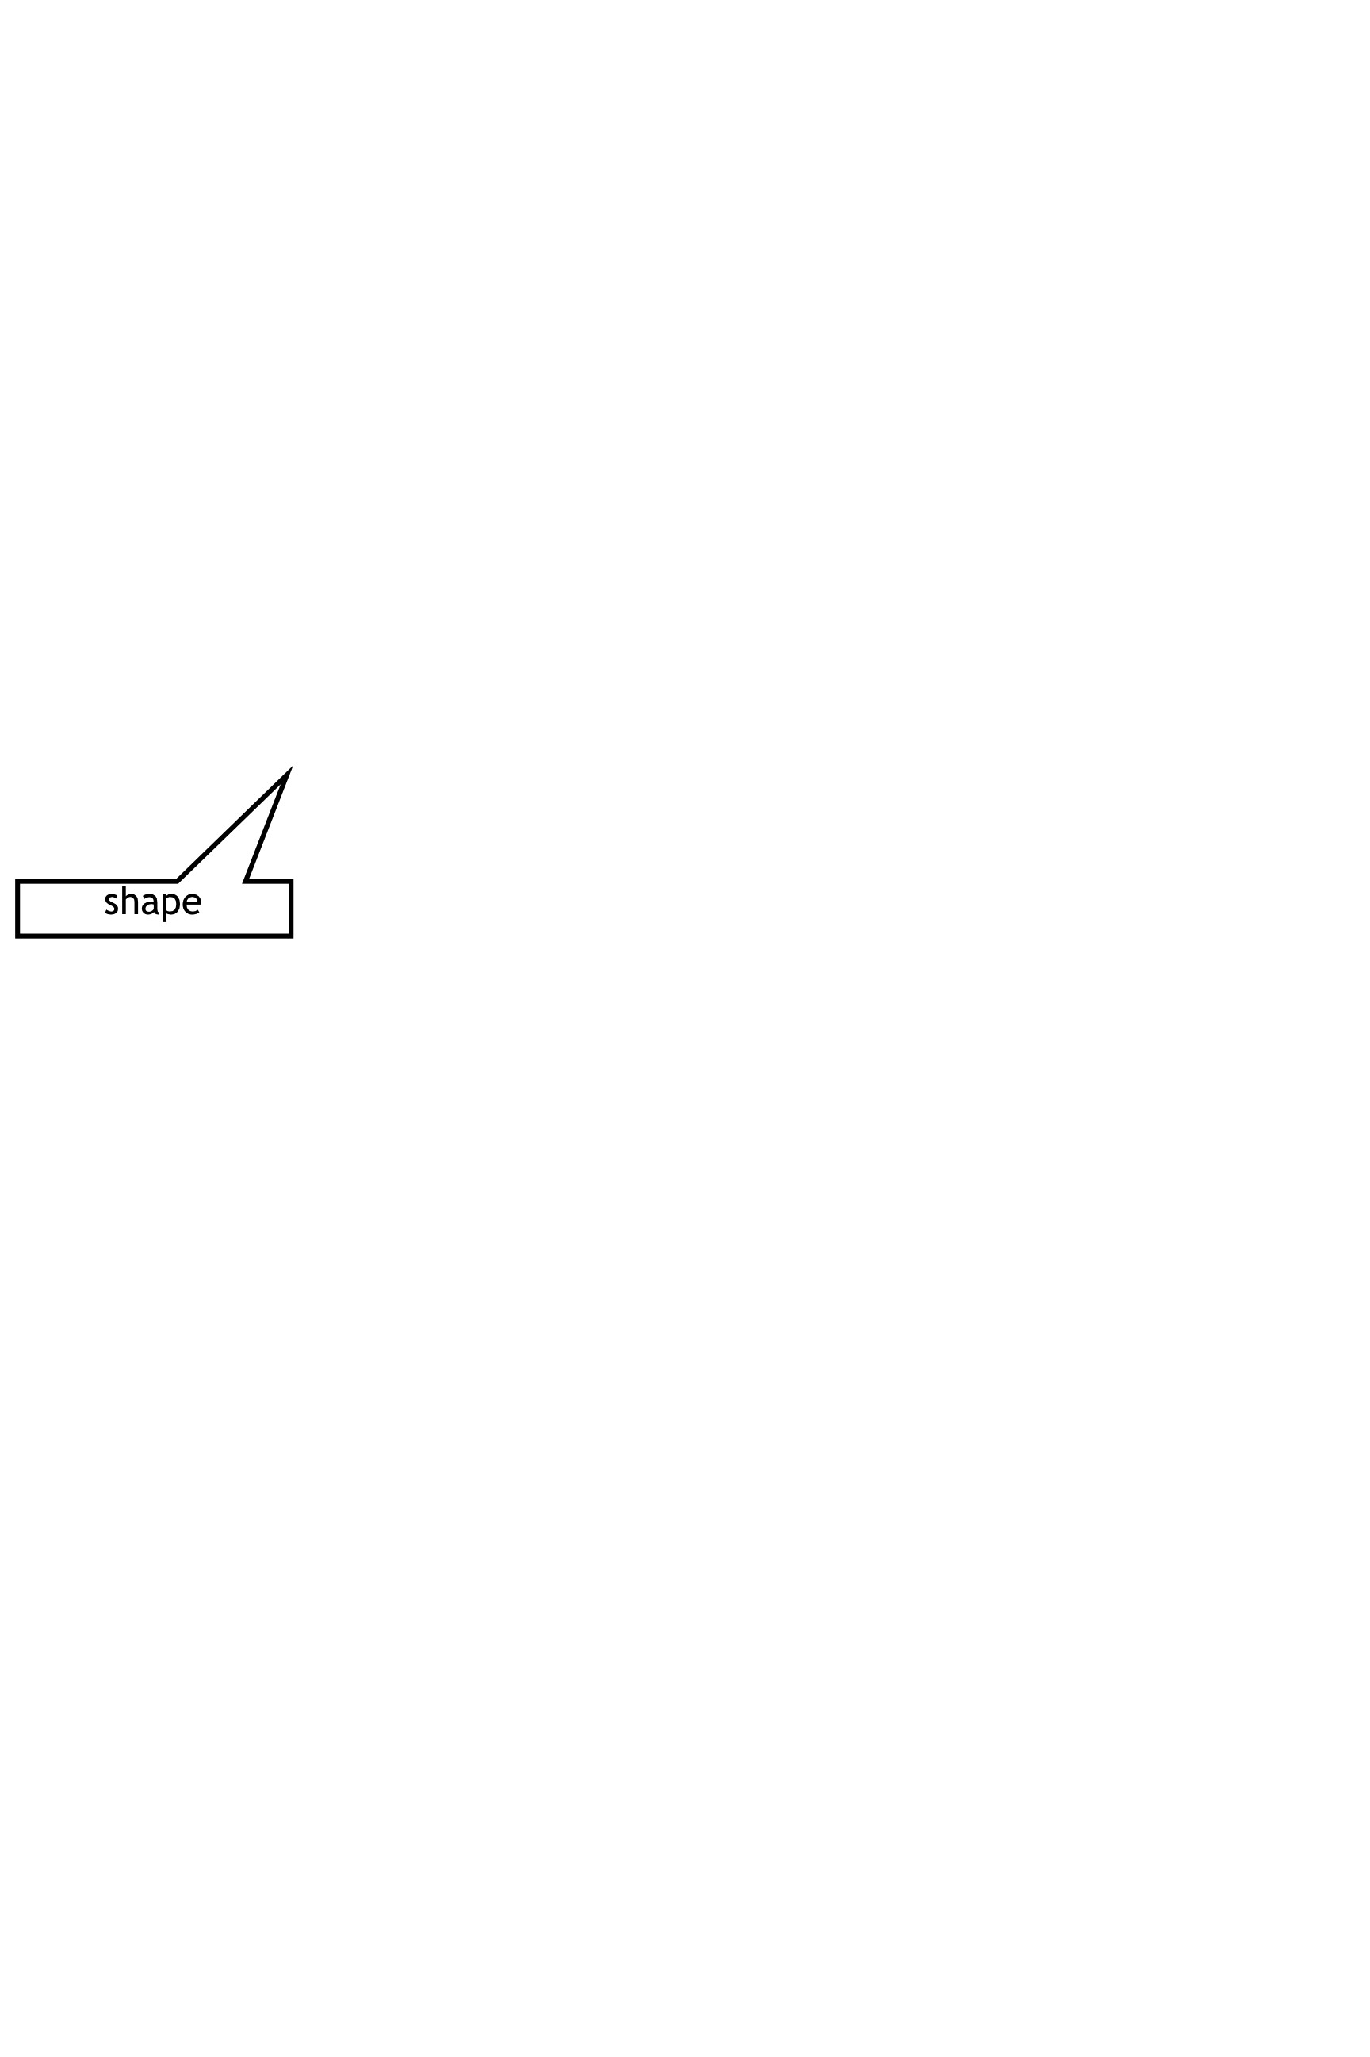

password

“Coolguy90”, “Coolguy90”

strong-password

_____________________(__________________________) is

“Your username cannot be the same as your password!”

______________________________________________________

message

“greatname”, “abc”

strong-password

_____________________(__________________________) is

“Your password is too short! Must be at least 8 characters.”

______________________________________________________

“Katie”, “BootstrapPro78”

strong-password

_____________________(__________________________) is

“Your password is strong enough! Account created.”

______________________________________________________

end

# Function

username, password

strong-password

fun ________________(_____________________) :

ask:

string-equal(username, password)

| __________________________________________________ then:

“Your username cannot be the same as your password!”

_______________________________________________________

string-length(password) < 8

| __________________________________________________ then:

“Your password is too short! Must be at least 8 characters.”

_______________________________________________________

“Your password is strong enough! Account created.”

| otherwise: _____________________________________________

end

end

Building Your Helper Functions

|  |
| --- |
| # is-off-right :____________________ -> ________________  Number  Boolean |
| examples:  ___________________(________) is  320  is-off-right  ______________________________________________  320 > 690 |
| ___________________(________) is  800  is-off-right  ______________________________________________  800 > 690  end  x-coordinate  fun ____________(_________________):  x-coordinate  is-off-right |
| x-coordinate > 690  _______________________________________________________  end |
| # is-off-left :_________________ -> ________________  Boolean  Number |
| examples:  ___________________(________) is  77  is-off-left  ______________________________________________  77 < -50 |
| ___________________(________) is  is-off-left  -400  ______________________________________________  -400 < -50  end  x-coordinate  fun ____________(_________________):  x-coordinate  is-off-left |
| x-coordinate < -50  _______________________________________________________  end |
| # _________________:_________________ -> _______________  Number  Boolean  is-in-air |
| examples:  ___________________(________) is  102  is-in-air  ______________________________________________  102 > 75 |
| ___________________(________) is  30  is-in-air  ______________________________________________  30 > 75  end  y-coordinate  fun ____________(_________________):  y-coordinate  is-in-air |
| y-coordinate > 75  _______________________________________________________  end |
| # _________________:_________________ -> ________________ |
| examples:  ___________________(________) is  ______________________________________________ |
| ___________________(________) is  ______________________________________________  end  fun ____________(_________________): |
| _______________________________________________________  end |

# Lesson 7

# Word Problem: line-length

Write a function called *line-length*, which takes in two numbers and returns the difference between them. It should always subtract the smaller number from the bigger one.

# Contract+Purpose Statement

Number, Number

Number

line-length

# __________________ : ________________________________________ -> ______________

Consumes 2 numbers and produces the difference by subtracting the smaller number from the larger

# _____________________________________________________________________________

# Give Examples

examples:

10, 8

line-length

_____________(_____________) is

b

a

a

b

10 - 8

________________________________________________________________

order

60, 300

line-length

_____________(_____________) is

300 - 60

________________________________________________________________

end

# Function Header

a, b

line-length

fun ___________________(__________________) :

function name variable names

ask

______:

| | a > b then: a - b |  |
| --- | --- |
| | otherwise: b - a |  |
|  |  |
|  |  |
|  |  |
|  |  |

end

end

# Distance:

The Player is at **(4, 2)** and the Target is at **(0, 5)**.

Distance takes in the player’s x, player’s y, character’s x and character’s y.

Use the formula below to fill in the EXAMPLE:

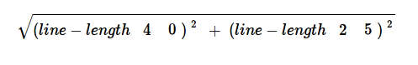

Convert it into a Circle of Evaluation. (We've already gotten you started!)

num-sqrt

+

num-sqr

num-sqr

line-length

line-length

4 0

2 5

Convert it into Pyret code:

num-sqrt(num-sqr(line-length(4, 0)) + num-sqr(line-length(2, 5)))

# Word Problem: distance

*Write a function* distance, *which takes FOUR inputs:*

* *px: The x-coordinate of the player*
* *py: The y-coordinate of the player*
* *cx: The x-coordinate of* another game character
* *cy: The y-coordinate of another game character*

*It should return the distance between the two, using the Distance formula:*

Distance2 = (line-length px cx)2 + (line-length py cy)2 )

# Contract+Purpose Statement

Number, Number, Number, Number

Number

distance

# __________________ : ________________________________________ -> ______________

Given the coordinates of 2 characters: px, py, cx, and cy, use the distance formula to calculate the distance between them

# ______________________________________________________________________________

# Give Examples

Write examples of your function in action

py

cx

cy

px

examples:

4, 2, 0, 5

distance

_____________(_____________) is

num-sqrt(num-sqr(line-length(4, 0)) + num-sqr(line-length(2, 5)))

________________________________________________________________

80, 33, 6, 50

distance

_____________(_____________) is

num-sqrt(num-sqr(line-length(80, 6)) + num-sqr(line-length(33, 50)))

________________________________________________________________

end

# Function

distance

px, py, cx, cy

fun ___________________(__________________) :

num-sqrt(num-sqr(line-length(px, cx)) + num-sqr(line-length(py, cy)))

______________________________________________________________

end

# Word Problem: is-collision

Write a function *is-collision*, which takes FOUR inputs:

* px: The x-coordinate of the player
* py: The y-coordinate of the player
* cx: The x-coordinate of another game character
* cy: The y-coordinate of another game character

It should return true if the coordinates of the player are within **50 pixels** of the  
 coordinates of the other character. Otherwise, false.

# Contract+Purpose Statement

Number, Number, Number, Number

Boolean

is-collision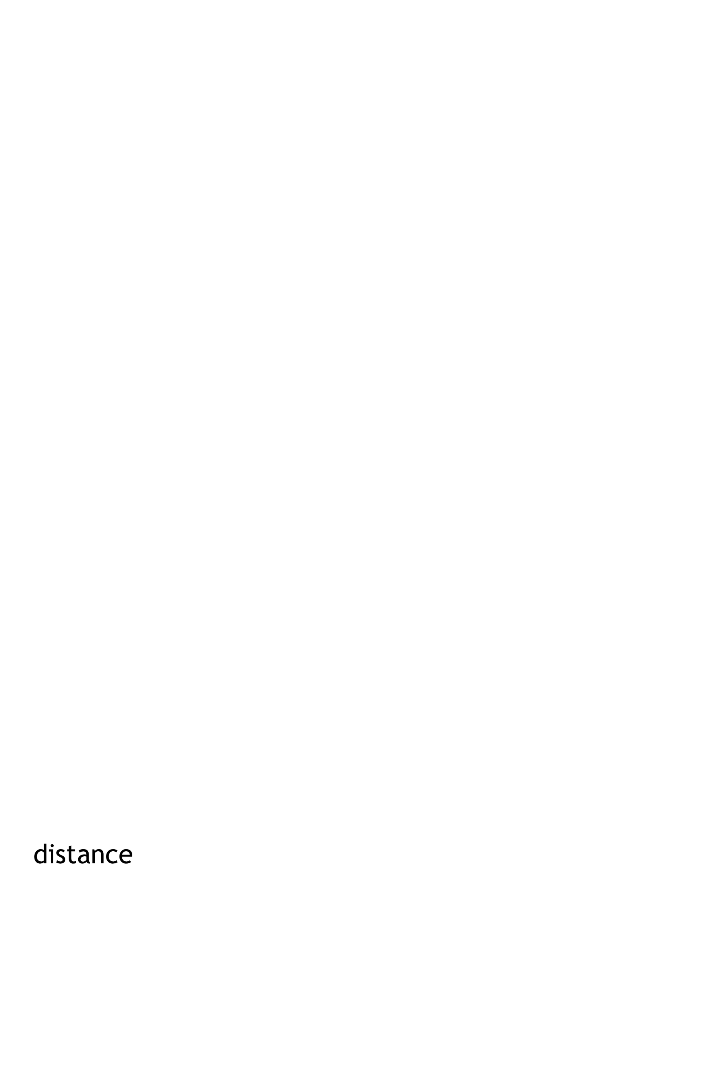

# __________________ : ________________________________________ -> ______________

Given the coordinates of 2 characters: px, py, cx, and cy, return true if the distance between them is less than 50 pixels

# ______________________________________________________________________________

# Give Examples

cx

Write examples of your function in action

py

cy

px

examples:

78, 30, 9, 2

is-collision

__________________________(_____________________) is

distance(78, 30, 9, 2) < 50

________________________________________________________________

20, 40, 60, 80

is-collision

__________________________(_____________________) is

distance(20, 40, 60, 80) < 50

________________________________________________________________

end

# Function

is-collision

px, py, cx, cy

fun ___________________(__________________) :

distance(px, py, cx, cy) < 50

______________________________________________________________

end

# Game Design

*“Start Simple, Get Complex”*

# Draw a rough sketch of your game when it begins, and another sketch just a moment later

*A sketch for the very NEXT moment…*

*A sketch at the START of the game…*

# What images will you need for your game? Name them in the 1st column, and describe them in the 2nd

|  |  |
| --- | --- |
| BACKGROUND |  |
|  |  |
|  |  |
|  |  |
|  |  |
|  |  |

# List everything that has changed from one sketch to the other. What datatype will represent it?

|  |  |
| --- | --- |
| **Changed** (position, score, color, costume…) | **Datatype** (Number, String, Image, Boolean…) |
|  |  |
|  |  |
|  |  |
|  |  |
|  |  |

# Data Structures

# a **world** is a ______________________________

data **World**:

| **world**(________________________________

________________________________

________________________________

________________________________

_________________________________)

end

To make example worlds that represent my sketches from page 31, I would write…

**worldA** = ____________________________________________

**worldB** = ____________________________________________

To access the fields of **worldA**, I would write:

_______________________________________

_______________________________________

_______________________________________

_______________________________________

_______________________________________

# Lesson 8

# Word Problem: draw-world (My game)

# Contract

# __________________ : _________________________________________ -> ______________

# Definition

fun ____________(_______________________________) :

put-image(_____________________________________________________

_____________________________________________________

_____________________________________________________

_____________________________________________________

_____________________________________________________

_____________________________________________________

_____________________________________________________

_____________________________________________________

_____________________________________________________

_____________________________________________________

_____________________________________________________

_____________________________________________________

_____________________________________________________

_____________________________________________________

end

# Word Problem: next-world (My game)

# State the problem (What changes?):

# Contract+Purpose Statement

# __________________ : ________________________________________ -> ______________

# ______________________________________________________________________________

# Give Examples

examples:

_____________(___________________) is

___________________________________________

___________________________________________

___________________________________________

___________________________________________

___________________________________________

_____________(___________________) is

___________________________________________

___________________________________________

___________________________________________

___________________________________________

___________________________________________

end

# Function

fun ___________________(__________________) :

___________________________________________

___________________________________________

___________________________________________

___________________________________________

___________________________________________

end

# Lesson 9

|  |  |  |
| --- | --- | --- |
| **When *this* key is pressed…** | ***..this* field of the new world...** | **…changes by…** |
|  |  |  |
|  |  |  |
|  |  |  |
|  |  |  |
|  |  |  |
|  |  |  |

# Word Problem: keypress (My game)

For each keypress in your game, show how keypress(worldA, <key>) should change your world.

# : ->

#

# Give Examples

examples:

keypress(worldA, _________) is

___________________________________________

___________________________________________

___________________________________________

___________________________________________

___________________________________________

keypress(worldA, _________) is

___________________________________________

___________________________________________

___________________________________________

___________________________________________

___________________________________________

keypress(worldA, _________) is

___________________________________________

___________________________________________

___________________________________________

___________________________________________

___________________________________________

end

# Function

fun _____________(________________________________)

ask:

| _____________________________________ then:

_____________________________________________

| _______________________________________ then:

_____________________________________________

| _______________________________________ then:

_____________________________________________

| _______________________________________ then:

_____________________________________________

| _______________________________________ then:

_____________________________________________

| _______________________________________ then:

_____________________________________________

| ______________________________________________

end

end

Building Your Helper Functions

|  |
| --- |
| # is-off-right :____________________ -> ________________ |
| examples:  ___________________(________) is  ______________________________________________ |
| ___________________(________) is  ______________________________________________  end  fun ____________(_________________): |
| _______________________________________________________  end |
| # is-off-left :_________________ -> ________________ |
| examples:  ___________________(________) is  ______________________________________________ |
| ___________________(________) is  ______________________________________________  end  fun ____________(_________________): |
| _______________________________________________________  end |
| # _________________:_________________ -> _______________ |
| examples:  ___________________(________) is  ______________________________________________ |
| ___________________(________) is  ______________________________________________  end  fun ____________(_________________): |
| _______________________________________________________  end |
| # _________________:_________________ -> ________________ |
| examples:  ___________________(________) is  ______________________________________________ |
| ___________________(________) is  ______________________________________________  end  fun ____________(_________________): |
| _______________________________________________________  end |

# Using Helpers inside next-world:

# How does the World structure change when….?

|  |  |
| --- | --- |
| **TEST** | **RESULT** |
|  | world(______________________________________  ______________________________________  ______________________________________  ______________________________________  ______________________________________) |
|  | world(______________________________________  ______________________________________  ______________________________________  ______________________________________  ______________________________________) |
|  | world(______________________________________  ______________________________________  ______________________________________  ______________________________________  ______________________________________) |
|  | world(______________________________________  ______________________________________  ______________________________________  ______________________________________  ______________________________________) |

|  |  |
| --- | --- |
| **TEST** | **RESULT** |
|  | world(______________________________________  ______________________________________  ______________________________________  ______________________________________  ______________________________________) |
|  | world(______________________________________  ______________________________________  ______________________________________  ______________________________________  ______________________________________) |
|  | world(______________________________________  ______________________________________  ______________________________________  ______________________________________  ______________________________________) |
|  | world(______________________________________  ______________________________________  ______________________________________  ______________________________________  ______________________________________) |

# Using Helpers inside draw-world:

# What changes the *appearance* of your game?

|  |  |
| --- | --- |
| **TEST** | **RESULT** |
|  | put-image(___________________________________  put-image( ______________________________  put-image(_______________________________  put-image(_______________________________  put-image(_______________________________ |
|  | put-image(___________________________________  put-image( ______________________________  put-image(_______________________________  put-image(_______________________________  put-image(_______________________________ |
|  | put-image(___________________________________  put-image( ______________________________  put-image(_______________________________  put-image(_______________________________  put-image(_______________________________ |
|  | put-image(___________________________________  put-image( ______________________________  put-image(_______________________________  put-image(_______________________________  put-image(_______________________________ |

|  |  |
| --- | --- |
| **TEST** | **RESULT** |
|  | put-image(___________________________________  put-image( ______________________________  put-image(_______________________________  put-image(_______________________________  put-image(_______________________________ |
|  | put-image(___________________________________  put-image( ______________________________  put-image(_______________________________  put-image(_______________________________  put-image(_______________________________ |
|  | put-image(___________________________________  put-image( ______________________________  put-image(_______________________________  put-image(_______________________________  put-image(_______________________________ |
|  | put-image(___________________________________  put-image( ______________________________  put-image(_______________________________  put-image(_______________________________  put-image(_______________________________ |

# Lesson 10

# Supplemental

Design Recipe

# Contract+Purpose Statement

Every contract has three parts:

# __________________ : ________________________________________ -> ______________

name Domain Range

# ______________________________________________________________________________

What does the function do?

# Give Examples

Write examples of your function in action

examples:

_____________(_____________) is

the user types…

________________________________________________________________

...which should become

_____________(_____________) is

the user types…

________________________________________________________________

...which should become

end

# Function

Circle the changes in the examples, and name the variables.

fun ___________________(__________________) :

______________________________________________________________

end

Design Recipe

# Contract+Purpose Statement

Every contract has three parts:

# __________________ : ________________________________________ -> ______________

name Domain Range

# ______________________________________________________________________________

What does the function do?

# Give Examples

Write examples of your function in action

examples:

_____________(_____________) is

the user types…

________________________________________________________________

...which should become

_____________(_____________) is

the user types…

________________________________________________________________

...which should become

end

# Function

Circle the changes in the examples, and name the variables.

fun ___________________(__________________) :

______________________________________________________________

end

