

**Data Science**

**Pilot Workbook – Summer 2017**



Workbook v0.9b

Brought to you by the Bootstrap team:

* Emmanuel Schanzer
* Kathi Fisler
* Shriram Krishnamurthi
* Sam Dooman
* Ed Campos

Bootstrap is licensed under a Creative Commons 3.0 Unported License. Based on a work from www.BootstrapWorld.org. Permissions beyond the scope of this license may be available at schanzer@BootstrapWorld.org.

**Unit 1**

*The question I chose is…*

|  |
| --- |
|  |
|  |
|  |
|  |
| *My answer is…*   |  | | --- | |  | |  | |  | |  | | *The data I would use to support my answer is…*   |  | | --- | |  | |  | |  | |  | |  | |  | |  | |  | |  | |  | |  | |  | |  | |  | | |

# Expressions, Values, and Errors

For each expression, if it produces an error when evaluated,

write what kind of error occurs:

* For division by zero errors, write "division by 0".
* For errors where the operator is given the wrong type, write "wrong type".
* Otherwise, write what the expression evaluates to.

|  |  |
| --- | --- |
| Expression | Value, or Error? |
| 8 - 5.3 |  |
| 2 / 0 |  |
| "Three" * 2 |  |
| (3 + 5) * 3 |  |
| 1.5 * "6" |  |
| (2 / (3 - (2 + 1))) |  |

# Identifiers and Expressions

Imagine the program below has been written in your definitions window:

x = (3 * 2) - 2

y = x * 1.5

For each expression, if it produces an error when evaluated,

write what kind of error occurs:

* For division by zero errors, write "division by 0".
* For errors where a variable hasn’t been defined, write “unbound id”
* Otherwise, write what the expression evaluates to.

|  |  |
| --- | --- |
| **Expression** | **Value, or Error?** |
| y |  |
| x - 3 |  |
| (y - 1) * z |  |
| (x + y) / 2 |  |
| x + y |  |

# **Unit 2**

*“What is the relationship between calories and sugar?”*

I hypothesize…

|  |
| --- |
|  |
|  |
|  |
|  |
|  |
|  |
|  |
|  |
|  |
|  |
|  |

I found…

|  |
| --- |
|  |
|  |
|  |
|  |
|  |
|  |
|  |
|  |
|  |
|  |
|  |

# Animals

|  |  |
| --- | --- |
| **Animal** | **Number-of-legs** |
| "Human" | 2 |
| "Ant" | 6 |
| "Spider" | 8 |
| "Bear" | 4 |
| "Snake" | 0 |

1. How many rows does this table have? ___________
2. How many columns does this table have? ___________
3. What are the names of the columns? ___________
4. For the row with value “Human” in the **Animal** column, what is the value in the **Number-of-legs** column? ___________
5. Circle the header row of this table

# Presidents and Nutrition

Answer the following questions about the presidents and nutrition tables, using your Unit-2 Pyret program:

1. How many columns does the presidents table have? _________
2. What are the names of the columns? _________
3. How many rows does the presidents table have? _________
4. Is the party column quantitative or categorical? _________
5. Is the data in the home-state column categorical? _________
6. If so, how many categories are there? _________
7. What is the home state of Millard Fillmore? _________
8. Who was the first president from the Federalist party? _________
9. How many columns does the nutrition table have? _________
10. How many rows does the nutrition table have? _________
11. How many grams of cholesterol does the Hamburger have? _________
12. Which food has the largest serving size? _________
13. Is the data in the calories column quantitative? If so, why?

___________________________________________________________________________

# **Unit 3**

*“The average US Household makes more than $45,000/yr[1]. So why are so many people living in poverty?”*

I hypothesize…

|  |
| --- |
|  |
|  |
|  |
|  |
|  |
|  |
|  |
|  |
|  |
|  |

I found…

|  |
| --- |
|  |
|  |
|  |
|  |
|  |
|  |
|  |
|  |
|  |
|  |

# Mean, Median, Mode Practice

Using pencil & paper, calculate the 3 numbers that measure the center of each list. If a list contains more than one mode, write the number with the smallest value.

These lists are bound to variables a, b, c, d, e in the Unit 3 template file, so you can check your answers with Pyret.

|  |  |  |  |
| --- | --- | --- | --- |
| **List** | **Mean** | **Median** | **Mode** |
| a = [list: 1, 1, 4] |  |  |  |
| b = [list: 3, 4, 5] |  |  |  |
| c = [list: 3, 3, 4, 6] |  |  |  |
| d = [list: -1, 0.5, 2, 0.5, 2, 6] |  |  |  |
| e = [list: 2, 11, 7, 4] |  |  |  |

# Measuring Center in Pyret

1. What is the mode of the calories-list? _________
2. What is the mean amount of sodium for menu items? _________
3. What is the median GDP for all the countries in countries? _________
4. What is the median of life-expectancy-list? _________

Imagine the following code is in your definitions window:

mystery-list = [list: 1, 2, 3, 4, 5, 6, 7, 8, 9]

1. What is the median of this mystery-list? _________

Now imagine these lists (which contain the same elements as mystery-list) are in your definitions window:

mystery1 = [list: 1, 4, 7]

mystery2 = [list: 2, 3, 8]

mystery3 = [list: 5, 6, 9]

1. What is the median of mystery1? _________
2. What is the median of mystery2? _________
3. What is the median of mystery3? _________
4. What is the median of a list containing these 3 medians? _________
5. Is this different from the median of mystery-list? _________

# **Unit 4**

|  |
| --- |
|  |
|  |
|  |
|  |
|  |
|  |
|  |
|  |
|  |
|  |
|  |
|  |
|  |
|  |
|  |
|  |
|  |
|  |
|  |
|  |
|  |
|  |
|  |
|  |
|  |
|  |
|  |
|  |

# Reading Charts

1. Which menu item has the most sodium? __________
2. Which menu item has the least sodium? __________
3. Do french fries have more sodium than hamburgers? __________
4. Which country has the largest GDP? __________
5. What percent of the total world GDP is from China? __________

# Frequency Bar Chart

|  |  |  |
| --- | --- | --- |
| **First** | **Last** | **Eye-Color** |
| "John" | "Doe" | "Green" |
| "Jane" | "Smith" | "Brown" |
| "Javon" | "Jackson" | "Brown" |
| "Angela" | "Enriquez" | "Hazel" |
| "Jack" | "Thompson" | "Blue" |
| "Dominique" | "Rodriguez" | "Hazel" |
| "Sammy" | "Carter" | "Blue" |
| "Andrea" | "Garcia" | "Brown" |

1. How many students have Brown eyes? ____________
2. How many students have Green eyes? ____________
3. How many students have Hazel eyes? ____________
4. How many students have Blue eyes? ____________
5. Points scored

   image32.pngAbove the “Blue” label on this bar chart, add a bar with height that corresponds to the number of students with Blue eyes.

# Chart Practice

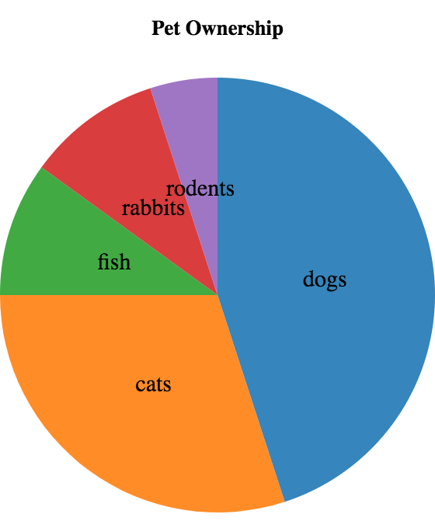

1. Is this a pie chart, or a bar chart? _____________________
2. Which pet is the most popular? _____________________
3. Which pet is the least popular? _____________________
4. Which are more popular, fish or rodents? _____________________

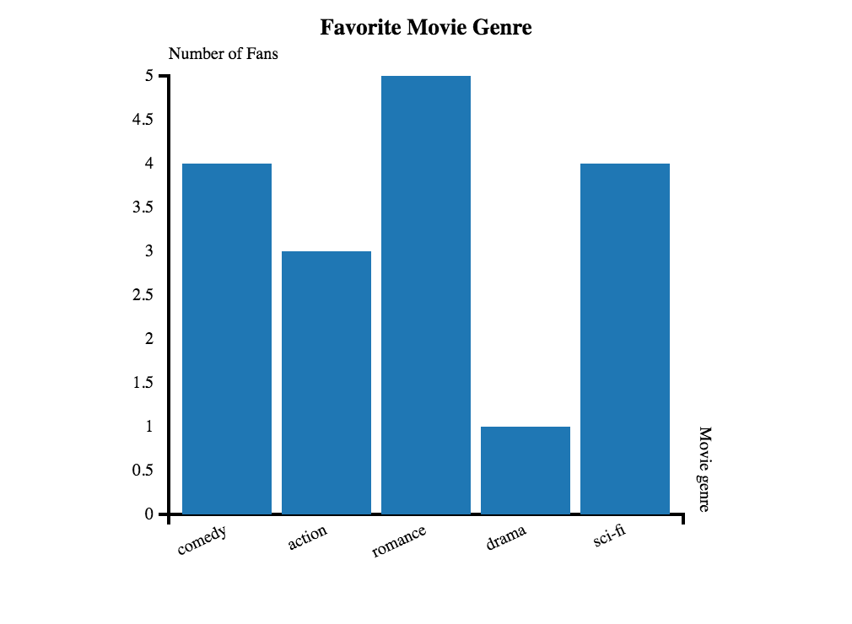

1. Is this a bar chart or a pie chart? _______________________
2. What genre is most popular? _______________________
3. What are the labels of this chart? _______________________
4. What are the values of this chart? ________________________
5. Is this a frequency bar chart? ________________________

More Chart Practice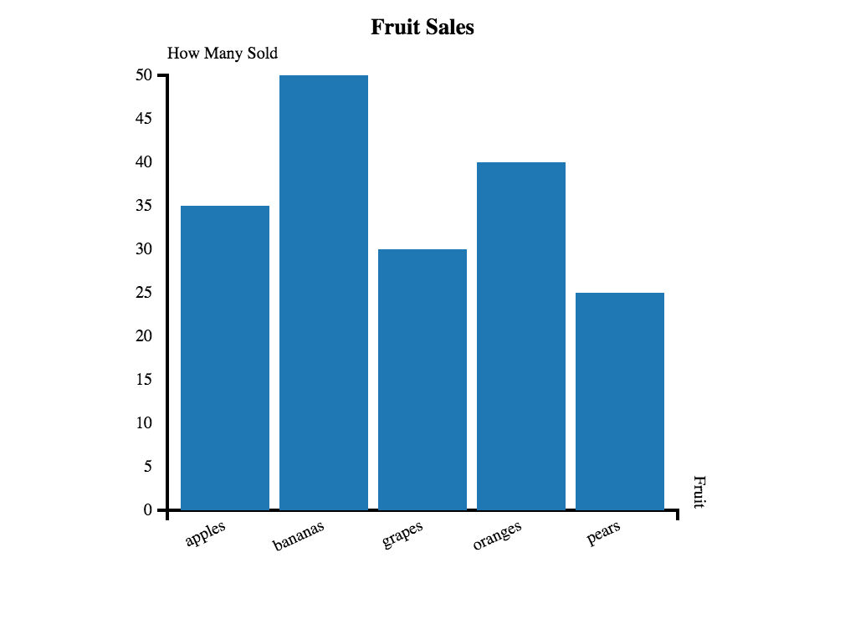

1. Are apples more popular than grapes? _______________
2. How many categories of fruit are there? _______________
3. How many pears were sold? _______________
4. What fruit is least popular? _______________

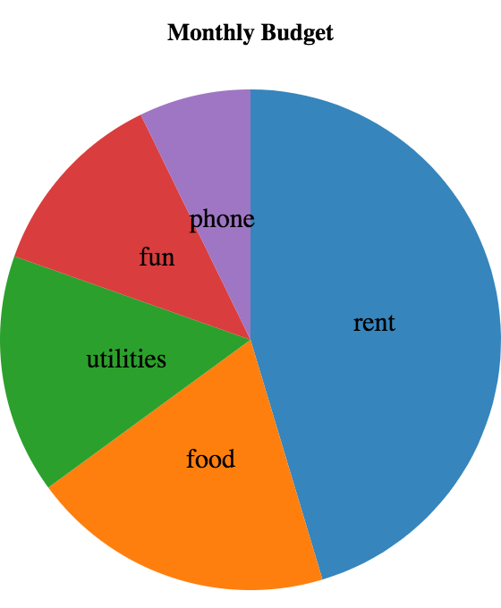

1. Which expense needs the least amount of money? ______________
2. Which expense takes up almost half of the budget? ______________
3. Suppose a person has a $2000 monthly budget, and they spend 15% on food. How many dollars is spent on food in a single month? ______________

# **Unit 5**

Roll two dice, and guess the sum of the roll. Guess right and you win. Guess wrong and you lose.

*“What are your chances of winning?”*

I hypothesize…

|  |
| --- |
|  |
|  |
|  |
|  |
|  |
|  |
|  |
|  |
|  |
|  |

I found…

|  |
| --- |
|  |
|  |
|  |
|  |
|  |
|  |
|  |
|  |
|  |
|  |

# Introducing Histograms

|  |  |  |
| --- | --- | --- |
| **First** | **Last** | **Height** |
| "John" | "Doe" | 52.0 |
| "Jane" | "Smith" | 49.1 |
| "Javon" | "Jackson" | 57.7 |
| "Angela" | "Enriquez" | 52.5 |
| "Jack" | "Thompson" | 53.0 |
| "Dominique" | "Rodriguez" | 51.1 |
| "Sammy" | "Carter" | 56.2 |
| "Andrea" | "Garcia" | 50.8 |

1. How many students are between 48 and 50 inches tall? ______________
2. How many students are between 50 and 52 inches tall? ______________
3. How many students are between 52 and 54 inches tall? ______________
4. How many students are between 54 and 56 inches tall? ______________
5. How many students are between 56 and 58 inches tall? ______________
6. 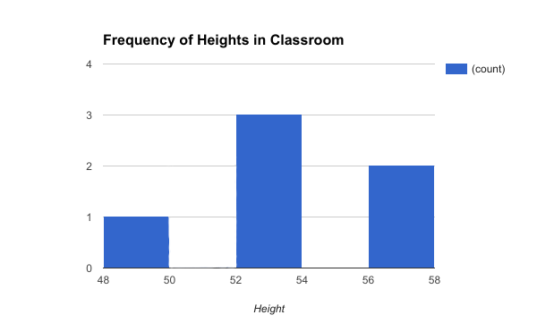Add a bar to this histogram for students who are between 50 and 52 inches tall.

Histogram Practice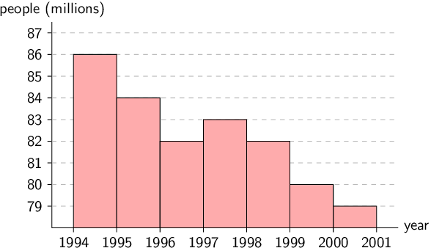

1. How many people were born between 1996 and 1997? ___________
2. On what year were the most number of people born? ___________
3. How many bins does this histogram have? ____________
4. Were more people born in 1994 or 1995? ____________

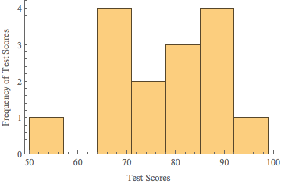

1. How many bins does this histogram have? ____________
2. What is (are) the bins with the highest frequency of scores? ____________
3. How many students scored between 85 and 92? ____________

# **Unit 6**

*“Are more expensive restaurants generally*

*better than cheaper ones?”*

I hypothesize…

|  |
| --- |
|  |
|  |
|  |
|  |
|  |
|  |
|  |
|  |
|  |
|  |

I found…

|  |
| --- |
|  |
|  |
|  |
|  |
|  |
|  |
|  |

# Creating a Scatter Plot

For each row in the following table, add a dot to the scatter plot. The first 3 rows have been completed for you. Use the values from the left column along the horizontal axis, and values from the right column along the vertical axis.

|  |  |
| --- | --- |
| 0 | 3 |
| 1 | 5 |
| 2.5 | 1 |
| 2 | 2 |
| 6 | 0 |
| 4 | 3 |

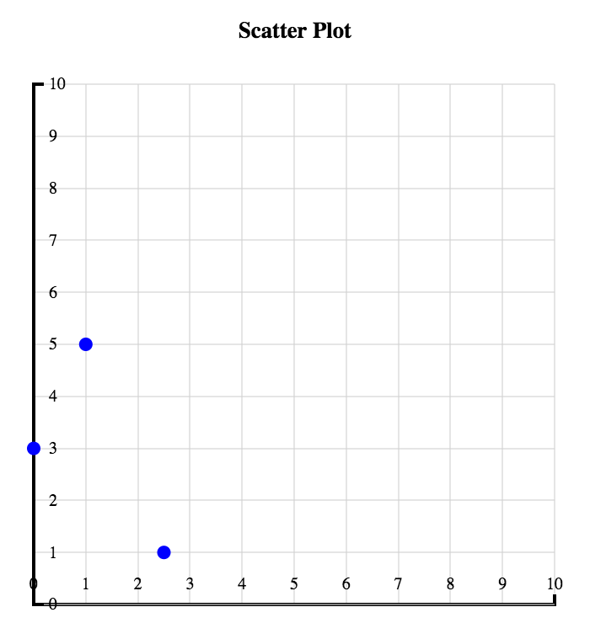

# Grading Predictor Functions

Below are the scatterplots for 4 data sets, with two different predictors shown for each set. For each data set**, circle the plot with the predictor function that fits better**, and **give it a grade between 0 (worst possible fit) and 1 (best possible fit).**

|  |  |  |  |
| --- | --- | --- | --- |
| 1 | wb-pred-a-1.png | wb-pred-a-2.png | Grade for best predictor:  _____________ |
| 2 | wb-pred-b-2.png | wb-pred-b-1.png | Grade for best predictor:  _____________ |
| 3 | wb-pred-c-2.png | wb-pred-c-1.png | Grade for best predictor:  _____________ |
| 4 | wb-pred-d-2.png | wb-pred-d-1.png | Grade for best predictor:  _____________ |

|  |  |  |  |
| --- | --- | --- | --- |
|  |  |  |  |

# Checking for Understanding

|  |
| --- |
|  |

1. In your own words, explain what a **predictor function** is.

|  |
| --- |
|  |
|  |
|  |
|  |
|  |
|  |

1. In your own words, explain what the **r-squared** value of a predictor is.

|  |
| --- |
|  |
|  |
|  |
|  |
|  |
|  |

# **Unit 7**

|  |
| --- |
|  |
|  |
|  |
|  |
|  |
|  |
|  |
|  |
|  |
|  |
|  |
|  |
|  |
|  |
|  |
|  |
|  |
|  |
|  |
|  |
|  |
|  |
|  |
|  |
|  |
|  |
|  |

# Practice with Select

Below is a table bound to the variable name animals.

|  |  |  |  |
| --- | --- | --- | --- |
| **name** | **legs** | **eyes** | **lifespan** |
| "Human" | 2 | 2 | 71 |
| "Garden Ant" | 6 | 2 | 8 |
| "Spider" | 8 | 8 | 2.5 |
| "Bear" | 4 | 2 | 10 |

1. Draw the table produced by this code (don’t forget the header row!):

select lifespan, name from animals end

|  |
| --- |
|  |
|  |
|  |
|  |
|  |

|  |
| --- |
| **eyes** |
| 2 |
| 2 |
| 8 |
| 2 |

1. What code will produce the table shown here?
2. *Challenge:* Draw table2, produced by this code:

table1 = **select** name, legs **from** animals **end**

table2 = **select** legs **from** mystery **end**

**table2**

|  |
| --- |
|  |
|  |
|  |
|  |
|  |

# Table Plan: Anything Unnecessary?

We can use tables to do all sorts of things – but we need a plan. Each of the following questions involves some subset of the animals table. Read each one carefully, then write a table query that will *remove unnecessary columns* –keeping only those we need – and binds the new table to a variable you choose.

**animals**

|  |  |  |  |
| --- | --- | --- | --- |
| **name** | **legs** | **eyes** | **lifespan** |
| "Human" | 2 | 2 | 71 |
| "Garden Ant" | 6 | 2 | 8 |
| "Spider" | 8 | 8 | 2.5 |
| "Bear" | 4 | 2 | 10 |

1. We want to make a frequency bar chart showing the distribution of legs

**Are any of the columns unnecessary?**

_______________________ =

myTable-selected

**select** ___________________________ **from** ______________

animals

**end**

1. We want to make a scatterplot of the relationship between legs and eyes.

**Are any of the columns unnecessary?**

_______________________ =

**select** ___________________________ **from** ______________

animals

**end**

1. We want to search for a predictor function linking eyes and lifespan

**Are any of the columns unnecessary?**

_______________________ =

**select** ___________________________ **from** ______________

**end**

# Table Plan: Is there an order?

We can use tables to do all sorts of things – but we need a plan. Each of the following questions involves the animals table. Read each one carefully, then write a table query that will *orders the rows of the table* –in the correct order – and binds the new table to a variable you choose.

**animals**

|  |  |  |  |
| --- | --- | --- | --- |
| **name** | **legs** | **eyes** | **lifespan** |
| "Human" | 2 | 2 | 71 |
| "Garden Ant" | 6 | 2 | 8 |
| "Spider" | 8 | 8 | 2.5 |
| "Bear" | 4 | 2 | 10 |

1. We want a table that has the shortest-lived animal first and longest-lived last.

**Do the rows need to be in some order?**

_______________________ =

myTable-ordered

**select** ___________________________ **from** ______________

animals

**end**

1. We want to extract a list of legs, from most-to-least.

**Do the rows need to be in some order?**

_______________________ =

**select** ___________________________ **from** ______________

animals

**end**

1. We want an alphabetized list of animal names.

**Do the rows need to be in some order?**

_______________________ =

**select** ___________________________ **from** ______________

**end**

# Table Plan: Total and Domestic

We’d like to sort our movies in ascending order of total, and then show only the title, total, and domestic.

*(The table on the left is a* ***sample table****, containing a few rows from the full table. This is a small sample we can start from. The* ***sample table*** *on the right is where we need to end up. Your job is to write the queries that get us there.)*

|  |  |  |  |  |  |  |  |  |  |  |  |  |  |  |  |  |  |  |  |  |  |  |  |  |  |  |  |  |  |  |  |  |  |  |  |  |  |  |  |  |  |  |  |  |  |  |  |  |  |  |  |  |  |  |  |
| --- | --- | --- | --- | --- | --- | --- | --- | --- | --- | --- | --- | --- | --- | --- | --- | --- | --- | --- | --- | --- | --- | --- | --- | --- | --- | --- | --- | --- | --- | --- | --- | --- | --- | --- | --- | --- | --- | --- | --- | --- | --- | --- | --- | --- | --- | --- | --- | --- | --- | --- | --- | --- | --- | --- | --- |
| **movies**   |  |  |  |  |  |  | | --- | --- | --- | --- | --- | --- | | **Movie Title** | **Studio** | **Total** | **Domestic** | **Overseas** | **Year** | | Interstellar | Par. | 675.1 | 188 | 487.1 | 2014 | | The Sixth Sense | BV | 672.8 | 293.5 | 379.3 | 1999 | | Man of Steel | WB | 668 | 291 | 377 | 2013 | | Kung Fu Panda 2 | P/DW | 665.7 | 165.2 | 500.4 | 2011 | | Ice Age: The  Meltdown | Fox | 660.9 | 195.3 | 465.6 | 2006 | | **total-and-domestic**   |  |  |  | | --- | --- | --- | | **Movie Title** | **Total** | **Domestic** | | Ice Age: The Meltdown | 660.9 | 188 | | Kung Fu Panda 2 | 665.7 | 293.5 | | Man of Steel | 668 | 291 | | The Sixth Sense | 672.8 | 165.2 | | Interstellar | 675.1 | 195.3 | |

**Do the rows need to be in some order?**

movies-ordered

movies

_______________________ = **order** ________________________:

_______________________________________

**end**

**Are any of the columns unnecessary?**

total-and-domestic

_______________________ = **select**

________________________________ **from** ______________

**end**

# Table Plan: Title and Year

We’d like to sort our movies in descending order of year, and then show only the title and year.

*(The table on the left is a* ***sample table****, containing a few rows from the full table. This is a small sample we can start from. The* ***sample table*** *on the right is where we need to end up. Your job is to write the queries that get us there.)*

|  |  |  |  |  |  |  |  |  |  |  |  |  |  |  |  |  |  |  |  |  |  |  |  |  |  |  |  |  |  |  |  |  |  |  |  |  |  |  |  |  |  |  |  |  |  |  |  |  |  |
| --- | --- | --- | --- | --- | --- | --- | --- | --- | --- | --- | --- | --- | --- | --- | --- | --- | --- | --- | --- | --- | --- | --- | --- | --- | --- | --- | --- | --- | --- | --- | --- | --- | --- | --- | --- | --- | --- | --- | --- | --- | --- | --- | --- | --- | --- | --- | --- | --- | --- |
| **movies**   |  |  |  |  |  |  | | --- | --- | --- | --- | --- | --- | | **Movie Title** | **Studio** | **Total Gross** | **Domestic** | **Overseas** | **Year** | | Interstellar | Par. | 675.1 | 188 | 487.1 | 2014 | | The Sixth Sense | BV | 672.8 | 293.5 | 379.3 | 1999 | | Man of Steel | WB | 668 | 291 | 377 | 2013 | | Kung Fu Panda 2 | P/DW | 665.7 | 165.2 | 500.4 | 2011 | | Ice Age: The  Meltdown | Fox | 660.9 | 195.3 | 465.6 | 2006 | | **title-and-year**   |  |  | | --- | --- | | **Title** | **Year** | | Interstellar | 2014 | | Man of Steel | 2013 | | Kung Fu Panda 2 | 2011 | | Ice Age: The Meltdown | 2006 | | The Sixth Sense | 1999 | |

**Do the rows need to be in some order?**

movies-ordered

movies

_______________________ = **order** ________________________:

______________________________________________________________

**end**

**Are any of the columns unnecessary?**

title-and-year

_______________________ = **select**

________________________________ **from** ______________

**end**

# **Unit 8**

*“How much of Asia’s GDP does China generate?”*

I hypothesize…

|  |
| --- |
|  |
|  |
|  |
|  |
|  |
|  |
|  |
|  |
|  |

I found…

|  |
| --- |
|  |
|  |
|  |
|  |
|  |
|  |
|  |
|  |

# Booleans and Comparison

Suppose your program has the following definitions:

legs = 2

eyes = 2

class = "Mammal"

continent = "North America"

What will each of the following expressions evaluate to?

|  |  |
| --- | --- |
| **Expression** | **Value** |
| legs <= 4 |  |
| eyes == 2 |  |
| legs <> 4 |  |
| eyes <> 5 - 3 |  |
| legs == eyes |  |

When you finish the first table try these challenge questions:

|  |  |
| --- | --- |
| **Expression** | **Value** |
| class == "Mammal" |  |
| class == "Invertebrate" |  |
| class <> "mammal" |  |
| continent == "Asia" |  |

# Table Plan: Recent Title and Year

Show the title and year for movies released after 2011, in descending order of total gross.

|  |  |  |  |  |  |  |  |  |  |  |  |  |  |  |  |  |  |  |  |  |  |  |  |  |  |  |  |  |  |  |  |  |  |  |  |  |  |  |  |  |  |  |  |  |  |
| --- | --- | --- | --- | --- | --- | --- | --- | --- | --- | --- | --- | --- | --- | --- | --- | --- | --- | --- | --- | --- | --- | --- | --- | --- | --- | --- | --- | --- | --- | --- | --- | --- | --- | --- | --- | --- | --- | --- | --- | --- | --- | --- | --- | --- | --- |
| **movies**   |  |  |  |  |  |  | | --- | --- | --- | --- | --- | --- | | **Movie Title** | **Studio** | **Total** | **Domestic** | **Overseas** | **Year** | | Interstellar | Par. | 675.1 | 188 | 487.1 | 2014 | | The Sixth Sense | BV | 672.8 | 293.5 | 379.3 | 1999 | | Man of Steel | WB | 668 | 291 | 377 | 2013 | | Kung Fu Panda 2 | P/DW | 665.7 | 165.2 | 500.4 | 2011 | | Ice Age: The  Meltdown | Fox | 660.9 | 195.3 | 465.6 | 2006 | | **solution4**   |  |  | | --- | --- | | **Title** | **Year** | | Interstellar | 2014 | | Man of Steel | 2013 | | Kung Fu Panda 2 | 2011 | |

**Do I need to get rid of any rows?**

movies-sieved

_______________________ = **sieve** _______________ **using** _________________________:

_______________________________________________________________________

**end**

**Do the rows need to be in some order?**

movies-ordered

_______________________ = **order** ________________________:

_______________________________________________________________________

**end**

**Are any of the columns unnecessary?**

solution4

_______________________ = **select**

_______________________________________ **from** ______________

**end**

# Table Plan: Title and Overseas

Starting with the table below, produce a table of Titles and Overseas profits, for all movies made before 2010, in ascending order of Total Gross.

***Note:*** *Start by filling in what the solution table should look like!*

|  |  |  |  |  |  |  |  |  |  |  |  |  |  |  |  |  |  |  |  |  |  |  |  |  |  |  |  |  |  |  |  |  |  |  |  |  |  |  |  |
| --- | --- | --- | --- | --- | --- | --- | --- | --- | --- | --- | --- | --- | --- | --- | --- | --- | --- | --- | --- | --- | --- | --- | --- | --- | --- | --- | --- | --- | --- | --- | --- | --- | --- | --- | --- | --- | --- | --- | --- |
| **movies-start**   |  |  |  |  |  |  | | --- | --- | --- | --- | --- | --- | | **Movie Title** | **Studio** | **Total Gross** | **Domestic** | **Overseas** | **Year** | | Interstellar | Par. | 675.1 | 188 | 487.1 | 2014 | | The Sixth Sense | BV | 672.8 | 293.5 | 379.3 | 1999 | | Man of Steel | WB | 668 | 291 | 377 | 2013 | | Kung Fu Panda 2 | P/DW | 665.7 | 165.2 | 500.4 | 2011 | | Ice Age: The Meltdown | Fox | 660.9 | 195.3 | 465.6 | 2006 | | **solution5**   |  | | --- | |  | |  | |

**Do I need to get rid of any rows?**

_______________________ = **sieve** _______________ **using** _________________________:

movies-sieved

_______________________________________________________________________

**end**

**Do the rows need to be in some order?**

movies-ordered

_______________________ = **order** ________________________:

_______________________________________________________________________

**end**

**Are any of the columns unnecessary?**

solution5

_______________________ = **select**

_______________________________________ **from** ______________

**end**

# Bad Starter Tables!

For each of the questions below, find out what’s wrong with the provided starter table. Write your answer in space below each table.

1. **“Make a table of all the presidents, sorted alphabetically by home-state”**

|  |  |  |  |  |  |
| --- | --- | --- | --- | --- | --- |
| **nth** | **name** | **home-state** | **yr-started** | **yr-ended** | **Party** |
| 7 | Andrew Jackson | Tennessee | 1829 | 1837 | Democratic |

1. **“Make a table showing only Democratic Presidents”**

|  |  |  |  |  |  |
| --- | --- | --- | --- | --- | --- |
| **nth** | **name** | **home-state** | **yr-started** | **yr-ended** | **party** |
| 7 | Andrew Jackson | Tennessee | 1829 | 1837 | Democratic |
| 35 | John F. Kennedy | Massachusetts | 1961 | 1963 | Democratic |
| 11 | James K. Polk | Tennessee | 1845 | 1849 | Democratic |
| 44 | Barack Obama | Illinois | 2009 | 2017 | Democratic |

1. **“Make a table showing the presidents sorted in ascending order of year-started”**

|  |  |  |  |  |  |
| --- | --- | --- | --- | --- | --- |
| **nth** | **name** | **home-state** | **yr-started** | **yr-ended** | **party** |
| 22 | Grover Cleveland | New York | 1885 | 1889 | Democratic |
| 24 | Grover Cleveland | New York | 1893 | 1897 | Democratic |

1. **“Make a table showing all presidents from New York.”**

|  |  |  |  |  |  |
| --- | --- | --- | --- | --- | --- |
| **nth** | **name** | **home-state** | **yr-started** | **yr-ended** | **party** |
| 45 | Donald Trump | New York | 2017 | 2021 | Republican |
| 32 | Franklin D. Roosevelt | New York | 1933 | 1945 | Democratic |
| 21 | Chester A. Arthur | New York | 1881 | 1885 | Republican |
| 26 | Theodore Roosevelt | New York | 1901 | 1909 | Republican |

# Table Plan: Asian GDPs

Define a table showing the names and GDPs of all countries in Asia, starting with the countries table.

***Start out*** *by creating a realistic “starter table”, using a sample of rows from the countries table, then a desired “end table” showing only the rows and columns you want, in the order you want them.*

|  |  |  |  |  |  |
| --- | --- | --- | --- | --- | --- |
| **countries**   |  | | --- | |  | |  | | **asian-GDPs**   |  | | --- | |  | |  | |

**Do I need to get rid of any rows?**

_______________________ = **sieve** _______________ **using** _________________________:

_______________________________________________________________________

**end**

**Do the rows need to be in some order?**

_______________________ = **order** ________________________:

________________________________________________________________________

**end**

**Are any of the columns unnecessary?**

_______________________ = **select**

______________________________________________ **from** ____________________

**end**

# **Unit 9**

**Unit 9**

*“Is GDP-per-capita positively correlated with life expectancy?”*

I hypothesize…

|  |
| --- |
|  |
|  |
|  |
|  |
|  |
|  |
|  |
|  |
|  |
|  |

I found…

|  |
| --- |
|  |
|  |
|  |
|  |
|  |
|  |
|  |
|  |
|  |

Extending Tables

Below is a table called games, which contains the number of points scored by different NBA players in their first 3 games of a season. Complete the new table on the right by filling in the value of the **total** column (just add the **game1, game2, game3** columns together).

|  |  |  |  |  |  |  |  |  |  |  |  |  |  |  |  |  |  |  |  |  |  |  |  |  |  |  |  |  |  |  |  |  |  |  |  |  |  |  |  |  |  |  |  |  |  |  |  |  |  |  |  |  |  |  |  |
| --- | --- | --- | --- | --- | --- | --- | --- | --- | --- | --- | --- | --- | --- | --- | --- | --- | --- | --- | --- | --- | --- | --- | --- | --- | --- | --- | --- | --- | --- | --- | --- | --- | --- | --- | --- | --- | --- | --- | --- | --- | --- | --- | --- | --- | --- | --- | --- | --- | --- | --- | --- | --- | --- | --- | --- |
| **games**   |  |  |  |  | | --- | --- | --- | --- | | **player** | **game1** | **game2** | **game3** | | "Lebron James" | 30 | 28 | 36 | | "Steph Curry" | 26 | 32 | 29 | | "Kyrie Irving" | 21 | 24 | 27 | | "John Wall" | 27 | 30 | 25 | | "Isaiah Thomas" | 25 | 22 | 24 | | **games-with-total**   |  |  |  |  |  | | --- | --- | --- | --- | --- | | **player** | **game1** | **game2** | **game3** | **total** | | "Lebron James" | 30 | 28 | 36 |  | | "Steph Curry" | 26 | 32 | 29 |  | | "Kyrie Irving" | 21 | 24 | 27 |  | | "John Wall" | 27 | 30 | 25 |  | | "Isaiah Thomas" | 25 | 22 | 24 |  | |

1. Which player has scored the most points so far? ________________________

Below is a table named socks, containing the prices of *packs of socks* at several different stores. Each store sells different size packs, for different prices. Complete the new table on the right by filling in the value of the **price-per-sock** column.

|  |  |  |  |  |  |  |  |  |  |  |  |  |  |  |  |  |  |  |  |  |  |  |  |  |  |  |  |  |  |  |  |  |  |  |  |  |  |  |  |  |  |  |  |
| --- | --- | --- | --- | --- | --- | --- | --- | --- | --- | --- | --- | --- | --- | --- | --- | --- | --- | --- | --- | --- | --- | --- | --- | --- | --- | --- | --- | --- | --- | --- | --- | --- | --- | --- | --- | --- | --- | --- | --- | --- | --- | --- | --- |
| **socks**   |  |  |  | | --- | --- | --- | | **name** | **price** | **socks** | | "Super Store" | 2.50 | 4 | | "Clothes Galore" | 5.40 | 4 | | "Bargain Mart" | 4.50 | 6 | | "Fashion Statement" | 15.00 | 12 | | "Sock Emporium" | 7.00 | 10 | | **socks-with-proce**   |  |  |  |  | | --- | --- | --- | --- | | **name** | **price** | **socks** | **price-per-sock** | | "Super Store" | 2.50 | 4 |  | | "Clothes Galore" | 5.40 | 4 |  | | "Bargain Mart" | 4.50 | 6 |  | | "Fashion Statement" | 15.00 | 12 |  | | "Sock Emporium" | 7.00 | 10 |  | |

1. Which store has the best deal on socks? ______________________

Table Plan: Body Building

Your aunt is a bodybuilder, and wants to eat only foods that have at least .12 grams of protein per serving. Starting with nutrition, build a table showing only the name, calories and protein-per-gram for menu items that fit this criterion.

*(Suggestion: draw a start and end sample table on a sheet of scrap paper!)*

**Do I need to add a column?**

_____________________ = **extend** ________________ **using** ________________________:

-extended

______________________ : ________________________________________________

**end**

**Do I need to get rid of any rows?**

_______________________ = **sieve** _______________ **using** _________________________:

_______________________________________________________________________

**end**

**Do the rows need to be in some order?**

_______________________ = **order** ________________________:

________________________________________________________________________

**end**

**Are any of the columns unnecessary?**

_______________________ = **select**

______________________________________________ **from** ____________________

**end**

Table Plan: Term Length

For how many years was each Democratic president in office? We’d like to make a histogram showing how many democratic presidents served between 0 - 4 years, or 4 - 8 years. How do we make the necessary table?

**Do I need to add a column?**

_____________________ = **extend** ________________ **using** ________________________:

-extended

______________________ : ________________________________________________

**end**

**Do I need to get rid of any rows?**

_______________________ = **sieve** _______________ **using** _________________________:

_______________________________________________________________________

**end**

**Do the rows need to be in some order?**

_______________________ = **order** ________________________:

________________________________________________________________________

**end**

**Are any of the columns unnecessary?**

_______________________ = **select**

______________________________________________ **from** ____________________

**end**

Table Plan: GDP v. Population

The United Nations wants us to investigate whether per-capita-gdp or population size has a larger influence on median life expectancy in Africa.

*(Suggestion: draw a start and end sample table on a sheet of scrap paper!)*

**Do I need to add a column?**

_____________________ = **extend** ________________ **using** ________________________:

-extended

______________________ : ________________________________________________

**end**

**Do I need to get rid of any rows?**

_______________________ = **sieve** _______________ **using** _________________________:

_______________________________________________________________________

**end**

**Do the rows need to be in some order?**

_______________________ = **order** ________________________:

________________________________________________________________________

**end**

**Are any of the columns unnecessary?**

_______________________ = **select**

______________________________________________ **from** ____________________

**end**

Countries Table Plan Practice

Make a histogram of per-capita GDP for countries with universal health care. Do most of these countries have a per-capita GDP that is higher than the average per-capita GDP of all countries?

**Do I need to add a column?**

_____________________ = **extend** ________________ **using** ________________________:

-extended

______________________ : ________________________________________________

**end**

**Do I need to get rid of any rows?**

_______________________ = **sieve** _______________ **using** _________________________:

_______________________________________________________________________

**end**

**Do the rows need to be in some order?**

_______________________ = **order** ________________________:

________________________________________________________________________

**end**

**Are any of the columns unnecessary?**

_______________________ = **select**

______________________________________________ **from** ____________________

**end**

Table Plan

**Do I need to add a column?**

_____________________ = **extend** ________________ **using** ________________________:

-extended

______________________ : ________________________________________________

**end**

**Do I need to get rid of any rows?**

_______________________ = **sieve** _______________ **using** _________________________:

_______________________________________________________________________

**end**

**Do the rows need to be in some order?**

_______________________ = **order** ________________________:

________________________________________________________________________

**end**

**Are any of the columns unnecessary?**

_______________________ = **select**

______________________________________________ **from** ____________________

**end**

Table Plan

**Do I need to add a column?**

_____________________ = **extend** ________________ **using** ________________________:

______________________ : ________________________________________________

**end**

**Do I need to get rid of any rows?**

_______________________ = **sieve** _______________ **using** _________________________:

_______________________________________________________________________

**end**

**Do the rows need to be in some order?**

_______________________ = **order** ________________________:

________________________________________________________________________

**end**

**Are any of the columns unnecessary?**

_______________________ = **select**

______________________________________________ **from** ____________________

**end**

Table Plan

**Do I need to add a column?**

_____________________ = **extend** ________________ **using** ________________________:

______________________ : ________________________________________________

**end**

**Do I need to get rid of any rows?**

_______________________ = **sieve** _______________ **using** _________________________:

_______________________________________________________________________

**end**

**Do the rows need to be in some order?**

_______________________ = **order** ________________________:

________________________________________________________________________

**end**

**Are any of the columns unnecessary?**

_______________________ = **select**

______________________________________________ **from** ____________________

**end**

Query Reference

**Select**

*What it’s for:*

**select** ___________**,**___________**,**________________________ **from** ____________________ **end**

***table***

***column3***

***column2***

***column1***

**Order**

*What it’s for:*

**order** ________________________ **:**

***table***

______________________________________________ **,**

***column1 ascending***

______________________________________________

***column2 descending***

**end**

**Sieve**

*What it’s for:*

***column2***

**sieve** ________________________ **using** _________________________________________ **:**

***table***

***column2 > 42***

_________________________________________________________________

**end**

**Extend**

*What it’s for:*

**extend** ________________________ **using** ___________________**,**______________________ **:**

***column1 column2***

***(2 * column1) – column2***

***new-column1***

***table***

_____________________ **:** ____________________________________________ **,**

_____________________ **:** ____________________________________________

***column2 / 4***

***new-column2***

**end**

Contracts

|  |  |  |  |
| --- | --- | --- | --- |
| **Name** | **Domain** | **Range** | **Example** |
| num-max |  |  | num-max(-1, 3) |
| string-length |  |  | string-length("pyret") |
| string-repeat | String Number | String |  |
|  |  |  |  |
|  |  |  |  |
|  |  |  |  |
|  |  |  |  |
|  |  |  |  |
|  |  |  |  |
|  |  |  |  |
|  |  |  |  |
|  |  |  |  |
|  |  |  |  |
|  |  |  |  |
|  |  |  |  |

1. https://web.archive.org/web/20060903121944/http://www.census.gov/hhes/income/histinc/h13.html