

**Data Science**



Workbook v0.9b

Brought to you by the Bootstrap team:

* Emmanuel Schanzer
* Kathi Fisler
* Shriram Krishnamurthi
* Sam Dooman
* Ed Campos

Bootstrap is licensed under a Creative Commons 3.0 Unported License. Based on a work from www.BootstrapWorld.org. Permissions beyond the scope of this license may be available at schanzer@BootstrapWorld.org.

**Unit 1**

*The question I chose is…*

|  |
| --- |
|  |
|  |
|  |
|  |
| *I think the answer is…*   |  | | --- | |  | |  | |  | |  | | *The data I would use to support my answer is…*   |  | | --- | |  | |  | |  | |  | |  | |  | |  | |  | |  | |  | |  | |  | |  | |  | | |

# Numbers and Strings

Make sure you’ve loaded the Unit 1 Starter File, and clicked “Run”.

1. In the Interactions Area (on the right), type language and hit “Enter”.
2. In Pyret, values are grouped by *Types*. What Types do you see in this table?
3. Each Type can have many different values, and the second column of the table has *lists* of example values for each type. For example, 42 is a Number value. Try typing 42 into the Interactions Area and hitting “Enter”. What happens?
4. Try typing in other Numbers. What happens if you try a decimal like 0.5? A fraction like 1/3? Try really big Numbers, and really small ones.
5. String values are always in quotes. Try typing in each of the String examples from the table, and see what happens when you hit “Enter”.
6. What happens if you leave off both quotation marks? What happens if you leave off just one of them?
7. Is 42 the same as “42”? Why or why not? Write your answer below:
8. Just like in math, Pyret has *operators* like + and -. Try typing in 4 + 2, and then 4+2 (without the spaces). What can you conclude from this? Write your answer below:
9. Try typing in 4 + 2 + 6, 4 + 2 * 6, and 4 + (2 * 6). What can you conclude from this? Write your answer below:
10. Try typing in 4 + “cat”, and then “dog” + “cat”. What can you conclude from this? Write your answer below:

# Booleans and Lists

Boolean expressions are yes-or-no questions, and you probably already know some Boolean operators from math class. What do you think each of the following expressions will evaluate to? Try typing some into Pyret to experiment.

|  |  |
| --- | --- |
| 0 > (0 * 2) ___________  (1 + 2) <= 4 ___________  (5 – 3) == 2 ___________  2 <> 4 ___________ | “a” > “b” ___________  “a” < “b” ___________  “a” <> “b” ___________  “a” == “b” ___________ |

1. How many Number values are there?
2. How many String values are there?
3. How many Boolean values are there?

A List is a way of grouping values together. Here are four different List values:

[list: 1, 2, 3]

[list: 1 + 1, 2 + 2, 3 + 3]

[list: "lists", "can", "be", "strings"]

[list: true, false]

1. Every list is written in square brackets, with list: at the beginning and each value separated by commas. In Pyret, make a List of Numbers, a List of Strings, and a List of Booleans.
2. Pyret will show an error message if a List is typed incorrectly. Try typing in each of the following, and see what error messages you get:

[list 1, 2, 3]

[list: 1 2 3]

(list: 1, 2 3)

# Definitions

For each of the definitions below, write a value that matches the Type shown in the comment (after the #). The first one has been done for you.

13

age = _________________________ # age :: Number

big = _________________________ # bigNum :: Number

small = _________________________ # smallNum :: Number

name = _________________________ # name :: String

city = _________________________ # city :: String

state = _________________________ # state :: String

[list: ]

evens = ___________________________ # evens :: List<Number>

odds = _________________________ # odds :: List<Number>

colors = _________________________ # colors :: List<String>

# **Unit 2**

*“What is the relationship between calories and sugar?”*

I hypothesize…

|  |
| --- |
|  |
|  |
|  |
|  |
|  |
|  |
|  |
|  |
|  |
|  |
|  |

I found…

|  |
| --- |
|  |
|  |
|  |
|  |
|  |
|  |
|  |
|  |
|  |
|  |
|  |

# Cities

|  |  |
| --- | --- |
| **name** | **population** |
| "New York" | 8500000 |
| "Chicago" | 2700000 |
| "Houston" | 2300000 |
| "Phoenix" | 1600000 |
| "San Diego" | 1400000 |

1. How many rows does this table have? ___________
2. How many columns does this table have? ___________
3. What are the names of the columns? ___________
4. For the row with “Houston” in the **name** column,

what is the value in the **population** column? ___________

1. Circle the header row of this table

# Presidents and Nutrition

Answer the following questions about the presidents and nutrition tables, using your Unit-2 Pyret program:

1. How many columns does the presidents table have? _________
2. What are the names of the columns? _________
3. How many rows does the presidents table have? _________
4. Is the party column quantitative or categorical? _________
5. Is the data in the home-state column categorical? _________
6. If so, how many categories are there? _________
7. What is the home state of Millard Fillmore? _________
8. Who was the first president from the Federalist party? _________
9. How many columns does the nutrition table have? _________
10. How many rows does the nutrition table have? _________
11. How many grams of cholesterol does the Hamburger have? _________
12. Which food has the largest serving size? _________
13. Is the data in the calories column quantitative? If so, why?

___________________________________________________________________________

# **Unit 3**

|  |
| --- |
|  |
|  |
|  |
|  |
|  |
|  |
|  |
|  |
|  |
|  |
|  |
|  |
|  |
|  |
|  |
|  |
|  |
|  |
|  |
|  |
|  |
|  |
|  |
|  |
|  |
|  |
|  |
|  |

# Reading Charts

1. Which menu item has the most sodium? __________________
2. Which menu item has the least sodium? __________________
3. Do french fries have more sodium than hamburgers? __________________
4. Which country has the largest GDP? __________________
5. What percent of the total world GDP is from China? __________________

# Frequency Bar Chart

|  |  |  |
| --- | --- | --- |
| **First** | **Last** | **Eye-Color** |
| "John" | "Doe" | "Green" |
| "Jane" | "Smith" | "Brown" |
| "Javon" | "Jackson" | "Brown" |
| "Angela" | "Enriquez" | "Hazel" |
| "Jack" | "Thompson" | "Blue" |
| "Dominique" | "Rodriguez" | "Hazel" |
| "Sammy" | "Carter" | "Blue" |
| "Andrea" | "Garcia" | "Brown" |

1. How many students have Brown eyes? ____________
2. How many students have Green eyes? ____________
3. How many students have Hazel eyes? ____________
4. How many students have Blue eyes? ____________
5. Points scored

   image32.pngAbove the “Blue” label on this bar chart, add a bar with height that corresponds to the number of students with Blue eyes.

# Chart Practice

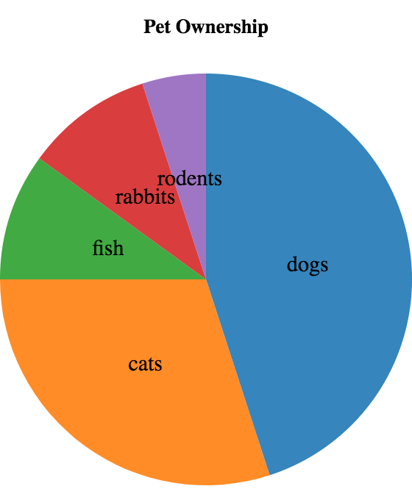

1. Is this a pie chart, or a bar chart? _____________________
2. Which pet is the most popular? _____________________
3. Which pet is the least popular? _____________________
4. Which are more popular, fish or rodents? _____________________

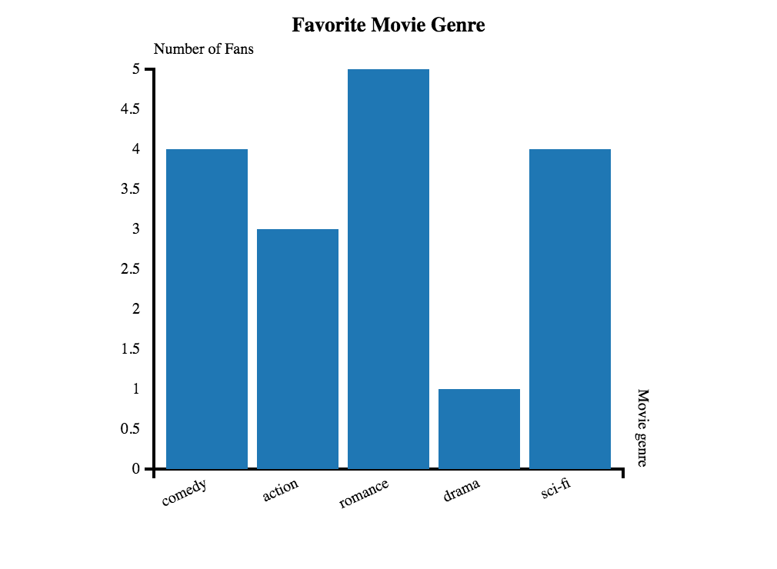

1. Is this a bar chart or a pie chart? _______________________
2. What movie genre is most popular? _______________________
3. What are the labels of this chart? _______________________
4. What are the values of this chart? ________________________
5. Is this a frequency bar chart? ________________________

More Chart Practice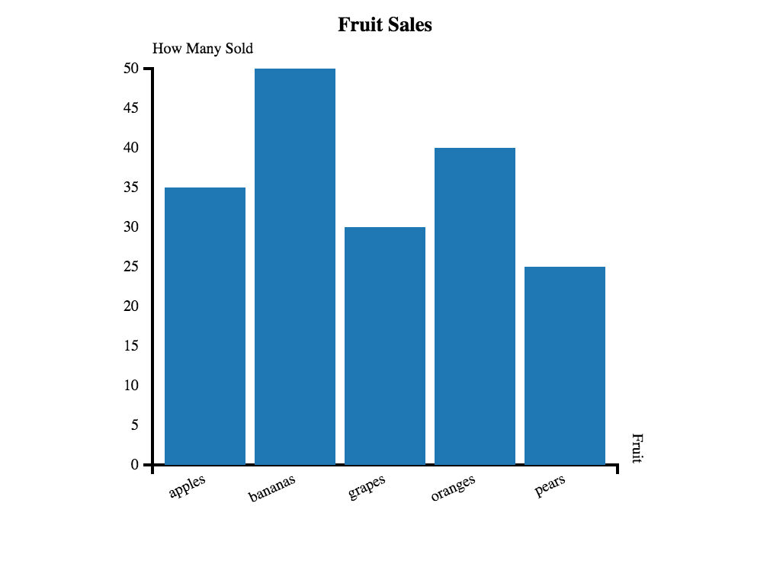

1. Are apples more popular than grapes? _______________
2. How many categories of fruit are there? _______________
3. How many pears were sold? _______________
4. What fruit is least popular? _______________

______________

# **Unit 4**

*“According to the US Census Bureau, the average American household earned more than $45,000 in 2003 - more than 3x the poverty line that year. Does that mean only a small percentage of Americans were in poverty that year?”*

I hypothesize…

|  |
| --- |
|  |
|  |
|  |
|  |
|  |
|  |
|  |
|  |
|  |
|  |

I found…

|  |
| --- |
|  |
|  |
|  |
|  |
|  |
|  |
|  |
|  |
|  |
|  |

# Mean, Median, Mode Practice

Using pencil & paper, calculate the 3 numbers that measure the center of each list. If a list contains more than one mode, write the number with the smallest value.

These lists are bound to variables a, b, c, d, e in the Unit 4 template file, so you can check your answers with Pyret.

|  |  |  |  |
| --- | --- | --- | --- |
| **List** | **Mean** | **Median** | **Mode-List** |
| a = [list: 1, 1, 4] |  |  | [list: ] |
| b = [list: 3, 4, 5] |  |  | [list: ] |
| c = [list: 3, 3, 4, 6] |  |  | [list: ] |
| d = [list: -1,0.5,2,0.5,2,6] |  |  | [list: ] |
| e = [list: 2, 11, 7, 4] |  |  | [list: ] |

# Measuring Center in Pyret

1. What is the mode of the calories-list? _________
2. What is the mean amount of sodium for menu items? _________
3. What is the median GDP for all the countries in countries? _________
4. What is the median of life-expectancy-list? _________

Imagine the following code is in your definitions window:

mystery-list = [list: 1, 2, 3, 4, 5, 6, 7, 8, 9]

1. What is the median of this mystery-list? _________

Now imagine these lists (which contain the same elements as mystery-list) are in your definitions window:

mystery1 = [list: 1, 4, 7]

mystery2 = [list: 2, 3, 8]

mystery3 = [list: 5, 6, 9]

1. What is the median of mystery1? _________
2. What is the median of mystery2? _________
3. What is the median of mystery3? _________
4. What is the median of a list containing these 3 medians? _________
5. Is this different from the median of mystery-list? _________

# **Unit 5**

Roll two dice, and guess the sum of the roll. Guess right and you win $1. Guess wrong and you lose $1.

*“Is this game worth playing?”*

I hypothesize…

|  |
| --- |
|  |
|  |
|  |
|  |
|  |
|  |
|  |
|  |
|  |
|  |

I found…

|  |
| --- |
|  |
|  |
|  |
|  |
|  |
|  |
|  |
|  |
|  |
|  |

# Histograms

|  |  |  |
| --- | --- | --- |
| **First** | **Last** | **Height** |
| "John" | "Doe" | 52.0 |
| "Jane" | "Smith" | 49.1 |
| "Javon" | "Jackson" | 57.7 |
| "Angela" | "Enriquez" | 52.5 |
| "Jack" | "Thompson" | 53.0 |
| "Dominique" | "Rodriguez" | 51.1 |
| "Sammy" | "Carter" | 56.2 |
| "Andrea" | "Garcia" | 50.8 |

1. How many students are 48in or above, *and* less than 50in tall? ____________
2. How many students are 50in or above, *and* less than 52in tall? ____________
3. How many students are 52in or above, *and* less than 54in tall? ____________
4. How many students are 54in or above, *and* less than 56in tall? ____________
5. How many students are 56in or above, *and* less than 58in tall? ____________
6. 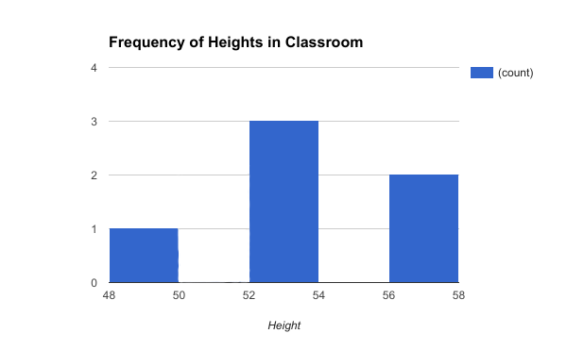Add a bar to this histogram for students who are 50in or above, *and* less than 52in tall.

Histogram Practice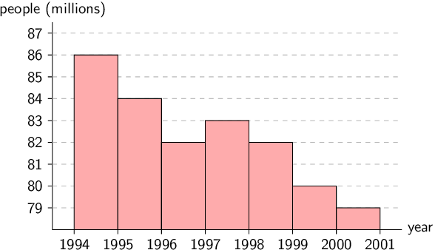

1. How many people were born between 1996 and 1997? ___________
2. On what year were the most number of people born? ___________
3. How many bins does this histogram have? ____________
4. Were more people born in 1994 or 1995? ____________

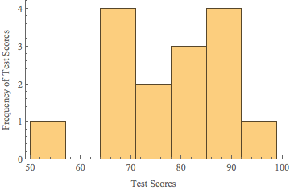

1. How many bins does this histogram have? ____________
2. What is (are) the bins with the highest frequency of scores? ____________
3. How many students scored between 85 and 92? ____________

# **Unit 6**

***“The more you pay at a restaurant, the better it is.”***

*Do you agree?*

I hypothesize…

|  |
| --- |
|  |
|  |
|  |
|  |
|  |
|  |
|  |
|  |
|  |
|  |

I found…

|  |
| --- |
|  |
|  |
|  |
|  |
|  |
|  |
|  |

# Creating a Scatter Plot

For each row in the following table, add a dot to the scatter plot. The first 3 rows have been completed for you. Use the values from the left column along the horizontal axis, and values from the right column along the vertical axis.

|  |  |
| --- | --- |
| **Dollars** | **Fingers** |
| 0 | 3 |
| 1 | 5 |
| 2.5 | 1 |
| 2 | 2 |
| 6 | 0 |
| 4 | 3 |



# Grading Predictor Functions

Below are the scatterplots for 4 data sets, with two different predictors shown for each set. For each data set**, circle the plot with the predictor function that fits better**, and **give it a grade between 0 (worst possible fit) and 1 (best possible fit).**

|  |  |  |  |
| --- | --- | --- | --- |
| 1 | wb-pred-a-1.png | wb-pred-a-2.png | Grade for best predictor:  _____________ |
| 2 | wb-pred-b-2.png | wb-pred-b-1.png | Grade for best predictor:  _____________ |
| 3 | wb-pred-c-2.png | wb-pred-c-1.png | Grade for best predictor:  _____________ |
| 4 | wb-pred-d-2.png | wb-pred-d-1.png | Grade for best predictor:  _____________ |

|  |  |  |  |
| --- | --- | --- | --- |
|  |  |  |  |

# Checking for Understanding

|  |
| --- |
|  |

1. In your own words, explain what a **predictor function** is.

|  |
| --- |
|  |
|  |
|  |
|  |
|  |
|  |

1. In your own words, explain what the **r-squared** value of a predictor is.

|  |
| --- |
|  |
|  |
|  |
|  |
|  |
|  |

# **Unit 7**

|  |
| --- |
|  |
|  |
|  |
|  |
|  |
|  |
|  |
|  |
|  |
|  |
|  |
|  |
|  |
|  |
|  |
|  |
|  |
|  |
|  |
|  |
|  |
|  |
|  |
|  |
|  |
|  |
|  |

# Practice with Select

Below is a table bound to the name animals.

|  |  |  |  |
| --- | --- | --- | --- |
| **name** | **legs** | **eyes** | **lifespan** |
| "Human" | 2 | 2 | 71 |
| "Garden Ant" | 6 | 2 | 8 |
| "Spider" | 8 | 8 | 2.5 |
| "Bear" | 4 | 2 | 10 |

1. Draw the table produced by this code (don’t forget the header row!):

animals.select-columns([list: “lifespan”, “name”])

|  |
| --- |
|  |
|  |
|  |
|  |
|  |

|  |
| --- |
| **eyes** |
| 2 |
| 2 |
| 8 |
| 2 |

1. What code will produce the table shown here?
2. *Challenge:* Draw table2, produced by this code:

table1 = animals.select-columns([list: “name”, “legs”])

table2 = table1.select-columns([list: “legs”])

**table2**

|  |
| --- |
|  |
|  |
|  |
|  |
|  |

# Table Plan: What do we need?

We can use tables to do all sorts of things – but we need a plan. Each of the following questions involves some subset of the animals table. Read each one carefully, then write a table query that will *remove unnecessary columns* –keeping only those we need – and binds the new table to a variable you choose.

**animals**

|  |  |  |  |
| --- | --- | --- | --- |
| **name** | **legs** | **eyes** | **lifespan** |
| "Human" | 2 | 2 | 71 |
| "Garden Ant" | 6 | 2 | 8 |
| "Spider" | 8 | 8 | 2.5 |
| "Bear" | 4 | 2 | 10 |

1. We want to make a histogram showing the distribution of legs

**Do I want to *select* only certain columns?**

animals-selected

_____________________________________________ =

______________________________________________________________________

1. We want to make a scatterplot of the relationship between legs and eyes.

**Do I want to *select* only certain columns?**

_____________________________________________ =

______________________________________________________________________

1. We want to search for a predictor function linking eyes and lifespan

**Do I want to *select* only certain columns?**

_____________________________________________ =

______________________________________________________________________

# Table Plan: Is there an order?

We can use tables to do all sorts of things – but we need a plan. Each of the following questions involves the animals table. Read each one carefully, then write a table query that will *orders the rows of the table* –in the correct order – and binds the new table to a variable you choose.

**animals**

|  |  |  |  |
| --- | --- | --- | --- |
| **name** | **legs** | **eyes** | **lifespan** |
| "Human" | 2 | 2 | 71 |
| "Garden Ant" | 6 | 2 | 8 |
| "Spider" | 8 | 8 | 2.5 |
| "Bear" | 4 | 2 | 10 |

1. We want a table that has the shortest-lived animal first and longest-lived last.

**Do I want to *order* *by* a specific column?**

animals-ordered

_____________________________________________ =

______________________________________________________________________

1. We want to extract a list of legs, from most-to-least.

**Do I want to *order* *by* a specific column?**

_____________________________________________ =

______________________________________________________________________

1. We want an alphabetized list of animal names.

**Do I want to *order* *by* a specific column?**

_____________________________________________ =

______________________________________________________________________

# Table Plan: Total and Domestic

We’d like to sort our movies in ascending order of total, and then show only the title, total, and domestic.

*(The table on the left is a* ***sample table****, containing a few rows from the full table. This is a small sample we can start from. The* ***sample table*** *on the right is where we need to end up. Your job is to write the queries that get us there.)*

|  |  |  |  |  |  |  |  |  |  |  |  |  |  |  |  |  |  |  |  |  |  |  |  |  |  |  |  |  |  |  |  |  |  |  |  |  |  |  |  |  |  |  |  |  |  |  |  |  |  |  |  |  |  |  |  |
| --- | --- | --- | --- | --- | --- | --- | --- | --- | --- | --- | --- | --- | --- | --- | --- | --- | --- | --- | --- | --- | --- | --- | --- | --- | --- | --- | --- | --- | --- | --- | --- | --- | --- | --- | --- | --- | --- | --- | --- | --- | --- | --- | --- | --- | --- | --- | --- | --- | --- | --- | --- | --- | --- | --- | --- |
| **movies**   |  |  |  |  |  |  | | --- | --- | --- | --- | --- | --- | | **Movie Title** | **Studio** | **Total** | **Domestic** | **Overseas** | **Year** | | Interstellar | Par. | 675.1 | 188 | 487.1 | 2014 | | The Sixth Sense | BV | 672.8 | 293.5 | 379.3 | 1999 | | Man of Steel | WB | 668 | 291 | 377 | 2013 | | Kung Fu Panda 2 | P/DW | 665.7 | 165.2 | 500.4 | 2011 | | Ice Age: The  Meltdown | Fox | 660.9 | 195.3 | 465.6 | 2006 | | **total-and-domestic**   |  |  |  | | --- | --- | --- | | **Movie Title** | **Total** | **Domestic** | | Ice Age: The Meltdown | 660.9 | 195.3 | | Kung Fu Panda 2 | 665.7 | 165.2 | | Man of Steel | 668 | 291 | | The Sixth Sense | 672.8 | 293.5 | | Interstellar | 675.1 | 188 | |

**Do I want to *order* *by* a specific column?**

movies-ordered

_____________________________________________ =

______________________________________________________________________

**Do I want to *select* only certain columns?**

movies-selected

_____________________________________________ =

______________________________________________________________________

# Table Plan: Title and Year

We’d like to sort our movies in descending order of year, and then show only the title and year.

*(The table on the left is a* ***sample table****, containing a few rows from the full table. This is a small sample we can start from. The* ***sample table*** *on the right is where we need to end up. Your job is to write the queries that get us there.)*

|  |  |  |  |  |  |  |  |  |  |  |  |  |  |  |  |  |  |  |  |  |  |  |  |  |  |  |  |  |  |  |  |  |  |  |  |  |  |  |  |  |  |  |  |  |  |  |  |  |  |
| --- | --- | --- | --- | --- | --- | --- | --- | --- | --- | --- | --- | --- | --- | --- | --- | --- | --- | --- | --- | --- | --- | --- | --- | --- | --- | --- | --- | --- | --- | --- | --- | --- | --- | --- | --- | --- | --- | --- | --- | --- | --- | --- | --- | --- | --- | --- | --- | --- | --- |
| **movies**   |  |  |  |  |  |  | | --- | --- | --- | --- | --- | --- | | **Movie Title** | **Studio** | **Total Gross** | **Domestic** | **Overseas** | **Year** | | Interstellar | Par. | 675.1 | 188 | 487.1 | 2014 | | The Sixth Sense | BV | 672.8 | 293.5 | 379.3 | 1999 | | Man of Steel | WB | 668 | 291 | 377 | 2013 | | Kung Fu Panda 2 | P/DW | 665.7 | 165.2 | 500.4 | 2011 | | Ice Age: The  Meltdown | Fox | 660.9 | 195.3 | 465.6 | 2006 | | **title-and-year**   |  |  | | --- | --- | | **Title** | **Year** | | Interstellar | 2014 | | Man of Steel | 2013 | | Kung Fu Panda 2 | 2011 | | Ice Age: The Meltdown | 2006 | | The Sixth Sense | 1999 | |

**Do I want to *order* *by* a specific column?**

_____________________________________________ =

______________________________________________________________________

**Do I want to *select* only certain columns?**

_____________________________________________ =

______________________________________________________________________

# **Unit 8**

*“How much of Asia’s GDP does China generate?”*

I hypothesize…

|  |
| --- |
|  |
|  |
|  |
|  |
|  |
|  |
|  |
|  |
|  |

I found…

|  |
| --- |
|  |
|  |
|  |
|  |
|  |
|  |
|  |
|  |

# Table Plan: Recent Title and Year

Show the title and year for movies released after 2010, in descending order of total gross.

|  |  |  |  |  |  |  |  |  |  |  |  |  |  |  |  |  |  |  |  |  |  |  |  |  |  |  |  |  |  |  |  |  |  |  |  |  |  |  |  |  |  |  |  |  |  |
| --- | --- | --- | --- | --- | --- | --- | --- | --- | --- | --- | --- | --- | --- | --- | --- | --- | --- | --- | --- | --- | --- | --- | --- | --- | --- | --- | --- | --- | --- | --- | --- | --- | --- | --- | --- | --- | --- | --- | --- | --- | --- | --- | --- | --- | --- |
| **movies**   |  |  |  |  |  |  | | --- | --- | --- | --- | --- | --- | | **Movie Title** | **Studio** | **Total** | **Domestic** | **Overseas** | **Year** | | Interstellar | Par. | 675.1 | 188 | 487.1 | 2014 | | The Sixth Sense | BV | 672.8 | 293.5 | 379.3 | 1999 | | Man of Steel | WB | 668 | 291 | 377 | 2013 | | Kung Fu Panda 2 | P/DW | 665.7 | 165.2 | 500.4 | 2011 | | Ice Age: The  Meltdown | Fox | 660.9 | 195.3 | 465.6 | 2006 | | **solution4**   |  |  | | --- | --- | | **Title** | **Year** | | Interstellar | 2014 | | Man of Steel | 2013 | | Kung Fu Panda 2 | 2011 | |

**Do I want to *filter* just certain rows? (circle the name of filter function)**

_____________________________________________ =

______________________________________________________________________

**Do I want to *order* by a specific column?**

_____________________________________________ =

______________________________________________________________________

**Do I want to *select* only certain columns?**

_____________________________________________ =

______________________________________________________________________

# Table Plan: Title and Overseas

Starting with the table below, produce a table of Titles and Overseas profits, for all movies made before 2010, in ascending order of Total Gross.

***Note:*** *Start by filling in what the solution table should look like!*

|  |  |  |  |  |  |  |  |  |  |  |  |  |  |  |  |  |  |  |  |  |  |  |  |  |  |  |  |  |  |  |  |  |  |  |  |  |  |  |  |
| --- | --- | --- | --- | --- | --- | --- | --- | --- | --- | --- | --- | --- | --- | --- | --- | --- | --- | --- | --- | --- | --- | --- | --- | --- | --- | --- | --- | --- | --- | --- | --- | --- | --- | --- | --- | --- | --- | --- | --- |
| **movies-start**   |  |  |  |  |  |  | | --- | --- | --- | --- | --- | --- | | **Movie Title** | **Studio** | **Total Gross** | **Domestic** | **Overseas** | **Year** | | Interstellar | Par. | 675.1 | 188 | 487.1 | 2014 | | The Sixth Sense | BV | 672.8 | 293.5 | 379.3 | 1999 | | Man of Steel | WB | 668 | 291 | 377 | 2013 | | Kung Fu Panda 2 | P/DW | 665.7 | 165.2 | 500.4 | 2011 | | Ice Age: The Meltdown | Fox | 660.9 | 195.3 | 465.6 | 2006 | | **solution5**   |  | | --- | |  | |  | |

**Do I want to *filter* just certain rows? (circle the name of filter function)**

_____________________________________________ =

______________________________________________________________________

**Do I want to *order* by a specific column?**

_____________________________________________ =

______________________________________________________________________

**Do I want to *select* only certain columns?**

_____________________________________________ =

______________________________________________________________________

# Bad Starter Tables!

For each of the questions below, find out what’s wrong with the provided starter table. Write your answer in space below each table.

1. **“Make a table of all the presidents, sorted alphabetically by home-state”**

|  |  |  |  |  |  |
| --- | --- | --- | --- | --- | --- |
| **nth** | **name** | **home-state** | **yr-started** | **yr-ended** | **Party** |
| 7 | Andrew Jackson | Tennessee | 1829 | 1837 | Democratic |

1. **“Make a table showing only Democratic Presidents”**

|  |  |  |  |  |  |
| --- | --- | --- | --- | --- | --- |
| **nth** | **name** | **home-state** | **yr-started** | **yr-ended** | **party** |
| 7 | Andrew Jackson | Tennessee | 1829 | 1837 | Democratic |
| 35 | John F. Kennedy | Massachusetts | 1961 | 1963 | Democratic |
| 11 | James K. Polk | Tennessee | 1845 | 1849 | Democratic |
| 44 | Barack Obama | Illinois | 2009 | 2017 | Democratic |

1. **“Make a table showing the presidents sorted in ascending order of year-started”**

|  |  |  |  |  |  |
| --- | --- | --- | --- | --- | --- |
| **nth** | **name** | **home-state** | **yr-started** | **yr-ended** | **party** |
| 22 | Grover Cleveland | New York | 1885 | 1889 | Democratic |
| 24 | Grover Cleveland | New York | 1893 | 1897 | Democratic |

1. **“Make a table showing all presidents from New York.”**

|  |  |  |  |  |  |
| --- | --- | --- | --- | --- | --- |
| **nth** | **name** | **home-state** | **yr-started** | **yr-ended** | **party** |
| 45 | Donald Trump | New York | 2017 | 2021 | Republican |
| 32 | Franklin D. Roosevelt | New York | 1933 | 1945 | Democratic |
| 21 | Chester A. Arthur | New York | 1881 | 1885 | Republican |
| 26 | Theodore Roosevelt | New York | 1901 | 1909 | Republican |

# Table Plan: Asian GDPs

Define a table showing the names and GDPs of all countries in Asia, starting with the countries table.

***Start out*** *by creating a realistic “starter table”, using a sample of rows from the countries table, then a desired “end table” showing only the rows and columns you want, in the order you want them.*

|  |  |  |  |  |  |
| --- | --- | --- | --- | --- | --- |
| **countries**   |  | | --- | |  | |  | | **asian-GDPs**   |  | | --- | |  | |  | |

**Do I want to *filter* just certain rows? (circle the name of filter function)**

_____________________________________________ =

______________________________________________________________________

**Do I want to *order* by a specific column?**

_____________________________________________ =

______________________________________________________________________

**Do I want to *select* only certain columns?**

_____________________________________________ =

______________________________________________________________________

# **Unit 9**

**Unit 9**

*“Is GDP-per-capita positively correlated with life expectancy?”*

I hypothesize…

|  |
| --- |
|  |
|  |
|  |
|  |
|  |
|  |
|  |
|  |
|  |
|  |

I found…

|  |
| --- |
|  |
|  |
|  |
|  |
|  |
|  |
|  |
|  |
|  |

Extending Tables

Below is a table called games, which contains the number of points scored by different NBA players in their first 3 games of a season. Complete the new table on the right by filling in the value of the **total** column (just add the **game1, game2, game3** columns together).

|  |  |  |  |  |  |  |  |  |  |  |  |  |  |  |  |  |  |  |  |  |  |  |  |  |  |  |  |  |  |  |  |  |  |  |  |  |  |  |  |  |  |  |  |  |  |  |  |  |  |  |  |  |  |  |  |
| --- | --- | --- | --- | --- | --- | --- | --- | --- | --- | --- | --- | --- | --- | --- | --- | --- | --- | --- | --- | --- | --- | --- | --- | --- | --- | --- | --- | --- | --- | --- | --- | --- | --- | --- | --- | --- | --- | --- | --- | --- | --- | --- | --- | --- | --- | --- | --- | --- | --- | --- | --- | --- | --- | --- | --- |
| **games**   |  |  |  |  | | --- | --- | --- | --- | | **player** | **game1** | **game2** | **game3** | | "Lebron James" | 30 | 28 | 36 | | "Steph Curry" | 26 | 32 | 29 | | "Kyrie Irving" | 21 | 24 | 27 | | "John Wall" | 27 | 30 | 25 | | "Isaiah Thomas" | 25 | 22 | 24 | | **games-with-total**   |  |  |  |  |  | | --- | --- | --- | --- | --- | | **player** | **game1** | **game2** | **game3** | **total** | | "Lebron James" | 30 | 28 | 36 |  | | "Steph Curry" | 26 | 32 | 29 |  | | "Kyrie Irving" | 21 | 24 | 27 |  | | "John Wall" | 27 | 30 | 25 |  | | "Isaiah Thomas" | 25 | 22 | 24 |  | |

1. Which player has scored the most points so far? ________________________

Below is a table named socks, containing the prices of *packs of socks* at several different stores. Each store sells different size packs, for different prices. Complete the new table on the right by filling in the value of the **price-per-sock** column.

|  |  |  |  |  |  |  |  |  |  |  |  |  |  |  |  |  |  |  |  |  |  |  |  |  |  |  |  |  |  |  |  |  |  |  |  |  |  |  |  |  |  |  |  |
| --- | --- | --- | --- | --- | --- | --- | --- | --- | --- | --- | --- | --- | --- | --- | --- | --- | --- | --- | --- | --- | --- | --- | --- | --- | --- | --- | --- | --- | --- | --- | --- | --- | --- | --- | --- | --- | --- | --- | --- | --- | --- | --- | --- |
| **socks**   |  |  |  | | --- | --- | --- | | **name** | **price** | **socks** | | "Super Store" | 2.50 | 4 | | "Clothes Galore" | 5.40 | 4 | | "Bargain Mart" | 4.50 | 6 | | "Fashion Statement" | 15.00 | 12 | | "Sock Emporium" | 7.00 | 10 | | **socks-with-proce**   |  |  |  |  | | --- | --- | --- | --- | | **name** | **price** | **socks** | **price-per-sock** | | "Super Store" | 2.50 | 4 |  | | "Clothes Galore" | 5.40 | 4 |  | | "Bargain Mart" | 4.50 | 6 |  | | "Fashion Statement" | 15.00 | 12 |  | | "Sock Emporium" | 7.00 | 10 |  | |

1. Which store has the best deal on socks? ______________________

Table Plan: Body Building

Your aunt is a bodybuilder, and wants to eat only foods that have at least 0.12 grams of protein per gram of food. Starting with nutrition, build a table showing only the name, calories and protein-per-gram for menu items that fit this criterion.

*(Suggestion: draw a start and end sample table on a sheet of scrap paper!)*

**Do I need to *build* a column? (circle the name of filter function)**

_____________________________________________ =

______________________________________________________________________

**Do I want to *filter* just certain rows? (circle the name of filter function)**

_____________________________________________ =

______________________________________________________________________

**Do I want to *order* by a specific column?**

_____________________________________________ =

______________________________________________________________________

**Do I want to *select* only certain columns?**

_____________________________________________ =

______________________________________________________________________Table Plan: Term Length

For how many years was each Democratic president in office? We’d like to make a histogram showing how many democratic presidents served between 0 - 4 years, or 4 - 8 years. How do we make the necessary table?

**Do I need to *build* a column?**

_____________________________________________ =

______________________________________________________________________

**Do I want to *filter* just certain rows?**

_____________________________________________ =

______________________________________________________________________

**Do I want to *order* by a specific column?**

_____________________________________________ =

______________________________________________________________________

**Do I want to *select* only certain columns?**

_____________________________________________ =

______________________________________________________________________

Table Plan: GDP v. Population

The United Nations wants us to investigate whether per-capita-gdp or population size has a larger influence on median life expectancy in Africa.

*(Suggestion: draw a start and end sample table on a sheet of scrap paper!)*

**Do I need to *build* a column?**

_____________________________________________ =

______________________________________________________________________

**Do I want to *filter* just certain rows?**

_____________________________________________ =

______________________________________________________________________

**Do I want to *order* by a specific column?**

_____________________________________________ =

______________________________________________________________________

**Do I want to *select* only certain columns?**

_____________________________________________ =

______________________________________________________________________

Table Plan

**Do I need to *build* a column?**

_____________________________________________ =

______________________________________________________________________

**Do I want to *filter* just certain rows?**

_____________________________________________ =

______________________________________________________________________

**Do I want to *order* by a specific column?**

_____________________________________________ =

______________________________________________________________________

**Do I want to *select* only certain columns?**

_____________________________________________ =

______________________________________________________________________

Table Plan

**Do I need to *build* a column?**

_____________________________________________ =

______________________________________________________________________

**Do I want to *filter* just certain rows?**

_____________________________________________ =

______________________________________________________________________

**Do I want to *order* by a specific column?**

_____________________________________________ =

______________________________________________________________________

**Do I want to *select* only certain columns?**

_____________________________________________ =

______________________________________________________________________

# Table Plan

**Do I need to *build* a column?**

_____________________________________________ =

______________________________________________________________________

**Do I want to *filter* just certain rows?**

_____________________________________________ =

______________________________________________________________________

**Do I want to *order* by a specific column?**

_____________________________________________ =

______________________________________________________________________

**Do I want to *select* only certain columns?**

_____________________________________________ =

______________________________________________________________________

Contracts

|  |  |  |
| --- | --- | --- |
| **Name** | **Domain** | **Range** |
| triangle | :: (side :: *Number*, mode :: *String*, color :: *String*) | 🡪 *Image* |
|  | :: | 🡪 |
|  | :: | 🡪 |
|  | :: | 🡪 |
|  | :: | 🡪 |
|  | :: | 🡪 |
|  | :: | 🡪 |
|  | :: | 🡪 |
|  | :: | 🡪 |
|  | :: | 🡪 |
|  | :: | 🡪 |
|  | :: | 🡪 |
|  | :: | 🡪 |
|  | :: | 🡪 |
|  | :: | 🡪 |
|  | :: | 🡪 |
|  | :: | 🡪 |

Contracts

|  |  |  |
| --- | --- | --- |
| **Name** | **Domain** | **Range** |
|  | :: | 🡪 |
|  | :: | 🡪 |
|  | :: | 🡪 |
|  | :: | 🡪 |
|  | :: | 🡪 |
|  | :: | 🡪 |
|  | :: | 🡪 |
|  | :: | 🡪 |
|  | :: | 🡪 |
|  | :: | 🡪 |
|  | :: | 🡪 |
|  | :: | 🡪 |
|  | :: | 🡪 |
|  | :: | 🡪 |
|  | :: | 🡪 |
|  | :: | 🡪 |
|  | :: | 🡪 |