Housing Price Predictions - EDA

Divya Reddy

9/25/2019

Load packages

library(dplyr)

##   
## Attaching package: 'dplyr'

## The following objects are masked from 'package:stats':  
##   
## filter, lag

## The following objects are masked from 'package:base':  
##   
## intersect, setdiff, setequal, union

library(ggplot2)

Set present working directory and load the data

setwd("C:/Users/dreddy/Desktop/HousingData")  
housing <- read.csv("./train.csv")

Looking at the datatypes of the variables

str(housing)

## 'data.frame': 1460 obs. of 81 variables:  
## $ Id : int 1 2 3 4 5 6 7 8 9 10 ...  
## $ MSSubClass : int 60 20 60 70 60 50 20 60 50 190 ...  
## $ MSZoning : Factor w/ 5 levels "C (all)","FV",..: 4 4 4 4 4 4 4 4 5 4 ...  
## $ LotFrontage : int 65 80 68 60 84 85 75 NA 51 50 ...  
## $ LotArea : int 8450 9600 11250 9550 14260 14115 10084 10382 6120 7420 ...  
## $ Street : Factor w/ 2 levels "Grvl","Pave": 2 2 2 2 2 2 2 2 2 2 ...  
## $ Alley : Factor w/ 2 levels "Grvl","Pave": NA NA NA NA NA NA NA NA NA NA ...  
## $ LotShape : Factor w/ 4 levels "IR1","IR2","IR3",..: 4 4 1 1 1 1 4 1 4 4 ...  
## $ LandContour : Factor w/ 4 levels "Bnk","HLS","Low",..: 4 4 4 4 4 4 4 4 4 4 ...  
## $ Utilities : Factor w/ 2 levels "AllPub","NoSeWa": 1 1 1 1 1 1 1 1 1 1 ...  
## $ LotConfig : Factor w/ 5 levels "Corner","CulDSac",..: 5 3 5 1 3 5 5 1 5 1 ...  
## $ LandSlope : Factor w/ 3 levels "Gtl","Mod","Sev": 1 1 1 1 1 1 1 1 1 1 ...  
## $ Neighborhood : Factor w/ 25 levels "Blmngtn","Blueste",..: 6 25 6 7 14 12 21 17 18 4 ...  
## $ Condition1 : Factor w/ 9 levels "Artery","Feedr",..: 3 2 3 3 3 3 3 5 1 1 ...  
## $ Condition2 : Factor w/ 8 levels "Artery","Feedr",..: 3 3 3 3 3 3 3 3 3 1 ...  
## $ BldgType : Factor w/ 5 levels "1Fam","2fmCon",..: 1 1 1 1 1 1 1 1 1 2 ...  
## $ HouseStyle : Factor w/ 8 levels "1.5Fin","1.5Unf",..: 6 3 6 6 6 1 3 6 1 2 ...  
## $ OverallQual : int 7 6 7 7 8 5 8 7 7 5 ...  
## $ OverallCond : int 5 8 5 5 5 5 5 6 5 6 ...  
## $ YearBuilt : int 2003 1976 2001 1915 2000 1993 2004 1973 1931 1939 ...  
## $ YearRemodAdd : int 2003 1976 2002 1970 2000 1995 2005 1973 1950 1950 ...  
## $ RoofStyle : Factor w/ 6 levels "Flat","Gable",..: 2 2 2 2 2 2 2 2 2 2 ...  
## $ RoofMatl : Factor w/ 8 levels "ClyTile","CompShg",..: 2 2 2 2 2 2 2 2 2 2 ...  
## $ Exterior1st : Factor w/ 15 levels "AsbShng","AsphShn",..: 13 9 13 14 13 13 13 7 4 9 ...  
## $ Exterior2nd : Factor w/ 16 levels "AsbShng","AsphShn",..: 14 9 14 16 14 14 14 7 16 9 ...  
## $ MasVnrType : Factor w/ 4 levels "BrkCmn","BrkFace",..: 2 3 2 3 2 3 4 4 3 3 ...  
## $ MasVnrArea : int 196 0 162 0 350 0 186 240 0 0 ...  
## $ ExterQual : Factor w/ 4 levels "Ex","Fa","Gd",..: 3 4 3 4 3 4 3 4 4 4 ...  
## $ ExterCond : Factor w/ 5 levels "Ex","Fa","Gd",..: 5 5 5 5 5 5 5 5 5 5 ...  
## $ Foundation : Factor w/ 6 levels "BrkTil","CBlock",..: 3 2 3 1 3 6 3 2 1 1 ...  
## $ BsmtQual : Factor w/ 4 levels "Ex","Fa","Gd",..: 3 3 3 4 3 3 1 3 4 4 ...  
## $ BsmtCond : Factor w/ 4 levels "Fa","Gd","Po",..: 4 4 4 2 4 4 4 4 4 4 ...  
## $ BsmtExposure : Factor w/ 4 levels "Av","Gd","Mn",..: 4 2 3 4 1 4 1 3 4 4 ...  
## $ BsmtFinType1 : Factor w/ 6 levels "ALQ","BLQ","GLQ",..: 3 1 3 1 3 3 3 1 6 3 ...  
## $ BsmtFinSF1 : int 706 978 486 216 655 732 1369 859 0 851 ...  
## $ BsmtFinType2 : Factor w/ 6 levels "ALQ","BLQ","GLQ",..: 6 6 6 6 6 6 6 2 6 6 ...  
## $ BsmtFinSF2 : int 0 0 0 0 0 0 0 32 0 0 ...  
## $ BsmtUnfSF : int 150 284 434 540 490 64 317 216 952 140 ...  
## $ TotalBsmtSF : int 856 1262 920 756 1145 796 1686 1107 952 991 ...  
## $ Heating : Factor w/ 6 levels "Floor","GasA",..: 2 2 2 2 2 2 2 2 2 2 ...  
## $ HeatingQC : Factor w/ 5 levels "Ex","Fa","Gd",..: 1 1 1 3 1 1 1 1 3 1 ...  
## $ CentralAir : Factor w/ 2 levels "N","Y": 2 2 2 2 2 2 2 2 2 2 ...  
## $ Electrical : Factor w/ 5 levels "FuseA","FuseF",..: 5 5 5 5 5 5 5 5 2 5 ...  
## $ X1stFlrSF : int 856 1262 920 961 1145 796 1694 1107 1022 1077 ...  
## $ X2ndFlrSF : int 854 0 866 756 1053 566 0 983 752 0 ...  
## $ LowQualFinSF : int 0 0 0 0 0 0 0 0 0 0 ...  
## $ GrLivArea : int 1710 1262 1786 1717 2198 1362 1694 2090 1774 1077 ...  
## $ BsmtFullBath : int 1 0 1 1 1 1 1 1 0 1 ...  
## $ BsmtHalfBath : int 0 1 0 0 0 0 0 0 0 0 ...  
## $ FullBath : int 2 2 2 1 2 1 2 2 2 1 ...  
## $ HalfBath : int 1 0 1 0 1 1 0 1 0 0 ...  
## $ BedroomAbvGr : int 3 3 3 3 4 1 3 3 2 2 ...  
## $ KitchenAbvGr : int 1 1 1 1 1 1 1 1 2 2 ...  
## $ KitchenQual : Factor w/ 4 levels "Ex","Fa","Gd",..: 3 4 3 3 3 4 3 4 4 4 ...  
## $ TotRmsAbvGrd : int 8 6 6 7 9 5 7 7 8 5 ...  
## $ Functional : Factor w/ 7 levels "Maj1","Maj2",..: 7 7 7 7 7 7 7 7 3 7 ...  
## $ Fireplaces : int 0 1 1 1 1 0 1 2 2 2 ...  
## $ FireplaceQu : Factor w/ 5 levels "Ex","Fa","Gd",..: NA 5 5 3 5 NA 3 5 5 5 ...  
## $ GarageType : Factor w/ 6 levels "2Types","Attchd",..: 2 2 2 6 2 2 2 2 6 2 ...  
## $ GarageYrBlt : int 2003 1976 2001 1998 2000 1993 2004 1973 1931 1939 ...  
## $ GarageFinish : Factor w/ 3 levels "Fin","RFn","Unf": 2 2 2 3 2 3 2 2 3 2 ...  
## $ GarageCars : int 2 2 2 3 3 2 2 2 2 1 ...  
## $ GarageArea : int 548 460 608 642 836 480 636 484 468 205 ...  
## $ GarageQual : Factor w/ 5 levels "Ex","Fa","Gd",..: 5 5 5 5 5 5 5 5 2 3 ...  
## $ GarageCond : Factor w/ 5 levels "Ex","Fa","Gd",..: 5 5 5 5 5 5 5 5 5 5 ...  
## $ PavedDrive : Factor w/ 3 levels "N","P","Y": 3 3 3 3 3 3 3 3 3 3 ...  
## $ WoodDeckSF : int 0 298 0 0 192 40 255 235 90 0 ...  
## $ OpenPorchSF : int 61 0 42 35 84 30 57 204 0 4 ...  
## $ EnclosedPorch: int 0 0 0 272 0 0 0 228 205 0 ...  
## $ X3SsnPorch : int 0 0 0 0 0 320 0 0 0 0 ...  
## $ ScreenPorch : int 0 0 0 0 0 0 0 0 0 0 ...  
## $ PoolArea : int 0 0 0 0 0 0 0 0 0 0 ...  
## $ PoolQC : Factor w/ 3 levels "Ex","Fa","Gd": NA NA NA NA NA NA NA NA NA NA ...  
## $ Fence : Factor w/ 4 levels "GdPrv","GdWo",..: NA NA NA NA NA 3 NA NA NA NA ...  
## $ MiscFeature : Factor w/ 4 levels "Gar2","Othr",..: NA NA NA NA NA 3 NA 3 NA NA ...  
## $ MiscVal : int 0 0 0 0 0 700 0 350 0 0 ...  
## $ MoSold : int 2 5 9 2 12 10 8 11 4 1 ...  
## $ YrSold : int 2008 2007 2008 2006 2008 2009 2007 2009 2008 2008 ...  
## $ SaleType : Factor w/ 9 levels "COD","Con","ConLD",..: 9 9 9 9 9 9 9 9 9 9 ...  
## $ SaleCondition: Factor w/ 6 levels "Abnorml","AdjLand",..: 5 5 5 1 5 5 5 5 1 5 ...  
## $ SalePrice : int 208500 181500 223500 140000 250000 143000 307000 200000 129900 118000 ...

After looking at the datatypes and going through the data_description.txt, we need to convert the following columns to character datatype

housing$MSSubClass <- as.character(housing$MSSubClass)  
housing$YearBuilt <- as.character(housing$YearBuilt)  
housing$YearRemodAdd <- as.character(housing$YearRemodAdd)  
housing$MoSold <- as.character(housing$MoSold)  
housing$YrSold <- as.character(housing$YrSold)  
housing$GarageYrBlt <- as.character(housing$GarageYrBlt)  
#str(housing)

Looking at the summary of the dataset #{r} #summary(housing) #

Identify the numeric columns to check for outliers

colnames(dplyr::select_if(housing, is.numeric))

## [1] "Id" "LotFrontage" "LotArea" "OverallQual"   
## [5] "OverallCond" "MasVnrArea" "BsmtFinSF1" "BsmtFinSF2"   
## [9] "BsmtUnfSF" "TotalBsmtSF" "X1stFlrSF" "X2ndFlrSF"   
## [13] "LowQualFinSF" "GrLivArea" "BsmtFullBath" "BsmtHalfBath"   
## [17] "FullBath" "HalfBath" "BedroomAbvGr" "KitchenAbvGr"   
## [21] "TotRmsAbvGrd" "Fireplaces" "GarageCars" "GarageArea"   
## [25] "WoodDeckSF" "OpenPorchSF" "EnclosedPorch" "X3SsnPorch"   
## [29] "ScreenPorch" "PoolArea" "MiscVal" "SalePrice"

Plotting graphs for outlier analysis

boxplot(housing$LotFrontage, ylab = "Lot Frontage", main = "Boxplot for Lot Frontage")

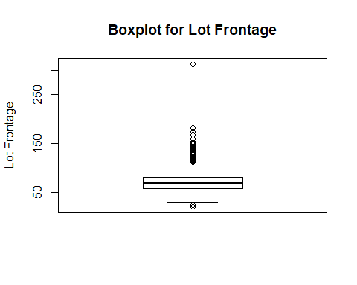

boxplot(housing$LotArea, ylab = "Lot Area", main = "Boxplot for Lot Area")

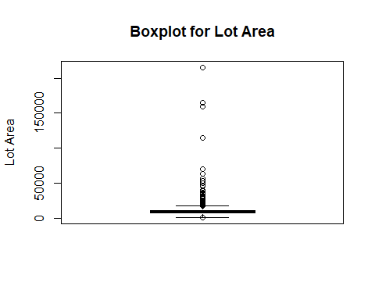

boxplot(housing$OverallQual, ylab = "Quality", main = "Over all Quality")

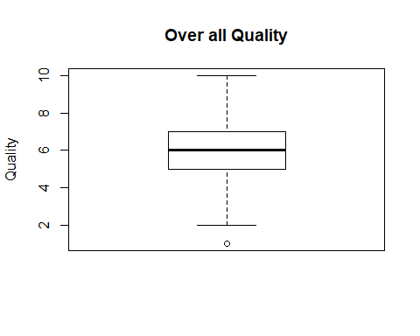

boxplot(housing$OverallCond, ylab = "Quality", main = "Over all Condition")

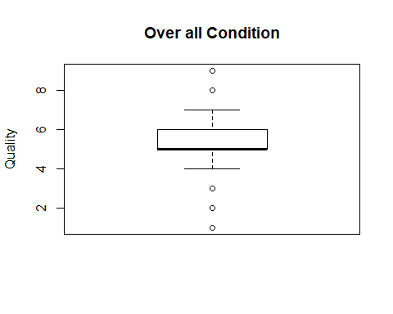

boxplot(housing$MasVnrArea, ylab = "Masonry Area", main = "Masonry venner area")

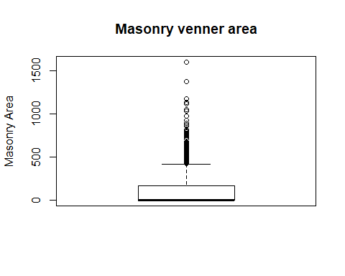

boxplot(housing$BsmtFinSF1, ylab = "Basement Type1 Area", main = "Basement Type 1 Area")

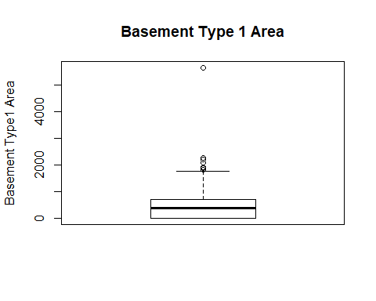

boxplot(housing$BsmtFinSF2, ylab = "Basement Type2 Area", main = "Basement Type 2 Area")

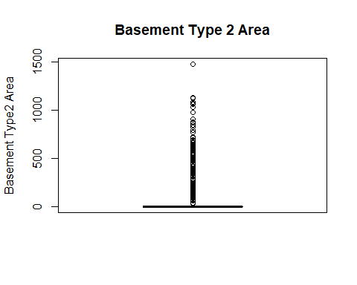

boxplot(housing$BsmtUnfSF, ylab = "Basement unfinished Area", main = "Basement Unfinished Area")

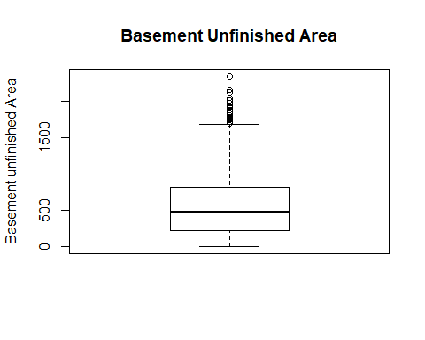

boxplot(housing$TotalBsmtSF, ylab = "Basement Area", main = "Total Basement Area")

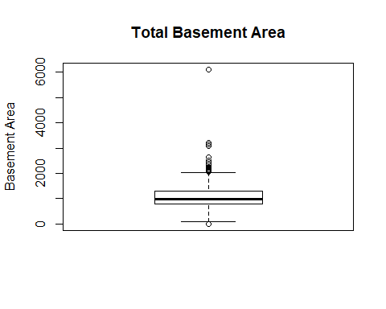

boxplot(housing$X1stFlrSF, ylab = "1st floor sq ft", main = "!st floor Area")

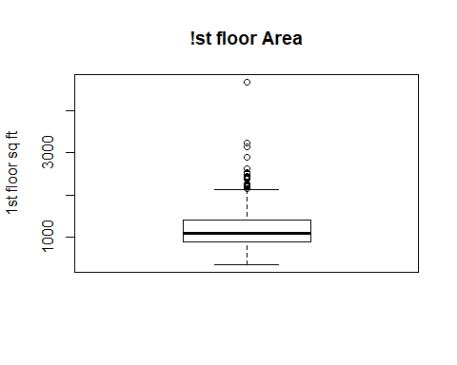

boxplot(housing$X2ndFlrSF, ylab = "2nd floor sq ft", main = "2nd floor Area")

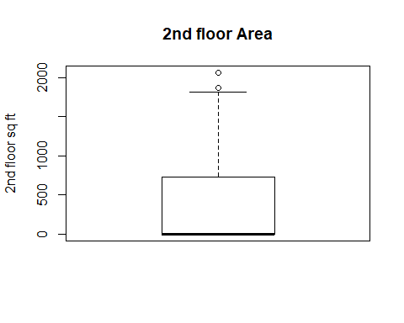

boxplot(housing$LowQualFinSF, ylab = "Low quality finish sq ft", main = "Low quality finish sq ft")

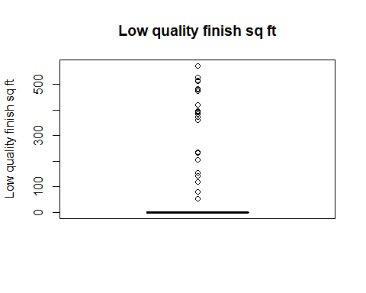

boxplot(housing$GrLivArea)

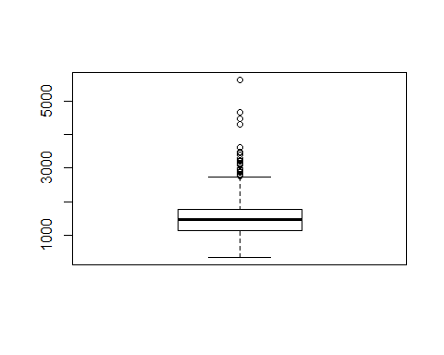

boxplot(housing$BsmtFullBath)

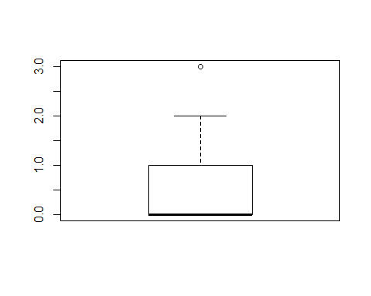

boxplot(housing$BsmtHalfBath)

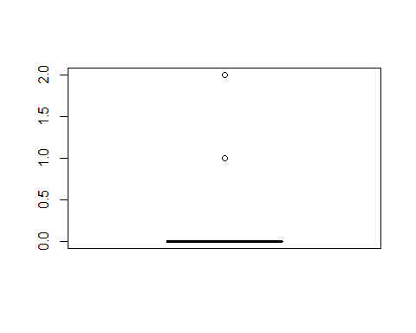

boxplot(housing$FullBath)

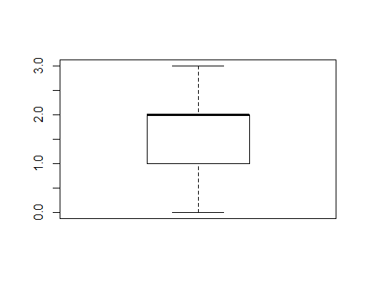

boxplot(housing$HalfBath)

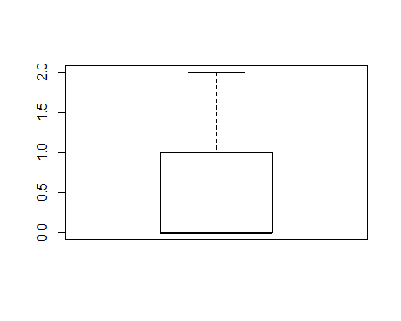

boxplot(housing$BedroomAbvGr)

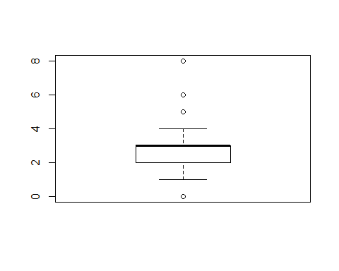

boxplot(housing$KitchenAbvGr)

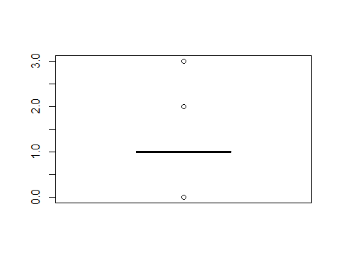

boxplot(housing$TotRmsAbvGrd)

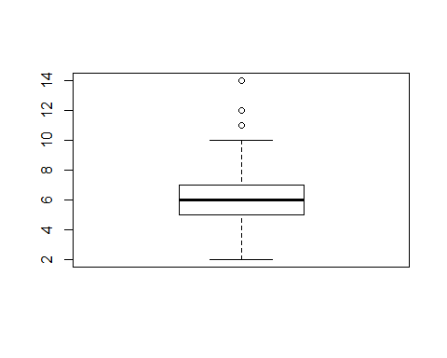

boxplot(housing$Fireplaces)

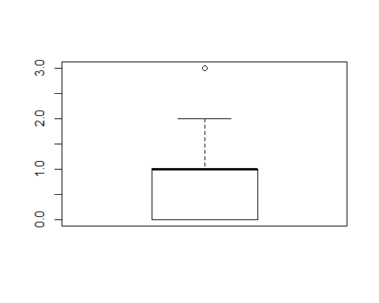

boxplot(housing$GarageCars)

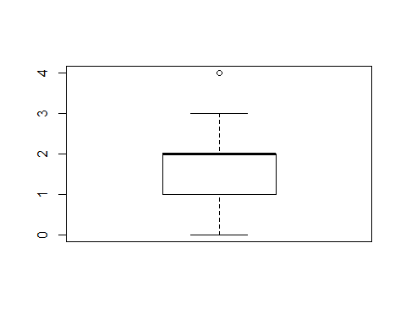

boxplot(housing$GarageArea)

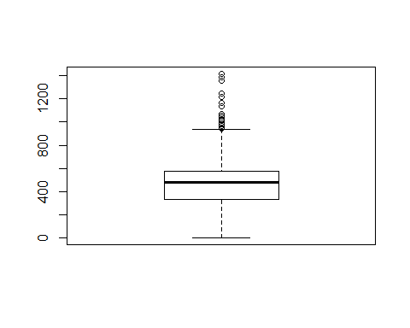

boxplot(housing$WoodDeckSF)

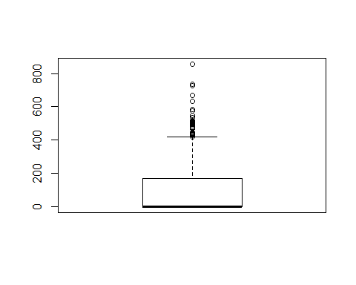

boxplot(housing$OpenPorchSF)

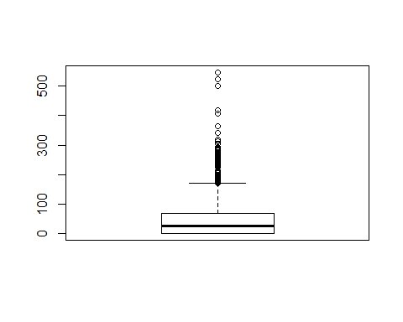

boxplot(housing$EnclosedPorch)

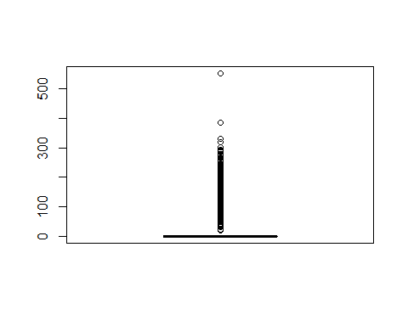

boxplot(housing$X3SsnPorch)

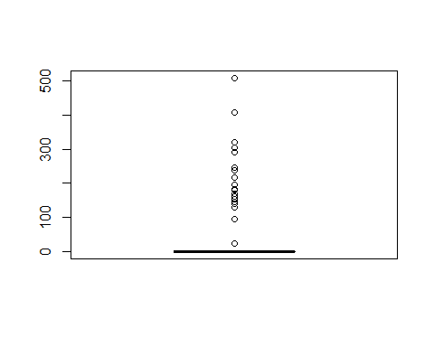

boxplot(housing$ScreenPorch)

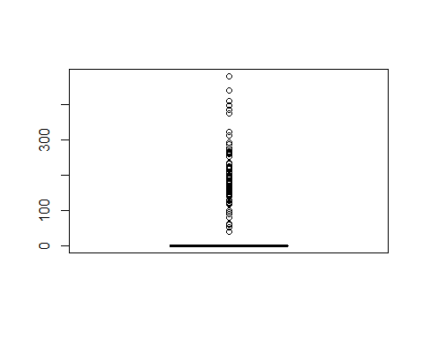

boxplot(housing$PoolArea)

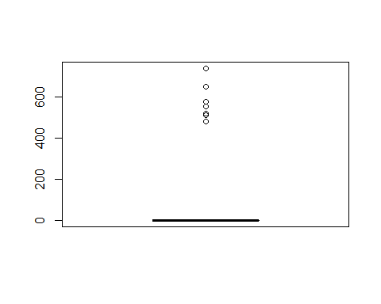

boxplot(housing$MiscVal)

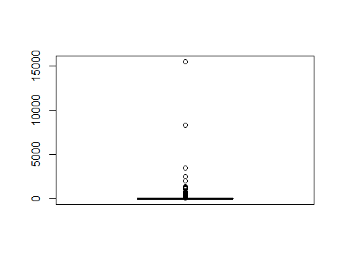

boxplot(housing$SalePrice)

