Housing Predictions - EDA [Day3]

Divya Reddy

9/26/2019

Load packages

library(dplyr)

##   
## Attaching package: 'dplyr'

## The following objects are masked from 'package:stats':  
##   
## filter, lag

## The following objects are masked from 'package:base':  
##   
## intersect, setdiff, setequal, union

library(ggplot2)  
library(data.table)

##   
## Attaching package: 'data.table'

## The following objects are masked from 'package:dplyr':  
##   
## between, first, last

Set present working directory and load the data

setwd("C:/Users/dreddy/Desktop/HousingData")  
housing <- read.csv("./train.csv")

Convert data frame to data table

housing <- setDT(housing)

Looking at the datatypes of the variables

str(housing)

## Classes 'data.table' and 'data.frame': 1460 obs. of 81 variables:  
## $ Id : int 1 2 3 4 5 6 7 8 9 10 ...  
## $ MSSubClass : int 60 20 60 70 60 50 20 60 50 190 ...  
## $ MSZoning : Factor w/ 5 levels "C (all)","FV",..: 4 4 4 4 4 4 4 4 5 4 ...  
## $ LotFrontage : int 65 80 68 60 84 85 75 NA 51 50 ...  
## $ LotArea : int 8450 9600 11250 9550 14260 14115 10084 10382 6120 7420 ...  
## $ Street : Factor w/ 2 levels "Grvl","Pave": 2 2 2 2 2 2 2 2 2 2 ...  
## $ Alley : Factor w/ 2 levels "Grvl","Pave": NA NA NA NA NA NA NA NA NA NA ...  
## $ LotShape : Factor w/ 4 levels "IR1","IR2","IR3",..: 4 4 1 1 1 1 4 1 4 4 ...  
## $ LandContour : Factor w/ 4 levels "Bnk","HLS","Low",..: 4 4 4 4 4 4 4 4 4 4 ...  
## $ Utilities : Factor w/ 2 levels "AllPub","NoSeWa": 1 1 1 1 1 1 1 1 1 1 ...  
## $ LotConfig : Factor w/ 5 levels "Corner","CulDSac",..: 5 3 5 1 3 5 5 1 5 1 ...  
## $ LandSlope : Factor w/ 3 levels "Gtl","Mod","Sev": 1 1 1 1 1 1 1 1 1 1 ...  
## $ Neighborhood : Factor w/ 25 levels "Blmngtn","Blueste",..: 6 25 6 7 14 12 21 17 18 4 ...  
## $ Condition1 : Factor w/ 9 levels "Artery","Feedr",..: 3 2 3 3 3 3 3 5 1 1 ...  
## $ Condition2 : Factor w/ 8 levels "Artery","Feedr",..: 3 3 3 3 3 3 3 3 3 1 ...  
## $ BldgType : Factor w/ 5 levels "1Fam","2fmCon",..: 1 1 1 1 1 1 1 1 1 2 ...  
## $ HouseStyle : Factor w/ 8 levels "1.5Fin","1.5Unf",..: 6 3 6 6 6 1 3 6 1 2 ...  
## $ OverallQual : int 7 6 7 7 8 5 8 7 7 5 ...  
## $ OverallCond : int 5 8 5 5 5 5 5 6 5 6 ...  
## $ YearBuilt : int 2003 1976 2001 1915 2000 1993 2004 1973 1931 1939 ...  
## $ YearRemodAdd : int 2003 1976 2002 1970 2000 1995 2005 1973 1950 1950 ...  
## $ RoofStyle : Factor w/ 6 levels "Flat","Gable",..: 2 2 2 2 2 2 2 2 2 2 ...  
## $ RoofMatl : Factor w/ 8 levels "ClyTile","CompShg",..: 2 2 2 2 2 2 2 2 2 2 ...  
## $ Exterior1st : Factor w/ 15 levels "AsbShng","AsphShn",..: 13 9 13 14 13 13 13 7 4 9 ...  
## $ Exterior2nd : Factor w/ 16 levels "AsbShng","AsphShn",..: 14 9 14 16 14 14 14 7 16 9 ...  
## $ MasVnrType : Factor w/ 4 levels "BrkCmn","BrkFace",..: 2 3 2 3 2 3 4 4 3 3 ...  
## $ MasVnrArea : int 196 0 162 0 350 0 186 240 0 0 ...  
## $ ExterQual : Factor w/ 4 levels "Ex","Fa","Gd",..: 3 4 3 4 3 4 3 4 4 4 ...  
## $ ExterCond : Factor w/ 5 levels "Ex","Fa","Gd",..: 5 5 5 5 5 5 5 5 5 5 ...  
## $ Foundation : Factor w/ 6 levels "BrkTil","CBlock",..: 3 2 3 1 3 6 3 2 1 1 ...  
## $ BsmtQual : Factor w/ 4 levels "Ex","Fa","Gd",..: 3 3 3 4 3 3 1 3 4 4 ...  
## $ BsmtCond : Factor w/ 4 levels "Fa","Gd","Po",..: 4 4 4 2 4 4 4 4 4 4 ...  
## $ BsmtExposure : Factor w/ 4 levels "Av","Gd","Mn",..: 4 2 3 4 1 4 1 3 4 4 ...  
## $ BsmtFinType1 : Factor w/ 6 levels "ALQ","BLQ","GLQ",..: 3 1 3 1 3 3 3 1 6 3 ...  
## $ BsmtFinSF1 : int 706 978 486 216 655 732 1369 859 0 851 ...  
## $ BsmtFinType2 : Factor w/ 6 levels "ALQ","BLQ","GLQ",..: 6 6 6 6 6 6 6 2 6 6 ...  
## $ BsmtFinSF2 : int 0 0 0 0 0 0 0 32 0 0 ...  
## $ BsmtUnfSF : int 150 284 434 540 490 64 317 216 952 140 ...  
## $ TotalBsmtSF : int 856 1262 920 756 1145 796 1686 1107 952 991 ...  
## $ Heating : Factor w/ 6 levels "Floor","GasA",..: 2 2 2 2 2 2 2 2 2 2 ...  
## $ HeatingQC : Factor w/ 5 levels "Ex","Fa","Gd",..: 1 1 1 3 1 1 1 1 3 1 ...  
## $ CentralAir : Factor w/ 2 levels "N","Y": 2 2 2 2 2 2 2 2 2 2 ...  
## $ Electrical : Factor w/ 5 levels "FuseA","FuseF",..: 5 5 5 5 5 5 5 5 2 5 ...  
## $ X1stFlrSF : int 856 1262 920 961 1145 796 1694 1107 1022 1077 ...  
## $ X2ndFlrSF : int 854 0 866 756 1053 566 0 983 752 0 ...  
## $ LowQualFinSF : int 0 0 0 0 0 0 0 0 0 0 ...  
## $ GrLivArea : int 1710 1262 1786 1717 2198 1362 1694 2090 1774 1077 ...  
## $ BsmtFullBath : int 1 0 1 1 1 1 1 1 0 1 ...  
## $ BsmtHalfBath : int 0 1 0 0 0 0 0 0 0 0 ...  
## $ FullBath : int 2 2 2 1 2 1 2 2 2 1 ...  
## $ HalfBath : int 1 0 1 0 1 1 0 1 0 0 ...  
## $ BedroomAbvGr : int 3 3 3 3 4 1 3 3 2 2 ...  
## $ KitchenAbvGr : int 1 1 1 1 1 1 1 1 2 2 ...  
## $ KitchenQual : Factor w/ 4 levels "Ex","Fa","Gd",..: 3 4 3 3 3 4 3 4 4 4 ...  
## $ TotRmsAbvGrd : int 8 6 6 7 9 5 7 7 8 5 ...  
## $ Functional : Factor w/ 7 levels "Maj1","Maj2",..: 7 7 7 7 7 7 7 7 3 7 ...  
## $ Fireplaces : int 0 1 1 1 1 0 1 2 2 2 ...  
## $ FireplaceQu : Factor w/ 5 levels "Ex","Fa","Gd",..: NA 5 5 3 5 NA 3 5 5 5 ...  
## $ GarageType : Factor w/ 6 levels "2Types","Attchd",..: 2 2 2 6 2 2 2 2 6 2 ...  
## $ GarageYrBlt : int 2003 1976 2001 1998 2000 1993 2004 1973 1931 1939 ...  
## $ GarageFinish : Factor w/ 3 levels "Fin","RFn","Unf": 2 2 2 3 2 3 2 2 3 2 ...  
## $ GarageCars : int 2 2 2 3 3 2 2 2 2 1 ...  
## $ GarageArea : int 548 460 608 642 836 480 636 484 468 205 ...  
## $ GarageQual : Factor w/ 5 levels "Ex","Fa","Gd",..: 5 5 5 5 5 5 5 5 2 3 ...  
## $ GarageCond : Factor w/ 5 levels "Ex","Fa","Gd",..: 5 5 5 5 5 5 5 5 5 5 ...  
## $ PavedDrive : Factor w/ 3 levels "N","P","Y": 3 3 3 3 3 3 3 3 3 3 ...  
## $ WoodDeckSF : int 0 298 0 0 192 40 255 235 90 0 ...  
## $ OpenPorchSF : int 61 0 42 35 84 30 57 204 0 4 ...  
## $ EnclosedPorch: int 0 0 0 272 0 0 0 228 205 0 ...  
## $ X3SsnPorch : int 0 0 0 0 0 320 0 0 0 0 ...  
## $ ScreenPorch : int 0 0 0 0 0 0 0 0 0 0 ...  
## $ PoolArea : int 0 0 0 0 0 0 0 0 0 0 ...  
## $ PoolQC : Factor w/ 3 levels "Ex","Fa","Gd": NA NA NA NA NA NA NA NA NA NA ...  
## $ Fence : Factor w/ 4 levels "GdPrv","GdWo",..: NA NA NA NA NA 3 NA NA NA NA ...  
## $ MiscFeature : Factor w/ 4 levels "Gar2","Othr",..: NA NA NA NA NA 3 NA 3 NA NA ...  
## $ MiscVal : int 0 0 0 0 0 700 0 350 0 0 ...  
## $ MoSold : int 2 5 9 2 12 10 8 11 4 1 ...  
## $ YrSold : int 2008 2007 2008 2006 2008 2009 2007 2009 2008 2008 ...  
## $ SaleType : Factor w/ 9 levels "COD","Con","ConLD",..: 9 9 9 9 9 9 9 9 9 9 ...  
## $ SaleCondition: Factor w/ 6 levels "Abnorml","AdjLand",..: 5 5 5 1 5 5 5 5 1 5 ...  
## $ SalePrice : int 208500 181500 223500 140000 250000 143000 307000 200000 129900 118000 ...  
## - attr(*, ".internal.selfref")=<externalptr>

After looking at the datatypes and going through the data_description.txt, we need to convert the following columns to character datatype

housing$MSSubClass <- as.character(housing$MSSubClass)  
housing$YearBuilt <- as.character(housing$YearBuilt)  
housing$YearRemodAdd <- as.character(housing$YearRemodAdd)  
housing$MoSold <- as.character(housing$MoSold)  
housing$YrSold <- as.character(housing$YrSold)  
housing$GarageYrBlt <- as.character(housing$GarageYrBlt)  
#str(housing)

Outliers can be identified by using boxplots, boxplots(IQR) or using Z scores. The boxplot(IQR) method using the 1.5xIQR- Q1 (lower limit) and Q3+ 1.5xIQR (upper limit) to eliminate outliers The z-score value is the measure of how far the data point is from the mean = 0 and SD = 1, i.e., a normal deviation. We consider the z scores between -3 to 3 to eliminate outliers. You can also remove all outliers less than the 5th percentile and greater than the 95th percentile

Plotting graphs for outlier analysis

varlist <- colnames(dplyr::select_if(housing, is.numeric))  
  
plot <- function (varlist) {  
 # require(ggplot2)  
 ggplot(data = housing, mapping = aes_string(y=varlist))+  
 geom_boxplot() + scale_x_discrete(limits=c("0.5", "1"))  
}

lapply(varlist, FUN = plot)

## [[1]]

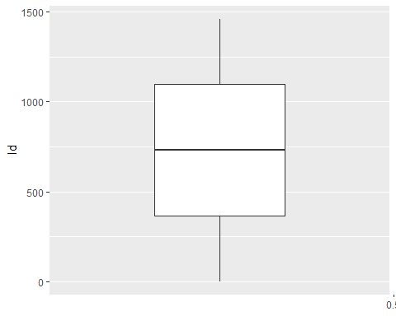

##   
## [[2]]

## Warning: Removed 259 rows containing non-finite values (stat_boxplot).

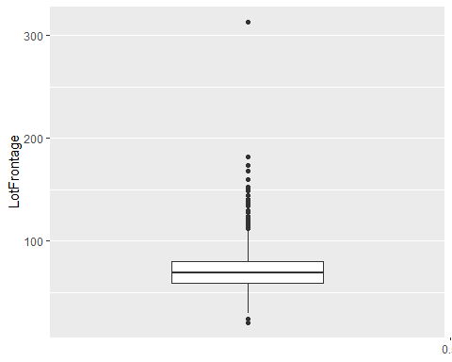

##   
## [[3]]

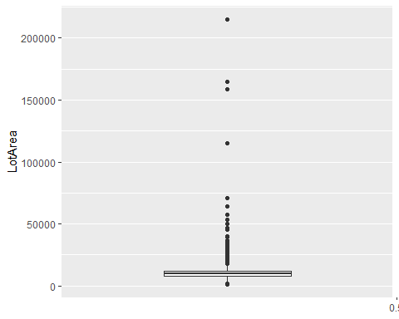

##   
## [[4]]

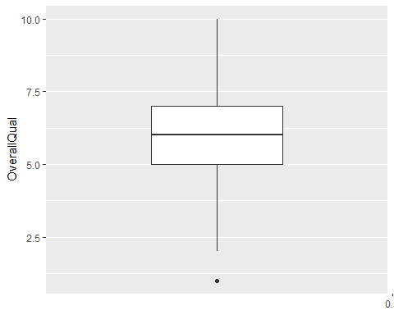

##   
## [[5]]

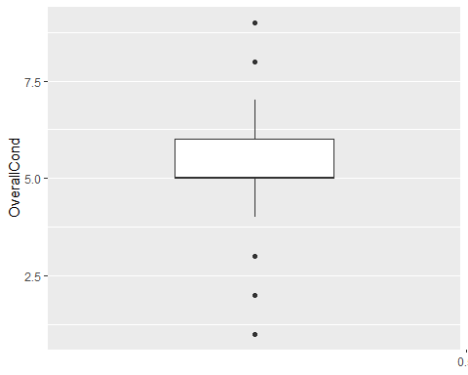

##   
## [[6]]

## Warning: Removed 8 rows containing non-finite values (stat_boxplot).

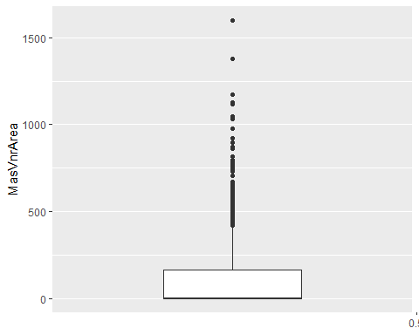

##   
## [[7]]

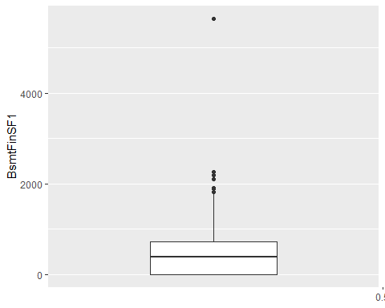

##   
## [[8]]

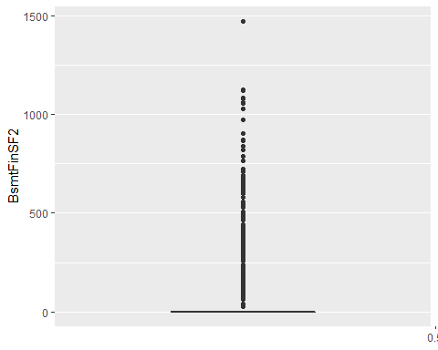

##   
## [[9]]

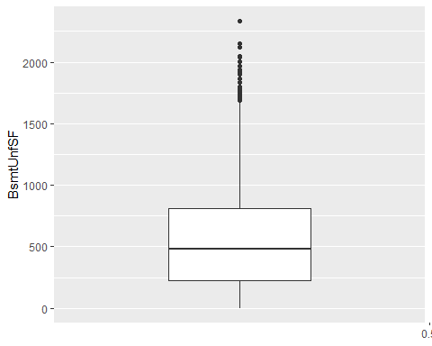

##   
## [[10]]

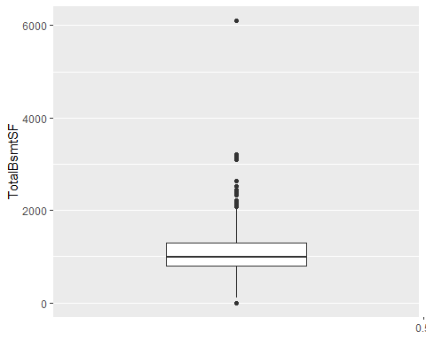

##   
## [[11]]

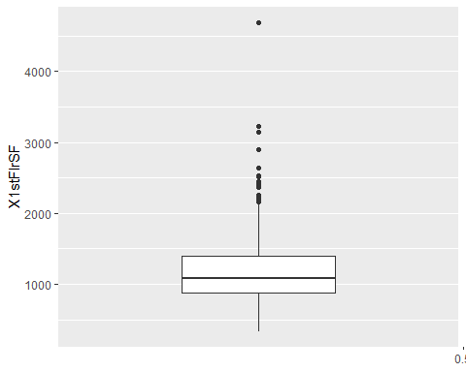

##   
## [[12]]

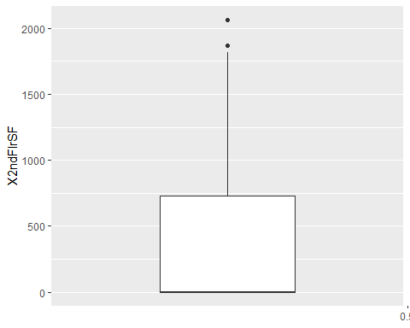

##   
## [[13]]

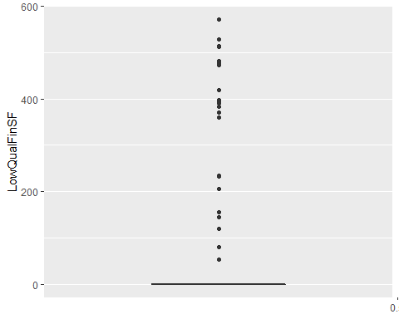

##   
## [[14]]

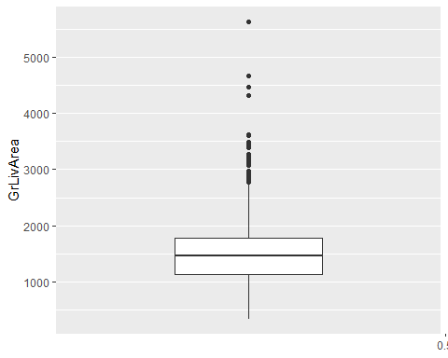

##   
## [[15]]

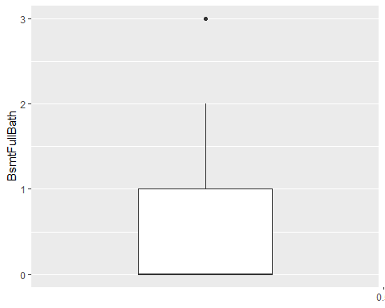

##   
## [[16]]

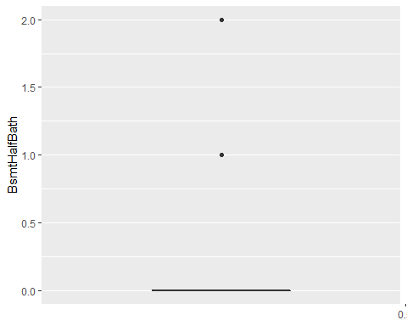

##   
## [[17]]

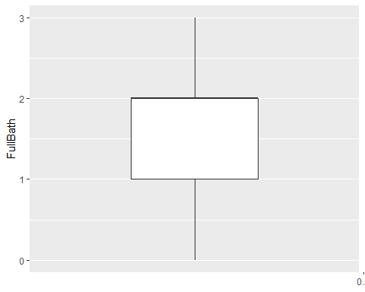

##   
## [[18]]

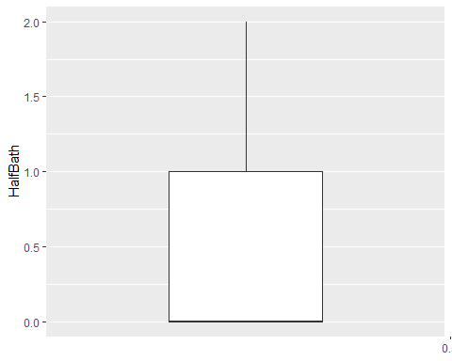

##   
## [[19]]

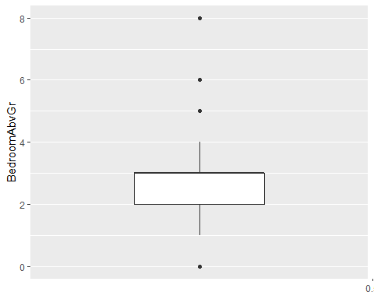

##   
## [[20]]

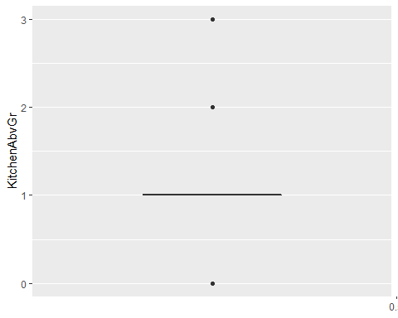

##   
## [[21]]

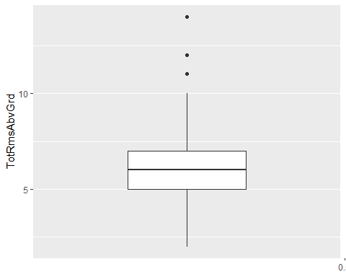

##   
## [[22]]

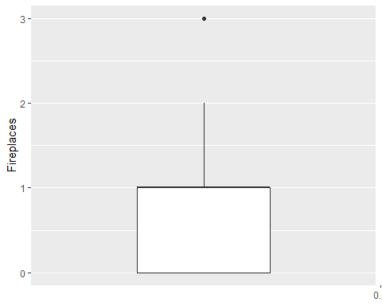

##   
## [[23]]

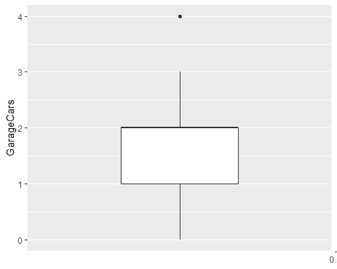

##   
## [[24]]

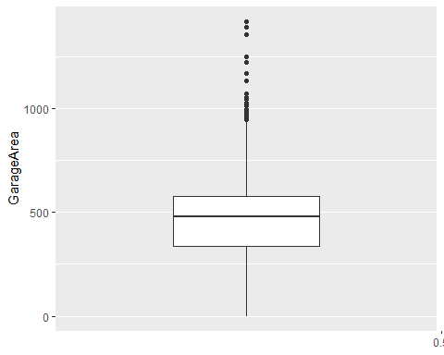

##   
## [[25]]

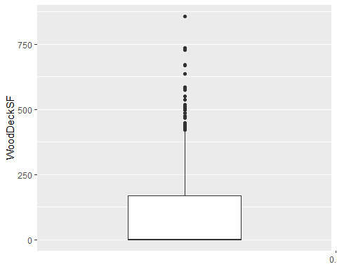

##   
## [[26]]

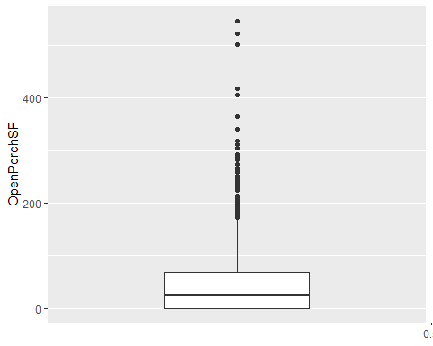

##   
## [[27]]

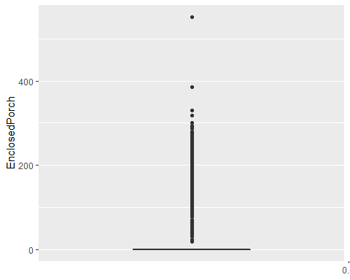

##   
## [[28]]

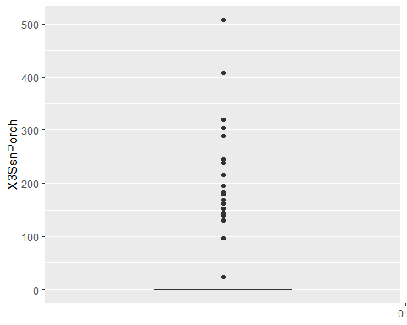

##   
## [[29]]

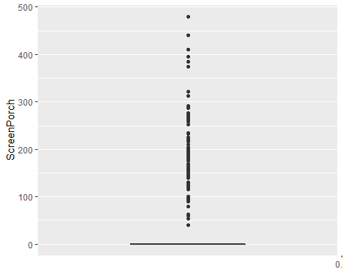

##   
## [[30]]

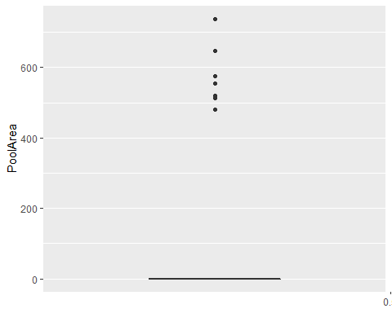

##   
## [[31]]

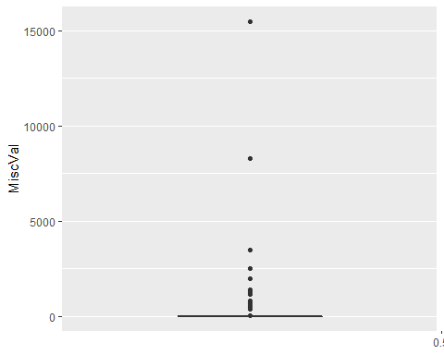

##   
## [[32]]

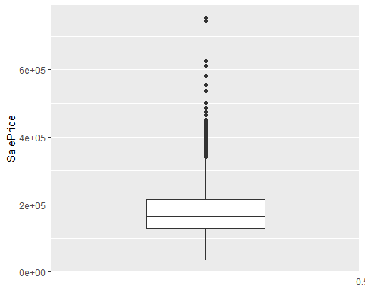

Display the outliers using boxplot.stats and by using the 5th and 95th percentile

boxplot.stats(housing$Fireplaces)$out

## [1] 3 3 3 3 3

select(housing,Fireplaces) %>% filter(Fireplaces > quantile(housing$Fireplaces, 0.05),Fireplaces > quantile(housing$Fireplaces, 0.95))

## Fireplaces  
## 1 3  
## 2 3  
## 3 3  
## 4 3  
## 5 3