Request for Information Response
Airbus A220 FOD Detection Program
Avathon Vision Model Capabilities Overview

Submission Date: 2026 May
Requested By: Jose Andres Gonzalez Valdes, Airbus Central Innovation
Submitted By: Avathon

1. Background: A Long-term Partner for Airbus
Avathon is a full-spectrum AI company operating across capital-intensive sectors, with demonstrated operational depth and commercial focus in Aerospace and Defense. In 2021, Airbus Commercial announced Airbus Cognitive Platform (“AIRKOG”), powered by Avathon, which was renewed in 2025 for an additional three-year agreement to 2029. AIRKOG encodes the subject matter expertise of people, orchestrates systems, and uses terabytes of data from multiple sources for the development and deployment of intelligent applications to answer critical technical questions on A320, A330 and A350 aircraft models. Complementing our mutli-year relationship with Airbus we have deployed production-grade vision AI and machine learning systems that solve real-time operational safety challenges in complex manufacturing, energy, and aerospace environments.

1.1 Expertise Grounded in Aviation and Defense Rigor for FOD Detection
Avathon credentials are built upon solving the most demanding high-regulated safety, quality assurance, and sustainment challenges in the world:
- Deep Domain Experience (Visual AI Inspection): Our experience is not generic. Avathon has successfully designed, trained, and deployed vision AI models for behavior analysis of zone or path deviations, Foreign Object Debris (FOD) detection, surface anomaly inspection, and precision object classification. Vision capabilities include end-to-end deployment of VAIA (Visual AI Advisor), Mobile Augmented Visual Inspection (MAVI) for assembly all validated against object detection thresholds on floors and ramp environments.
- Proven in Aerospace & Highly Regulated Environments (Maintenance, Safety, & Quality): Our wholly owned subsidiary, Avathon Government, has deployed and tested all their solutions at the edge. Proven across the three branches of the U.S. military, Avathon has designed quality workflows to detect non-routines and reduce routing of non-conformances to engineering to increase maintenance turnaround time. Semantic search and knowledge libraries of maintenance and quality, guarantee that Avathon is engineered to meet the highest standards of data integrity, security, and operational compliance - qualities essential for safety-critical FOD programs. Our visual solutions have been deployed across some select names such as Haliburton - a major oilfield service provider, Patterson - the 2nd largest onshore drilling and completions services provider, Exxon - a oil and gas super major, ENI S.p.A. - a major Italian multinational energy company, Network Rail - a public sector body and infrastructure manager for the majority of the railway network in England, Scotland, and Wales.
- Commercialization Speed: Avathon has gone through a decisive shift in AI research and development, leveraging 150+ patents to commercial product deployment. MAVI has been used for technicians to identify accurate angles and trajectory of bolts. VAIA has been used across highly regulated industries. Both are market-ready solutions, engineered for long-term support, and designed to meet the operational imperatives of assembly line and aerospace customers including strict uptime, portability, and data sovereignty requirements.

1.2 Technological Future Proofing: The VAIA Platform
The core difference between Avathon and traditional imaging vendors is our trained use cases across the full spectrum of operations.
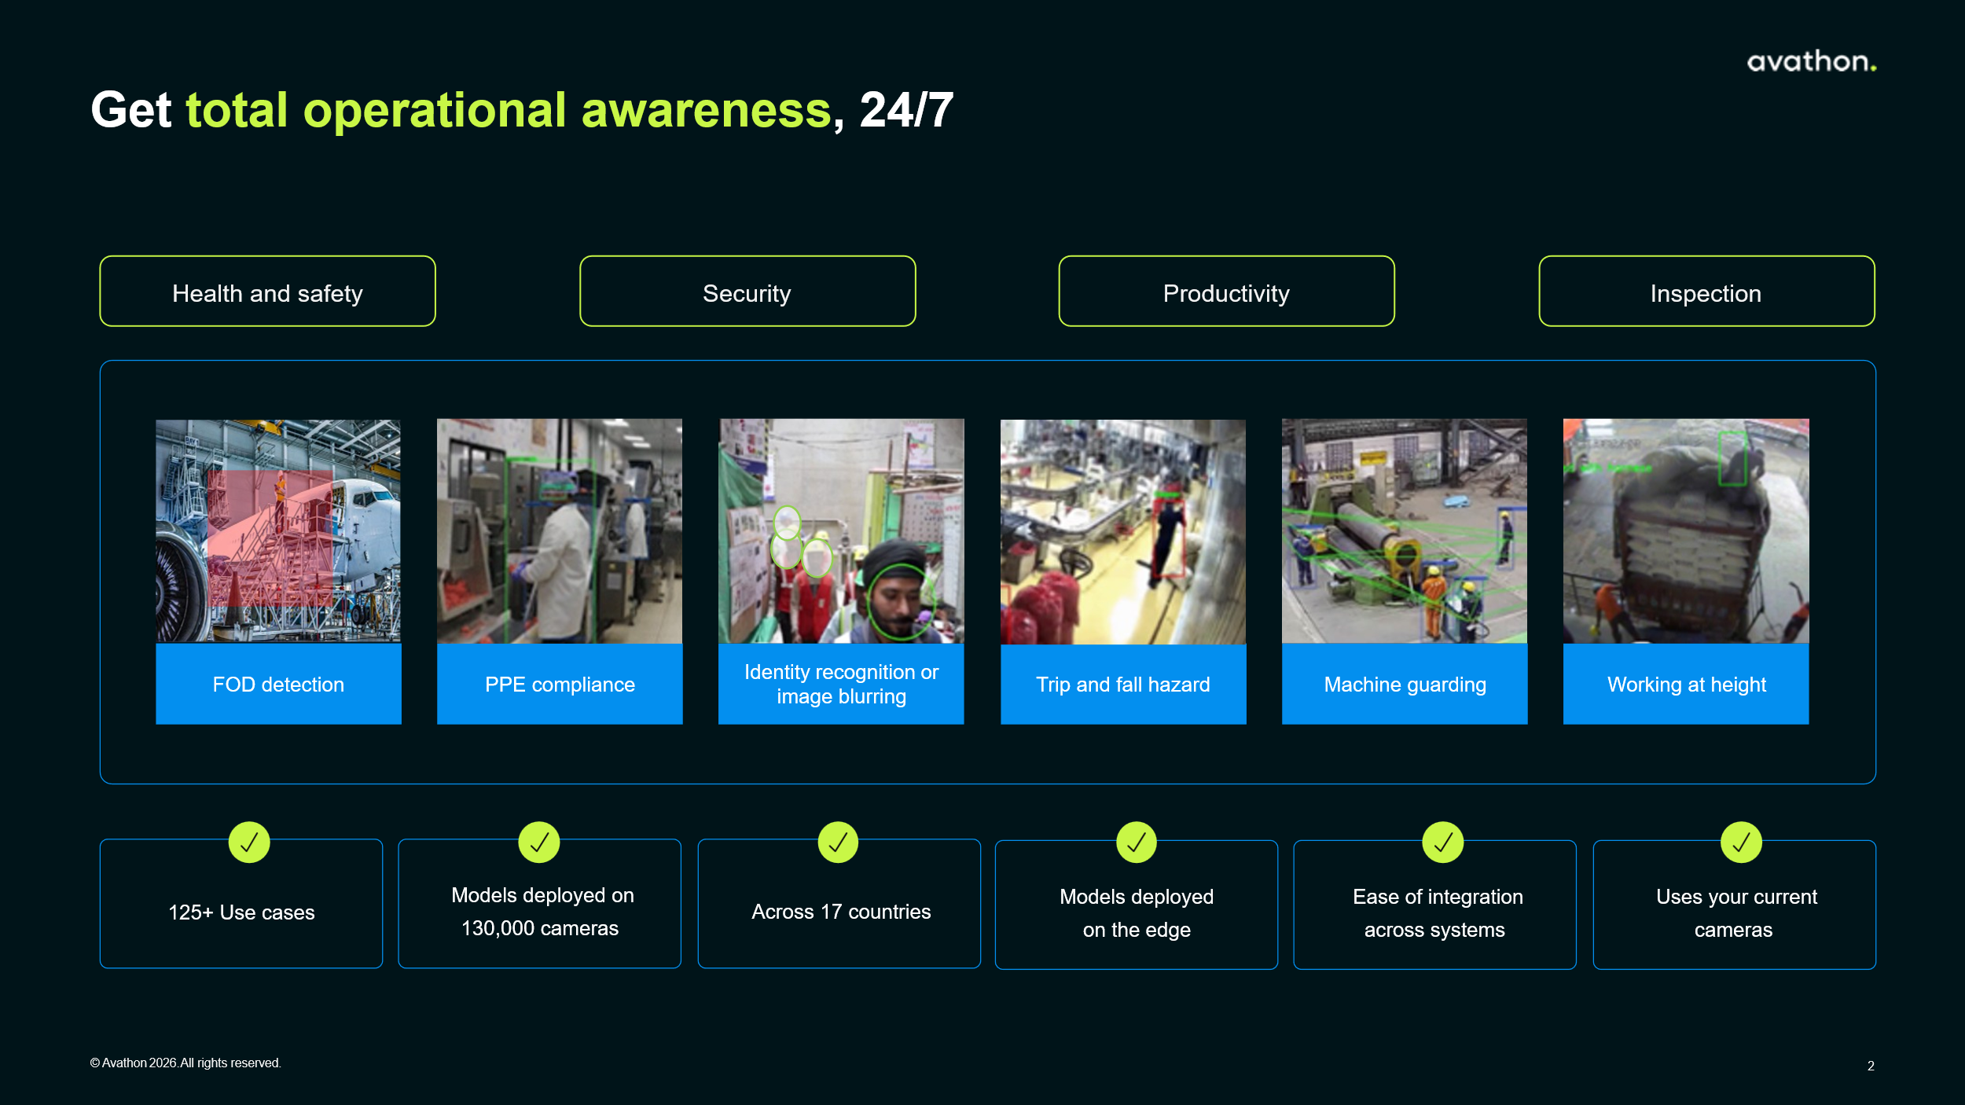

At the center of VAIA is a multi-modal deep learning inference engine, optimized for real-time edge deployment without cloud or internet dependency. The architecture is designed for:
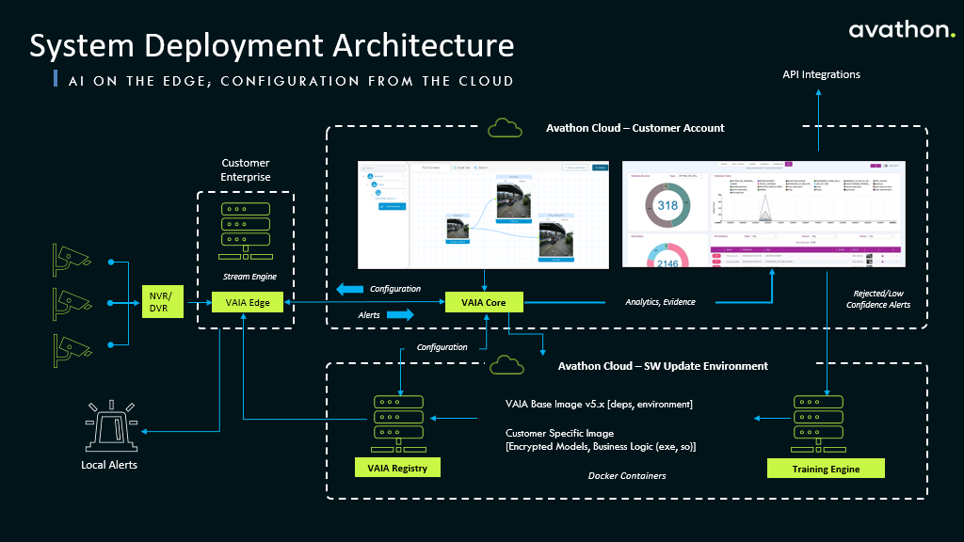

2. Capability Briefing
Request | Capability Setup
Quick FOD identification and location | - Capability: Automated zone-tagging of detections, cross-referenced against Airbus structural zone maps pre-loaded; Audiovisual alert can trigger upon detection, enabling Airbus to act immediately.  - Deployment: Leverage current camera, install new, or mobile and historical videos for classification of detected objects by type category (metallic debris, composite fragments, tooling) with confidence scoring.
Portable/handheld detection and capability | - Capability: Support for integrated camera arrays and on-device inference processors.  - Deployment: Mobile detection available for inspector and bay sweeps; without dependence on stationary sensors or network uplinks.
Precision objects of 1 cm size | - Capability: Detection across diverse surface textures including bare aluminum, CFRP panels, painted sections, and high-clutter tool layouts.  - Deployment: Site-specific model fine-tuning along with continuous model retraining support against true and false-positive patterns for new debris classes.
Immediate geo-localized reporting of detected FODs | - Capability: Geo-localized detection logs embed GPS coordinates, zone identifiers, and timestamp data into each detection event record – all able to be processed and stored on-device.  - Deployment: Heat map visualization of recurring risk zones enables Airbus safety teams to identify systemic processes or tooling contributors to debris, moving from reactive to proactive risk reduction.
Compatible with a fully disconnected work environment (no internet/cloud connectivity during operations) | - Capability: AI inference can run on-device using optimized edge model weights and still process and record locally, based on requirements.  - Deployment: Data can be stored and encrypted locally; then transmitted to external servers, cloud platforms, or sync’d to facility systems when the device is connected to an approved local network.
General Data Protection Regulation (GDPR) compliance | - Capability: Able to do PII obfuscation with imagery to be processed exclusively for object detection; local data sovereignty on data and inspection imagery; configurable retention policies.  - Deployment: Avathon maintains a GDPR-compliant data processing agreement (DPA) framework available for execution as part of any commercial engagement, ensuring full regulatory alignment for EU-based deployments.
Non-intrusive monitoring | - Capability: Co-op existing camera network and historical video feeds; minimal training burden; Silent operation mode suppresses audible alerts in production zones while maintaining full visual notification and logging functionality; EMI-safe operation for sensitive equipment.  - Deployment: Integrates into existing aerospace assembly and MRO workflows without requiring modifications to physical infrastructure, production line sequencing, or personnel procedures: handheld with no fixed install for reduced capital costs (if necessary)

60k per site, 8 sites min, 480 total / 30k per site once hit 20
60k with 3 mo pilot / after and keep on it is 20k per month, until they hit the tiered pricing (no more than 10 cameras, and 5 preconfigured use case) 9-30 rigs per year went to 30k. services for additional rollout past the initial agreement. / 1800 for blended rate on time and materials per day
Everything is based on subscription
Services is based on actual time and materials per day

