Submission Date: 2026 May 22
Requested By: BSH Hausgeräte GmbH
Submitted By: Avathon

Avathon: A Strategic Partner for BSH 2
Technical Approach: Three Layers 2
CKG Foundation: Agentic Build Engine for the Graph Overlay 3
Query Retrieval & Agent Design: Operating On the Graph 3
Conclusion: Expected Outcomes and Team Evolution 4

Avathon: A Strategic Partner for BSH
Avathon is a full-spectrum AI company operating across capital-intensive sectors, with demonstrated operational depth, over 150+ patents, and a commercial focus in Supply Chain. Avathon specializes in transforming complex, fragmented data into actionable intelligence by overlaying atop current systems. Avathon call this the computational knowledge graph (CKG).

BSH is midway through a SAP S/4HANA rollout running through to 2032. Two processes demand attention now and where Avathon can help, not in eight years:

- transport management with impacts of business drag of high freight costs, manual carrier selection, and reactive re-routing
- production planning clear-to-build (C2B), where multi-tier BOM availability checks remain manual, slow, and dependent on SAP APO screens. The Avathon CKG overlay addresses both without touching the rollout.

Technical Approach: Three Layers
The platform sits above SAP. No module is replaced or reconfigured. SAP remains the system of record; the CKG is the system of intelligence.

Layer | Components | Role
SAP Backbone | S/4HANA, IBP, APO, TM, GTS | System of record is unchanged. Data extracted via OData, BAPI/RFC, and CDC connectors
CKG Foundation | Agentic Build Engine, Embedding Store & Vector Index for Knowledge Queries, Reinforcement Reasoning | Ingests and semantically enriches all SAP data into living knowledge
Agent & Interface Layer | API endpoints, SAP writeback (if needed) with Transport, C2B, Carrier, Audit Agents · in Conversational AI | Agents operate over the CKG; planners approve consequential actions via dashboard
Security | IAM, RBAC, | Access control, audit trail, data residency compliance

To support the SAP backbone with a living data fabric, also known as a knowledge graph, Avathon can leverage when available, - OData for modern SAP systems, BAPI/RFC as a pragmatic fallback for legacy APO, and Change Data Capture (CDC) as the event backbone that keeps the Avathon CKG live rather than stale. If BSH fully migrates APO to IBP during their 2032 rollout, the BAPI layer gets replaced by OData for that module, and the CKG ingestion architecture accommodates that without redesign. The Agentic Build Engine's Discovery Agents will then autonomously resolve SAP field codes to business semantics (MATNR → Material Number, LIFNR → Vendor ID) with no hardcoded rules.

CKG Foundation: Agentic Build Engine for the Graph Overlay
As part of the first step, we have the knowledge graph built as part of a three step approach that minimizes disruption to teams and enables deployment across global regions and IT teams.

Stage | Process | BSH Relevance
1 · Discovery | Agents autonomously profile each SAP system's schema — tables, fields, data types, foreign keys — producing a machine-readable schema manifest. | Runs at initial connection and whenever a new S/4HANA region goes live. No manual SAP ABAP expertise required.
2 · LLM Semantic Translation | Fine-tuned LLM resolves cryptic SAP field names to business semantics. MAKTX → material description, MEINS → base UoM, EKGRP → purchasing group. Handles BSH custom fields from the rollout. | No hardcoded translation rules. Adapts automatically to custom fields introduced region by region.
3 · Graph-Architect Agents | Translate entities into CKG node and edge types; apply BSH domain extension; populate the graph. Auto-detect and re-map on schema changes, zero pipeline disruption. | Compatible with S/4HANA rollout cadence. Each new region onboards in <24 hours, then tests and incorporates feedback, no integration project required.

Query Retrieval & Agent Design: Operating On the Graph
All graph traversals handle exact and structured prompts. Once the CKG has been built, nodes are enriched with dense vectors combining structural, attribute, textual, and graph-neighborhood features. Semantic and approximate queries become possible for transportation planning and production planning. Examples of embedding based retrievals by distance and query type made possible by the technical approach are:
Query Type | Example
Freight cost anomaly | A shipment on lane is quoted at €14,200. The CKG holds historical cost vectors for that lane (avg €11,400, σ €800). The distance is flagged to the normal is an outlier, where absolute magnitude matters here, a €2,800 overage is genuinely different from a €200 one.
Vendor risk profiling | Sanctions proximity, country risk score, OTD trend direction matter more than raw numbers eg a vendor moving toward higher risk is flagged even if their absolute score is still acceptable.
Price band queries | Production planning: find substitute components with MAP within 20% of €10k. A metadata pre-filter on the MAP attribute narrows the candidate set before ANN runs, so the similarity search only operates over materials already in the right price band.
All agents follow the OTRA framework (Observe · Trigger · Reason · Act). Every agent Avathon delivers can be delivered in incremental phases while collaborating with BSH on change management. A suite of autonomous agents are always available for BSH to further expand the opportunity area:
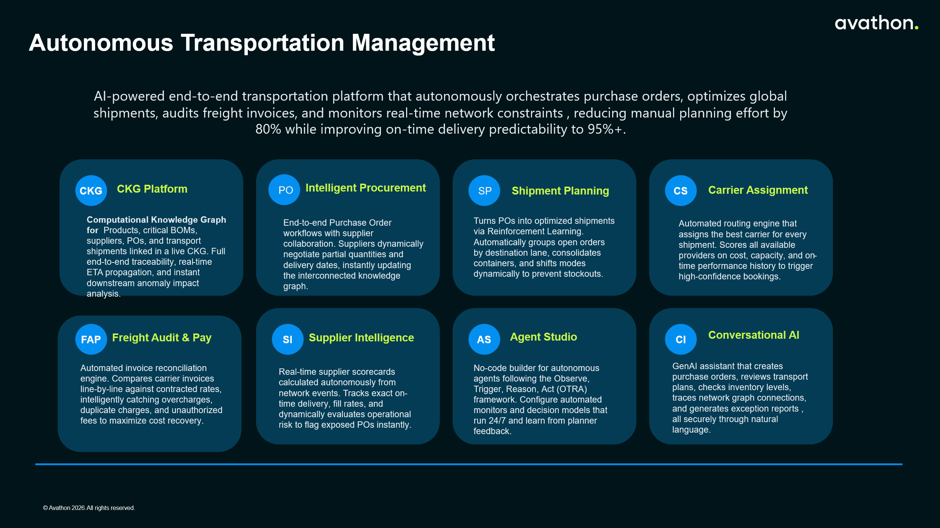

Conclusion: Expected Outcomes
The Avathon CKG overlay gives BSH AI-native supply chain intelligence today on transport management and production planning, without displacing the S/4HANA program. The graph can in phases ingest SAP data per agent domain, propagate those changes across the entire operation, with interactions on the graph (queries and agents) explainable, auditable, and traceable. S/4HANA rollout can then continue its timeline, unimpacted by this approach with Avathon as the middle layer for agents design by Avathon or BSH.
Outcomes for the business have been identified and will be further evaluated for the June workshop date:
Outcome Metrics | Current State to Evaluate
Manual transport planning effort | High with time spent and in the current systems
High freight cost | Current baseline and new target baseline
On-time delivery predictability | Define the BSH target on key lanes
Freight invoice anomaly detection | Manual, <X% catch rate or post-resolution time
Clear to Build exception resolution | Hours–days (manual APO + calls)
Manual production planning effort | X% of time spent and in the current systems

