Submission Date: 2025 December 15
Requested By: Derco
Submitted By: Avathon

1. Background: Avathon - A Strategic Partner for Derco 2
1.1 Expertise Grounded in Aviation and Defense Rigor 2
1.2 Technological Future Proofing 2
1.3 Delivery Team Leadership Driving Operational Rigor 3
1.4 Problem Definition 4
1.5 Strategic Approach and Phased Delivery Acceleration 5
2. Program Schedule for Delivery 7
2.2 Risk Assessment & Mitigation Strategies 7
3. Rough Order of Magnitude 9

Background: Avathon - A Strategic Partner for Derco
Avathon is a full-spectrum AI company operating across capital-intensive sectors, with demonstrated operational depth and commercial focus in Aerospace and Defense. We specialize in transforming complex, fragmented data into actionable intelligence.

1.1 Expertise Grounded in Aviation and Defense Rigor
Avathon credentials are built upon solving the most demanding aerospace planning, logistics, maintenance and sustainment challenges in the world:
- Deep Domain Experience (Aerospace): Our experience is not generic. We have successfully designed and deployed data management and inventory forecasting solutions for leading global aerospace OEMs. This includes focused expertise in optimization flows, parts analysis, and managing the cost dynamics limits. We understand the tradeoffs of between forecast planning and the inherent complexities around pricing decisions.
- Proven Military/Defense Traceability: Our wholly owned subsidiary, Avathon Government, is a testament to our commitment to operational rigor. We have successfully built and deployed products for three branches of the U.S. military. This background guarantees that our platforms are engineered to meet the highest standards of data integrity, security, and compliance (e.g., CMMC and ISO 27001 readiness) - qualities essential for handling sensitive proprietary data. The government team, led by General Manager Art Sellers, ensures that this disciplined approach permeates the commercial products.
- Commercialization Speed: In 2024 Avathon, made a sharp shift from past research and development projects to commercialization deployment. Our solutions are now market-ready, engineered for long-term support, and driven by the commercial imperatives for our clients.

Technological Future Proofing
The core difference between Avathon and traditional software vendors is Avathon’s proposed solution directly targets the cloud migration, structural, and scalability limitations of the legacy EFPAC environment while prepping maintenance and integrations for Derco’s enterprise infrastructure. Avathon’s has a core competence in ingesting and linking complex, heterogeneous data. We are designed to handle ATA 2200 and S1000D formats, including XML/SGML, JSON, PDF, CSV, TXT with additional data connectors for real-time data ingestion. Input data/documents supported are FIM, CMM, TOs, Contracts, SBs, and engineering directives.
At the center of our solution is the Computational Knowledge Graph (CKG) - a modern architectural backbone that replaces manual scenario building and rigid data structures with a fully data unified, semantically rich model of fleet, maintenance, and cost data.
The platform uses commercial off-the-shelf identity services and configurable, secure Role-Based Access Control (RBAC), all deployed on a high-performance Data Lakehouse that immediately scales up to Derco and customer requirements. Further this architecture supports true semantic modeling, where data engineers at forward-thinking airlines can define and extend data relationships through JavaScript and Python workflows. This technology differentiator is key workbench enabler for financial planners and maintenance.
To address key feature development and a final key differentiator, the platform is structurally capable to support AI workflows and Agentic Compute. Every forecast and recommendation can include full data lineage enabling users to verify data points and ensuring customers can trust the system’s outputs (a key weakness of current data normalization processes by the Derco team).

1.3 Delivery Team Leadership Driving Operational Rigor
Our product and engineering teams bring a wealth of operational experience directly to this engagement:
- Engineering Leadership: Our engineering development, led by Jason Gross, emphasizes stability, scalability (via AKS), and adherence to the rigid standards required for aviation safety systems. Having deployed multiple aerospace and defense solutions to the web or the edge.
- Product Strategy: Product leadership, driven by Peter Glowa across both commercial and defense sectors, ensures that every feature built from the planned forecasts to maintenance availability to the multi-scenario comparison is prioritized by its highest market value and operational necessity.
In summary, Avathon brings proven technology coupled with product-market feedback loops to mitigate delivery risks.

1.4 Problem Definition
Based on Avathon's comprehensive review and analysis of the existing Derco’s initial Statement of Work (SOW), we propose a revised Supplier Statement of Work (SSOW).
Derco’s current challenge is the classic "Autozone Problem", where large, speculative stock is underutilized due to fragmented data, inconsistent part identification, and a lack of optimized, automated decision-making across transactional and program business units.

This Statement of Work outlines a phased approach to deploy an AI-driven Inventory and Pricing Optimization Platform designed to solve your core data challenges and transform your inventory from a holding cost into a maximized profit center. Our solution will focus on data harmonization, predictive forecasting, dynamic pricing, and establishing a self-service AI assistant layer.

The foundation of the solution addresses Derco's four operational complexities:
- Data Fragmentation and Trust: Two key business units, Transactional and Program, suffer from disparate systems. The transactional business does not trust its own data, and the program business lacks optimization for automated ordering and forecasting. Critical inventory data remains isolated in flat files (e.g., Excel sheets) and program systems, disconnected from the central ERP.
- Part Number Normalization (The NSN/Part Number Discrepancy): The lack of a single data standard is a critical hurdle. The same physical part may be listed under multiple identifiers—such as the US military’s National Stock Number (NSN) (with its 4-digit part structure, 2-digit country of origin, and 7-digit unique item breakdown) and the supplier's simple part number. This complexity means a single part can be shelved three times under different numbers, making it difficult to communicate this commonality to foreign customers and hindering accurate aggregated inventory views. Further, there are challenges around Customer Segmentation and Pricing Complexity. Derco may serve three distinct customer segments at any time like the US government with DLA contract flowdowns (requiring NSNs), Foreign Military Sales (FMS), and Direct Sales. The current system fails to optimize pricing by customer type or aircraft platform block number.
- Reactive vs. Proactive Inventory: Dero is struggling with "uncertain inventory" and an inability to convert current stock into sales, divestures, or just poor hit-rate optimization on parts. There is a need to reframe the organizational question to an aggregated macro view, "If we had $10 million, what's the next part Derco would go buy?" This requires transforming stale parts (seen 2-4 years ago) into a divest/replace/upgrade decision set.
- Manual/Difficult Quoting and Order House Challenges: Quoting requires significant data engineering and normalization. The process is quick if the part is "in the house" (which could be turned into an auto-price to RFQ) but becomes complex and difficult to price if the part is not in stock or is under a different number. Lead-time retrieval from suppliers is also a key bottleneck.

Strategic Approach and Phased Delivery Acceleration
To accelerate Time-to-Market (TTM) and recognition of Derco’s unique data requirements, Avathon will work towards a solution for on-prem to ensure maximum security and integration control within the Lockheed Martin ecosystem. Avathon will test, implement and support Derco throughout the entire UAT to production phases. Avathon will leverage our own monitoring services to proactively manage tickets during this build phase. Future Customer support will need to be detailed in a SLA for the on-prem deployment. Severity Levels will be defined as Severity 1 (High): Faults that cause non-availability of the system, Severity 2 (Medium): Faults that cause severe impairment causing delay to the Customer, Severity 3 (Low): Faults that interfere with the system causing inconvenience, Severity 4 (Minor): Single user or small set of users affected. Below are the anticipated Deliverables based on the revised workshop guidance.
- Deliverable 1: Data Engineering and Normalization (Foundation Layer)
- Deliverable 2: AI/ML Models for Optimization Flows (CKG Layer)
- Deliverable 3: Front-end Usability and AI Assistant (Application Layer)
Implementation Approach and Value to Derco
# | Avathon Solution Description | Deliverable
1 | Data Ingestion: Build robust connectors for the ERP, ILS, Integrated Work Order Transfer from Lockheed, and daily Japan data (addressing Japanese Kanji processing). Transactional data will be integrated weekly. | Integrated Data Pipeline
1 | Part Normalization: Develop an NSN/Part Number reconciliation engine to map supplier part numbers, DLA NSNs, and internal stock-keeping units (SKUs) to a single, authoritative master part ID. This solves the core numbering issue. | Master Data Schema
1 | Data Enrichment: Implement data standards and an Anomaly Detection system to flag critical parts and inconsistent data points. Calculate the Total Holding Cost for all inventoried parts to support financial constraints and optimization. | Data Standard & Anomaly Detection
1 | RBAC and IAM: Define the roles and permissions for user access along with necessary audit trail or data governance patterns. | User Access Permissions
# | AI Model Solution: Key Variables & Patterns | Outcome/Optimization
2 | Predictive Demand & Inventory Forecasting: Historical Usage/Consumption: Aggregate usage to platform and customer. Demand Lumpy/Slow-Moving Models: Use appropriate statistical distributions for lumpy demand items. Replacement Factor: Incorporate DLA statistical analysis on where parts go if possible. Customer Type: Incorporate FMS vs. DLA vs. Direct Sales demand. Supplier Initiated Inventory: Flat files from program systems. Transactional Consumption Rate: Weekly transactional sales data. | Optimize reorder points (MIN/MAX) and generate automatic order flow, answering "What should I invest in parts?".
2 | Inventory Portfolio Optimization: Holding Cost: Total cost to hold inventory. Part Age & Obsolescence: Parts seen 2-4 years ago. Upgrade Data: Data on part replacement/upgrade factors. | Recommend divestiture, replacement, or upgrade decisions for slow-moving/obsolete inventory, maximizing ROI on existing stock.
2 | Dynamic Pricing & Win Rate Optimization: Part Status: Part on shelf vs. Order House side (not in house). Lead-Time: Retrieval and quote time from supplier. Last Price Point. Customer Segment: Optimize price per customer type (US/FMS/Direct) and aircraft platform. Competitor/Market Data: Tweak pricing dials dynamically like an airline, utilizing any available market data. | Maximize sales and profit by providing a dynamic "pricing to win" recommendation and optimizing the time-to-quote and win rate.
2 | Stretch - NLP & MRO Insight: Work Order History: Tear-down information, repair reports, and maintenance schedules. | Apply Natural Language Processing (NLP) to structure MRO data, enabling vectorized search on similar work order history for faster troubleshooting and maintenance planning.
# | Avathon Solution Description | Deliverable
3 | Build a Master Inventory Schema of current parts in inventory, shelf-life, with some KPIs | Aggregated Inventory UI
3 | Implement Avathon’s AI assistant interface that provides immediate, actionable insights to sales and procurement teams. | AI Assistant Workflow
3 | AI Assistant analytics retrieval: Empower users to create new reports and perform win-rate analysis over custom increments (e.g., 3/6/9 days, weeks, and moves) and instantly visualize forecasting results | AI Assistant Workflow
3 | Automated Quote/Order House Triage: For "In-House" parts, automatically generate a winning price for an RFQ. For "Order House" parts (not in stock or under a different part number), the AI will instantly surface the normalized part ID, supplier lead time, historical win-rate for that part/customer, and a recommended price range. | Automated Order UI

2. Program Schedule for Delivery
The Derco modernization program is structured into three parallel development milestones. During Milestones, Avathon will refine all feature requirements, data pipelines specifications, and interoperability needs to guarantee seamless alignment with Derco existing systems. The overall project timeline is anticipated between 9-12 months for parallel work and timeline slippage.
Figure 2.1: Avathon Project Timeline
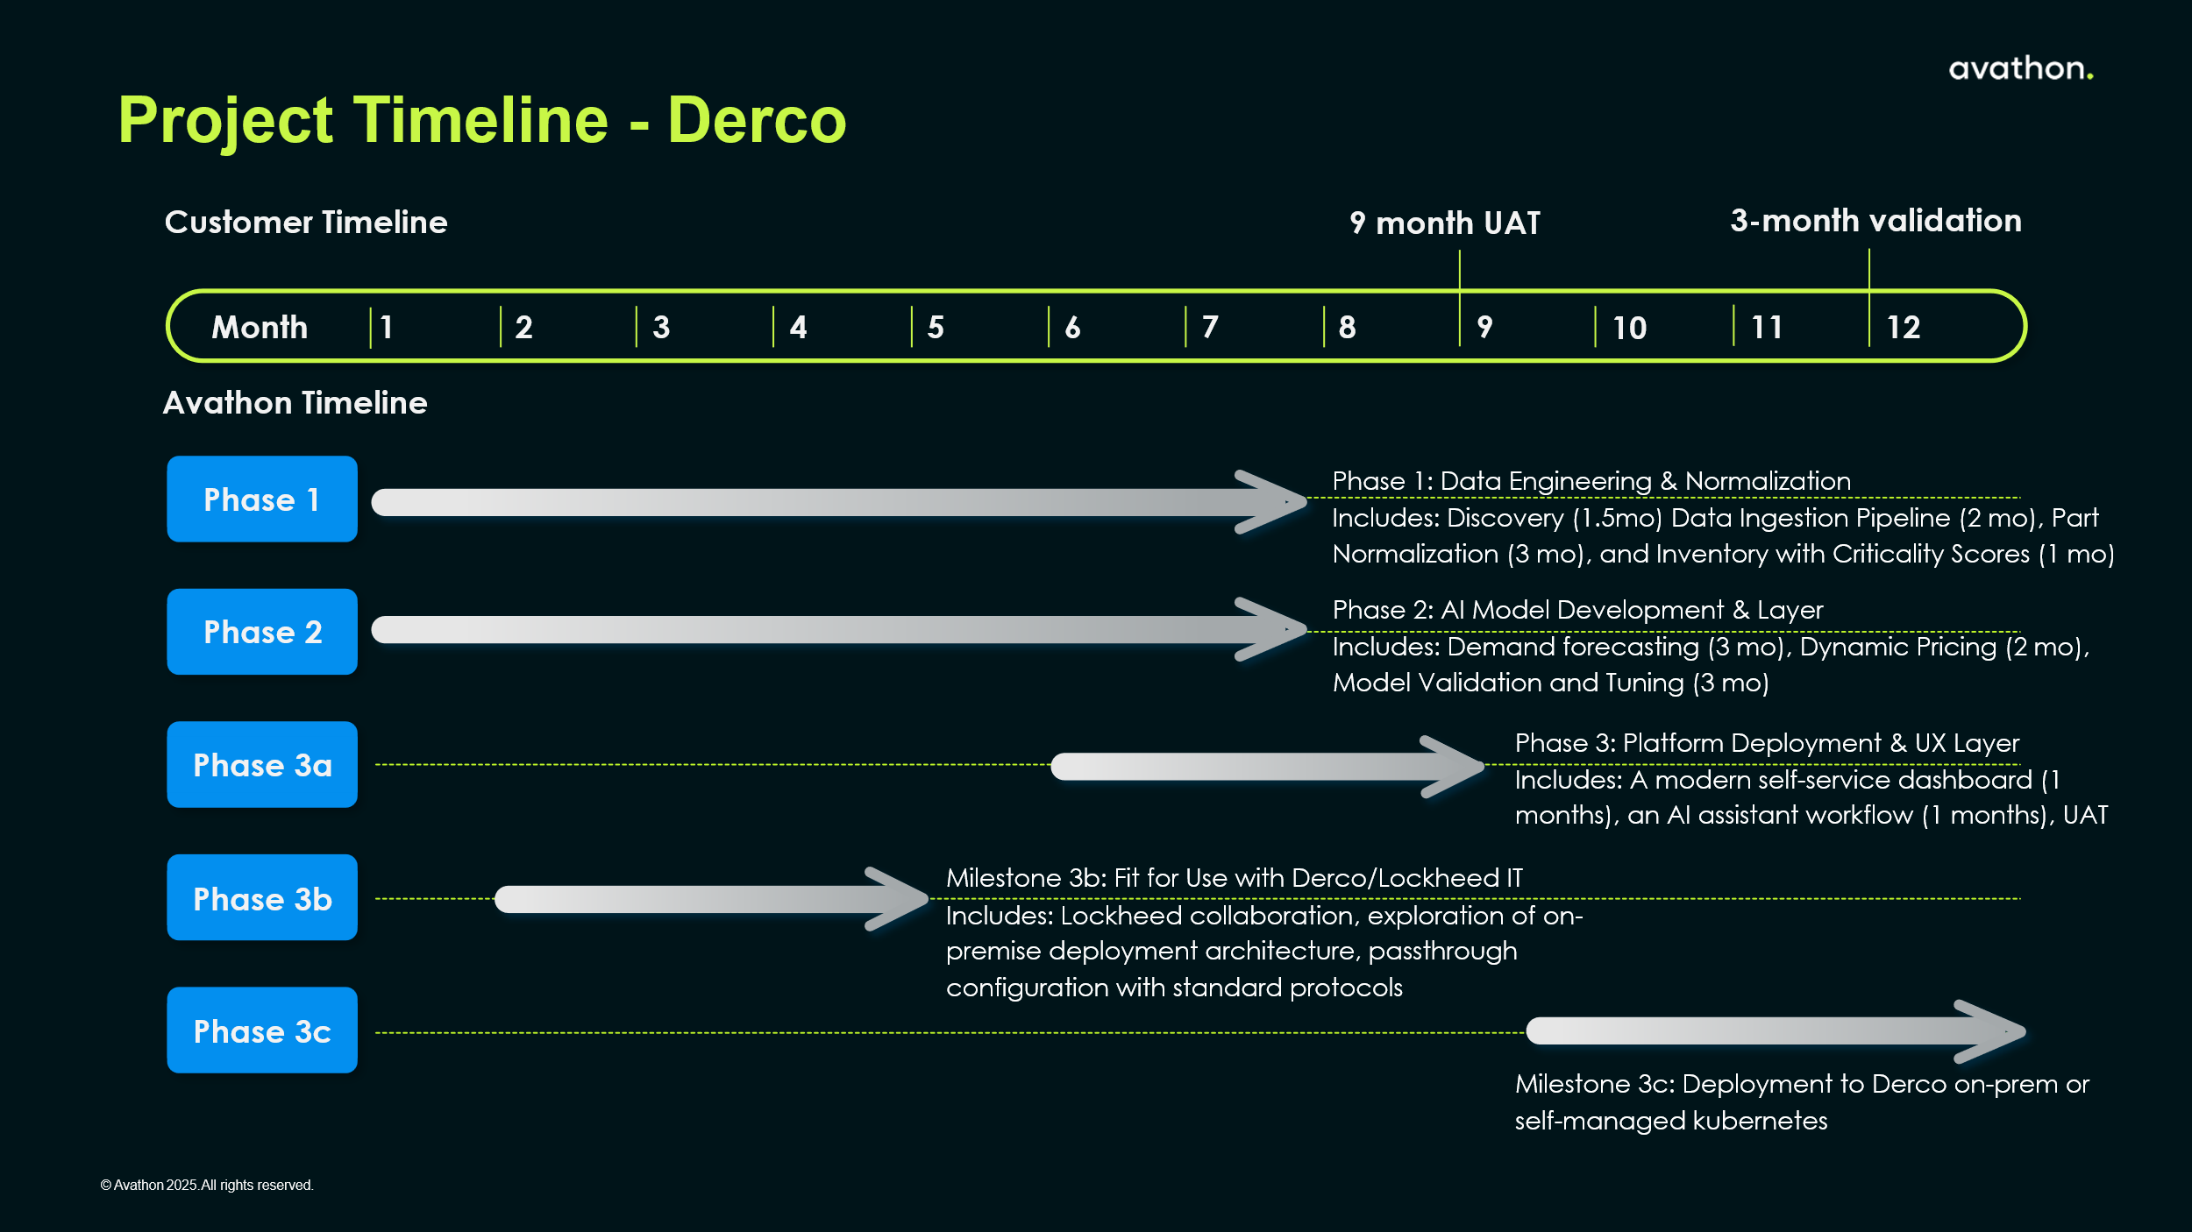

2.2 Risk Assessment & Mitigation Strategies
To enable successful delivery, completion of the proposed solution and mitigate risk across the project timeline, Avathon has identified risk mitigation strategies.
Table 2.3: Avathon Risk Mitigation Recommendations
Risk Category | Mitigation Strategy
I. Data Integrity & Normalization | - Risk: Failure to create a single, trustworthy Master Part Catalog due to the complex NSN vs. part number reconciliation challenge and the lack of data standards.  - Mitigation: Support Avathon with access to data availability contractually. Also front-loaded Data Engineering Reviews in Phase 1 are dedicated entirely to this. Implement strict Data Quality Reviews (DQR) and schema master reviews for NSN/Part reconciliation and classification.
II. Scope Creep & Integration Complexity | - Risk: The project relies on integrating data from multiple sources (ERP, ILS, Lockheed Work Order Transfer, flat files). Scope could balloon by requiring integration with a non-existent market data source or by trying to solve all historical data trust issues at once.  - Mitigation: Define the project scope around fixed scope and rollout of the Normalized Master Part Catalog and initial predictive models (DFM/DPM) as non-negotiable requirements. For "Market Data," formally define a placeholder API and limit early development to internal data optimization (price history, win rate). There are no good sources today. Use the Automated Order Flow trigger system as a Minimal Viable Product (MVP) for Phase 3 and future renewals.
III. Project Governance & Business Unit Trust | - Risk: The solution spans two different business units (Transactional and Program) , one of which doesn't trust its own data. Lack of unified sponsorship or conflicting priorities could stall adoption and decision-making  - Mitigation: Establish a Joint Executive Steering Committee (JESC) with Transactional Business Unit and the Program Business Unit, and other key stakeholders.
IV. Talent Domain Expertise (Internal) | - Risk: Once developed and tuned, Derco will need to manage their AI models post-deployment. This can lead to model decay or inability to use self-service analytics.  - Mitigation: Avathon and Derco will need to define ongoing support and knowledge transfer or co-development phases for latter stages.
V. On-premises deployment and operational burden | - Risk: Deploying a new, complex platform on-premise within the Lockheed Martin environment introduces risks related to internal network security protocols, latency, and resource provisioning for compute-intensive AI models  - Mitigation: Containerize all application components (AI models, API, UI) from the start. Collaborate with Derco/LMCO IT to immediately establish a GitOps workflow and DevSecOps pipeline for the Kubernetes cluster, automating deployment, scaling, and security compliance. Use Kubernetes Namespaces and Network Policies for immediate separation of customer/business unit data, leveraging the platform’s native security features.

3. Rough Order of Magnitude
Avathon is pleased to submit this ROM, based on Derco’s SSOW requirements and insights from the November workshop.
Includes | Option A | Option B
Agreement Term
Base Services Fee
Resource Commitment
Platform Fee

