Request for Proposal: CXC-K1125-5066
Submission Date: 2025 December 1
Requested By: Boeing Digital Aviation Services for the Engine Fleet Planning & Costing (EFPAC) Modernization product
Submitted By: Avathon

1. Background: Avathon - A Strategic Partner for Boeing EFPAC 2
1.1 Expertise Grounded in Aviation and Defense Rigor 2
1.2 Technological Future Proofing 2
1.3 Delivery Team Leadership Driving Operational Rigor 3
1.4 Architectural Complexity 4
1.5 Strategic Approach and Phased Delivery Acceleration 4
2. Program Schedule for Delivery 7
2.1 Team Size, Domain-Driven Design, & Cost Breakdown 7
2.2 Risk Assessment 9
2.3 Risk Mitigation Strategies 10
3. Customer Support 11
4. Rough Order of Magnitude 12
5. Go-to-Market 13
Contents

Background: Avathon - A Strategic Partner for Boeing EFPAC
Avathon is a full-spectrum AI company operating across capital-intensive sectors, with demonstrated operational depth and commercial focus in Aerospace and Defense. We specialize in transforming complex, fragmented data into actionable intelligence.

1.1 Expertise Grounded in Aviation and Defense Rigor
Avathon credentials are built upon solving the most demanding aerospace planning, logistics, maintenance and sustainment challenges in the world:
- Deep Domain Experience (Engines and Fleet): Our experience is not generic. We have successfully designed and deployed digital maintenance solutions for multiple MROs and leading global aerospace OEMs. This includes focused expertise in engine performance monitoring, predictive failure analysis, and managing the cost dynamics associated with TSO (Time Since Overhaul) and TSN (Time Since New) limits. We understand the tradeoffs of maintenance planning and the inherent complexities of avoiding costly unplanned engine and part removals.
- Proven Military/Defense Traceability: Our wholly owned subsidiary, Avathon Government, is a testament to our commitment to operational rigor. We have successfully built and deployed products for three branches of the U.S. military. This background guarantees that our platforms are engineered to meet the highest standards of data integrity, security, and compliance (e.g., CMMC and ISO 27001 readiness) - qualities essential for handling sensitive Boeing proprietary data. The government team, led by General Manager Art Sellers, ensures that this disciplined approach permeates the commercial products.
- Commercialization Speed: This renewed partnership with Boeing in 2025 marks a sharp shift from past research and development with Boeing to the sole commercialization of products. Our solution is market-ready, engineered for long-term support, and driven by the commercial imperatives of the EFPAC business.

Technological Future Proofing
The core difference between Avathon and traditional software vendors is Avathon’s proposed solution directly targets the cloud migration, structural, and scalability limitations of the legacy EFPAC environment while prepping maintenance and integrations for Boeing’s enterprise infrastructure. Avathon’s has a core competence in ingesting and linking complex, heterogeneous data. We are designed to handle ATA 2200 and S1000D formats, including XML/SGML, JSON, PDF, CSV, TXT with additional data connectors for real-time data ingestion. Input data/documents supported are FIM, CMM, TOs, Contracts, SBs, and engineering directives.
At the center of our solution is the Computational Knowledge Graph (CKG) - a modern architectural backbone that replaces manual scenario building and rigid data structures with a fully data unified, semantically rich model of fleet, maintenance, and cost data.
The platform uses commercial off-the-shelf identity services and configurable, secure Role-Based Access Control (RBAC), all deployed on a high-performance Data Lakehouse that immediately scales up to Boeing and customer requirements. Further this architecture supports true semantic modeling, where data engineers at forward-thinking airlines can define and extend data relationships through JavaScript and Python workflows. This technology differentiator is key workbench enabler for financial planners and maintenance.
To address key feature development and a final key differentiator, the platform is structurally capable to support AI workflows and Agentic Compute. Every forecast and recommendation can include full data lineage, enabling users to verify model logic and ensuring customers can trust the system’s outputs (a key weakness shared by the EFPAC team). This turns EFPAC from a black box into an auditable, high-availability, cloud workflow co-pilot aligned with Boeing Digital Aviation Services’ standards for reliability, explainability, and operational readiness.

1.3 Delivery Team Leadership Driving Operational Rigor
Our product and engineering teams bring a wealth of operational experience directly to this engagement:
- Engineering Leadership: Our engineering development, led by Jason Gross, emphasizes stability, scalability (via AKS), and adherence to the rigid standards required for aviation safety systems. Having deployed multiple aerospace and defense solutions to the web or the edge.
- Product Strategy: Product leadership, driven by Peter Glowa across both commercial and defense sectors, ensures that every feature built from the planned forecasts to maintenance availability to the multi-scenario comparison is prioritized by its highest market value and operational necessity.
In summary, Avathon brings proven technology coupled with product-market feedback loops to mitigate delivery risks.

1.4 Architectural Complexity
Based on Avathon's comprehensive review and analysis of the existing Boeing Statement of Work (SOW), we propose a revised Supplier Statement of Work (SSOW). This revision is specifically designed to optimize cost-effectiveness, reduced complexity, and practical feasibility, ensuring a successful, market-ready solution within the requested one-year delivery timeline. Figure 1.1 highlights the complexity of delivering an all-in-one solution with all Boeing services. This architectural representative approach would delay customer satisfaction, and jeopardize the Boeing EFPAC customer and market demands.
Figure 1.1: Architectural Complexity of Proposed Deliverables, excluding APIs
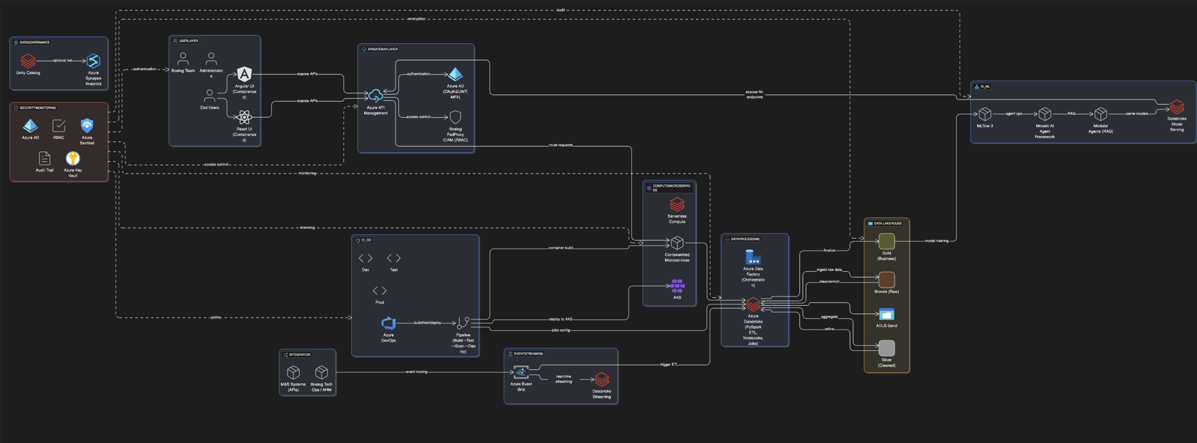
Our assessment identified potential challenges in achieving rapid customer adoption and market validation given the original SOW's timelines, particularly concerning integration with the existing Boeing services framework across critical technical domains: authentication, cloud infrastructure, front-end development, feature design, data processing, data lakehouse architecture, and Artificial Intelligence (AI) capabilities.

1.5 Strategic Approach and Phased Delivery Acceleration
To drastically accelerate Time-to-Market (TTM), Avathon will prioritize a focused development path to establish a functional, modern version of the EFPAC application. Specifically, we propose an initial revision on the core requirements encapsulated within the following original Deliverables:
- Deliverable 1: Cloud Hosting Solution Design
- Deliverable 5: User Management
- Deliverable 6: Application and API Development
- Deliverable 8: Testing, Implementation, and Support
- Deliverables 2, 3, 4, 7, and 9: Avathon accepts along with Appendix A requirements
Implementation Approach and Value to Boeing
The immediate objective is to build a new EFPAC web-responsive application hosted within Avathon’s controlled Azure cloud environment. This approach establishes feature parity, cloud portability, and modern front-end maintainability of the application codebase and infrastructure, allowing for a seamless future migration to Boeing’s Azure cloud. Speed, cost, and complexity were all considered in this approach.
Deliverable | Avathon Proposed Delivery Solution | Key Benefit
1: Cloud Hosting Solution Design | - Primary Infrastructure: Avathon-owned and managed Azure Environment designed and configured for EFPAC’s performance, security, and scalability.  - Storage & Data Architecture: Will be in Avathon’s data lakehouse with Avathon processing data foundation namespaces configured to Bronze, Silver, and Gold layers for unified data access and future migration  - UI/UX: Based on our current front-end team experience, development will be done in React with responsive design for cross-compatibility. Deployment will be containerized and deployed via AKS.  - AI/Agentic Workflows: Will be configured to support AI/ML workflows specific to EFPAC  - Compute & Deployment: Azure will be the preferred services with Avathon’s platform for compute | Optimizes performance, cost control, and complete architectural autonomy for a highly resilient and migration-ready compliant system. Managing Avathon’s own cloud infrastructure will enable faster tenant configuration and feature deployment to customers.
5: User Management | Avathon Identity and Access Management (IAM) service, keycloak, has prebuilt RBAC and Admin UI that can be defined to match EFPAC’s user definitions. This ready-made solution additionally supports audit trail for user access to application resources as foundational work. | Streamlines secure access for different user types, ensuring data privacy and compliance. Additionally, enables Boeing enterprise directories to be more easily managed and integrated.
6: Application & API Development | Avathon owned, managed, and documented APIs enable seamless data ingestion, application integration at the beginning of onboarding for customers, to further increase time-to-market. | Maximizes interoperability with external systems, facilitating easier data exchange and workflow automation without having to focus on Boeing APIs at the outset.
8: Testing, Implementation, and Support | In order to provide the quickest application and customer support for the EFPAC customers, an Avathon built solution that handles tickets from the EFPAC services team + our own monitoring services would be better deployed. | Accelerates development of feature-design, leading to faster deployment and time-to-value.

Alternative modernization approaches would require substantial time and cost to build foundational cloud-native capabilities, while the Avathon Platform already provides them out of the box. This includes a full cloud and AI/ML environment, data ingestion pipelines, API connectivity, pre-built models, and configurable workflows that can be rapidly tailored to the EFPAC business.
As shown in the below figure, developing EFPAC as an application on top of Avathon’s existing platform accelerates delivery and reduces risk. Our assessment is that alternative development paths would require roughly 18 months to reach market readiness, whereas leveraging the Avathon Platform enables a six-month delivery timeline.
Figure 1.2 Time to Market Comparison
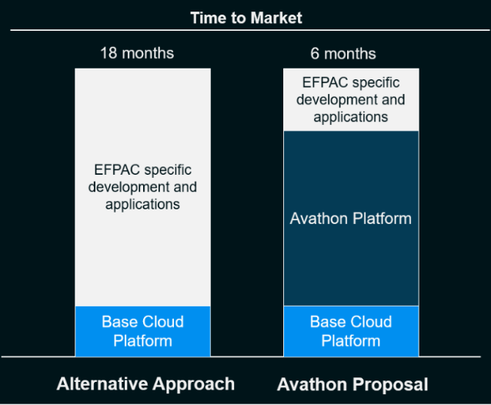

2. Program Schedule for Delivery
The EFPAC modernization program is structured into four parallel development milestones, followed by a fifth milestone dedicated to coordinated migration into Boeing’s operational environments. Because Boeing’s environments and integration points represent a critical dependency with expanded scope, Avathon has sequenced this work into Phase 5 to ensure accurate mapping, validation, and smooth Boeing customer onboarding. During Milestones 1–4, Avathon will refine all feature requirements, API specifications, and interoperability needs to guarantee seamless alignment with Boeing Digital Aviation Solutions and existing Boeing systems.
Figure 2.1: Avathon Project Timeline
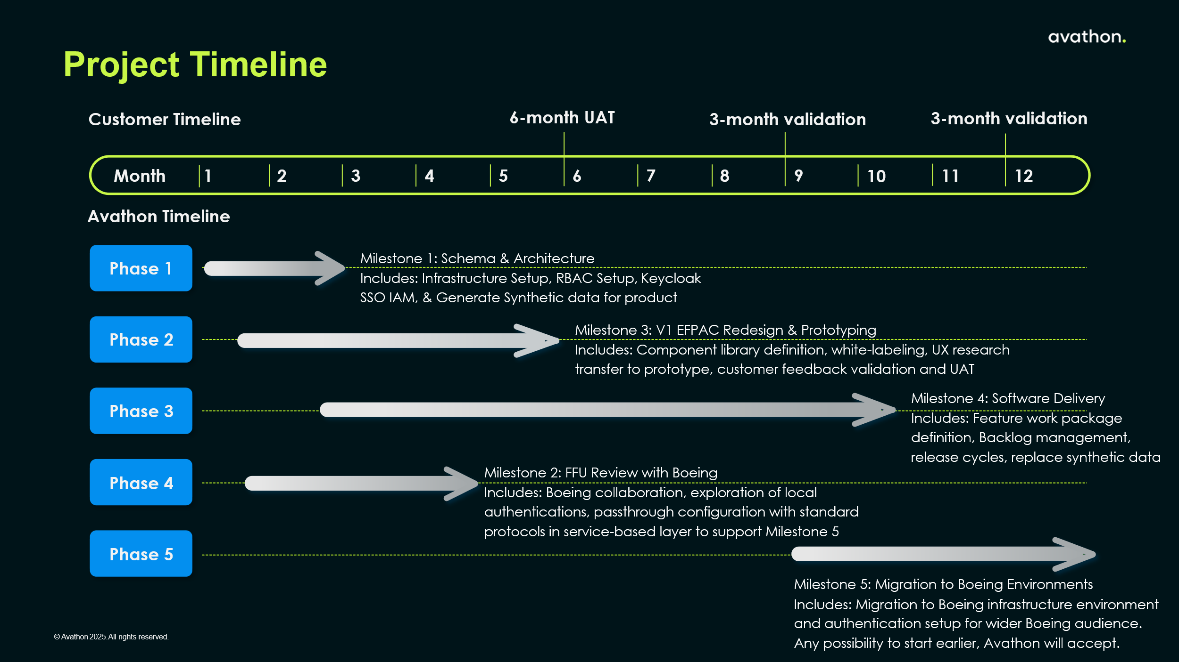

2.1 Team Size, Domain-Driven Design, & Cost Breakdown
Avathon’s initial estimate assumed a ten-person core delivery team; however, this staffing level is not sufficient to deliver the full scope defined in Boeing’s expanded SSOW. To meet all requirements within the accelerated timeline, Avathon recommends a 17-person core team. This team integrates all required disciplines - data engineering, backend services, UI/UX development, CloudOps, DevOps, product management, and solution architecture - ensuring complete coverage of every capability necessary to build and maintain a modern, scalable, browser-based EFPAC.
The operating model is structured around a Domain-Driven Design (DDD) approach, with work organized into clear business domains such as work-scope generation and performance data ingestion. Each cross-functional team owns a “bounded context,” meaning it has full responsibility for a cohesive segment of the system and its data behaviors. This reduces hand-offs, minimizes engineering dependencies, and accelerates delivery while ensuring the software aligns tightly with real operational needs across airlines, MROs, and Boeing stakeholders.
A federated data governance model reinforces this structure by giving the EFPAC program authoritative control over its domain data and roadmap while enabling standardized schema sharing with the Avathon Platform. This ensures both autonomy and interoperability.
Overall, the recommended team size, composition, and operating model provide the structure needed to deliver a modular, future-ready EFPAC platform in year one. Depending on the final negotiated scope - either Boeing’s expanded SSOW or Avathon’s reduced alternative - the program will have the resources required to support long-term scalability, continuous modernization, and predictable operational efficiency.
Table 2.2: Avathon Original Scope to Resource Alignment – Year 1
Milestone Phase | Estimated Cost | Avathon Resources
1: Architecture Design (Mos. 1-3) | US$200k | - 1 FTE: Development  - 2 FTE: Data Engineer  - 1 FTE: Split between Dev & CloudOps  - 1 FTE: Engineering Mgr
2: V1 EFPAC Redesign and Path to UAT (Mos. 1-5) | US$450k | - 6 Engineering FTEs  - 2 FTE: UX and UI  - 1 FTE: SME
3: Software Delivery (Mos. 2-12) | US$800k | - 7 FTE: 2 Squads = Development + Data Science  - 2 FTE: UX  - 1 FTE: SME  - 1 FTE: Split between Product Manager & PMO
4: FFU Review  (Mos. 2-4) | NA | - NA
5: Migration & Integration with Boeing (Mos. 9-12) | US$300K | - 1 FTE: Development  - 1 FTE: Data Engineer  - 1 FTE: Integration Lead  - 1 FTE: Split between Dev & CloudOps  - 1 FTE: Split between Engineering Manager & PMO
 | US$1.75M | Year 1 Reduced Scope Services Fee with 10 FTE
 | US $2.55M | Year 1 Full Scope Services Fee (expanded scope in Milestones 3 & 5 with 17 FTEs to do all the feature parity, integration, and authentication with Boeing services networks)

Overseeing the Avathon resources and services team is a dedicated management team across business, engineering, strategy, product, and data science. Typically, this level of engagement is rarely ever included in blended hourly rate.
Figure 2.3: Management Team for Aerospace
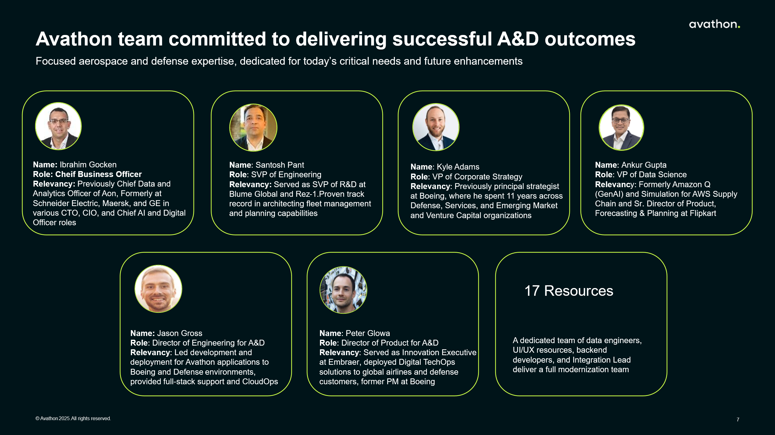

2.2 Risk Assessment
Avathon and Boeing conducted a workshop on November 24, 2025. During this workshop Avathon provided feedback to Boeing on risks and dependencies. Avathon has categorized these risks into four categories and scored them based on impact to the project and occurrence probability.
Figure 2.4 Risk Categorizing and Scoring for EFPAC Delivery
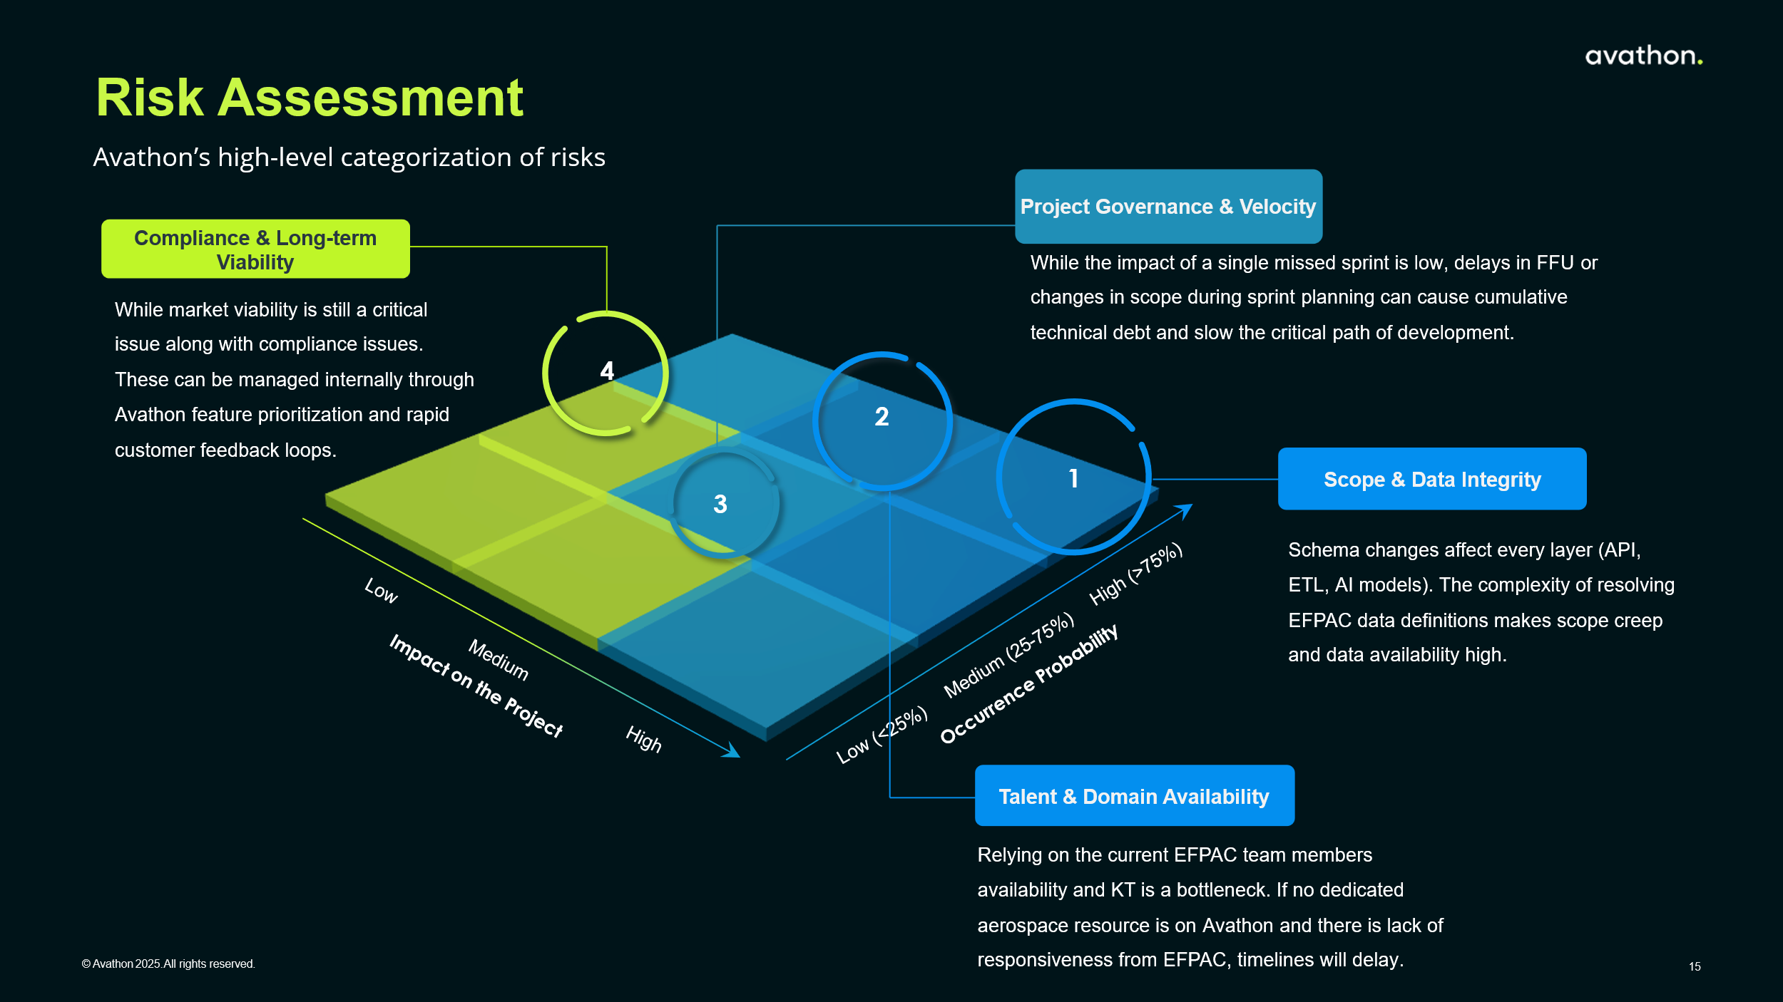

2.3 Risk Mitigation Strategies
To enable successful delivery, completion of the proposed solution and mitigate risk across the timeline, Avathon has identified risk mitigation strategies.
Table 2.3: Avathon Risk Mitigation Recommendations
Risk Category | Mitigation Strategy
I. Scope & Data Integrity | - Mandate an EFPAC Engineering Lead & SME is paired with Avathon Engineers before engineering work begins to map EFPAC v1 capabilities with user role access.  - Ensure Data Availability, Data Approval, and Boeing responsibility terms are written into the contract to avoid delay, blame, and early termination of supplier when dependencies have been identified.
II. Project Governance & Velocity | - Implement an accelerated, executive-level sign-off process for all major deliverables (e.g., FFU, data shares) by routing decisions through the Steering Committee for quick decision-making. Avathon will be balancing final system design during FFU review, which will require executive-level support for approval.  - Continuous Planning Cadence: Establish weekly sessions with mandatory EFPAC team/representative attendance  - Backlog Synchronization: Export ticket synchronization from ADO to JIRA for refinement.
III. Talent & Domain Expertise | - EFPAC Availability & KT: Secure contractual terms availability (25%) to ensure continuous delivery cycles. Avathon SME: ensure a project management function is included in scope to reduce cost overruns and scope changes.
IV. Compliance & Long-Term Viability | - Build customer validation into the sprint cycle (prototyping with initial launch partners) to mitigate dependence on dev partners.

3. Customer Support
We have a customer support team ready-made to support 24/7 support for the EFPAC team with severity levels 1-4. The team is driven to ensure daily issue resolution with end-to-end support from troubleshooting, diagnosis, and escalation related to the service delivered. Via our proactive infrastructure monitoring, we are able to continuously track infrastructure to spot and fix risks early, driving continuous improvement. For customers to be properly addressed the four severity levels we have within our customer support team are:
- Severity 1 (High): Faults that cause non-availability of the system
- Severity 2 (Medium): Faults that cause severe impairment causing delay to the Customer
- Severity 3 (Low): Faults that interfere with the system causing inconvenience
- Severity 4 (Minor): Single user or small set of users affected
Avathon further structures the team to address all timezones with four shifts.
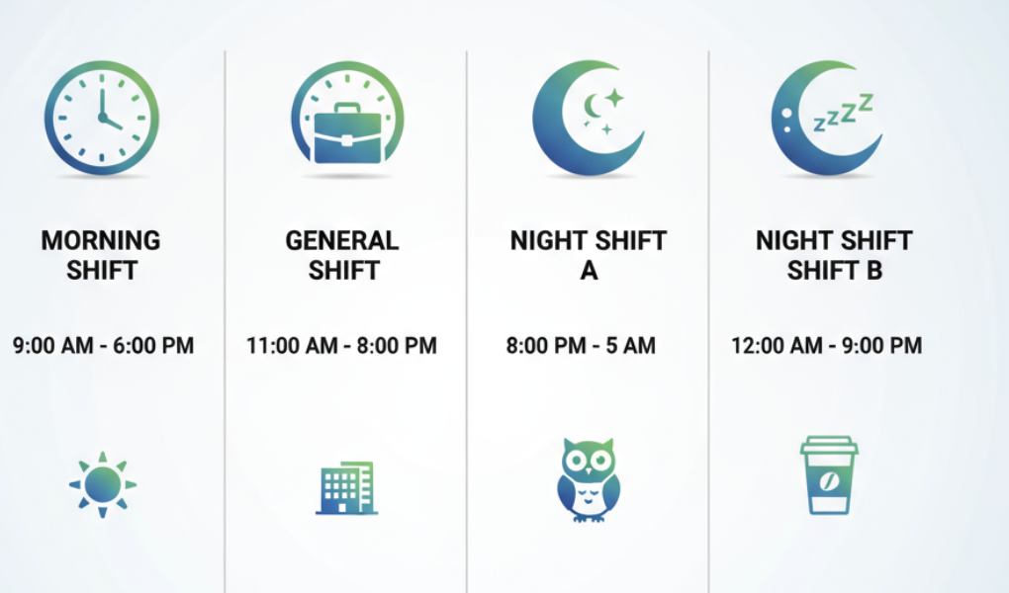

4. Rough Order of Magnitude
Avathon is pleased to submit this ROM, based on Boeing’s SSOW requirements and insights from the November EFPAC workshop. To fully meet functional, non-functional, and integration obligations, the delivery plan has been expanded from 10 to 17 full-time resources, ensuring full coverage and on-schedule modernization.
For predictability and cost management, year-one development costs are allocated and amortized across Option B’s multi-year commitment to achieve all SSOW deliverables. A five-year agreement locks in predictable pricing, protects Boeing from rising cloud, AI compute, and labor costs, and ensures ongoing access to platform upgrades, AI enhancements, cybersecurity updates, and performance optimizations. If a five-year term is too long, costs can be amortized over a shorter period.
A multi-year partnership delivers unmatched discounted first-year pricing on blended labor rates including access to Avathon’s AI management team in Figure 2.3, avoids future cost escalation, and supports stable, long-term financial planning. This approach enables the new EFPAC by Avathon to scale efficiently, stay aligned with a jointly planned roadmap, and integrate seamlessly into Boeing’s broader Digital Aviation Services ecosystem.
Includes | Option A | Option B
Agreement Term | 1 Year | 5 Year
Base Services Fee | $2.55M for year 1, full scope | $1.5M for year 1, full scope
Resource Commitment | 17 FTE for year 1 and TBD for year 2 onward with no commitment | 17 FTE for year 1 and  8 FTE for year 2-5
Platform Fee | Negotiated Rate after year 1 | Fixed at 500k/year after year 1
Customer Fee (Rev Share + Deployment Costs) | Negotiated Rate after year 1 | Discounted & Negotiated Rate after year 1

5. Go-to-Market
Avathon recommends a collaborative go-to-market and performance-based revenue sharing framework with Boeing to reinforce EFPAC’s competitive edge and deliver sustained value and differentiation to customers. Pursuant to this, Avathon is currently engaged with a current EFPAC customer that is interested in an upgraded version of EFPAC built on the Avathon Platform. Avathon will direct this customer to the modernized version of the EFPAC product being built because of this proposal and SSOW.
In addition, Avathon believes that an upgraded version of EFPAC marketed, for example, as “Powered by Avathon”, a notation similar to “Intel Inside” will generate additional demand in the marketplace for this current customer and future prospects, taking advantage of the market awareness of partnering with an innovative company at the forefront of AI for aerospace, defense, and industrial markets, based out of the Silicon Valley area.
Avathon and Boeing will make best efforts to upcharge current customers of EFPAC who receive the modernized version.
Finally, Avathon will invest its own Sales, Support, & Marketing (S&M) resources toward the success of this joint go-to-market approach. These S&M resources are included in the annual price and performance share proposed in this ROM.

