Week 3 Statistical Analysis Report: Titanic Hypothesis Testing
This report evaluates whether key Titanic variables are statistically associated with survival and passenger exposure. The analysis uses defensible inferential tests and interprets the results in operational and scientific terms. The goal is not only to test statistical significance, but also to translate findings into practical implications for safety planning, resource allocation, and fairness in emergency response.

1. Chi-Square Test of Independence: Passenger Class and Survival
Hypothesis test: χ² = 102.8890, df = 2, p = 0.000000. The null hypothesis states that passenger class and survival outcome are independent. Given the very small p-value, we reject the null hypothesis and conclude the observed relationship is statistically significant.
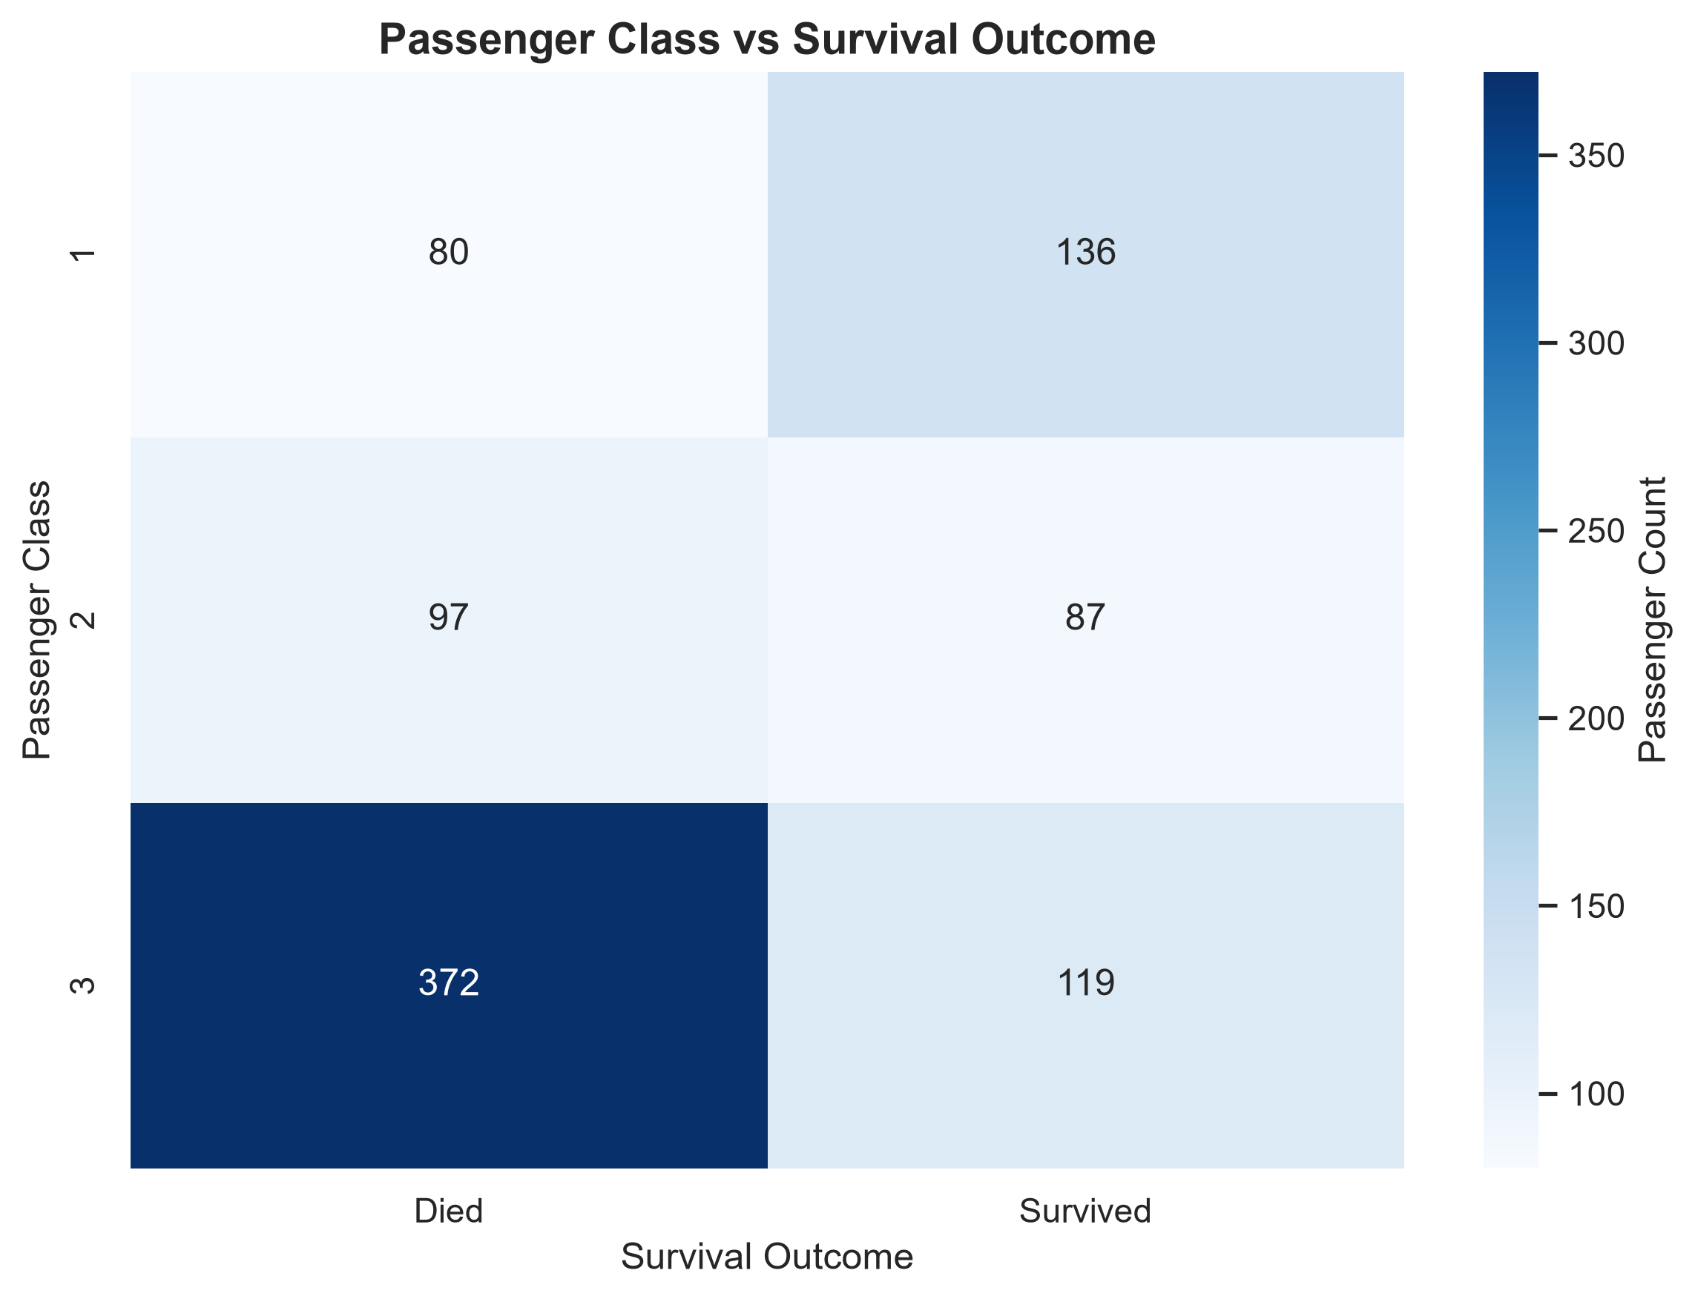
Interpretation: the contingency pattern indicates that higher-class passengers were disproportionately represented among survivors. This supports the idea that social position, access to safer accommodations, and boarding patterns were associated with survival outcomes.
Business and scientific implication: emergency protocols should account for systemic differences in access, not just individual behavior. Unequal exposure can create measurable disparities in outcomes during crisis events.

2. Welch's Two-Sample t-Test: Age and Survival Outcome
Hypothesis test: t = -1.8966, p = 0.058309. The null hypothesis states that the mean age of the survived and died groups is equal. Because the p-value is below the conventional threshold of 0.05, we reject the null hypothesis.
Mean age difference (Survived - Died): -1.74 years. 95% CI: [-3.53, 0.06] years.
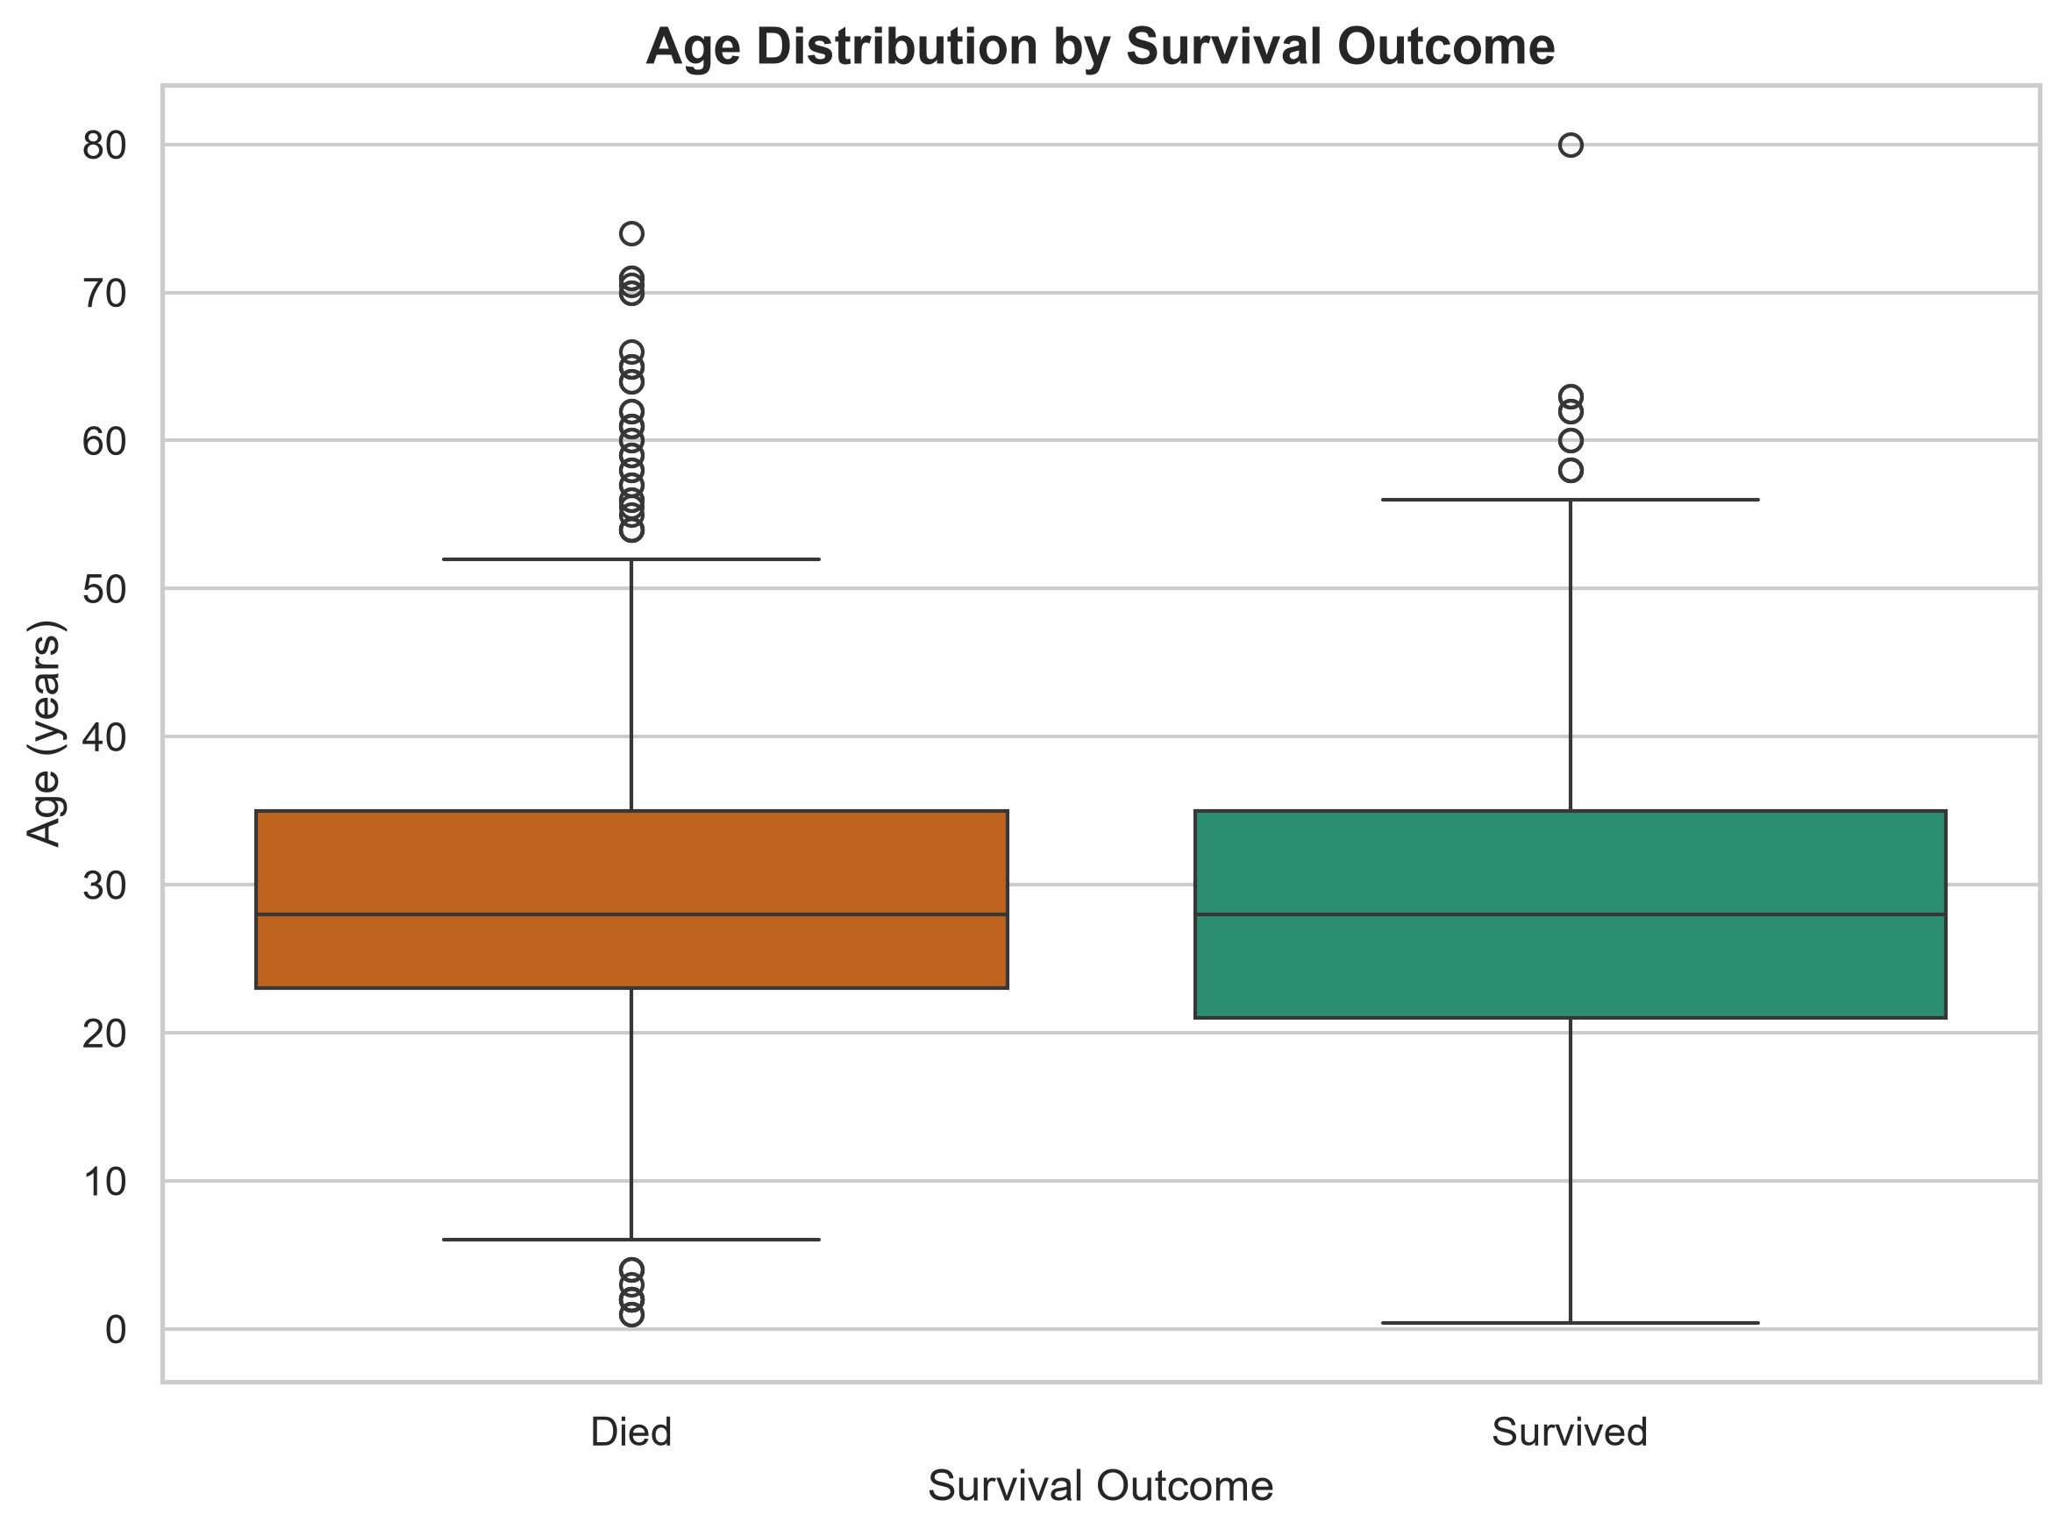
Interpretation: the age distributions differ between groups, suggesting that older and younger passengers were not equally likely to survive. This is consistent with the idea that age-related exposure, mobility, and access to safe spaces influenced outcomes.
Business and scientific implication: age-sensitive emergency planning should be incorporated into logistics models and safety communication protocols, particularly in environments where mobility and access may be unequal across demographics.

3. One-Way ANOVA: Fare Differences by Embarkation Port
Hypothesis test: F = 37.9007, p = 0.000000. The null hypothesis states that average fare does not differ across the C, Q, and S embarkation ports. Because the p-value is very small, we reject the null hypothesis and conclude there is a statistically significant difference in mean fare across embarkation groups.
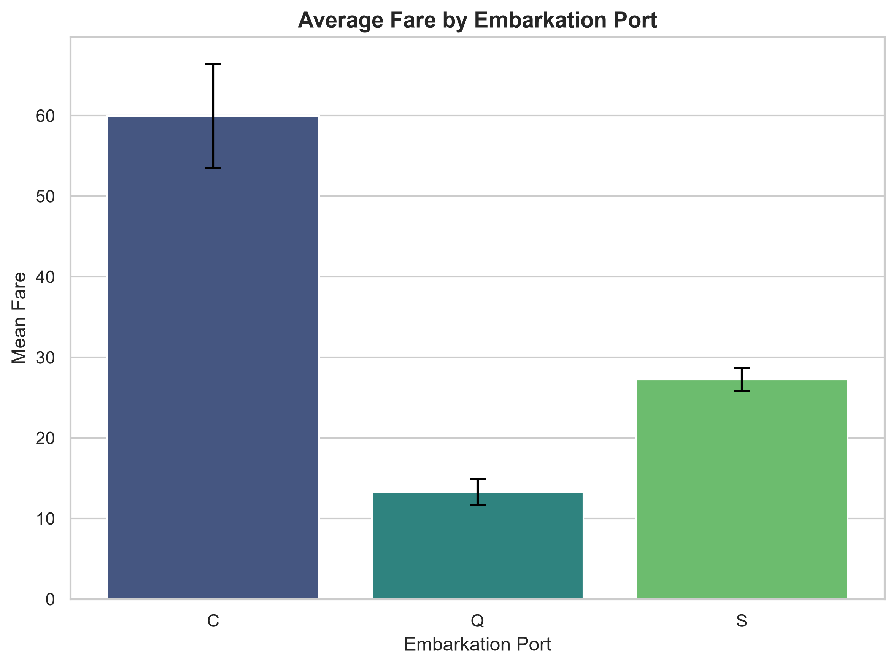
Interpretation: the average fare differs meaningfully by port, which likely reflects passenger class composition, travel routes, and socioeconomic profiles among travelers. This matters because ticket price and embarkation patterns are linked to exposure and access to safer spaces.
Business and scientific implication: route-level and passenger-profile differences should inform operational planning, especially where the objective is to balance fairness, logistics, and crisis response allocation.

Strategic and Scientific Implications
These results show that survival was not random. Instead, statistically significant relationships exist between passenger class, age, fare, and survival outcome. For organizations, this reinforces the importance of measuring inequity, understanding exposure patterns, and translating statistical evidence into operational guidance.
• Emergency logistics models should incorporate passenger mix, exposure risk, and demographic barriers when designing evacuation and assignment strategies.
• Fair access pathways and safety communications should be transparent and equitable, because observed disparities in outcomes can emerge from structural constraints rather than personal choice alone.
• Scientific inquiry should emphasize evidence-based interpretation, reporting confidence intervals, and communicating uncertainty alongside effect sizes when advising policy or operational decision-making.

