Week 2 Visual Storytelling Report: Titanic Survival Analysis
This report examines how survival on the Titanic was distributed across age, gender, passenger class, fare level, and embarkation route. The historical tragedy offers a useful case study for modern operations because it captures how access, exposure, and resource allocation influence outcomes under pressure. The dataset contains a broad mix of passengers with different economic, social, and travel profiles, making it well suited for visual storytelling and decision-oriented analysis. Across the figures, a clear pattern emerges: women, higher-class passengers, and those with greater access to safer accommodations experienced meaningfully better survival outcomes. The analysis also suggests that age and family structure mattered, although the strongest patterns are linked to social position and access to protected space. For executives and business leaders, the key lesson is not simply that survival was uneven; it is that unequal access to safety, information, and protected spaces shapes outcomes in predictable ways. In operational terms, this means that emergency systems, logistics planning, and access policies must be designed to reduce disparities rather than rely on ad hoc behavior during a crisis. The Titanic case remains a practical reminder that safety performance depends on both infrastructure and fairness.

Visual Storytelling Section

Figure 1: Age Distribution by Gender and Survival Status
This split violin reveals how the age distribution differs between men and women and how those patterns change for passengers who survived versus those who died. The width of each violin shows the density of passengers at each age, while the split makes the comparison immediately visible. This chart type is especially effective because age is continuous, and survival outcomes are categorical, so a density comparison is more informative than a simple bar chart.
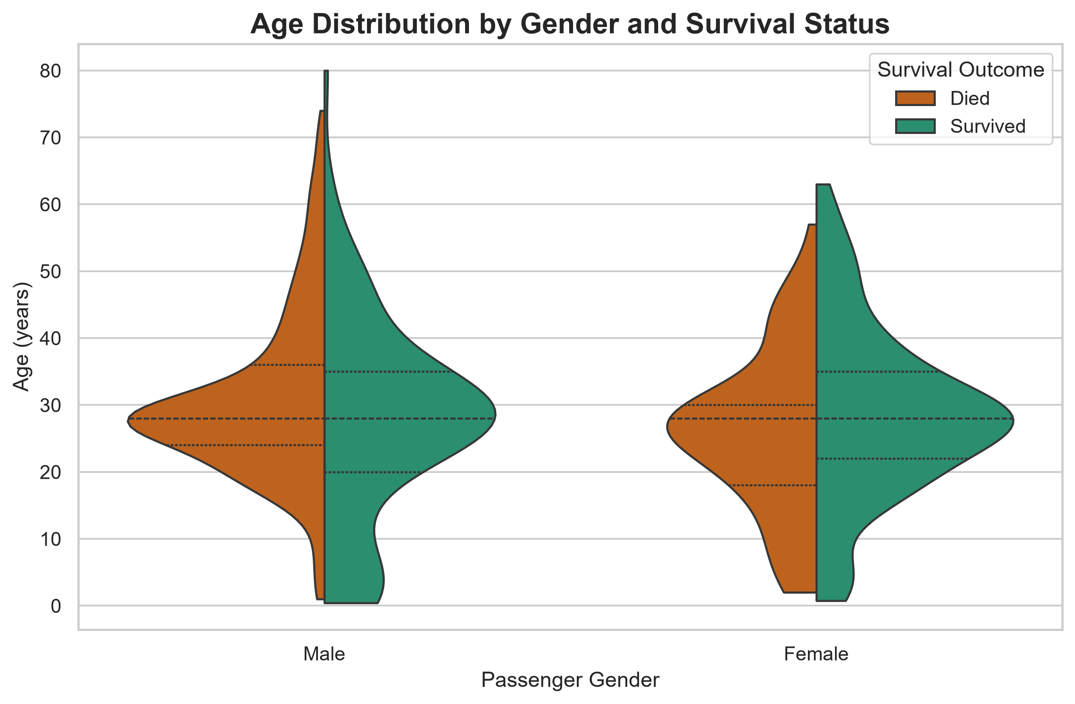
Analytical takeaway: The visual suggests that younger adults and women were disproportionately represented among the survivors, which has strong implications for equitable emergency access and the design of age-sensitive evacuation procedures.

Figure 2: Survival Proportions Across Passenger Classes
The 100% stacked bar chart shows the composition of survival outcomes within each passenger class. It standardizes each class to 100%, making it easy to compare the mix of survivors and non-survivors across classes without distortion from the different number of passengers in each group. This chart is ideal for communicating proportional differences to non-technical stakeholders.
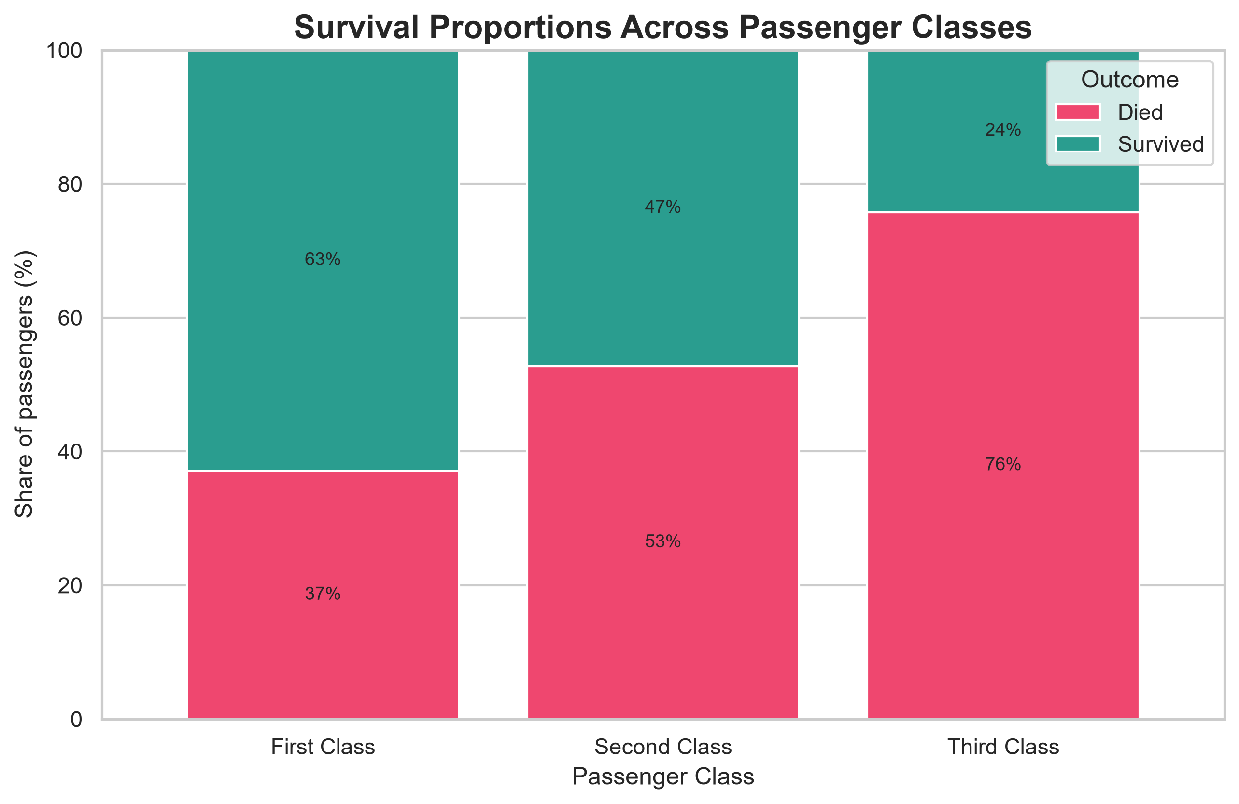
Analytical takeaway: The chart makes clear that access to safer, higher-class accommodations was associated with a materially better survival outcome, highlighting the operational importance of passenger prioritization and cabin access in crisis response systems.

Figure 3: Age vs. Fare Paid by Survival Status
This bubble plot combines age, price paid, and passenger class into a single narrative. Each point represents a passenger, the x-axis shows age, the y-axis shows fare, the bubble size reflects class level, and the color distinguishes survival. This multivariate format is valuable because it reveals whether higher-paid passengers clustered in more favorable survival zones or whether age and class mattered more than ticket price alone.
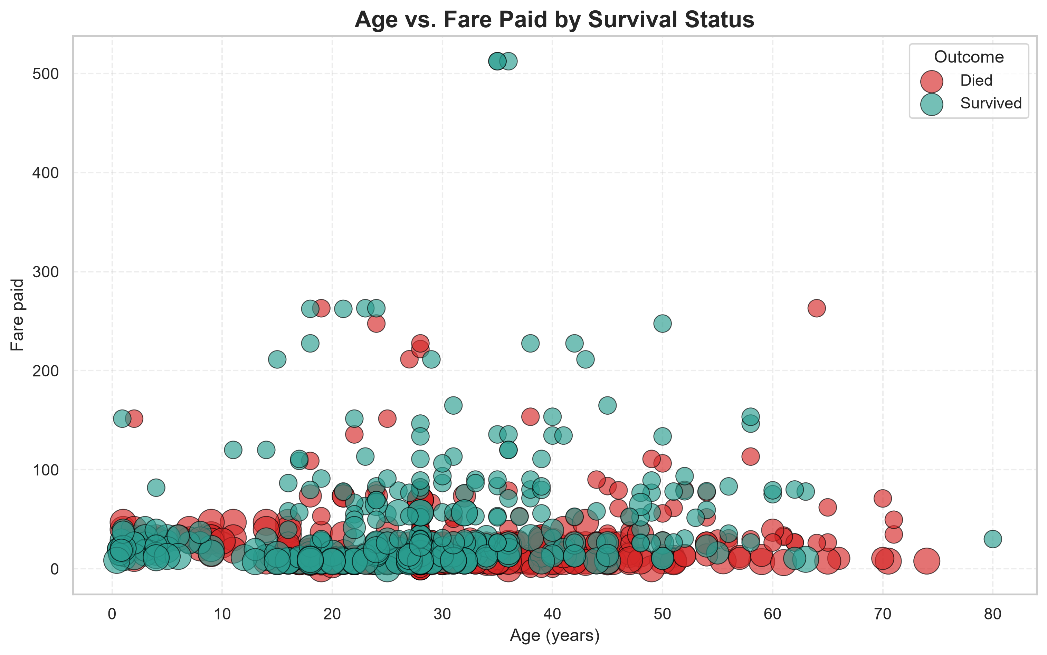
Analytical takeaway: The bubble pattern suggests that class and financial access were intertwined with survival outcomes, reinforcing the need for fair, risk-aware evacuation planning that does not depend solely on wealth or cabin position.

Figure 4: Correlation Matrix of Key Variables
The correlation heatmap summarizes the linear relationships among the most important variables in the dataset. It helps identify which features move together and which show stronger or weaker relationships with survival. For executive audiences, heatmaps are effective because they condense a large amount of statistical information into a simple color scale.
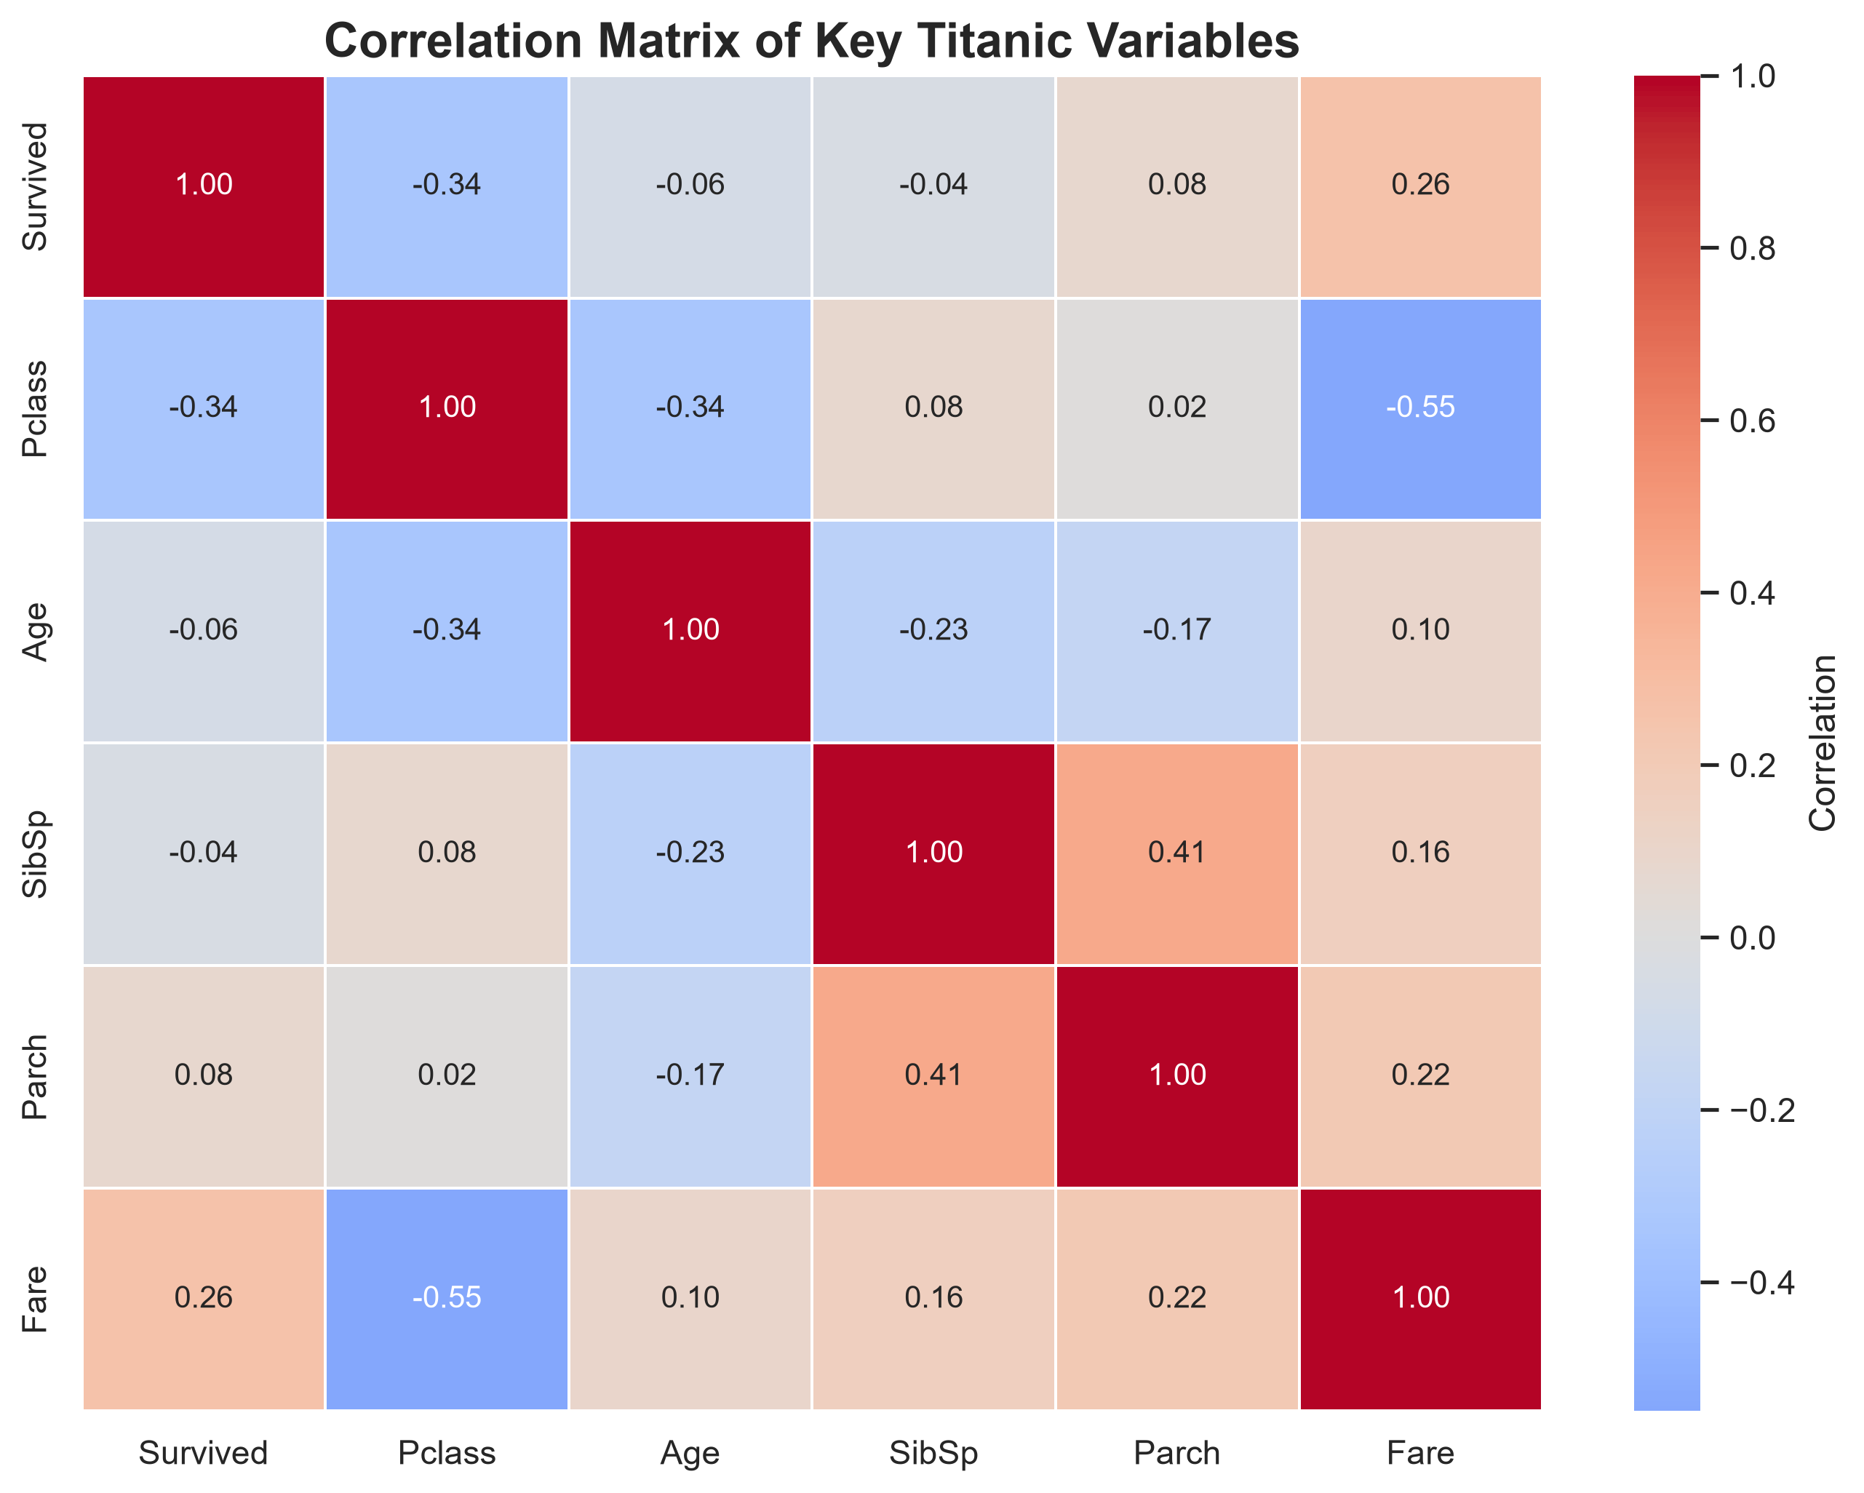
Analytical takeaway: The strongest story from the heatmap is that survival is influenced by class and fare-related exposure factors, while age and family counts show more moderate patterns. This supports better operational targeting for safety training, logistics, and emergency planning.

Figure 5: Embarkation, Class, Sex, and Survival Hierarchy
The sunburst chart organizes the data into a hierarchical flow from embarkation port to passenger class, sex, and survival result. This makes it easy to see where the highest-risk and highest-protected groups were concentrated. It is particularly effective for storytelling because it turns a multi-step decision path into a visual journey that executives can interpret quickly.
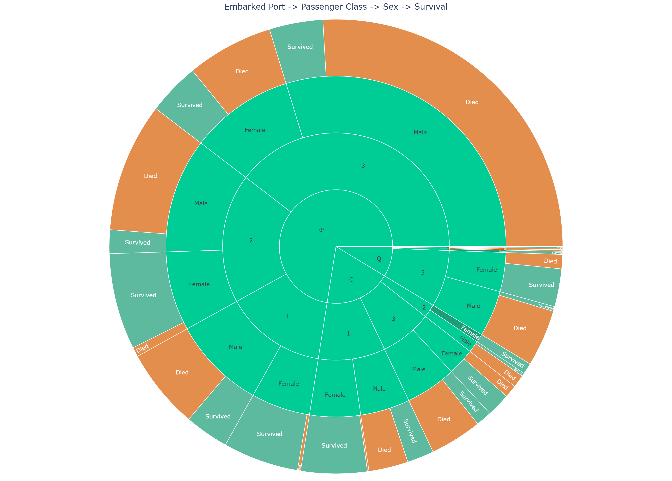
Analytical takeaway: The hierarchy emphasizes that survival was not random; it was shaped by both exposure pattern and social structure. That insight strengthens the business case for layered safety protocols, equitable access strategies, and improved emergency logistics planning.

Strategic and Scientific Implications
• Emergency logistics should account for who is likely to be most exposed, most constrained, and least able to reach safe areas quickly. Safety planning must therefore include crowd flow modeling, access mapping, and explicit prioritization rules for vulnerable groups.
• Access equality matters because outcomes were strongly associated with class, fare level, and cabin position. Infrastructure, staffing, and procedural fairness should reduce avoidable disparities rather than reinforcing them under crisis conditions.
• Safety protocols should be informed by empirical evidence, not intuition alone. This analysis demonstrates that operational decisions about positioning, communication, and resource mobilization can be sharpened with a clear understanding of risk patterns and demographic exposure.
• From a scientific perspective, this case study reinforces the value of human-centered data storytelling: when information is visualized clearly, complex decisions become more transparent and more actionable for managers, regulators, and emergency teams.

